Supplementary Table 1: Samples identified as strongly discrepant (outliers) and excluded from analysis

Nr | Cohort | NF-Light Adv V2 (Plus) | Lumipulse G NfL* | Elecsys NfL*
1 | MS | 6.79 | 7.87 (6.07) | 2.67 (14.52)
2 | MS | 10.53 | 12.2 4 (10.16) | 0.50 (0.82)
3 | MS | 29.16 | 9.81 (7.88) | 1.60 (7.76)
4 | MS | 10.00 | 9.18 (7.29) | 4.61 (26.76)
5 | Healthy controls | 9.73 | 147.22 (136.53) | 1.74 (8.65)
6 | Healthy controls | 18.32 | 5.85 (4.18) | 1.21 (5.30)
7 | Healthy controls | 14.49 | 16.54 (14.19) | 5.20 (30.48)
8 | Healthy controls | 11.66 | 4.56 (2.97) | 0.92 (3.47)
9 | Healthy controls | 4.16 | 11.34 (9.32) | 2.06 (10.67)
10 | Healthy controls | 5.27 | 39.27 (35.47) | 1.19 (5.18)
11 | High to low | 1.74 | 11.92 (9.86) | 2.14 (11.17)
12 | High to low | 1.40 | 6.60 (4.88) | 1.11 (4.67)
13 | High to low | 6.29 | 140.67 (130.40) | 1.60 (7.76)
14 | High to low | 149.15 | 407.85 (380.55) | 0.59 (1.39)
*Converted values are shown in brackets; bold font indicates subjective assessment of outlier plattform; red background color indicates the outlier sample >4SD; RRMS = relapsing remitting multiple sclerosis; SD = standard deviation.

Supplementary Table 2: Comparison of the Area under the Curve (AUC) in ROC analysis between platforms, separate analysis of converted concentrations, and Z-scores. Significant (p<0.05) pairwise comparisons are shown in green.

Comparison | AUC 1 | AUC 2 | p value | Type
NF-Light Adv V2 (Plus) (Raw) vs NF-Light Adv V2 (Plus) (Z) | 0.691 | 0.719 | 0.18200 | Raw vs Z-Score
Elecsys NfL (Raw) vs Elecsys NfL (Z) | 0.754 | 0.781 | 0.22600 | Raw vs Z-Score
Lumipulse G NfL (Raw) vs Lumipulse G NfL (Z) | 0.709 | 0.731 | 0.32700 | Raw vs Z-Score
NF-Light Adv V2 (Plus) vs Elecsys NfL | 0.691 | 0.754 | 0.00858 | Concentrations
NF-Light Adv V2 (Plus) vs Lumipulse G NfL | 0.691 | 0.709 | 0.30500 | Concentrations
Elecsys NfL vs Lumipulse G NfL | 0.754 | 0.709 | 0.03880 | Concentrations
NF-Light Adv V2 (Plus) Z scores vs Elecsys NfL | 0.719 | 0.781 | 0.02130 | Z score
NF-Light Adv V2 (Plus) Z scores vs Lumipulse NfL | 0.719 | 0.731 | 0.51000 | Z score
Elecsys NfL Z Scores vs Lumipulse NfL | 0.781 | 0.731 | 0.02700 | Z score

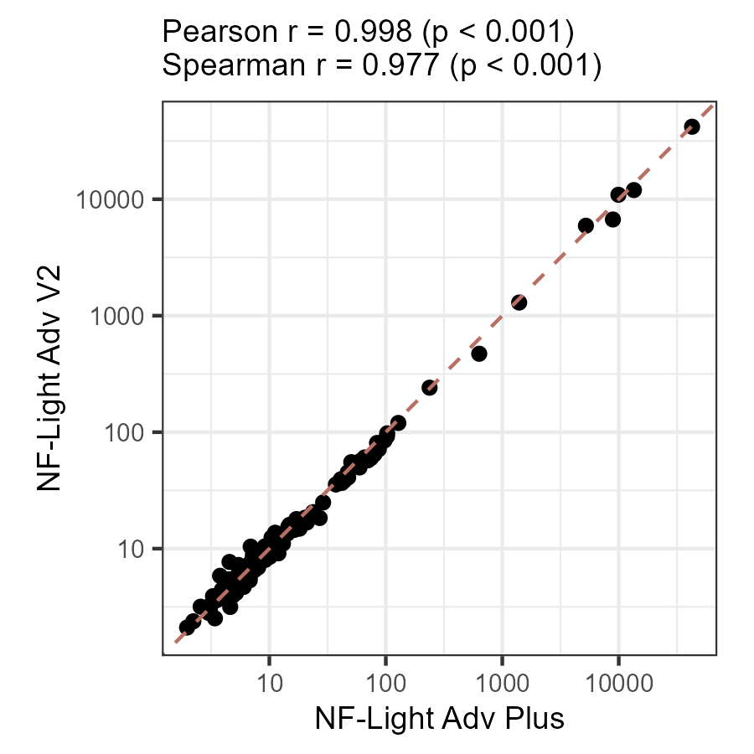

Supplementary Figure 1: Comparison between NF-light Advantage Adv V2 and NF-light Advantage Adv Plus assays on HD-X analyzer, Quanterix (Passing Bablok Regression: NF-Light Adv V2 = 0.919 * NF-Light Adv Plus+ 0.461, CI Slope: [0.88-0.95], CI Intercept: [0.28-0.85], N=159, results in pg/ml).

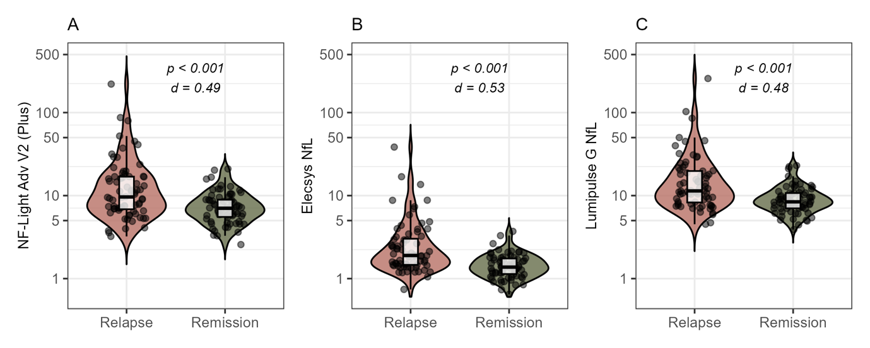
Supplementary Figure 2: Analytical performance of non-converted absolute sNFL values on all platforms to discriminate MS patients with relapse and remission. A) sNfL values in relapse and remission measured with NF-light Advantage (Adv) V2 (Plus), Quanterix; B) sNfL values in relapse and remission measured with Elecsys NfL, Roche Diagnostics; C) sNfL values in relapse and remission measured with Lumipulse G NfL blood, FujiRebio.

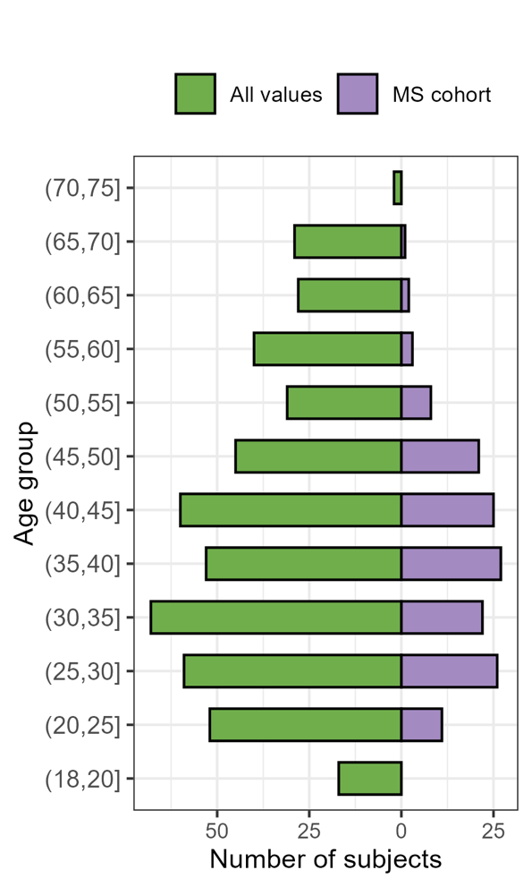
Supplementary Figure 3: Age distribution in the study. MS= multiple sclerosis.

