An isotope dilution-liquid chromatography-tandem mass spectrometry based candidate reference measurement procedure for the quantification of mycophenolic acid glucuronide in human serum and plasma

Short title: An ID-LC-MS/MS-based candidate reference method for the quantification of MPAG

Tobias Schierscherª, Janik Wildª, Neeraj Singh^{b}, Martina Bachmann^{b}, Julia Hoopª, Friederike Bauland^{c}, Andrea Geistanger^{b}, Lorenz Rischª, Christoph Segerª, Judith Taibon^{b}*

ªDr. Risch Ostschweiz AG, Lagerstrasse 30, 9470 Buchs, Switzerland
^{b}Roche Diagnostics GmbH, Nonnenwald 2, 82377 Penzberg, Germany
^{c}Chrestos Concept GmbH & Co. KG, Girardestaße 1–5, 45131 Essen, Germany

*Corresponding author: Judith Taibon, PhD, Nonnenwald 2, 82377 Penzberg, Germany, Phone: +49 8856 6012941, E-Mail: judith.taibon@roche.com
Characterization of reference material by quantitative nuclear magnetic resonance (qNMR) measurements

Quantitative nuclear magnetic resonance (qNMR) measurements were performed in six replicates using the International System of Units (SI units) traceable internal standard (ISTD) for the quantification of the absolute content of Mycophenolic acid glucuronide (MPAG).

The following formula was utilized to calculate the absolute content of Mycophenolic acid glucuronide:

$$Px=\frac{Ix*Nstd*Mx*mstd}{Istd*Nx*Mstdmx}*Pstd$$

Px: Purity of the analyte as mass fraction
Pstd: Purity of the internal qNMR standard as mass fraction
Ix: Integral of the analyte
Istd: Integral of the internal standard
Nx: No. of analyte protons
Nstd: No. of internal qNMR standard protons
Mx: Molecular weight of the analyte
Mstd: Molecular weight of the qNMR internal standard
mx: Mass of analyte
mstd: Mass of qNMR internal standard

For Mycophenolic acid glucuronide (MPAG):
The following values are common to all the qNMR measurements:
Molecular Weight of Mycophenolic acid glucuronide = 496.4612 g/mol; Molecular weight of the qNMR internal standard ISTD (Methyl-3,5-dinitrobenzoate = 226.143 g/mol; Purity of the qNMR internal standard as mass fraction = 99.71 ± 0.29% (k = 2); Number of Protons taken into account for the ISTD = 2 and for Mycophenolic acid glucuronide = 1; Integral of Mycophenolic acid glucuronide proton = 1.
Procedure for sample preparation and processing parameter:
Mycophenolic acid glucuronide (Alsachim; Product Number C2565 Batch Nr. JA-ALS-21-093-P3) and Methyl-3,5-dinitrobenzoate (TraceCert qNMR standard traceable to NIST PS1; Lot No. BCCF2011) was purchased from SigmaAldrich, Germany. 5mm NMR tubes were obtained from Euroisotop GmbH. Mycophenolic acid glucuronide (Table 1) and the qNMR standard (Table 1) were weighed together in a glass vial on an Ultra-microbalance (XPR6U), from Mettler Toledo. Pyridine-d₅ (approx. 700 µL) was added to the glass vial, and after a short vortexing, the solution was transferred to a 5 mm NMR tube. The single-pulse-¹H{¹³C}NMR measurements were performed on a JEOL 600 MHz NMR spectrometer equipped with an ultra-cool probe head, which provides 4-5 times sensitivity enhancement compared to normal room-temperature probe heads. For Mycophenolic acid glucuronide, single-pulse-¹H{¹³C}NMR was utilized for the quantitation (Figure 1; 1H; δ = 6.30 ppm); Methyl-3,5-dinitrobenzoate as qNMR internal standard, 2H; Pyridine-d₅ as solvent) with an inter-scan delay of 70 seconds. NMR measurements were performed at 298K/300 K utilizing 64k data points and the number of scans were limited to 64 with automatic receiver gain conditions. Processing was performed with an exponential window function (line broadening = 0.3 Hz), followed by manual phase and baseline corrections. Six individual experiments involving six individual weightings, yield a final absolute content value of 93.7 ± 0.4% (k=1) for Mycophenolic acid glucuronide (Table 1 and Figure 2).

Table 1: qNMR calculation of the purity of Mycophenolic acid glucuronide; mass is given in milligrams (mg).

Mycophenolic acid glucuronide  source | Measurement No. | Mass of Mycophenolic acid glucuronide (mx) | Mass of qNMR ISTD weighed (mstd) | Integral of the qNMR ISTD (Istd) | Purity of Mycophenolic acid glucuronide  as mass fraction (Px) %
Alsachim | 1 | 4.8158 | 1.5744 | 1.5246 | 93.88
Alsachim | 2 | 4.3703 | 1.9225 | 2.0485 | 94.01
Alsachim | 3 | 3.3102 | 1.7102 | 2.4308 | 94.07
Alsachim | 4 | 5.7240 | 1.3059 | 1.0624 | 94.01
Alsachim | 5 | 7.4714 | 1.7121 | 1.0766 | 93.18
Alsachim | 6 | 4.0952 | 1.7090 | 1.9576 | 93.33

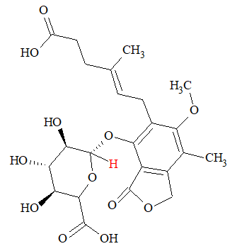
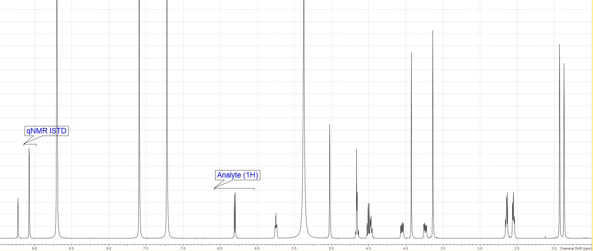
Figure 1: qNMR spectrum indicating the proton (in red) utilized for the quantification of Mycophenolic acid glucuronide.

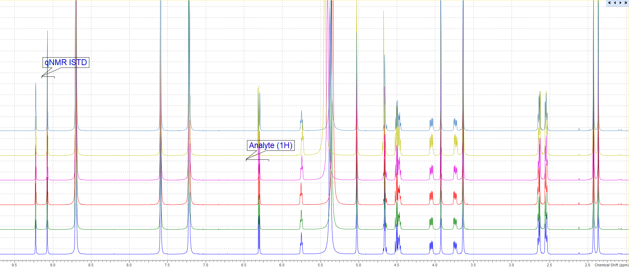
Figure 2: Overlay of the 6-qNMR spectra (Mycophenolic acid glucuronide) acquired under the afore-mentioned quantitative conditions.

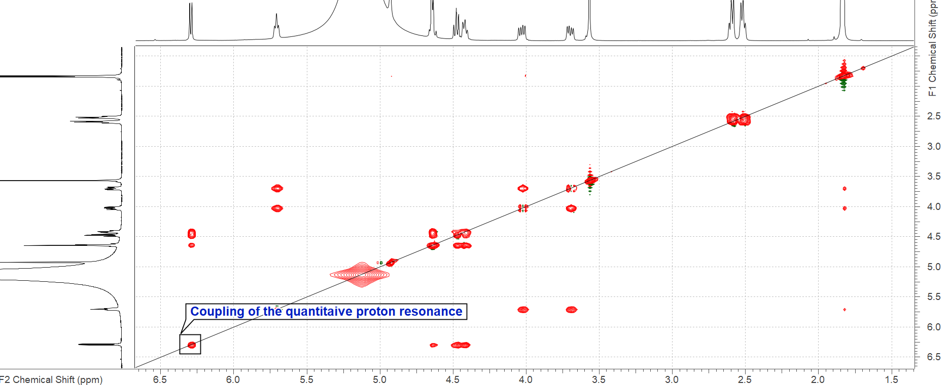
Figure 3: Qualitative 2D-TOCSY (mixing time: 90 ms) spectrum of Mycophenolic acid glucuronide showing the coupling partners of the quantitative resonance.

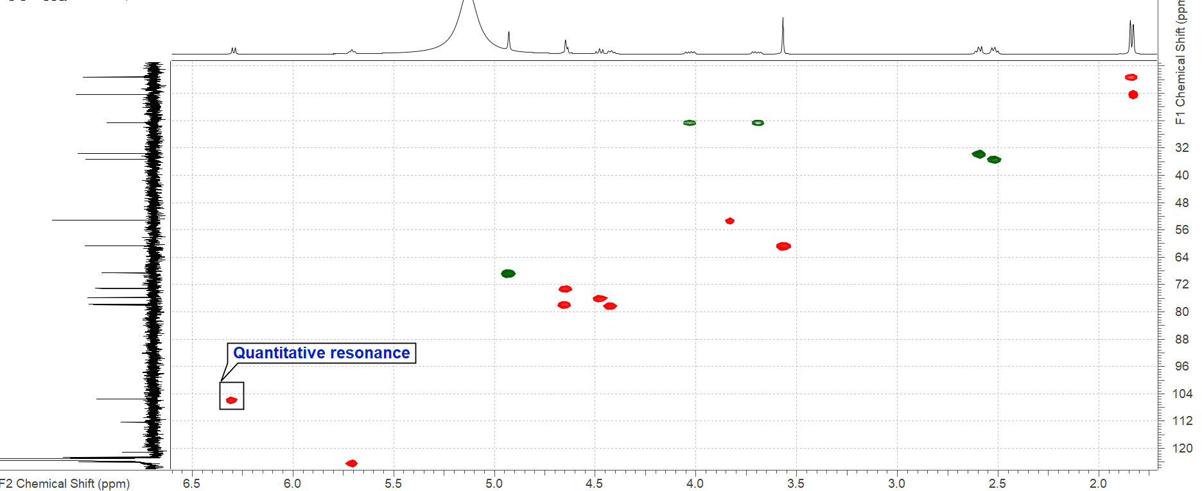
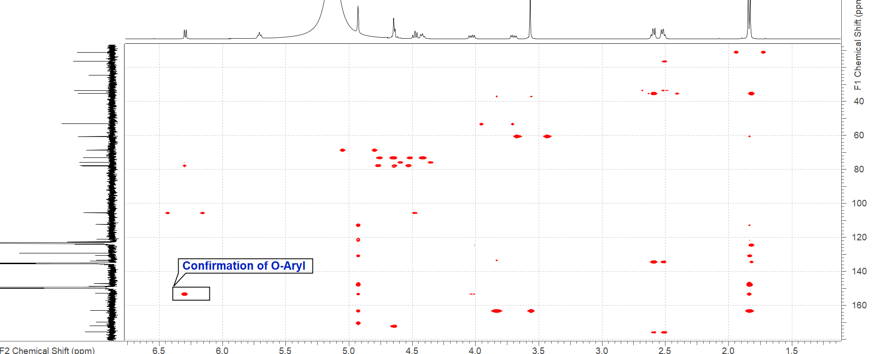
Figure 4: Qualitative 2D-gHSQCAD and 2D-gHMBCAD (optimized for 3Hz) spectrum of Mycophenolic acid glucuronide showing the identity of the quantitative resonance.

Conformer Search (MPAG) using wB97X-V with def2-TZVP basis set
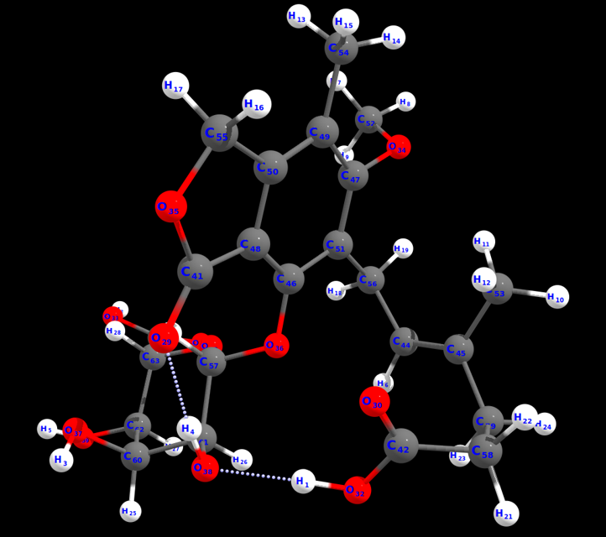
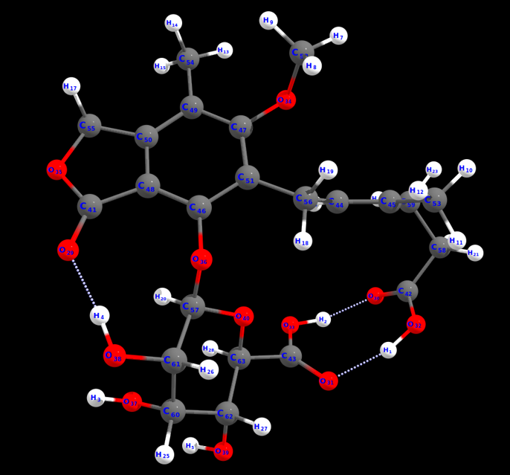

Conformer No. 1 (26.24%) Conformer No. 2 (26.19%)
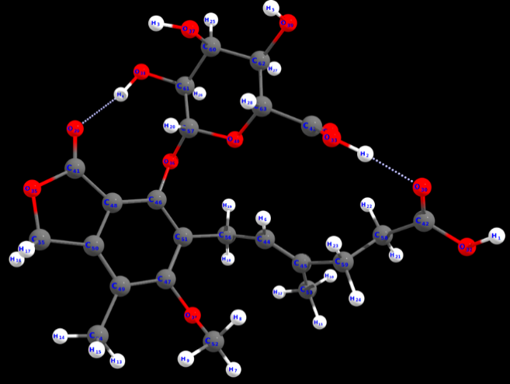
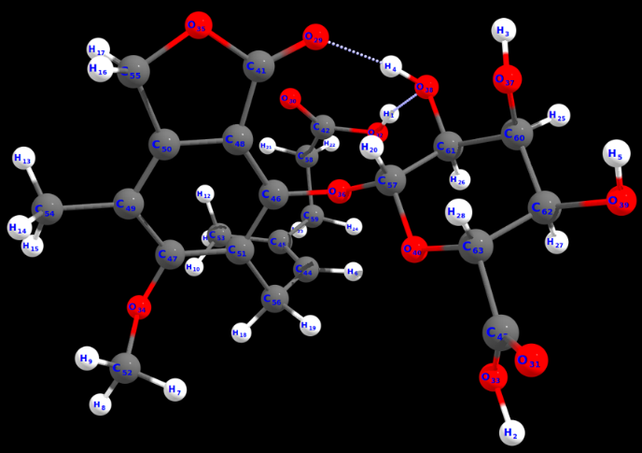

Conformer No. 3 (13.57%) Conformer No. 4 (7.64%)
Figure 5: Four least-energy Conformers of MPAG, which constitute the structure in solution (pyridine). The Boltzmann population is indicated within brackets. DFT calculations were done using D3 correction and CPCM solvent model is utilized for chloroform. The following steps were performed for calculating the energies of the conformers: (i) Generation of conformer ensemble with GOAT using GFN-FF; (ii) Initial conformer filtering using XTB; (iii) Conformer preoptimization using XTB followed by clustering; (iv) Conformer optimization using r2SCAN-3c; (iv) Conformer DFT SP Energy calculation using wB97X-V/def2-TZVPP.
All the quantum chemical calculations were performed with the program ORCA/Weasel.

Cartesian coordinates of the 4 conformers:
63
Energy: -1127178.402645222 kcal/mol (wB97X-V / def2-TZVP / CPCM(Pyridine)) ++ ChemEnsembleNo: 1 ++ ConformerNo: 1++ Version: 1.11.0
H -1.9969323613991581 3.8767122439609434 1.2339561744682377
H -1.7163688019710277 2.0812349732885442 2.8464455445442463
H -3.9278330936431729 -3.0325201116063507 -1.1829199003142545
H -1.6746981080749355 -2.8485672298632378 -2.5895355696112872
H -5.2687096401969775 -0.8350737487489118 0.6687437476858025
H 1.5013382920481739 1.3377866355285375 1.4120720214233407
H 5.6301258127482292 1.3377998150978352 -0.1679595971383391
H 4.5902029797050714 0.8920365750816448 -1.5552153188675795
H 5.6325138017579972 -0.3429918662672911 -0.7836596677118366
H 2.8997662043116748 4.8613531767902032 -0.3060611153104317
H 1.1601373438301261 4.8749151574193803 -0.5768011893299145
H 2.1622739298126397 3.7069634611263615 -1.4386150740078734
H 5.1623856469635223 -1.6383427388542084 1.3743272367101960
H 5.4392227947075060 -2.8115514514395166 0.0758812667663214
H 4.5386873360415159 -3.2956817835904797 1.5152345951550801
H 2.5610185523977336 -4.8765571767040905 0.7898021242482601
H 3.4221625018035651 -4.8808735647979846 -0.7755571384462595
H 0.6056966503041624 1.2975734477936871 -1.2646105690487093
H 2.3129062638743032 1.6202252092178475 -1.4999337816576819
H -1.3516020388283345 -1.9508497744274009 -0.4131025568400128
H 0.8673214225504201 5.7364852651968299 1.6475830274776726
H 1.0147038936397808 5.3037471236375167 3.3709099535876841
H 2.9086472798799297 4.3731488990216603 2.1448966574473678
H 1.9031311855156317 3.0741620662120277 2.8038371633993879
H -4.6500420554969022 -1.0173611580326003 -2.1302750938691042
H -2.4111942291595598 -0.2397531858062038 -2.7315992480697480
H -3.9462548485007765 1.0155569388328141 -0.9975418768965364
H -2.7518656389399587 -0.7815797787919990 1.1813775979149026
O -0.4302080362180682 -4.0007788371426489 -1.9013499570735422
O -0.8486410314906612 3.4522377778001534 3.2228473622667226
O -3.0026988956730731 2.4548949158306579 0.9027567525214022
O -1.2051793262320607 4.4759872206006586 1.2500556262099298
O -1.9742196560362444 1.1904931099477580 2.4602348786038162
O 3.9730170100416489 0.2708999309281007 0.3498247441895924
O 1.3531774734367972 -4.9025126102990901 -0.8963959880036536
O -0.1576992741394082 -0.9129505111871710 -1.7600759227938731
O -4.0369787032828688 -2.2779419206924647 -0.5867784011711461
O -2.4341569342791511 -2.3077224761290536 -2.8820965645945571
O -5.1517438046379578 0.0689714059040306 0.3411477498948420
O -1.5243032917063994 0.1112251652064126 -0.2646224461095936
C 0.6162603778795539 -3.8308152197702658 -1.2987787823354702
C -0.4863414458504616 4.2283546984507572 2.3382270755130277
C -2.6163503454397206 1.3718642675456023 1.3224541814472126
C 1.6367605142756347 1.9420092206102497 0.5145743072818292
C 1.8471237056756933 3.2561206340054354 0.6635434720475806
C 0.9884560653221341 -1.2639003396526860 -1.0731092136635356
C 3.0965079163504337 -0.7043170850977923 -0.0555280545985645
C 1.3122955468785151 -2.6123069595304580 -0.8913052916612504
C 3.4299285998442186 -2.0479639755933094 0.1688078653781282
C 2.4989577186036760 -2.9787322810328041 -0.2695807546084075
C 1.8804382778618567 -0.2827430987482102 -0.6429400785169931
C 5.0179814004081873 0.5475293525908095 -0.6060695133915078
C 2.0311062866150085 4.2139098005810771 -0.4802329886350504
C 4.7132888151578705 -2.4661934206905287 0.8223977469655251
C 2.5656661224199269 -4.4698835223150715 -0.2285151008207948
C 1.5893348077274296 1.1893451230110483 -0.7966274274038543
C -1.3734044868258148 -1.0596763377990146 -1.0632078321564615
C 0.8453159785737595 4.9114544798476683 2.3636254101036536
C 1.9419541665893891 3.8614271256831576 2.0434819842178134
C -3.8542205140495462 -1.0982992435711907 -1.3727877909012047
C -2.4982354179749859 -1.1303456195155048 -2.0886707105416229
C -3.9480235963566401 0.0861689832594257 -0.4166860149024362
C -2.7346725372526524 0.0903920250302069 0.5106338933134535
63
Energy: -1127178.4015971192 kcal/mol (wB97X-V / def2-TZVP / CPCM(Pyridine)) ++ ChemEnsembleNo: 1 ++ ConformerNo: 2 ++ Version: 1.11.0
H -1.3129370147267894 2.0699103484478480 -2.1380597964519725
H -3.6409258997837770 -2.5593583438077632 4.5212738633072407
H -3.9424322962332559 -1.5224407221063354 -1.9945125069680196
H -1.7268947538351214 -0.1402623040753825 -2.3265489700303523
H -5.2706820906778962 -2.1084586245772599 0.6872454552277115
H 0.0828235963190861 2.9069855721379199 1.2037789701646060
H 4.2427429525531144 -1.8362672784035472 2.8469340992174885
H 4.8259209845727842 -0.3504829242380126 3.6585740510102900
H 3.0675445991383956 -0.6690793642245724 3.5312466829947886
H 3.8957130362907337 3.8241767479540614 -0.2698954534642962
H 3.7558351568510719 2.3246899431142820 0.6734582173056421
H 3.3645112301641755 2.3339746198171905 -1.0499276090465943
H 4.7680196553074286 -3.1094817009395883 0.5376276569142636
H 5.5537243628616801 -1.5231158068916477 0.5498487063285903
H 5.1867152175734477 -2.3291844796335384 -0.9901537850657908
H 3.4207548692445893 -2.5779476950585827 -2.7710061478044743
H 2.7102553594143068 -3.8432354858303199 -1.7283650280195326
H 0.7370283263993912 1.0321282595339059 2.4707985090508235
H 2.4227424659283292 1.5410732634967859 2.4170536480056319
H -1.3205586323118552 -1.3590464586021456 -0.3497849125623291
H 0.6939113118015114 4.9496983725228905 -2.6083003578117734
H 2.1912793891373785 3.9975431551168348 -2.5343897455092210
H 0.2841145797679060 4.6635105259433489 -0.2099386464169615
H 1.9087279836141706 5.3193553519521570 -0.4741891670367278
H -4.7260534495098998 0.2377412315839622 -0.8216714125078588
H -2.6583828472336291 1.3965288288534092 -0.1779989711023233
H -4.2687593453071067 0.3753702331714511 1.5648554295158230
H -2.7229563787721043 -2.2602390295799735 1.2669467729718402
O -0.5309829209308280 -1.4786069439757759 -2.6496104379074410
O 0.9039152752864442 1.8337124209892308 -2.8455802161541857
O -2.7987071436553159 -0.4541857771824727 3.9713524639566815
O -0.8688426626469824 2.9511735382526192 -2.0247144997282351
O -3.4913837100120650 -2.5628918106756307 3.5590272470129789
O 4.0561829039849862 -0.0283595953223861 1.7976589107660583
O 1.3518771308369160 -2.6716379910805674 -2.7683789153036833
O -0.2846162759145684 0.4221822731605512 -0.0932976518206124
O -3.8501044342716568 -1.6439744388779538 -1.0408032738539175
O -2.3157476385935682 0.5875842464758290 -2.0321767067343242
O -5.2950976517974553 -1.3581634921681065 1.3000342328195789
O -1.7323478879072443 -0.4256675097635899 1.4505726227160829
C 0.5595308124747705 -1.7441769073611266 -2.1677884448870564
C 0.4215532678156599 2.8483159788184058 -2.3712935377814728
C -3.0287541167509318 -1.3564589928503734 3.1977188392693678
C 1.1130740254990841 2.5894114462951459 1.0555365051867540
C 1.8697864242403819 3.2740686748187708 0.1909352404783565
C 0.9231838112417031 -0.2302713276633794 -0.0695179575143174
C 3.1201179466901197 -0.4533906179250309 0.8861949254544590
C 1.2611652682781902 -1.2226969106534660 -0.9949951121465812
C 3.4781936798178408 -1.4768158001365277 -0.0081201959340116
C 2.5174257452555411 -1.8224453254433595 -0.9446413737248504
C 1.8676292306920579 0.1928244551130504 0.8649875945023245
C 4.0389717833254908 -0.7749095416687882 3.0325733374574848
C 3.2971274721973369 2.9175222984071505 -0.1216130823617803
C 4.8227396795278139 -2.1412177340737282 0.0251235560080539
C 2.6129040158798249 -2.8044503365627294 -2.0654200019679534
C 1.5439044945896623 1.3403800770242831 1.7964012995945968
C -1.4490454234381576 -0.3441585533539074 0.0541376099867971
C 1.1944508949596118 4.1156296161566193 -2.1023069941604087
C 1.2830250659605342 4.4239494503637848 -0.5884270440567959
C -3.8904374998306932 -0.3554980510198825 -0.4213821100062710
C -2.5799592463159886 0.4018446890085192 -0.6397686636321995
C -4.1260542185957654 -0.5943967406218318 1.0713076299578983
C -2.8682778668710665 -1.2559452415555317 1.6928086440722805
63
Energy: -1127178.0120131453 kcal/mol (wB97X-V / def2-TZVP / CPCM(Pyridine)) ++ ChemEnsembleNo: 1 ++ ConformerNo: 3 ++ Version: 1.11.0
H -1.3167017501917524 2.0726444890849276 -2.0985661628052243
H -2.9878547749035129 -0.5779909503060038 4.7932074000480611
H -3.9084704478751138 -1.5443574480597659 -2.0361498525255519
H -1.7170253016417840 -0.1282010410137449 -2.3343190605503166
H -5.2461492142625961 -2.1901247290774299 0.6284309033095548
H 0.0633310917235405 2.8811101801829802 1.2462775862429649
H 3.0657480375468587 -0.7009331613132646 3.5271139576878343
H 4.8223803797138753 -0.3752310227084265 3.6614783539386573
H 4.2481826966987315 -1.8541939681248556 2.8311973361279081
H 3.7447127420982902 2.3477186289105920 0.7203155390357726
H 3.8691706183986816 3.8548915451615926 -0.2135274787777400
H 3.3548121100234956 2.3636881859831398 -1.0029651483640702
H 5.1884799077944654 -2.3221762135922401 -1.0077443365428662
H 4.7850255301837148 -3.0864630093802323 0.5320189228561669
H 5.5648307977252243 -1.4979676540152447 0.5208476547590395
H 2.7311649403689975 -3.8082994425912666 -1.7777743633987309
H 3.4391632571420629 -2.5250609340239447 -2.7995882847193823
H 2.4192362973248120 1.5174203868443938 2.4370127340823702
H 0.7366298046382475 0.9996856768055664 2.4948492381714469
H -1.3087987949620057 -1.3731933102941190 -0.3685745070355542
H 2.1681517991231374 4.0421710471864545 -2.4706077754962705
H 0.6598731477893167 4.9782090917203963 -2.5353289792670890
H 1.8691018548727150 5.3342140002701193 -0.3944555188315390
H 0.2503662646774052 4.6586392131869063 -0.1412939680801403
H -4.7259403603244534 0.1917463992662961 -0.8470370010208272
H -2.6770991525468122 1.3659324615132469 -0.1674419481293613
H -4.2984927573961293 0.3012332128240547 1.5434693842914506
H -2.7126900900908857 -2.3096366896586487 1.2222399604896712
O -0.5177600141792719 -1.4455405810495146 -2.6713476965996126
O 0.9024023711879752 1.8679554833580050 -2.8104485340305287
O -3.4612920419418645 -2.5424364837458655 3.6406227670688720
O -0.8803684830128389 2.9564827451812348 -1.9731322597862007
O -2.8106511133113150 -0.3919577237538724 3.8542110198296373
O 4.0541489906292618 -0.0352404715796033 1.8030350164965498
O 1.3707471673966805 -2.6270865707703939 -2.8036638033770140
O -0.2900232123829755 0.4137610047655983 -0.0817354899579972
O -3.8249067298503805 -1.6761013332223000 -1.0830580596447017
O -2.3126816494227169 0.5910411487808426 -2.0313556328824260
O -5.2919110642265759 -1.4454728737458327 1.2469045356510988
O -1.7423165269719851 -0.4670623499113783 1.4404305695370707
C 0.5724419909444577 -1.7136160099707858 -2.1903181098880022
C 0.4102172328448797 2.8714623755642292 -2.3226306917802315
C -3.0673574315465033 -1.5057471524016857 3.1523036552263113
C 1.0969708560570368 2.5755619829474936 1.0958346529809098
C 1.8489828444640986 3.2798879517367965 0.2429769504416956
C 0.9229991214525305 -0.2298262437636104 -0.0681708503499263
C 3.1211769078867753 -0.4538721589071783 0.8854571260599323
C 1.2682377456738683 -1.2064218880555486 -1.0080982799251224
C 3.4851200354125393 -1.4641750802454079 -0.0212991021986877
C 2.5278275703409925 -1.8003238802584027 -0.9644616087295178
C 1.8651214946757400 0.1859119232312860 0.8720619598453095
C 4.0386876873660880 -0.7962310283402620 3.0291215115054624
C 3.2803289746782163 2.9409960327516087 -0.0712535569023108
C 4.8319127677890892 -2.1239009397941011 0.0080019575815250
C 2.6304053170350268 -2.7650128294796161 -2.0995781943332861
C 1.5378321100973951 1.3198580047346926 1.8191764261292525
C -1.4491175930313629 -0.3645853384507871 0.0466067874693940
C 1.1693840911913336 4.1438273453395880 -2.0389756176942080
C 1.2521965987890427 4.4344220691453033 -0.5212942009761445
C -3.8867395380792931 -0.3967014814968043 -0.4472916809137126
C -2.5837221027474850 0.3795336683442566 -0.6439928023440759
C -4.1338950716386060 -0.6595795866768529 1.0401331632455442
C -2.8719560320726218 -1.3142495452337140 1.6627167551024804
63
Energy: -1127177.671935767 kcal/mol (wB97X-V / def2-TZVP / CPCM(Pyridine)) ++ ChemEnsembleNo: 1 ++ ConformerNo: 4 ++ Version: 1.11.0
H -0.7517499621465144 5.9901658847595831 4.4244306564341347
H -1.9106865719451473 2.5870464597279650 2.6264933972055933
H -3.8816478181183220 -3.0463335671433800 -0.5851919111670130
H -1.8050788799498312 -3.1263010340650270 -2.3953791508665465
H -5.0046840890944662 -0.5101390924787127 1.0315969404041090
H 0.5769621088267393 1.1260198431822115 0.7523889907366038
H 4.9569178675571814 1.3104841687154960 1.2239049315300232
H 3.3150744111125419 0.7723410703694484 1.6854328579582514
H 4.6802020314403991 -0.3929944666269001 1.6865013296983995
H 2.0076511569269031 4.7176414430937141 -0.5736316425341825
H 3.3613723722497317 4.1730750375635903 0.4112199788562837
H 2.9916801314784616 3.3555337750642567 -1.1212175105643016
H 5.6327825413585888 -1.6975758508869274 -0.0149672880931642
H 5.2622477350826999 -3.4035157068486273 -0.3294727981143534
H 4.9287841980541671 -2.7093881088504728 1.2583292333364737
H 3.5444205648792662 -4.9745321102633975 -1.2104696043317991
H 2.8510637670132422 -4.9788258377995751 0.4362592203343212
H 2.3646443726445430 1.5155685212491428 -1.7284453370433064
H 0.6569929463907940 1.0849318476165000 -1.8617092147429630
H -1.2650455551201354 -1.9355201939209272 -0.3219535652022993
H 0.6509115013619470 5.4864101245373629 1.3629232356307783
H -0.5963439002981885 4.2861526316503324 0.9235123129806531
H 0.6584099604735680 2.5880846619795403 2.3917364804987957
H 1.9913962500550593 3.7530441457461055 2.4672933818392986
H -4.7388052501218771 -1.1930809748787252 -1.7620858195366023
H -2.5843386550154044 -0.6063440276475217 -2.7544473316898417
H -3.8642878523903827 0.9730667682403851 -1.0819590848169061
H -2.4316619897115954 -0.4817219988949955 1.2044543007509005
O -0.4308824253778439 -4.2461856250330010 -1.9426929593194486
O -1.4574605160478011 4.0541139680151455 3.4069754340579759
O -2.4196649163657327 2.6814425003696765 0.3197206539939907
O -0.2388302092223137 5.9230313231480762 3.5989062412891877
O -2.0773937172572277 1.6574396392339179 2.2996991988196314
O 3.9996403100006255 0.2299511747653010 -0.2109871444102157
O 1.4767833228446421 -5.0711533581958159 -1.1127477818721283
O -0.2304715923027744 -1.1753994338610450 -1.9544915073543823
O -3.9564153402206559 -2.2032501545551297 -0.1150672087742139
O -2.6630113832316549 -2.6751048969712321 -2.5225317040739035
O -4.9234553023805656 0.3097024422307569 0.5227820432432249
O -1.4036034953010850 0.1305294239814242 -0.5120075945314635
C 0.6661258003733272 -4.0316197117827137 -1.4554971423051393
C -0.6038002245728116 4.8093577206806843 2.9552446795132168
C -2.3327343081062120 1.6745443771095525 0.9945346885228956
C 1.2331266304299802 1.6965937108085232 0.0963892218521145
C 1.6443384723913474 2.8971083877899622 0.5192408066125875
C 0.9829524041800367 -1.4556427209894363 -1.3516613063280496
C 3.1320164449631536 -0.7964844447643341 -0.4788450086133017
C 1.3585322225408907 -2.7851985291053865 -1.1438747832971659
C 3.5433968220767036 -2.1270624301558980 -0.2918428652029479
C 2.6110991167378450 -3.0972365090374980 -0.6305212606139297
C 1.8748511133390076 -0.4373972360012314 -1.0210549847621158
C 4.2477578206349342 0.4813640641135208 1.1904873956379149
C 2.5496376529383680 3.8232632440170971 -0.2392000927475257
C 4.9176368692373762 -2.4993664229892611 0.1819400893459317
C 2.7357694654592466 -4.5855654667904764 -0.5805321658983655
C 1.5375389603852132 1.0200483192895902 -1.2134845170505508
C -1.3584605041034925 -1.1619015619863124 -1.1044057695106702
C 0.1431544104673210 4.5725151331798104 1.6792882349453053
C 1.1502817665392191 3.4046200208051740 1.8525202567740771
C -3.8562296269808898 -1.1753334327943992 -1.1021515631445404
C -2.6003264111317663 -1.3718920000723107 -1.9609473385978129
C -3.8161843591983149 0.1530559868616342 -0.3553010083752734
C -2.4919801129577031 0.2743161978804804 0.4083167990057047

Deprotomer Search (MPAG) using wB97X-V with def2-TZVP basis set
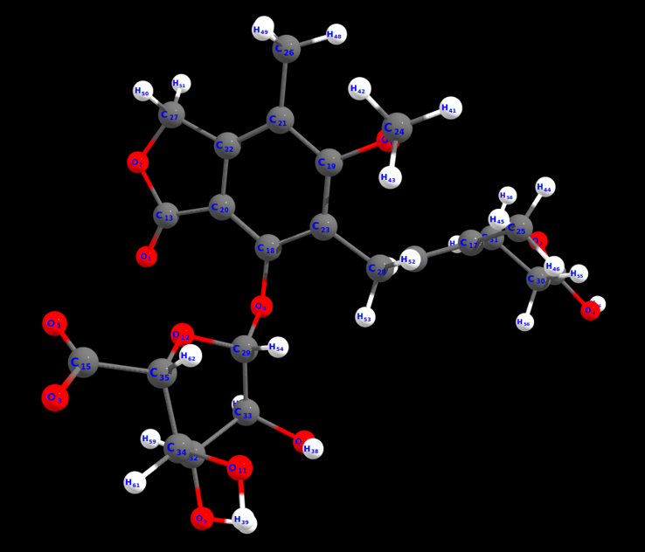
Figure 6: The least energy deprotomer calculated at wB97X-V/def2-TZVP shows that deprotonation occurs at O3. The following steps were involved:
1: Generating anions with CREST.
2: Initial anion filtering using XTB.
3: Anion preoptimizations using XTB followed by clustering.
4: Anion optimizations using r2SCAN-3c.
5: Anion DFT SP Energy calculation using wB97X-V with def2-TZVP basis set.
All the quantum chemical calculations were performed with the program ORCA/Weasel.

Cartesian coordinates of the De-Protomer:
62
Energy: -1126870.8331713208 kcal/mol (wB97X-V / def2-TZVP / CPCM(Pyridine)) ++ ChemEnsembleNo: 1 ++ ConformerNo: 1 ++ Version: 1.11.1
O 2.1128788978875903 0.8368786467792869 3.2810229971739346
O -7.1141910428723598 -3.0199538230973428 0.8543103074512448
O 5.9664538550005606 1.0967609483532974 -1.2711847396312452
O -6.9664604395886895 -4.6106220620781730 -0.7323057259823051
O 5.0805220877727102 1.5352496870145373 0.7578536785529848
O -2.4114017122678497 2.4072008192365373 -1.1779976931686653
O 1.4216674540140504 2.9737550185488772 3.3247687269218544
O 0.7657876141427205 -0.5537850657825630 0.8506710658730948
O 4.2449938740447806 -3.5848554897250526 -0.4546977152295053
O 1.6084395507119502 -3.0408335551827426 -0.9024261112487952
O 3.6032478994416004 -1.5810037363743026 -2.4832115530154755
O 2.8770558287075203 0.1326095245466270 0.2477622563379147
C 1.4396260601801503 1.7094724670045174 2.7822348535542343
C -6.5926162662245495 -3.4464931416538125 -0.1557294395576153
C 5.0836690969561804 1.0112865384442673 -0.3788981040229353
C -2.6134010512403498 -0.7826545424835731 -0.4622225631444053
C -3.8327058664696598 -0.8686615685539131 -1.0077407464197354
C 0.1608791331754804 0.6846926129078369 0.7560378778683848
C -1.4120065534998396 2.2055951439809074 -0.2539899827550953
C 0.5171021402376805 1.7045535893700074 1.6396643681596448
C -1.0522050232826397 3.2554336911423372 0.6033691875261848
C -0.0830496237777096 2.9532582481858571 1.5514856642441346
C -0.8356696153168195 0.9186225546389869 -0.1916582409035653
C -1.9576233822495896 3.0514762490375373 -2.3860384551878253
C -4.1967785690384600 -0.3569432884836030 -2.3742596538145055
C -1.6862364305501296 4.6135199665914168 0.5329794372243848
C 0.4936322318854602 3.8279172068079772 2.6174419452575046
C -1.3718858371215696 -0.1857851851751530 -1.0735499333081653
C 1.8263630059043503 -0.7482060741154931 -0.0745378696038953
C -5.4845127062013894 -2.7799573701830829 -0.9222803821973152
C -4.9567626394751896 -1.5182623940395628 -0.2361908189334553
C 3.8213278240879105 -2.2588330996850425 -0.1509548638672153
C 2.2888807550225705 -2.2050103206209926 0.0383191062220447
C 4.2571973730538799 -1.2683917350998026 -1.2288548384992453
C 3.8564501345635605 0.1586505367102270 -0.8092826684836252
H -7.6881278032704001 -4.9906408350478229 -0.2025351121746853
H 3.5035074607576102 -4.0143201732943830 -0.9094764350409552
H 1.7984436309971303 -2.6730935076615325 -1.7815850436397054
H 4.0273235379258105 -2.3773031622092629 -2.8318455827144957
H -2.4702077230044397 -1.1847584132954327 0.5422732205017148
H -2.8353715921790998 3.1560479903511274 -3.0267035607899153
H -1.5358687824150496 4.0401614744849370 -2.1708448688600055
H -1.2014220774558597 2.4349838871379474 -2.8882494399654557
H -5.1626940278513000 0.1618515228078070 -2.3370543859831656
H -3.4543822213125197 0.3351704815186970 -2.7751579374806856
H -4.3081075620988898 -1.1823394157269327 -3.0893366725395257
H -1.8501476731092796 5.0141277237990867 1.5386248185155247
H -2.6461407192498498 4.5749847702349467 0.0137872357454347
H -1.0401165083447996 5.3227421358267373 0.0010482767757147
H 1.0450370095959503 4.6866148555679965 2.2152847478079143
H -0.2562163835920797 4.1885580376365370 3.3322439536766644
H -1.5664819229945397 0.1963333117858470 -2.0772467564785253
H -0.6206741821963295 -0.9768739658250131 -1.1674473533548153
H 1.4720299720758103 -0.5350723198698131 -1.1020677339357654
H -5.8759057978296800 -2.5617988685079025 -1.9246463729173053
H -4.6811206860520098 -3.5138080699554926 -1.0686156886476554
H -4.6188091573893200 -1.7727784251556526 0.7738919663022648
H -5.7860512153391594 -0.8049366938611531 -0.1310723774194253
H 4.2983183943868202 -1.9674818204697626 0.7933517358864248
H 2.0266510092704104 -2.5905365853266829 1.0295510043376848
H 5.3432991519329907 -1.3169138604365527 -1.3690669155460853
H 3.4154089028937102 0.6530518574582869 -1.6905260256668353

