Supplemental Table A1. Overview of units, instruments and methods used for the clinical chemistry and hormone measurands included in the study.
Measurands | Unit | Instruments | Methods
GLU | mmol/L | Beckman AU 5800 | Hexokinase method
TC | mmol/L | Beckman AU 5800 | Cholesterol oxidase method
HDL-C | mmol/L | Beckman AU 5800 | Enzymatic method
P | mmol/L | Beckman AU 5800 | Phosphomolybdate ultraviolet endpoint method
ALT | U/L | Beckman AU 5800 | Rate method
ALP | U/L | Beckman AU 5800 | Rate assay (AMP buffer)
Ca | mmol/L | Beckman AU 5800 | Azo arsenic III method
TG | mmol/L | Beckman AU 5800 | Go free glycerol
Mg | mmol/L | Beckman AU 5800 | Xylaniline blue method
E2 | pg/mL | Roche Elecsys 2010 | Electrochemiluminescence
T | nmol/L | Roche Elecsys 2010 | Electrochemiluminescence
Crea | µmol/L | Beckman AU 5800 | Enzymatic method
FSH | IU/L | Roche Elecsys 2010 | Electrochemiluminescence
GLU, glucose; TC, total cholesterol; HDL-C, high-density lipoprotein cholesterol; P, phosphorus; ALT, alanine aminotransferase; ALP, alkaline phosphatase; Ca, calcium; TG, triglycerides; Mg, magnesium; E2, estradiol; T, testosterone; Crea, creatinine; FSH, follicle-stimulating hormone.

Supplemental Table A2. Simplified staging criteria for female reproductive aging based on the Stages of Reproductive Aging Workshop + 10 (STRAW+10) [20].
Terminology | Reproductive | Menopausal Transition |  | Postmenopause
Terminology |  | Perimenopause ª
Principal criteria
Menstrual cycles | Regular or subtle changes in flow/length | Early (Stage -2): difference in length between consecutive cycles ≥ 7 days, occurring more than once in 10 cycles | Late (Stage -1): amenorrhea lasting ≥ 60 days | Amenorrhea for ≥ 12 consecutive months; retrospective confirmation of the final menstrual period (FMP)
Supportive criteria
FSH | Normal/low/variable ª | ↑ Variable ^{b} | ↑ ＞25 IU/L ^{c} | ↑ Variable/stabilizes
AMH / Inhibin B | Normal/low | Low | Low | Very low
Antral follicle count | Normal/low | Low | Low | Very low
Symptoms | - | - | Vasomotor symptoms | Vasomotor symptoms or urogenital atrophic symptoms
a. Perimenopause is defined as the period from the onset of menstrual cycle variability (STRAW+10 Stage -2) to 12 months after the final menstrual period (FMP); b. Blood draw on cycle days 2-5; ↑ = elevated; c. Based on the approximate expected levels according to current international standards for pituitary hormones; FSH, follicle-stimulating hormone; AMH, anti-müllerian hormone.

Supplemental Table A3. Normality test results and number of outliers deleted for 13 biomarkers in the overall and three stages.
Measurands | All |  | REP |  | MT |  | POST
Measurands | p-Valueª | Number of outliers deleted | p-Valueª | Number of outliers deleted | p-Valueª | Number of outliers deleted | p-Valueª | Number of outliers deleted
GLU, mmol/L | <0.001 | 23 | 0.05 | 17 | 0.11 | 9 | <0.001 | 5
TC, mmol/L | <0.001 | 9 | 0.005 | 4 | 0.019 | 8 | 0.09 | 6
HDL-C, mmol/L | <0.001 | 12 | 0.005 | 5 | 0.001 | 7 | <0.001 | 8
P, mmol/L | 0.002 | 11 | 0.025 | 5 | 0.15 | 2 | 0.06 | 3
ALT, U/L | <0.001 | 46 | <0.001 | 28 | <0.001 | 25 | <0.001 | 23
ALP, U/L | <0.001 | 15 | 0.023 | 6 | 0.004 | 6 | 0.002 | 4
Ca, mmol/L | 0.001 | 6 | 0.003 | 1 | 0.002 | 1 | 0.32 | 8
TG, mmol/L | <0.001 | 41 | <0.001 | 17 | <0.001 | 23 | <0.001 | 25
Mg, mmol/L | <0.001 | 12 | <0.001 | 7 | 0.007 | 2 | <0.001 | 4
E2, pg/ml | <0.001 | 49 | <0.001 | 23 | <0.001 | 35 | 0.001 | 38
T, nmol/L | <0.001 | 12 | 0.005 | 4 | 0.02 | 4 | <0.001 | 6
Crea, µmol/L | 0.002 | 13 | 0.08 | 3 | 0.11 | 0 | 0.03 | 1
FSH, IU/L | <0.001 | 14 | <0.001 | 42 | <0.001 | 32 | 0.54 | 5
a. Shapiro-Wilk test (n < 50) or Kolmogorov-Smirnov test (n ≥ 50).
b. Outliers were removed using Tukey's method.
GLU, glucose; TC, total cholesterol; HDL-C, high-density lipoprotein cholesterol; P, phosphorus; ALT, alanine aminotransferase; ALP, alkaline phosphatase; Ca, calcium; TG, triglycerides; Mg, magnesium; E2, estradiol; T, testosterone; Crea, creatinine; FSH, follicle-stimulating hormone; REP, reproductive; MT, menopausal transition; POST, postmenopause.

Supplemental Table A4. Results of the Kruskal-Wallis Test for the clinical chemistry measurands across three periods.
Measurands | p-Value
Measurands | REP vs MT | REP vs POST | MT vs POST | Overall
GLU, mmol/L | <0.01 | <0.001 | <0.001 | <0.001
TC, mmol/L | <0.001 | <0.001 | <0.001 | <0.001
HDL-C, mmol/L | - | - | - | 0.17
P, mmol/L | 0.99 | <0.001 | <0.001 | <0.001
ALT, U/L | <0.001 | <0.001 | <0.001 | <0.001
ALP, U/L | <0.001 | <0.001 | <0.001 | <0.001
Ca, mmol/L | 0.35 | <0.001 | <0.001 | <0.001
TG, mmol/L | <0.001 | <0.001 | <0.001 | <0.001
Mg, mmol/L | - | - | - | 0.11
E2, pg/ml | <0.001 | <0.001 | <0.001 | <0.001
T, nmol/L | <0.001 | <0.001 | <0.01 | <0.001
Crea, µmol/L | <0.001 | <0.001 | <0.001 | <0.001
FSH, IU/L | <0.001 | <0.001 | <0.001 | <0.001
GLU, glucose; TC, total cholesterol; HDL-C, high-density lipoprotein holesterol; P, phosphorus; ALT, alanine aminotransferase; ALP, alkaline phosphatase; Ca, calcium; TG, triglycerides; Mg, magnesium; E2, estradiol; T, testosterone; Crea, creatinine; FSH, follicle-stimulating hormone; REP, reproductive; MT, menopausal transition; POST, postmenopause.

Supplemental Table A5. Comparison of CV_{I} and CV_{G} estimates for six measurands across different studies.
Measurands | Group | CV_{I}%  (95% CI) | CV_{G}  (95% CI) | EFLM database (2025) ª [28] |  | Wang S et al. (2022) ^{b} [27] |  | Coşkun A et al. (2023) ^{c} [26]
 |  |  |  | CV_{I}% (95% CI) | CV_{G}% (95% CI) | CV_{I}% (95% CI) | CV_{G}% (95% CI) | CV_{I}% (95% CI) | CV_{G}% (95% CI)
GLU,  mmol/L | All | 5.4(5.3-5.7) | 6.2(5.6-6.8) | 4.7(3.0-5.4) | 8.0(2.7-10.8) | 5.1(5.0-5.2) | 5.1(4.5-5.9) | 5.6(4.8-6.7) | 5.3(3.7-8.2)
GLU,  mmol/L | REP | 4.6(4.1-5.2) | 6.5(4.6-9.1)
GLU,  mmol/L | MT | 5.5(5.1-5.9) | 6.1(5.0-7.4)
GLU,  mmol/L | POST | 5.3(5.0-5.6) | 6.0(5.1-7.1)
TC,  mmol/L | All | 8.6(8.2-8.9) | 14.3(12.9-15.8) | 5.4(4.9-6.4) | 15.6(12.9-17.4) | 11.1(9.8-12.8) | 10.9(7.9-16.3) | 5.4(4.5-6.6) | 17.8(13.5-26.1)
TC,  mmol/L | REP | 7.2(6.4-8.2) | 13.0(9.3-18.1)
TC,  mmol/L | MT | 7.9(7.3-8.4) | 14.8(12.3-17.9)
TC,  mmol/L | POST | 9.3(8.7-9.9) | 13.3(11.2-15.7)
ALT,  U/L | All | 35.0(33.7-36.3) | 40.0(34.0-46.3) | 11.2(9.3-16.0) | 35.2(28.0-41.6) | 40.2(35.3-46.8) | 27.6(17.7-44.0) | 12.4(10.6-14.7) | 21.1(15.5-31.5)
ALT,  U/L | REP | 28.4(24.7-32.8) | 27.2(16.8-41.1)
ALT,  U/L | MT | 35.6(33.1-38.3) | 32.4(10.8-48.4)
ALT,  U/L | POST | 32.8(30.8-35.0) | 45.6(37.5-55.0)
TG,  mmol/L | All | 28.5(27.4-29.5) | 46.6(42.1-51.5) | 19.8(17.8-21.6) | 34.3(30.1-40.3) | 28.1(24.9-32.5) | 24.7(17.4-37.1) | 19.1(16.5-22.7) | 34.9(25.5-53.7)
TG,  mmol/L | REP | 45.8(40.3-52.2) | 29.3(10.3-47.7)
TG,  mmol/L | MT | 25.2(23.3-26.9) | 43.4(35.9-52.5)
TG,  mmol/L | POST | 27.8(26.2-29.6) | 41.2(34.0-49.4)
Crea,  µmol/L | All | 12.4(11.8-13.0) | 10.3(8.7-11.9) | 4.4(2.3-4.9) | 16.2(12.5-17.4) | 7.0(6.2-8.1) | 9.7(7.2-14.2) | 4.9(3.8-6.2) | 11.9(8.9-17.5)
Crea,  µmol/L | REP | 13.0(11.1-15.2) | 7.7(2.6-13.2)
Crea,  µmol/L | MT | 11.6(10.7-12.6) | 7.7(5.6-10.0)
Crea,  µmol/L | POST | 11.2(10.3-12.1) | 11.22(8.8-14.0)
FSH,  IU/L | All | 44.0(42.2-45.9) | 97.4(87.6-108.3) | 9.5(8.6-17.3) | 19.8(17.8-21.6) | -^{d} | - ^{d} | -^{d} | - ^{d}
FSH,  IU/L | REP | 25.3(22.7-28.2) | 27.2(18.6-37.8)
FSH,  IU/L | MT | 65.6(61.1-70.5) | 63.7(48.2-81.0)
FSH,  IU/L | POST | 20.4(19.0-22.0) | 29.8(24.6-36.1)
a. Data were from online European Federation of Clinical Chemistry and Laboratory Medicine (EFLM) biological variation database. b. Data were from female participants in the annual group of this study; c. Data were from female participants with weekly sampling; d. FSH data were not reported in these two studies; GLU, glucose; TC, total cholesterol; ALT, alanine aminotransferase; TG, triglycerides; Crea, creatinine; FSH, follicle-stimulating hormone; REP, reproductive; MT, menopausal transition; POST, postmenopause.
Supplemental Figure A1. Variable importance of predictors in the Random Forest model for menopausal status.
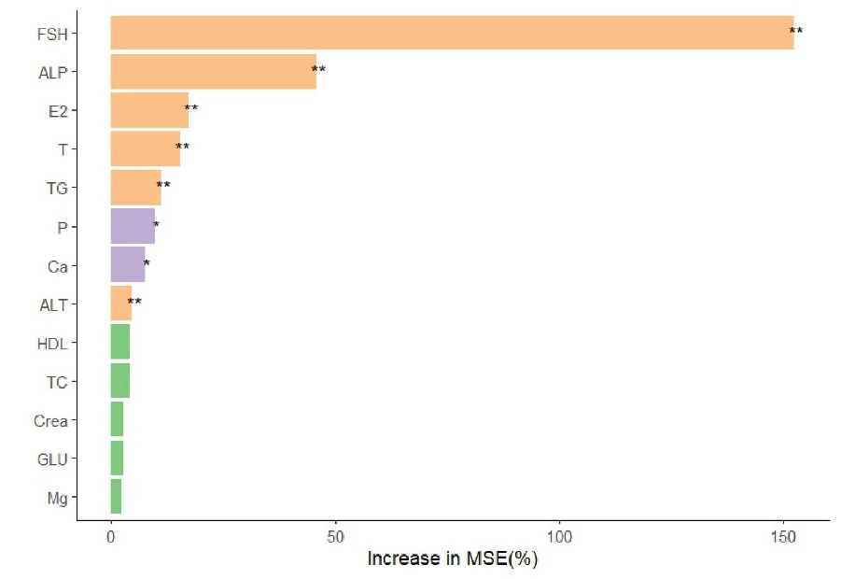
The bar plot illustrates the importance of each predictor variable in menopausal status, as measured by the percentage increase in mean squared error (MSE) when the variable is permuted. Variables with longer bars contribute more significantly to the menopausal status. Statistical significance is indicated by * (p < 0.05) and ** (p < 0.01).

Supplemental Figure A2. The personalized reference intervals for individuals in the reproductive, menopausal transition, and postmenopausal stages.
Vertical black error bars: prRIs (personalized reference intervals) for six measurands in the reproductive, menopausal transition, and postmenopausal stages, derived from CV_{P} estimates; black dots: mean of six measurements per individual; blue horizontal lines: lower and upper limits of popRIs (population-based reference intervals).
GLU, glucose; TC, total cholesterol; ALT, alanine aminotransferase; TG, triglycerides; Crea, creatinine; REP, reproductive; MT, menopausal transition; POST, postmenopause; n, the number of individuals.

