Supplementary Figure 1. Method comparisons for FIT results (ug/g) of the three FIT assays. Dashed lines represent the line of equality (y = x), while solid lines represent the fitted regression line.
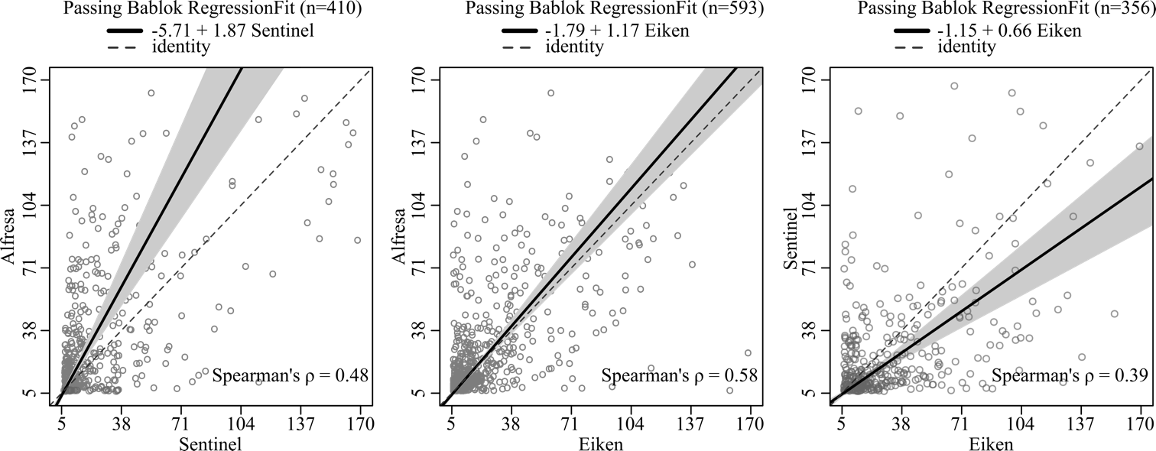

Supplementary Figure 2. The ROC curves obtained for each FIT assay (Eiken Chemical, Sentinel Diagnostics, and Alfresa Pharma) for the detection of AN among participants who underwent colonoscopy (n = 327).

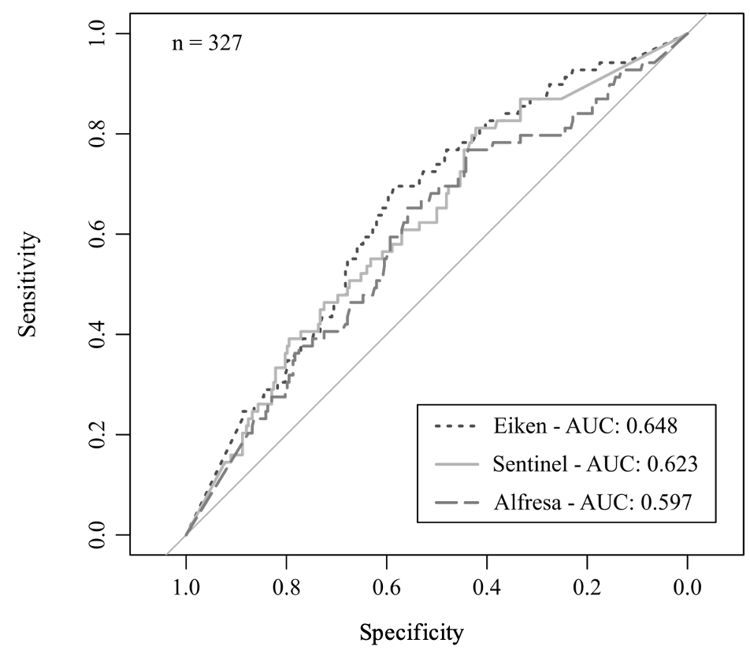

Supplementary Table 1. Concordance tables of all FIT results and manufacturers. (A) Without threshold adjustment; (B) With adjusted thresholds.

Supplementary Table 2. Concordance tables of FIT results within the reportable range of the assays for all manufacturers. (A) Without threshold adjustment; (B) With adjusted thresholds.

Supplementary Table 3. Concordance metrics of FIT results for subjects undergoing colonoscopy (n = 327), using non-adjusted and adjusted thresholds. Values in parentheses indicate 95% confidence intervals.

n=327 | Comparison for each pair | Concordance rate | Cohen kappa | P-value
Non adjusted thresholds | Eiken (35.00 μg/g) - Sentinel (29.75 μg/g) | 63% (58% - 50%) | 27% (17% - 37%) | 2.77E-04
Non adjusted thresholds | Sentinel (29.75 μg/g) - Alfresa (35.00 μg/g) | 63% (56% - 23%) | 28% (16% - 35%) | 4.91E-08
Non adjusted thresholds | Alfresa (35.00 μg/g) - Eiken (35.00 μg/g) | 66% (59% - 42%) | 32% (18% - 39%) | 0.07
Adjusted thresholds | Eiken (35.00 μg/g) - Sentinel (21.60 μg/g) | 62% (57% - 58%) | 25% (15% - 36%) | 0.1491
Adjusted thresholds | Alfresa (39.20 μg/g) - Eiken (35.00 μg/g) | 68% (62% - 48%) | 35% (25% - 45%) | 0.7708

Supplementary Table 4. Concordance metrics between FIT result and AN finding at colonoscopy for the colonoscopy subgroup using non-adjusted and adjusted thresholds. Values in parentheses indicate 95% confidence intervals.

n=327 | Company (threshold) | Concordance rate | Cohen kappa
Non adjusted thresholds | Eiken (35.00 μg/g) | 57% (52% - 63%) | 16% (7% - 24%)
Non adjusted thresholds | Sentinel (29.75 μg/g) | 62% (56% - 67%) | 13% (2% - 23%)
Non adjusted thresholds | Alfresa (35.00 μg/g) | 50% (45% - 56%) | 9% (1% - 17%)
Adjusted thresholds | Sentinel (21.60 μg/g) | 57% (52% - 63%) | 11% (2%- 20%)
Adjusted thresholds | Alfresa (39.20 μg/g) | 55% (49% - 60%) | 12% (4% - 21%)

