Supplementary Figure 1. Variation of hemolysis index (HI) and potassium in a heparinized whole blood sample over ten consecutive measurements on GEM Premier 7000.

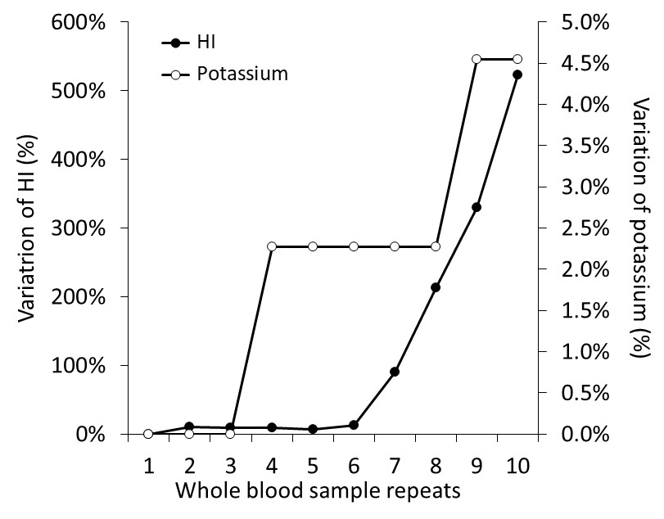

Supplementary Figure 2. Linearity of the hemolysis index (HI) on GEM Premier 7000 using heparinized whole blood.
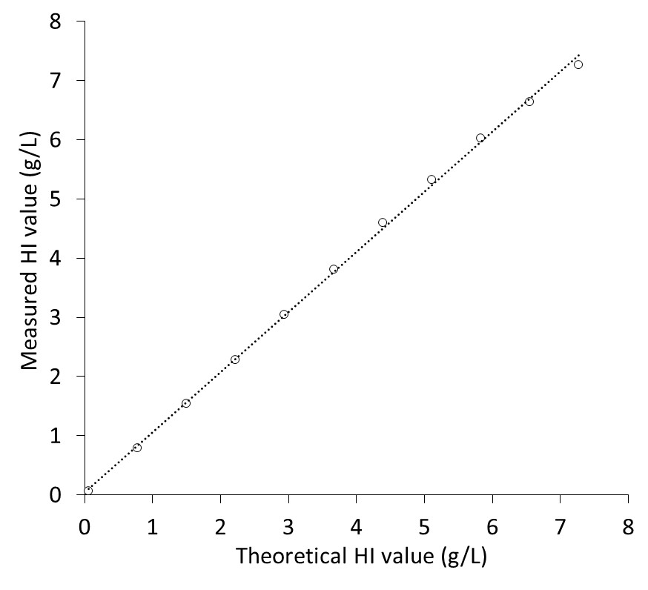

Supplementary Figure 3. Comparison of hemolysis index (HI) values measured on paired samples using heparinized whole blood on GEM Premier 7000 (six categories) and heparinized plasma on Cobas c702. The HI categories are as follows: 1: 0–0.50 g/L; 2: 0.51–1.15 g/L, 3: 1.16–2.00 g/L, 4: 2.01–3.00 g/L, 5: 3.01–4.00 g/L; 6: ≥4.01 g/L.

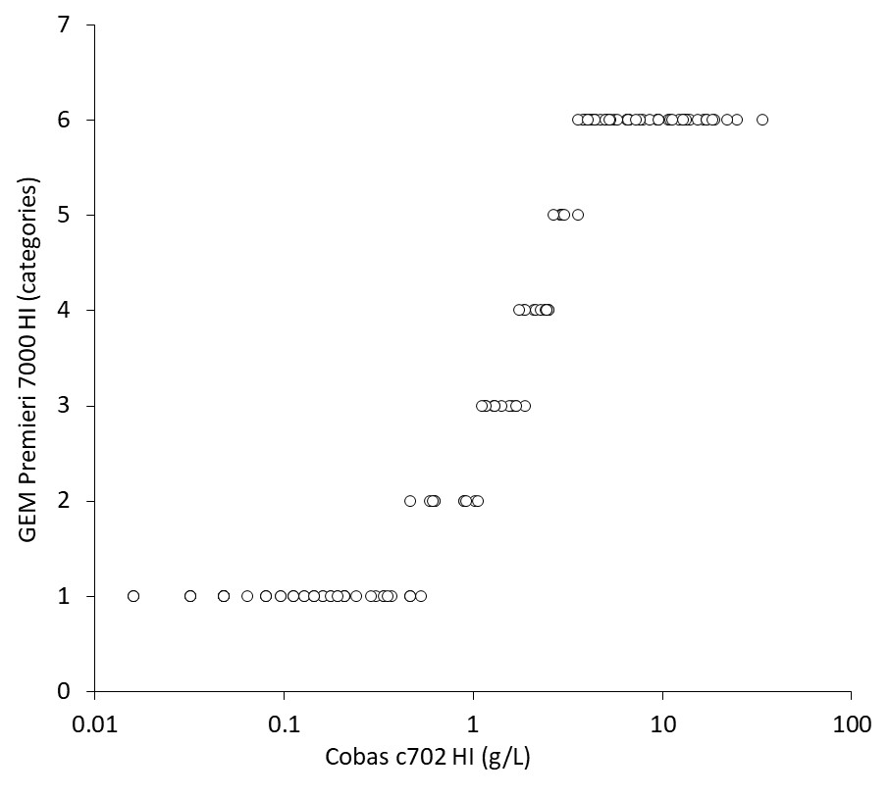

Supplementary Figure 4. Receiver Operating Characteristic (ROC) curves evaluating the diagnostic performance of the hemolysis index (HI) measured in heparinized whole blood using the GEM Premier 7000. Curves are shown for plasma HI thresholds on the Cobas c702 analyzer of (a) 0.50 g/L and (b) 1.16 g/L.
