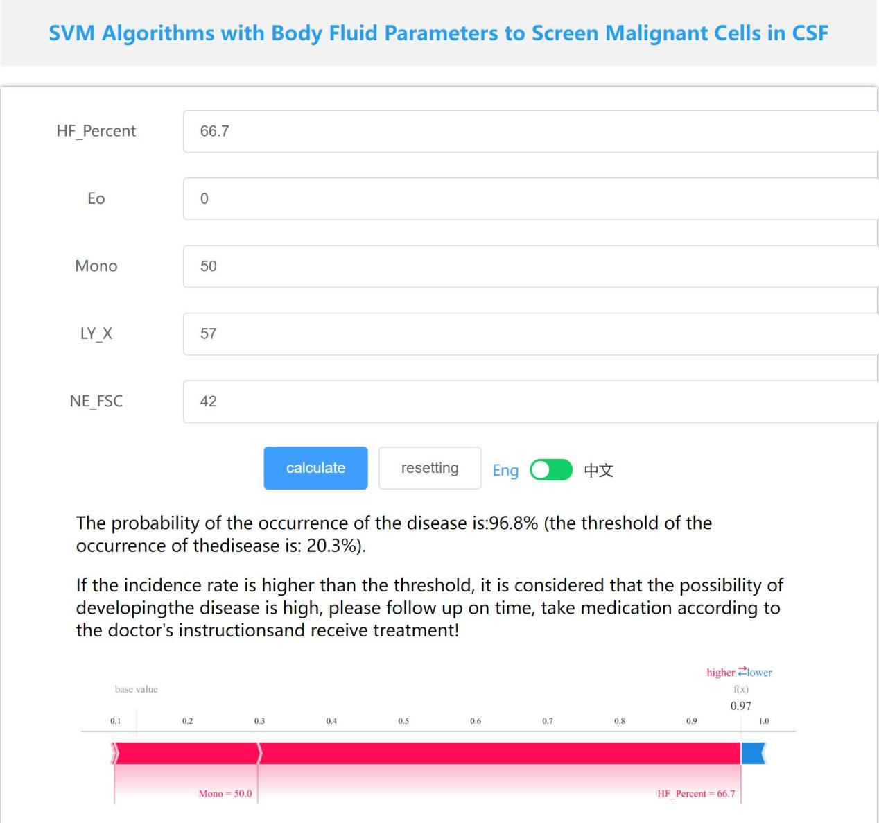
Supplementary Figure 1 Convenient application for laboratory utility. The application of the final SVM model (with 5 selected features) provides cytological results prediction. When entering actual values, the system calculates and automatically displays a prediction probability of 96.8%. The application is available at: https://www.xsmartanalysis.com/model/list/predict/model/html?mid=24969&symbol=4174sa4892Po32zwoE02

