Supplementary Materials
Contents
Supplementary Materials 1
Supplementary Methods 2
1 Preparations of antibody conjugated magnetic beads 2
2 Assessment of Ab reactivity of Ab conjugated magnetic beads 2
3 Inclusion and exclusion criteria for healthy individuals 2
4 Diagnostic criteria for patients diagnosed with diabetes insipidus 3
5 Interference check experiment 3
Supplementary Tables 5
Supplemental Table 1. Detailed information of obtained antibodies. 5
Supplemental Table 2. The results of matrix effect. 6
Supplemental Table 3. The signal detected in different antibody pair groups. 7
Supplemental Table 4. Recovery experiment of the LC–MS/MS method for measuring copeptin using another SCIEX Triple Quad 6500+ system and reagent Lots. 8
Supplemental Table 5. Precision of the LC–MS/MS method for measuring copeptin using another SCIEX Triple Quad 6500+ system and reagent Lots. 8
Supplemental Table 6. The results of interference check experiment. 9
Supplementary Figures 11
Supplemental Fig. 1. The absolute responses of copeptin surrogate peptide and its IS captured by nine types of antibodies. 11
Supplemental Fig. 2. Representative chromatographs of copeptin surrogate peptide and the corresponding IS in a serum sample after extraction. 12
Supplemental Fig. 3. The regression curve for copeptin determination 13
Supplemental Fig. 4. The chromatographs at the concentrations of LOD (a) and LOQ (b). 14

Supplementary Methods

1 Preparations of antibody conjugated magnetic beads
The conjugation of antibodies (Abs) to magnetic beads was performed by Autobio (Zhengzhou, China). Briefly, the carboxyl groups on the magnetic beads were activated using EDC and NHS in an acidic environment (MES buffer, pH 4-6) for one hour. Following completion of activation, the magnetic beads were washed. Subsequently, MES buffer-diluted Ab was added for coating at a concentration of 20 μg Ab/1mg magnetic microbeads. The coating process typically lasted for two hours. Finally, the magnetic beads were blocked with a solution (pH 7.4) containing BSA.

2 Assessment of Ab reactivity of Ab conjugated magnetic beads
The reactivity with copeptin was evaluated through following steps: First, based on the epitope information provided in the antibody datasheets, pairwise combinations of antibodies were tested to identify reactive pairs. One antibody was immobilized on magnetic beads as the capture antibody, while another was labeled with horseradish peroxidase as the detection antibody. The antibody pair was then tested with synthetic antigens, recombinant antigens, and native antigens in serum, and the signals generated from these reactions were collected and recorded. The pair with the best reactivity was chosen by comparing signal intensities of each pair. From among the most reactive pairs, one targeting the C-terminal or N-terminal region was paired with all other Abs.

3 Inclusion and exclusion criteria for healthy individuals
Inclusion criteria included: 1) age > 18-year-old; 2) normonatremia (normal serum sodium level); 3) results of blood routine examination, biochemistry tests (including kidney function, liver function, lipid profile, glucose, etc.), glycosylated hemoglobin, and thyroid function tests within normal reference intervals. Exclusion criteria included a recorded history of cardiovascular and cerebrovascular diseases, malignant tumors, or diabetes insipidus.

4 Diagnostic criteria for patients diagnosed with diabetes insipidus
The diagnosis was based on three diagnostic components: 1) results of urine osmolality, urine volume, and serum sodium after the water deprivation test; 2) patients’ history (including psychiatric disease, head trauma or surgery, family history, nocturia) and diagnostic findings (anterior pituitary function test, cranial imaging if available, evidence of autoimmune/inflammatory or neoplastic/infectious etiology of vasopressin deficiency); 3) treatment response.

5 Interference check experiment
Endogenous interference substances including bilirubin, hemoglobin, and chyle, as well as the potential exogenous interference substance, desmopressin, were added to the serum pools.
The Interference Check A kit (Sysmex Wuxi Co,.Ltd., Lot No. ZR4001) was employed to evaluate the influence of bilirubin (F: free type and C: conjugated type), hemoglobin, and chyle according to its instruction manual. Briefly, (1) each vial was reconstituted with 2.0 mL of purified water; (2) the vials were gently swirled until dissolved equally; (3) 1.0 mL of reconstituted sample and 9.0 mL of the specimen which was prepared previously were mixed (Sample A); (4) 1.0 mL of reconstituted Blank and 9.0 mL of the sample specimen were mixed (Sample B); (5) the dilution series were prepared by mixing Sample A and Sample B as per the following table; (6) the prepared dilution series for the measurement were used, and each dilution was measured four times.
 | Ref. | 2/10 | 5/10 | 8/10 | 10/10
Sample A (mL) | 0 | 0.2 | 0.5 | 0.8 | 1.0
Sample B (mL) | 1.0 | 0.8 | 0.5 | 0.2 | 0
Desmopressin was added to the serum pool to generate final concentrations of 5 ng/mL and 50 ng/mL. Each mixed concentration was measured for copeptin four times.
The specific methods for evaluating the influence of interfering substances on the detection process were in accordance to the Guide to interference testing in clinical chemistry (WS/T 416-2013) from the Health Industry Standard of China. Briefly, (1) The deviation (d_{obs}) between the mean values of the experimental samples and the reference samples was used to represent the interference effect. The calculation formula was $d_{obs}=\overline{x_{test}}−\overline{x_{ref.}}$ ; (2) threshold d_{c} was calculated. The calculation formula was $d_{c}=\frac{d_{null}+{sz}_{(1−α/2)}}{\sqrt{n}}$; (3) If d_{obs} ≤ d_{c}, it could be concluded that the deviation caused by the evaluated interfering substance did not exceed the allowable standard, and this substance was not regarded as an interfering substance. On the contrary, it was considered that the evaluated interfering substance had a significant interfering effect on the evaluated method.

Supplementary Tables

Supplemental Table 1. Detailed information of obtained antibodies.
Ab No. | Manufacturer | Catalog No. | Clonality | Host | Isotype | Immunogen
Ab#1 | Cloud-Clone Corp. (CCC, Wuhan) | PAA365Hu08 | Polyclonal | Rabbit | IgG | KLH Conjugated human Copeptin (ASDRSNATQLDGPAGALLLRLVQLAGAPEPFEPAQPDAY)
Ab#2 | Medix Biochemica (Shanghai, China) | 100638 | Monoclonal | Mouse | IgG1 | ATQLDGPAGALLLRLVQ in the N-terminal part of copeptin
Ab#3 | Medix Biochemica (Shanghai, China) | 100639 | Monoclonal | Mouse | IgG1 | ATQLDGPAGALLLRLVQ in the N-terminal part of copeptin.
Ab#4 | Medix Biochemica (Shanghai, China) | 100649 | Monoclonal | Mouse | IgG1 | QLAGAPEPFEPAQPDAY in the C-terminal part of copeptin
Ab#5 | R&Dsystems(RND) (BIOPIKE, China) | MAB6077 | Monoclonal | Mouse | IgG1 | Human Copeptin precursor  aa126-140 (ASDRSNATQLDGPAG)
Ab#6 | USBiological | C7900-56B | Polyclonal | Rabbit | IgG | Synthetic peptide corresponding to aa126-164 of human AVP. (ASDRSNATQLDGPAGALLLRLVQLAGAPEPFEPAQPDAY)
Ab#7 | USBiological | 546220 | Polyclonal | Rabbit | IgG | Synthetic peptide corresponding to human Copeptin, conjugated to KLH.
Ab#8 | Biomatik | CAU31041 | Polyclonal | Rabbit | NA | Human Copeptin precursor  aa128~144 (DRSNATQLDGPAGALLL)
Ab#9 | Beijing KeyGen Gene Technology Co (Beijing, China) | BXE027 | Monoclonal | Mouse | NA | NA

Supplemental Table 2. The results of matrix effect.
Sample | Copeptin (synthesized surrogate peptide) spiked concentration
Sample | 1.25 ng/mL |  | 5 ng/mL
Sample | Without IS correction | With IS correction | Without IS correction | With IS correction
5% serum 1 | 95.9% | 96.0% | 108.3% | 105.7%
5% serum 2 | 72.8% | 106.3% | 87.5% | 96.3%
5% serum 3 | 63.8% | 87.7% | 52.7% | 97.9%
5% serum 4 | 60.8% | 98.1% | 62.6% | 107.2%
5% serum 5 | 42.2% | 93.3% | 77.5% | 114.6%
Serum 1 | 245.2% | 118.8% | 163.8% | 99.0%
Serum 2 | 245.4% | 97.2% | 162.8% | 97.6%
Serum 3 | 207.9% | 94.9% | 154.5% | 85.7%
Serum 4 | 200.0% | 112.7% | 161.4% | 82.3%
Serum 5 | 137.4% | 97.1% | 161.1% | 107.1%
Serum 6 | 140.7% | 87.8% | 154.3% | 83.3%

Supplemental Table 3. The signal detected in different antibody pair groups.
Capture Ab |  | Ab#1 | Ab#2 | Ab#3 | Ab#5 | Ab#6 | Ab#7 | Ab#8 | Ab#9
Detection Ab and enzyme |  | HRP-Ab#4
Background signal |  | 57,628 | 55,637 | 28,402 | 6,821 | 6,218 | 7,993 | 17,398 | 15,919
Type of Antigen | Concentration (pg/mL)
Synthetic antigen | 20 | 36,714 (0.64) | 13,074 (0.23) | 6,651 (0.23) | 5,176 (0.76) | 7,105 (1.14) | 7,442 (0.93) | 20,763 (1.19) | 18,742 (1.18)
Synthetic antigen | 100 | 53,814 (0.93) | 45,218 (0.81) | 11,173 (0.39) | 4,720 (0.69) | 5,928 (0.95) | 43,219 (5.41) | 29,502 (1.70) | 58,210 (3.66)
Synthetic antigen | 500 | 188,876 (3.28) | 21,422 (0.39) | 26,365 (0.93) | 8,278 (1.21) | 5,123 (0.82) | 17,814 (2.23) | 122,186 (7.02) | 2,810,154 (176.53)
Synthetic antigen | 2000 | 2,670,542 (46.34) | 421,580 (7.58) | 399,407 (14.06) | 26,370 (3.87) | 6,010 (0.97) | 280,826 (35.13) | 2,305,596 (132.52) | 51,476,597 (3233.66)
Synthetic antigen | 20000 | 235,926,988 (4093.96) | 19,082,656 (342.98) | 68,312,302 (2405.19) | 10,076,943 (1477.34) | 8,305 (1.34) | 45,337,919 (5672.20) | 204,839,377 (11773.73) | 777,895,459 (48865.85)
Synthetic antigen | 200000 | 1,321,117,446 (22924.92) | 611,262,232 (10986.61) | 1,067,870,183 (37598.42) | 625,346,112 (91679.54) | 13,843 (2.23) | 424,697,210 (53133.64) | 1,153,196,140 (66283.26) | 1,346,655,096 (84594.20)
Recombinant antigen | 20 | 59,203 (1.03) | 12,893 (0.23) | 6,978 (0.25) | 89,687 (13.15) | 7,480 (1.20) | 11,218 (1.40) | 56,137 (3.23) | 79,464 (4.99)
Recombinant antigen | 100 | 279,320 (4.85) | 17,703 (0.32) | 13,394 (0.47) | 1,050,082 (153.95) | 6,692 (1.08) | 55,174 (6.90) | 183,698 (10.56) | 667,984 (41.96)
Recombinant antigen | 500 | 1,911,981 (33.18) | 50,883 (0.91) | 101,776 (3.58) | 6,742,791 (988.53) | 6,322 (1.02) | 269,513 (33.72) | 1,520,450 (87.39) | 4,577,504 (287.55)
Recombinant antigen | 2000 | 9,119,440 (158.25) | 331,812 (5.96) | 796,152 (28.03) | 29,691,052 (4352.89) | 5,757 (0.93) | 1,767,524 (221.13) | 7,303,103 (419.77) | 20,522,789 (1289.20)
Recombinant antigen | 20000 | 97,432,890 (1690.72) | 5,872,095 (105.54) | 11,470,651 (403.87) | 289,450,343 (42435.18) | 11,148 (1.79) | 23,113,091 (2891.67) | 82,316,562 (4731.38) | 191,934,752 (12056.96)
Recombinant antigen | 200000 | 500,497,866 (8684.98) | 47,788,942 (858.94) | 85,910,793 (3024.81) | 1,112,106,187 (163041.52) | 60,463 (9.72) | 130,442,010 (16319.53) | 426,765,642 (24529.58) | 613,865,423 (38561.81)
Serum | NO.1 | 108,769 (1.89) | 38,930 (0.70) | 29,896 (1.05) | 271,513 (39.81) | 202,658 (32.59) | 248,574 (31.10) | 189,426 (10.89) | 92,877 (5.83)
Serum | NO.2 | 217,991 (3.78) | 92,674 (1.67) | 64,971 (2.29) | 393,940 (57.75) | 416,731 (67.02) | 479,253 (59.96) | 480,707 (27.63) | 166,888 (10.48)
Serum | NO.3 | 240,291 (4.17) | 86,808 (1.56) | 90,361 (3.18) | 547,030 (80.20) | 452,349 (72.75) | 569,985 (71.31) | 561,801 (32.29) | 288,468 (18.12)
For each measurement, the signal intensity was reported first, followed by the signal-to-noise ratio (signal/background signal ratio) in parentheses.

Supplemental Table 4. Recovery experiment of the LC–MS/MS method for measuring copeptin using another SCIEX Triple Quad 6500+ system and reagent Lots.
Background (pg/mL) | Spiked theoretical concentration (pg/mL) | Observed concentration (pg/mL) | Recovery (%) | Bias (%)
13.47 | 20.00 | 34.04 | 102.8 | 2.8
13.47 | 100 | 115.5 | 102.1 | 2.1
13.47 | 300 | 308.7 | 98.4 | -1.6

Supplemental Table 5. Precision of the LC–MS/MS method for measuring copeptin using another SCIEX Triple Quad 6500+ system and reagent Lots.
 | Mean (pg/mL) | Within-run CV (%) | Between-run CV (%) | Total CV (%)
Low pool | 37.9 | 11.5 | 13.1 | 13.4
Median pool | 107.2 | 10.6 | 10.7 | 10.7
High pool | 302.9 | 6.8 | 6.8 | 6.8

Supplemental Table 6. The results of interference check experiment.
Interference substance | Approximate concentration | Mean results of Copeptin (pg/mL)-low level | d_{obs} (pg/mL) | d_{c} (pg/mL) | Mean results of Copeptin (pg/mL)-high level | d_{obs} (pg/mL) | d_{c} (pg/mL)
Bilirubin-F | 0 | 146.0 | \ | 9.4 | 521.5 | \ | 10.9
Bilirubin-F | 43 mg/dL | 142.3 | -3.7 | 9.4 | 525.5 | 4 | 10.9
Bilirubin-F | 107.5 mg/dL | 143.0 | -3 | 9.4 | 513.5 | -8 | 10.9
Bilirubin-F | 172 mg/dL | 146.5 | 0.5 | 9.4 | 526.0 | 4.5 | 10.9
Bilirubin-F | 215 mg/dL | 142.7 | -3.3 | 9.4 | 524.0 | 2.5 | 10.9
Bilirubin-C | 0 | 118.4 | \ | 9.4 | 448.2 | \ | 10.9
Bilirubin-C | 41.4 mg/dL | 118.6 | 0.2 | 9.4 | 450.5 | 2.3 | 10.9
Bilirubin-C | 103.5 mg/dL | 114.7 | -3.7 | 9.4 | 443.5 | -4.7 | 10.9
Bilirubin-C | 165.6 mg/dL | 115.1 | -3.3 | 9.4 | 437.5 | -10.7 | 10.9
Bilirubin-C | 207 mg/dL | 113.8 | -4.6 | 9.4 | 444.2 | -4 | 10.9
Hemolytic hemoglobin | 0 | 106.7 | \ | 9.4 | 420.2 | \ | 10.9
Hemolytic hemoglobin | 980 mg/dL | 115.0 | 8.3 | 9.4 | 421.2 | 1 | 10.9
Hemolytic hemoglobin | 2450 mg/dL | 110.5 | 3.8 | 9.4 | 427.5 | 7.3 | 10.9
Hemolytic hemoglobin | 3920 mg/dL | 111.7 | 5 | 9.4 | 417.2 | -3 | 10.9
Hemolytic hemoglobin | 4900 mg/dL | 108.9 | 2.2 | 9.4 | 415 | -5.2 | 10.9
Chyle | 0 | 115.3 | \ | 9.4 | 458.7 | \ | 10.9
Chyle | 3783.6 FTU | 117.3 | 2 | 9.4 | 449.5 | -9.2 | 10.9
Chyle | 9459 FTU | 120.0 | 4.7 | 9.4 | 448.5 | -10.2 | 10.9
Chyle | 15134.4 FTU | 118.5 | 3.2 | 9.4 | 466.7 | 8 | 10.9
Chyle | 18918 FTU | 116.4 | 1.1 | 9.4 | 449.5 | -9.2 | 10.9
Desmopressin | 0 | 15.2 | \ | 3.7 | \ | \ | \
Desmopressin | 5 ng/mL | 15.7 | 0.5 | 3.7 | \ | \ | \
Desmopressin | 50 ng/mL | 14.7 | -0.5 | 3.7 | \ | \ | \
If d_{obs} ≤ d_{c}, it could be concluded that the deviation caused by the evaluated interfering substance did not exceed the allowable standard, and this substance was not regarded as an interfering substance.

Supplementary Figures

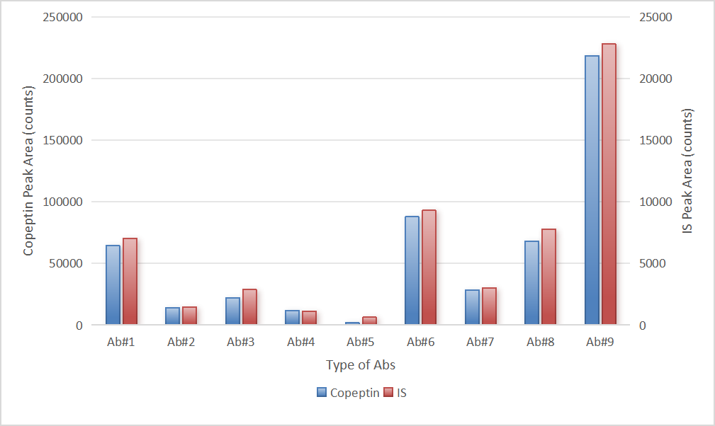
Supplemental Fig. 1. The absolute responses of copeptin surrogate peptide and its IS captured by nine types of antibodies.

Supplemental Fig. 2. Representative chromatographs of copeptin surrogate peptide and the corresponding IS in a serum sample after extraction.
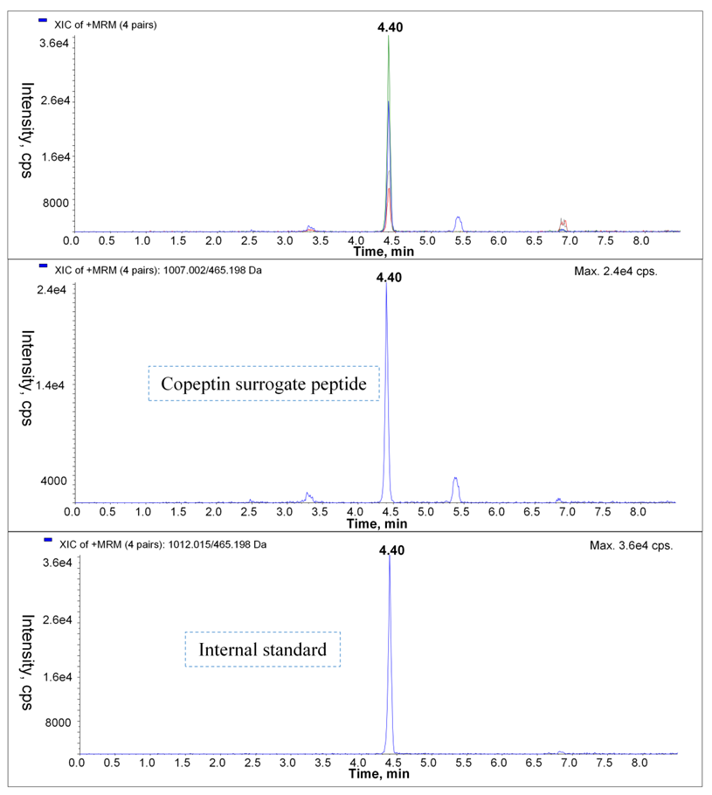

Supplemental Fig. 3. The regression curve for copeptin determination

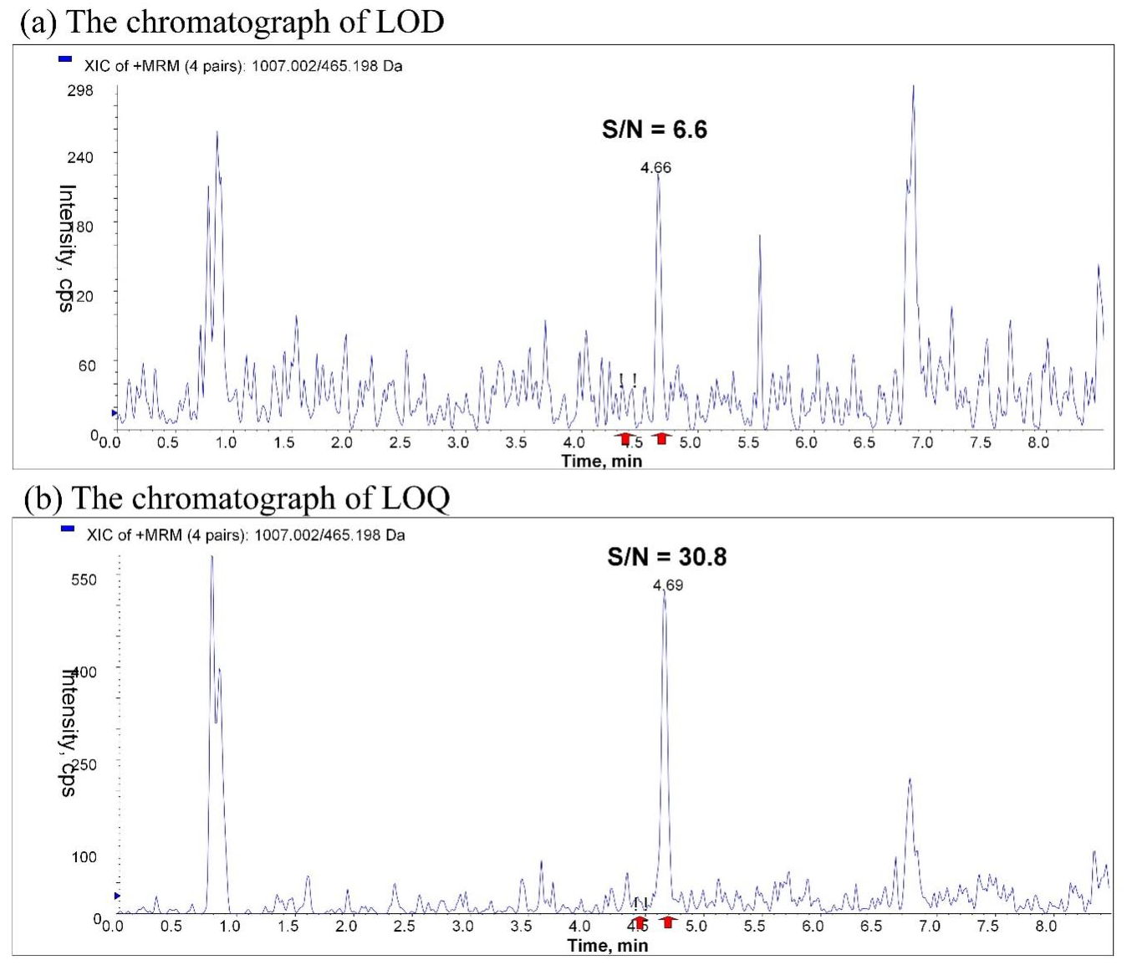
Supplemental Fig. 4. The chromatographs at the concentrations of LOD (a) and LOQ (b).

