Supplementary Table 1. Fluorescence channel and markers according to each MFC panel for hematologic malignancy
Fluorescence channel | Laser (excitation wavelength) | Emission peak | MFC panel
Fluorescence channel | Laser (excitation wavelength) | Emission peak | ALOT | BCL | MM | B-MRD | MM-MRD
BV421 | Violet (405 nm) | 421 nm |  |  | CD138 |  | CD138
BV450 | Violet (405 nm) | 450 nm | cCD3 | CD20 |  | CD20
BV500 | Violet (405 nm) | 500 nm | CD45 | CD45 | CD45 | CD45 | CD45
BV605 | Violet (405 nm) | 605 nm |  |  |  | CD58 | CD81
FITC | Blue (488 nm) | 519 nm | cMPO | CD5 | CD38 | CD38 | CD38
PE | Blue (488 nm) | 578 nm | cCD79a | Lambda | cLambda | C66c, CD123 | CD56
PerCP-Cy5.5 | Blue (488 nm) | 695 nm | CD34 | CD19 | CD19 | CD34 | CD117
PE-Cy7 | Blue (488 nm) | 767 nm | CD19 | CD10 | CD56 | CD19 | CD19
APC | Red (640 nm) | 660 nm | CD7 | Kappa | cKappa | CD10 | cKappa
R718 | Red (640 nm) | 718 nm |  |  |  | CD73, CD304 | CD27
APC-Cy7 | Red (640 nm) | 767 nm | CD3 | FVD |  | CD81 | cLambda
Abbreviations: MFC, multiparameter flow cytometry; ALOT, acute leukemia orientation tube; BCL, B-cell lymphoma; MM, multiple myeloma; MRD, measurable residual disease; cMPO, cytoplasmic myeloperoxidase; FVD, fixable viability dye

Supplementary Table 2. Comparison between manual gating and DR-based gating results in the ALOT panel
 | Manual gating results (Sample, N)
 | Myeloblast | B-lymphoblast | T-lymphoblast | Unknown lineage | Total
t-SNE-based gating results
(Sample, N)
Myeloblast | 44 | 0 | 0 | 0 | 44
B-lymphoblast | 0 | 16 | 0 | 0 | 16
T-lymphoblast | 0 | 0 | 7 | 0 | 7
Unknown lineage | 0 | 0 | 0 | 13 | 13
UMAP-based gating results
(Sample, N)
Myeloblast | 43 | 0 | 0 | 0 | 43
B-lymphoblast | 0 | 16 | 0 | 0 | 16
T-lymphoblast | 0 | 0 | 7 | 0 | 7
Unknown lineage | 1 | 0 | 0 | 13 | 14
Total | 44 | 16 | 7 | 13 | 80
Abbreviations: DR, dimensionality reduction; ALOT, acute leukemia orientation; t-SNE, t-Distributed Stochastic Neighbor Embedding; UMAP, Uniform Manifold Approximation and Projection

Supplementary Table 3. Comparison between manual gating and DR-based gating results in BCL panel
DR-based gating results (Sample, N)  : both t-SNE and UMAP | Manual gating results (Sample, N)
DR-based gating results (Sample, N)  : both t-SNE and UMAP | CD5-/CD10-  clonal B-cells | CD5+/CD10-  clonal B-cells | CD5-/CD10+  clonal B-cells | CD5+/CD10+  clonal B-cells | Normal | Total
CD5-/CD10-  clonal B-cells | 9 | 1 | 0 | 0 | 1 | 11
CD5+/CD10-  clonal B-cells | 0 | 5 | 0 | 0 | 0 | 5
CD5-/CD10+  clonal B-cells | 0 | 0 | 4 | 0 | 0 | 4
CD5+/CD10+  clonal B-cells | 0 | 0 | 0 | 1 | 0 | 1
Normal | 0 | 0 | 0 | 0 | 21 | 21
Total | 9 | 6 | 4 | 1 | 22 | 42
Abbreviation: DR, dimensionality reduction; BCL, B-cells lymphoma; t-SNE, t-Distributed Stochastic Neighbor Embedding; UMAP, Uniform Manifold Approximation and Projection

Supplementary Table 4. Comparison between manual gating and DR-based gating results in MM panel
DR-based gating results (Sample, N)  : both t-SNE and UMAP | Manual gating results (Sample, N)
DR-based gating results (Sample, N)  : both t-SNE and UMAP | cKappa-type  clonal plasma cells | cLambda-type  clonal plasma cells | Normal | Total
Kappa-type  clonal plasma cells | 16 | 0 | 0 | 16
Lambda-type  clonal plasma cells | 0 | 19 | 0 | 19
Normal | 0 | 0 | 10 | 10
Total | 16 | 19 | 10 | 45
Abbreviation: DR, dimensionality reduction; MM, multiple myeloma; t-SNE, t-Distributed Stochastic Neighbor Embedding; UMAP, Uniform Manifold Approximation and Projection

Supplementary Table 5. Comparison between manual gating and DR-based gating results in B-MRD and MM-MRD panels
DR-based gating results (Sample, N)  : both t-SNE and UMAP | Manual gating results (Sample, N)
DR-based gating results (Sample, N)  : both t-SNE and UMAP | MRD-positive | MRD-negative | Total
B-MRD
MRD-positive | 18 | 0 | 18
MRD-negative | 0 | 22 | 22
Total | 18 | 12 | 40
MM-MRD
MRD-positive | 14 | 1 | 15
MRD-negative | 0 | 15 | 15
Total | 14 | 16 | 30
Abbreviations: DR, dimensionality reduction; MRD, measurable residual disease; t-SNE, t-Distributed Stochastic Neighbor Embedding; UMAP, Uniform Manifold Approximation and Projection

Supplementary Methods. Detailed description of DR-based gating for each panel

1. Acute leukemia orientation tube panel
Target clusters were identified either as CD34+ clusters in the DR dot plot heatmap mode and/or as populations located in the CD45dim blast area on the CD45/SSC-A dot plot (Supplementary Figure 1). The lineage of these target cluster was determined by evaluating marker expression in heatmap mode, identifying them as myeloblasts (cMPO+), B-lymphoblasts (CD19+), T-lymphoblasts (cytoplasmic CD3 [cCD3]+ and/or CD3+), or blasts of unknown lineage (negative for cMPO, CD19, CD3, and cCD3).

2. B-cell lymphoma panel
Target clusters were identified as CD20+ clusters in the DR dot plot heatmap mode (Supplementary Figure 2). The expression of kappa and lambda light chains was observed within these clusters to determine clonality, with a kappa/lambda ratio of ≥ 2.0 or ≤ 0.5 indicating monoclonality [1]. Additionally, CD20+ clusters that were distinct from the two mature B-cell clusters expressing kappa and lambda, and that displayed aberrant immunophenotypes in CD5 or CD10 markers, or were located outside the typical lymphocyte area on the CD45/SSC-A plot, were interpreted as clonal B-cell clusters. The final categorization included CD5-/CD10- clonal B-cells, CD5+/CD10- clonal B-cells, CD5-/CD10+ clonal B-cells, and CD5+/CD10+ clonal B-cells, and normal groups.

3. Multiple myeloma panel
Target clusters were identified as CD138+ clusters in the DR dot plot heatmap mode (Supplementary Figure 3). The expression of ckappa and clambda was evaluated to determine clonality, with a ckappa/clambda ratio of ≥ 9 or ≤ 0.14 indicating clonality [2]. Additionally, CD138+ clusters that were distinct from the two polyclonal plasma cell clusters expressing ckappa and clambda, and that displayed aberrant immunophenotypes in CD19 and/or CD56 markers, were interpreted as clonal plasma cell clusters. The final categorization included ckappa-type clonal plasma cells, clambda-type clonal plasma cells, and normal groups.

4. Measurable residual disease panel for B-cell acute lymphoblastic leukemia
In the B-MRD panel, CD19-positive populations were gated before applying DR algorithms (Supplementary Figure 4). After applying the DR algorithms, clusters positive for CD10, also known as common acute lymphoblastic leukemia antigen (CALLA) and/or CD34 were identified as target clusters in the DR dot plot heatmap. The identified CD19+, CD10+ clusters were assessed for MRD if they exhibited one or more aberrant phenotypes, based on the EuroFlow guidelines and studies of leukemia-associated immunophenotypes [3-5]. MRD positivity was determined based on a lower limit of detection (LOD) of 20 MRD events. However, cases with 10–20 MRD events were also considered MRD-positive if they demonstrated clear clustering in both the DR plot and the CD45/SSC-A plot. The MRD percentage was calculated by dividing the number of MRD events by the total number of acquired events after excluding debris and doublets.

5. Measurable residual disease panel for multiple myeloma
In the MM-MRD panel, CD138-positive populations were gated before applying the DR algorithms (Supplementary Figure 5). After applying the DR algorithms, clusters positive for CD38 were identified as target clusters in the DR dot plot heatmap. In addition to the expression of aberrant immunophenotypes in CD19 and/or CD56 markers in plasma cells, cKappa and cLambda expression was evaluated to determine clonality, with a cKappa/cLambda ratio of ≥ 9 or ≤ 0.14 indicating clonality. MRD positivity was determined based on a LOD of 20 MRD events. However, cases with 10–20 MRD events were also considered MRD-positive if they demonstrated clear clustering in both the DR plot and the CD45/SSC-A plot. The MRD percentage was calculated by dividing the number of MRD events by the total number of acquired events after excluding debris and doublets.

Supplementary Figure 1. Example of DR-based gating for ALOT panel. The target cluster gated in the DR plot is represented as the red population in the CD45/SSC-A plot.
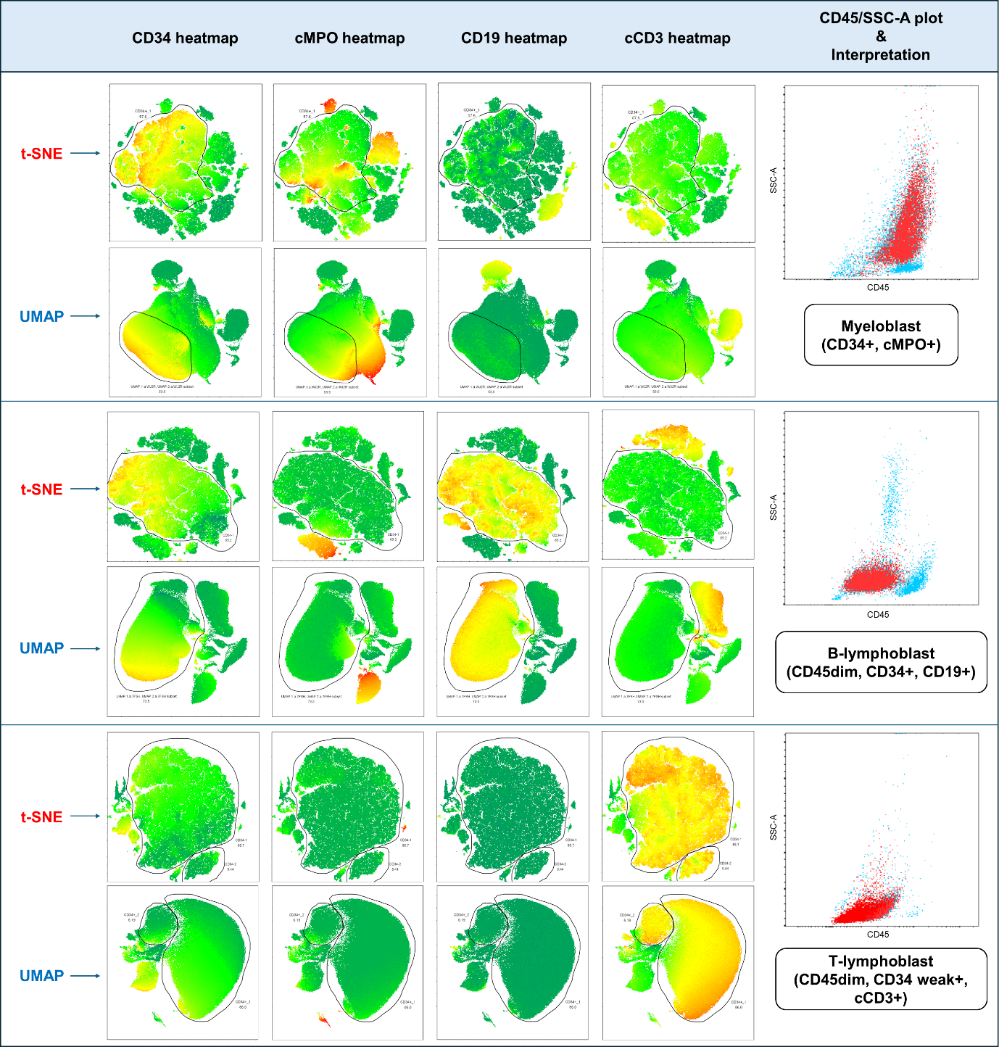

Supplementary Figure 2. Example of DR-based gating for BCL panel. The target cluster gated in the DR plot is represented as the red population in the CD45/SSC-A plot.
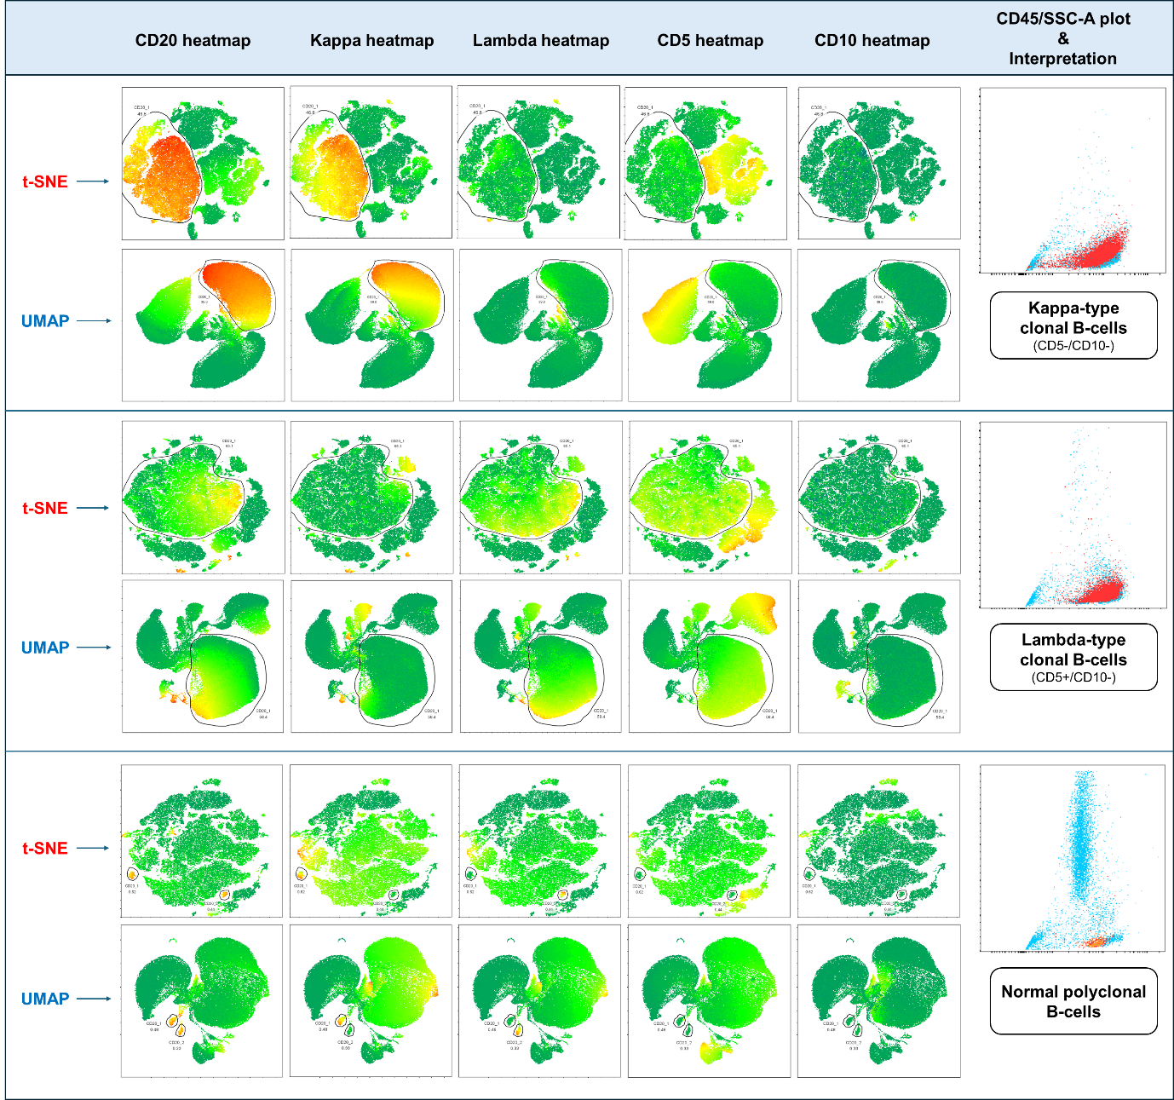

Supplementary Figure 3. Example of DR-based gating for MM panel. The target cluster gated in the DR plot is represented as the red population in the CD45/SSC-A plot.
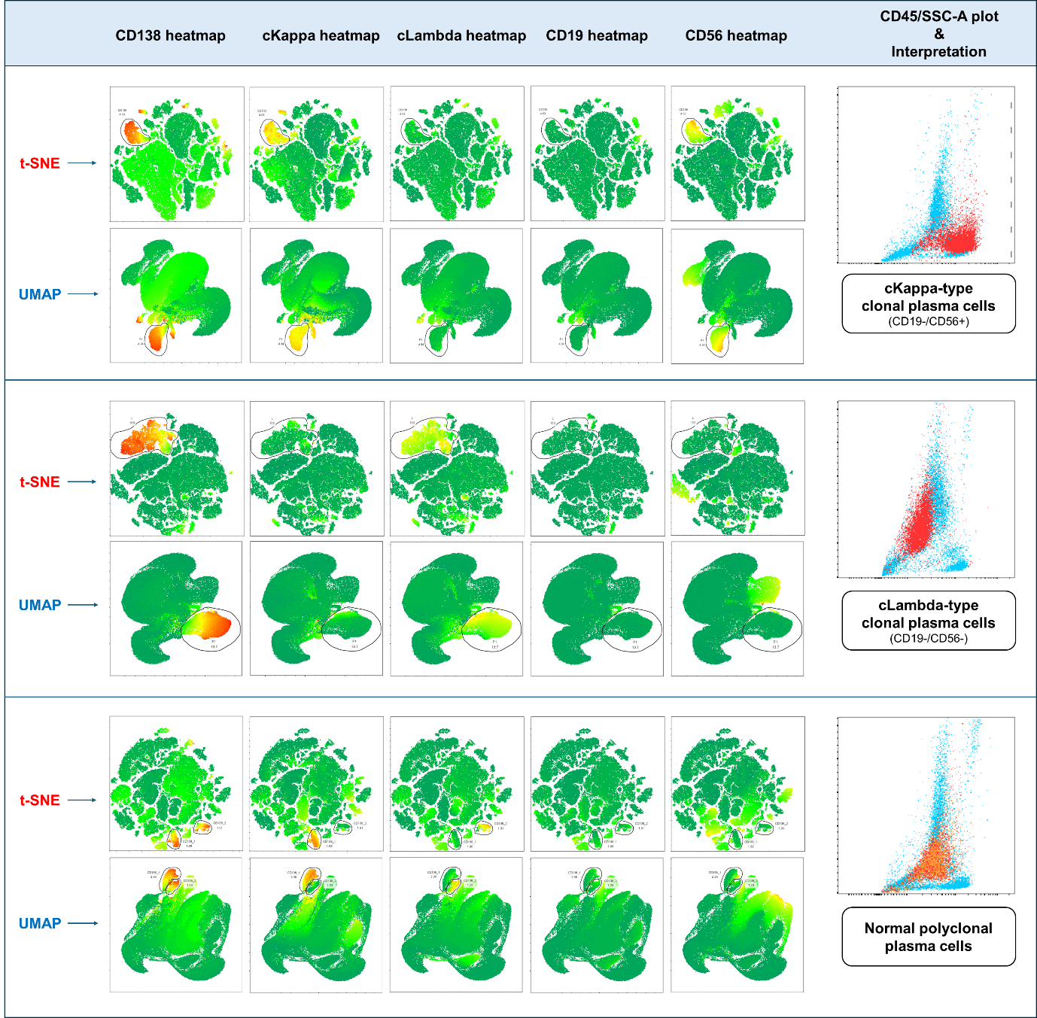

Supplementary Figure 4. Example of DR-based gating for B-MRD panel with primary-gating strategy. The target cluster gated in the DR plot is represented as the red population in the CD45/SSC-A plot.
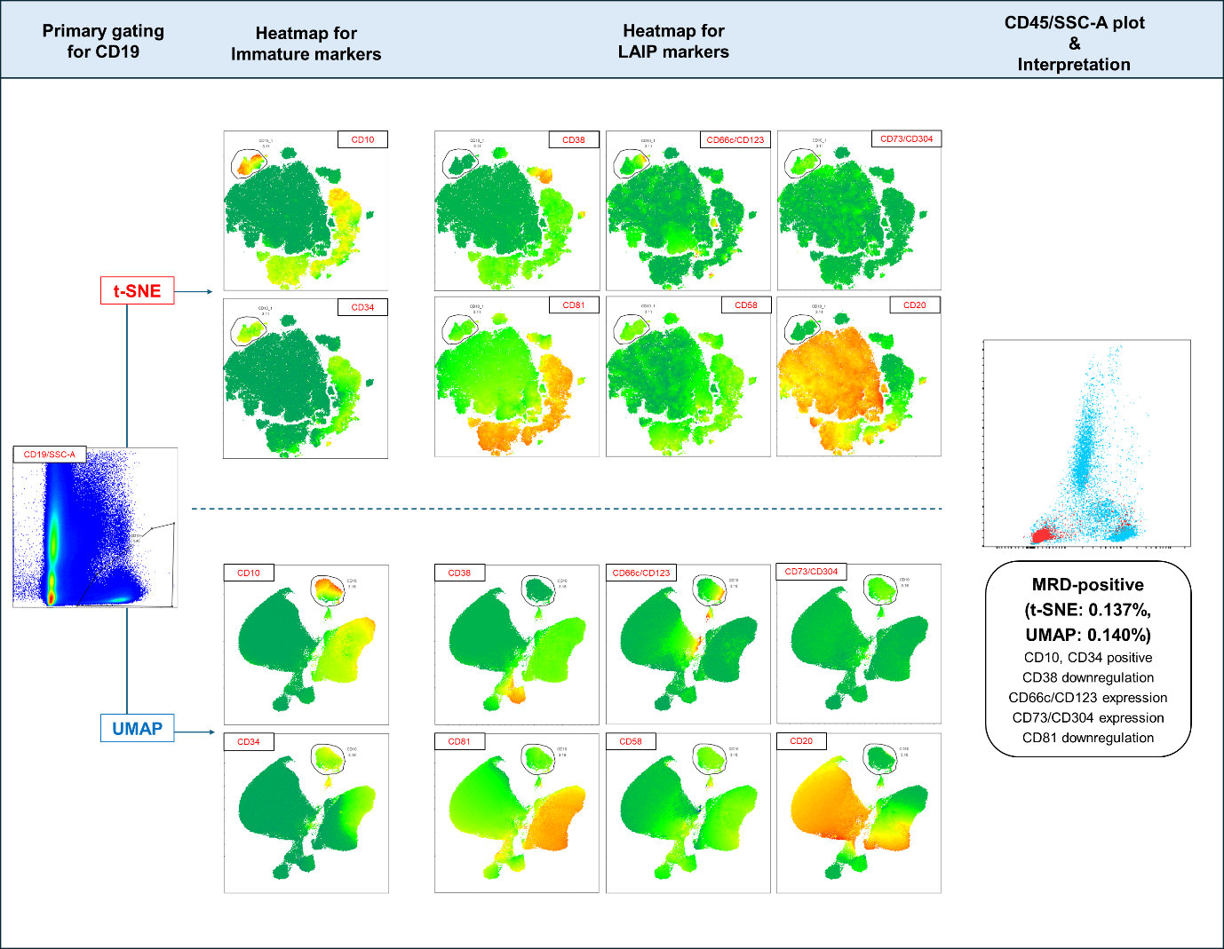

Supplementary Figure 5. Example of DR-based gating for MM-MRD panel with primary-gating strategy. The target cluster gated in the DR plot is represented as the red population in the CD45/SSC-A plot.
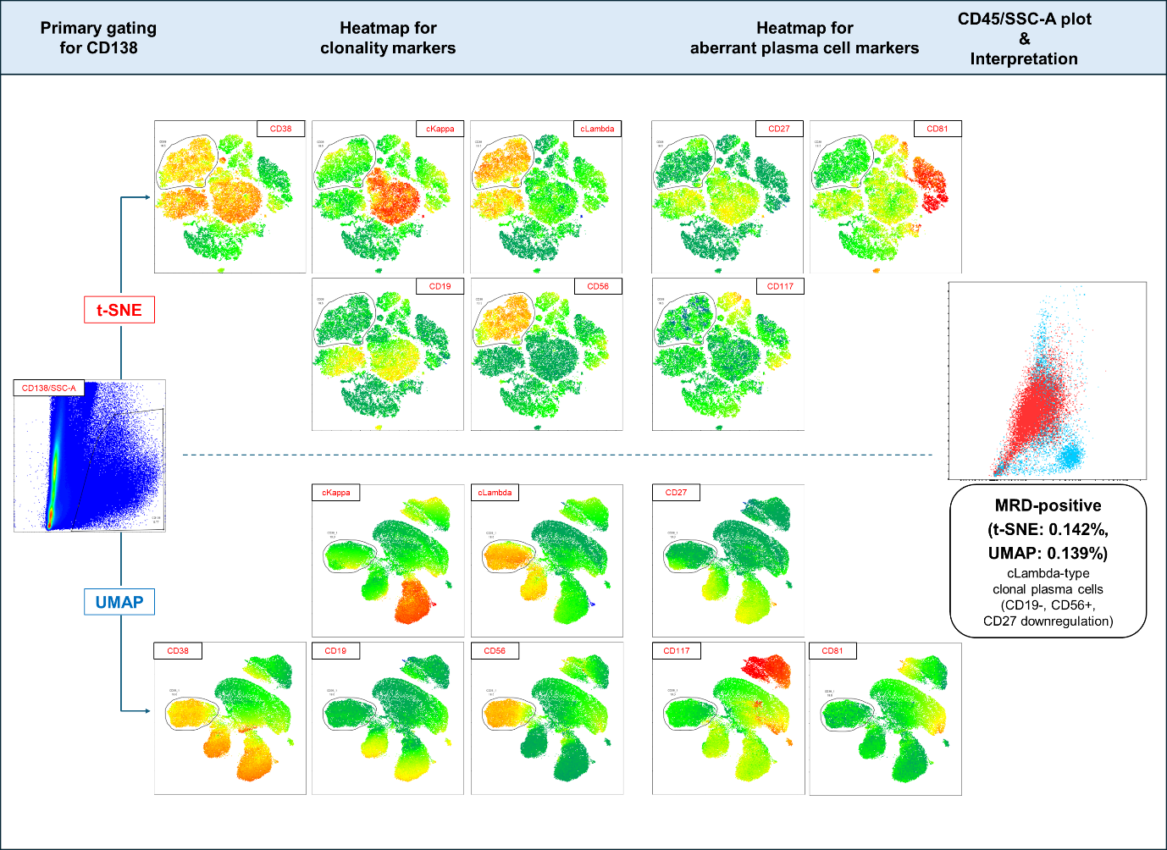

Supplementary Figure 6. Discrepant case between manual gating and DR-based gating in the BCL panel – identified only through DR-based gating.
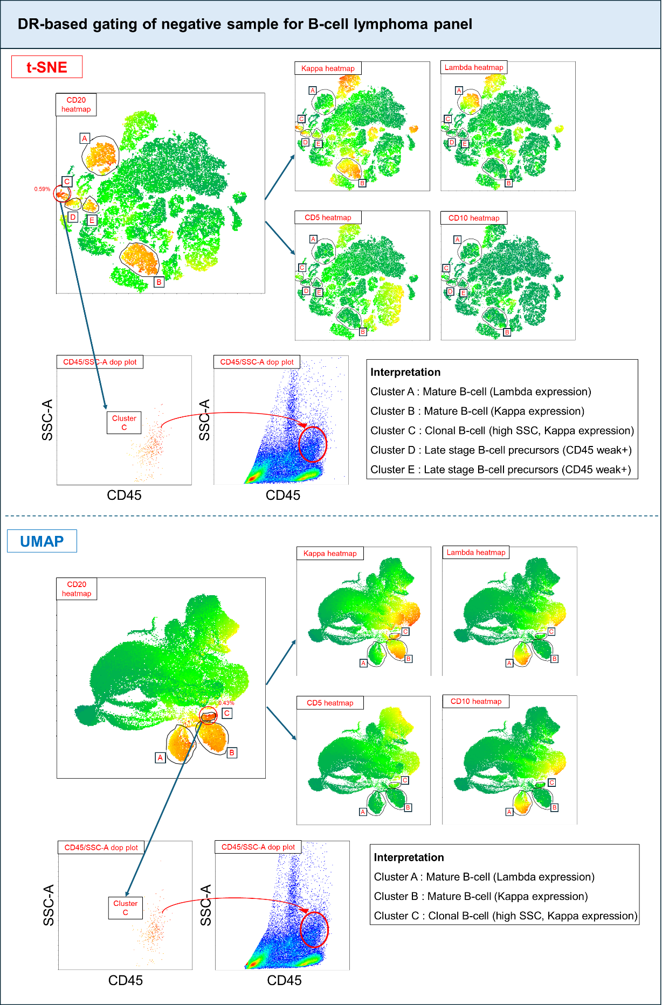
Supplementary Figure 7. Discrepant case between manual gating and DR-based gating in the MM-MRD panel. Both t-SNE and UMAP identified the MRD (0.009% of total events), while manual gating did not detect the MRD.
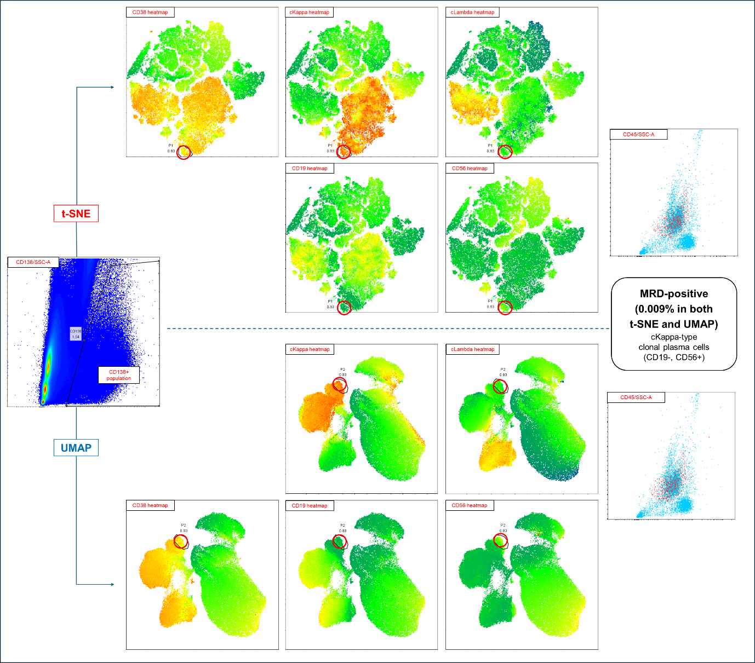

Supplementary Figure 8. DR plot of a sample with an MRD value of 10^{-4.70} (0.002%) in the sensitivity evaluation using total events in the B-MRD panel. The target cluster gated in the DR plot is represented as the red population in the CD45/SSC-A plot.
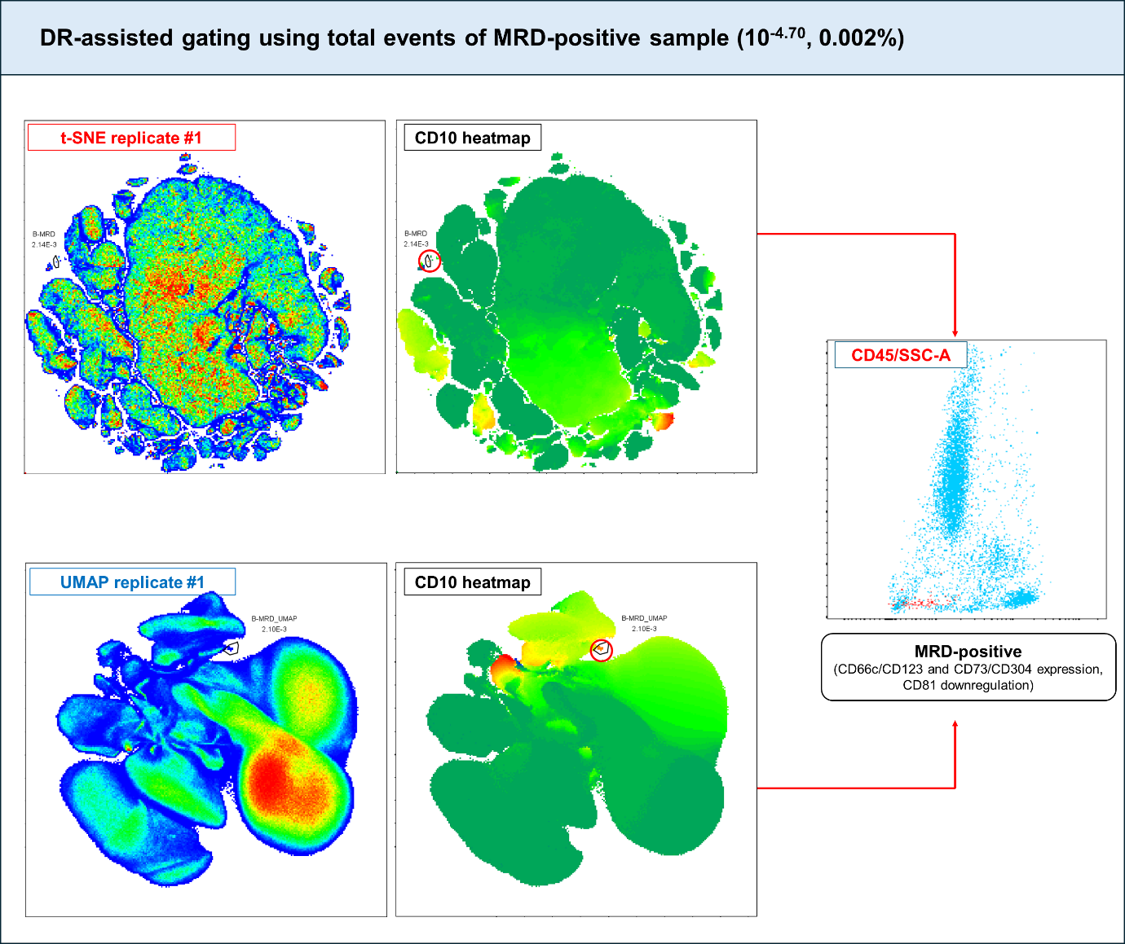

References

1. Chizuka A, Kanda Y, Nannya Y, Oshima K, Kaneko M, Yamamoto R, et al. The diagnostic value of kappa/lambda ratios determined by flow cytometric analysis of biopsy specimens in B-cell lymphoma. Clin Lab Haematol 2002;24:33-6.
2. Warnnissorn AN, Treetipsatit J, Limvorapitak W. The cut-offs for kappa/lambda ratio in bone marrow immunohistochemistry for the diagnosis of multiple myeloma. Hematology 2020;25:292-298.
3. Theunissen P, Mejstrikova E, Sedek L, van der Sluijs-Gelling AJ, Gaipa G, Bartels M, et al. Standardized flow cytometry for highly sensitive MRD measurements in B-cell acute lymphoblastic leukemia. Blood 2017;129:347-357.
4. Tsitsikov E, Harris MH, Silverman LB, Sallan SE, Weinberg OK. Role of CD81 and CD58 in minimal residual disease detection in pediatric B lymphoblastic leukemia. Int J Lab Hematol 2018;40:343-351.
5. Verbeek MWC, van der Velden VHJ. The Evolving Landscape of Flowcytometric Minimal Residual Disease Monitoring in B-Cell Precursor Acute Lymphoblastic Leukemia. Int J Mol Sci 2024;25:4881.

