**SUPPLEMENTARY DATA**

**Targeted proteomics of serum IGF-I, II, IGFBP 2,3,4,5, 6 and ALS**

Jakob Albrethsen1,2, Lylia Drici3,4, Lea Marie Slot Vilmann1,2, Stine A. Holmboe1,2, Charlotte Ehlers Thomsen1,2, Veronica Lykke Rogaczewska Groendahl1,2, Maud Ottenheijm3,4, Annelaura Bach Nielsen3,4, Christina Christoffersen5, Lise Aksglaede1,2, Casper P. Hagen1,2,6, Nicolai J. Wewer Albrechtsen3,4, Anders Juul1,2,6

1 Department of Growth and Reproduction, Copenhagen University Hospital - Rigshospitalet, Copenhagen, Denmark

2 International Centre for Research and Research Training in Endocrine Disruption of Male Reproduction and Child Health (EDMaRC), Rigshospitalet and University of Copenhagen, Denmark

3 NNF Center for Protein Research, Faculty and Medical Sciences, University of Copenhagen, Copenhagen, Denmark

4 Department of Clinical Biochemistry, Copenhagen University Hospital – Bispebjerg and Frederiksberg, Copenhagen, Denmark

5 Department of Clinical Biochemistry, Copenhagen University Hospital – Rigshospitalet Copenhagen, Denmark

6 Department of Clinical Medicine, University of Copenhagen, Denmark

**Contents**

Supplementary data 1 – Protein standards 2

Supplementary data 2 - ELISA 3

Supplementary data 3 – Literature search 4

Supplementary data 4 – LC-MS/MS of candidate tryptic peptides in serum 7

Supplementary data 5 – Posttranslational modifications 8

Supplementary data 6 – DIA proteomics of IGFBP3 and IGFALS 11

Supplementary data 7 – Method ranges and standards 12

Supplementary data 8 –Signal suppression of internal standards with digestion time. 13

Supplementary data 9 – WHO standards for IGF-I, IGF-II and IGFBP3 14

Supplementary data 10 – Targeted proteomics of IGF proteins in children 15

Supplementary data 11 – Proteomics profiling of serum 19

# Supplementary data 1 – Protein standards

|  |  |  |  |
| --- | --- | --- | --- |
|  | **Company name** | **Product number** | **Measured concentration of stock solution (µg/L)** |
| **IGF-I** | Bio-techne | 291-G1 | 170000 |
| **IGF-II** | Bio-techne | 292-G2 | 260000 |
| **IGFBP2** | SIGMA | SRP3063 | 60000 |
| **IGFBP3** | SIGMA | SRP3067 | 50000 |
| **IGFBP4** | SIGMA | SRP3064 | 40000 |
| **IGFBP5** | SIGMA | SRP3068 | 130000 |
| **IGFBP6** | SIGMA | SRP3065 | 100000 |
| **IGFALS** | Bio-techne | 9917 | 550000 |

List of commercial recombinant proteins used for creation of standard samples. Freeze-dried proteins were reconstituted in 5% acetonitrile and the protein concentration was measured by amino acid analysis (Alphalyse A/S, Odense, Denmark).

# Supplementary data 2 - ELISA

Targeted proteomics of 6 IGF proteins were compared with commercial ELISA of human serum. The ELISA was performed as described by the manufacturers.

|  |  |  |
| --- | --- | --- |
| **Protein** | **Company** | **Product number** |
| IGF-II | AnshLabs | AL-131 |
| IGFBP2 | AnshLabs | AL-140 |
| IGFBP4 | AnshLabs | AL-126 |
| IGFBP5 | AnshLabs | AL-127 |
| IGFBP6 | Fine Biotech | EH0170 |
| IGFALS | Mediagnost | E35 |

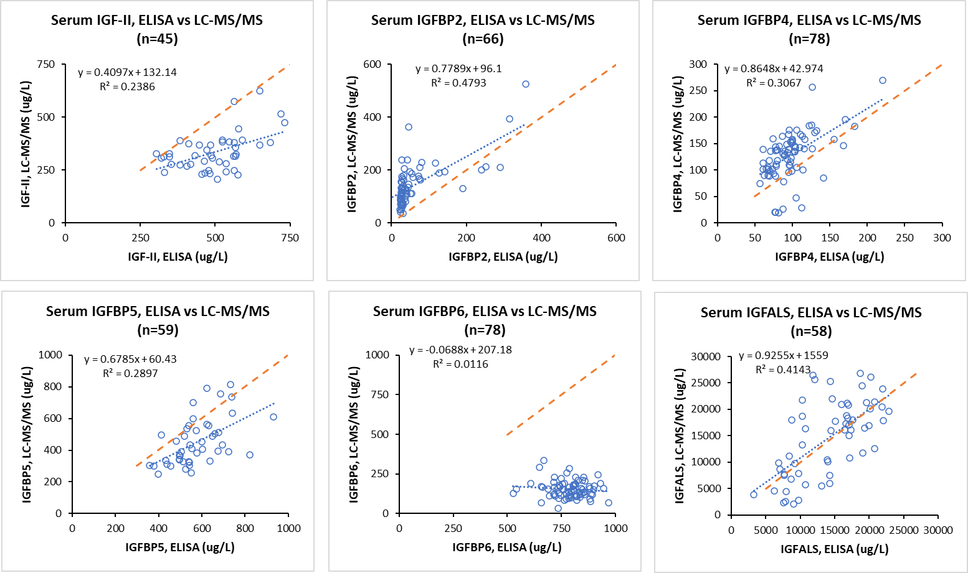

# Supplementary data 3 – Literature search

The PubMed. database was searched for publications on targeted proteomics of IGF proteins.



Row 1: Tryptic peptides previously identified.

Row 2: Literature reference (see reference list below).

Row 3: Tryptic peptides in human serum.

Row 4: Tryptic peptides selected for targeted proteomics of serum proteins.

**References to supplementary table 3**

Cox:

Interlaboratory agreement of insulin-like growth factor 1 concentrations measured by mass spectrometry.

Cox HD, Lopes F, Woldemariam GA, Becker JO, Parkin MC, Thomas A, Butch AW, Cowan DA, Thevis M, Bowers LD, Hoofnagle AN.

Clin Chem. 2014 Mar;60(3):541-8

Kay:

A novel mass spectrometry-based method for determining insulin-like growth factor 1: assessment in a cohort of subjects with newly diagnosed acromegaly.

Kay R, Halsall DJ, Annamalai AK, Kandasamy N, Taylor K, Fenwick S, Webb A, Wark G, Pleasance S, Gurnell M.

Clin Endocrinol (Oxf). 2013 Mar;78(3):424-30.

Barton:

Development of high-throughput chemical extraction techniques and quantitative HPLC-MS/MS (SRM) assays for clinically relevant plasma proteins.

Barton C, Kay RG, Gentzer W, Vitzthum F, Pleasance S.

J Proteome Res. 2010 Jan;9(1):333-40.

Bronsema:

A quantitative LC-MS/MS method for insulin-like growth factor 1 in human plasma.

Bronsema KJ, Klont F, Schalk FB, Bischoff R, Kema IP, van de Merbel NC.

Clin Chem Lab Med. 2018 Oct 25;56(11):1905-1912.

Domanski:

MRM-based multiplexed quantitation of 67 putative cardiovascular disease biomarkers in human plasma.

Domanski D, Percy AJ, Yang J, Chambers AG, Hill JS, Freue GV, Borchers CH.

Proteomics. 2012 Apr;12(8):1222-43.

Kirsch:

Development of an absolute quantification method targeting growth hormone biomarkers using liquid chromatography coupled to isotope dilution mass spectrometry.

Kirsch S, Widart J, Louette J, Focant JF, De Pauw E.

J Chromatogr A. 2007 Jun 15;1153(1-2):300-6.

Liu:

Validation of a multiplexed LC-MS/MS clinical assay to quantify insulin growth factor binding proteins in human serum and its application in a clinical study.

Liu N, Tengstrand E, Boernsen O, Bek S, Hsieh F.

Toxicol Appl Pharmacol. 2019 May 15:371:74-83

Penn:

Validation of a proteomic biomarker panel to diagnose minor-stroke and transient ischaemic attack: phase 2 of SpecTRA, a large scale translational study.

Penn AM, Bibok MB, Saly VK, Coutts SB, Lesperance ML, Balshaw RF, Votova K, Croteau NS, Trivedi A, Jackson AM, Hegedus J, Klourfeld E, Yu AYX, Zerna C, Modi J, Barber PA, Hoag G, Borchers CH; SpecTRA study group.

Biomarkers. 2018 Aug 23:1-11

Yoneyama:

Identification of IGFBP2 and IGFBP3 As Compensatory Biomarkers for CA19-9 in Early-Stage Pancreatic Cancer Using a Combination of Antibody-Based and LC-MS/MS-Based Proteomics.

Such-Sanmartín G, Bache N, Callesen AK, Rogowska-Wrzesinska A, Jensen ON.

J Proteomics. 2015 Jan 15;113:29-37

Ritter:

Mass spectrometry assays of plasma biomarkers to predict radiographic progression of knee osteoarthritis.

Ritter SY, Collins J, Krastins B, Sarracino D, Lopez M, Losina E, Aliprantis AO.

Arthritis Res Ther. 2014 Oct 7;16(5):456.

Qin:

SRM targeted proteomics in search for biomarkers of HCV-induced progression of fibrosis to cirrhosis in HALT-C patients.

Qin S, Zhou Y, Lok AS, Tsodikov A, Yan X, Gray L, Yuan M, Moritz RL, Galas D, Omenn GS, Hood L.

Proteomics. 2012 Apr;12(8):1244-52.

# Supplementary data 4 – LC-MS/MS of candidate tryptic peptides in serum

LC-MS/MS of selected tryptic peptides of serum IGF proteins and corresponding internal standards.

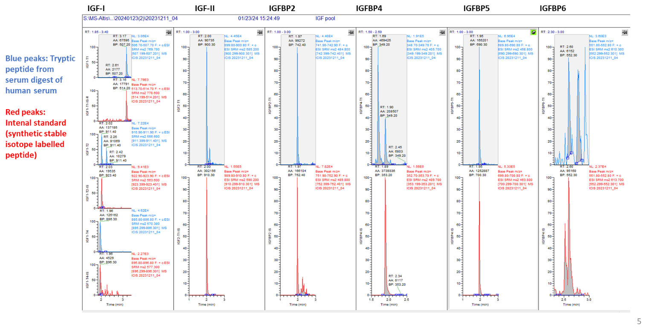

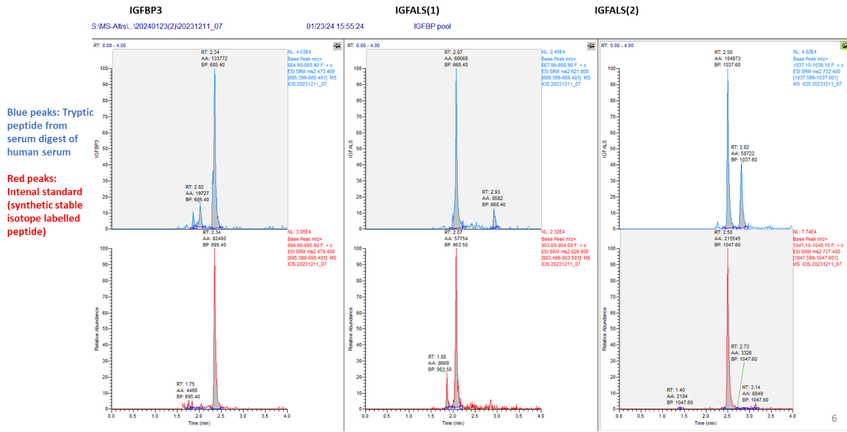

# Supplementary data 5 – Posttranslational modifications

List of known post-translational modifications (PTMs) on IGF proteins.

The tryptic peptides that were selected for targeted proteomics is provided above each table.

IGF-I, tryptic peptide: GPETLCGAELVDALQFVCGDR, Residues 49-69

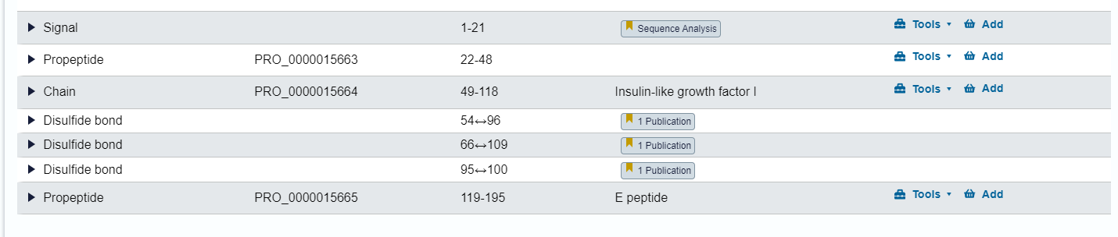

IGF-II, tryptic peptide: GIVEECCFR, Residues 65-73   
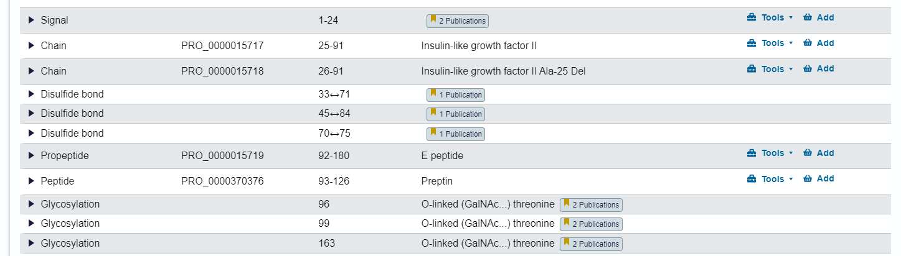

IGFBP2, tryptic peptide: LIQGAPTIR, Residues 293-301

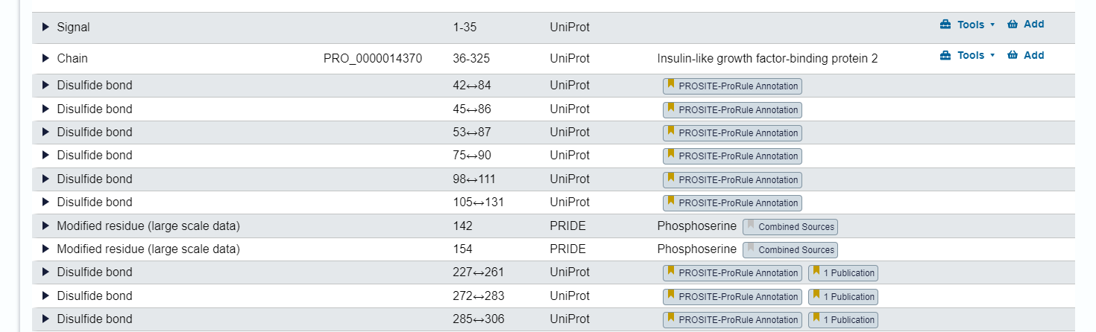

IGFBP3, tryptic peptide: FLNVLSPR, Residues 226- 233

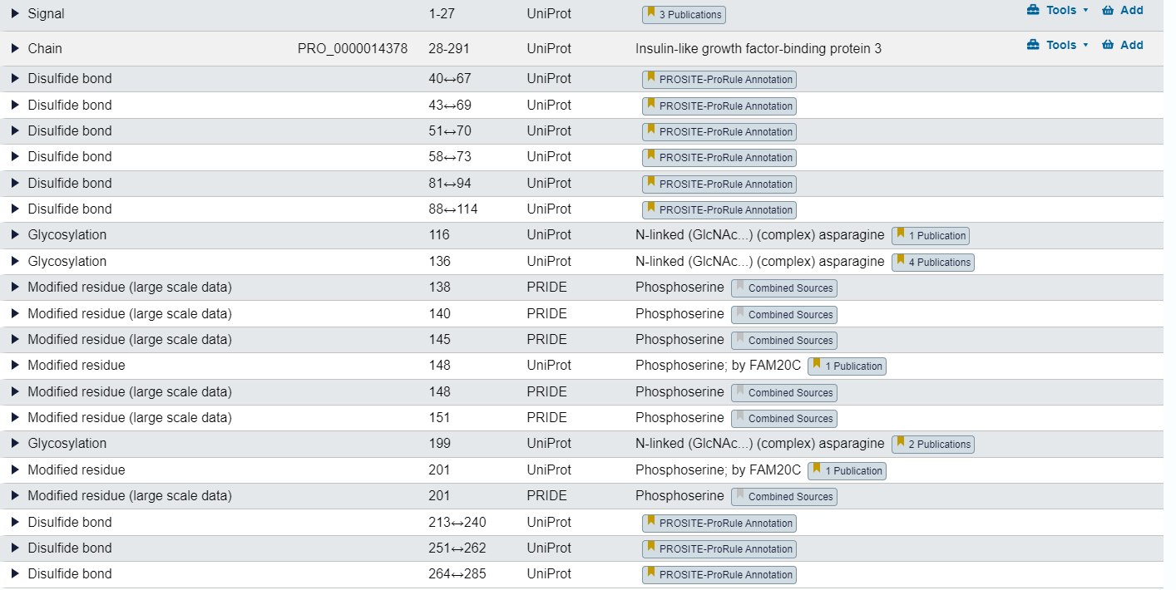

IGFBP4, tryptic peptide: LPGGLEPK, Residues 237-244

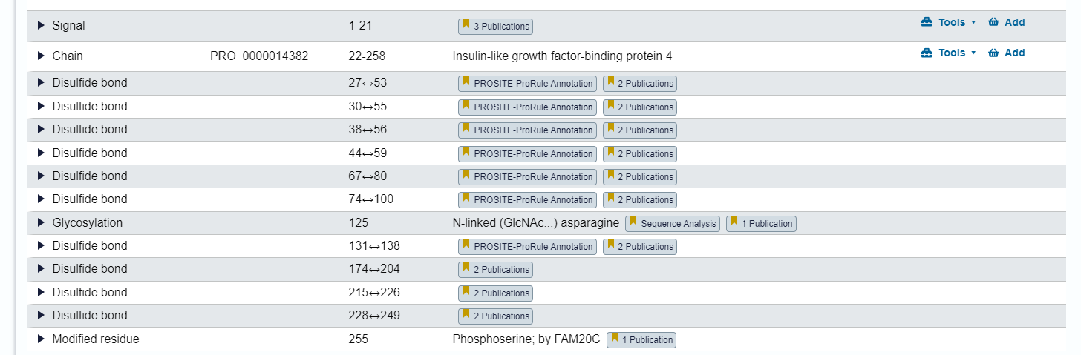

IGFBP5, tryptic peptide: IISAPEMR, Residues 177-184

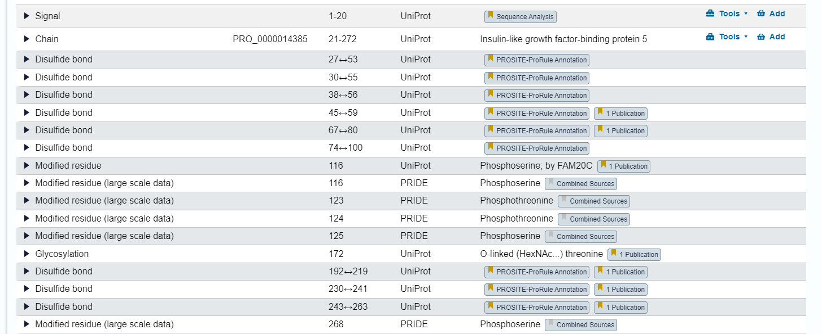

IGFBP6, tryptic peptide: HLDSVLQQLQTEVYR, Residues 166-180

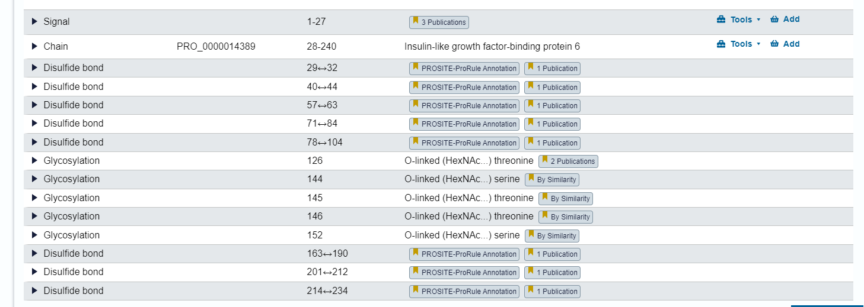

IGFALS, tryptic peptide: LAELPADALGPLQR, Residues 470-483

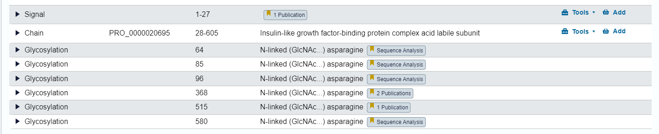

# Supplementary data 6 – DIA proteomics of IGFBP3 and IGFALS

The tryptic peptide used for targeted proteomics of IGFBP3 (FLNVLSPR) was confidently identified in all 44 samples by DIA proteomics profiling (LC-MS/MS-based sequencing, see supplementary data 11 for method description). There was close correlation (R>0.8) between the concentration of IGFBP3 measured by targeted proteomics and the peak area detected by DIA proteomics analysis (below left).

The tryptic peptide used for targeted proteomics of IGFALS (LAELPADALGPLQR) was confidently identified in all 44 samples by DIA proteomics profiling (LC-MS/MS-based sequencing). There was significant correlation (R>0.3) between the concentration of IGFALS measured by targeted proteomics and the peak area detected by DIA proteomics analysis (below right).

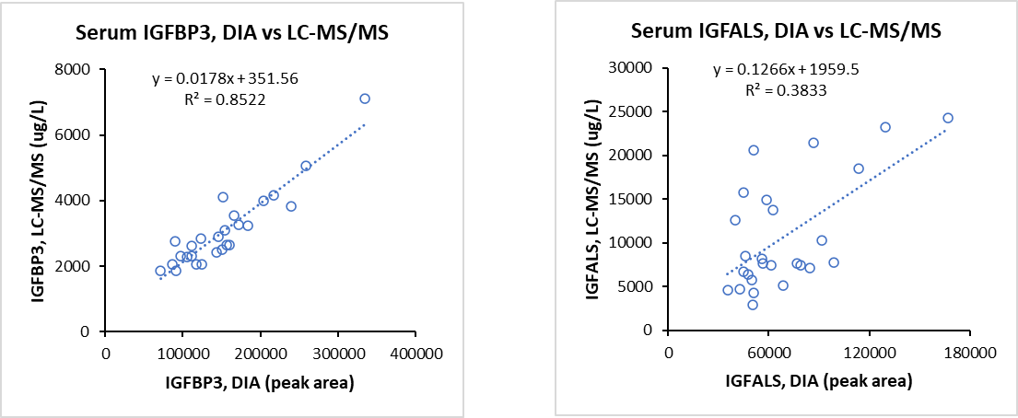

# Supplementary data 7 – Method ranges and standards

|  |  |  |  |  |  |  |  |
| --- | --- | --- | --- | --- | --- | --- | --- |
|  | **Normal range (expected) (µg/L)** | **Assay Linear range (µg/L)** | **Standards (µg/L)** | | | | |
|  | **S0** | **S1** | **S2** | **S3** | **S4** |
| **IGF-I** | 10-1200 | LOD - 1200 | 0.0 | 120.0 | 300.0 | 450.0 | 600.0 |
| **IGF-II** | 250-1000 | LOD-1000 | 0.0 | 100.0 | 250.0 | 375.0 | 500.0 |
| **IGFBP2** | 40-250 | LOD - 500 | 0.0 | 50.0 | 125.0 | 187.5 | 250.0 |
| **IGFBP3** | 80-8000 | LOD - 12000 | 0.0 | 2000.0 | 4000.0 | 6000.0 | 8000.0 |
| **IGFBP4** | 120-270 | LOD - 400 | 0.0 | 40.0 | 100.0 | 150.0 | 200.0 |
| **IGFBP5** | 200-400 | LOD - 600 | 0.0 | 60.0 | 150.0 | 225.0 | 300.0 |
| **IGFBP6** | 150-250 | LOD - 500 | 0.0 | 50.0 | 125.0 | 187.5 | 250.0 |
| **IGFALS** | 15-12000 | LOD -20000 | 0.0 | 2500.0 | 5000.0 | 7500.0 | 10000.0 |

# Supplementary data 8 –Signal suppression of internal standards with digestion time.

The figures show the peak areas of the internal standards (IS) (isotopic labelled tryptic peptides) for IGF-II, IGFBP2, 4, 5 and 6 as a function of digestion time. The IS peptides are spiked in serum and the peak areas are relatively high at the onset and decrease after a few minutes of trypsin digestion. The observations correspond with the commonly held view that the analytical sensitivity of shot-gun proteomics is undermined by the digestion of high abundant plasma proteins (i.e. albumin) that produce many highly abundant tryptic peptides that suppress the signal of all peptide ions in the low mass range.

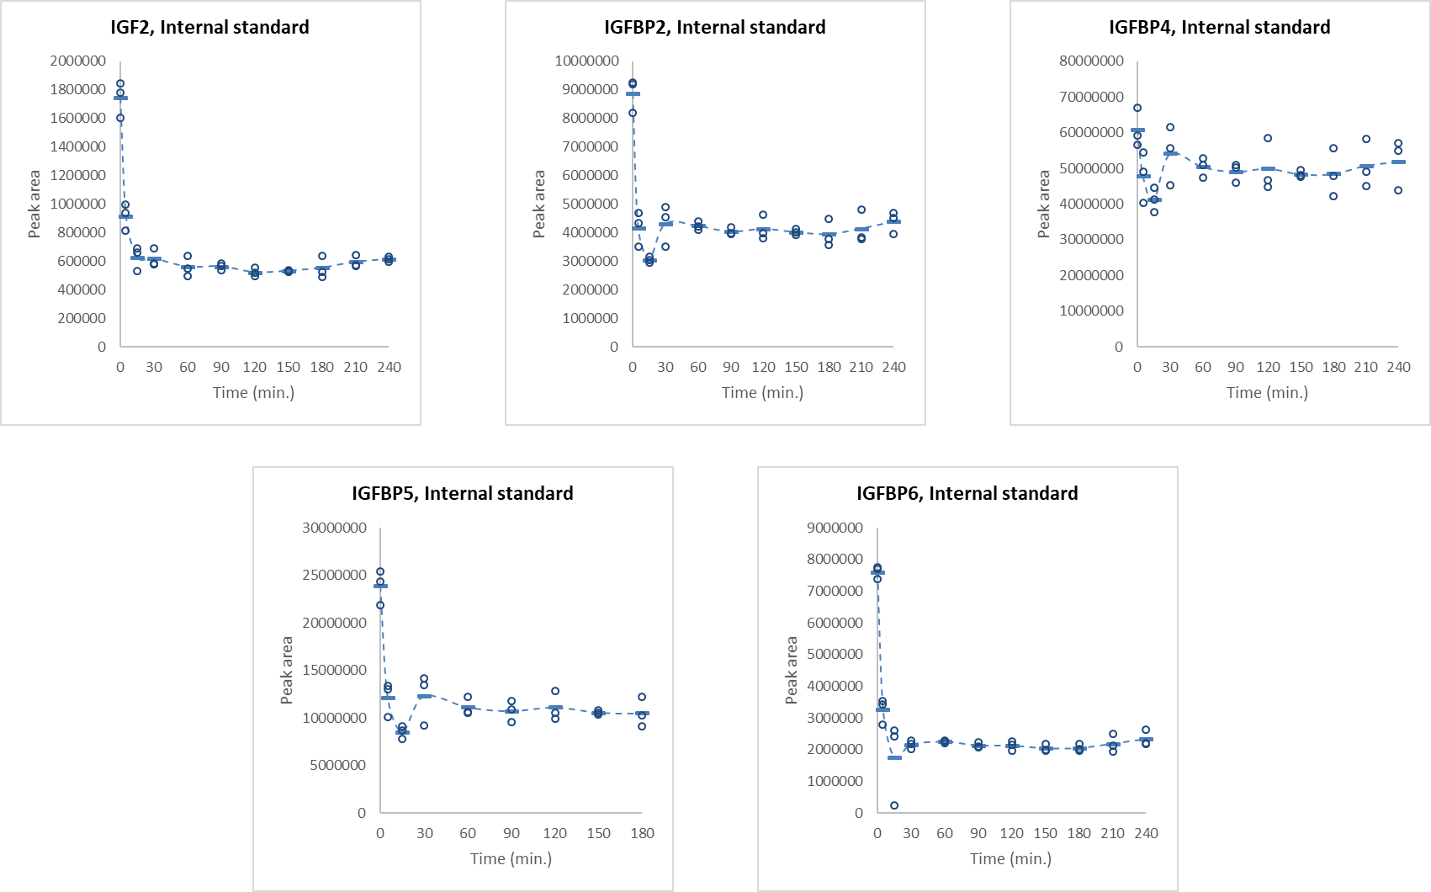

# Supplementary data 9 – WHO standards for IGF-I, IGF-II and IGFBP3

|  |  |  |  |
| --- | --- | --- | --- |
|  |  |  |  |
| **IGF-I: Targeted proteomics versus WHO standards** | | | |
| WHO IGF-I standard 02/254, 8500 | Expected (µg/L) | Measured (µg/L) | Difference (%) |
| Dilution x 10 | 850.0 | 903.4 | 5.9 |
| Dilution x 5 | 1700.0 | 1834.0 | 7.3 |
|  |  | **Mean difference(%)** | **6.6** |
|  |  |  |  |
|  |  |  |  |
| **IGF-II: Targeted proteomics versus WHO standards** | | | |
| WHO IGF-II standard 96/538 , 5000 µg/L | Expected (µg/L) | Measured (µg/L) | Difference (%) |
| Dilution x 10 | 500.0 | 494.0 | -1.2 |
| Dilution x 5 | 1000.0 | 956.7 | -4.5 |
|  |  | **Mean difference(%)** | **-2.85** |
|  |  |  |  |
|  |  |  |  |
| **IGFBP3: Targeted proteomics versus WHO standards** | | | |
| WHO IGFBP3 standard 93/560 , 5000 µg/L | Expected (µg/L) | Measured (µg/L) | Difference (%) |
| Dilution x 10 | 3500.0 | 1108.0 | -215.9 |
| Dilution x 5 | 7000.0 | 2917.0 | -247.1 |
|  |  | **Mean difference(%)** | **-231.5** |
|  |  |  |  |

# Supplementary data 10 – Targeted proteomics of IGF proteins in children

A total of 289 serum samples from healthy Danish boys and girls were measured by targeted proteomics. Below the concentration (µg/L) of IGF proteins is plotted as a function of age.

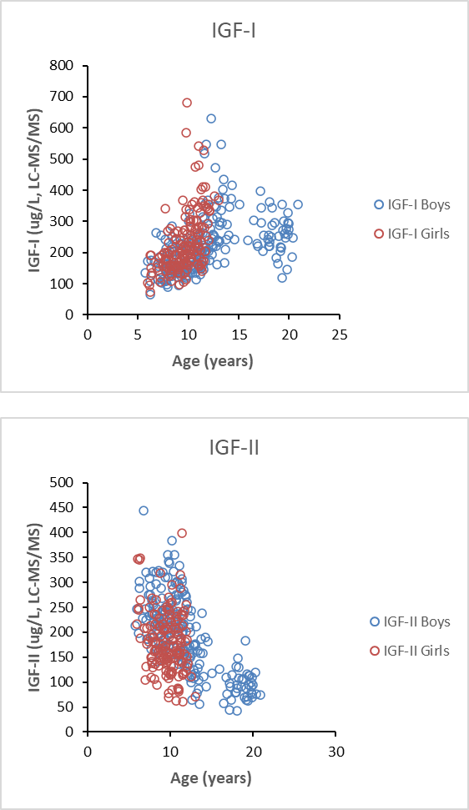

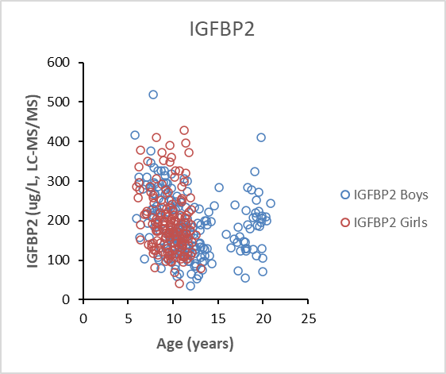

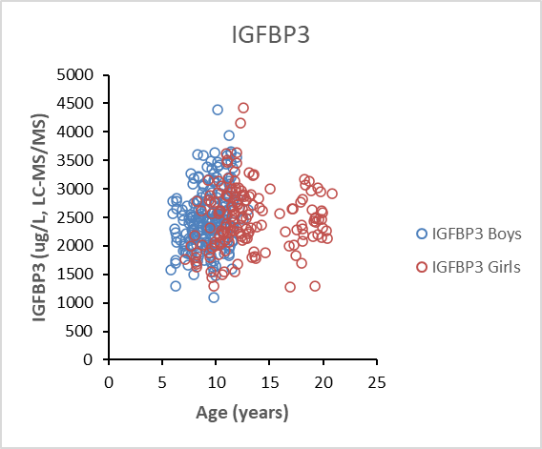

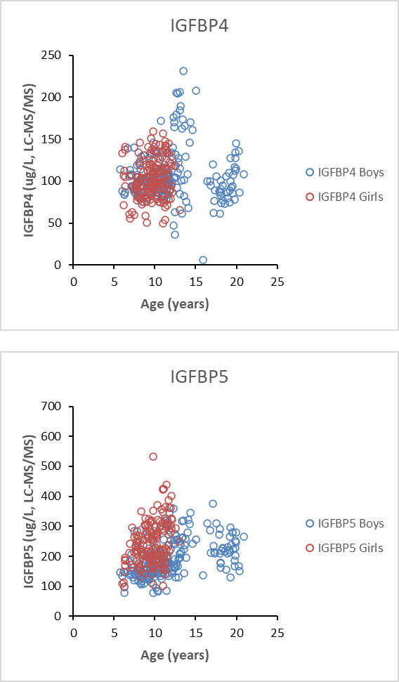

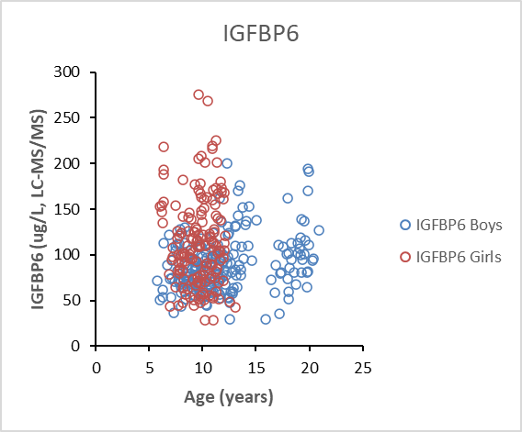

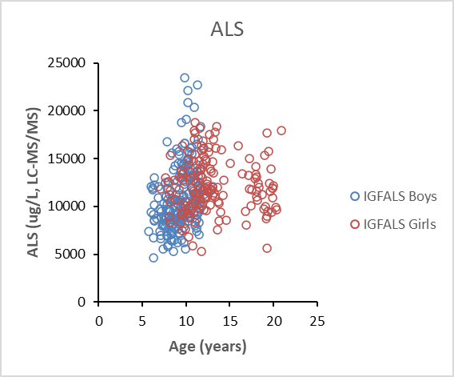

# Supplementary data 11 – Proteomics profiling of serum

**Protein digestion and Evotips loading for proteomics profiling**

Sample preparation was performed on an Agilent Bravo Liquid Handling Platform according to the previously published method described in (Geyer et al. 2016). Briefly, serum amples were aliquoted into a 96-well format plate and introduced to the Bravo Robot. Each serum sample was diluted 1:10 with the PreOmics Lysis buffer (P.O. 00001, PreOmics GmbH) and 20 µl of the dilution was incubated at 95 °C for 10 min in order to denature proteins, reduce disulfide bridges and alkylate cysteines (Kulak et al. 2014). After cooling the sample for 15 min at room temperature, trypsin and LysC were added in a ratio of 1 µg enzyme to 100 µg proteins and the mixture incubated at 37°C for 4 h. The enzymatic reaction was quenched by the addition of 64 µl of 0.2% TFA and the samples were loaded onto Evotips (Evosep Biosystem, Denmark) according to the manufacturer’s recommendations. The Evotips were wetted with isopropanol for 5 min, activated with 20 µl solvent B (99% ACN, 0.1% FA) and centrifuged at 700 x g for 1 min. 20 µl of buffer A was then added to equilibrate the tips followed by sample loading. Finally, 20 µl Buffer A was used to wash the Evotip and 100 µl was added to avoid drying.

**Proteomics profiling by liquid chromatography and mass spectrometry analysis**

The samples were injected to an Exploris 480 Thermo Fischer Scientific system using an Evosep One instrument (Evosep Biosystem). A preset chromatographic method was used corresponding to 60 samples per day**.** The peptides were separated on an 8 cm Pepsep (Marslev, Denmark) column (100 μm ID/3 μm bead size Reprosil-Pur C18 beads) at 1 μL/min flow rate with a 21 min gradient. The heated capillary temperature was set to 275, the spray voltage to 2650 V and the funnel radiofrequency to 40. The mass spectrometer was operated in a data-independent mode (DIA) with a full MS range from 350 to 1650 at a resolution of 60000 at 200 m/z. The AGC target was set to 300 % with an injection time of 50 ms. The AGC value of the targeted MS2 experiment was set to 1000%. Thirty-two windows of variable sizes were defined for target MS2 (tMS2) acquisition and subjected to high-energy collisional dissociation (HCD) fragmentation with a normalized collision energy at 30%. Each tMS2 scan was acquired at a resolution of 30000 with a maximum ion injection time (IT) of 100 ms for a scan range of m/z 349.5 to 1650.5.

**Data analysis of proteomics profiles**

The MS raw files were processed with Spectronaut version 15 (Biognosys, Zurich, Switzerland). A previously generated plasma spectral library was imported from (MaxQuant software analyses). The library contained 2137 protein groups and 16254 peptides. DIA files were searched against the library using default parameters except for the normalization which was set to local. Dynamic mass and retention time tolerances (for both MS1 and MS2) were applied. Qvalue cutoff was set to 1% both at precursor and protein level using a mutated decoy method (Bruderer et al. 2017). The calibration was performed based on a local regression model (Callister et al. 2006).

**Bioinformatic analysis of proteomics profiles**

Proteins data were exported from Spectronaut and loaded into the clinical knowledge graph (CKG) together with their matching experimental and clinical data.