**A physio-chemical mathematical model of the effects of blood analysis delay on acid-base, metabolite and electrolyte status: evaluation in blood from critical care patients.**

Bahareh Nevirian, Steen Kåre Fagerberg, Mette Krogh Pedersen, Søren Risom Kristensen, Kjeld Asbjørn Jensen Damgaard, Stephen Edward Rees, Lars Pilegaard Thomsen.

**Electronic supplementary material**

This electronic supplementary material includes additional data describing the following: the variability of measurements assessed from the two baseline values (figure ESM.1); the relationship between the rate of acid production ( $ΔAcid)$ and the rate of total CO2 loss () assumed to be due to diffusion across the syringe wall (figure ESM.2); a summary of the WRSS errors for model fit to each patient (figure ESM.3); and plots of all measured data and all model fits for each of the 30 patients studied. The details of each of these is presented below.

**Variability of baseline measurements.**

To understand the variability of the two measurements taken at baseline values, figure ESM.1 illustrates the Bland-Altman analysis of bias and LoA for paired baseline measurements of each variable across all measurements. For all variables, bias is close to zero. The standard deviations calculated from these analyses are presented in table 3 of the main paper, along with a discussion of the values.

Figure ESM.1: Bland-Altman analyses illustrating variation in the two baseline measurements for all measurements in each of the 30 patients. Outliers are indicated with arrows and values.

**Relationship between the rate of acid production ( $ΔAcid)$ and the rate of total CO2 loss ()**

As stated in the main paper, it is assumed in our model formulation that the degree of CO2 diffusion across the syringe wall is related to the acid production due to red blood cell metabolism. This is assumed to be due to the dissociation of bicarbonate on acid addition which is likely to result in values of PCO2 which remain high despite diffusion.

To evaluate this postulate, values of BE and total CO2 concentration in the whole blood were calculated from each blood sample using the model of Rees and Andreassen (figure 2 of the main paper). Changes in BE from baseline was assumed to be equivalent to acid addition ( $ΔAcid),$ and these were used to examine the relationship of this to changes in tCO2 from baseline ($Δ{tCO}_{2}$). The resulting relationship illustrated in figure ESM.2 appeared linear and close to the line of identity. The resulting linear equation is used in the model as described in the main text.



Figure ESM.2: The relationship between acid added to and total CO2 removed from whole blood.

**WRSS and goodness of model fit in all patients.**

Figure ESM.3 illustrates the WRSS for the best model fit for each patient partitioned by color to illustrate the error in fit to each variable. Horizontal lines indicate the expected level of WRSS due to measurement noise alone (i.e. E(WRSS) = 52) and the WRSS value associated with a p>0.1 cut off for chi-squared test, WRSS = 65. Twenty-nine of the 30 patients are below the p>0.1 cut-off indicating no evidence for difference between model fit and errors due to measurement error alone. The remaining patient data set is discussed in the main text.

Figure ESM.3: WRSS values for model fit to each patient according to each measurement. Horizontal line A illustrates E(WRSS) for measurement error, and line B chi-squared p>0.1 cut-off for model fit assessment.

**Raw data and model fits in all patients**

Figure ESM.4 illustrates baselines measurements (triangles), raw data (circles) and model fits (crosses) for all patients. Where the two baseline values lie on top of each other then this appears as a star in the figure. Outliers are indicated with arrows and values.

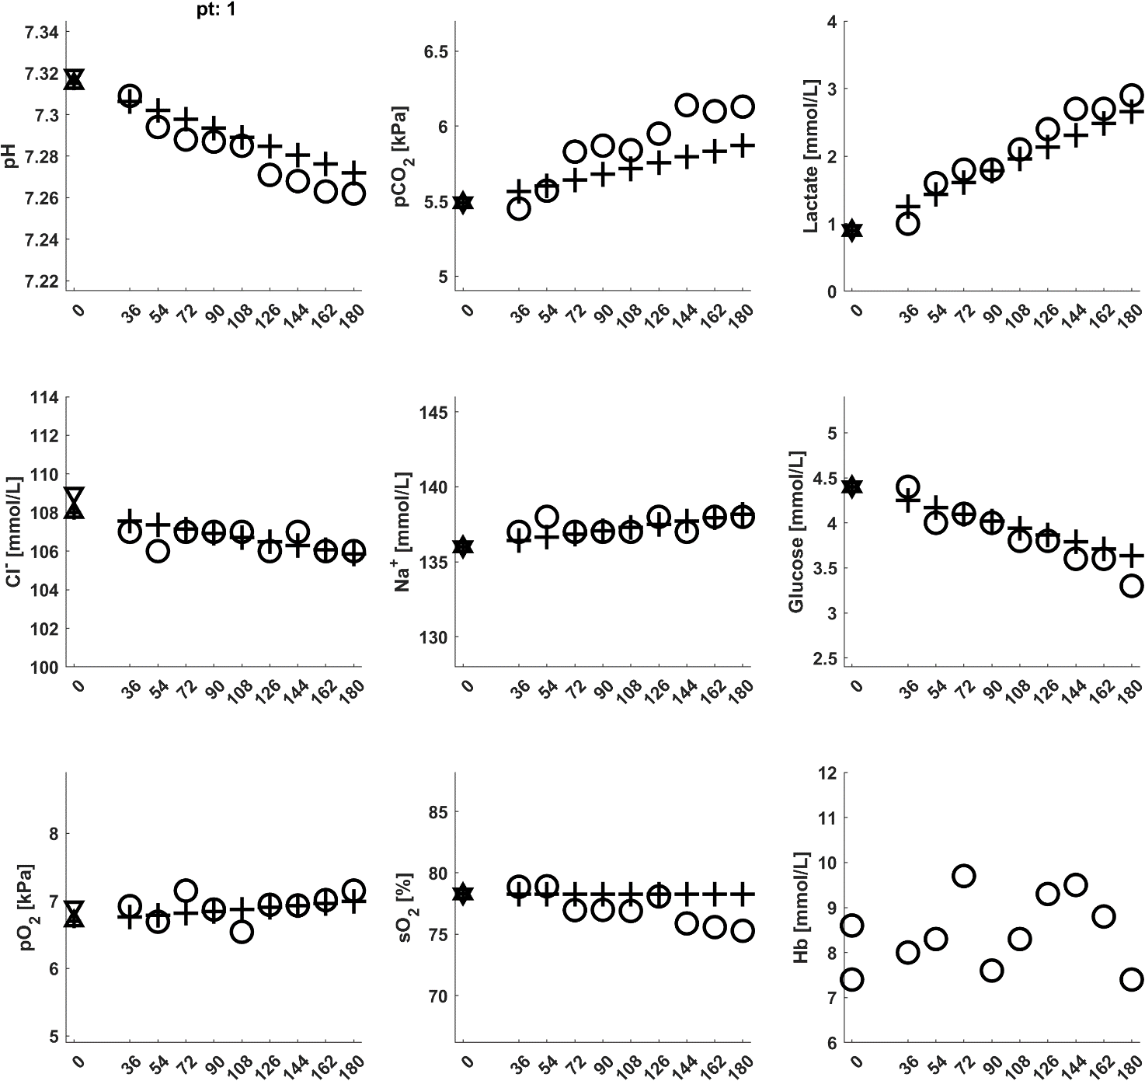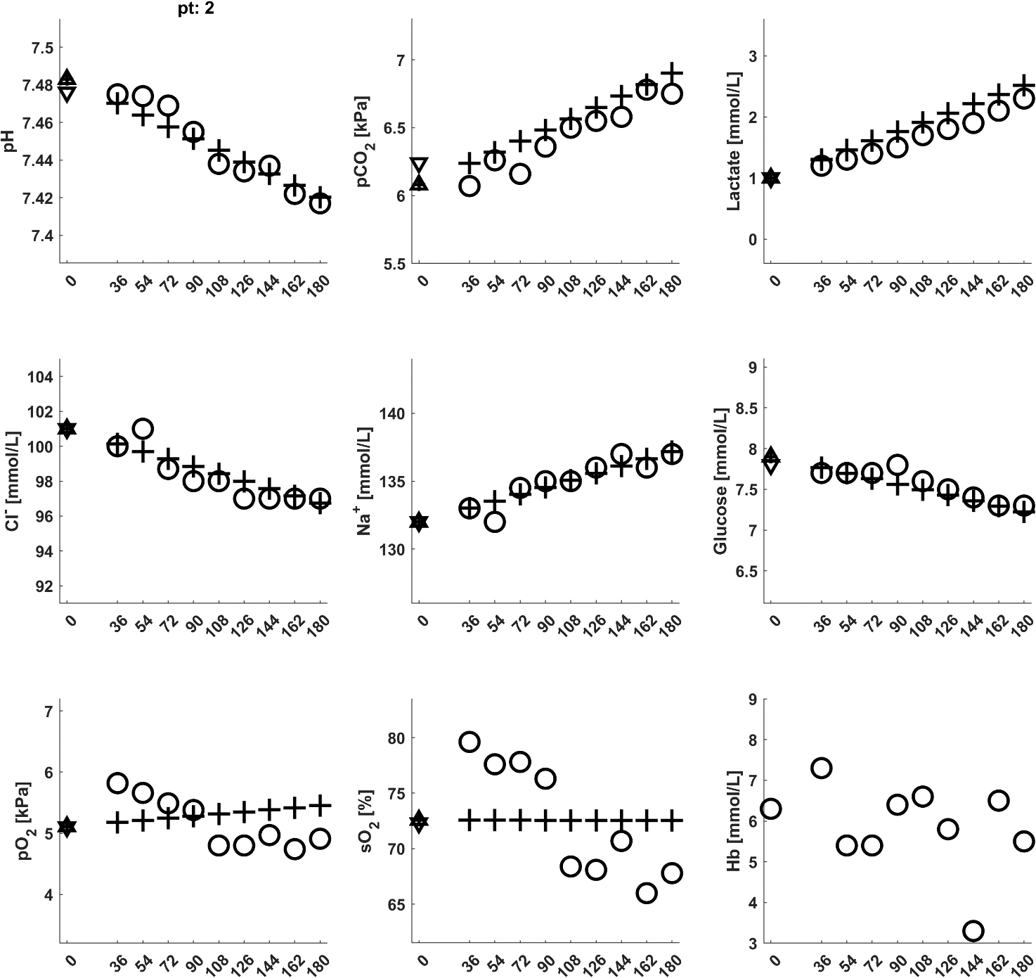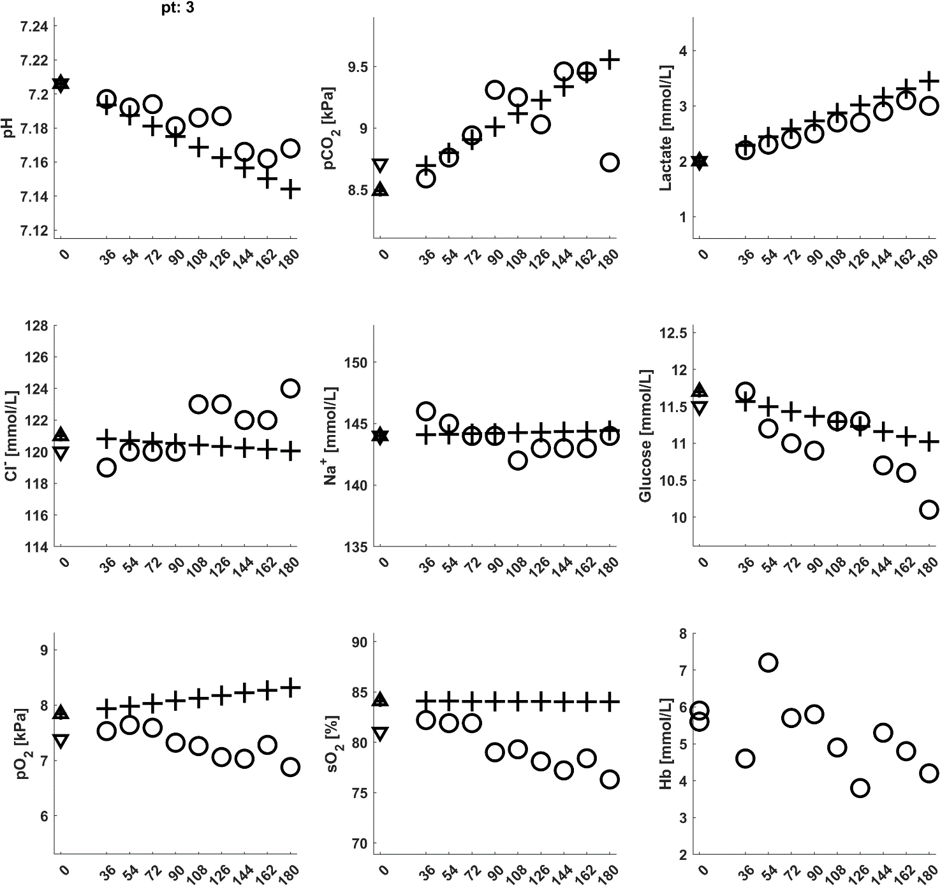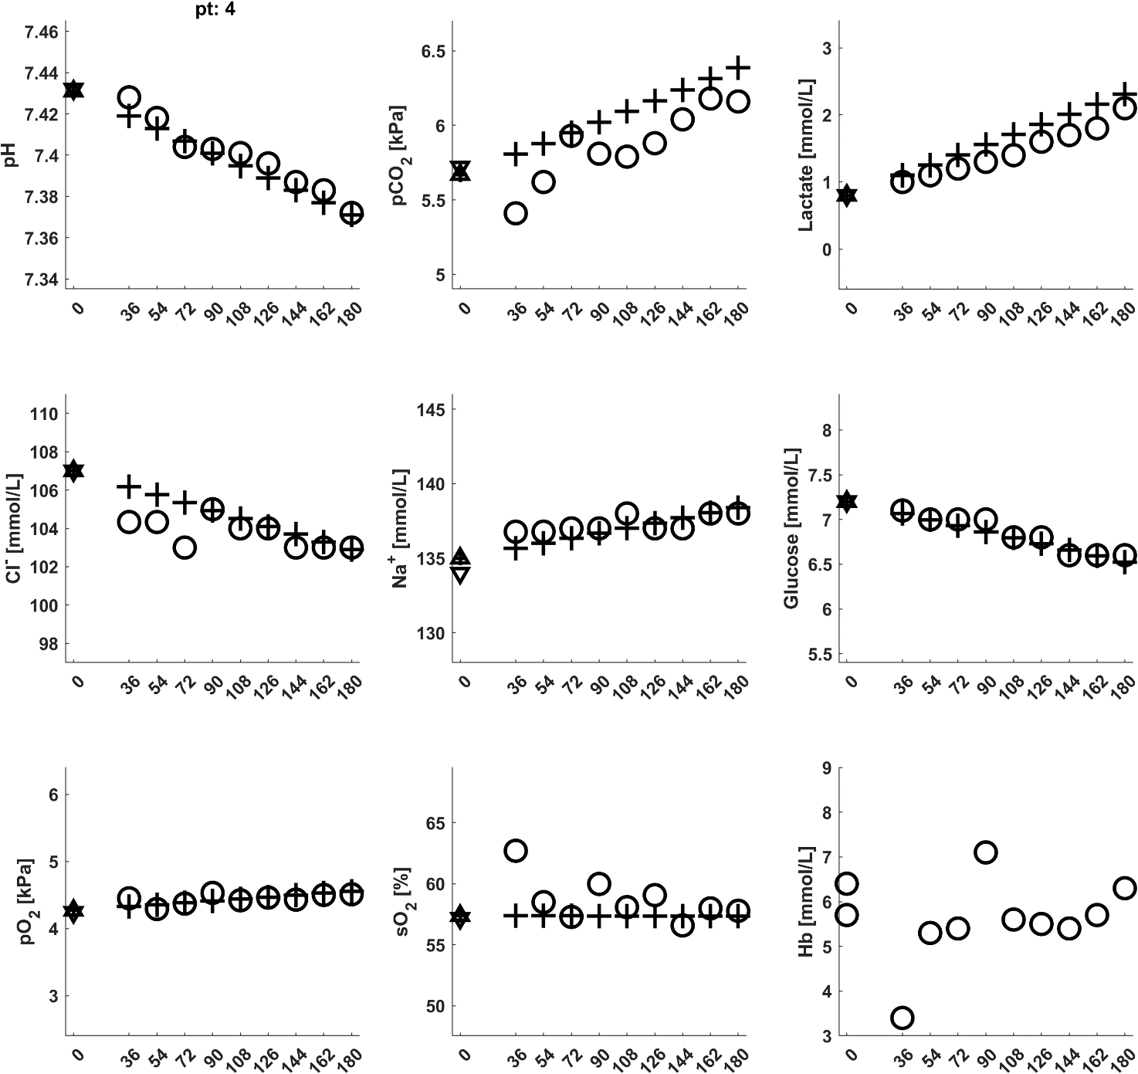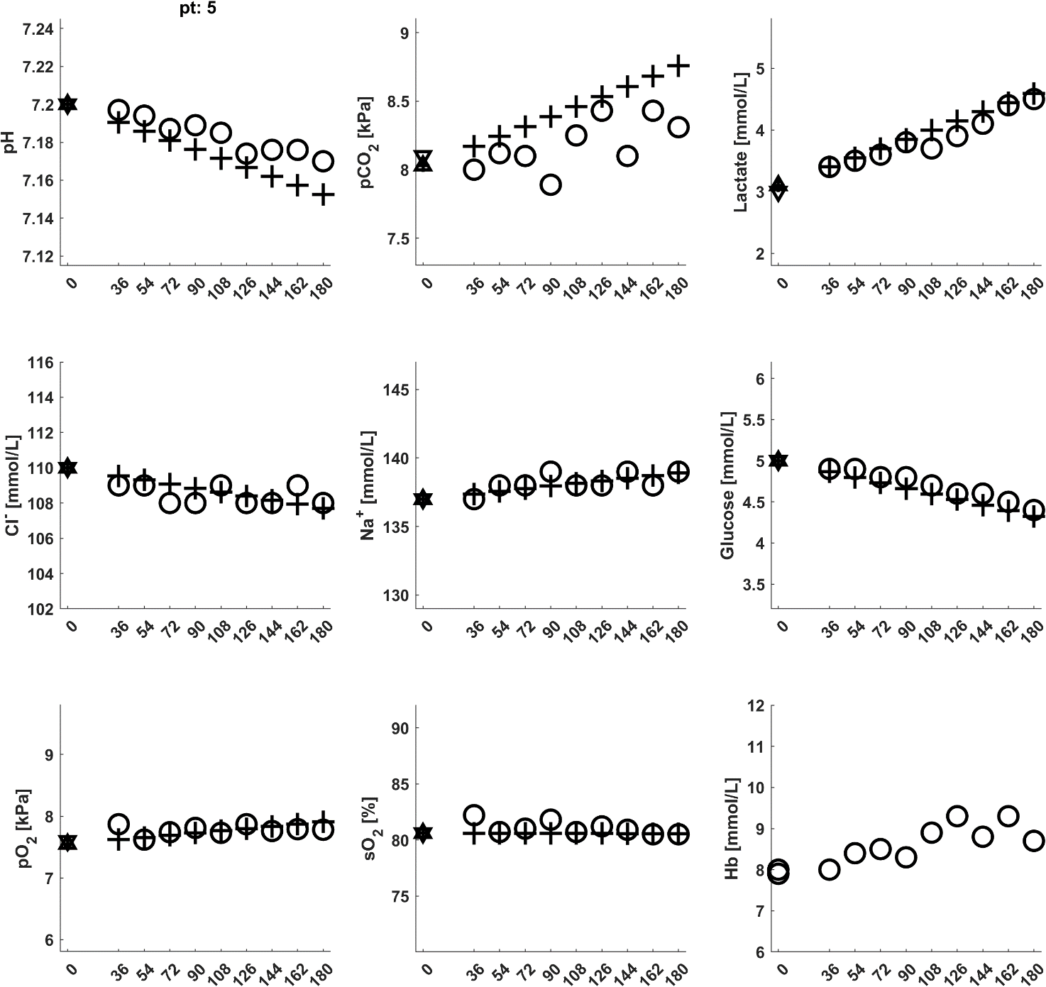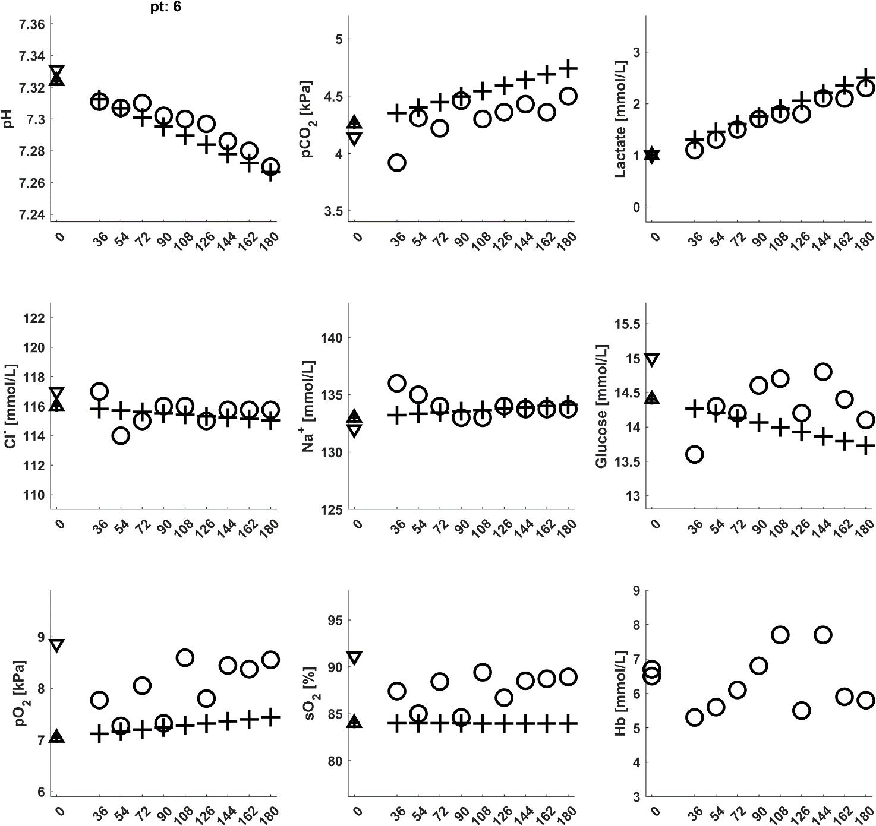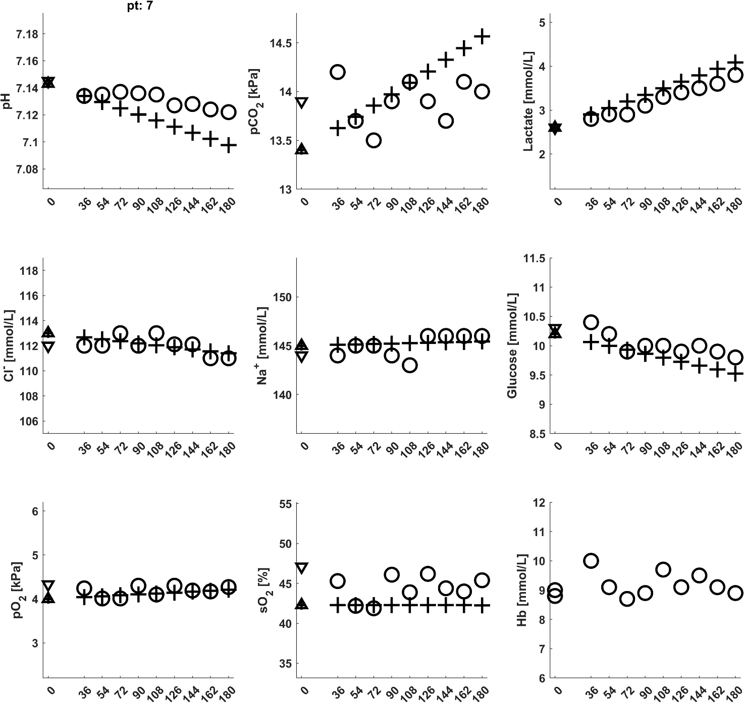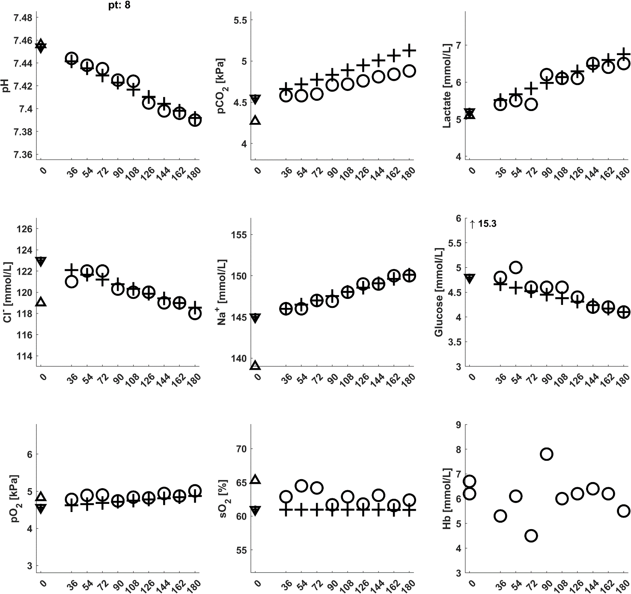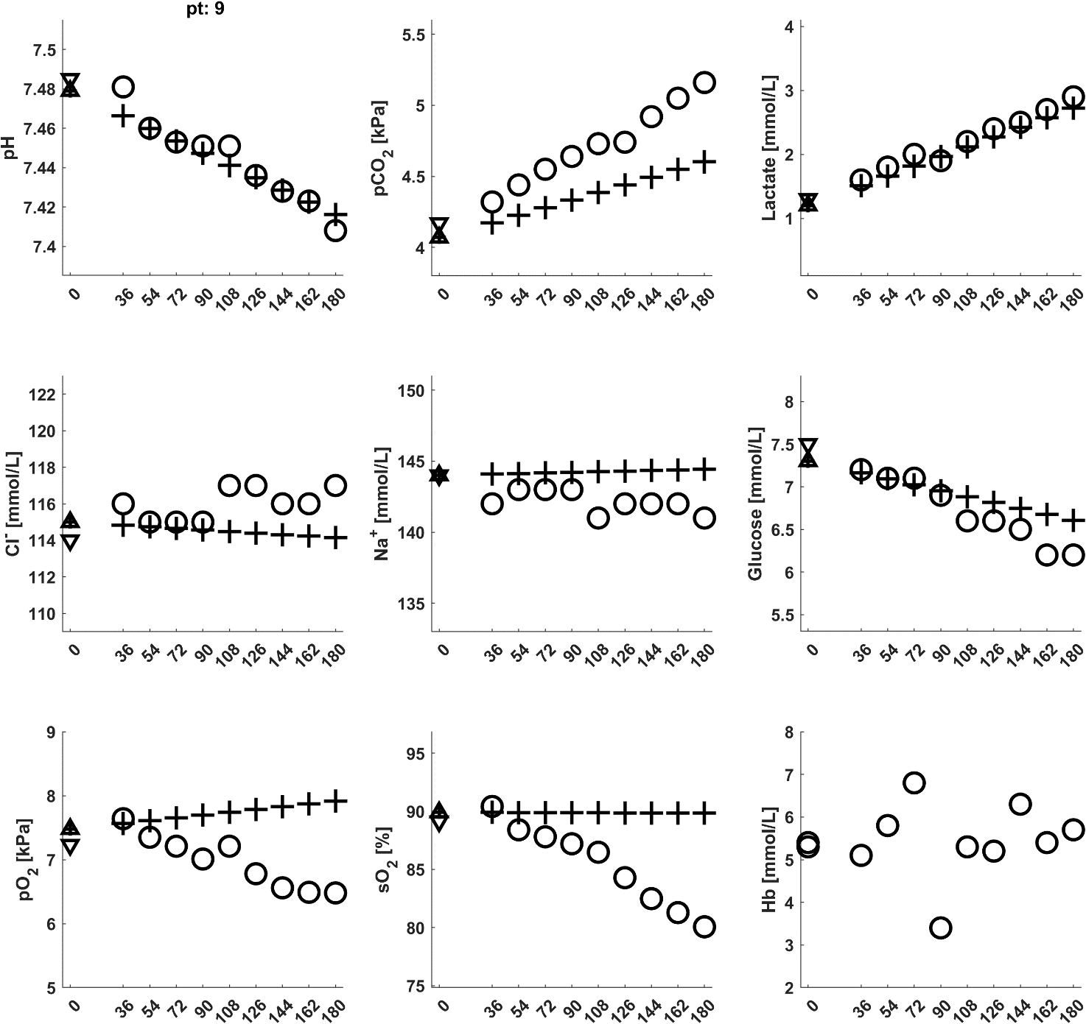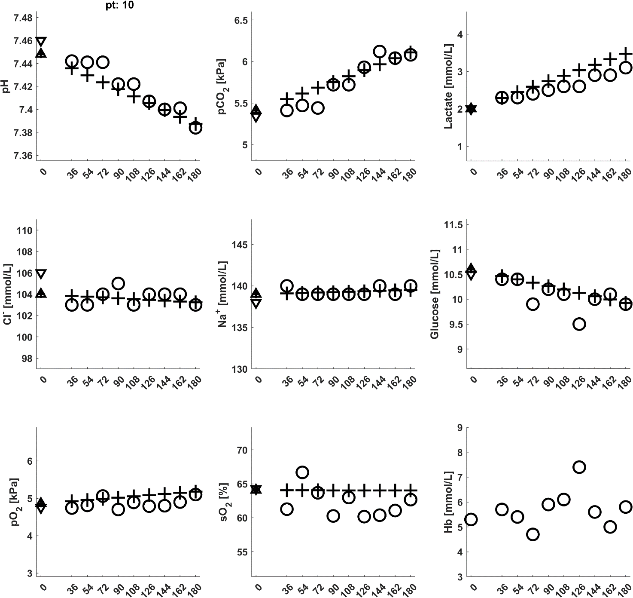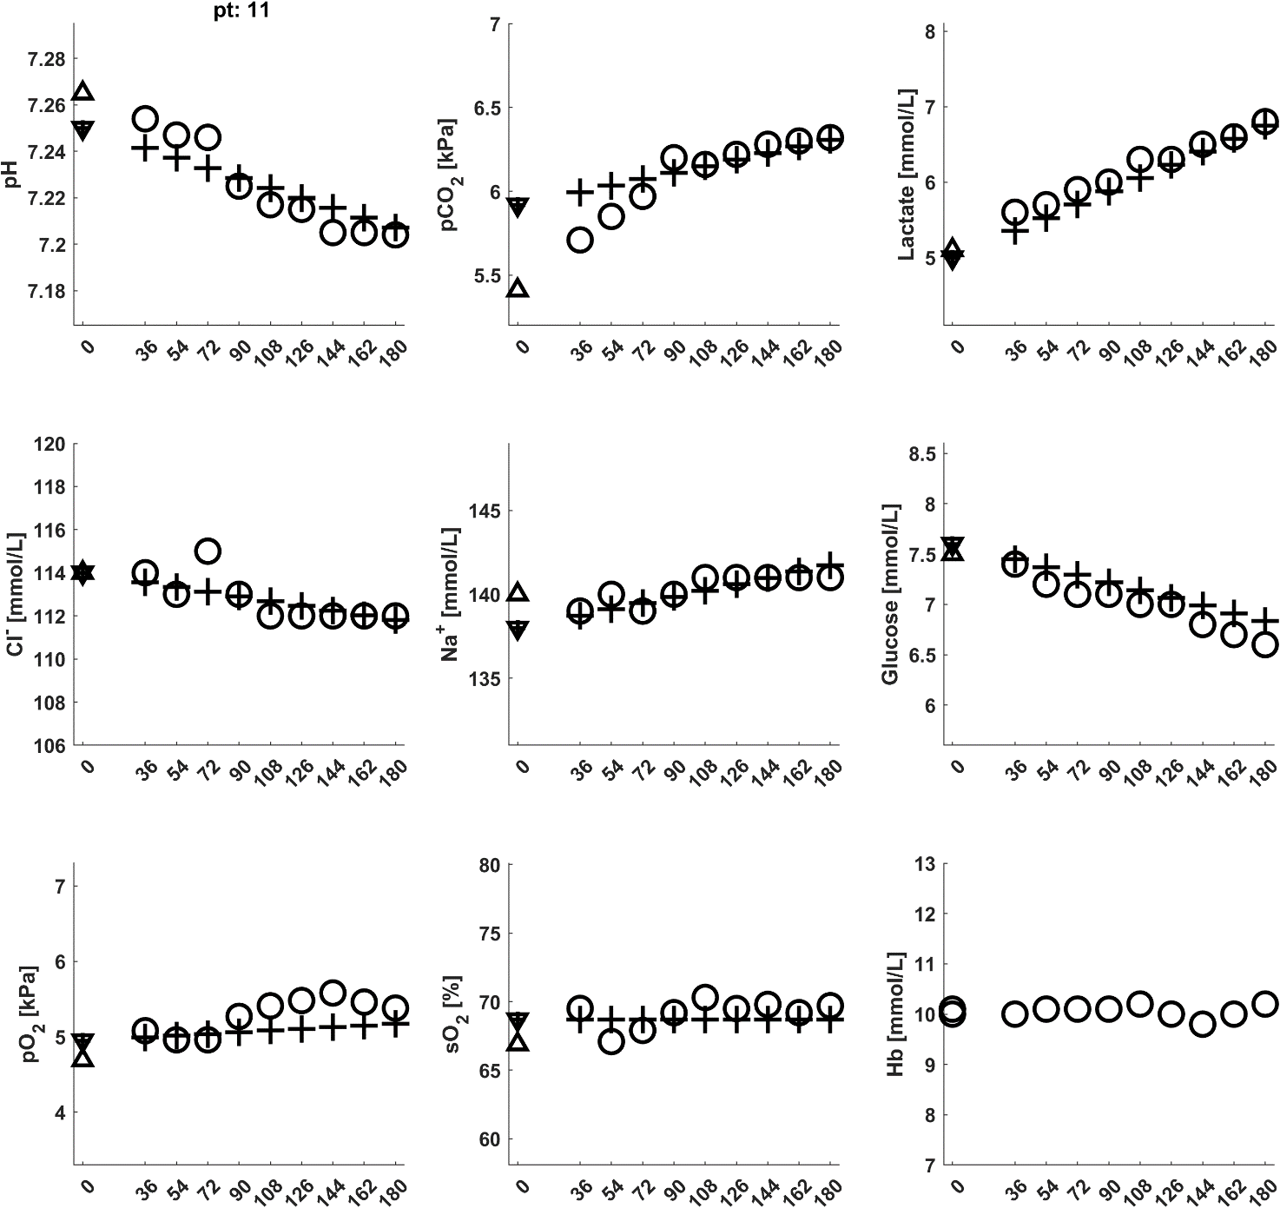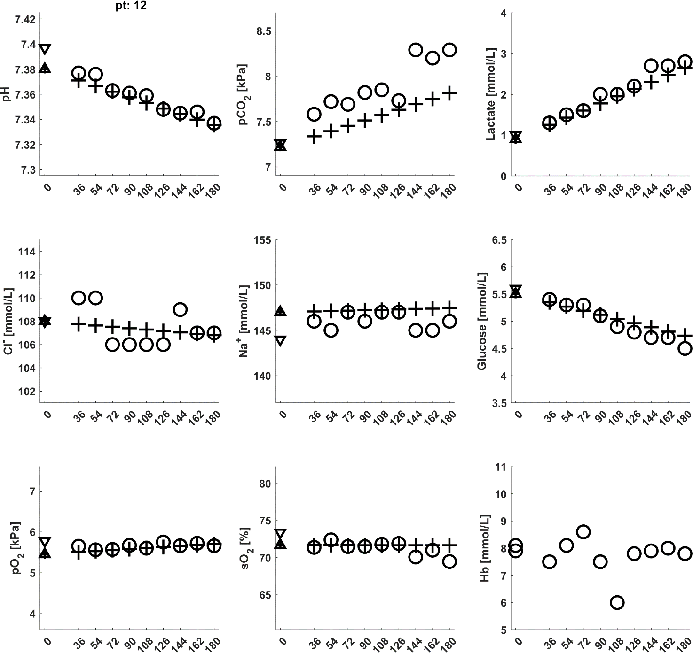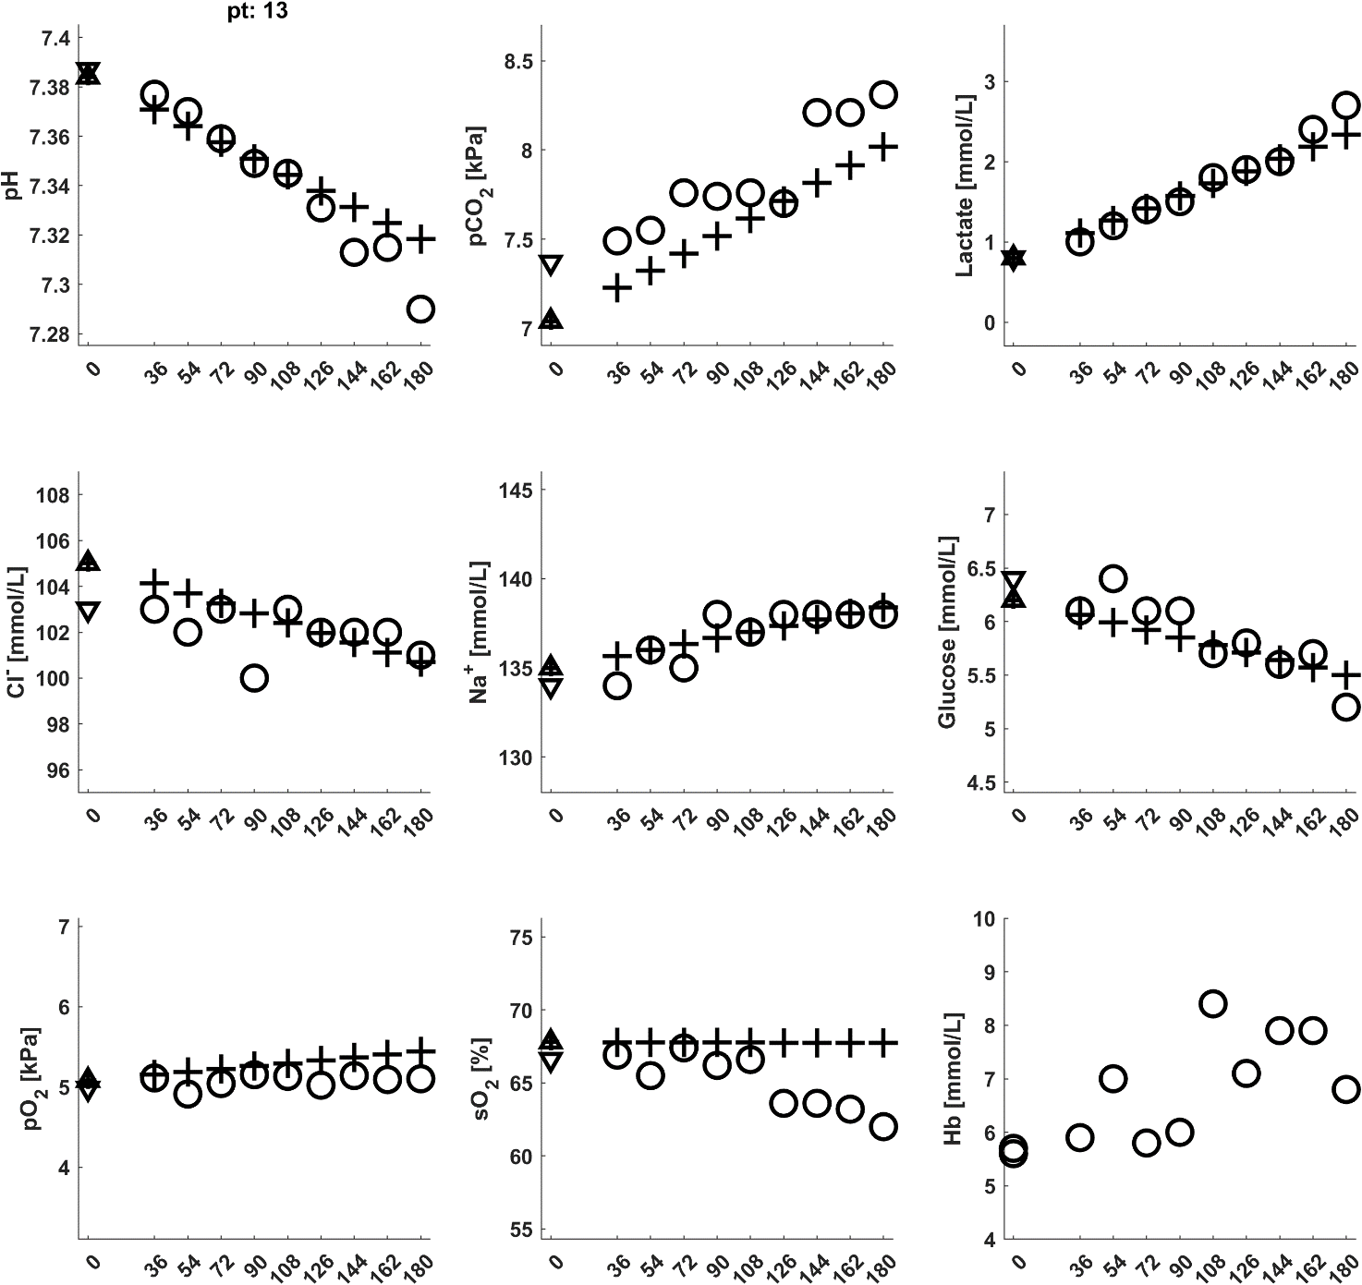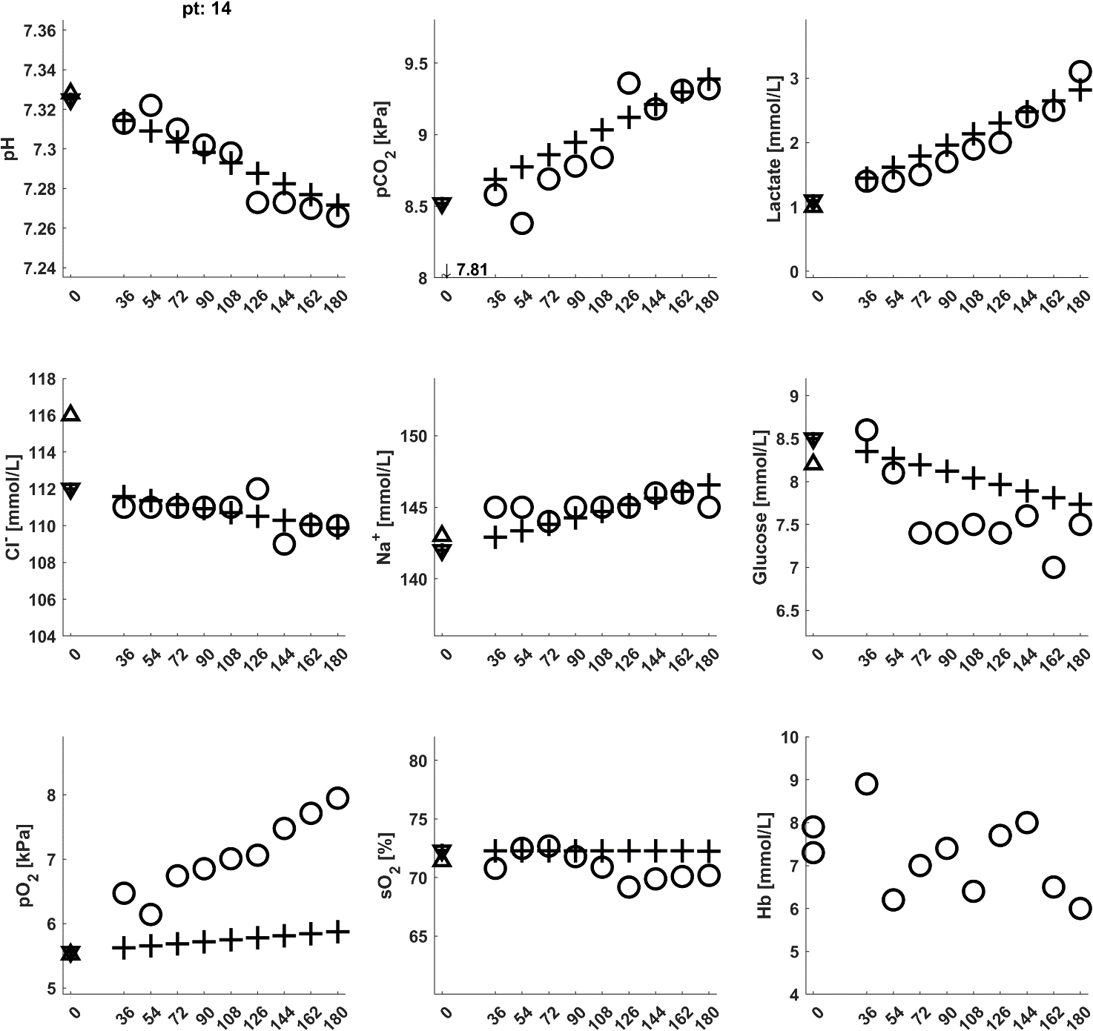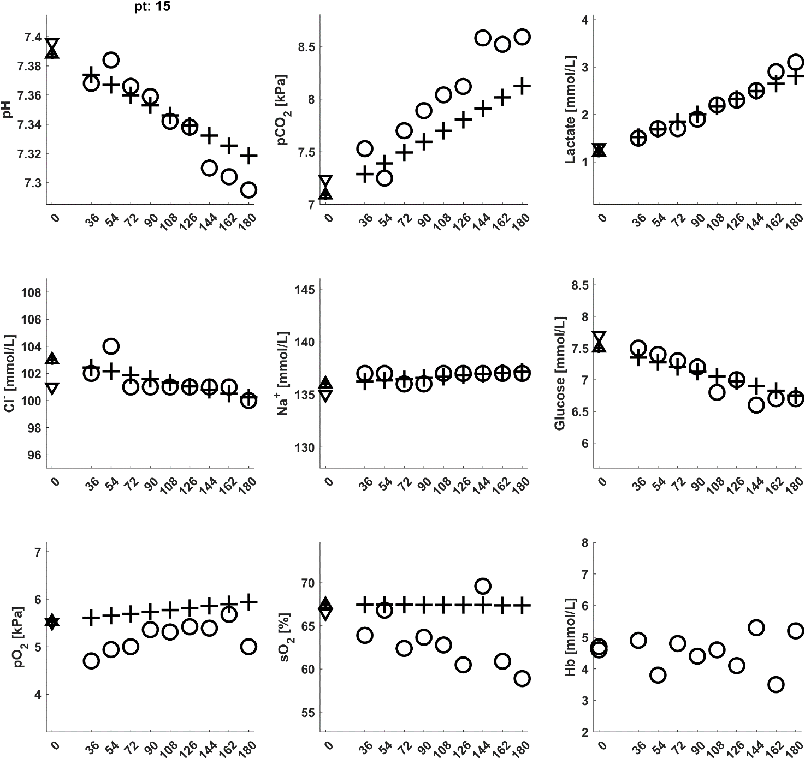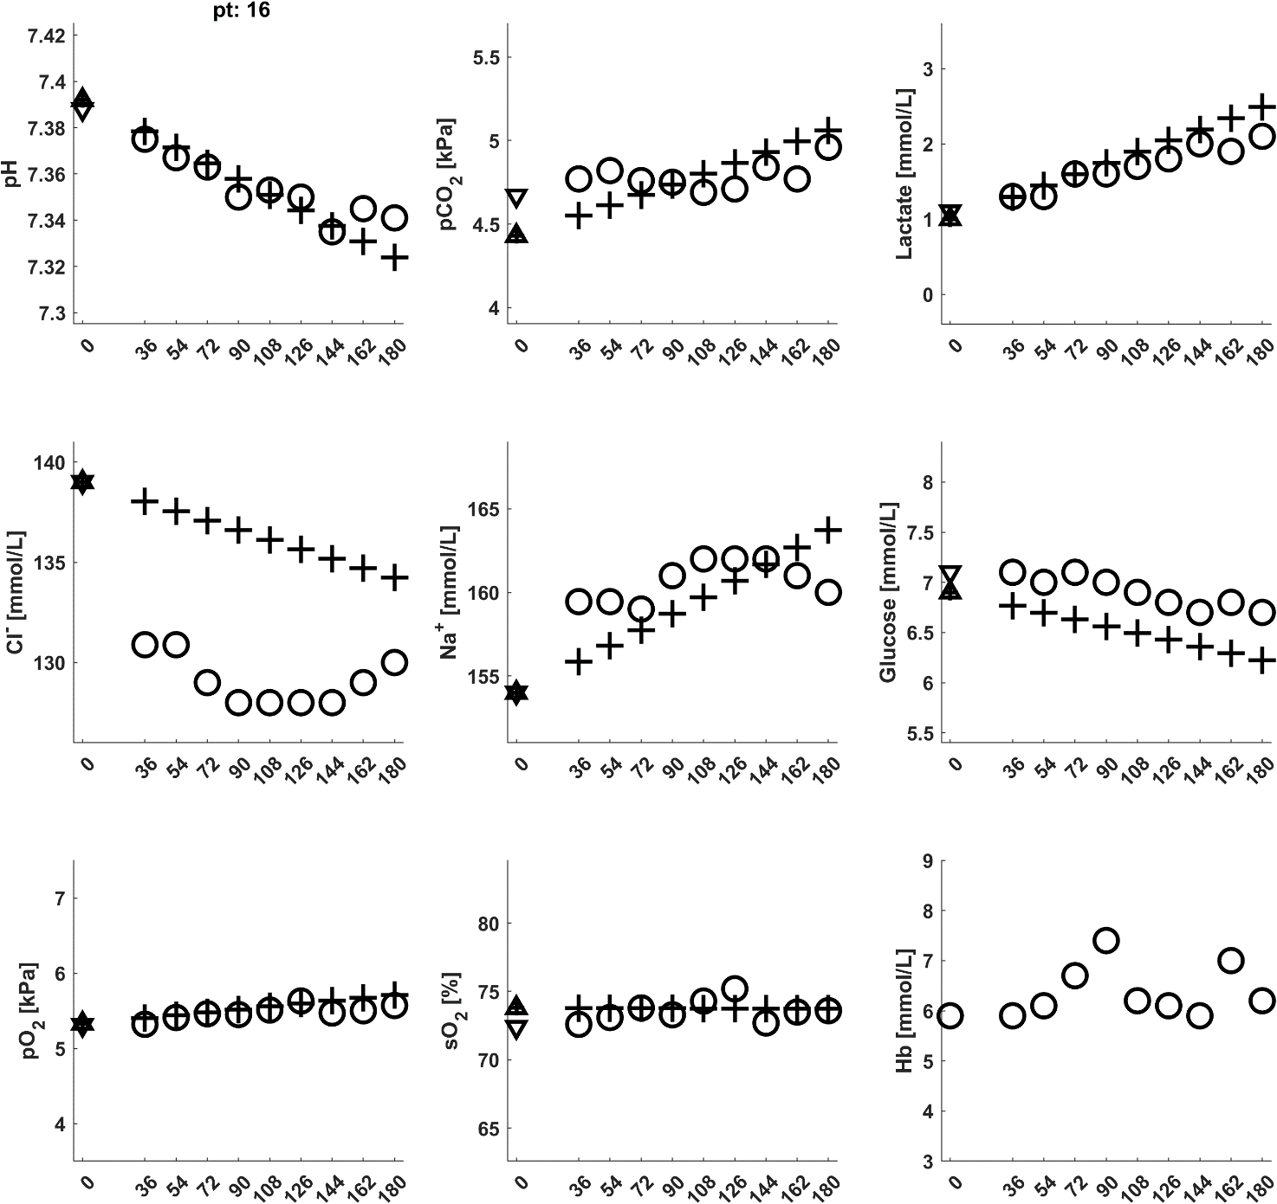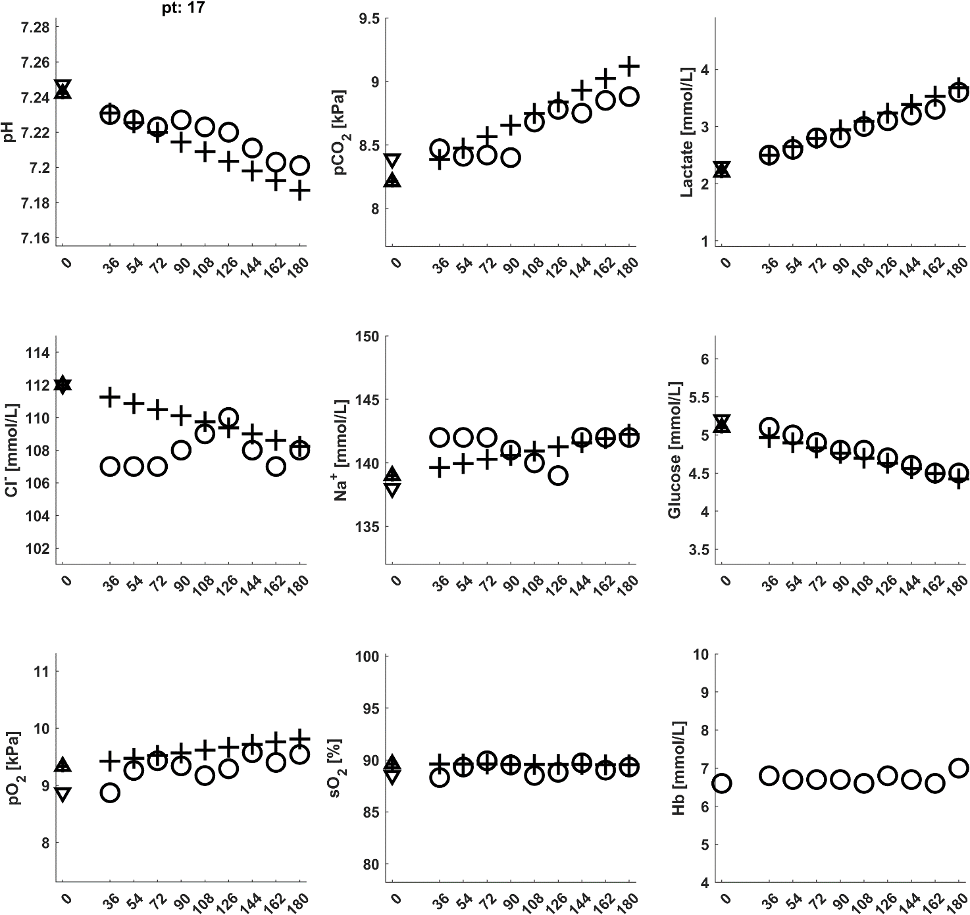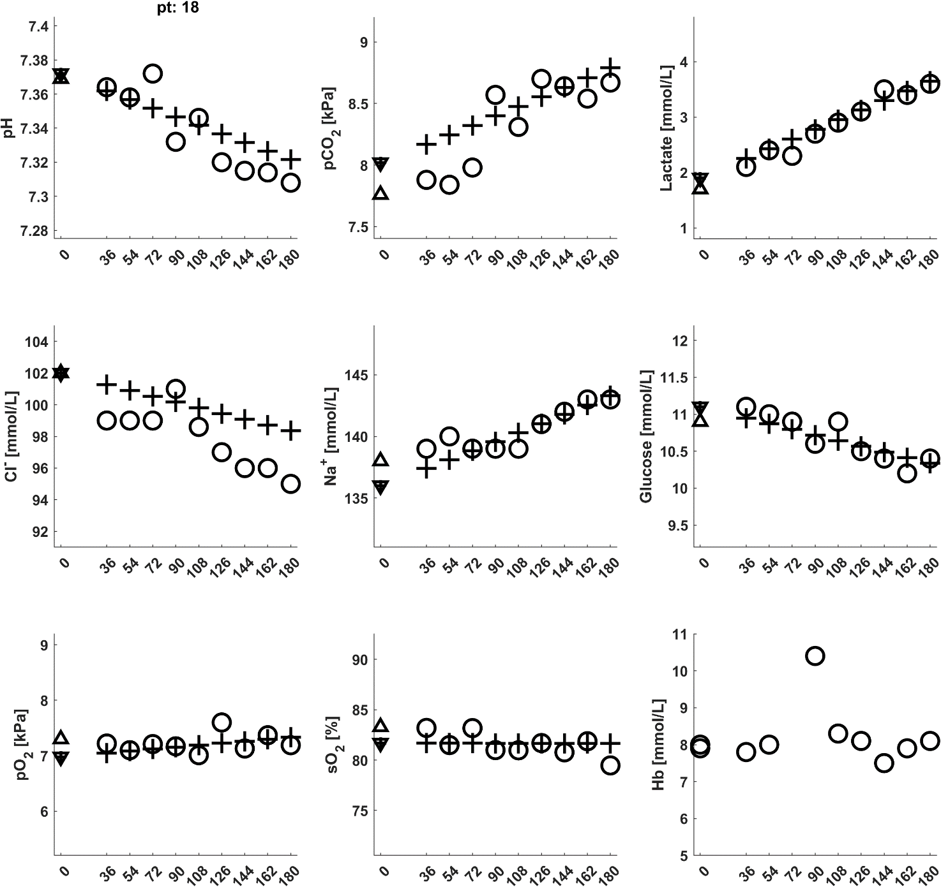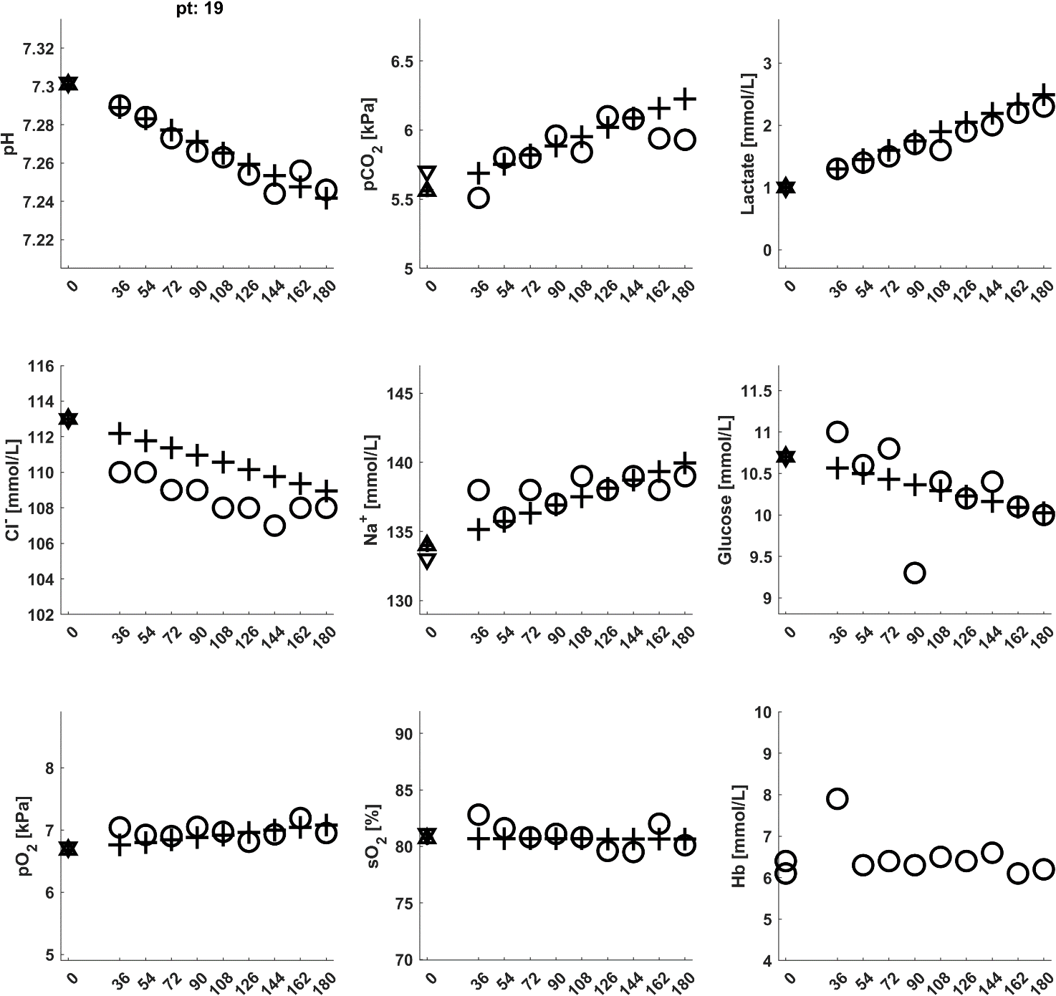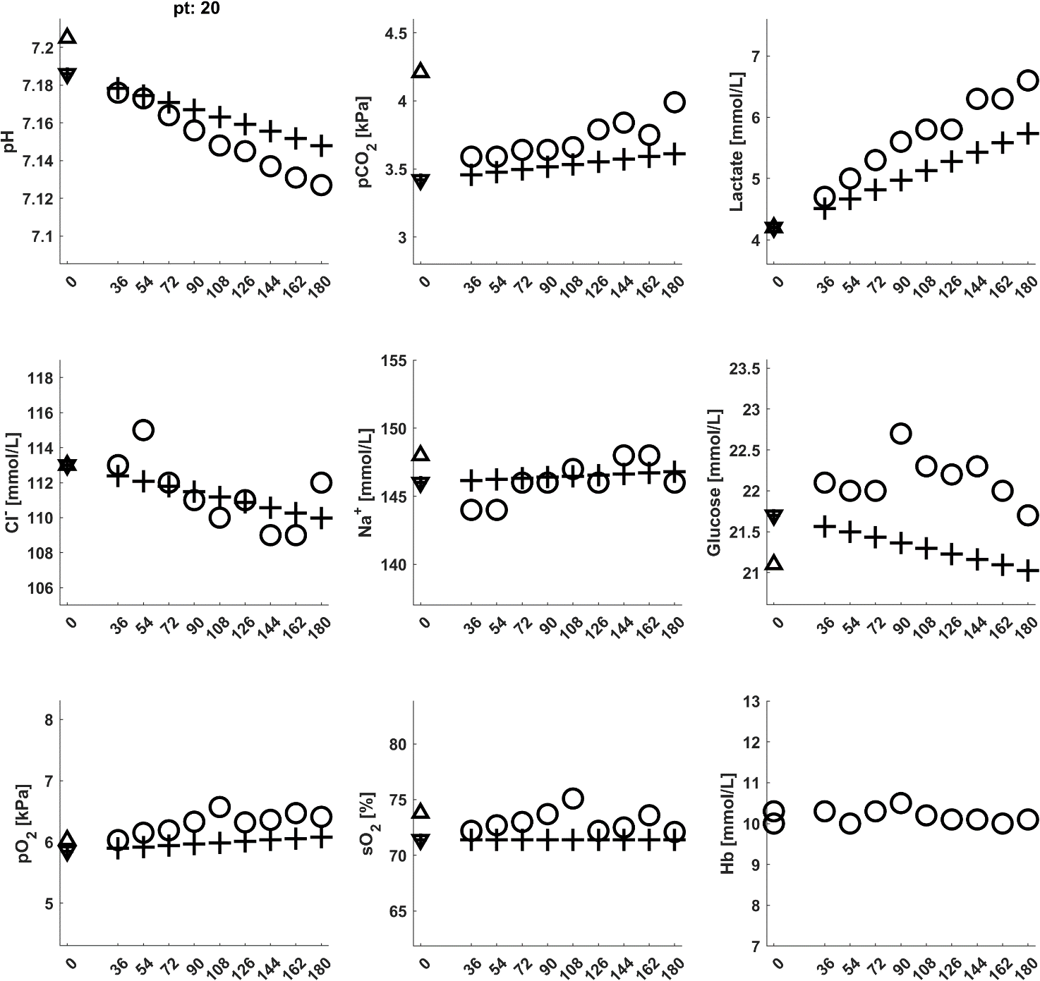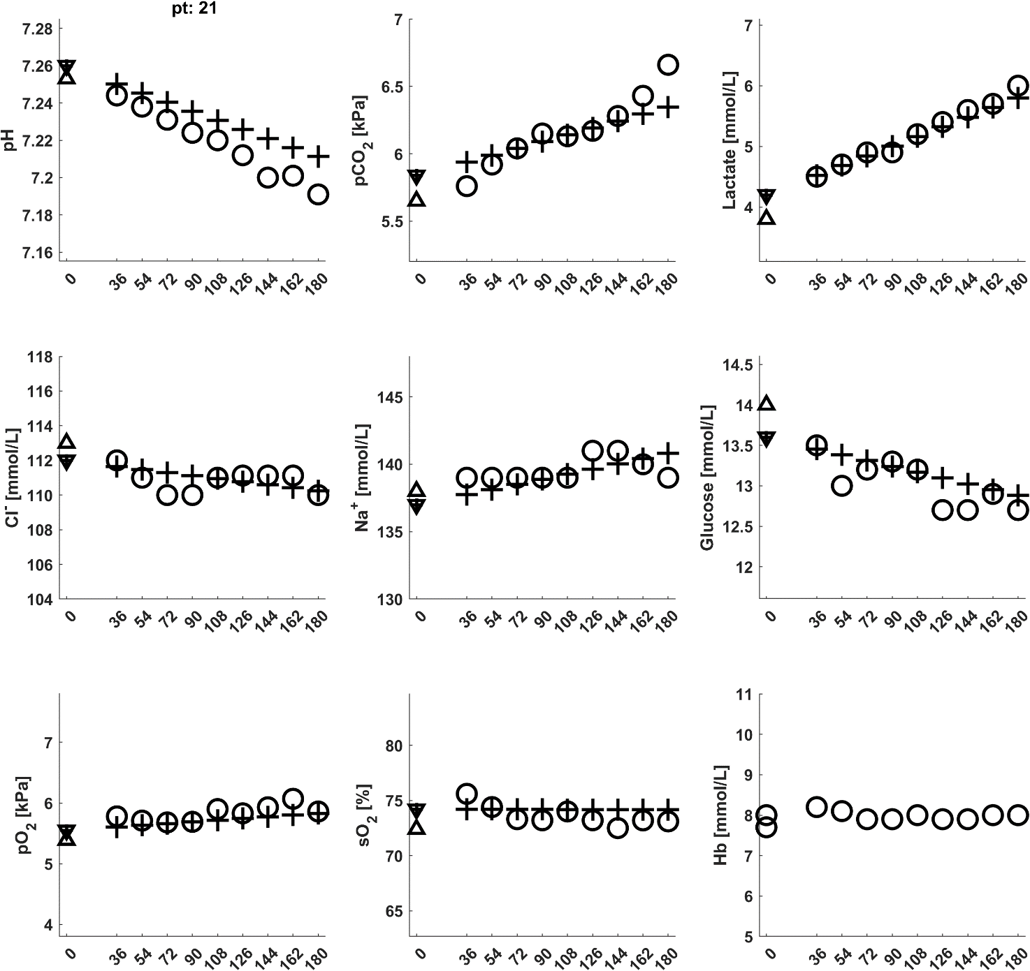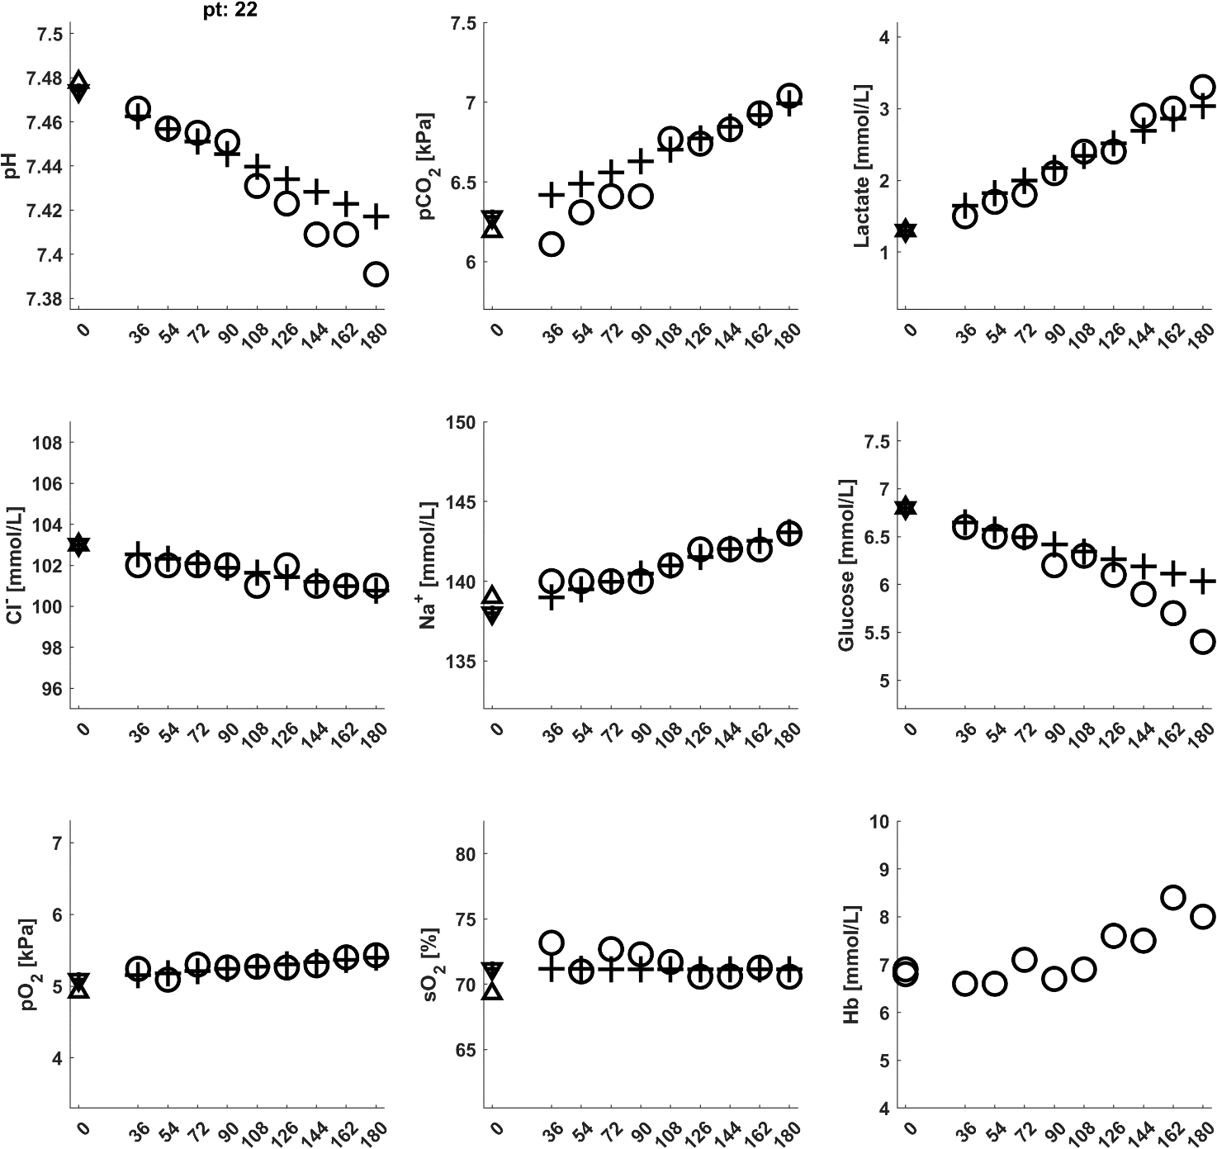

Figure ESM.4. Plots illustrating baselines measurements (triangles), raw data (circles) and model fits (crosses) for all patients.