An isotope dilution-liquid chromatography-tandem mass spectrometry-based candidate reference measurement procedure for the quantification of 17β-estradiol in human serum and plasma

Short Title: ID-2D-LC-MS/MS-based candidate RMP for the quantification of 17β-estradiol

Myriam Ottª, Tobias Santnerª, Neeraj Singhª Friederike Bauland^{b},, Daniel Köppl^{c}, Alexander Gaudl^{d}, Andrea Geistangerª, Uta Ceglarek^{d}, Manfred Rauh^{c}, Christian Geletnekyª Judith Taibonª*

ªRoche Diagnostics GmbH, Nonnenwald 2, 82377 Penzberg, Germany
^{b}Chrestos Concept GmbH & Co. KG, Girardestaße 1–5, 45131 Essen, Germany
^{c}Department of Pediatrics and Adolescent Medicine, University Hospital Erlangen, Loschgestraße 15, 91054 Erlangen, Germany
^{d}Institute of Laboratory Medicine, Clinical Chemistry and Molecular Diagnostics, University of Leipzig Medical Center, Paul-List-Straße 13-15, 04103 Leipzig, Germany

Correspondence:
Judith Taibon, PhD
Roche Diagnostics GmbH, Nonnenwald 2, 82377 Penzberg, Germany,
Phone: +49 8856 6012941
Email: judith.taibon@roche.com
Characterization of reference material by quantitative nuclear magnetic resonance (qNMR) measurements

Quantitative nuclear magnetic resonance (qNMR) measurements were performed using the International System of Units (SI units) traceable internal standard (ISTD) for the quantification of the absolute content of estradiol.

The following formula was utilized to calculate the absolute content of estradiol:

$$Px=\frac{Ix*Nstd*Mx*mstd}{Istd*Nx*Mstdmx}*Pstd$$

Px: Purity of the analyte as mass fraction
Pstd: Purity of the internal qNMR standard as mass fraction
Ix: Integral of the analyte
Istd: Integral of the internal standard
Nx: No. of analyte protons
Nstd: No. of internal qNMR standard protons
Mx: Molecular weight of the analyte
Mstd: Molecular weight of the qNMR internal standard
mx: Mass of analyte
mstd: Mass of qNMR internal standard

For estradiol:
The following values are common to all the qNMR measurements:
Molecular Weight of Estradiol = 272.382 g/mol; Molecular weight of the qNMR internal standard ISTD (Dimethyl terephthalate = 194.184 g/mol; Purity of the qNMR internal standard as mass fraction = 99.95% ± 0.21% (k = 2); Number of Protons taken into account for the ISTD = 4 and for Estradiol = 1; Integral of Estradiol proton = 1.

Procedure for sample preparation and processing parameter:
Estradiol (NMIJ 6004-a) and Dimethyl terephthalate (TraceCert qNMR standard traceable to NIST 350b; Lot No. BCBT9974) was purchased from SigmaAldrich, Germany. 5mm NMR tubes were obtained from Euroisotop GmbH. Estradiol (Table 1) and the qNMR standard (Table 1) were weighed together in a glass vial on an Ultra-microbalance (XPR6U), from Mettler Toledo. Acetonitrile-d₃ (approx. 700 µL) was added to the glass vial, and after a short vortexing, the solution was transferred to a 5 mm NMR tube. The single-pulse-¹HNMR measurements were performed on a JEOL 600 MHz NMR spectrometer equipped with an ultra-cool probe head, which provides 4-5 times sensitivity enhancement compared to normal room-temperature probe heads. For Estradiol, single-pulse-¹HNMR was utilized for the quantitation (Figure 1; aromatic proton meta to the phenolic group δ = 7.10 ppm; 1H); Dimethyl terephthalate as qNMR internal standard, 4H; CD₃CN as solvent) with an inter-scan delay of 70 seconds. NMR measurements were performed at 298K/300 K utilizing 64k data points and the number of scans were limited to 128 with automatic receiver gain conditions. Processing was performed with an exponential window function (line broadening = 0.3 Hz), followed by manual phase and baseline corrections. Our in-house qNMR methodology yields a final absolute content value of 98.4% for estradiol (Table 1 and Figure 2). The certified value of this Estradiol primary standard is also 98.4%.
Table 1: qNMR calculation of the purity of Estradiol; mass is given in milligrams (mg).

Estradiol  source | Measurement No. | Mass of Estradiol (mx) | Mass of qNMR ISTD weighed (mstd) | Integral of the qNMR ISTD (Istd) | Purity of Estradiol  as mass fraction (Px) %
NMIJ 6004-a | 1 | 1.1916 | 2.0408 | 3.328 | 98.4

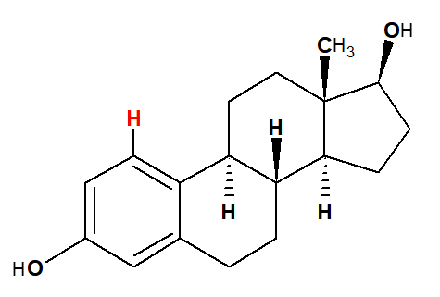
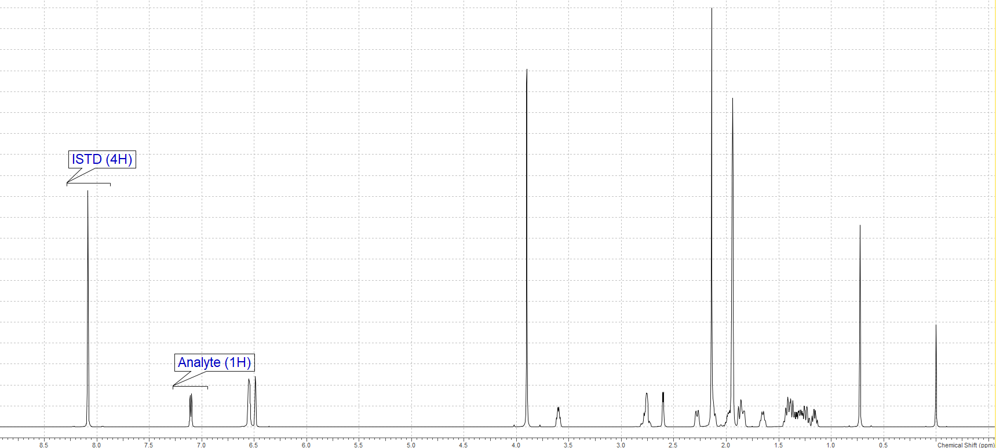
Figure 1: qNMR spectrum indicating the proton (in red) utilized for the quantification of Estradiol

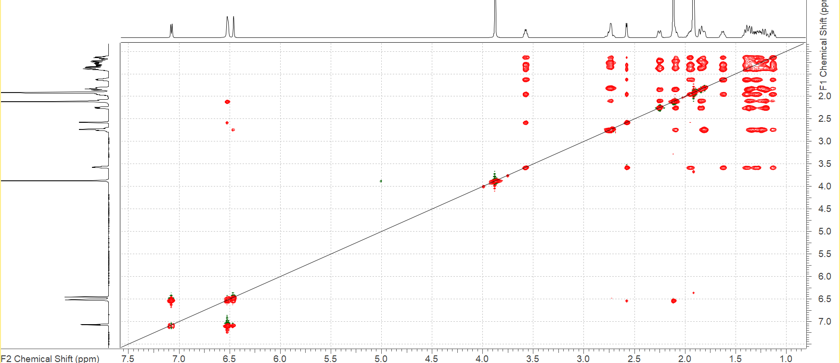

Figure 2: 2D-TOCSY spectrum of Estradiol showing the identity (blue arrow) of the quantitative resonance.

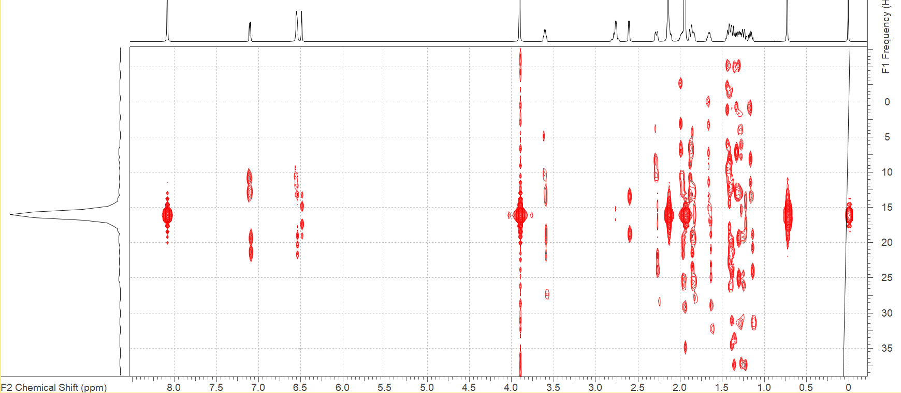
Figure 3: J_{Res} spectrum of Estradiol showing the dd (doublet of doublet) splitting of the quantitative resonance.

Conformer Search (Estradiol) using wB97X-V with def2-TZVPD basis set
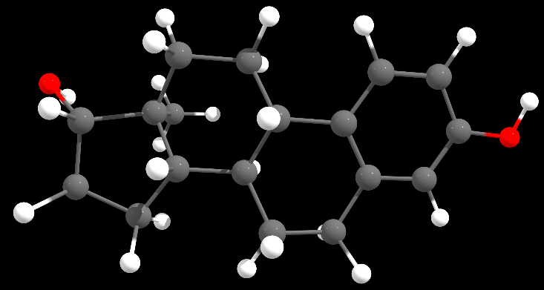
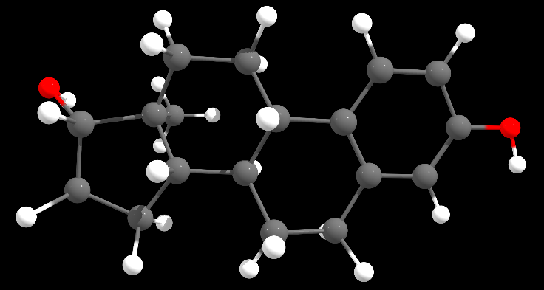

Conformer 5; 0.02 kcal/mole; 29.86%
Conformer 8; 0.00 kcal/mole; 30.69%
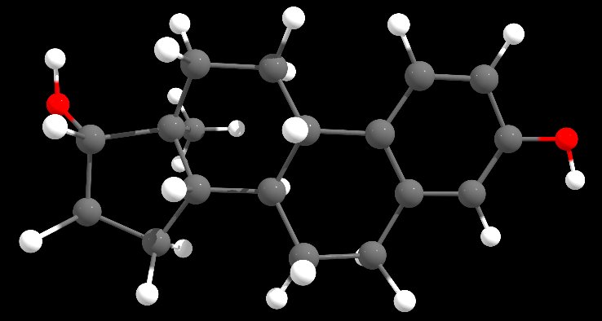
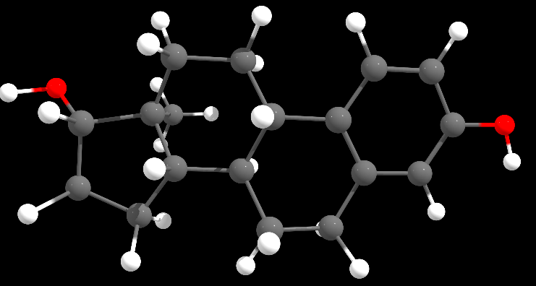

Conformer 11; 0.15 kcal/mole; 11.40%%
Conformer 3; 0.15 kcal/mole; 23.90%

Figure 4: Four major Conformers of Estradiol, which constitute the structure in solution (acetonitrile). The Boltzmann population and their relative energies are indicated within brackets. DFT calculations were done using D3 correction and CPCM solvent model is utilized for acetonitrile. The following steps were performed for calculating the energies of the conformers: (i) Generation of conformer ensemble with CREST; (ii) Initial conformer filtering using XTB; (iii) Conformer preoptimization using XTB followed by clustering; (iv) Conformer optimization using r2SCAN-3c; (iv) Conformer DFT SP Energy calculation using wB97X-V/def2-TZVPD.
All the quantum chemical calculations were performed with the program ORCA/Weasel.

Cartesian coordinates of the 4 conformers:
44
Energy: -533982.964185534 kcal/mol (wB97X-V / def2-TZVPD / CPCM(Acetonitrile)) ++ ChemEnsembleNo: 1 ++ ConformerNo: 8 ++ Version: 1.11.1
H 6.2115771181539001 0.6524424517863797 0.6047122466126745
H -5.1676824718279999 -1.0037329680843203 1.0423381090456745
H 4.5590647020979000 -2.3716308647791307 -0.1687553520388054
H 4.2739909268614102 1.8602309307367197 0.4719694130975345
H 2.1412091619283595 -2.4603537461019407 -0.5817320547689055
H -1.6137276138376906 -0.7009106726170903 2.0998395145582247
H -3.1363664920994605 0.1859615309188396 2.1299182303192246
H -3.1348254706606604 -1.5799728332925003 1.9739673671273346
H 1.5751465707850796 2.4375997045283793 1.1811709726998045
H 2.2210129732108297 2.9691126733376394 -0.3612733389176154
H -4.9022014801617599 1.6440211338155497 -0.8497621296325455
H -4.8259639597100996 1.2734401109801097 0.8699417186584045
H -0.1888224518400704 -1.9100467998721604 0.9129611545916745
H 0.1030280199776896 -2.5807932300492604 -0.6839950018713855
H -2.6684394882136404 2.1818530894968196 1.0463405577416445
H -2.7793864012474705 2.7180927154856493 -0.6302640348528855
H -0.3357550198920104 2.9646843612343594 -0.1665970406955554
H 0.2793863190382797 2.0772151289818397 -1.5657295037830055
H -2.3084325760968505 -2.7105303095298106 -0.0971891595905054
H -2.0143154279227207 -1.7545877956522904 -1.5559291044456955
H -4.0181048535490698 -0.4725524724032203 -1.4712807546423754
H 0.1739026043798296 -0.3376825775666304 -1.6740605721518256
H -1.9401003695468704 0.6487404393203197 -1.4821088594979954
H -0.3616460858882304 0.7695892618006797 1.1101963624005444
O 5.9199775930153899 -0.2470347817645304 0.4025299662302446
O -5.0385471788223297 -1.1902664646965002 0.1031275687931646
C 3.9600610103195395 -1.4668399468171502 -0.1160316057971154
C 3.7970938584684895 0.9074463736380197 0.2432628094631046
C 2.5905935999773497 -1.5009876780144602 -0.3450640275451354
C 4.5675208762321100 -0.2485628758127904 0.1830925108673446
C 2.4181758524184196 0.8692265525362897 0.0122217570379946
C 1.7887613311494794 -0.3527392872871903 -0.2843114621982654
C -2.6175023007473404 -0.6620103256249004 1.6704930789250245
C 1.6464717072621395 2.1662714398818594 0.1171338461406946
C -4.2779553337590697 1.1860797593887997 -0.0763231122884654
C -0.3664347807271004 -1.7427768617574804 -0.1579575869343654
C -2.8749694850136307 1.8455269852857696 0.0228979436863246
C 0.2399265441696396 2.0808277775681296 -0.4662506459224054
C -1.8734622482316305 -1.7712824430684002 -0.4648900416923454
C -4.0216490687680198 -0.3113836406241003 -0.3847200014493855
C 0.2950388630154796 -0.4168766644046903 -0.5779322293469055
C -1.9113544687824304 0.7167681825683997 -0.3791747429757054
C -0.4443126298099304 0.8033984556089997 0.0110798914108446
C -2.5914419931034707 -0.5652286000382704 0.1380958754897246
44
Energy: -533982.9479493558 kcal/mol (wB97X-V / def2-TZVPD / CPCM(Acetonitrile)) ++ ChemEnsembleNo: 1 ++ ConformerNo: 5 ++ Version: 1.11.1
H 6.3466601936376135 -0.8792132072841712 0.3475716573152711
H -5.1593902753748919 -1.0888537341356945 1.0211165311257990
H 4.5981953328915548 -2.2943489827789008 -0.1431991871084033
H 4.2484413874699953 1.9370290598568036 0.4647813131546702
H 2.1864298312140233 -2.4273285056121710 -0.5492202259716027
H -1.6161609845334313 -0.7277926945436164 2.1023973300974808
H -3.1286410326567875 -1.6204196359460152 1.9727559905673682
H -3.1465731500226708 0.1460398921702247 2.1179842766095840
H 2.1666715809174932 3.0072802777080812 -0.3605231602130686
H 1.5274070077569006 2.4654678400054721 1.1807119043200958
H -4.9248271655827978 1.5480324270898482 -0.8861938012112927
H -4.8554571218675342 1.1902986660879993 0.8366029061853023
H 0.1524573626697298 -2.5836361855965690 -0.6620264978810256
H -0.1583201853865206 -1.9103425720325120 0.9299540521755540
H -2.8235473211627782 2.6625966476261018 -0.6563170645879752
H -2.7158708622727348 2.1368657422199600 1.0237956383099249
H 0.2455811376846267 2.0728678172027100 -1.5684909339796411
H -0.3883924290839624 2.9553613033265558 -0.1750085240087084
H -2.2586141880487238 -2.7539944739768152 -0.0843493057481069
H -1.9744315680161324 -1.8031131690814151 -1.5480471683939483
H -3.9983940746674285 -0.5564540606131688 -1.4863861366370017
H 0.1866575280036627 -0.3449823198455679 -1.6634626996746185
H -1.9414985638838598 0.6021367610486226 -1.4896259873332061
H -0.3829472968181490 0.7667983397506882 1.1119727936217008
O 5.9152726918780214 -0.0174664315469961 0.4231357250850002
O -5.0184748056993804 -1.2813350205297822 0.0847377532915248
C 3.9879909995659739 -1.3948481848218619 -0.0953061214281502
C 3.7811899128639568 0.9794548587528497 0.2442683472745570
C 2.6173988906950130 -1.4575017463761735 -0.3214394059865034
C 4.5725006207136927 -0.1622871534633810 0.1908416386048023
C 2.4046104202875935 0.9124276415118378 0.0172156041475390
C 1.7963944064332669 -0.3242484254854988 -0.2697229011031493
C -2.6175569134187837 -0.6998823133007305 1.6666116305899448
C 1.6066661071370707 2.1939446781445247 0.1173051397486227
C -4.2986684818115464 1.1065961671656459 -0.1048074765139927
C -0.3344776641950964 -1.7515707781561025 -0.1424994063407076
C -2.9085748646575134 1.7918154862313542 0.0005640023952657
C 0.2037931325902338 2.0805754015070677 -0.4691305557658229
C -1.8390319667673465 -1.8094243538135264 -0.4562134698133576
C -4.0129592088832400 -0.3876813568533024 -0.4010846519420702
C 0.3049257165625088 -0.4163824982650734 -0.5664567251495072
C -1.9218637846645801 0.6782328168582176 -0.3870112358865865
C -0.4591927308143798 0.7936064415331239 0.0121824238391727
C -2.5826523765824771 -0.6126179693823804 0.1340316080151441
44
Energy: -533982.8160754712 kcal/mol (wB97X-V / def2-TZVPD / CPCM(Acetonitrile)) ++ ChemEnsembleNo: 1 ++ ConformerNo: 3 ++ Version: 1.11.1
H 6.2236122564856871 0.6002767142179458 0.5230239455675352
H -4.9424411136189157 -1.9735738895281514 -0.0153022723600542
H 4.5319204761066132 -2.4208148601976358 -0.1750964738814832
H 4.2974654284501730 1.8249642362286653 0.3886280567568121
H 2.1092485460260555 -2.4917388976133186 -0.5612258526435198
H -3.1439177357852430 -1.5084066860303951 2.0291066032407210
H -3.0929936413681878 0.2521496999791108 2.1615208771435950
H -1.5896929860810836 -0.6727294360569283 2.1219383557475031
H 2.2456971895811266 2.9403997425040425 -0.4402992779792110
H 1.6145401795961962 2.4415794538631808 1.1189211215410235
H -4.9026209870990103 1.6756677044265569 -0.8025815211758570
H -4.7969213926021830 1.3085921006180659 0.9183658432893156
H 0.0692432401900655 -2.5911890335687868 -0.6574307610586025
H -0.1947753724346856 -1.9005138509586654 0.9357822036091683
H -2.7686921496660117 2.7326273891612871 -0.6380920558702462
H -2.6347091057777718 2.2220121390725711 1.0445303967688837
H 0.2793911361877736 2.0482107293642335 -1.6042426006108312
H -0.3084532190568232 2.9648612613659879 -0.2125200912819354
H -2.3335752097191516 -2.6908884997182483 -0.0351037888294185
H -2.0510482714776046 -1.7554087005983265 -1.5103543929377143
H -4.0311706888817538 -0.4428421613162819 -1.4249197809212775
H 0.1523740395026595 -0.3622773952734232 -1.6735852002307916
H -1.9513020623154969 0.6472832153368866 -1.4705752636498444
H -0.3409042457448162 0.7896968551671472 1.1005523290128618
O 5.9210302559482608 -0.2997638852107783 0.3403391305568689
O -5.0653633134290645 -1.0573389421677108 0.2639963712305485
C 3.9430598474716225 -1.5088149282909822 -0.1336687262646630
C 3.8083958686296087 0.8732576372433632 0.1822867282104789
C 2.5709460941867595 -1.5328007104233035 -0.3478211114298373
C 4.5662569313895647 -0.2916047558669879 0.1354656577154012
C 2.4267496408005873 0.8451639213121954 -0.0329901647540142
C 1.7817025274656082 -0.3752813001781881 -0.3006877441146405
C -2.5997084745248120 -0.6136000118505596 1.7093412321928356
C 1.6694298571103150 2.1515251619090314 0.0588478628115709
C -4.2679245452002759 1.2191040749951692 -0.0369968603949222
C -0.3847426090333573 -1.7428096563764062 -0.1343361702359943
C -2.8586013338719090 1.8707669323253817 0.0298794387974366
C 0.2546208198108513 2.0703971872968170 -0.5045799357575823
C -1.8958664937826306 -1.7592936278579194 -0.4209286203264046
C -4.0264639303130219 -0.2746930464766475 -0.3344577196993767
C 0.2844491679236095 -0.4285323448639536 -0.5779005220241930
C -1.9083915116283947 0.7299357149138407 -0.3692696905086360
C -0.4360634249557211 0.8076407449109080 0.0021630882076776
C -2.5939554932006756 -0.5379676198019878 0.1765797070347335
44
Energy: -533982.3771921762 kcal/mol (wB97X-V / def2-TZVPD / CPCM(Acetonitrile)) ++ ChemEnsembleNo: 1 ++ ConformerNo: 11 ++ Version: 1.11.1
H 6.2167996223573532 0.6302514319507767 0.5182866177132159
H -5.8288271916979699 -1.0176025346259550 -0.1086407242029244
H 4.5402734815122630 -2.3941662437031788 -0.2015335088165280
H 4.2846280471472022 1.8462083226656048 0.3929256546036910
H 2.1175855345564538 -2.4744900047665288 -0.5873783390571025
H -3.0784974726967071 0.2232235227728221 2.1727688316713745
H -3.1200117908933529 -1.5378638870240275 2.0298413000439335
H -1.5710348335080793 -0.6927886454679020 2.1102950120618029
H 1.6018828510411858 2.4452952840235174 1.1282736894307954
H 2.2258707158383668 2.9567967945557170 -0.4296644674360789
H -4.9174787012773393 1.6622778637726068 -0.7659572068296193
H -4.7932777315773256 1.2847596774595165 0.9534219003284918
H -0.1833319870886504 -1.9093204259211942 0.9132905463587770
H 0.0759253615878613 -2.5826455301346214 -0.6878365283575801
H -2.6356227031780382 2.2097659745873415 1.0625419845227801
H -2.7839805524970340 2.7254310494698908 -0.6175097834038596
H -0.3281107198931735 2.9663396133117348 -0.1923185169317096
H 0.2603762024194708 2.0645258696538900 -1.5933887437107466
H -2.3231143200379516 -2.6996291666777044 -0.0528572985944923
H -2.0530325877243363 -1.7527065126981447 -1.5220472392154001
H -4.0393683112847265 -0.4517599814611147 -1.4108709993720299
H 0.1479010948590302 -0.3449454351503312 -1.6822749535682580
H -1.9617483893919836 0.6496140290217198 -1.4640730068730907
H -0.3437927921919256 0.7806214209551594 1.1027956289073297
O 5.9187877191304086 -0.2699598507289033 0.3290909227632074
O -4.9669738149093590 -1.1839391564463395 0.2923782396991585
C 3.9468290939052388 -1.4854610589064279 -0.1536209377966280
C 3.8003150178620495 0.8935890751601110 0.1796189602820408
C 2.5747738983481372 -1.5148242352315866 -0.3675905737971265
C 4.5639613399479337 -0.2671006629224290 0.1242428703392317
C 2.4187826515269770 0.8600879510702716 -0.0356131224497188
C 1.7797948656490135 -0.3616214333310381 -0.3119736116392026
C -2.5860796666105546 -0.6374606542420828 1.7101650150474370
C 1.6550355160891752 2.1619788202422372 0.0663049937057571
C -4.2742090079356805 1.2034876482126189 -0.0080636830351949
C -0.3794909009098787 -1.7415696986580318 -0.1541980232042521
C -2.8667589545452778 1.8612024443143387 0.0485007793997687
C 0.2389641810722695 2.0774535163051864 -0.4934955947376741
C -1.8919608352584620 -1.7641196449152308 -0.4337651921084901
C -4.0252851165087220 -0.2942143595862411 -0.3194096386757707
C 0.2824322391534030 -0.4203677268816263 -0.5874833886521014
C -1.9158845924810495 0.7250453947689779 -0.3624961715755262
C -0.4429925096504439 0.8067146056000420 0.0050321705968466
C -2.5943344199392167 -0.5511556575177338 0.1763928380597949
44
Energy: -533981.3447049914 kcal/mol (wB97X-V / def2-TZVPD / CPCM(Acetonitrile)) ++ ChemEnsembleNo: 1 ++ ConformerNo: 9 ++ Version: 1.11.1
H 6.1659391270545933 -0.7314704631842245 1.1108117491483331
H -5.1062713622281493 -1.2070478696532387 0.9228080360966904
H 4.4136590281738171 -2.1984370809796503 0.8996138277413092
H 4.2643368663912673 1.9814817981681503 -0.0733898275802303
H 2.0511595802946325 -2.4392723362085400 0.2480572278511387
H -1.5344114180436461 -1.0404952356901720 1.9457018080382873
H -3.0920303724376108 -0.2414391300298769 2.1375118157633342
H -3.0193668988815743 -1.9568218925375771 1.6983448412587543
H 2.1755192040832152 2.9680752059489972 -0.8247499859015007
H 1.4843058811298853 1.8584802519365275 -2.0028004563651760
H -4.8588156785944037 1.7155438789620316 -0.5308593487425115
H -4.7723884006743553 1.0678799775987970 1.1044516915888194
H -0.1935478577257916 -2.0831301304618677 0.5778132162738803
H 0.1346558607313286 -2.5136034531795550 -1.0938510193605091
H -2.5983299747364077 1.9001212175984408 1.4090183216343151
H -2.7312691617323215 2.7351994792032923 -0.1392128864611846
H 0.3250454469698130 2.7178458121835813 0.6620562343210593
H -0.4213006874311078 2.6867796683207610 -0.9286127635573417
H -2.2980578070667619 -2.7101561487788253 -0.5617365092883077
H -2.0012952917607638 -1.5188988622831319 -1.8372001088820793
H -4.0100979293695023 -0.2806387363526248 -1.4981877397576187
H 0.2474633205408369 -0.1651483415724390 -1.7543002810092536
H -1.9380595525719588 0.8338559678128818 -1.3671633818550490
H -0.2669702686671924 0.5627654042791724 1.1492775667458885
O 5.7881895804114158 0.1053698615509819 0.8083741084592811
O -4.9991456269249817 -1.2415029691504678 -0.0368309018193721
C 3.8573636106404834 -1.3353324963196214 0.5395694072806461
C 3.7666894446480579 1.0164789383284358 -0.0089340014135216
C 2.5179388985362294 -1.4621514608527018 0.1679618503912919
C 4.4784592168647270 -0.0916984846254181 0.4532824613979682
C 2.4348777775766983 0.8793574414847173 -0.3856670839268909
C 1.7905082284095974 -0.3686623251060807 -0.2983128976142640
C -2.5469228344267956 -0.9800051780525904 1.5403195905412124
C 1.6288523828420842 2.0246757485918354 -0.9251902017941658
C -4.2325289567994764 1.1333210355257965 0.1519828816143269
C -0.3500804568610703 -1.7601308450600310 -0.4598238312921358
C -2.8233276089356751 1.7583500384879012 0.3450403026676542
C 0.2409945206171775 2.1268172609523797 -0.2568784532426627
C -1.8546874138940788 -1.7264909861777047 -0.7667938270302191
C -3.9898883422935820 -0.2957599031643925 -0.4001156573509417
C 0.3276819503449886 -0.4023512825454720 -0.6774366511588246
C -1.8763476728283885 0.7147038200998986 -0.2694122968883864
C -0.3937230747094909 0.7532697868934030 0.0735667071094898
C -2.5515107261385221 -0.6339629296630477 0.0439344484444521
44
Energy: -533981.1419872288 kcal/mol (wB97X-V / def2-TZVPD / CPCM(Acetonitrile)) ++ ChemEnsembleNo: 1 ++ ConformerNo: 6 ++ Version: 1.11.1
H 6.1432943929109243 0.7255821840928844 0.6032395432270521
H -4.9566525746634023 -1.8899031812898730 -0.2900896746081668
H 4.3741296454936371 -2.3135901549608535 0.8239821783511367
H 4.3116181230970065 1.8653279375205933 -0.1642309895215121
H 1.9881095886474947 -2.4932383749961864 0.2212077015378251
H -3.0605424794412501 -1.8528557970264166 1.7605134685291519
H -3.0634818329233937 -0.1400299326174539 2.1882472648496338
H -1.5323322115486997 -0.9919566982168927 1.9783363026029439
H 1.4995670360384150 1.8152020536570344 -2.0325963884785732
H 2.2420223934763657 2.9056609914738609 -0.8680255788035884
H -4.8208751164237897 1.8422061143570767 -0.4581245904248528
H -4.7248806512795323 1.1867008067358142 1.1753779493174532
H 0.0469438031892169 -2.5200147565544495 -1.0807850800891652
H -0.2400968407807716 -2.0726523338767602 0.5941561533947050
H -2.6640944342349631 2.8075970599096967 -0.1074046612040698
H -2.5272292178594178 1.9781747968727315 1.4433344138323816
H -0.3629815592843029 2.6959584836599277 -0.9269387787823216
H 0.4112692352239120 2.7100551020876855 0.6503410040307716
H -2.3784278695300181 -2.6490988416412127 -0.5052443920457667
H -2.0732625744311948 -1.4712236344996674 -1.7922288142529144
H -4.0297829095637452 -0.1671998359990212 -1.4362971592802838
H 0.2106151896272672 -0.1774853261528241 -1.7549214917015239
H -1.9354840797509221 0.8818871087834907 -1.3365666269259828
H -0.2334844039720089 0.5737057429213860 1.1541927321387078
O 5.8090001008812520 -0.1736010431103576 0.7227946597480160
O -5.0462984777655944 -1.0346928131496198 0.1493773237724156
C 3.8294375868175190 -1.4418292587623887 0.4722069356608433
C 3.7953294094826777 0.9096156970228639 -0.0827867417305229
C 2.4814542481313580 -1.5303541875843478 0.1286103502497512
C 4.4848179634629206 -0.2176141854805096 0.3683735261505759
C 2.4507252151757823 0.8104733917788087 -0.4317517704666899
C 1.7745398204406286 -0.4174833845247640 -0.3272212257603337
C -2.5497337598539302 -0.8991103334984996 1.5910241818994126
C 1.6677192634813536 1.9777012840859187 -0.9578440673362552
C -4.1993712338065885 1.2447928799161248 0.2157428402731040
C -0.4056394181509775 -1.7505253003690207 -0.4422622174061177
C -2.7715786187258309 1.8358487266252135 0.3837797741031899
C 0.2951830521305263 2.1193484674094756 -0.2652957748153598
C -1.9139147792157210 -1.6771263804701184 -0.7231489559725224
C -4.0009170291661631 -0.1837510023954828 -0.3336337189070148
C 0.3044075262547078 -0.4125079761405360 -0.6786572786847014
C -1.8605192647480875 0.7661675933981411 -0.2393766475541417
C -0.3720664002672110 0.7650163476751615 0.0801625777561591
C -2.5675636659871657 -0.5618300236823869 0.0937916547251230
44
Energy: -533980.7556275603 kcal/mol (wB97X-V / def2-TZVPD / CPCM(Acetonitrile)) ++ ChemEnsembleNo: 1 ++ ConformerNo: 7 ++ Version: 1.11.1
H 6.1896962501639781 -0.7210278688930266 0.9635272842286474
H -5.7947316077602071 -1.0508875762865277 -0.1571126373063808
H 4.4341511545605661 -2.1908656815318044 0.7988400904693561
H 4.2573219459707277 1.9853017187114803 -0.1857568936529920
H 2.0566157254768620 -2.4360660853819796 0.2060717607487478
H -3.0437412591054396 -0.2281067477469682 2.2086880341465958
H -1.4830722927227713 -1.0196295282807317 1.9819568124893678
H -2.9774819146024920 -1.9416057749961675 1.7841970802946796
H 1.4328955466230657 1.8519812361258825 -2.0476651728294639
H 2.1503493196966255 2.9671582436979151 -0.8906606155748358
H -4.8710257582539320 1.7096472780976590 -0.4266327388982719
H -4.7468308932888954 1.0637635291710954 1.2106800663573156
H 0.1070261748731335 -2.5176181667106072 -1.0848392919812524
H -0.1799430731778533 -2.0786859233427823 0.5921513711674713
H -2.7385894461703719 2.7343716364042274 -0.0927812722274918
H -2.5664557004410709 1.9102042433336148 1.4575627389977399
H -0.4481392980512305 2.6822339602466205 -0.9341932612724508
H 0.3342644058342051 2.7231447756848346 0.6387716489576921
H -2.3096982121708480 -2.7140505510558195 -0.4904373116328273
H -2.0474373187411992 -1.5304149279130637 -1.7805393646008114
H -4.0385056647323863 -0.2856865359796110 -1.4042826975413982
H 0.2027511084005953 -0.1725869614532600 -1.7601983109864290
H -1.9714144329575680 0.8266789257422220 -1.3268142865824706
H -0.2421609596790623 0.5698335351822519 1.1511173472091256
O 5.8037419266549124 0.1141117394916953 0.6667355996996892
O -4.9222918734518828 -1.2767101012900990 0.1879805009318649
C 3.8684182385400061 -1.3295200884605769 0.4493822194842128
C 3.7622782896640108 1.0201316256333890 -0.1053585909149355
C 2.5204778234471026 -1.4589005163432425 0.1109731219427100
C 4.4861101561222450 -0.0856248604892828 0.3437602900176853
C 2.4218628720928619 0.8804418273697191 -0.4492504429077239
C 1.7808359892224142 -0.3677517440580483 -0.3413189248593355
C -2.5080014882389188 -0.9685466129952750 1.6074488370052327
C 1.6023968199915997 2.0228793897247552 -0.9744293339993898
C -4.2304486198564861 1.1309755776088120 0.2466868702887404
C -0.3621186502602679 -1.7610055277140353 -0.4428806412769333
C -2.8172694495432871 1.7607390551187043 0.4004405554368536
C 0.2301859751309536 2.1269225287849327 -0.2747404425160552
C -1.8739172431088307 -1.7309628144549676 -0.7128614622184067
C -3.9951190395579981 -0.3007709631679549 -0.3025798785861077
C 0.3091929976934428 -0.4042081528748746 -0.6844092299579378
C -1.8851575370032962 0.7140115448408808 -0.2302662522475361
C -0.3949451410519547 0.7543976401183669 0.0779142337001051
C -2.5535972419171582 -0.6339440885127027 0.1084354976329883

Deprotomer Search (Estradiol) using wB97X-V with def2-TZVP basis set
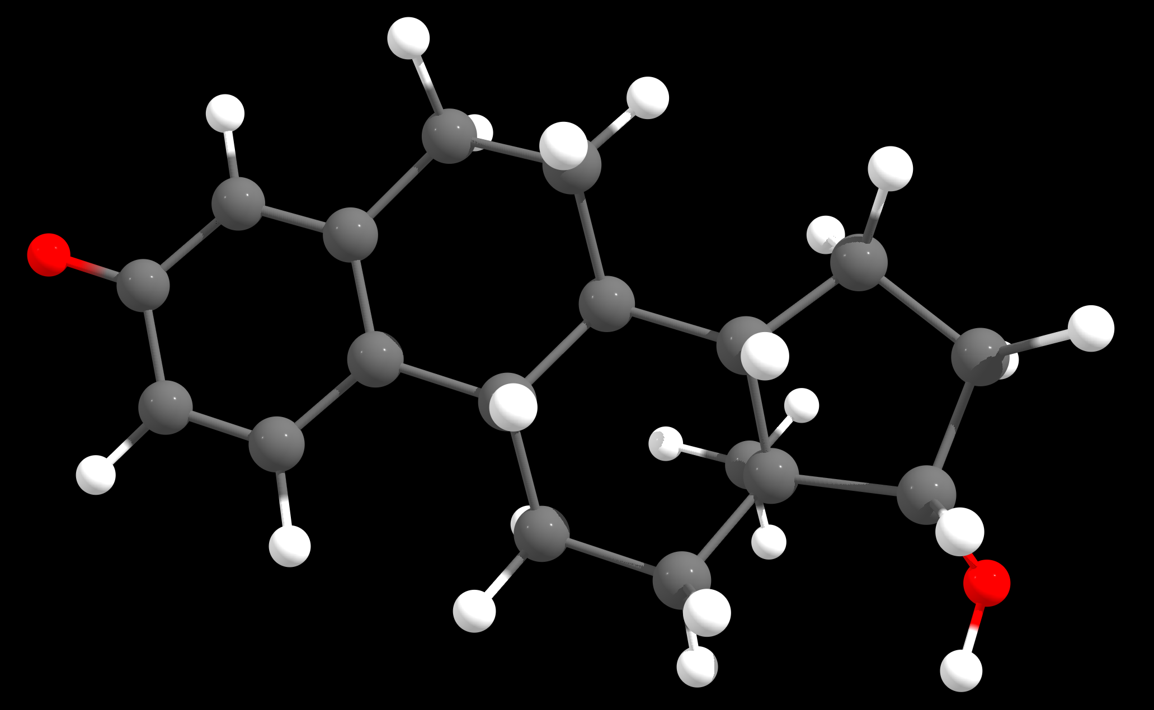
Anion 1; 0.00 kcal/mole; 100%

Figure 5: The least energy deprotomer calculated at wB97X-V/def2-TZVP shows that deprotonation occurs at phenolic group. The following steps were involved:
1: Generating anions with CREST.
2: Initial anion filtering using XTB.
3: Anion preoptimizations using XTB followed by clustering.
4: Anion optimizations using r2SCAN-3c.
5: Anion DFT SP Energy calculation using wB97X-V with def2-TZVP basis set.
All the quantum chemical calculations were performed with the program ORCA/Weasel.

Cartesian coordinates of the De-protomer:
43
Energy: -533673.0370429755 kcal/mol (wB97X-V / def2-TZVP / CPCM(Acetonitrile)) ++ ChemEnsembleNo: 1 ++ ConformerNo: 1 ++ Version: 1.11.0
O 5.9246624866601989 -0.0462129653177492 -0.6860218302317000
O -4.9248916539937406 1.3865398633811510 0.7406607919632799
C 4.1120808872041685 0.9628534644856207 0.5066358171265900
C 3.7172761807993893 -0.9350078051722392 -0.9102832474022100
C 2.7588848324608195 0.9811035183751607 0.8162979042379099
C 4.6690552307481985 -0.0084988167041392 -0.3850479715341101
C 2.3574728630271693 -0.9079605998969393 -0.6005877038079200
C 1.8395619260756393 0.0646200630356908 0.2789471711107599
C -2.5843195146575808 1.5582002719326709 -0.9551841955113900
C 1.4549923351480394 -1.9302268829065090 -1.2657544948631101
C -4.3503261249201008 -0.7865888270054993 -0.1882406637357601
C -0.1862343622053008 1.4766660333476609 0.9900091184159799
C -3.0192275930469608 -1.4071250873686691 -0.6969914687008800
C 0.0853071685598792 -2.0513910579714993 -0.6052669376774400
C -1.6718281907874906 1.4472945707107310 1.3881565795353799
C -3.9438328061178307 0.3434354314740208 0.7799136582390900
C 0.3693942356429592 0.0741779041974207 0.6794743183273599
C -1.9398356076431407 -0.6826309005305193 0.1241302127392499
C -0.4989759928995008 -0.6622587554807793 -0.3631729962169401
C -2.5182696562588305 0.7308937665521807 0.3357578608090599
H -4.6976365757238909 2.0293292367519409 1.4245401542426699
H 4.7803563450119793 1.7013079666150208 0.9489441104573899
H 4.0844181009825586 -1.7024327363671390 -1.5941982823522702
H 2.4086523341412294 1.7434180923503209 1.5096645095971999
H -1.5917306501083806 1.7335979645681909 -1.3763023852890302
H -3.1930170083686904 1.0756838763066809 -1.7260437579846402
H -3.0344562261970305 2.5334564985160508 -0.7418898165045801
H 1.3113599254014194 -1.6361282199103890 -2.3170310625012300
H 1.9614605102958294 -2.9035509873646292 -1.2920441349509302
H -4.9898901790991808 -1.5216426931745490 0.3100508053471899
H -4.9326092435909210 -0.3556854457528492 -1.0104353226438101
H -0.0346165241533808 2.1259676011835107 0.1169077195415799
H 0.3801999140684892 1.9298059170010109 1.8108428193916200
H -2.8810414150532404 -1.2188477409530691 -1.7686933889898002
H -2.9874255950281507 -2.4912501759282994 -0.5523036883501801
H -0.5815981127953108 -2.6476829751758992 -1.2406631277418902
H 0.1691637312542592 -2.5771929159886291 0.3583038642663899
H -2.0333283005000906 2.4726612091403708 1.5523035412271198
H -1.7732764011322306 0.9106414943341007 2.3436451962919800
H -3.8785612437106405 -0.0517837356241092 1.8079474739707500
H 0.2607951632437692 -0.5118495391018293 1.6126388303294699
H -1.9258257002962207 -1.1573598327362791 1.1222972056579399
H -0.4489783836693508 -0.1109277934222192 -1.3172322594563701

