An isotope dilution-liquid chromatography-tandem mass spectrometry-based candidate reference measurement procedure for the quantification of 17β-estradiol in human serum and plasma

Short Title: ID-2D-LC-MS/MS-based candidate RMP for the quantification of 17β-estradiol

Myriam Ottª, Tobias Santnerª, Neeraj Singhª Friederike Bauland^{b},, Daniel Köppl^{c}, Alexander Gaudl^{d}, Andrea Geistangerª, Uta Ceglarek^{d}, Manfred Rauh^{c}, Christian Geletnekyª Judith Taibonª*

ªRoche Diagnostics GmbH, Nonnenwald 2, 82377 Penzberg, Germany
^{b}Chrestos Concept GmbH & Co. KG, Girardestaße 1–5, 45131 Essen, Germany
^{c}Department of Pediatrics and Adolescent Medicine, University Hospital Erlangen, Loschgestraße 15, 91054 Erlangen, Germany
^{d}Institute of Laboratory Medicine, Clinical Chemistry and Molecular Diagnostics, University of Leipzig Medical Center, Paul-List-Straße 13-15, 04103 Leipzig, Germany

Correspondence:
Judith Taibon, PhD
Roche Diagnostics GmbH, Nonnenwald 2, 82377 Penzberg, Germany,
Phone: +49 8856 6012941
Email: judith.taibon@roche.com

Content
1 Summary of test principle and scope of application 4
2 Safety Precautions 5
3 Normal Range Method (5.00-5000 pg/mL) 6
3.1 Equipment and Instrumentation 6
3.2 Preparation of Reagents, Calibration standards, Controls and all Other Materials 7
3.2.1 Chemicals and reagents 8
3.2.2 Preparation of Reagents 8
3.2.2.1 0.5 M ammonium fluoride solution 9
3.2.2.2 Mobile phases first dimension 9
3.2.2.3 Mobile phases second dimension 9
3.2.2.4 Autosampler wash solutions 9
3.2.2.4.1 LC systems with multiwash option: 9
3.2.2.4.2 LC systems without multiwash option: 10
3.2.2.5 Other reagents 10
3.2.3 Preparation of Calibration standards 10
3.2.3.1 17ß-Estradiol stock solutions for Calibration 11
3.2.3.2 17ß-Estradiol working solutions for Calibration 11
3.2.3.3 17ß-Estradiol Calibrator spike solutions 12
3.2.3.4 17ß-Estradiol Calibrator preparation 13
3.2.4 Preparation of Control samples 13
3.2.4.1 17β-Estradiol stock solution for Controls 14
3.2.4.2 17β-Estradiol working solution for Controls 14
3.2.4.3 17β-Estradiol spike solutions for Controls 14
3.2.4.4 17ß-Estradiol Control preparation 15
3.2.4.5 Patient Control samples (QC native) 15
3.2.4.6 ERM Panel 15
3.2.5 Internal standard solution 16
3.2.5.1 Internal standard stock solution NR 16
3.2.5.2 Internal standard working solution NR 16
3.2.5.3 Internal standard spike solution NR 16
3.2.6 System suitability test samples NR 16
3.3 Specimen Collection, Storage and Handling Procedure 17
3.3.1 Sample preparation 17
3.4 Procedure operating instructions, System Suitability Test (SST) and the Structure of analytical series 19
3.4.1 LC-MS parameter 19
3.4.1.1 LC parameter 19
3.4.1.2 MS and source parameters 21
3.4.2 System suitability test NR 22
3.4.3 System Maintenance 22
3.4.4 Calibration 22
3.5 Structure of analytical series 22
3.6 Data processing and Calculation of measurement results 23
3.7 Reporting of Results 24
4.1 Equipment and Instrumentation 25
4.2 Preparation of Reagents, Calibration standards, Controls and all Other Materials 26
4.2.1 Chemicals and reagents 27
4.2.2 Preparation of Reagents 27
4.2.2.1 Mobile phases first dimension 28
4.2.2.2 Mobile phases second dimension 28
4.2.2.3 Autosampler wash solutions 28
4.2.2.3.1 LC systems with multiwash option: 28
4.2.2.3.2 LC systems without multiwash option: 28
4.2.2.4 Other reagents 29
4.2.3 Preparation of Calibration standards 29
4.2.3.1 17ß-Estradiol stock solutions for Calibration 30
4.2.3.2 17ß-Estradiol working solutions for Calibration 30
4.2.3.3 17ß-Estradiol Calibrator spike solutions 31
4.2.3.4 Calibrator preparation 31
4.2.4 Preparation of Control samples 32
4.2.4.1 17β-Estradiol stock solution for Controls 32
4.2.4.2 17β-Estradiol working solution for Controls 32
4.2.4.3 Control spike solutions 33
4.2.4.4 Control preparation 33
4.2.4.5 ERM Panel 34
4.2.5 Internal standard solution HS 34
4.2.5.1 Internal standard stock solution HS 34
4.2.5.2 Internal standard working solution HS 34
4.2.5.3 Internal standard spike solution HS 35
4.2.6 System suitability test samples HS 35
4.3 Specimen Collection, Storage and Handling Procedure 35
4.3.1 Sample preparation 36
4.4 Procedure operating instructions, System Suitability Test (SST) and the Structure of analytical series 37
4.4.1 LC-MS parameter 37
4.4.1.1 LC parameter 37
4.4.1.2 MS and source parameters 39
4.4.2 System suitability test 40
4.4.3 System Maintenance 40
4.4.4 Calibration 40
4.5 Structure of analytical series 41
4.6 Data processing and Calculation of measurement results 41
4.7 Reporting of Results 42

- Summary of test principle and scope of application
17ß-Estradiol (E2) is an estrogen steroid hormone and the major female sex hormone. It is involved in the regulation of the estrous and menstrual female reproductive cycles.
Here, an istotope dilution liquid-liquid chromatography-tandem mass spectrometry (ID-LC-MS/MS) method for the accurate quantification of 17ß-estradiol was established. To minimize matrix effects and the coelution of isobaric interferences (known as well as unknown), we have chosen a two-dimensional heart cut LC approach for the accurate and precise analysis of estradiol (E2) in human serum. The combination of two orthogonal stationary phases and/or mobile phases dramatically increases peak capacity and the selective transfer of the compound of interest from the first dimension via a standard 2 switch 10-port-valve into the second dimension allows for measurments with high specificity.
Due to the wide measurement range from 0.400 – 5000 pg/mL, two separate methods had to be developed. The normal range method (normal range, NR) is able to quantify analyte in the range of 5.00 – 5000 pg/mL using two dimensional HPLC with H₂O – acetonitrile on a C18 column in the first dimension and 0.2 mM NH₄F in H₂O – methanol on a biphenyl column in the second dimension. The high sensitivity method (high sensitivity, HS) covers the range from 0.400 – 5.00 pg/mL. For the later method, derivatization with dansyl chloride is required. Chromatography also includes two dimensional LC with H₂O – acetonitrile on a C8 column in the first dimension and 0.1 % formic acid in H₂O – 0.1 % formic acid in methanol / acetonitril (3+1) on a biphenyl column in the second dimension.
For sample preparation, solid liquid extraction (SLE) was employed for the normale range method and liquid liquid extraction (LLE) for the high sensitivity method.

Calibration is performed by calculating the peak area ratios of analyte to the added internal standard (ISTD):

$$Peak area ratio=\frac{Peak area analyte}{Peak area ISTD}=Response$$

These response factors are plotted against the concentration of the calibrators and the unknown samples are determined using their specific peak area ratios.

The following flowchart helps in determining if the normal range or if the high sensitivity method should be used for analysis (see Figure 1).
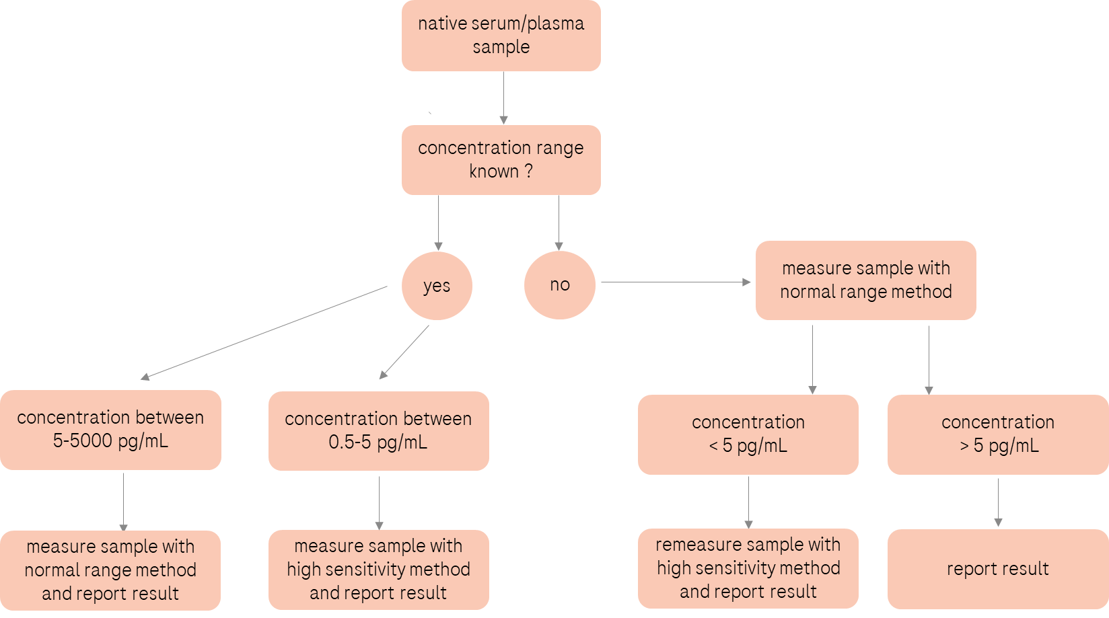
Figure 1: Flowchart to decide whether the normal range method or the high sensitivity method should be employed.

- Safety Precautions

CAUTION: Observe universal precautions, wear laboratory coats, safety glasses, and protective gloves during all steps of this method. Consider all serum specimen received for analysis as potentially positive infectious. We recommend the handling of biological materials in a microbiological safety cabinet. All areas in which biological material was handled have to be disinfected after work is completed. Any residual sample material as well as any plastic or glassware that contacts biological material has to be disposed by autoclaving; liquid waste has to be chemically deactivated.

CAUTION: For all chemicals, reagents and solvents used in this reference measurement procedure „Material safety data sheets“ (MSDSs) have to be considered and can be viewed e.g. at Sigma Aldrich Homepage (http://www.sigmaaldrich.com/sigma-aldrich/home.html) or at VWR Homepage (http://www.vwr.com/index.htm).

- Normal Range Method (5.00-5000 pg/mL)
  - Equipment and Instrumentation

Instrument: e.g. Mass Spectrometer AB Sciex QTrap 6500
coupled to an Agilent 1290 Infinity II LC System with two pumps and a column thermostat including a 2 position/ 10-port or 6-port switching valve*.

*) Alternatively, any conventional QQQ-mass spectrometer with an ESI-source coupled to an LC-system with two pumps can be used (with the same resolution, sensitivity and mass range) as long as the system suitability test is passed.

Columns: 1st Dimension: Waters Acquity BEH C18 1.7 µm, 50 x 2.1 mm
2nd Dimension: Restek Raptor Biphenyl 2.7 µm, 100 x 2.1 mm

Pre Column Filter: 1st Dimension: UltraShield UHPLC PreColumn Filter, Restek 0.5 µm frit
2nd Dimension: UltraShield UHPLC PreColumn Filter, Restek 0.5 µm frit

SLE cartridges: e.g. Phenomenex Novum SLE 6cc tube

Manifold: e.g. Supelco Visiprep with disposable PTFE liner

Pipettes: e.g. Eppendorf Reference variable 20-200 µL
Eppendorf Reference variable 100-1000 µL
Eppendorf Multipette E3

Balance: e.g. Metter Toledo ultra micro balance XP6U/M

Centrifuges: e.g. Eppendorf 5430R and 5810R

Evaporation System: e.g. Biotage TurboVap LV

Overhead rotation mixer: e.g. Sarstedt Sarmix M2000

Thermomixer: e.g. Eppendorf 5382 thermomixer C

Reaction tubes: e.g. Sarstedt polypropylene microtubes 1.5 mL

Caps for Reaction tubes: e.g. VWR PP Screw Cap

Centrifuge glasses: e.g. Marienfeld 16/17 x 98 mm

Caps for centrifuge glasses: e.g. VWR lamellar plugs, PP

HPLC Vials: e.g. VWR glass Vials 1.5 mL
HPLC Vial Caps: e.g. VWR PTFE Screw Cap, 9mm blue

Microinserts: e.g. VWR micro insert 0.1 mL, 31*6 mm

Filtration Tube e.g. Corning Costar SPIN-X centrifuge tube 20 µm

Volumetric flasks: e.g. Brand, 10 mL, 20 mL, 50 mL and 100 mL USP-certificated

Measuring cylinder: e.g. VWR in different volumina

Screw cap bottles (glass): e.g. Pyrex borosilicate glass bottles 1000 mL, with S.C.A.T safety caps

  - Preparation of Reagents, Calibration standards, Controls and all Other Materials

For all listed chemicals different vendors/ producers can be used, provided that the corresponding qualities are available. For all chemicals, reagents and solvents used in this reference measurement procedure „Material safety data sheets“ (MSDSs) have to be considered. All reagents/ solutions have to be signed with hazard symbols.

Certified reference materials, which fit the intended use, must be applied if available. A given certified reference material is supported by documentation providing source of material, and a specified property value with uncertainty and metrological traceability. If another material is used, the determination of the absolute content including measurement uncertainty by qNMR analysis is mandatory.

The ultra-microbalance used has to be calibrated and certified. The minimum sample weight has to be determined according to USP guidelines (USP Chapters 41 and 1251). Each weighing process has to be in accordance with the determined minimum sample weight.

Pipettes used have to be calibrated and certified by the manufacturer. The requalification intervals have to be compliant with the requirements communicated by the manufacturers as well as within the internal SOP. For pipetting organic solvents and body fluids, e.g. serum and plasma, solely use direct displacement pipettes.

For the preparation of stock and spike solutions, volumetric glassware has to be of highest quality with highest accuracy of measurement and has to fulfill requirements of ISO 1042 and USP. Glassware with USP individual certificate is required.

    - Chemicals and reagents

Material | Vendor / producer
17ß-Estradiol  CAS 50-28-2 | NMIJ  CRM 6004-a
17β-Estradiol-2,3,4-13C3  CAS 1261254-48-1 | Merck, Supelco  Cat. No.: E-073
17ß-Estradiol in human serum, low level | European Commission, Joint Research Centre (JRC), European Union  BCR 576
17ß-Estradiol in human serum, medium level | European Commission, Joint Research Centre (JRC), European Union  BCR 577
17ß-Estradiol in human serum, high level | European Commission, Joint Research Centre (JRC), European Union  BCR 578
Acetonitrile ULC/MS grade  CAS 75-05-8 | Biosolve  Cat No. 0001204102BS
Methanol absolute, ULC/MS grade  CAS 67-56-1 | Biosolve  Cat No. 0013684102BS
Ethyl acetate  CAS 141-78-6 | Merck  Cat No.: 1.00868.2500
2-Propanol  CAS 67-63-0 | Honeywell  Cat No.: 34863-2.5
Formic acid LC/MS grade  CAS 64-18-6 | Biosolve  Cat No. 06914132
Ammonium fluoride  CAS 12125-01-8 | Sigma Aldrich  Cat. No.: 338869-25G
Serum, steroid free* | Roche, serum <-> human, 3B3 f. MC3  Mat. Nr: 000000005866979001 or Golden West, Mass Spect Gold Human Serum, Ultra-Low Hormones & Steroids, SKU: MSG4000
Water | Milli-Q IQ 7000 system (Merck)

* The used steroid free serum needs to be checked for residual content of 17-ß Estradiol before use.

    - Preparation of Reagents

If the volume of solutions for either sample preparation or chromatographic analysis is not sufficient, a whole multiple of the given volume has to be prepared as described. Final volumes are combined prior to use.
Volumetric flasks, measuring cylinders and screw cap bottles need to be washed with methanol and Milli-Q water before use (dependent on eluent that will be used). The use of a dishwasher is not suitable for USP volumetric flasks.

      - 0.5 M ammonium fluoride solution

Weigh approximately 185 mg ammonium fluoride (M (NH₄F) = 37.04 g/mL) into a 10 mL volumetric flask. Fill the flask to the mark with Milli-Q water. Shake thoroughly until the solution is clear.

Store the ammonium fluoride solution at – 20 °C for a maximum of 3 months.

      - Mobile phases first dimension

Eluent A1: Milli-Q water
Fill 1000 mL Milli-Q water into a screw cap bottle (glass).

Eluent B1: acetonitrile
Fill 1000 mL acetonitrile into a screw cap bottle (glass).

Store mobile phases at room temperature. Eluent A is useable for a maximum of 2 weeks and eluent B for a maximum of 3 months.

      - Mobile phases second dimension

Eluent A2: 0.2 mM ammonium fluoride in Milli-Q water
Fill 1000 mL Milli-Q water into a screw cap bottle (glass) using a 1000 mL measuring cylinder and add 400 µL 0.5 M aqueous ammonium fluoride solution.

Eluent B2: methanol
Fill 1000 mL methanol into a screw cap bottle (glass).

Store mobile phases at room temperature. Eluent A is useable for a maximum of 2 weeks and eluent B for a maximum of 3 months.

      - Autosampler wash solutions

        - LC systems with multiwash option:

Wash solution 1: 50 % methanol in Milli-Q water
500 mL Milli-Q water and 500 mL methanol are combined in a 1000 mL screw cap bottle (glass).

Store autosampler wash solution at room temperature for a maximum of 6 months.

Wash solution 2: 0.1 % formic acid in acetonitrile
1000 mL acetonitrile and 1 mL of formic acid are combined in a 1000 mL screw cap bottle (glass).

Store autosampler wash solution at room temperature for a maximum of 12 months.

Wash solution 3: 2-propanol
Fill 1000 mL 2-propanol into a 1000 mL screw cap bottle (glass).

Store autosampler wash solution at room temperature for a maximum of 12 months.

        - LC systems without multiwash option:

Wash solution 4:
Fill 250 mL Milli-Q water, 250 mL methanol, 250 mL acetonitrile and 250 mL 2-propanol, for each using a
measuring cylinder, into a screw cap bottle (glass) and add 1000 µL formic acid.

Store autosampler wash solution at room temperature for a maximum of 12 months.

      - Other reagents

50 % methanol solution (1+1 v+v)
In a 1000 mL screw cap bottle (glass) mix 500 mL methanol (measuring cylinder) with 500 mL Milli-Q water (measuring cylinder).

Store 50 % methanol at room temperature for a maximum of 3 months.

100 mM Na₂CO₃-NaHCO₃ buffer
Dissolve 0.73 g sodium carbonate (M(Na₂CO₃) =105.98 g/mol) and 0.26 g sodium bicarbonate (M(NaHCO₃ M) = 84.01 g/mol) in 100 mL water.

Stable for one month at 4 °C.

Reconstitution buffer
Mix 25 mL methanol and 25 mL 100 mM Na₂CO₃-NaHCO₃ buffer.

Stable for one month at 4 °C.

    - Preparation of Calibration standards

As a primary reference material, the certified reference material (CRM) 6004-a from the National Measurement Institute of Japan (NMIJ) is used. The certified 17ß-Estradiol mass fraction and measurement uncertainty of the material is determined by quantitative ¹H-nuclear magnetic resonance spectroscopy (¹H-qNMR) as given in the certificate of analysis.

If a material from another vendor/ manufacturer is used the determination of the absolute content including measurement uncertainty by qNMR analysis is mandatory.

For pipetting solely use a Eppendorf Multipette E3 with the corresponding pipette tips as described in the following sections.

Note: Final calibrator concentrations are allowed to vary for a maximum of ± 10 % from the target value. Purity has to be either included by weighing more analyte to achieve the target concentration, or by multiplying the weighed amount with the purity factor.

If other pipettes or glassware is used, the uncertainty must be recalculated.

      - 17ß-Estradiol stock solutions for Calibration

Two independently weighed calibration stock solutions are prepared for calibrator preparation.

Material | Target | ID. No.
17ß-Estradiol (NMIJ) | approx. 10 mg | NMIJ 6004-a
Acetonitrile | approx. 100 mL | n.a.

Stock solution 17ß-Estradiol NR 1:
Weigh approximately 5 mg (± 5 %) 17β-Estradiol in a disposable weighing boat and transfer it into a 50 mL volumetric flask. Fill the volumetric flask to the mark with acetonitrile.
- c = 100 µg/mL (± 5 %)

Stock solution 17ß-Estradiol NR 2:
Weigh approximately 5 mg (± 5 %) 17β-Estradiol in a disposable weighing boat and transfer it into a 50 mL volumetric flask. Fill the volumetric flask to the mark with acetonitrile.
- c = 100 µg/mL (± 5 %)

      - 17ß-Estradiol working solutions for Calibration

Material | Target | ID No.
Stock solution 17ß-Estradiol NR 1 | 300 µL | See section 3.2.3.1
Stock solution 17ß-Estradiol NR 2 | 300 µL | See section 3.2.3.1
50 % methanol in Milli-Q water | approx. 240 mL | See section 3.2.2.5

Working solution 17ß-Estradiol NR 1:
Pipette 200 µL of the stock solution 17ß-Estradiol NR 1 directly into a 20 mL volumetric flask. Fill the flask to the mark with 50 % methanol. Use Combitip advanced® 0.2 mL.
- c = 1000 ng/mL

Working solution 17ß-Estradiol NR 2:
Pipette 200 µL of the stock solution 17ß-Estradiol NR 2 directly into a 20 mL volumetric flask. Fill the flask to the mark with 50 % methanol. Use Combitip advanced® 0.2 mL.
- c = 1000 ng/mL

Working solution 17ß-Estradiol NR 3:
Pipette 100 µL of the stock solution 17ß-Estradiol NR 1 directly into a 100 mL volumetric flask. Fill the flask to the mark with 50 % methanol. Use Combitip advanced® 0.1 mL.
- c = 100 ng/mL

Working solution 17ß-Estradiol NR 4:
Pipette 100 µL of the stock solution 17ß-Estradiol NR 2 directly into a 100 mL volumetric flask. Fill the flask to the mark with 50 % methanol. Use Combitip advanced® 0.1 mL.
- c = 100 ng/mL

      - 17ß-Estradiol Calibrator spike solutions

Material | Target | ID No.
Working solution 17ß-Estradiol NR 1 | 2000 µL | See section 3.2.3.2
Working solution 17ß-Estradiol NR 2 | 3000 µL | See section 3.2.3.2
Working solution 17ß-Estradiol NR 3 | 750 µL | See section 3.2.3.2
Working solution 17ß-Estradiol NR 4 | 1000 µL | See section 3.2.3.2
50 % methanol in Milli-Q water | approx. 280 mL | See section 3.2.2.5

Prepare calibrator spike solution as follows:
Pipette volumes of working solutions given in the table below into volumetric flasks for each calibrator spike solution. Fill the volumetric flasks with 50 % methanol to the mark.

 | Solution | Combitip advanced® | V Solution [µL] | V flask [mL] | Conc. [ng/mL]
Cal spike solution NR 1 | Working solution  17ß-Estradiol NR 3 | 0.5 mL | 250 | 100 | 0.250
Cal spike solution NR 2 | Working solution  17ß-Estradiol NR 4 | 0.5 mL | 500 | 100 | 0.500
Cal spike solution NR 3 | Working solution  17ß-Estradiol NR 3 | 0.5 mL | 500 | 20 | 2.50
Cal spike solution NR 4 | Working solution  17ß-Estradiol NR 4 | 0.5 mL | 500 | 10 | 5.00
Cal spike solution NR 5 | Working solution  17ß-Estradiol NR 1 | 0.5 mL | 500 | 20 | 25.0
Cal spike solution NR 6 | Working solution  17ß-Estradiol NR 2 | 0.5 mL | 500 | 10 | 50.0
Cal spike solution NR 7 | Working solution  17ß-Estradiol NR 1 | 2.5 mL | 1500 | 10 | 150
Cal spike solution NR 8 | Working solution  17ß-Estradiol NR 2 | 2.5 mL | 2500 | 10 | 250

Calibrator spike solutions (NR) are stable for 29 weeks when stored at – 80 °C.

      - 17ß-Estradiol Calibrator preparation

Material | Target | ID No.
Steroid free human serum | approx. 50 mL | n.a.
Cal spike solutions NR 1-8 | 100 µL | See section 3.2.3.3
50 % methanol in Milli-Q water | 100 µL | See section 3.2.2.5

Transfer volumes of 4900 µL steroid free* serum each to separate 15 mL tubes (Combitip advanced® 5 mL). Add 100 µL of the respective calibrator spike solutions NR 1-8 to the corresponding tube (Combitip advanced® 0.1 mL). For the zero sample, pipette 4900 µL steroid free serum into a 15 mL tube (Combitip advanced® 5 mL) and add 100 µL (Combitip advanced® 0.1 mL) 50 % methanol in Milli-Q water. Incubate all calibrator samples for 30 min on an overhead rotary mixer. Prepare aliquots of 500 µL (Combitip advanced® 5.0 mL, dispense mode).
* The used steroid free serum needs to be checked for residual content of 17ß-Estradiol before use.

Calibrators in steroid free serum (NR) are stable for 20 days when stored at -80 °C.

Final concentrations with 5 significant figures in matrix samples are approximately:

 | Concentration [pg/mL]
Zero | 0.00000
Cal 1 (NR) | 5.0000
Cal 2 (NR) | 10.000
Cal 3 (NR) | 50.000
Cal 4 (NR) | 100.00
Cal 5 (NR) | 500.00
Cal 6 (NR) | 1000.0
Cal 7 (NR) | 3000.0
Cal 8 (NR) | 5000.0

    - Preparation of Control samples

The certified reference materials BCR-576, BCR-577 and BCR-578, are used as control material as well as self-spiked controls (QCs) and a native patient sample.

The CRM material 6004-a from NMIJ is used for the preparation of self-spiked control samples.

Material from other vendors / producers can be used, if they are available in corresponding quality.

For pipetting solely use a Eppendorf Multipette E3 with the corresponding pipette tips as described in the following sections.

Note: Purity has to be either included by weighing more analyte to achieve the target concentration, or by multiplying the weighed amount with the purity factor.

      - 17β-Estradiol stock solution for Controls

Material | Target | ID. No.
17ß-Estradiol (NMIJ) | approx. 10 mg | NMIJ 6004-a
Acetonitrile | approx. 50 mL | n.a.

Stock solution 17ß-Estradiol NR 3:
Weigh approximately 5 mg (± 5 %) 17β-Estradiol in a disposable weighing boat and transfer it into a 50 mL volumetric flask. Fill the volumetric flask to the mark with acetonitrile.
- c = 100 µg/mL (± 5 %)

      - 17β-Estradiol working solution for Controls

Material | Target | ID. No.
Stock solution 17ß-Estradiol NR 3 | 1100 µL | See section 3.2.4.1
50 % methanol in Milli-Q water | approx. 20 mL | See section 3.2.2.5

Working solution 17ß-Estradiol NR 5:
Pipette 200 µL of the stock solution 17ß-Estradiol NR 3 directly into a 20 mL volumetric flask. Fill the flask to the mark with 50 % methanol. Use Combitip advanced® 0.2 mL.
- c = 1000 ng/mL

Working solution 17ß-Estradiol NR 6:
Pipette 100 µL of the stock solution 17ß-Estradiol NR 3 directly into a 100 mL volumetric flask. Fill the flask to the mark with 50 % methanol. Use Combitip advanced® 0.1 mL.
- c = 100 ng/mL

      - 17β-Estradiol spike solutions for Controls

Material | Target | ID. No.
Working solution 17ß-Estradiol NR 5 | 3500 | See section 3.2.4.2
Working solution 17ß-Estradiol NR 6 | 375 | See section 3.2.4.2
50 % methanol in Milli-Q water | approx. 70 mL | See section 3.2.2.5

Prepare control spike solution as follows:
Pipette volumes of working solutions given in the table below into volumetric flasks for each control spike solution. Fill the volumetric flasks with 50 % methanol to the mark.
 | Solution | Combitip advanced® [mL] | V Solution [µL] | V flask [mL] | Conc. [ng/mL]
QC spike solution NR 1 | Working solution  17ß-Estradiol NR 6 | 0.5 mL | 375 | 50 | 0.750
QC spike solution NR 2 | Working solution  17ß-Estradiol NR 5 | 5.0 mL | 3500 | 20 | 175

Control spike solutions (NR) are stable for 29 weeks when stored at - 80 °C.

      - 17ß-Estradiol Control preparation

Material | Target | ID. No.
Steroid free human serum | approx. 10 mL | n.a.
QC spike solutions NR 1-2 | 100 µL | See section 3.2.4.3

Transfer volumes of 4900 µL steroid free serum* each to separate 15 mL tubes (Combitip advanced® 5 mL). Add 100 µL of the respective QC spike solutions NR 1-2 to the corresponding tubes (Combitip advanced® 0.1 mL). Incubate all control samples for 30 min on an overhead rotary mixer. Aliquots of 500 µL (Combitip advanced® 5.0 mL, dispense mode) are prepared.
* The used steroid free serum needs to be checked for residual content of 17ß-Estradiol before use.

Controls in steroid free serum (NR) are stable for 20 days when stored at -80°C.

Final concentrations with 5 significant figures in matrix samples are approximately:

 | Concentration [pg/mL]
QC 1 (NR) | 15.000
QC 2 (NR) | 3500.0

      - Patient Control samples (QC native)

In addition to the self-spiked control samples, one native anonymized patient sample is used as QC sample to establish a control chart.
Store 500 µL aliquots (Combitip advanced® 5.0 mL, dispense mode) of this sample at - 80 °C until they are required. Ensure an overlap of minimum 5 samples starting with a new batch of native samples.

      - ERM Panel

BCR-576, BCR-577 and BCR-578, certified secondary reference materials, are used as additional control materials. These samples are lyophilized human serum samples stored in ampoules. The reconstitution procedure is described in the certificate of analysis. Aliquots of 500 µL (Combitip advanced® 5.0 mL, dispense mode) can be prepared and stored at ‑ 80 °C until use.

The reconstituted BCR-576, BCR-577 and BCR-578 are stable for 20 days when stored at -80°C.

Other certified reference materials can be used, if they are available in corresponding qualities.

NOTE: If other certified secondary reference materials / batches are used certificates have to be checked and values adjusted if needed.

    - Internal standard solution

Commercially available isotope-labeled material from other vendors/ producers can be used, if they are available with the desired isotopic composition.

      - Internal standard stock solution NR

Material | Target | ID. No.
17β-Estradiol-2,3,4-¹³C₃ (100 μg/mL) | 1 mL | E-073

Store internal standard stock solution (NR) at – 80 °C.

      - Internal standard working solution NR

Material | Target | ID. No.
Internal standard stock solution NR | 20 µL | E-073
Acetonitrile | 20 mL | n.a.

Pipette 20 µL (Combitip advanced® 0.1 mL) of the internal standard stock solution NR (Cerilliant) directly into a 20 mL volumetric flask and fill it to the mark with acetonitrile. Aliquots are stored at - 80 °C until they are required.
- c = 100 ng/mL

      - Internal standard spike solution NR

Material | Target | ID. No.
Internal standard working solution NR | 500 µL | n.a
50% methanol | 50 mL | See section 3.2.2.5

Pipette 500 µL (Combitip advanced® 0.5 mL) of the internal standard working solution NR directly into a 50 mL volumetric flask and fill it to the mark with 50 % methanol. Aliquots are stored at - 80 °C until they are required.
- c = 1.0 ng/mL

    - System suitability test samples NR

Material | Target
Cal spike solution NR 1 | 80 µL
Cal spike solution NR 8 | 80 µL
Internal standard spike solution NR | 400 µL
Reconstitution buffer | 2 mL

520 µL reconstitution buffer are transferred into two separate 1.5 mL Sarstedt micro tube (Combitip advanced® 1.0 mL) and 80 µL of the respective Calibrator is added to each vial (Combitip advanced® 0.1 mL). Then 400 µL Internal standard spike solution NR (Combitip advanced® 0.5 mL) is added to each vial and the resulting solution is vortexed for 10 seconds.
Both samples are transferred to an HPLC-vial and stored in the autosampler at 8 °C until further analysis.

  - Specimen Collection, Storage and Handling Procedure

As sample matrix, serum, plasma (Lithium Heparin plasma, K2 EDTA plasma and K3 EDTA plasma) and steroid free serum can be used. Various freeze thaw cycles should be avoided. All used native samples are anonymized.

High concentrated samples (>5000 pg/mL) have to be diluted 1+1 (v+v) with human serum (e.g. Golden West, Mass Spect Gold Human Serum, Ultra-Low Hormones & Steroids) before sample preparation. Therefore, 450 µL of the sample are diluted with 450 µL steroid free human serum. After mixing for 30 min on an overhead shaker 100 µL of the diluted samples are used for further sample preparation.

CAUTION: Consider all serum and plasma specimen received for analysis as potentially positive infectious. We recommend the handling of biological materials in a microbiological safety cabinet. All areas in which biological material is handled have to be disinfected after work is completed. Any residual sample material as well as any plastic or glassware that contacts biological material has to be disposed by autoclaving; liquid waste has to be chemically deactivated.

    - Sample preparation

Material | Target per sample
Native sample, calibrator, control | 450 µL
Internal standard spiking solution NR | 50 µL
SLE Cartridges 6cc | 1
Milli-Q water | 500 µL
Ethyl acetate | 5000 µL
Reconstitution buffer | 100 µL
Spin-X centrifuge tubes | 1

Schematic overview of sample preparation:

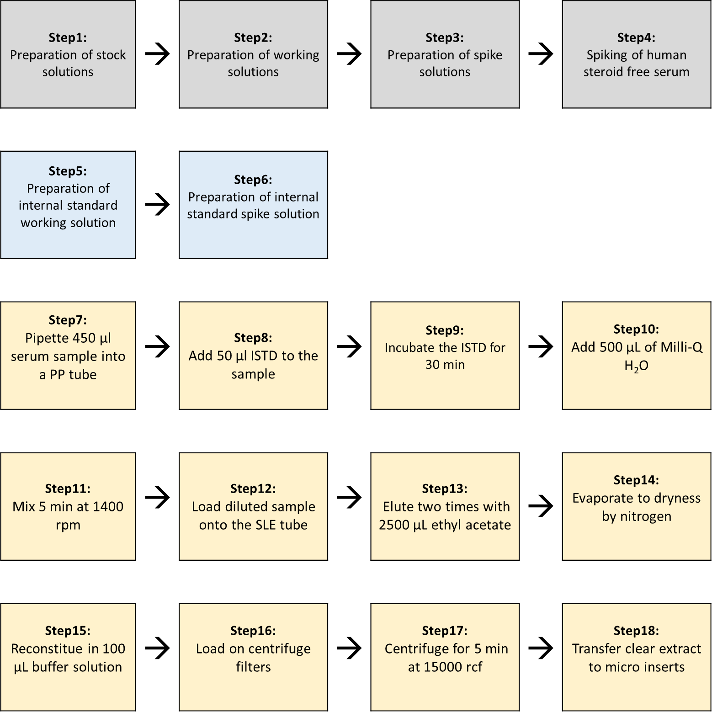

Transfer 450 µL native sample, calibrator or control sample (Combitip advanced® 0.5 mL) into a 1.5 mL screw cap. Add 50 µL of the internal standard spike solution NR (Combitip advanced® 0.5 mL, dispense mode) and incubate samples on an overhead shaker for 30 min at room temperature. Add 500 µL Milli-Q water to each sample and shake them for 5 min on a thermomixer at 1400 rpm. For final sample purification 1000 µL of the sample/water mixture is loaded onto a 6cc Novum SLE cartridge. Start the equilibration by applying vacuum for 5 seconds and let sit for 15 min. For extraction, add 2.5 mL ethyl acetate and capture the extract in a glass tube. Repeat this step once.
Evaporate the extract to dryness in a nitrogen evaporation system (50 °C, 1.3 mL/min, 20 min) and reconstitute the residue in 100 µL reconstitution buffer. Filter the solution using centrifuge filter tubes (5 min, 15000 rcf) and transfer it into a HPLC vial with a 150 µL insert.

  - Procedure operating instructions, System Suitability Test (SST) and the Structure of analytical series

The preparation of the LC-MS system is carried out as described in the manufacturer’s instructions for use.
Prior to sample analysis a system suitability test (SST, Chapter 3.4.2) needs to be passed.
All details concerning hazards and precaution, analytical solutions and analytical portions are described in chapter 2 and chapter 3.

    - LC-MS parameter

      - LC parameter

Analysis system: Agilent 1290 Infinity LC system, including two binary pumps, a column temperature control device with a 2 position/ 10-port or 6-port switching valve and an autosampler *)

*) Alternatively, any conventional QQQ-mass spectrometer with an ESI-source coupled to an LC-system with two pumps can be used (with the same resolution, sensitivity and mass range) as long as the system suitability test is passed.

Stationary phase: 1st Dimension: Waters Acquity BEH C18 1.7 µm, 50 x 2.1 mm
2nd Dimension: Restek Raptor Biphenyl 2.7 µm, 100 x 2.1 mm

Pre Column Filter: 1st Dimension: UltraShield UHPLC PreColumn Filter, Restek 0.5 µm frit
2nd Dimension: UltraShield UHPLC PreColumn Filter, Restek 0.5 µm frit

Mobile phase 1st Dimension: Eluent A1: Milli-Q water
Eluent B1: acetonitrile

Mobile phase 2nd Dimension: Eluent A2: 0.2 mM ammonium fluoride in Milli-Q water
Eluent B2: methanol

Autosampler: temperature control set to 8 °C

Injection volume: 20 µL
Flow rate: 1st dimension: 300 µL/min
2nd dimension: 500 µL/min

Column temperature: 50 °C

LC gradient:

1st Dimension:
Time [min] | Flow [ml/min.] | Eluent A [%] | Eluent B [%]
0.00 | 0.30 | 80 | 20
0.25 | 0.30 | 80 | 20
2.00 | 0.30 | 55 | 45
3.50 | 0.30 | 55 | 45
3.60 | 0.30 | 3 | 97
7.40 | 0.30 | 3 | 97
7.50 | 0.30 | 80 | 20
9.00 | 0.30 | 80 | 20

2nd Dimension:
Time [min] | Flow [ml/min.] | Eluent A [%] | Eluent B [%]
0.00 | 0.50 | 3 | 97
0.50 | 0.50 | 3 | 97
0.60 | 0.50 | 90 | 10
3.30 | 0.50 | 90 | 10
8.00 | 0.50 | 3 | 97
9.00 | 0.50 | 3 | 97

Autosampler wash method for LC systems with multiwash function:

Step | Solvent | Wash Time [sec.] | Seat Back Flush | Needle Wash
1 | Wash solution 1 | 5 | Yes | No
2 | Wash solution 2 | 5 | Yes | Yes
3 | Wash solution 3 | 5 | Yes | Yes
4 | Wash solution 1 | -- | Yes | No

Autosampler wash method for LC systems without multiwash function:

Step | Program Table | Solvent
1 | Wash needle flush seat for 10 sec. | Wash solution 4
2 | Wash needle in flush port for 10 sec. | Wash solution 4
3 | Valve mainpass | ---
4 | Valve bypass | ---
5 | Valve mainpass | ---
6 | Valve bypass | ---
7 | Draw def. amount from sample, def. speed, def. offset | ---
8 | Inject | ---
Note: With alternative LC-systems, an equally effective autosampler cleaning procedure must be used so that carry-over can be avoided.

Column Switching Valve:

Time [min] | Function | Parameter
2.73 | Change Valve Position | Column at Position 2
2.88 | Change Valve Position | Column at Position 1
Note: For the heart cut, the analyte peak in the 1st dimension is cut out with a window of 0.15 min and transferred to the 2nd dimension via a 100 µL-loop. For the whole procedure, the highest calibrator is used. First, the calibrator is injected only on the 1st dimension to determine the approximate cutting time. After determining a stable retention time in the 1st dimension, various 2D-LC methods are written which differs in the cutting of the heart-cut by approx. 0.02 min. The methods are then measured one after the other so that the peak is scanned in the 1st dimension and transferred to the 2nd dimension. The analyte areas and the areas of the internal standard are applied and the method with the highest signal is used as the final method.

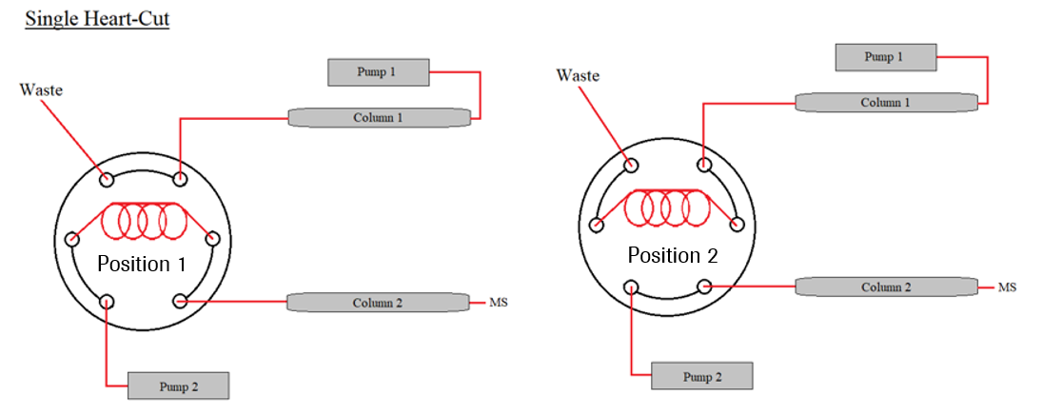

      - MS and source parameters

Analysis system: e.g. mass spectrometer AB Sciex QTrap 6500 operating in the electrospray ionization (ESI) mode and selecting ions at unit resolution in the multiple reaction mode (MRM mode) *)

*) Alternatively, any conventional triple-quadrupol-mass spectrometer equipped with an ESI-Source (with comparable resolution, sensitivity and mass range) can be used, if the system suitability test is passed successfully

Manual tuning for optimal and stable signal in ESI- mode for 17ß-Estradiol transitions.
Tuning solution: 100 ng/mL in Eluent A: Eluent B (20:80) (first dimension)
Syringe pump: 10 µL/min
SIM Mode negative m/z 271.2 Q1 mass
MRM Mode negative m/z 271.2 → 145.0 (Quantifier) and 271.2 → 182.9 (Qualifier)

Typical values for MRM parameters are:
Compound | Precursor [m/z] | Product [m/z] | DP  [V] | CE  [V] | CXP  [V] | Dwell Time [msec]
17β-Estradiol Quan | 271.2 | 145.0 | -55 | -52 | -15 | 50
17β-Estradiol Qual | 271.2 | 182.9 | -55 | -48 | -17 | 50
17β-Estradiol-13C3 Quan | 274.2 | 147.9 | -55 | -52 | -15 | 50
17β-Estradiol-13C3 Qual | 274.2 | 186.0 | -55 | -48 | -17 | 50

Manual optimization of source parameters for all transitions in ESI- mode with syringe pump and HPLC-System connected over T-piece assembly.
Eluents: 10 % Eluent A2 and 90 % Eluent B2 (flow rate 500 µl/min).

Typical final ESI- source parameter values parameters from manual tuning under which an optimal (stable ion yield over the peak, high sensitivity) estradiol peak was realized in all transitions:

Parameter | Value (QTrap 6500) negative mode
Curtain Gas (psi) | 35
Collision Gas | High
Spray Voltage (Volt) | -4500
Temperature (°C) | 650
Ion Source Gas 1 (psi) | 40
Ion Source Gas 2 (psi) | 70
Entrance Potential (Volt) | -10

All settings and conditions may vary from device to device and can be adapted.

    - System suitability test NR

To assure the long-term traceability of the method a system suitability test (SST) is performed.

Material | Target
SST NR 1 | 20.0 pg/ml 17ß-Estradiol in 50 % methanol
SST NR 2 | 20000 pg/ml 17ß-Estradiol in 50 % methanol

To pass the SST, S/N has to be ≥ 100 for SST NR 1 for the quantifier transition.

To examine a potential carry over SST NR 2 is injected followed by the injection of two solvent blanks. The analyte peak area observed in the first blank needs to be ≤ 35 % of the analyte peak area of the SST NR 1. The analyte peak area observed in the second blank needs to be ≤ 15 % of the analyte peak area of the SST NR 1 to pass the SST.
The retention time of analyte signal in SST NR 1 and SST NR 2 has to be 7.5 min ± 0.5 min.

Note: To calculate the noise, the software uses the SD (using a mean of zero) of all the chromatographic data points between the specified background. To calculate the S/N ratio, the background from 6.50 to 7.00 min is used.

    - System Maintenance

After analysis is finished, the whole system, including column, is flushed with 50 % methanol for 30 min.
Columns are stored in 100 % methanol at room temperature.

    - Calibration

For calibration, the spiked calibrators (see section 3.2) are prepared as described in section 3.3.1. Calibration is performed in bracketing mode and calibrator levels are measured in increasing concentration.
The calibration function (using 8 levels) is obtained by quadratic regression and 1/x weighting.

  - Structure of analytical series

Sequences setup may vary due to specific measurement requirements.

- Solvent blank (5 times for sufficent equilibration of the 2D system)
- SST 1 (Cal 1 in neat)
- SST 2 (Cal 8 in neat)
- Solvent blank SST 1
- Solvent blank SST 2
- Zero (matrix with IS, without analyte)
- 2x solvent blank
- Calibrators (increasing concentration)
- 2x solvent blank
- QCs (spiked QCs in increasing concentration and native QCs)
- 2x solvent blank
- Samples (Unknowns) *, **, ***
- 2x solvent blank
- QCs (spiked QCs in increasing concentration and native QCs)
- 2x solvent blank
- Calibrators (increasing concentration)
- 2x solvent blank

* If reference values should be assigned the number of sample preparations is depended on the desired measurement uncertainty (n = x). Additionally, samples have to be measured at least at two different days.
** If a method comparison study has to be performed, or complaint samples have to be measured, samples are prepared with a n= 1.
*** To avoid carry-over from extremly high concentrated samples (>3500 pg/mL) to very low concentrated samples (<20 pg/mL), measurement of the low concentrated sample should be repeated.

With this method all calibrators and QCs are measured in duplicate (n=2 injections) and unknown samples are injected once. As unknown samples, native serum and plasma samples can be measured.

  - Data processing and Calculation of measurement results

For the raw file processing, the Analyst software, e.g. version 1.6.2 or higher is used with IntellliQuan as the Quantitation Integration Algorithm. 17ß-Estradiol and its internal standard show a retention time of 7.5 minutes and are integrated with a 30 sec window. Raw data are processed with a smoothing factor of three. The calibration curve (8 levels) is quadratic with a 1/x weighting. The calibration function (using 8 levels) is obtained by quadratic regression of the area ratios of the analyte and the internal standard (y) over the analyte concentration (x) resulting by the function, y = a2x² + a1x + a0

The nominal concentrations of calibrator and QC samples are entered with 5 significant figures into the Analyst software. The reportable result is calculated in pg/mL with 3 significant figures. Measurement uncertainty SD (ng/mL) is reported with 3 significant figures, and the CV (%) with 1 decimal place.
For the assignment of reference or target values, the reportable result is calculates as the arithmetic mean of n = x sample preparations, in which sample preparations are performed over at least two days. Measurement uncertainty is calculated and reported as total uncertainty, given by the formula:

$${unc}_{total}=\sqrt{{unc}_{cal}^{2}+{(\frac{{unc}_{prec}}{\sqrt{n}})}^{2}}$$

(unc_{cal}) uncertainty of calibrator preparation
(unc_{prec}) uncertainty of n= x sample preparations

Results of a method comparison study or complaint sample (n= 1) are reported as the reportable result with the measurement uncertainty determined within the validation.

$${unc}_{total}=\sqrt{{unc}_{cal}^{2}+{unc}_{prec}^{2}}$$

(unc_{cal}) uncertainty of calibrator preparation
(unc_{prec}) uncertainty of precision experiment within the validation

If other pipettes or glassware are used, the uncertainty must be recalculated.

  - Reporting of Results

All analysis requests are controlled by a sample management system. Each sample / sample set to be measured has to be requested using a specific order form which includes:
- identification of source and type of sample (native samples are anonymized)
- sample receipt and latest date of measurement
- sample storage place
- reference measurement procedure employed

Within the corresponding report, results are presented as follows:
- short description on reference measurement procedure used
- observations of unusual properties of sample
- observations as unusual features of the measurement procedure or use of modifications
- results are reported with sample name / identification name, numerical value, measurement unit and measurement uncertainty if required

All data (e.g. sequences, raw data, and calculations) have to be checked in four-eyes principle. Except for calculations done by a validated tool, e.g. Biowarp. The final report has to be signed from the operator and approver.

- High Sensitivity method

  - Equipment and Instrumentation

Instrument: e.g. Mass Spectrometer AB Sciex QTrap 6500
coupled to an Agilent 1290 Infinity II LC System with two pumps and a column thermostat including a 2 position/ 10-port or 6-port switching valve*.

*) Alternatively, any conventional QQQ-mass spectrometer with an ESI-source coupled to an LC-system with two pumps can be used (with the same resolution, sensitivity and mass range) as long as the system suitability test is passed.

Columns: 1st Dimension: Waters Acquity BEH C8 1.7 µm, 50 x 2.1 mm
2nd Dimension: Restek Raptor Biphenyl 2.7 µm, 100 x 2.1 mm

Pre Column Filter: 1st Dimension: UltraShield UHPLC PreColumn Filter, Restek 0.5 µm frit
2nd Dimension: UltraShield UHPLC PreColumn Filter, Restek 0.5 µm frit

Pipettes: e.g. Eppendorf Reference variable 20-200 µL
Eppendorf Reference variable 100-1000 µL
Eppendorf Multipette E3 or Xstream

Balance: e.g. Metter Toledo ultra micro balance XP6U/M

Centrifuges: e.g. Eppendorf 5430R and 5810R

Evaporation System: e.g. Biotage TurboVap LV

Overhead rotation mixer: e.g. Sarstedt Sarmix M2000

Reaction tubes: e.g. Sarstedt polypropylene microtubes 1.5 mL

Caps for Reaction tubes: e.g. VWR PP Screw Cap

Centrifuge glasses: e.g. Pyrex, disposable 12 x 75mm borosilicate glass tubes
Pyrex, 10 mL disposable glass conical centrifuge tubes with screw cap

Caps for centrifuge glasses: e.g. VWR lamellar plugs, PP

HPLC Vials: e.g. VWR glass Vials 1.5 mL

HPLC Vial Caps: e.g. VWR PTFE Screw Cap, 9mm blue

Microinserts: e.g. VWR micro insert 0.1 mL, 31*6 mm

Volumetric flasks: e.g. Brand, 10 mL, 20 mL, 50 mL and 250 mL USP-certificated

Measuring cylinder: e.g. VWR in different volumina

Screw cap bottles (glass): e.g. Pyrex borosilicate glass bottles 1000 mL, with S.C.A.T safety caps

Block heater: e.g. IKA Dry block heater 1

  - Preparation of Reagents, Calibration standards, Controls and all Other Materials

For all listed chemicals and reagents different vendors/producers can be used, provided that the corresponding qualities are available. For all chemicals, reagents and solvents used in this reference measurement procedure „Material safety data sheets“ (MSDSs) have to be considered. All reagents / solutions have to be signed with hazard symbols.

Certified reference materials, which fit the intended use, must be applied if available. A given certified reference material is supported by documentation providing source of material, and a specified property value with uncertainty and metrological traceability. If another material is used the determination of the absolute content including measurement uncertainty by qNMR analysis is mandatory.

The ultra-microbalance used has to be calibrated and certified. The minimum sample weight has to be determined according to USP guidelines (USP Chapters 41 and 1251). Each weighing process has to be in accordance with the determined minimum sample weight.

Pipettes used have to be calibrated and certified by the manufacturer. The requalification intervals have to be compliant with the requirements communicated by the manufacturers as well as within the internal SOP. For pipetting organic solvents and body fluids, e.g. serum and plasma, solely use direct displacement pipettes.

For the preparation of stock and spike solutions, volumetric glassware has to be of highest quality with highest accuracy of measurement and has to fulfill requirements of ISO 1042 and USP. Glassware with USP individual certificate is required.

    - Chemicals and reagents

Material | Vendor / producer
17ß-Estradiol  CAS 50-28-2 | NMIJ  CRM 6004-a
17β-Estradiol-d5  CAS 221093-45-4 | Merck, Supelco  Cat. No.: E-061
17ß-Estradiol in human serum, low level | European Commission, Joint Research Centre (JRC), European Union  BCR 576
Acetonitrile ULC/MS grade  CAS 75-05-8 | Biosolve  Cat No. 0001204102BS
Methanol absolute, ULC/MS grade  CAS 67-56-1 | Biosolve  Cat No. 0013684102BS
Ethyl acetate  CAS 141-78-6 | Merck  Cat No.: 1.00868.2500
n-Heptane  CAS 142-82-5 | Sigma  Cat No.: 650536-1L
2-Propanol  CAS 67-63-0 | Honeywell  Cat No.: 34863-2.5
Formic acid LC/MS grade  CAS 64-18-6 | Biosolve  Cat No. 06914132
Dansylchloride  CAS 605-65-2 | Sigma-Aldrich Supelco  Car. No. 03641-100MG
Serum, steroid free* | Roche, serum <-> human, 3B3 f. MC3  Mat. Nr: 000000005866979001 or Golden West, Mass Spect Gold Human Serum, Ultra-Low Hormones & Steroids, SKU: MSG4000
Water | Milli-Q IQ 7000 system (Merck)

* The used steroid free serum needs to be checked for residual content of 17-ß Estradiol before use.

    - Preparation of Reagents

If the volume of solutions for either sample preparation or chromatographic analysis is not sufficient, a whole multiple of the given volume has to be prepared as described. Final volumes are combined prior to use.
Volumetric flasks, measuring cylinders and screw cap bottles need to be washed with methanol and Millipore water before use (dependent on eluent that will be used). The use of a dishwasher is not suitable for USP volumetric flasks.

      - Mobile phases first dimension

Eluent A1: 0.1 % formic acid in Milli-Q water
Fill 1000 mL Milli-Q water into a screw cap bottle (glass) using a 1000 mL measuring cylinder, add 1 mL formic acid and mix gently.

Eluent B1: 0.1 % formic acid in acetonitrile
Fill 1000 mL acetonitrile into a screw cap bottle (glass) using a 1000 mL measuring cylinder, add 1 mL formic acid and mix gently.

Store mobile phases at room temperature. Eluent A is useable for a maximum of 2 weeks and eluent B for a maximum of 6 months.

      - Mobile phases second dimension

Eluent A2: 0.1 % formic acid in Milli-Q water
Fill 1000 mL Milli-Q water into a screw cap bottle (glass) using a 1000 mL measuring cylinder, add 1 mL formic acid and mix gently.

Eluent B2: 0.1 % formic acid in methanol:acetonitrile (7+3 v+v)
Fill 700 mL methanol into a screw cap bottle (glass) using a 1000 mL measuring cylinder and add 300 mL acetonitrile using a 1000 mL measuring cylinder. Then add 1 mL formic acid and mix gently.

Store mobile phases at room temperature. Eluent A is useable for a maximum of 2 weeks and eluent B for a maximum of 6 months.

      - Autosampler wash solutions

        - LC systems with multiwash option:

Wash solution 1: 50 % methanol in Milli-Q water
500 mL Milli-Q-water and 500 mL methanol are combined in a 1000 mL screw cap bottle (glass).

Store autosampler wash solution at room temperature for a maximum of 6 months.

Wash solution 2: 0.1 % formic acid in acetonitrile
1000 mL acetonitrile and 1 mL of formic acid are combined in a 1000 mL screw cap bottle (glass).

Store autosampler wash solution at room temperature for a maximum of 12 months.

Wash solution 3: 2-propanol
Fill 1000 mL 2-propanol into a 1000 mL screw cap bottle (glass).

Store autosampler wash solution at room temperature for a maximum of 12 months.

        - LC systems without multiwash option:

Wash solution 4:
Fill 250 mL Milli-Q water, 250 mL methanol, 250 mL acetonitrile and 250 mL 2-propanol, for each using a
measuring cylinder, into a screw cap bottle (glass) and add 1000 µL formic acid.

Store autosampler wash solution at room temperature for a maximum of 12 months.

      - Other reagents

50 % methanol solution (1+1 v+v)
In a 1000 mL screw cap bottle (glass) mix 500 mL methanol (measuring cylinder) with 500 mL Milli-Q water (measuring cylinder).

Store 50 % methanol at room temperature for a maximum of 3 months.

Heptane:ethylacetate (9+1 v+v)
Combine 50 mL ethyl acetate and 450 mL heptane in a 500 mL screw cap bottle and mix gently.

100 mM Na₂CO₃-NaHCO₃ buffer
Dissolve 0.73 g sodium carbonate (M(Na₂CO₃) =105.98 g/mol) and 0.26 g sodium bicarbonate (M(NaHCO₃ M) = 84.01 g/mol) in 100 mL water.

Stable for one month at 4 °C.

Reconstitution buffer
Mix 25 mL methanol and 25 mL 100 mM Na₂CO₃-NaHCO₃ buffer.

Stable for one month at 4 °C

Dansylchloride in acetonitrile
Weigh 5 mg dansylchloride in a disposable weighing boat and transfer it into a 10 mL glass vial. Add a acetonitrile volume in accordance to the exact weighing to receive a solution with a final concentration of 1 mg/mL.

Prepare this solution fresh prior to the derivatization reaction.

    - Preparation of Calibration standards

As a primary reference material, the certified reference material (CRM) 6004-a from the National Measurement Institute of Japan (NMIJ) is used. The certified 17ß-Estradiol mass fraction and measurement uncertainty of the material is determined by quantitative ¹H-nuclear magnetic resonance spectroscopy (¹H-qNMR) as given in the certificate of analysis.

If a material from another vendor/manufacturer is used the determination of the absolute content including measurement uncertainty by qNMR analysis is mandatory.

For pipetting solely use a Eppendorf Multipette E3 with the corresponding pipette tips as described in the following sections.

Note: Final calibrator concentrations are allowed to vary for a maximum of ± 10 % from the target value. Purity has to be either included by weighing more analyte to achieve the target concentration, or by multiplying the weighed amount with the purity factor.
If other pipettes or glassware is used, the uncertainty must be recalculated.

      - 17ß-Estradiol stock solutions for Calibration

Two independently weighed calibration stock solutions are prepared for calibrator preparation.

Material | Target | ID. No.
17ß-Estradiol (NMIJ) | approx. 10 mg | NMIJ 6004-a
Acetonitrile | approx. 100 mL | n.a.

Stock solution 17ß-Estradiol HS 1:
Weigh approximately 5 mg (± 5 %) 17β-Estradiol in a disposable weighing boat and transfer it into a 50 mL volumetric flask. Fill the volumetric flask to the mark with acetonitrile.
- c = 100 µg/mL (± 5 %)

Stock solution 17ß-Estradiol HS 2:
Weigh approximately 5 mg (± 5 %) 17β-Estradiol in a disposable weighing boat and transfer it into a 50 mL volumetric flask. Fill the volumetric flask to the mark with acetonitrile.
- c = 100 µg/mL (± 5 %)

      - 17ß-Estradiol working solutions for Calibration

Material | Target | ID. No
Stock solution 17ß-Estradiol HS 1 | 50 µL | See section 4.2.3.1
Stock solution 17ß-Estradiol HS 2 | 50 µL | See section 4.2.3.1
50 % methanol in Milli-Q water | approx. 500 mL | See section 4.2.2.4

Working solution 17ß-Estradiol HS 1:
Pipette 50 µL of the stock solution 17ß-Estradiol HS 1 directly into a 250 mL volumetric flask. Fill the flask to the mark with 50 % methanol. Use Combitip advanced® 0.1 mL.
- c = 20 ng/mL

Working solution 17ß-Estradiol HS 2:
Pipette 50 µL of the stock solution 17ß-Estradiol2 HS 2 directly into a 250 mL volumetric flask. Fill the flask to the mark with 50 % methanol. Use Combitip advanced® 0.1 mL.
- c = 20 ng/mL

      - 17ß-Estradiol Calibrator spike solutions

Material | Target | ID. No
Working solution 17ß-Estradiol HS 1 | 250 µL | See section 4.2.3.2
Working solution 17ß-Estradiol HS 2 | 325 µL | See section 4.2.3.2
50 % methanol in Milli-Q water | approx. 130 mL | See section 4.2.2.4

Prepare calibrator spike solution as follows:
Pipette volumes of working solutions given in the table below into volumetric flasks for each calibrator spike solution. Fill the volumetric flasks with 50 % methanol to the mark.

 | Solution | Combitip advanced® | V Solution [µL] | V flask [mL] | Conc. [ng/mL]
Cal spike solution HS 1 | Working solution  17ß-Estradiol HS 1 | 0.1 mL | 50 | 50 | 0.0200
Cal spike solution HS 2 | Working solution  17ß-Estradiol HS 2 | 0.1 mL | 50 | 20 | 0.0500
Cal spike solution HS 3 | Working solution  17ß-Estradiol HS 1 | 0.1 mL | 100 | 20 | 0.100
Cal spike solution HS 4 | Working solution  17ß-Estradiol HS 2 | 0.2 mL | 150 | 20 | 0.150
Cal spike solution HS 5 | Working solution  17ß-Estradiol HS 1 | 0.1 mL | 100 | 10 | 0.200
Cal spike solution HS 6 | Working solution  17ß-Estradiol HS 2 | 0.2 mL | 125 | 10 | 0.250

Calibrator spike solutions (HS) are stable for 45 weeks when stored at – 80 °C.

      - Calibrator preparation

Material | Target | ID. No
Steroid free human serum | approx. 30 mL | n.a.
Cal spike solutions HS 1-6 | 100 µL | See section 4.2.3.3
50 % methanol in Milli-Q water | 100 µL | See section 4.2.2.4

Transfer volumes of 4900 µL steroid free serum* each to separate 15 mL tubes (Combitip advanced® 5 mL). Add 100 µL of the respective calibrator spike solutions HS 1-6 to the corresponding tube (Combitip advanced® 0.1 mL). For the zero sample, pipette 4900 µL steroid free serum into a 15 mL tube (Combitip advanced® 5 mL) and add 100 µL (Combitip advanced® 0.1 mL) 50 % methanol in Milli-Q water. Incubate all calibrator samples for 30 min on an overhead rotary mixer. Prepare aliquots of 1000 µL (Combitip advanced® 10.0 mL, dispense mode).

Calibrators in steroid free serum (HS) are stable for 6 weeks when stored at -80 °C.

* The used steroid free serum needs to be checked for residual content of 17ß-Estradiol before use.

Final concentrations with 5 significant figures in matrix samples are approximately:

 | Concentration [pg/mL]
Zero | 0.00000
Cal 1 (HS) | 0.40000
Cal 2 (HS) | 1.0000
Cal 3 (HS) | 2.0000
Cal 4 (HS) | 3.0000
Cal 5 (HS) | 4.0000
Cal 6 (HS) | 5.0000

    - Preparation of Control samples

The certified reference materials BCR-576 ((1+9 v+v) diluted) is used as control material as well as self-spiked controls (QCs).

The CRM material 6004-a from NMIJ is used for the preparation of self-spiked control samples.

Material from other vendors / producers can be used, if they are available in corresponding quality.

For pipetting solely use a Eppendorf Multipette E3 with the corresponding pipette tips as described in the following sections.

Note: Purity has to be either included by weighing more analyte to achieve the target concentration, or by multiplying the weighed amount with the purity factor.

      - 17β-Estradiol stock solution for Controls

Material | Target | ID. No.
17ß-Estradiol (NMIJ) | approx. 5 mg | NMIJ 6004-a
Acetonitrile | approx. 50 mL | n.a.

Stock solution 17ß-Estradiol HS 3:
Weigh approximately 5 mg (± 5 %) 17β-Estradiol in a disposable weighing boat and transfer it into a 50 mL volumetric flask. Fill the volumetric flask to the mark with acetonitrile.
- c = 100 µg/mL (± 5 %)

      - 17β-Estradiol working solution for Controls

Material | Target | ID. No.
Stock solution 17ß-Estradiol HS 3 | 50 µL | See section 4.2.4.1
50 % methanol in Milli-Q water | approx. 250 mL | See section 4.2.2.4

Working solution 17ß-Estradiol HS 3:
Pipette 50 µL of the stock solution 17ß-Estradiol HS 3 directly into a 250 mL volumetric flask. Fill the flask to the mark with 50 % methanol. Use Combitip advanced® 0.1 mL.
- c = 20 ng/mL

      - Control spike solutions

Material | Target | ID. No.
Working solution 17ß-Estradiol HS 3 | 150 µL | See section 4.2.4.2
50 % methanol in Milli-Q water | approx. 30 mL | See section 4.2.2.4
Prepare control spike solution as follows:

Pipette volumes of working solutions given in the table below into volumetric flasks for each control spike solution. Fill the volumetric flasks with 50 % methanol to the mark.
 | Solution | Combitip advanced® [mL] | V Solution [µL] | V flask [mL] | Conc. [ng/mL]
QC spike solution HS 1 | Working solution  17ß-Estradiol HS 3 | 0.2 mL | 50 | 20 | 0.0500
QC spike solution HS 2 | Working solution  17ß-Estradiol HS 3 | 0.5 mL | 100 | 10 | 0.200

Control spike solutions (HS) are stable for 45 weeks when stored at - 80 °C.

      - Control preparation

Material | Target
Steroid free human serum | approx. 10 mL
QC spike solutions HS 1-2 | 100 µL

Transfer volumes of 4900 µL steroid free serum* each to separate 15 mL tubes (Combitip advanced® 5 mL). Add 100 µL of the respective QC spike solutions HS 1-2 to the corresponding tubes (Combitip advanced® 0.1 mL). Incubate all control samples for 30 min on an overhead rotary mixer. Aliquots of 1000 µL (Combitip advanced® 10.0 mL, dispense mode) are prepared.

Controls in steroid free serum are stable for 6 weeks when stored at -80°C.

* The used steroid free serum needs to be checked for residual content of 17ß-Estradiol before use.

Final concentrations with 5 significant figures in matrix samples are approximately:

 | Concentration [pg/mL]
QC HS 1 | 1.0000
QC HS 2 | 4.0000

      - ERM Panel

BCR-576, certified reference materials is off-label used as control material. This is a lyophilized human serum sample. The reconstitution procedure is described in the certificate of analysis. After reconstruction, the material is diluted with steroid free human serum* 1+9 (v+v). Therefore, pipette 27 mL steroid free serum (Combitip advanced® 50.0 mL) into a 50 mL falcon tube and add 3 mL of the reconstituted BCR-576. Mix gently on a IKA roller for 30 min. Aliquots of 1000 µL (Combitip advanced® 10.0 mL, dispense mode) are prepared.

The diluted BCR-576 (1+9, v+v) is stable for 6 weeks when stored at -80°C.

* The used steroid free serum needs to be checked for residual content of 17ß-Estradiol before use.

Other certified reference materials can be used, if they are available in corresponding qualities.

    - Internal standard solution HS

Commercially available isotope-labeled material from other vendors/ producers can be used, if they are available with the desired isotopic composition.

      - Internal standard stock solution HS

Material | Target | ID. No.
17β-Estradiol-D5 (100 μg/mL) | 1 mL | E-061

Store internal standard stock solution (HS) at – 80 °C.

      - Internal standard working solution HS

Material | Target | ID. No.
Internal standard stock solution HS | 20 µL | E-061
Acetonitrile | 20 mL | n.a.

Pipette 20 µL (Combitip advanced® 0.1 mL) of the internal standard stock solution HS (Cerilliant) directly into a 20 mL volumetric flask and fill it to the mark with acetonitrile. Aliquots are stored at - 80 °C until they are required.
- c = 100 ng/mL

      - Internal standard spike solution HS

Material | Target | ID. No.
Internal standard working solution HS | 25 µL | See section 4.2.5.2
50 % Methanol | 100 mL | See section 4.2.2.4

Pipette 25 µL (Combitip advanced® 0.1 mL) of the internal standard spike solution HS directly into a 100 mL volumetric flask and fill it to the mark with 50% methanol. Aliquots are stored at - 80 °C until they are required.
- c = 25.0 pg/mL

    - System suitability test samples HS

Material | Target
Cal spike solution HS 1 | 18 µL
Cal spike solution HS 6 | 18 µL
Internal standard spike solution HS | 100 µL
Reconstitution buffer | 100 µL
Dansyl chloride in acetonitilre | 100 µL

18 µL of the respective calibrator (Combitip advanced® 0.1 mL) is added to a 5 mL centrifuge tube, then 100 µL internal standard spike solution (Combitip advanced® 0.1 mL) is added to each tube and the resulting solution is evaporated in a Biotage TurboVap system (50°C, 0.9 mL/min, 15 minutes). The dried residue is resuspended in 100 μL reconstitution buffer and 100 μL dansylchloride in acetonitrile is added. The mixture is briefly vortexed and incubated at 65 °C for 3 minutes. The reaction mixture is immediately transferred to an HPLC-vial with insert and placed on the autosampler at 8°C for further analysis.

  - Specimen Collection, Storage and Handling Procedure

As sample matrix serum, plasma (Lithium Heparin plasma, K2 EDTA plasma and K3 EDTA plasma) and steroid free serum can be used. Various freeze thaw cycles should be avoided. All used native samples are anonymized.

CAUTION: Consider all serum and plasma specimen received for analysis as potentially positive infectious. We recommend the handling of biological materials in a microbiological safety cabinet. All areas in which biological material is handled have to be disinfected after work is completed. Any residual sample material as well as any plastic or glassware that contacts biological material has to be disposed by autoclaving; liquid waste has to be chemically deactivated.

    - Sample preparation

Material | Target per sample
Native sample, calibrator, control | 900 µL
Internal standard spike solution HS | 100 µL
Pyrex® disposable centrifuge tube with screw cap, 10 mL | 1
Pyrex® disposable centrifuge tube, 5 mL | 1
Heptane:Ethylacetate (9+1 v+v) | 4.5 mL
Reconstitution buffer | 100 µL
Dansyl chloride in acetonitirle | 100 µL

Schematic overview of sample preparation:

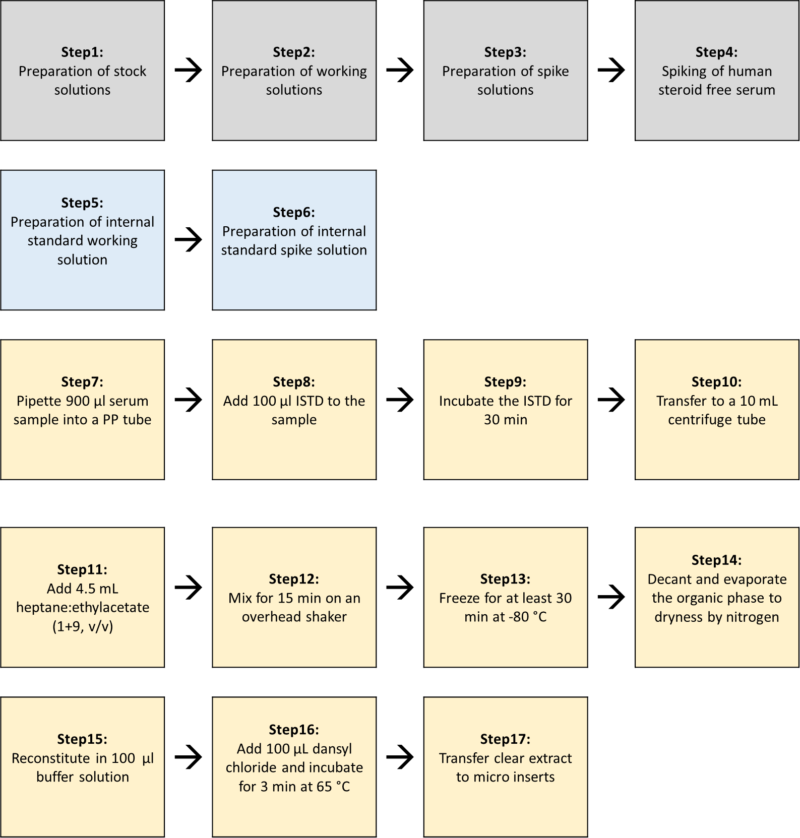

900 μL of sample specimen (native sample / calibrator / quality control) are pipetted (Combitip advanced® 1.0 mL) into a 1.5 mL tube, 100 μL ISTD-solution is added (Combitip advanced® 1.0 mL, dispense mode) and the mixture is shaken for 30 minutes. Then the mixture is transferred to a 10 mL centrifuge tube and 4.5 mL heptane:ethylacetate (9+1, v+v) was added. The two layers are briefly vortexed and shaken on an overhead mixer (15 minutes, 60 rpm).
Then the tubes are centrifuged (15 minutes, 1500 rpm) and frozen at - 80 °C for at least 30 minutes to solidify the water layer. The organic layer is decanted into a 5 mL glass tube and evaporated in a Biotage TurboVap system (50 °C, 0.9 mL/min, 20 minutes). The dried residue is resuspended in 100 μL 100 mM Na₂CO₃-NaHCO₃ buffer and 100 μL dansyl chloride in acetonitrile is added. The mixture is briefly vortexed and incubated at 65 °C for 3 minutes. The reaction mixture is immediately transferred to an HPLC-vial with insert and put in the autosampler at 8 °C for further analysis.

  - Procedure operating instructions, System Suitability Test (SST) and the Structure of analytical series

The preparation of the LC-MS system is carried out as described in the manufacturer’s instructions for use.
Prior to sample analysis a system suitability test (SST, Chapter 4.9) needs to be passed.
All details concerning hazards and precaution, analytical solutions and analytical portions are described in chapter 2, chapter 4.

    - LC-MS parameter

      - LC parameter

Analysis system: Agilent 1290 Infinity LC system, including two binary pumps, a column temperature control device with a 2 position/ 10 port valve, and an autosampler *)

*) Alternatively, any conventional QQQ-mass spectrometer with an ESI-source coupled to an LC-system with two pumps can be used (with the same resolution, sensitivity and mass range) as long as the system suitability test is passed.

Stationary phase: 1st Dimension: Waters Acquity BEH C8 1.7 µm, 50 x 2.1 mm
2nd Dimension: Restek Raptor Biphenyl 2.7 µm, 100 x 2.1 mm

Pre Column Filter: 1st Dimension: UltraShield UHPLC PreColumn Filter, Restek 0.5 µm frit
2nd Dimension: UltraShield UHPLC PreColumn Filter, Restek 0.5 µm frit

Mobile phase 1st Dimension: Eluent A1: 0.1% formic acid in Milli-Q water
Eluent B1: 0.1 % formic acid in acetonitrile

Mobile phase 2nd Dimension: Eluent A2: 0.1 % formic acid in Milli-Q water
Eluent B2: 0.1 % formic acid in methanol:acetonitrile (7+3, v+v)

Autosampler: temperature control set to 8 °C

Injection volume: 20 µL

Flow rate: 1st dimension: 300 µL/min
2nd dimension: 500 µL/min
Column temperature: 50 °C

LC gradient:
1st Dimension:
Time [min] | Flow [ml/min.] | Eluent A [%] | Eluent B [%]
0.00 | 0.30 | 80 | 20
0.50 | 0.30 | 80 | 20
0.60 | 0.30 | 25 | 75
3.60 | 0.30 | 25 | 75
3.70 | 0.30 | 3 | 97
6.50 | 0.30 | 3 | 97
6.60 | 0.30 | 80 | 20
9.00 | 0.30 | 80 | 20

2nd Dimension:
Time [min] | Flow [ml/min.] | Eluent A [%] | Eluent B [%]
0.00 | 0.50 | 3 | 97
0.20 | 0.50 | 3 | 97
0.30 | 0.50 | 90 | 10
2.50 | 0.50 | 90 | 10
2.51 | 0.50 | 20 | 80
7.00 | 0.50 | 20 | 80
7.10 | 0.50 | 3 | 97
9.00 | 0.50 | 3 | 97

Autosampler wash method for LC systems with multiwash function:

Step | Solvent | Wash Time [sec.] | Seat Back Flush | Needle Wash
1 | Wash solution 1 | 5 | Yes | No
2 | Wash solution 2 | 5 | Yes | Yes
3 | Wash solution 3 | 5 | Yes | Yes
4 | Wash solution 1 | -- | Yes | No

Autosampler wash method for LC systems without multiwash function:

Step | Program Table | Solvent
1 | Wash needle flush seat for 10 sec. | Wash solution 4
2 | Wash needle in flush port for 10 sec. | Wash solution 4
3 | Valve mainpass | ---
4 | Valve bypass | ---
5 | Valve mainpass | ---
6 | Valve bypass | ---
7 | Draw def. amount from sample, def. speed, def. offset | ---
8 | Inject | ---

Note: With alternative LC-systems, an equally effective autosampler cleaning procedure must be used so that carry-over can be avoided.
Column Switching Valve:

Time [min] | Function | Parameter
2.05 | Change Valve Position | Column at Position 2
2.25 | Change Valve Position | Column at Position 1

Note: For the heart cut, the analyte peak in the 1st dimension is cut out with a window of 0.20 min and transferred to the 2nd dimension via a 100 µL-loop. For the whole procedure, the highest calibrator is used. First, the calibrator is injected only on the 1st dimension to determine the approximate cutting time. After determining a stable retention time in the 1st dimension, various 2D-LC methods are written which differs in the cutting of the heart-cut by approx. 0.02 min. The methods are then measured one after the other so that the peak is scanned in the 1st dimension and transferred to the 2nd dimension. The analyte areas and the areas of the internal standard are applied and the method with the highest signal is used as the final method.

      - MS and source parameters

Analysis system: e.g. mass spectrometer AB Sciex QTrap 6500 operating in the electrospray ionization (ESI) mode and selecting ions at unit resolution in the multiple reaction mode (MRM mode) *)

*) Alternatively, any conventional triple-quadrupol-mass spectrometer equipped with an ESI-Source (with comparable resolution, sensitivity and mass range) can be used, if the system suitability test is passed successfully

Manual tuning for optimal and stable signal in ESI+ mode for 17ß-danysl-estradiol transitions.
Tuning solution: 100 ng/mL 17ß-danysl-estradiol in 80 % 0.1% formic acid methanol
Syringe pump: 10 µL/min
SIM Mode positive m/z 506.1 Q1 mass
MRM Mode positive m/z 506.1 → 171.1 (Quantifier) and 506.1 → 156.1 (Qualifier)
Typical values for MRM parameters are:

Compound | Precursor [m/z] | Product [m/z] | DP  [V] | CE  [V] | CXP  [V] | Dwell Time [msec]
17β-Dansyl-Estradiol Quan | 506.1 | 171.1 | 130 | 44 | 11 | 80
17β- Dansyl-Estradiol Qual | 506.1 | 156.1 | 130 | 52 | 11 | 80
17β- Dansyl-Estradiol-D5 Quan | 511.1 | 171.1 | 130 | 44 | 11 | 80
17β- Dansyl-Estradiol-D5 Qual | 511.1 | 156.1 | 130 | 52 | 11 | 80

Manual optimization of source parameters for all transitions in ESI+ mode with syringe pump and HPLC-System connected over T-piece assembly.
Eluents: 10% Eluent A2 and 90% Eluent B2 (flow rate 500 µl/min).

Typical final ESI+ source parameter values parameters from manual tuning under which an optimal (stable ion yield over the peak, high sensitivity) Dansyl estradiol peak was realized in all transitions:

Parameter | Value (QTrap 6500)
Curtain Gas (psi) | 35
Collision Gas | Medium
Spray Voltage (Volt) | 5500
Temperature (°C) | 500
Ion Source Gas 1 (psi) | 70
Ion Source Gas 2 (psi) | 80
Entrance Potential (Volt) | 10

All settings and conditions may vary from device to device and can be adapted.

    - System suitability test

To assure the long-term traceability of the method a system suitability test (SST) is performed.

Material | Target
SST HS 1 | 1.8 pg/mL 17ß-dansyl-estradiol, 12,5 pg/mL ISTD
SST HS 2 | 22.5 pg/mL 17ß-dansyl-Estradiol, 12,5 pg/mL ISTD

To pass the SST, S/N has to be ≥ 10 for SST HS 1 for the quantifier transition.

To examine a potential carry over, SST HS 2 is injected followed by the injection of two solvent blanks. The analyte peak area observed in the first blank needs to be ≤ 20 % of the analyte peak area of the SST HS 1 to pass the SST.
The retention time of SST HS 1 and SST HS 2 has to be 5.8 min ± 0.5 min.

Note: To calculate the noise, the software uses the SD (using a mean of zero) of all the chromatographic data points between the specified background. To calculate the S/N ratio, the background from 6.50 to 7.50 min is used.

    - System Maintenance

After analysis is finished, the whole system, including column, is flushed with 50 % methanol for 30 min.
Columns are stored in 100 % methanol at room temperature.

    - Calibration

For calibration, the spiked calibrators (see section 4.2) are prepared as described in section 4.3.1. Calibration is performed in bracketing mode and calibrator levels are measured in increasing concentration. The calibration functions (using 6 levels) is obtained by linear regression and 1/x weighting.

  - Structure of analytical series

Sequences setup may vary due to specific measurement requirements.

- Solvent blank (5 times for sufficent equilibration of the 2D system)
- SST 1 (Cal 1 in neat)
- SST 2 (Cal 6 in neat)
- Solvent blank SST 1
- Solvent blank SST 2
- Zero (matrix with IS, without analyte)
- 2x solvent blank
- Calibrators (increasing concentration)
- 2x solvent blank
- QCs (spiked QCs in increasing concentration and native QCs)
- 2x solvent blank
- Samples (Unknowns) *, **
- 2x solvent blank
- QCs (spiked QCs in increasing concentration and native QCs)
- 2x solvent blank
- Calibrators (increasing concentration)
- 2x solvent blank

* If reference values should be assigned the number of sample preparations is depended on the desired measurement uncertainty (n = x). Additionally, samples have to be measured at least at two different days.
** If a method comparison study has to be performed, or complaint samples have to be measured, samples are prepared with a n= 1.

With this method all calibrators and QCs are measured in duplicate (n=2 injections) and unknowns samples are injected once. As unknown samples, native serum and plasma samples can be measured.

  - Data processing and Calculation of measurement results

For the raw file processing, the Analyst software, e.g. version 1.6.2 or higher is used with IntellliQuan as the Quantitation Integration Algorithm. 17ß-Estradiol danyslchloride and its internal standard show a retention time of 5.8 minutes and are integrated with a 15 sec window. Raw data are processed with a smoothing factor of three. The calibration curve (6 levels) is linear with a 1/x weighting. The calibration functions (using 6 levels) are obtained by linear regression of the area ratios of the analyte and the internal standard against the analyte concentration resulting by the function, y = acA + b

The nominal concentrations of calibrator and QC samples are entered with 5 significant figures into the Analyst software.The reportable result is calculated in pg/mL with 3 significant figures. Measurement uncertainty SD (pg/mL) is reported with 3 significant figures and the CV (%) with 1 decimal place.
For the assignment of reference or target values, the reportable result is calculated as the arithmetic mean of n = x sample preparations, in which sample preparations are performed over at least two days. Measurement uncertainty is calculated and reported as total uncertainty, given by the formula:

$${unc}_{total}=\sqrt{{unc}_{cal}^{2}+{(\frac{{unc}_{prec}}{\sqrt{n}})}^{2}}$$

(unc_{cal}) uncertainty of calibrator preparation
(unc_{prec}) uncertainty of n= x sample preparations

Results of a method comparison study or complaint sample (n= 1) are reported as the reportable result with the measurement uncertainty determined within the validation.

$${unc}_{total}=\sqrt{{unc}_{cal}^{2}+{unc}_{prec}^{2}}$$
(unc_{cal}) uncertainty of calibrator preparation
(unc_{prec}) uncertainty of precision experiment within the validation

If other pipettes or glassware are used, the uncertainty must be recalculated.

  - Reporting of Results

All analysis requests are controlled by a sample management system. Each sample / sample set to be measured has to be requested using a specific order form which includes:
- identification of source and type of sample (native samples are anonymized)
- sample receipt and latest date of measurement
- sample storage place
- reference measurement procedure employed

Within the corresponding report, results are presented as follows:
- short description on reference measurement procedure used
- observations of unusual properties of sample
- observations as unusual features of the measurement procedure or use of modifications
- results are reported with sample name / identification name, numerical value, measurement unit and measurement uncertainty if required

All data (e.g. sequences, raw data, and calculations) have to be checked in four-eyes principle. Except for calculations done by a validated tool, e.g. Biowarp. The final report has to be signed from the operator and approver.
- Comment
New columns have to be sufficiently equilibrated before first use - at least three empty gradients. In addition, the heart-cut must be checked and adjusted if necessary.

- List of abbreviations

MRM multiple Reaction Monitoring
ID-LC-MS/MS isotope Dilution Liquid Chromatography Mass Spectrometry
SLE suported Liquid Extraciton
ISTD internal standard
Id.Nr. identification number
ESI electrospray ionisation
DP declustering potential
CE collision energy
CXP collision cell exit potential
SST system suitability test
FIA flow injection analysis
NR normal range method
HS high sensitivity method
E2 17ß-Estradiol
USP U.S. Pharmacopeia

