Isotope dilution-liquid chromatography-tandem mass spectrometry-based candidate reference measurement procedures for the quantification of 24(R),25-dihydroxyvitamin D2 and 24(R),25-dihydroxyvitamin D3 in human serum and plasma

Short title: ID-LC-MS/MS-based candidate RMPs for the quantification of 24(R),25-dihydroxyvitamin D2 and D3

Kerstin Kandlerª, Michael Stadlmeierª, Neeraj Singhª, Friederike Bauland^{b}, Andrea Geistangerª, Christian Geletnekyª, Judith Taibonª*

ªRoche Diagnostics GmbH, Nonnenwald 2, 82377 Penzberg, Germany
^{b}Chrestos Concept GmbH & Co. KG, Girardestaße 1–5, 45131 Essen, Germany

Correspondence:
Judith Taibon, PhD
Roche Diagnostics GmbH, Nonnenwald 2, 82377 Penzberg, Germany
Phone: +49 8856 6012941
Email: judith.taibon@roche.com
Characterization of reference material by quantitative nuclear magnetic resonance (qNMR) measurements
Quantitative nuclear magnetic resonance (qNMR) measurements were performed in six replicates using the International System of Units (SI units) traceable internal standard (ISTD) for the quantification of the absolute content of 24,25-dihydroxyvitamin D3 and 24,25-dihydroxyvitamin D2.
The following formula was utilized to calculate the absolute content of both the analytes:

$$Px=\frac{Ix*Nstd*Mx*mstd}{Istd*Nx*Mstdmx}*Pstd$$

Px : Purity of the analyte as mass fraction
Pstd : Purity of the internal qNMR standard as mass fraction
Ix : Integral of the analyte
Istd : Integral of the internal standard
Nx : No. of analyte protons
Nstd : No. of internal qNMR standard protons
Mx : Molecular weight of the analyte
Mstd : Molecular weight of the qNMR internal standard
mx : Mass of analyte
mstd : Mass of qNMR internal standard

For 24,25-dihydroxyvitamin D3:
The following values are common to all the qNMR measurements:
Molecular Weight of 24,25-dihydroxyvitamin D3 = 416.6365 g/mol; Molecular weight of the qNMR internal standard ISTD (Tecnazene = 260.8896 g/mol; Purity of the qNMR internal standard as mass fraction = 99.79 ± 0.19% (k = 2); Number of Protons taken into account for the ISTD = 1 and for 24,25-dihydroxyvitamin D3 = 1; Integral of 24,25-dihydroxyvitamin D3 proton = 1.

Procedure for sample preparation and processing parameter:
24,25-dihydroxyvitamin D3 (MedchemExpress; Cat Nr HY-32343, Lot.# 08808), CDCl₃ and tecnazene (TraceCert standard traceable to NIST PS1; Lot Nr. BCCD1553) were purchased from SigmaAldrich, Germany. 5mm NMR tubes was obtained from Euroisotop GmbH. 24,25-dihydroxyvitamin D3 (Table 1) and the qNMR standard (Table 1) were weighed together in a glass vial on an Ultra-microbalance (XPR6U), from Mettler Toledo. CDCl₃ (approx. 700 µL) was added to the glass vial, and after a short vortexing, the solution was transferred to a 5 mm NMR tube. The single-pulse-¹H{¹³C}NMR measurements were performed on a JEOL 600 MHz NMR spectrometer equipped with an ultra-cool probe head, which provides 4-5 times sensitivity enhancement compared to normal room-temperature probe heads. For 24,25-dihydroxyvitamin D3, single-pulse-¹H{¹³C}NMR was utilized for the quantitation (Figure 1; olefinic proton; δ = 6.24 ppm; 1H; tecnazene as qNMR internal standard; CDCl₃ as solvent) with an inter-scan delay of 70 seconds. NMR measurements were performed at 298K/300 K utilizing 64k data points and the number of scans were limited to 128 with automatic receiver gain conditions. Processing was performed with an exponential window function (line broadening = 0.3 Hz), followed by manual phase and baseline corrections. Three individual experiments involving three individual weightings, yield a final absolute content value of 97.1 ± 0.2% (k=1) for 24,25-dihydroxyvitamin D3 (Table 1 and Figure 2).

Table 1: qNMR calculation of the purity of 24,25-dihydroxyvitamin D3; mass is give in milligrams (mg).

24,25-dihydroxyvitamin D3  source | Measurement No. | Mass of 24,25-dihydroxyvitamin D3 weighed (mx) | Mass of qNMR ISTD weighed (mstd) | Integral of the qNMR ISTD (Istd) | Purity of 24,25-dihydroxyvitamin D3 as mass fraction (Px) %
MedchemExpress | 1 | 1.0253 | 1.3099 | 2.0991 | 96.99
MedchemExpress | 2 | 1.5504 | 2.0025 | 2.2103 | 97.08
MedchemExpress | 3 | 1.0377 | 0.9628 | 1.5202 | 97.26

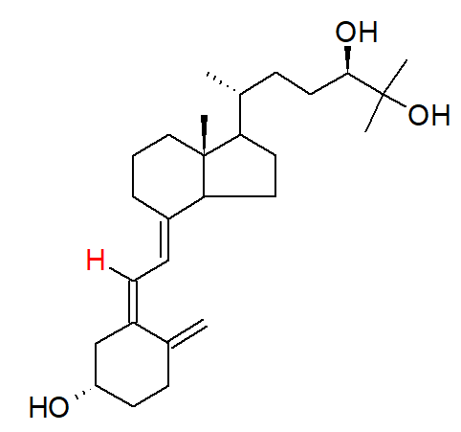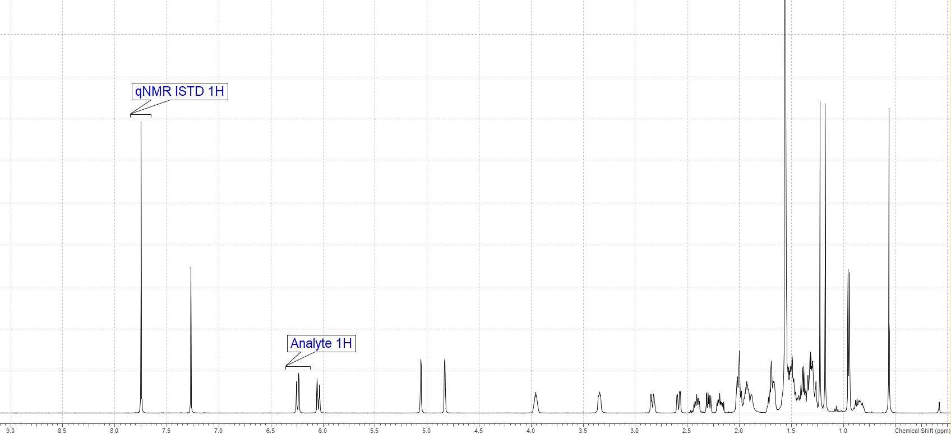
Figure 1: qNMR spectrum indicating the protons (in red) utilized for the quantification of 24,25-dihydroxyvitamin D3

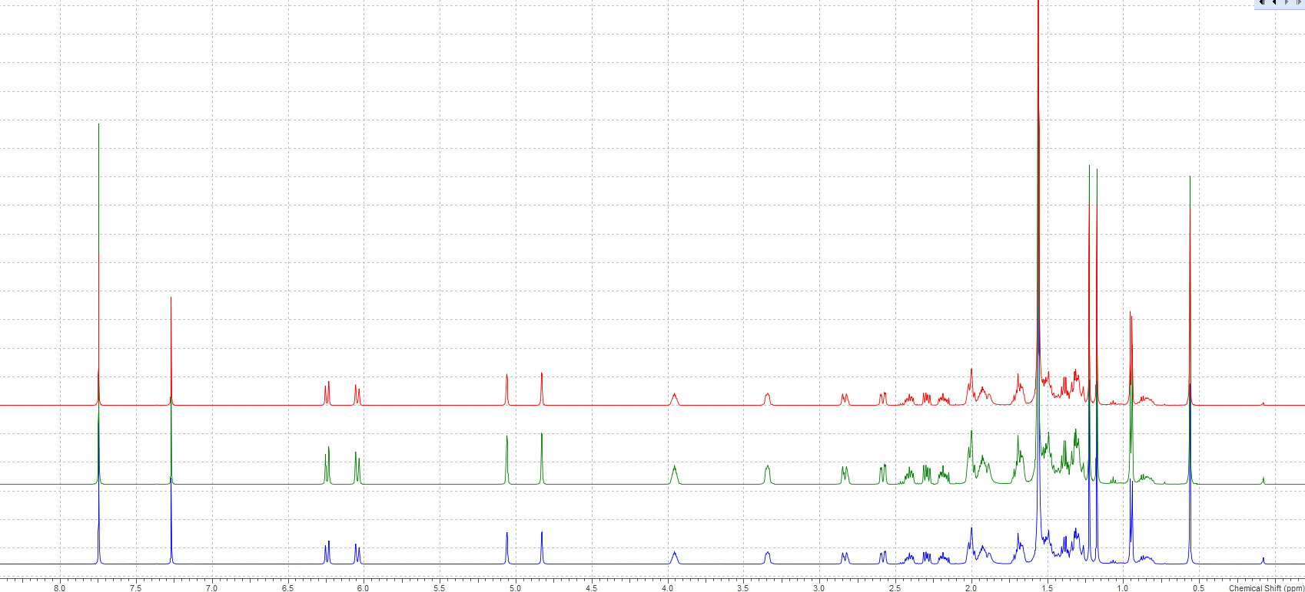
Figure 2: Overlay of the six spectra (24,25-dihydroxyvitamin D3) acquired under the afore-mentioned quantitative conditions.

For 24,25-dihydroxyvitamin D2:
The following values are common to all the qHNMR measurements:
Molecular Weight of 24,25-dihydroxyvitamin D2 = 428.6472 g/mol; Molecular weight of the qNMR internal standard ISTD (Tecnazene = 260.8896 g/mol; Purity of the qNMR internal standard as mass fraction = 99.79 ± 0.19% (k = 2); Number of Protons taken into account for the ISTD = 1 and for 24,25-dihydroxyvitamin D2 = 1; Integral of 24,25-dihydroxyvitamin D2 proton = 1.

Procedure for sample preparation and processing parameter:
24,25-dihydroxyvitamin D2 (Endotherm ENA250 Batch Nr ERI2483FR2), CDCl₃ and tecnazene (TraceCert standard traceable to NIST PS1; Lot Nr. BCCD1553) were purchased from SigmaAldrich, Germany. 5mm NMR tubes was obtained from Euroisotop GmbH. 24,25-dihydroxyvitamin D2 (Table 2) and the qNMR standard (Table 2) were weighed together in a glass vial on an Ultra-microbalance (XPR6U), from Mettler Toledo. CDCl₃ (approx. 700 µL) was added to the glass vial, and after a short vortexing, the solution was transferred to a 5 mm NMR tube. The single-pulse-¹H{¹³C}NMR measurements were performed on a JEOL 600 MHz NMR spectrometer equipped with an ultra-cool probe head, which provides 4-5 times sensitivity enhancement compared to normal room-temperature probe heads. For 24,25-dihydroxyvitamin D2, single-pulse-¹H{¹³C}NMR was utilized for the quantitation (Figure 3; olefinic proton; δ = 6.24 ppm; 1H; tecnazene as qNMR internal standard; CDCl₃ as solvent) with an inter-scan delay of 70 seconds. NMR measurements were performed at 298K/300 K utilizing 64k data points and the number of scans were limited to 128 with automatic receiver gain conditions. Processing was performed with an exponential window function (line broadening = 0.3 Hz), followed by manual phase and baseline corrections. Three individual experiments involving three individual weightings, yield a final absolute content value of 91.1 ± 0.5% (k=1) for 24,25-dihydroxyvitamin D2 (Table 1 and Figure 4).

Table 2: qNMR calculation of the purity of 24,25-dihydroxyvitamin D2; mass is give in milligrams (mg).

24,25-dihydroxyvitamin D2  source | Measurement No. | Mass of 24,25-dihydroxyvitamin D2 weighed (mx) | Mass of qNMR ISTD weighed (mstd) | Integral of the qNMR ISTD (Istd) | Purity of 24,25-dihydroxyvitamin D2 as mass fraction (Px) %
Endotherm | 1 | 1.6245 | 1.1946 | 1.3249 | 91.00
Endotherm | 2 | 1.1246 | 1.3258 | 2.1321 | 90.66
Endotherm | 3 | 1.2126 | 1.2984 | 1.9168 | 91.59
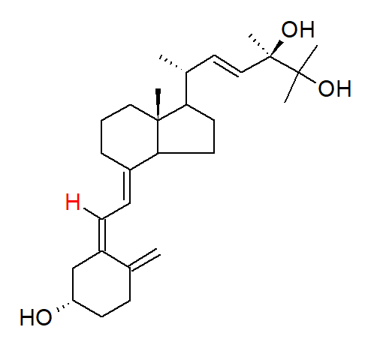

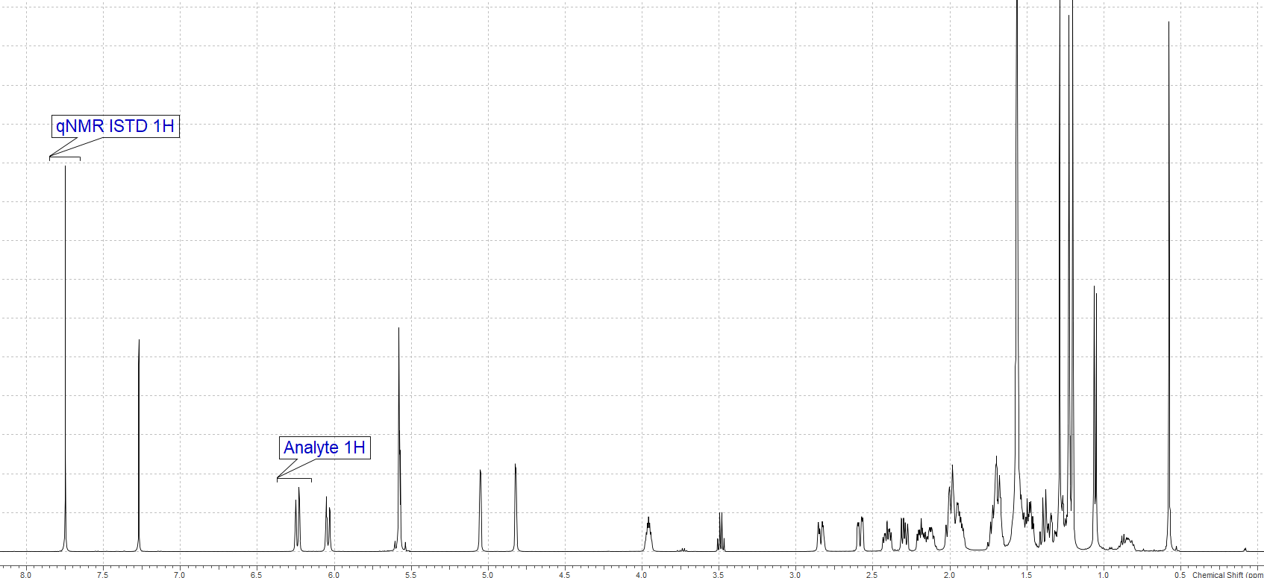
Figure 3: qNMR spectrum indicating the protons (in red) utilized for the quantification of 24,25-dihydroxyvitamin D2
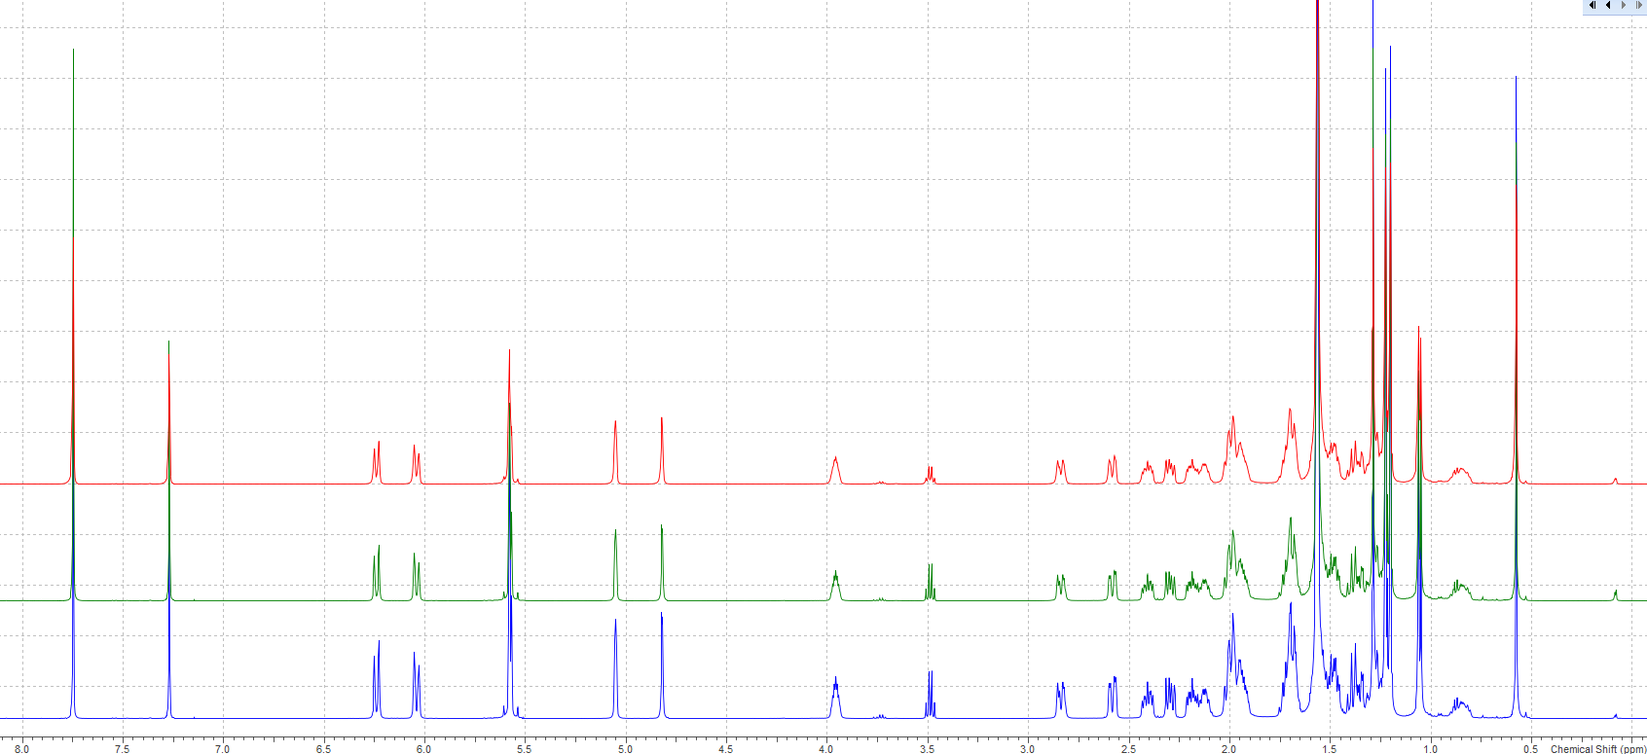
Figure 4: Overlay of the six spectra (24,25-dihydroxyvitamin D2) acquired under the afore-mentioned quantitative conditions.

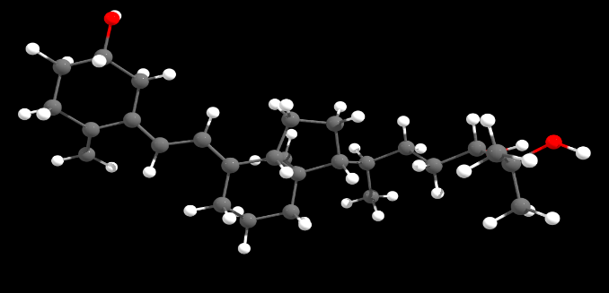
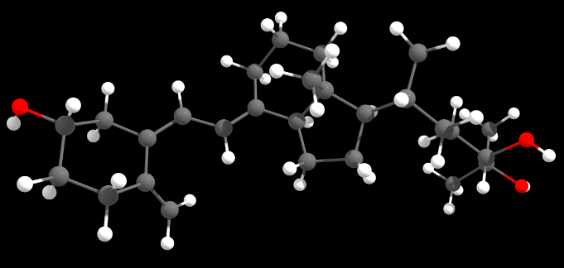
Conformer Search (24,25-dihydrovitamin D3) using wB97X-V with def2-TZVPP basis set

Conformer No. 176 (18.35%; 0.00 kcal/mol) Conformer No. 128 (16.14%; 0.08 kcal/mol)
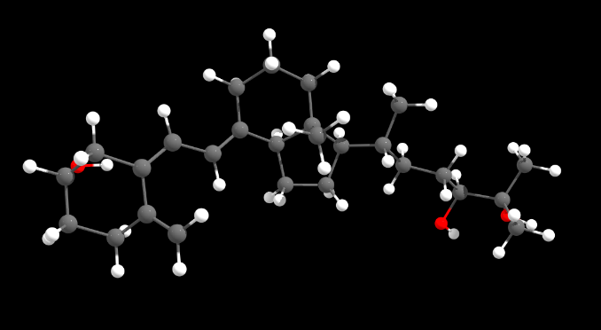
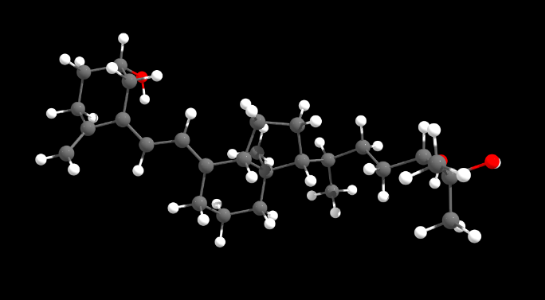

Conformer No. 111 (13.83%; 0.17 kcal/mol) Conformer No. 137 (11.09%; 0.30 kcal/mol)
Figure 5: Four Conformers of 24,25-dihydroxyvitamin D3, which constitute major part of the structure in solution (chloroform). The Boltzmann population and their relative energies are indicated within brackets. DFT calculations were done using D3 correction and CPCM solvent model is utilized for chloroform. The following steps were performed for calculating the energies of the conformers: (i) Generation of conformer ensemble with GOAT using GFN-FF; (ii) Initial conformer filtering using XTB; (iii) Conformer preoptimization using XTB followed by clustering; (iv) Conformer optimization using r2SCAN-3c; (iv) Conformer DFT SP Energy calculation using wB97X-V/def2-TZVPP.
All the quantum chemical calculations were performed with the program ORCA/Weasel.

Cartesian coordinates of the 4 conformers for 24,25-dihydroxyvitamin D3:
74
Energy: -803957.357236023 kcal/mol (wB97X-V / def2-TZVP / CPCM(Chloroform)) ++ ChemEnsembleNo: 1 ++ ConformerNo: 176 ++ Version: 1.11.0
H -7.3460126683770159 -0.7554270624949231 3.0285043110833239
H 8.5120407248321257 -0.6464249926482531 -3.4836738730231711
H -6.9894353315819169 0.8222423822007546 5.5190493942696861
H 4.7304659889950598 -0.3894990235964363 1.2235577331271004
H 5.2799409485114133 -2.1581050128168089 1.3958853174046411
H 3.9016722496640890 1.2882748764751217 -2.2922159802402917
H 2.7038142255574580 -0.6355035793327647 -0.1742246897113384
H -3.6041231261853488 0.5224082748221861 -2.3099061254948103
H -4.1536613278301626 1.4847750407194122 -0.9338224656263074
H -5.0983351962502219 0.0877284626899762 -1.4761386613592804
H -5.6473697972967249 2.6824551401613341 2.8287346136172244
H -6.6165076353875527 2.7977378643936377 4.3042994556085530
H -7.2569547856177197 1.9283420015141499 2.8881106183229108
H -3.7276757425090725 1.6950531036297456 4.1740621359930410
H -3.9824700805281070 0.1950296787285613 5.0975730114767099
H -4.6823132223828159 1.7271849159237340 5.6620755861667167
H -1.5397328736605826 -0.6420753048285780 -2.7000696918976055
H 0.2206226175810339 -0.5043401028325492 -2.5471779589122820
H -0.6720596807864830 -1.5977555071570415 -1.4907553053429667
H 6.0708228951461889 -3.3761849497859369 -0.4832667915395539
H 5.0073953686238477 -3.0484953105852721 -1.8590028504403655
H 7.0753275688911437 0.4123203979750355 -1.8347685813577341
H 5.9468403196861042 0.8142687398935835 -3.1467790185999105
H 2.2941469083580510 2.5401032546807945 -2.1985720866106169
H 1.3187321758897339 3.1151104233074918 -0.8498503871360885
H 0.0000450400770957 3.2873966854278769 -2.8865598785906776
H 0.3115003887738002 1.6106308745671585 -3.3111450003550207
H -3.6859538027555687 0.7178411612481372 2.1989862128683644
H -5.0985623927093853 1.0695516181161588 1.2001969555168166
H 7.8613115950041861 -1.9843372467051077 -1.5238009706618132
H 7.3274376079312900 -3.2282822886027165 -2.6695339012323904
H 0.7611607972003906 -1.4346069082740716 0.3410706609205911
H 0.8568766592747161 -0.4215854861490501 1.7798161969701218
H -3.6854805826710821 -1.6425763994395113 1.4054152140613969
H -5.1035645772838025 -1.3279064527782545 0.4166196264558782
H -1.4999542673425343 -0.6240220441519295 2.1025133816820629
H -1.4668576647556260 -1.8517594678511544 0.8462024198241903
H -1.9494543069096255 1.8258183291156138 -2.3743069378942110
H -1.3315610441912094 2.6237892066553443 -0.9266013893167202
H -5.0345077526363040 -1.0694767152572147 3.3753726551603274
H 5.8662531193269425 -1.5765945423259786 -3.8031106919242057
H 0.1276801982738242 1.5366494082994770 0.5849548784143319
H -3.0755476922653329 -1.3844232555342766 -0.9161105142857732
H -2.1872180985368819 1.0812078633077247 0.6302761923108721
O -6.7418717335713136 -0.5890726848878934 2.2914865998493053
O 7.7736326834124094 -0.9551599106143170 -4.0256209660555911
O -6.6772754893395705 0.1793374558221081 4.8698748918631258
C 5.0833630820322897 -1.3031304543075217 0.7532824418278554
C 5.2833718454750258 -1.3748240102392248 -0.5676706901455433
C 3.9167666474803622 0.4838587745581666 -1.5582671260669378
C 5.0600096748571826 -0.2383625337154568 -1.4865696742681174
C 2.7071057166338592 0.2514302204782412 -0.8035966659253625
C 1.5918422263166123 1.0127466254240827 -0.8218038707007407
C -4.0793643351168081 0.4642813291817987 -1.3272508707443491
C -6.3530557528753979 2.1411082451960608 3.4664328915267424
C -4.4493223599922471 1.1310172221995338 4.7725380084699660
C -0.7104203354964133 -0.6214726119126732 -1.9844911159594052
C 5.8095801325291596 -2.6247591901953786 -1.2357944180114266
C 6.2156785722529770 0.0414729435064153 -2.4183606242306808
C 1.4204336862996316 2.3014371384254217 -1.5859380519797959
C 0.1539217586373404 2.2876285794071154 -2.4620453455334483
C -4.5860195447056675 0.2756336589745506 1.7576579142995017
C 7.0132928795889615 -2.3218785096865560 -2.1386686989021384
C 0.3091018123568897 -0.5721498227770462 0.8435183662790052
C -4.1929295522710905 -0.8664183420263111 0.8176772796548677
C -1.2061427157221396 -0.8090468903757493 1.0635193094371806
C -1.0990937424671039 1.8613405560262990 -1.6855697932442495
C -5.4968990941120879 -0.1941174042597952 2.8817881302580473
C 6.6751233675879202 -1.2281445460026343 -3.1457677169610978
C 0.3550199848109884 0.6621122609823256 -0.0526285957325574
C -3.3036225719966823 -0.4532234648875597 -0.3746203283612467
C -1.9663216657951577 0.1441151468540577 0.0946392962232021
C -5.7327112726600049 0.8508568728897143 3.9936457987279410
C -0.8987195070539336 0.5165680780448383 -0.9725530833052733
74
Energy: -803957.2811238501 kcal/mol (wB97X-V / def2-TZVP / CPCM(Chloroform)) ++ ChemEnsembleNo: 1 ++ ConformerNo: 128 ++ Version: 1.11.0
H -7.5017288615709168 -0.7454279235421449 2.5643250631654979
H 6.0623224339463988 -4.3000787169447792 -1.4492758899720033
H -7.0845742017706694 -0.0136034298921831 5.4044623024004057
H 7.0196671886570678 1.1340501678017623 -4.1067730238632221
H 5.1618690267981053 1.1527102165609366 -4.0252036411353025
H 4.1097115612834196 1.4245653836408414 -1.8588283499610503
H 2.4986852272679752 -0.9590399309526887 -0.6769827111220786
H -5.0314192500992201 1.3036978468100660 -1.4280927072642464
H -3.4650548241733219 1.7603250516183189 -2.1041829006496076
H -3.9073966117835579 2.2895763410807937 -0.4775370642460303
H -5.5380944473716118 2.4366446571215299 3.3842024618104278
H -6.5343307571780826 2.1889846380762465 4.8249356782776500
H -7.1986507151453072 1.8246760401925028 3.2130417592988283
H -4.1218955709938951 -0.7308917537709217 4.8279402896719246
H -4.7162218153907070 0.6241209618568505 5.8110750294038791
H -3.7297477527330094 0.9467017449177499 4.3791115571884758
H -0.9272964829473938 -0.9106928107265890 -2.0926355438299415
H -1.5807573687263763 0.5205114635054396 -2.8987886751612009
H 0.1704735506434955 0.3075246595934336 -2.7407165552938140
H 8.2794703427201419 -0.2970598446118111 -2.6975878316507251
H 7.6562189167382231 -0.0719744362909490 -1.0584135908548828
H 4.7429375036432804 -2.5364566063646592 -2.4326888185386362
H 4.0889204448810483 -2.1940823725173946 -0.8257217733388956
H 2.6570335760593848 2.7520175731644141 -1.4202999091436119
H 1.7212091637003748 2.9646799110149553 0.0582852191723588
H 0.5194780456859451 4.0043633721856526 -1.7894096511275281
H 0.6040714936522924 2.5363908687685170 -2.7531127503833792
H -3.6946514803359998 0.5366620143602742 2.1986780623959987
H -5.0391112542414485 1.3353461935409991 1.3788232817892099
H 7.2814407591219572 -2.5919921708978451 -2.7604915184554968
H 8.3352355346844718 -2.4253196496979963 -1.3431059280768889
H 0.4727824992419081 -1.5838616032902664 -0.3523409389052504
H 0.6903655226630319 -1.1391997133584419 1.3393122507264417
H -3.9652104121900882 -1.4561703006728000 0.7092290461659235
H -5.2933835581358677 -0.6609586062723688 -0.1216681380290111
H -1.6771733299465221 -1.0652930245377743 1.6454950066969862
H -1.8001999718242945 -1.8082116259550498 0.0574734862383068
H -1.6353433841823277 2.7553841490831212 -1.7639570242568043
H -0.9607396464918614 2.9317916942471975 -0.1432549948489483
H -5.2352365484322894 -1.3551478337982292 2.8080201316479814
H 6.3624887291685717 -1.9489399845447575 0.0821694820230065
H 0.2895836960876777 1.1929510573861251 0.8917194792691152
H -3.2611117390778470 -0.5518656969206337 -1.4260272527040168
H -2.0716575587012298 1.1047067319979884 0.8323048374741067
O -6.8646999776537028 -0.4294255235136527 1.9083046965294148
O 6.1774569384763431 -3.8355069067815419 -0.6095342435883152
O -6.8023590956363158 -0.4651280179498947 4.5992197353016486
C 6.1065247849581219 0.7993889935011569 -3.6208448949373180
C 6.1492295956961005 -0.0257773163305055 -2.5656827967833005
C 3.9342776197038152 0.3883293662095514 -1.5778645195440457
C 4.9324198627142479 -0.4839910723109109 -1.8630348790133071
C 2.6786593265271237 0.0808538182168096 -0.9382687191499507
C 1.6975800692962528 0.9634163898703278 -0.6424856258660844
C -3.9728955762406133 1.4554440648654832 -1.1857917246421266
C -6.2975091858978347 1.7882849291788487 3.8320441747142815
C -4.5069400586450801 0.2937220485163169 4.7873683470867698
C -0.7877591164980394 0.1662551501868256 -2.2309653942392247
C 7.4562901383354676 -0.5592022570464423 -2.0250384825680636
C 4.9062492927960406 -1.9530759096774291 -1.5103336286228615
C 1.7384529057369340 2.4455507244365826 -0.9132748260314175
C 0.5138391650681307 2.9093468286600794 -1.7249844095750484
C -4.6288377080298915 0.3559327694931604 1.6550139535442903
C 7.4011457817387756 -2.0739262436919579 -1.7968916740342957
C 0.1480483808083940 -0.8815415387661819 0.4234942370607282
C -4.3471044808615886 -0.4743751862982102 0.4004370440134170
C -1.3904570661243101 -0.9450360462332745 0.5951966010430723
C -0.8126583964030232 2.4371044969507150 -1.1152887356048011
C -5.6078615641016949 -0.3363043158572260 2.5908396025312967
C 6.2267346206778678 -2.4313615973306839 -0.8959775259020279
C 0.4028651371855632 0.5596531651068665 -0.0074468522555525
C -3.3690228539988150 0.1718182715351800 -0.6033756603610069
C -1.9741903053564944 0.3763215861045385 0.0118086424487840
C -5.7883059531075380 0.3554079828104709 3.9590064616099765
C -0.8324073728604350 0.9183384610897495 -0.8939525307323360
74
Energy: -803957.1896259212 kcal/mol (wB97X-V / def2-TZVP / CPCM(Chloroform)) ++ ChemEnsembleNo: 1 ++ ConformerNo: 111 ++ Version: 1.11.0
H -7.0320148659111483 0.2079368427946199 1.3612848140467111
H 4.5020659605073625 -2.0014347821201115 -3.0695958696082215
H -7.6498477808237659 -0.1816529209254913 3.9444588991730716
H 7.8596711027406378 1.6746601467494626 -2.2593569028482552
H 6.5072169591238840 2.0489501379727826 -1.0375970296589998
H 4.1984823241299329 1.4488827951101118 -1.7129863524525963
H 2.7712386981564112 -0.7813433621341135 -0.0802794401466166
H -3.3783548193314301 0.8366265799729421 -2.2844478747620851
H -3.9266565500207555 1.6957435684667759 -0.8427642044081983
H -4.9205593033966419 0.4042936355249901 -1.5409012799877295
H -5.4869110817193922 2.6018000171219979 2.9251208728198708
H -6.5910988460839741 2.6668756551376220 4.3133680841244688
H -7.1727463359313823 2.0615620984415255 2.7541573960068253
H -4.3863010656945809 -0.3000854803612026 5.0619228101018683
H -5.0236221551681215 1.2092093378348321 5.7462064108794815
H -3.8838599658775559 1.2713903676416696 4.3928206855414027
H -0.5611770826686469 -1.4546796853898381 -1.5828012841762276
H -1.3583467666990410 -0.3438047597240205 -2.7029445034697148
H 0.3987693339012215 -0.2870409512360682 -2.4916660392523462
H 6.4545716907232373 -0.8907880846324995 -3.8212644083513814
H 8.0611755699066379 -0.5026268383289789 -3.2089480094161007
H 4.3064081307981468 -2.0641926296856066 -0.3431824995190033
H 5.9774229623447095 -1.7306372656606275 0.1280566167203053
H 2.5698928953530449 2.6344175470740625 -1.7063266090423346
H 1.5499235978381203 3.0811164454687745 -0.3397466411069524
H 0.3382685573223960 3.5244104606654756 -2.4076471782265512
H 0.6187999898756674 1.8920582587513244 -2.9962164698310145
H -3.6725532271812034 0.5579175345797893 2.2725626538886403
H -4.9249550642301445 1.1473943597610958 1.1865370671794071
H 7.4935764862069432 -2.9711475677188663 -3.0660795882485155
H 7.8685081027790735 -2.2728877056344481 -1.4831630409007328
H 0.7906398257556135 -1.5494996477729261 0.2900583418891878
H 0.8812296549227113 -0.7143465928241158 1.8401206248227440
H -3.7035453601270860 -1.6644326912289613 1.1989386492444534
H -5.0584061298385006 -1.1982882688588938 0.1826961024234131
H -1.4923217152148618 -0.8340395984842058 2.0670440411108477
H -1.4650992612052933 -1.9253421267561988 0.6898123920501872
H -1.6756730010928147 2.0817728027097280 -2.1441868495786438
H -1.1077378921630394 2.7070314403377269 -0.5944204777062321
H -5.3189277174804683 -1.2252479507736853 3.0718002121172470
H 5.8883019113958808 -3.7026615248768313 -1.3118075598552223
H 0.2634913538163337 1.3999665914458945 0.8536229615163956
H -2.9811120188067317 -1.2102945255444775 -1.0649532154439201
H -2.0649925561816262 1.0401721348132569 0.7664893235580201
O -6.8561290920168236 -0.5302190903484305 1.9600466156733496
O 4.8247990130002050 -2.8792409017663383 -2.8222950284805379
O -6.9913113098504160 0.0785052372149931 4.6060348550490868
C 6.9592670050861161 1.3544638328171239 -1.7407000737947482
C 6.4335537766806761 0.1414039356269779 -1.9560189169771234
C 4.1078549522588155 0.4812570105299289 -1.2233345381885126
C 5.2000831563100469 -0.3199414515936918 -1.2819492480861987
C 2.8495364045030023 0.1781018974906008 -0.5856527817936878
C 1.7631004685547296 0.9819240976161409 -0.5477203312080948
C -3.8903775044123661 0.7130590559517742 -1.3268262389643710
C -6.3098716341628753 2.0853970810192233 3.4298993555102761
C -4.7225225830727631 0.7133893726654532 4.8177102771006446
C -0.5510155612018256 -0.4297663221141302 -1.9671784596585726
C 7.0673035501191288 -0.8495909789194119 -2.9076821016963601
C 5.2738767871760581 -1.7201818200328891 -0.7178998262808567
C 1.6647602757439086 2.3554546103654110 -1.1608303159698994
C 0.4404659770537581 2.4803351706816912 -2.0873289033532698
C -4.5505322161185351 0.2471321454723459 1.6939155313229510
C 7.1446390446077848 -2.2589403324045159 -2.3093401310201305
C 0.3597265519952167 -0.7311169551933735 0.8774027098028754
C -4.1507175332519379 -0.8153033098118662 0.6664588037651566
C -1.1706548508595325 -0.9234066620185784 1.0237642195420784
C -0.8599805763158781 2.0186953655433313 -1.4166167028143188
C -5.6220292027555816 -0.2533168684389534 2.6559172464941256
C 5.7887820350648047 -2.7104585166178246 -1.7686129784466735
C 0.4862253420296527 0.5932922772504268 0.1308890231109809
C -3.1937730175255443 -0.3280307491185975 -0.4415316471636536
C -1.8565082780726851 0.1591529872011177 0.1382466622360702
C -5.9079559468828293 0.6737512697887776 3.8620581231980329
C -0.7348166756124013 0.6001720989911153 -0.8438707681085768
74
Energy: -803957.0585767367 kcal/mol (wB97X-V / def2-TZVP / CPCM(Chloroform)) ++ ChemEnsembleNo: 1 ++ ConformerNo: 137 ++ Version: 1.11.0
H -5.1821595642256462 -0.3584061817904742 5.0423857694318244
H 6.7162910400402529 0.3601341669108240 -1.4099988402600898
H -8.1407010114693552 -0.5273010378861090 4.9620627189554547
H 2.8983291843759780 -2.8650284535847579 -1.7701887228128248
H 3.9266564743998629 -3.8784359398079822 -0.5963551842798643
H 4.0364943807331173 0.7844938464771931 -3.0054606490836759
H 2.8194950384151038 -0.6731337127602555 -0.5483485434356334
H -3.5635127538823834 2.6283423516929503 -0.4616291044305398
H -4.7887049770292638 1.3561409867410901 -0.5772347961560624
H -3.4123529808496245 1.3405173014157623 -1.6695714382726750
H -6.8597563884613519 -1.9735563978791271 2.0055184297433239
H -8.0711182789509976 -2.1593657199277190 3.2812039640689474
H -6.3411175764596788 -2.3322346441031030 3.6685150617421209
H -7.8812069145205141 1.5748259654369778 2.6832461182994338
H -9.0038844381947847 0.1992942012233356 2.7439405776041914
H -7.8197502304081690 0.3069290356061584 1.4347428569109570
H -0.0194478302036863 -0.4002549744351298 -2.3348986585501859
H -0.8788727727868401 -1.0784265724069175 -0.9517185485218697
H -1.7678120499379186 -0.1659670979141037 -2.1763663949040510
H 6.3447081498138607 -1.5921603206738479 -0.0079587288342163
H 6.2183700836670557 -3.3415563115685059 -0.2114912043307790
H 5.9245921728079418 -0.0701956073010186 -3.9459289727520881
H 5.8963099994970927 -1.8449182103054858 -4.0180650026929179
H 2.5390256979776935 2.1703480114844078 -3.0374753669952219
H 2.0053196438036549 3.1511736708103060 -1.6725222517589571
H 0.3127280974652549 3.2543609756865535 -3.4186992123303983
H 0.2298260120176680 1.5017877560724311 -3.5335402280483286
H -5.6299025020815270 0.5158889697606818 1.1311658064565109
H -4.7932335290751347 -0.9428446361095367 1.6696581330533173
H 8.3324345032431886 -2.3584478337621801 -1.2156186464824006
H 7.3408738078665481 -3.2023399045085248 -2.4150939977178547
H 0.9313891328426873 -0.9390212417983883 0.4666802640219258
H 1.5631678845704455 0.2163701945127539 1.6388409385257510
H -3.7073495294697678 1.9053202815596406 2.0174671485908959
H -2.9150610314616379 0.4191701112759965 2.5283461001152503
H -0.6270218080004329 0.6564387451915781 2.4523544894813130
H -1.1322868868612954 -0.7615348084074156 1.5445273479562525
H -1.6884618315032272 2.3480759261718642 -2.2539519764212179
H -0.6319011099247958 3.2212573368213699 -1.1434115690458171
H -5.6433756391347254 1.3583025195294942 3.4926007173997879
H 8.1280936090191656 -1.0911025679342432 -3.3535856283516052
H 0.9214708081347468 2.1037040862224008 0.2630136084057585
H -2.9776393824648255 -0.3335394989334908 0.0780273031855791
H -1.4042593301716635 2.1607932992040877 0.8291423241807825
O -4.6994578892584098 -0.3512363489098046 4.2039162225523974
O 7.5505079597930083 0.1206030039639104 -1.8382125983881288
O -7.3189181335124944 -0.0600665776318593 4.7659172491131363
C 3.8436478778802887 -3.0180156286701219 -1.2563315433135618
C 4.8754608071903576 -2.1862589500853105 -1.4346036994353089
C 3.9233608486675315 -0.0175540942561356 -2.2769588720103950
C 4.8314342472322602 -1.0199738585717839 -2.3450870067584511
C 2.8535773865062799 0.0988928989171854 -1.3134123775107527
C 1.9180545390597050 1.0715757243869106 -1.2682465046632596
C -3.7145394450853884 1.5565126500095892 -0.6422434855593545
C -7.0656097919957590 -1.7802247498206858 3.0627908564675517
C -7.9784753480604547 0.4992923453507306 2.5001204325276269
C -0.8259989685785144 -0.2125720660630766 -1.6192681237344821
C 6.2110210366816769 -2.3901574064682856 -0.7539527788183812
C 5.9677409640778709 -0.9820784893841108 -3.3393920897460694
C 1.8008865883976242 2.2245073052536393 -2.2327162922099308
C 0.3858488743865457 2.3307017435187323 -2.8315704822124901
C -4.9323131644434959 0.1265381207599030 1.8798372344416654
C 7.3766205732637378 -2.3275149589287674 -1.7515395999084420
C 0.7869416482320420 0.0648748601561415 0.8813882801682609
C -3.5825035216220891 0.8393391956620194 1.7702762628090774
C -0.6448381042398250 0.2166055061308125 1.4505801855069997
C -0.7123475391731178 2.3131663196291261 -1.7599288596211782
C -5.5662203837928246 0.2810574917935217 3.2537415162280738
C 7.3173571077967496 -1.0663787154499771 -2.6147960415773932
C 0.8444201229232822 1.1138266574774298 -0.2238601996211585
C -2.9298528320378030 0.7258717029418597 0.3785025853750333
C -1.4439781631860340 1.1219693192349156 0.4601815590163617
C -6.9976325324276774 -0.2867529428153063 3.3672918055157024
C -0.5907331182546388 1.0899707387416715 -0.8403283921579411
HAT (H-Atom Abstraction) site search (24,25-dihydroxyvitamin D3) using wB97X-V with def2-TZVP basis set
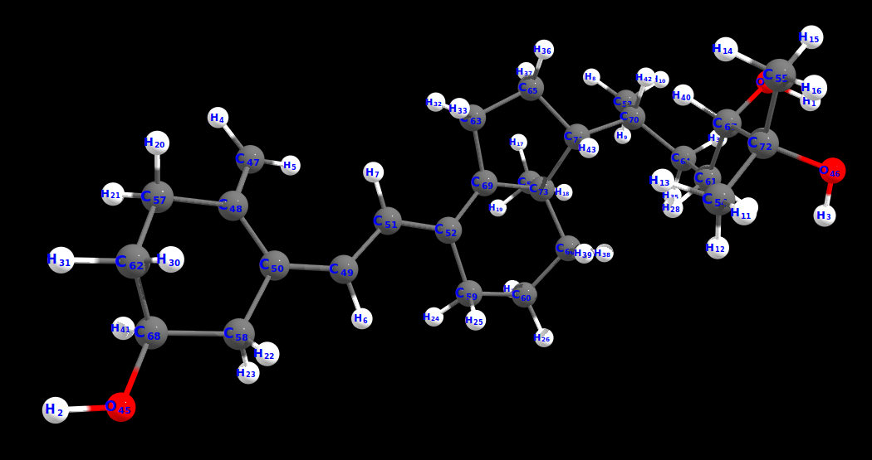

Figure 6: The least energy H-Atom abstraction site calculated at wB97X-V/def2-TZVP shows that HAT occurs at C69. The following steps were involved:
1: Generating H-Atom abstraction sites with CREST.
2: Initial H-Atom abstraction site filtering using XTB.
3: H-Atom abstraction site preoptimizations using XTB followed by clustering.
4: H-Atom abstraction site optimizations using r2SCAN-3c.
5: H-Atom abstraction site DFT SP Energy calculation using wB97X-V with def2-TZVP basis set.
All the quantum chemical calculations were performed with the program ORCA/Weasel.

Cartesian coordinates of the H-Atom abstraction site for 24,25-dihydroxyvitamin D3:
73
Energy: -803555.1966315014 kcal/mol (wB97X-V / def2-TZVP / CPCM(Chloroform)) ++ ChemEnsembleNo: 4 ++ ConformerNo: 4 ++ Version: 1.11.0
H -6.7884842796303762 0.2472139268430499 0.4177229735404065
H 8.0785277696225251 2.5145440066500302 2.6676350798293162
H -5.8818903904409661 2.7986257464597402 0.6210354905374965
H 5.1621083188704544 -3.0806650691321096 1.2625919609441363
H 4.2361616313776338 -2.2897620325949899 -0.1355961399271634
H 3.5442149336688451 1.4481099750610100 -0.6080146106662735
H 2.4593394787797349 -1.2665397035233499 0.3206762988654065
H -3.0896798963129650 -3.5200520838095999 -2.3932550720492936
H -3.4784948797606248 -2.2212846911351396 -3.5314821569647039
H -4.7511246558340057 -2.9409206905607599 -2.5451411545079337
H -3.8489771702370348 2.9281231444154403 2.6759854581427662
H -3.5888642966733348 2.8378094190388903 0.9227455460651165
H -2.8790151696047448 1.6087861053047801 1.9849665980575564
H -4.5678449818363562 0.1371998750230099 3.4079987059352361
H -6.2921539545581862 0.1884391961107499 2.9868773140292162
H -5.5320476376543759 1.5788639649859402 3.7975860184469261
H -0.8195123907213149 -2.6754396196302497 -3.0320429171727339
H -1.5706258221209546 -1.3740925677229698 -3.9747856688660939
H 0.1825876962114253 -1.4072681369821900 -3.7311053582164937
H 5.6481172320767543 -1.5299421104820998 3.2820114924498665
H 7.0245021866572843 -1.4484901222881998 2.1955706415831262
H 4.9201591499754338 2.2906372457222104 1.4826005247171063
H 5.8031989646637641 2.0141110664793400 -0.0109592355734634
H 2.3189083721962351 1.2578058784000601 -2.5007600113020136
H 1.3459311284011355 2.0300393152884904 -1.2655191704490738
H 0.0649336855150653 2.3304016392388904 -3.2250178298896737
H 0.4394758520900953 0.7398306368246100 -3.8621912205295437
H -3.3840295063368551 1.2212259999496802 -0.5842657799572035
H -5.0369172941065861 1.5677506356208102 -1.0739145280049238
H 5.5796445037554241 0.9150887945240000 3.5046407467785863
H 7.2714175412830038 0.4161195471237699 3.6873395990334661
H 0.8083800558960151 -2.9489052550504895 -0.4374243929168435
H 0.3226870212601554 -1.8427472940505800 0.8385469185897265
H -5.3337310807547658 -0.6495518079084399 -2.0108103279846636
H -3.9224046318066050 0.1157374822124300 -2.7153276964040338
H -1.8303505262453046 -2.8086832793520298 0.5734926912829565
H -1.4403907783104946 -3.4073007576097498 -1.0354680976634336
H -1.9206317529175245 0.8697137024213001 -3.0411065453869437
H -1.3294062762781744 1.2956841414291900 -1.4273139397107237
H -4.1521162029368259 -0.4582383618631801 1.0484804675036563
H 7.5579087788983541 0.8193850901847101 1.1835356607662062
H -3.9523832875349751 -2.0059725621407596 -0.5293202389380335
H -2.0919468730946349 -0.5523905030667400 -0.2038663152979234
O -6.1065945069502456 -0.4346056818774601 0.5137547458358965
O 7.2650181889002141 2.6359316437134201 2.1628318305781864
O -6.1524026370398461 2.2213504910518003 1.3467745796156463
C 4.8041801181532442 -2.1748622368926998 0.7795978778659964
C 5.1505395977027746 -0.9551368111662799 1.2769359602117962
C 3.5880476418473450 0.4785952872529299 -0.1094759764130334
C 4.7293083751045346 0.2954398681659499 0.6987183558823165
C 2.4971913498931451 -0.3552028641203901 -0.2680365308995435
C 1.3718520730168555 -0.0897155850835300 -1.1153693070774238
C -3.7016120232999747 -2.6254437415719498 -2.5399610447328138
C -3.7585687424792948 2.2434138708543605 1.8266646386915764
C -5.3791246315341859 0.7846443119917301 3.0604570692260165
C -0.7808586371937548 -1.6051822591655500 -3.2530982070375538
C 6.0953084292323938 -0.9352908589074299 2.4765064666045662
C 5.5402733404247639 1.5524822478651701 0.9511147950951965
C 1.3698639951851455 1.1725281142821902 -1.9558586358669037
C 0.2020149339936953 1.2807824109440802 -2.9388763739127639
C -4.3721466084436855 0.7685059813756201 -0.7130525033207735
C 6.4338910754521343 0.4649058324422299 2.9799289754882361
C 0.1176182393590453 -2.1285364019082698 -0.2008400799034234
C -4.3101930127916859 -0.3236320671313901 -1.7870435279605437
C -1.3566711329284544 -2.5371853975072498 -0.3760758867170035
C -1.0908547268949844 0.7293574474128701 -2.3388801508407235
C -4.8675729489359858 0.2729138571539699 0.6475105760527565
C 6.7888293061560141 1.3354584581111302 1.7855505206452162
C 0.3033318571207453 -0.9383933584575699 -1.1174137041418537
C -3.4944747866339347 -1.5788141848102799 -1.4361093002188436
C -2.0347990314892748 -1.3058691212939200 -1.0070682481240936
C -5.0199916906522359 1.3923778414481600 1.7090362518797664
C -0.9383448693579148 -0.7520132959546899 -1.9734188107649238

Conformer Search (24,25-dihydrovitamin D2) using wB97X-V with def2-TZVPP basis set
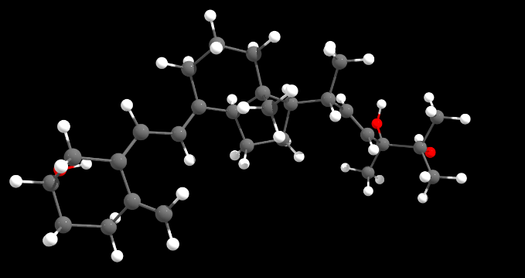
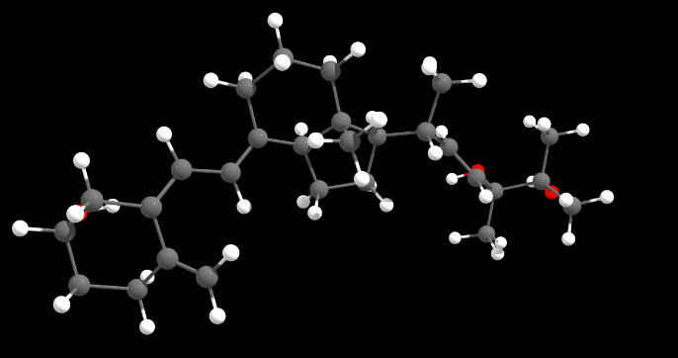

Conformer No. 64 (11.95%; 0.00 kcal/mol) Conformer No. 331 (11.24%; 0.04 kcal/mol)
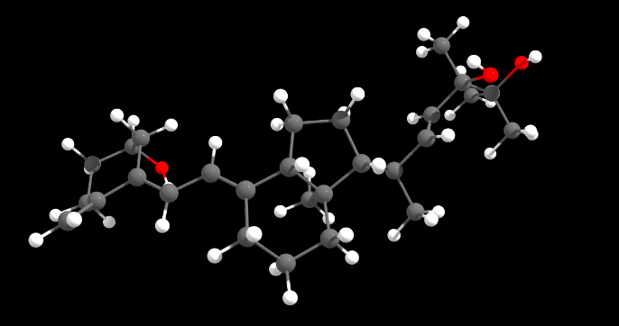
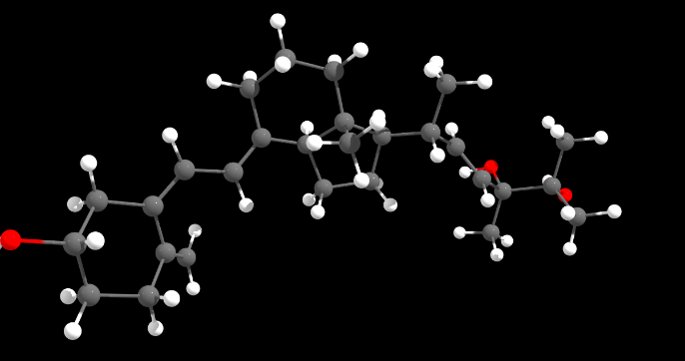

Conformer No. 88 (9.01%; 0.17 kcal/mol) Conformer No. 29 (8.14%; 0.23 kcal/mol)
Figure 7: Four Conformers of 24,25-dihydroxyvitamin D2, which constitute major part of the structure in solution (chloroform). The Boltzmann population and their relative energies are indicated within brackets. DFT calculations were done using D3 correction and CPCM solvent model is utilized for chloroform. The following steps were performed for calculating the energies of the conformers: (i) Generation of conformer ensemble with GOAT using GFN-FF; (ii) Initial conformer filtering using XTB; (iii) Conformer preoptimization using XTB followed by clustering; (iv) Conformer optimization using r2SCAN-3c; (iv) Conformer DFT SP Energy calculation using wB97X-V/def2-TZVPP.
All the quantum chemical calculations were performed with the program ORCA/Weasel

Cartesian coordinates of the 4 conformers for 24,25-dihydroxyvitamin D2:
75
Energy: -827858.8385936731 kcal/mol (wB97X-V / def2-TZVP / CPCM(Chloroform)) ++ ChemEnsembleNo: 1 ++ ConformerNo: 64 ++ Version: 1.11.0
H 2.6212944583482298 -3.3616335174511778 -5.3959375140689829
H -4.9050301048926856 0.4195756189516281 2.8649897373484796
H -6.2858537152774252 2.1742596210225300 4.8685359532541117
H 2.6965141965326733 1.1911086112201874 -3.3759495885883668
H 1.8085169299811052 1.6554262786870002 -4.9439726490715241
H 3.7807803807156022 -2.5595868248062312 -2.5372544618535509
H 1.2720767042553065 -0.7335547965569008 -2.5890528031297064
H -2.6157494517629662 0.0513285199638899 3.5482260409138231
H -2.3397916539762744 2.9833506446546241 2.7107164564323734
H -0.1562176467779177 1.2378772521732453 4.9231195559021232
H 1.1897031081903511 0.5647909121412393 3.9935395108222167
H -0.1377534894658558 -0.4884766074076353 4.5178211669429542
H -4.5169129299893447 3.7452669093774316 1.8205229566434213
H -6.0531497401896770 3.0152247287615883 2.3494338564416761
H -4.9267900238771283 2.1067904895445095 1.3050006530735216
H -4.1564155153868141 1.4173321010656541 6.0126364213357890
H -2.7782350302930352 2.5037179044558289 5.7573295320550173
H -4.1456732478455276 3.0287420872520086 6.7658839430504338
H -4.7231986604799889 5.0115384133815404 3.6874474548669345
H -3.0891086317000633 4.6087411212531171 4.2696805980806518
H -4.3565126153552720 5.0655576758128129 5.4196896885936017
H 2.5452577049170131 0.5192214491548341 0.2509439073149293
H 2.0509902654365497 1.1856057911005948 1.8160468911700420
H 1.0452320196782989 1.4377556986436577 0.3846296298411440
H 1.4084703469803115 -1.4444387310175413 -6.1949508735938981
H 1.7770674077884885 0.1689268991172909 -6.8078371770238464
H 5.3072565389080140 -1.1056827696492471 -5.1598964701722299
H 5.0577544250279125 -2.6965057822960037 -4.4103784981349383
H 2.0590333299815624 -3.6210271927669115 0.1911859036714403
H 3.5310216753176471 -2.9945823653249590 -0.5547438857155380
H 3.7002351096462371 -1.2215553420891356 1.1322886849978526
H 3.5339666341414113 -2.7747859112354210 1.9396291965555144
H 2.9938210897333972 -1.6826811066106369 -8.0449368927526113
H 4.1035055613349982 -0.5134196226644405 -7.3125332660052074
H -0.0825302339975878 0.3289524000449197 -1.3026919239348342
H -1.1710882357530445 -1.0531006771755289 -1.4099949393003146
H -2.3295043756764127 -0.3225366443471065 0.5510286728899063
H -1.4309892406979248 1.1759384508388273 0.4004556678488282
H 2.1157470719858109 -1.0232244833684434 3.0004709962994216
H 1.1515950647654047 -2.3716672537627517 2.3966507573902827
H 4.9181272353771943 -2.7818544116094257 -6.9039454038160724
H -0.3123342224697989 1.7786649558372745 2.4477541093411181
H 0.0433729014891623 -2.2714818307042570 0.2849018411847801
H -0.8887986868835681 -1.2028699122634467 2.1845967031970988
O 3.2100838372334031 -3.5538841039839810 -6.1395826714582844
O -4.9035432615374930 0.9449942402481092 3.6752213812883232
O -5.9916829608096496 3.0958764416378837 4.8987058463582809
C 2.3633147241213517 0.9147950035608009 -4.3727148556113971
C 2.6350776412175723 -0.2894006588534777 -4.8876727698593330
C 3.1167094146223850 -1.7914977946391883 -2.9316078480016912
C 3.4135350944842644 -1.3204458571899012 -4.1663901967077868
C 1.9886345758407460 -1.4019641975832564 -2.1170930534802714
C -2.1257187182860493 0.9562821457781366 3.1817604870338716
C 1.7411759696978426 -1.7988931998278048 -0.8504283311735529
C -2.8304434560362979 2.0799540719778116 3.0766138278780217
C 0.1085901500056729 0.5132982959703339 4.1454800830731937
C -4.9989145548553422 2.8164112527583405 2.1376370127002340
C -3.8653377616493980 2.4624062911221700 5.8722879454903341
C -4.1576803746302948 4.5271507422103099 4.4876050470546920
C 1.6842861382310947 0.7123214911572664 0.8983309265405135
C 2.2059116470627531 -0.6906566979308987 -6.2819597933973377
C 4.5622513230037613 -1.8911939399328168 -4.9644081809827796
C 2.6228448063154746 -2.6990368371040718 -0.0227469836712985
C 2.9989785945567142 -2.0443404529302520 1.3205330534957689
C 3.3638415223081952 -1.2942101376051065 -7.0890432169852824
C -0.5365355627503700 -0.4827982132344391 -0.7235732874071010
C -1.3170070776400173 0.0886515099962556 0.4858820758290959
C 1.7760561512088293 -1.5203296014383370 2.0858694006794822
C 4.0663476548028790 -2.4133957902169065 -6.3190721539049459
C -0.6636396360450311 0.8183313429500142 2.8528968961700758
C 0.5383874032462718 -1.3518678695714705 -0.0780181113385819
C -4.3055322952690274 2.2201035439931505 3.3687488701475989
C -0.4986075293512834 -0.2611357141233873 1.7646973166528876
C -4.5723781582842529 3.0721134332212570 4.6586359910585537
C 0.9226846360626240 -0.5793323939569007 1.2251323685357887
75
Energy: -827858.8023606561 kcal/mol (wB97X-V / def2-TZVP / CPCM(Chloroform)) ++ ChemEnsembleNo: 1 ++ ConformerNo: 331 ++ Version: 1.11.0
H 2.6218430703564501 -3.2385755495037687 -5.5148169187644536
H -4.1813377634366153 0.7163602787677403 4.9125259647753037
H -6.0897924154991063 2.4150986828544529 5.1015156766434497
H 2.6622283082357159 1.2002305603546126 -3.2332454340596390
H 1.8024860136842273 1.7494872637327969 -4.7895834153397603
H 3.7369390128490192 -2.5841577478123230 -2.5739857657441183
H 1.2271774093053889 -0.7587924577249128 -2.5690285038666527
H -2.5838882632761195 -0.1014725361539374 3.6547896168167262
H -2.3516623664395944 2.8114644720255639 2.7313918596574061
H -0.0915774285109893 -0.6426106644618946 4.5426699762128049
H -0.1105463945871352 1.0811627651872033 4.9612126773939984
H 1.2172045699274709 0.4220680290122964 3.9964150305264208
H -5.0508222423200380 1.2073332790869933 1.6990339934694467
H -4.7163894248333236 2.9398818837725700 1.5484471820058219
H -6.1576864377645997 2.3954037609504897 2.4399563979173617
H -2.5586520332348557 3.3533206709485457 5.3866402658331456
H -3.8638842109894229 4.1124676241940827 6.3268109018698953
H -3.7576748926074606 2.3499649820514308 6.2279183805201352
H -5.0237152094384827 4.7685031558861972 2.8730404812213313
H -3.2995868243695874 4.7567528817967704 3.3145201169973197
H -4.4906999189573851 5.4847395431909689 4.4029346242944891
H 1.0060241140609236 1.3210783396567891 0.4196452358585380
H 2.5065697509564089 0.4075970978215489 0.2594216736077076
H 2.0276828170502608 1.0542111877871561 1.8372034759940929
H 1.4291372978433803 -1.2817311211742619 -6.2120915362188951
H 1.8030646297359514 0.3631741598655056 -6.7310294838396008
H 5.3075999655382811 -0.9999725984551182 -5.0843449310421729
H 5.0406517441736831 -2.6297341139914581 -4.4324041589676693
H 2.0152090435267862 -3.7265982977294794 0.1378945953923158
H 3.4816886554621904 -3.0935156490312865 -0.6138568306344454
H 3.6741643157146551 -1.3474194531873451 1.0995383478746061
H 3.5154109482624523 -2.9138620812072800 1.8831417759083242
H 3.0480090836598608 -1.4155860200415673 -8.0441654867305417
H 4.1407010125051311 -0.2857473299360106 -7.2300302038895508
H -0.1496257183822704 0.2410994616509196 -1.2620092882257723
H -1.2320130276957753 -1.1447262917950547 -1.3779399852204330
H -2.3655280318012251 -0.4581056688863347 0.6131885841577100
H -1.4837685537647505 1.0509572714962809 0.4702261791535619
H 2.1123859979730835 -1.1770827629279208 2.9890473862188567
H 1.1404679070423416 -2.5158232385849861 2.3770398988723840
H 4.9557918009514621 -2.5698106077081317 -6.9293186256194996
H -0.3248059858670562 1.6376784670609124 2.4932597076861813
H 0.0098018503331809 -2.3862695164757577 0.2781306840093567
H -0.8995384781217575 -1.3431189428176471 2.2181674702532339
O 3.2367062237931221 -3.3901410155889051 -6.2465991300339763
O -4.7971297815209857 0.9313625260542326 4.1987250625186840
O -5.8951582181225621 3.3295610148200119 4.8460097906482993
C 2.3469485614726029 0.9785520824467441 -4.2493041687181838
C 2.6284472286422442 -0.1964571524434795 -4.8233684272804167
C 3.0788522865297057 -1.7965855305075578 -2.9388341482778153
C 3.3940240136832318 -1.2651085160490674 -4.1440534987279083
C 1.9429668750030853 -1.4428927681427759 -2.1186760393027253
C -2.1170806052777005 0.8069092115443143 3.2658811230605025
C 1.6938224630382266 -1.8838912837842992 -0.8670976574847178
C -2.8298662174168454 1.9250821622470913 3.1503325475484667
C 0.1402478358696166 0.3634778010129607 4.1724831752080780
C -5.1107843511059841 2.1696267310574591 2.2155458247597988
C -3.6151112880370673 3.2786839254259261 5.6632912923879939
C -4.3181828006024645 4.6626056392110584 3.7007288837550294
C 1.6521160282776646 0.5911064951229550 0.9180097518643926
C 2.2253433246287595 -0.5224683831360321 -6.2445611318867211
C 4.5572475861136184 -1.7934862880011864 -4.9502249743137705
C 2.5806614463203297 -2.8036743912996380 -0.0668458602641921
C 2.9741672249566693 -2.1724541495668892 1.2827484926772492
C 3.3996242481461558 -1.0791697916620209 -7.0619082023250943
C -0.5909573874216503 -0.5829189972995529 -0.6905793116330694
C -1.3582788005072413 -0.0362179917940684 0.5387724816129829
C 1.7610192939021756 -1.6598579341974671 2.0711226536656251
C 4.0907582841458208 -2.2378387365308265 -6.3421046032055912
C -0.6627449531064301 0.6733437179464431 2.8999435915175615
C 0.4961778993069365 -1.4582570669304178 -0.0745713731726423
C -4.2869782110734711 2.0867002425293353 3.5020620152436126
C -0.5177230963767711 -0.3971489269234196 1.8002520569375284
C -4.5198155417294217 3.3385479243369489 4.4277667742274023
C 0.8961495919097678 -0.7061155778587400 1.2359908772931394
75
Energy: -827858.6711787784 kcal/mol (wB97X-V / def2-TZVP / CPCM(Chloroform)) ++ ChemEnsembleNo: 1 ++ ConformerNo: 88 ++ Version: 1.11.0
H 5.6493302805613546 -2.2163061031418190 -7.1964150101037703
H -4.9032805453820254 0.4336917044444210 3.2906763101684890
H -6.1186715914001750 2.4648891766254311 5.1203438070964697
H 0.2388566584862953 -2.4955173053105391 -4.5338218835983000
H -0.1359617845582747 -1.1944094393276792 -5.8089102798706396
H 3.6396545210597848 -2.6055513805887389 -2.4769651681256906
H 0.9168759473632748 -1.1252364004161992 -2.6015899162690408
H -2.5718419341111551 0.1284461952735915 3.7603296324891993
H -2.3542437959235154 2.9538540636630808 2.6009872220726393
H -0.0657959710864749 -0.4127180561177691 4.5686559840404097
H -0.0434758372181848 1.3331959165540508 4.8791070752305403
H 1.2406107300196847 0.5923778196918810 3.9141882227231091
H -5.0568143848581055 1.8606970238975107 1.5072603284066395
H -4.6070690471755249 3.5536783820631408 1.7272744061585594
H -6.0944777357384554 2.9336904652947209 2.4864091609408994
H -2.5538563327164354 2.9297672426006209 5.6511720207694305
H -3.8392589761380953 3.5999829873007312 6.6813555267889502
H -3.8896134127504651 1.8927564276160107 6.1846565875224897
H -3.0157877885638555 4.7876823852125714 3.9013097670189891
H -4.1986911739520751 5.4088067761056910 5.0641595916689806
H -4.6959102277075555 5.0890230231901006 3.3942461133097392
H 0.9409038581403047 1.2784064514533309 0.3115841476930887
H 2.4109646885422045 0.3184219336362010 0.1471423747493990
H 2.0102024873257145 1.0641923347442608 1.7032544765063196
H 1.5874723510802147 0.1611782065909515 -6.7088926118199499
H 2.6497920851788845 0.6853538595852510 -5.3944581421017297
H 4.9326803205799648 -2.6406115701701589 -4.3384249447396899
H 3.9436802990719149 -3.1223846433272988 -5.7322496476511899
H 1.8896038954362047 -3.7984743585758691 0.2816169370954187
H 3.3255016622896845 -3.2042822466561689 -0.5462719373913705
H 3.5798627395043945 -1.3803247392532392 1.0758735180740995
H 3.4240126173951646 -2.9009965366452688 1.9433970281202695
H 3.3516678191623446 -1.4068081923780391 -7.5202743573581001
H 4.0158813873679851 0.2336063749460415 -7.3989437860576297
H -0.2809319471686347 0.1191674299813114 -1.2722490504000905
H -1.3941769117681653 -1.2479478423003592 -1.2795141130663605
H -2.4563431447075654 -0.4307888884427490 0.7007479783787196
H -1.5584485229750054 1.0532805694802807 0.4435615117552187
H 2.0660232331523747 -1.0952831750699892 2.9921811379960292
H 1.0642065684341546 -2.4502894863260392 2.4692330928253092
H 5.0205842670033443 -0.3206002394773090 -5.2020751606340498
H -0.3300276543394547 1.7402205201818008 2.3898298435176493
H -0.1287659919141748 -2.4138355257778792 0.4166684573985787
H -0.9583923977501052 -1.2417157563295993 2.3132898369198291
O 5.8895597106166546 -1.5078521299234091 -6.5842403575712600
O -4.8311679450129450 1.0715989762366107 4.0118792759773205
O -5.8354184509164657 3.3806072498017010 4.9861006653878501
C 0.5883129867375948 -1.6769194412835493 -5.1568299690967496
C 1.8666111066257347 -1.2818826024359493 -5.1379524539949601
C 2.7900205770705049 -2.1262385845240490 -2.9613749259184208
C 2.9013234235712346 -1.9176105831928592 -4.2948554707159401
C 1.6845581652887847 -1.7274441605625892 -2.1209973001621010
C -2.1089736387906455 0.9872328899143310 3.2689526462363694
C 1.5245840230427947 -2.0195354363625189 -0.8122652982099804
C -2.8195345060236954 2.0983521564340211 3.0930578516720693
C 0.1694653748617252 0.5640084700182409 4.1287142359118398
C -5.0610735665473552 2.6911637900331411 2.2230748967101293
C -3.6269014247432052 2.9048826308798610 5.8630703132532602
C -4.0629096365315549 4.7352628576671210 4.2120604291596102
C 1.5880417321567846 0.5609243000459910 0.8263473660799395
C 2.3781106072299747 -0.1722380551324485 -6.0285786892967996
C 4.1624691275107644 -2.2945812376035888 -5.0364285457002396
C 2.4430559869402746 -2.8837716902014292 0.0142850502824489
C 2.8754182884172947 -2.1861349454152190 1.3179649400600995
C 3.6221799274915747 -0.6066038340476790 -6.8149807339508897
C -0.7235955137571952 -0.6610382424758990 -0.6430469713391804
C -1.4457973026459354 -0.0297690046089486 0.5726420447086695
C 1.6882472937414947 -1.6188791253951693 2.1079367646548390
C 4.7025045188192642 -1.1293008174385493 -5.8748389029834902
C -0.6701442448984052 0.8087496612595410 2.8656655456459492
C 0.3651315834280454 -1.5192682043145491 -0.0062808903901911
C -4.2693699613215257 2.2836545213316111 3.4715284342889894
C -0.5741582020544652 -0.3289179465449791 1.8292212383436994
C -4.4407621278436951 3.3220099269519512 4.6351613049511400
C 0.8163233539613047 -0.6980722570906090 1.2435760298449494
75
Energy: -827858.6111272682 kcal/mol (wB97X-V / def2-TZVP / CPCM(Chloroform)) ++ ChemEnsembleNo: 1 ++ ConformerNo: 29 ++ Version: 1.11.0
H 3.3386750125597811 0.5375005613225214 -4.4360166931278222
H -4.7648679078851677 0.1008741766948104 3.5923847227063463
H -6.0668389796232676 2.2110838508620079 5.2675181824919779
H 5.4568223705664236 -3.9233882924397792 -5.5587840524752554
H 4.1320671675079881 -4.3702714058577117 -4.3310410577588447
H 3.6401584093211565 -2.6703686949912826 -2.5772932299937317
H 0.8197183289134731 -1.3575303014554621 -2.6177880612816802
H -2.3841845344695769 0.1144653746352370 3.8384101010563341
H -2.6066339562218448 2.7903751518087048 2.3665469708233156
H 0.2254279557720063 -0.0218276321914506 4.4806372608326237
H 0.0384197355232007 1.7379707636094679 4.5997357550545512
H 1.3375779698263544 1.0543250992760138 3.6136524244578090
H -4.9857073197447024 2.9874351352670758 1.6204475731498131
H -6.3182024189444137 2.3108868590278320 2.5895461777588209
H -5.2325106587275467 1.2399374865737094 1.6623736192670777
H -3.8318736777627489 3.8138249246290346 6.4271282782644406
H -3.6974497655963101 2.0599688370573190 6.1609491044151738
H -2.5616025737557080 3.1646101478089559 5.3647364234216370
H -4.5516968723827009 5.3231413917136159 4.6353170689243779
H -5.1574511066930233 4.7160480275609844 3.0849166661535201
H -3.4125503446020655 4.6843241259602362 3.4386243973662944
H 2.2497510485655163 0.5109771103353558 -0.1970050912733469
H 1.8699386870549564 1.3724665025023821 1.3032179713925272
H 0.6760330058593476 1.2824670871945443 0.0014038206611899
H 5.1384703956954487 -0.6171930693469675 -5.4738884467433779
H 5.3733804456031340 -1.8401708123195630 -6.7222515968240799
H 1.3333951629975138 -1.9891526085115172 -5.8780248576096037
H 1.0003734082128890 -0.8545797844089068 -4.5635179102754071
H 2.3212625556479027 -3.5909376184738133 0.4241029979484065
H 3.6041070194057432 -2.9209391024802884 -0.5815826753932518
H 3.7121031304353229 -0.8961048563010570 0.8000407041896289
H 3.8410294829098270 -2.3116684830267009 1.8354376353722888
H 3.9745032023937745 0.1283343061989975 -7.4943660822002975
H 3.1017521296098507 -1.4071031466687922 -7.6195843515950665
H -0.4809048383543351 -0.2022671597533771 -1.3401837390723321
H -1.3839229060375520 -1.6993586797561755 -1.1084162716813593
H -2.4046914149609870 -0.8102595443724407 0.8629018869247849
H -1.7507165694510229 0.7416428354582215 0.3731969244609287
H 2.3213151791420690 -0.5934453027208649 2.8039339745857790
H 1.4850847042521940 -2.1208327868715795 2.5188238954288225
H 1.6357674273650791 0.3017852929806937 -6.6610392381287475
H -0.4746308970178181 1.8095394802192661 2.1125170307159848
H 0.1560202661099196 -2.4847370485943738 0.5794981275716414
H -0.6942880364134425 -1.2159429241650035 2.4161457217483573
O 2.8698207251493710 0.9286140382042294 -5.1864952097607828
O -4.7125993516423330 0.8366198694834652 4.2153769406557435
O -5.9181008267894599 3.1244358398090530 4.9840867252477681
C 4.5721964216924400 -3.6329192989331531 -4.9971687647383476
C 4.0402883728706067 -2.4110570892219303 -5.1310110566699265
C 2.7781080934333726 -2.1848946348371823 -3.0303326275783640
C 2.8509492131718934 -1.9734278446307059 -4.3676306056355907
C 1.6881773387962558 -1.8218065513992205 -2.1569741156488189
C -2.0714776377490534 0.9574694100080516 3.2181123129159031
C 1.6445211324347455 -2.0114095266785670 -0.8189711307088073
C -2.9255769701151606 1.9513836250350058 2.9870791401455850
C 0.2976780333816921 0.9184154068494969 3.9206213814069639
C -5.2858205673352447 2.1552931356429981 2.2634671403498081
C -3.5997826487772673 3.0413828854225304 5.6873076771602493
C -4.4105393882933370 4.5565414618163667 3.8668080675926038
C 1.4557522820732141 0.7209583090834719 0.5259419323652745
C 4.6197960314045865 -1.3801479938779799 -6.0744510940829866
C 1.7964697629485464 -1.2676953951298671 -5.1882165462243393
C 2.7265604374803702 -2.6528681434307151 0.0123559920327111
C 3.1510217789298349 -1.7546743853275226 1.1900322489799589
C 3.5365991834770307 -0.6896389676184806 -6.9104680297490697
C -0.7597306554210868 -0.9584894857734093 -0.5979700816544963
C -1.4746131933011195 -0.2938558288991888 0.6048047296778218
C 1.9565797281596746 -1.2621753921087497 2.0173319183094751
C 2.4134748668770274 -0.1440338981476391 -6.0290729414888782
C -0.6541392383190312 0.9068198597323336 2.7146630047033948
C 0.4836033948059823 -1.5855069180272241 0.0260781675900346
C -4.3533626798631895 2.0182168754178167 3.4731081014746272
C -0.4796679205888472 -0.3250154834451568 1.8035602315732027
C -4.5624993439469854 3.1820788169150815 4.5051150329777565
C 0.9031504629282815 -0.5721247226601283 1.1404896618372922

HAT (H-Atom Abstraction) site search (24,25-dihydroxyvitamin D2) using wB97X-V with def2-TZVP basis set
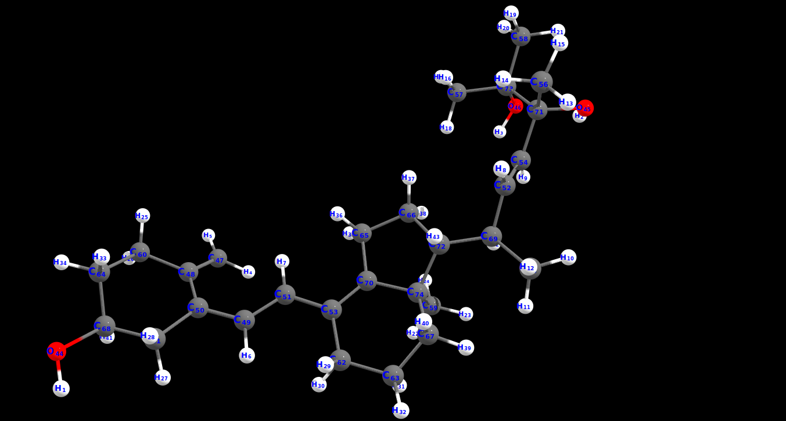
Figure 8: The least energy H-Atom abstraction site calculated at wB97X-V/def2-TZVP shows that HAT occurs at C70. The following steps were involved:
1: Generating H-Atom abstraction sites with CREST.
2: Initial H-Atom abstraction site filtering using XTB.
3: H-Atom abstraction site preoptimizations using XTB followed by clustering.
4: H-Atom abstraction site optimizations using r2SCAN-3c.
5: H-Atom abstraction site DFT SP Energy calculation using wB97X-V with def2-TZVP basis set.
All the quantum chemical calculations were performed with the program ORCA/Weasel.

Cartesian coordinates of the H-Atom abstraction site for 24,25-dihydroxyvitamin D2:
74
Energy: -827459.0401317583 kcal/mol (wB97X-V / def2-TZVP / CPCM(Chloroform)) ++ ChemEnsembleNo: 5 ++ ConformerNo: 5 ++ Version: 1.11.0
H 9.0419992128270366 -0.7921162995794561 -1.6068884248545292
H -7.5127493321469743 0.1650367415609139 0.8750527277485007
H -5.9089077927044542 2.1227167059599337 0.1132846644142707
H 3.5915250790280155 2.7056325016993537 -0.9151038478553393
H 3.9668083637680356 3.3392256641259439 -2.6162594676621791
H 4.7980733273371357 -0.5862179816959860 0.6303338445649207
H 2.5067536552684953 0.9113348559479939 -0.7527714688971393
H -3.6545366969732647 -1.9511964728105462 0.3426315360309806
H -5.0807707758079239 0.5172692899975139 1.4609915376768408
H -3.8556379078616647 -2.0546505337253063 3.4153930537068709
H -2.2033507229785148 -1.6923179216000761 3.9305388467311309
H -2.4877433792108148 -2.8782965130198663 2.6431186543102507
H -5.7802438850351141 -2.7401125863497162 -0.2015446414779992
H -5.0457832412422645 -1.9113191641742762 -1.5874977239182093
H -6.8069489871615341 -2.1233580774322660 -1.5030794539496792
H -4.5619378368039643 0.1576395425486538 -2.4428879673790194
H -5.1160894217116137 1.8418976763300339 -2.5116273052909093
H -4.1605448652362540 1.2656588427942439 -1.1231291610138392
H -7.0641886773608844 -0.3548137312724662 -2.8845147815876793
H -7.5599601635822244 1.3324197517963139 -2.6663896573598191
H -8.2708840772378842 0.0599608972882339 -1.6462058685742893
H 0.4683878710501856 1.2057347465679937 3.5925735195107906
H -1.1434518555815842 0.5350706446039339 3.9061222411528709
H -0.8905208197007044 1.6834912632620538 2.5778188429075106
H 5.0424636510049758 1.5506865525779039 -4.2216124792099698
H 6.2879323641031561 2.5242857340897937 -3.4598096841800894
H 7.0081164824433460 -0.2602043600504161 -0.1975545159142293
H 6.3403385120686755 -1.3243069665449363 -1.4306707485564893
H 3.1676096719413156 -1.8646179806558463 1.7995733989299707
H 3.7124672387199853 -0.3970865213172162 2.5874498452800005
H 1.8634610294353458 -0.3412451660204461 4.0839510068645302
H 2.2804842039268354 -2.0419286366731964 3.9877783667052409
H 6.2563174699112363 -0.5165034801524760 -3.7912065045772492
H 7.4603496728195760 0.6512960328170239 -4.3616242240252001
H 0.2406365778844056 1.8291681250732037 -0.1211667505938493
H 0.3823165876828856 0.3189682080550139 -1.0062360581436092
H -1.9480252457607143 0.1035950860989139 -0.6651517637117392
H -1.9469047493311844 1.3006976679644937 0.6214092649618308
H -0.1556581525966544 -1.7721400817836561 3.8104585887358509
H 0.4780151341146456 -2.4007072896904962 2.2861373144100408
H 7.9104231600628863 1.2359309381114039 -1.9259759691052292
H -3.0038267106213947 0.1483476108179438 2.4920168487332108
H -1.1864051462977743 -1.6447853004798563 0.8149690032947507
O 8.5936814378340554 -0.6609647349751161 -2.4519865271937493
O -7.2758909918665537 -0.7359107940340961 0.6051599232086807
O -6.6806414086968937 1.7442564965687437 -0.3273134545650194
C 4.1068650392467863 2.5723526194631536 -1.8585069473776192
C 4.9731356096545358 1.5456696603897437 -2.0793823900108794
C 4.3500048018416955 0.0874463640170639 -0.1013800364675193
C 5.2290913584569960 0.4964300931750338 -1.1248484913285592
C 2.9986930281367754 0.3477701611130039 0.0335545562429807
C -3.8276421261874147 -1.0734815837525862 0.9686154654053407
C 2.1741813740148253 -0.1159366442689161 1.1108418009170709
C -4.9299284735034838 -0.3448358504522762 0.8060340747464707
C -2.8269356585467245 -1.9239840587327861 3.0636527054558909
C -5.9084580580502042 -1.9220083794670062 -0.9163175522294292
C -4.9381121433832540 0.9925081803267539 -1.8440515936080493
C -7.3555961955372942 0.3934570837164438 -2.1433858149352392
C -0.4462512204103244 0.8412813488419439 3.1176211020320408
C 5.7574905139988157 1.5659536740167037 -3.3902295818280894
C 6.5385965148269758 -0.2676606745608062 -1.1926620933541292
C 2.8135772803331953 -0.9144259619155261 2.2286110846300606
C 1.8823825183273057 -1.2025220538974861 3.4053965482905006
C 6.7625851834443163 0.4277950435169738 -3.5468651490241991
C 0.0637566158277955 0.7475661939444339 -0.0484995289889693
C -1.4142269770847544 0.4230003020058338 0.2346715706314207
C 0.4604379074820756 -1.5183271104889662 2.9423787528073007
C 7.5099755785834557 0.2556476320251639 -2.2408896910194493
C -2.7688360070968545 -0.8099660926208261 2.0066564643246609
C 0.8293813886654655 0.1184581585940339 1.0936164271393107
C -6.0600483303295043 -0.6060419023090960 -0.1672066701896792
C -1.4001444501057143 -0.6821981851876361 1.3097406325709708
C -6.2359277658267338 0.6217600606282239 -1.1346690160737694
C -0.1421295264378044 -0.3386781251746062 2.1677540248757405

