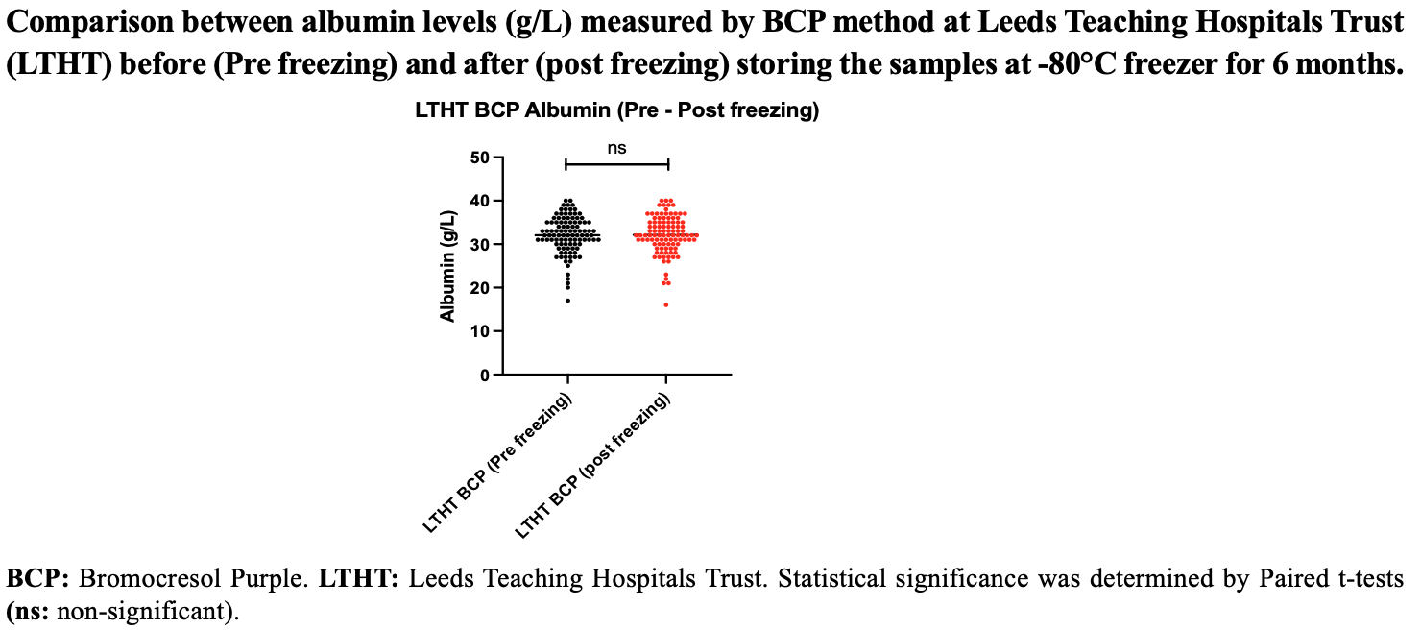
Supplementary Figure 1 (LTHT BCP Albumin pre- / post- freezing)

Supplementary Figure 2: Shows that albumin immunoassays (either immunometricor nephelometric) are not widely available in the UK, and certainly they are not routinely used by hospital-based laboratories as evidenced by the UK National External Quality Assurance Scheme (NEQAS).

