Supplemental material 3

Isotope dilution-liquid chromatography-tandem mass spectrometry-based candidate reference measurement procedures for the quantification of total and free phenytoin in human serum and plasma

Short title: An ID-LC-MS/MS candidate RMP for the quantitation of phenytoin

Tobias Schierscherª, Linda Salzmannª, Neeraj Singh^{b}, Manuel Seitz^{b}, Janik Wildª, Carina Schäferª, Friederike Bauland^{c}, Andrea Geistanger^{b}, Lorenz Rischª, Christian Geletneky^{b}, Christoph Segerª and Judith Taibon^{b}*

ªDr. Risch Ostschweiz AG, Lagerstrasse 30, 9470 Buchs, Switzerland
^{b}Roche Diagnostics GmbH, Nonnenwald 2, 82377 Penzberg, Germany
^{c}Chrestos Concept GmbH & Co. KG, Girardestaße 1–5, 45131 Essen, Germany

*Corresponding author: Judith Taibon, PhD, Nonnenwald 2, 82377 Penzberg, Germany, Phone: +49 8856 6012941, E-Mail: judith.taibon@roche.com
Characterization of reference material by quantitative nuclear magnetic resonance (qNMR) measurements

Quantitative nuclear magnetic resonance (qNMR) measurements were performed in six replicates using the International System of Units (SI units) traceable internal standard (ISTD) for the quantification of the absolute content of phenytoin.

The following formula was utilized to calculate the absolute content of phenytoin:

$$Px=\frac{Ix*Nstd*Mx*mstd}{Istd*Nx*Mstdmx}*Pstd$$

Px: Purity of the analyte as mass fraction
Pstd: Purity of the internal qNMR standard as mass fraction
Ix: Integral of the analyte
Istd: Integral of the internal standard
Nx: No. of analyte protons
Nstd: No. of internal qNMR standard protons
Mx: Molecular weight of the analyte
Mstd: Molecular weight of the qNMR internal standard
mx: Mass of analyte
mstd: Mass of qNMR internal standard

For phenytoin:
The following values are common to all the qNMR measurements:
Molecular Weight of Phenytoin = 252.2679 g/mol; Molecular weight of the qNMR internal standard ISTD (Methyl-3,5-dinitrobenzoate = 226.143 g/mol; Purity of the qNMR internal standard as mass fraction = 99.84 ± 0.17% (k = 2); Number of Protons taken into account for the ISTD = 3 and for Phenytoin = 4; Integral of Phenytoin proton = 4.
Procedure for sample preparation and processing parameter:
Phenytoin (Sigma; PHR1139; Lot Nr. LRAB7770) and Methyl-3,5-dinitrobenzoate (TraceCert qNMR standard traceable to NIST PS1; BCBW3152) was purchased from SigmaAldrich, Germany. 5mm NMR tubes were obtained from Euroisotop GmbH. Phenytoin (Table 1) and the qNMR standard (Table 1) were weighed together in a glass vial on an Ultra-microbalance (XPR6U), from Mettler Toledo. Pyridine-d₅ (approx. 700 µL) was added to the glass vial, and after a short vortexing, the solution was transferred to a 5 mm NMR tube. The single-pulse-¹H{¹³C}NMR measurements were performed on a JEOL 600 MHz NMR spectrometer equipped with an ultra-cool probe head, which provides 4-5 times sensitivity enhancement compared to normal room-temperature probe heads. For Phenytoin, single-pulse-¹H{¹³C}NMR was utilized for the quantitation (Figure 1; chemically equivalent aromatic protons ortho to the sp³-hybridised Carbon; δ = 7.85 ppm, 4H; Methyl-3,5-dinitrobenzoate as qNMR internal standard, CH₃; Pyridine-d₅ as solvent) with an inter-scan delay of 70 seconds. NMR measurements were performed at 298K/300 K utilizing 64k data points and the number of scans were limited to 64 with automatic receiver gain conditions. Processing was performed with an exponential window function (line broadening = 0.3 Hz), followed by manual phase and baseline corrections. Six individual experiments involving six individual weightings, yield a final absolute content value of 99.7 ± 0.2% (k=1) for phenytoin (Table 1 and Figure 2).

Table 1: qNMR calculation of the purity of Phenytoin; mass is given in milligrams (mg).

Phenytoin  source | Measurement No. | Mass of Phenytoin (mx) | Mass of qNMR ISTD weighed (mstd) | Integral of the qNMR ISTD (Istd) | Purity of Phenytoin  as mass fraction (Px) %
Sigma | 1 | 4.4386 | 2.4324 | 1.8329 | 99.90
Sigma | 2 | 3.8474 | 3.1139 | 2.7148 | 99.61
Sigma | 3 | 6.7037 | 3.6952 | 1.8490 | 99.61
Sigma | 4 | 4.8408 | 6.0607 | 4.2058 | 99.46
Sigma | 5 | 4.8813 | 2.3987 | 1.6470 | 99.69
Sigma | 6 | 5.8873 | 3.7048 | 2.1099 | 99.65

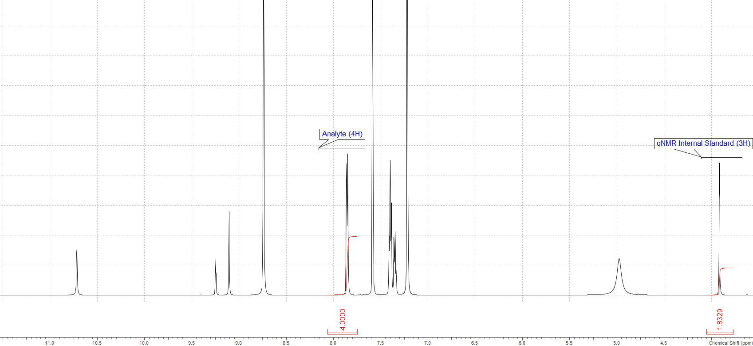
Figure 1: qNMR spectrum indicating the protons (in red) utilized for the quantification of Phenytoin

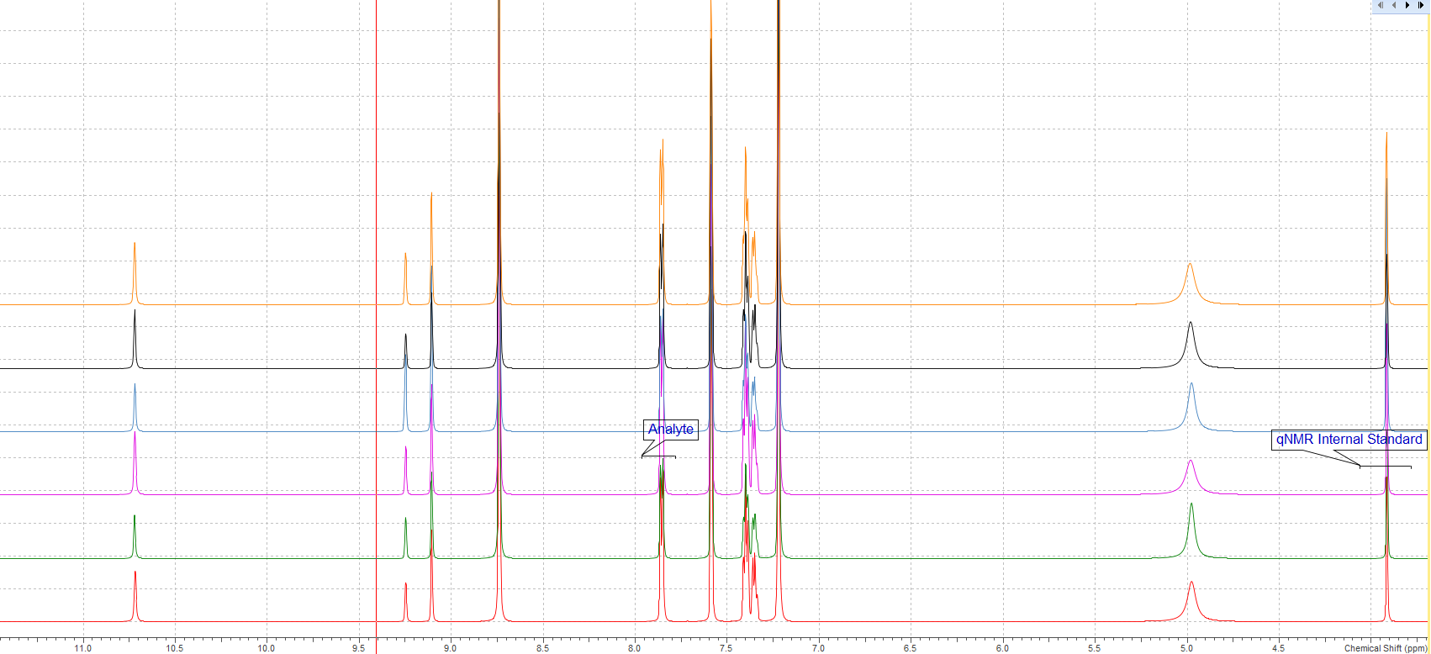
Figure 2: Overlay of the 6 qNMR spectra (Phenytoin) acquired under the afore-mentioned quantitative conditions.

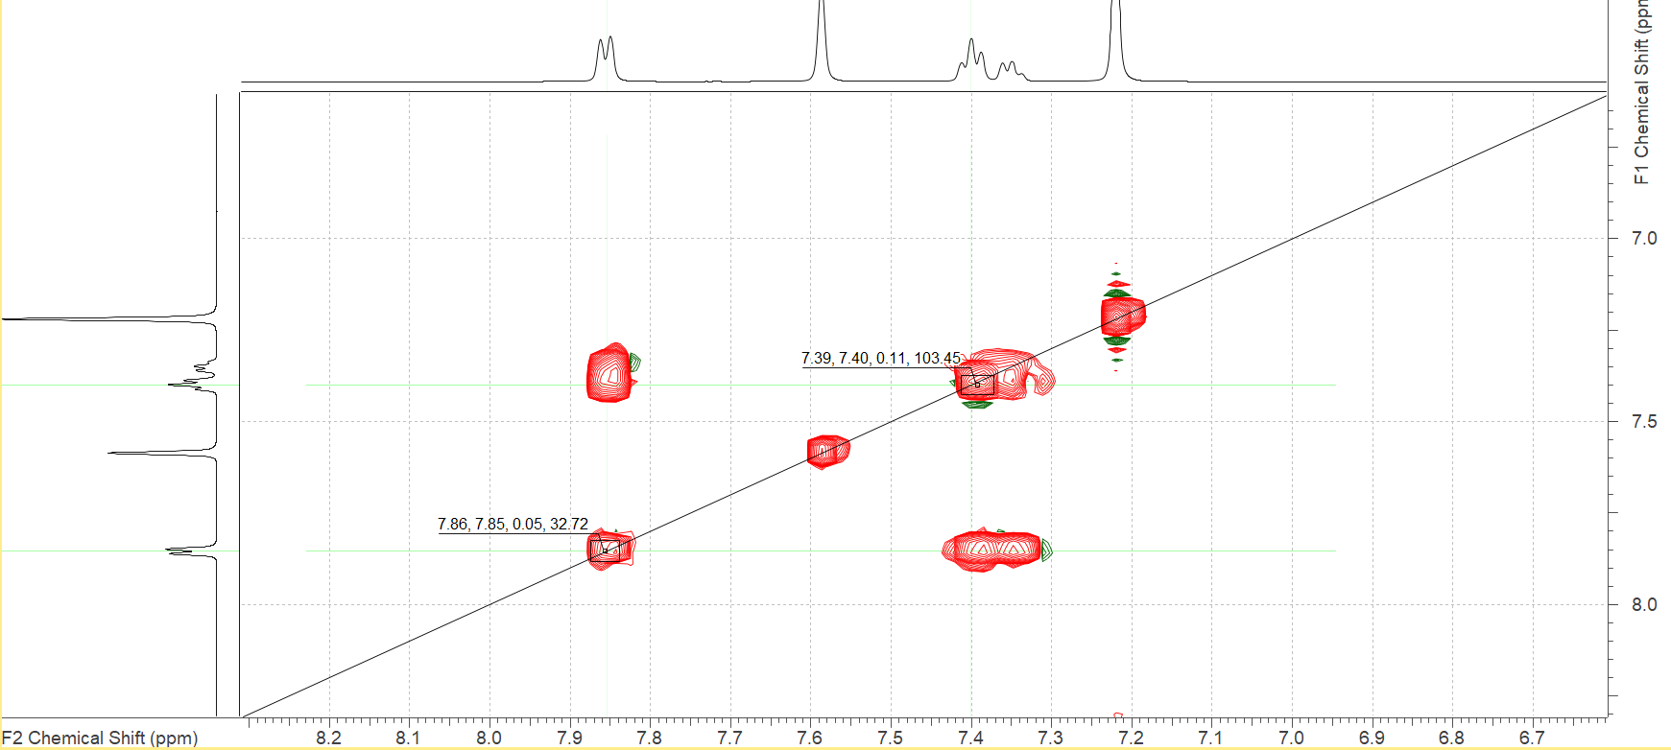
Figure 3: 2D-TOCSY spectrum of Phenytoin showing the coupling of the quantitative resonance.

