SUPPLEMENTAL TABLE AND FIGURE

Preservation of urine collection for metabolic evaluation of recurrent urinary stone formers.
Tomáš Šálek^{1,2}, Pavel Musil¹, Pieter Vermeersh³, Rachel Marrington⁴, Zeliha Gunnur Dikmen⁵, Radka Poláchová¹, Ulrike Kipman⁶, Timo T. Kouri^{7§}, and Janne Cadamuro^{8§},

Supplemental Table 1.
Measurement procedures on AbbottTM ArchitectTM ci16200 analyser and Lumex CAPEL-205 capillary electrophoresis. ª
 | Measurand |  | Assay application and reagent |  | Assay principle |  | Calibrator |  | Standard uncertainty of calibrator (k=1) |  | Day-to-day imprecision ^{b},  target value (mmol/L), CV_{A} (%) |  | Relative bias (%) |  | Intermediate  reproducibility,  mean CV_{A} of the two levels (%)
 | Sodium |  | Na-CU  ARCHITECT cSystems ICT, ICT Sample Diluent |  | Indirect ISE |  | ICT Urine Calibrator |  | 0.37%  at 180 mmol/L |  | 63.3 mmol/L, 1.17%  207 mmol/L, 0.84% |  | 1.96%  0.24% |  | 1.01%
 | Potassium |  | K-CU  ARCHITECT cSystems ICT, ICT Sample Diluent |  | Indirect ISE |  | ICT Urine Calibrator |  | 0.74%  at 90 mmol/L |  | 29.9 mmol/L, 0.89%  133 mmol/L, 0.83% |  | 1.66%  0.14% |  | 0.86%
 | Chloride |  | Cl-CU  ARCHITECT cSystems ICT, ICT Sample Diluent |  | Indirect ISE |  | ICT Urine Calibrator |  | 0.37%  at 180 mmol/L |  | 82.0 mmol/L, 0.91%  272 mmol/L, 1.28% |  | 3.37%  1.20% |  | 1.10%
 | Creatinine |  | CrEnzU  Creatinine (Enzymatic) |  | Spectrophotometry  Creatinase |  | Clin Chem Cal |  | 0.55%  at 0.48 mmol/L |  | 7.02 mmol/L, 1.48%  16.0 mmol/L, 1.50% |  | 1.24%  1.23% |  | 1.49%
 | Calcium |  | CaCU  Calcium |  | Spectrophotometry  Arsenazo III |  | Multiconstituent Calibrator |  | 0.2%  at 3 mmol/L |  | 1.53 mmol/L, 1.94%  4.21 mmol/L, 1.84% |  | 4.08%  6.05% |  | 1.89%
 | Magnesium |  | MAGU  Magnesium |  | Spectrophotometry  Isocitrate dehydrogenase |  | Multiconstituent Calibrator |  | 0.21%  at 1.93 mmol/L |  | 3.09 mmol/L, 2.28%  13.1 mmol/L, 2.14% |  | 5.96%  2.38% |  | 2.21%
 | Phosphate |  | Phos-U  Phosphorus |  | Spectrophotometry  Phosphomolybdate |  | Multiconstituent Calibrator |  | 0.17%  at 2.54 mmol/L |  | 9.00 mmol/L, 2.16%  26.8 mmol/L, 1.18% |  | 1.22%  0.82% |  | 1.67%
 | Uric acid |  | Uric2-U  Uric Acid2 |  | Spectrophotometry  Uricase |  | Consolidated Chemistry Calibrator |  | 0.22%  at 0.55 mmol/L |  | 0.702 mmol/L, 2.16%  1.21 mmol/L, 1.58% |  | 4.56%  2.84% |  | 1.87%
Oxalate |  | Capillary  electrophoresis |  | Indirect UV detection |  | Ammonium oxalate monohydrate |  | 1.2%  at 1.00 mmol/L |  | 0.201 mmol/L (3.87)^{b}  0.484 mmol/L (3.81)^{b} |  | 0.97%  2.95% |  | 3.84%
Citrate |  | Capillary  electrophoresis |  | Indirect UV detection |  | Sodium citrate dihydrate |  | 2.0%  at 6.00 mmol/L |  | 1.200 mmol/L (4.02)^{b}  3.00 mmol/L (3.47)^{b} |  | 2.06%  2.69% |  | 3.75%
ª Abbreviations in the names of materials of the AbbottTM ArchitectTM analyzers represent the commercial names of those products.
^{b} Randox Assayed Urine Controls (Crumlin, UK; on AbbottTM ArchitectTM), or in-house solutions (from Penta s.r.o, Prague, Czech Republic; on Lumex CAPEL-205 capillary electrophoresis) were measured once on each working day during the study, to calculate an intermediate reproducibility of 580 consecutive measurements. CV_{A} = coefficient of analytical variation.

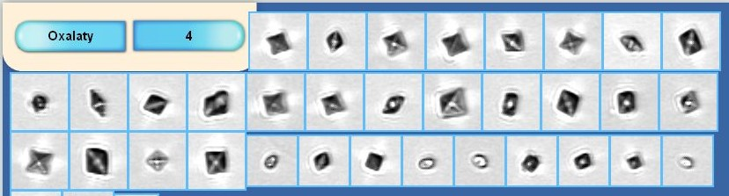

Supplemental Figure 1: Typical oxalate crystals in the urine sample of one patient. Both octahedral calcium oxalate-dihydrate (COD) and round-shaped calcium oxalate monohydrate (COM) crystals were detected quantitatively by the iQ200 instrument, as confirmed by visual microscopy.

