**Vitamin B12 deficiency in newborns: impact on individual’s health status and healthcare costs**

Simona Ferraro, Simona Lucchi, Chiara Montanari, Letizia Magnani, Martina Tosi, Davide Biganzoli, Andrea Lugotti, Laura Cappelletti, Alessia Poli, Elisa Pratiffi, Stephana Carelli, Laura Saielli, Luisella Alberti, Gianvincenzo Zuccotti, Marta Marsilio, Elvira Verduci and Cristina Cereda

**Supplementary material**

**Supplementary Table 1.** Vitamin B12 Reference Intake levels of Nutrients and Energy for the Italian population and Dietary Reference Values (DRV) for the European Food Safety Authority (EFSA) during pregnancy and breastfeeding.

The Average Requirement (AR) refers to the level of nutrient intake that is sufficient to meet the requirements of 50% of healthy reference subjects.

The Population Reference Intake (PRI) is sufficient to meet the requirements of 97.5% of healthy reference subjects.

The EFSA Dietary Reference Values are based on surveys in different European Union countries, with different average dietary intakes.

|  |  |  |
| --- | --- | --- |
| DRV of Nutrients and Energy for Italian population | **Pregnancy** | **Breastfeeding** |
| Average Requirement  (AR) | 2,2 μg/die | 2,4 μg/die |
| Population Reference Intake (PRI) | 2,6 μg/die | 2,8 μg/die |
| **EFSA DRV** | **Pregnancy** | **Breastfeeding** |
| Adequate Intake  (AI) | 4,5 μg/die | 5,0 μg/die |

**Supplementary Figure 1.** Flowchart describing the NBS biomarkers tested in newborns at possible risk of cobalamin metabolism defects according to Collaborative Laboratory Integrated Reports (CLIR – Mayo Clinic)[References 8-9].



**Supplementary Table 2.** Sources of information for cost analysis.

|  |  |  |  |
| --- | --- | --- | --- |
| **Perspective** | **Type of costs** | **Data** | **Source of information** |
| **RHS** | Direct costs | RHS services costs | Reimbursement established by the RHS - Regional price list for laboratory/clinical test costs |
| Cost-opportunity | *Cost of time* as:  Healthcare professionals average hourly wage  ×  Clinical activities time | Buzzi Children Hospital management control systems  Clinicians interviews |
| **Caregiver** | Direct costs | *Caregivers’ travel costs* as:  Average distance travelled  ×  Cost per km | Buzzi Children Hospital data – Patients birth points table  Automobile club of Italy table 2024 [Reference 11] |
| Cost-opportunity | *Cost of time* as:  Caregivers’ average hourly wage  ×  Caregivers’ time for travel and clinical activities | Italy’s National Institute of Statistics [Reference 10]  Buzzi Children Hospital management control systems and clinician’s interview |

* The total number of newborns included is retrieved from Italy’s National Institute of Statistics [Reference 12].

** The number of newborns with B12 deficiency is retrieved from Regional Reference Laboratory for Neonatal Screening (RRLNS), and Metabolic Diseases and Clinical Nutrition Service of the Buzzi Children Hospital

**Supplementary Figure 2.** Clinical pathway for diagnosis and management of B12 deficiency partitioned into 3 phases: B12 deficiency confirmation, start of treatment and follow-up. The actual sample size of newborns with B12 deficiency for each year is reported.

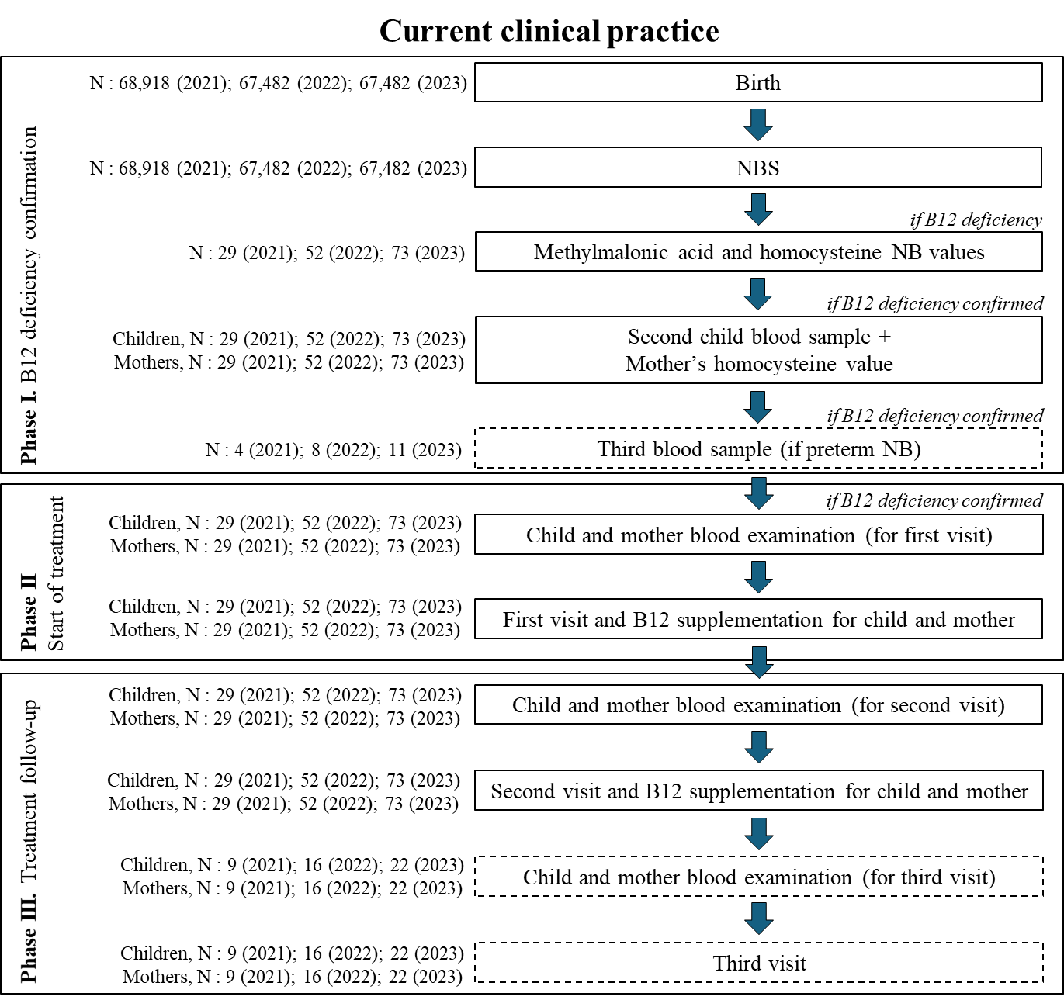

The diagnosis and management B12 deficiency in newbornsmay be partitioned in three phases, to allow an accurate estimation of the costs.

*Phase I* includes the samples and the laboratory tests required to confirm B12 deficiency, in newborns and their mothers, considering that in cases of preterm birth generally one additional DBS is required.

*Phase II* encompasses the start of treatment, which includes clinical evaluation, laboratory tests, specialist consultation with dietary and clinical nutrition evaluation, and neurological assessment. During the first visit, the newborn receives intramuscular B12 supplementation. The same laboratory tests are required for the mother, with recommendations for intramuscular B12 supplementation and folic acid supplementation until the subsequent check-up.

*Phase III* involves treatment follow-up, repeating the procedures of Phase II.

**Supplementary Table 3**. RHS and caregiver costs (single case).

|  |  |  |  |  |  |
| --- | --- | --- | --- | --- | --- |
|  | **RHS** | | **Caregiver** | |  |
|  | **Direct costs (€)** | **Cost-opportunity (€)** | **Direct costs (€)** | **Cost-opportunity (€)** | **Total (€)** |
| **Phase I**  ***Phase I***  ***Premature newborn*** | 520  *808* | 16.63  *25.78* | / | / | 536.63  *833.78* |
| **Phase II** | 1388.34 | 98.26 | 63.76 | 98.96 | 1649.32 |
| **Phase III** | 1131.67 | 98.26 | 63.76 | 98.96 | 1392.65 |

**Supplementary Table 4**. Cut-off of the biomarkers reported in table 1 adjusted for age and weight

|  |  |  |  |  |  |
| --- | --- | --- | --- | --- | --- |
| Age | <1500g  low-high | 1500g<x<2000g  low-high | 2000g<x<2500g  low-high | >2500g  low-high | Units |
| **48-72 h** |  |  |  |  |  |
| MET | 10,33-91,15 | 8,45-62,89 | 9-44,96 | 9,14-36,04 | µmol/L |
| C0 | 10,49-101,39 | 9,98-86,12 | 8,64-61,14 | 7,09-45,98 | µmol/L |
| C2 | 9,14-63,52 | 8,53-63,04 | 9,11-58,02 | 10,17-56,11 | µmol/L |
| C3 | 1,08-7,45 | 0,97-7,07 | 0,95-6,05 | 0,95-5,43 | µmol/L |
| C4 | 0,14-1,42 | 0,11-0,96 | 0,09-0,82 | 0,09-0,86 | µmol/L |
| C5 | 0,1-0,99 | 0,07-0,61 | 0,06-0,37 | 0,05-0,29 | µmol/L |
| C16 | 0,46-4,57 | 0,85-6,29 | 1,18-7,07 | 1,68-7,46 | µmol/L |
| C16:OH | 0,02-0,09 | 0,02-0,1 | 0,02-0,09 | 0,02-0,09 | µmol/L |
| MMA | 2,5 | 2,5 | 2,5 | 2,5 | µmol/L |
| HCY | 6,5 | 6,5 | 6,5 | 6,5 | µmol/L |
| C3/C16 | 0,49-6,13 | 0,32-4,29 | 0,26-2,39 | 0,25-1,54 |  |
| C3/MET | 0,03-0,54 | 0,03-0,47 | 0,04-0,40 | 0,05-0,41 |  |
| C4/C3 | 0,06-0,51 | 0,05-0,37 | 0,04-0,39 | 0,04-0,36 |  |
| C5/C3 | 0,04-0,36 | 0,03-0,24 | 0,03-0,17 | 0,02-0,13 |  |
| **336-384 h** |  |  |  |  |  |
| MET | 10,19-59,72 | 9,01-49,28 | 10,98-48,61 | 11,7-44,64 | µmol/L |
| C0 | 4,76-105,35 | 8,29-74,71 | 10,75-47,13 | 11,01-45,23 | µmol/L |
| C2 | 2,38-51,96 | 3,7-29,96 | 4,28-20,4 | 4,26-18,91 | µmol/L |
| C3 | 0,22-4,11 | 0,28-2,59 | 0,31-1,75 | 0,33-1,98 | µmol/L |
| C4 | 0,08-0,78 | 0,08-0,45 | 0,07-0,38 | 0,07-0,37 | µmol/L |
| C5 | 0,07-0,93 | 0,08-0,48 | 0,08-0,37 | 0,07-0,36 | µmol/L |
| C16 | 0,27-3 | 0,35-2,67 | 0,3-2,19 | 0,32-2,29 | µmol/L |
| C16:OH | 0,01-0,08 | 0,01-0,08 | 0,01-0,07 | 0,01-0,08 | µmol/L |
| MMA | 2,5 | 2,5 | 2,5 | 2,5 | µmol/L |
| HCY | 6,5 | 6,5 | 6,5 | 6,5 | µmol/L |
| C3/C16 | 0,2-3,59 | 0,21-2,77 | 0,27-2,5 | 0,26-2,41 |  |
| C3/MET | 0,01-0,17 | 0,01-0,12 | 0,01-0,11 | 0,01-0,11 |  |
| C4/C3 | 0,1-0,75 | 0,1-0,63 | 0,09-0,65 | 0,09-0,57 |  |
| C5/C3 | 0,11-0,75 | 0,11-0,68 | 0,1-0,57 | 0,08-0,51 |  |

**Supplementary Table 5.** Estimates of the coefficients of the multivariate model investigating the relationship between B12 levels and C3, Met, C16:OH (in bold) adjusting for type of diet, ethnicity and gestational age. A and B refer to the first and the second DBS.

A

coefficients lower bd upper bd

Intercept 0.78482 0.35597 1.89074

C3 -0.04009 -0.08225 0.02736

MET 0.01497 -0.00343 0.03522

**C16:OH -2.83609 -6.01829 3.66488**

Caucasian -0.16903 -0.34242 0.08612

Ethnicity (Other) 0.25445 -0.51329 0.47961

Lacto-Vegetarian 0.16153 -0.06078 0.39230

Omnivore 0.20536 0.05450 0.42772

Other diets 0.21805 -0.15898 0.44897

Preterm 0.24781 -0.19639 0.49936

Non adequate Intake 0.17612 -0.14089 0.25201

B

Coefficients:

coefficients lower bd upper bd

Intercept 0.83267 0.49244 1.31285

C3 0.00547 -0.05557 0.09690

MET 0.00285 -0.01310 0.01280

**C16:OH** **-3.67834 -6.99710 2.82195**

Caucasian -0.10988 -0.29657 0.10046

Ethnicity (Other) 0.29626 -0.63173 0.57602

Lacto-Vegetarian 0.14966 -0.06702 0.35627

Omnivore 0.15178 -0.01195 0.32463

Other diets 0.10944 -0.39238 0.54877

Preterm 0.27192 0.00657 0.47311

Non adequate Intake 0.11699 -0.09871 0.25180

**Supplementary Figure 3.** Projection of the total costs of diagnosis and management of B12 deficiency/year.

**Supplementary Table 6**. RHS and caregiver costs (all cases), for the current approach.

|  |  |  |  |
| --- | --- | --- | --- |
|  | **2021** | **2022** | **2023** |
| **Direct costs of RHS (€)** | 99,461 | 178,427 | 249,897 |
| **Costs-opp RHS (€)** | 7,102 | 12,729 | 17,822 |
| **Direct costs of caregiver (€)** | 4,272 | 7,651 | 10,712 |
| **Costs-opp caregiver (€)** | 6,630 | 11,875 | 16,625 |
| **Total (€)** | **117,466** | **210,683** | **295,057** |