Supplementary information for

An ultrasensitive DNA-enhanced amplification method for detecting cfDNA drug-resistant mutations in non-small cell lung cancer with selective FEN-assisted degradation of dominant somatic fragments
Junhua Zhang¹, Yifei Li², Wei Huang¹, Gaoyuan Sun², Hongjun Ren³, Min Tang^{4,*}

¹The Key Laboratory of Geriatrics, Beijing Institute of Geriatrics, Institute of Geriatric Medicine, Chinese Academy of Medical Sciences, Beijing Hospital/National Center of Gerontology of National Health Commission, P.R. China.
²Clinical Biobank, Beijing Hospital, National Center of Gerontology, Institute of Geriatric Medicine, Chinese Academy of Medical Sciences, P.R. China.
³Advanced Research Institute and Department of Chemistry, Taizhou University, Jiaojiang, 318000, P.R. China.
⁴Department of Oncology, Beijing Hospital, National Center of Gerontology, Institute of Geriatric Medicine, Chinese Academy of Medical Sciences, Beijing, 100730, P.R. China.

*Corresponding author: Min Tang, Department of Oncology, Beijing Hospital, National Center of Gerontology, Institute of Geriatric Medicine, Chinese Academy of Medical Sciences, Beijing, 100730, P.R. China.
E-mail: tangmin3911@bjhmoh.cn

Supplementary Figure 1. The purified Archaeoglobus fulgidus flap endonuclease (Afu FEN) protein. 1, Afu FEN protein (5 μg) with an expected molecular weight of 38.8 kDa. M, protein marker.

Supplementary Figure 2. 174 bp DNA fragments of wild-type 790T and mutant 790M EGFR DNA obtained by site-directed mutagenesis PCR using human genomic DNA as template. PCR products were then resolved by electrophoresis in 2% agarose gel. M, DNA marker.

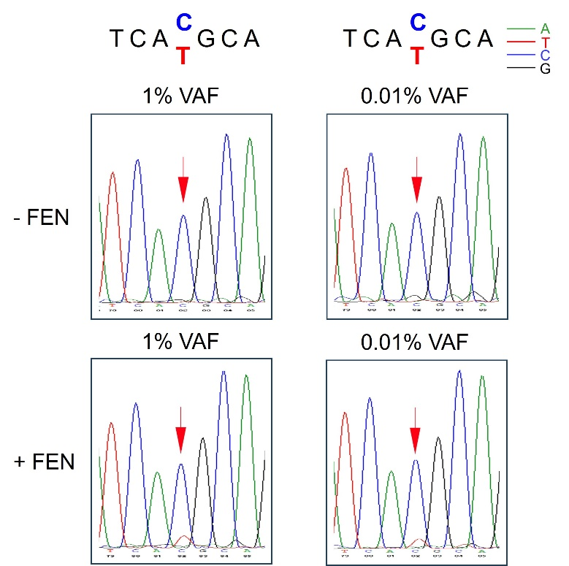
Supplementary Figure 3. Detection of different VAFs prepared by synthesized DNA fragments of 790T and 790M. FEN was added directly into the reaction system, and the reaction mixture was incubated 95°C for 5 min, annealed to 65°C for 1 h followed by PCR, electrophoresis and first-generation sequencing. 1% VAF: 790T (1200 fg), 790M (12 fg), FEN: 10 ng; 0.01% VAF: 790T (120 pg), 790M (12 fg), FEN: 40 ng. The chromatographic peaks in different colors represent different nucleotides (blue for C, red for T, black for G and green for A). Each experiment was repeated three times.

Supplementary Figure 4. Effects of temperature and reaction time on the cleavage of dominant wild-type EGFR DNA fragments. (A) Agarose gel electrophoresis of 174 bp PCR reaction products mediated by FEN cleavage at 60°C and 65°C, respectively. 790T (120 fg) and 790M DNA fragments (12 fg) were incubated at 95°C for 5 min and cooled down to indicated temperatures with probe 1 and probe 2 in the standard flap endonuclease cleavage assay mixture. After the probes were annealed to 790T, FEN was added or not into the standard reaction mixture at indicated temperatures for 10 min. Later, the standard reaction mixture was subjected to enhanced amplification by PCR. Samples were then resolved by electrophoresis in 2% agarose gel, exposed to a gel imager, and purified. Lanes 1, 2 and 3, FEN cleavage reactions were incubated for 10 min at 60°C, respectively. Lanes 4, 5 and 6, FEN cleavage reactions were incubated for 10 min at 65°C, respectively. Lanes 1 and 4, no FEN. Lanes 2 and 5, 10 ng FEN per reaction system. Lanes 3 and 6, 20 ng FEN per reaction system. M, DNA marker, 5000, 3000, 2000, 1000, 750, 500, 250 and 100 bp (from top to bottom). (B) First-generation sequencing was performed on 174 bp DNA purified from the gel to detect mutated bases (C→T) encoding T790M mediated by FEN cleavage at 60°C (2 and 3) and 65°C (5 and 6), respectively. 2 and 5, 10 ng FEN per reaction system. 3 and 6, 20 ng FEN per reaction system. The mutated DNA base site ′X′ to be detected is indicated by red arrows. The chromatographic peaks in different colors represent different nucleotides (blue for C, red for T, black for G and green for A). Each experiment was repeated three times.

Table S1. Oligonucleotides and primers used in this study.
Name | DNA sequence (5’-3’)
Probe 1 | GGCAGCCGAAGGGCATGAGCTGCGGCCGCGCTGAGTGCCTTTTGGCACTCAGCGCGGCT
Probe 2 | CCTCCACCGTGCAGCTCATCACCGCCTGGACCTGGCGGTTTTCCGCCAGGTCCAGGCGT
174bp EGFR FP | CCTACGTGATGGCCAGCG
174bp EGFR RP | TCTGCACACACCAGTTGAG
T790M forward primer 1 | CCTACGTGATGGCCAGCGTGGACAACCCCCACGTGTGCCGCCTGCTG
T790M forward primer 2 | GCCTGCTGGGCATCTGCCTCACCTCCACCGTGCAGCTCATCATGCAGCTC

