Supplemental Materials
Contents
Table S1. Equations to predict glomerular filtration rate 2
Table S2. Medians and lower and upper reference limits for SCr (μmol/L) in each center 3
Table S3. Medians and lower and upper reference limits for SCr (μmol/L) calculated by the non-parametric method 6
Figure S1. Flow diagram for inclusion of healthy individuals 7
Figure S2. Selection scheme for the validation cohort 8
Figure S3. The reference intervals of serum creatinine estimated using refineR algorithm in males across all age groups 9
Figure S4. The reference intervals of serum creatinine estimated using refineR algorithm in females across all age groups 10
Figure S5. The reference intervals of serum creatinine estimated using refineR algorithm in groups divided by the adjusted optimal segmentation points 11
Figure S6. Agreement of GFR categories among FAS and EKFC equations with different Q-values 12

Table S1. Equations to predict glomerular filtration rateª.
Name | Year | Age, years | SCr | Equation
FAS | 2016 | 18-40 |  | 107.3/(SCr/Q)
 |  | >40 |  | 107.3/(SCr/Q)×0.988^{(Age-40)}
EKFC | 2021 | 18-40 | SCr<Q | 107.3×(SCr/Q)^{-0.322}
 |  |  | SCr≥Q | 107.3×(SCr/Q)^{-1.132}
 |  | >40 | SCr<Q | 107.3×(SCr/Q)^{-0.322}×0.990^{(Age-40)}
 |  |  | SCr≥Q | 107.3×(SCr/Q)^{-1.132}×0.990^{(Age-40)}
Abbreviation: SCr, serum creatinine; FAS, Full Age Spectrum; EKFC, European Kidney Function Consortium.
SI conversion: To convert μmol/L to mg/dL, divide by 88.4.
ª Q-values (in μmol/L or mg/dL) correspond to the median SCr values for the age- and sex-specific populations. In the FAS equation, the European males: Q= 62 μmol/L (0.70 mg/dL), the European females: Q= 80 μmol/L (0.90 mg/dL). In the EKFC equation, the European males: ln(Q) = 3.200+0.259×Age−0.543×ln(Age)−0.00763×Age²+0.0000790×Age³ (18-25 y), Q = 80 μmol/L (0.90 mg/dL) (>25 y), the European females: ln(Q) = 3.080+0.177×Age−0.223×ln(Age)−0.00596×Age²+ 0.0000686×Age³ (18-25 y), Q = 62 μmol/L (0.70 mg/dL) (>25 y).

Table S2. Medians and lower and upper reference limits for SCr (μmol/L) in each centerª.
Center | Age, years | Males |  |  |  | Females
 |  | n | Median  (95%CI) | Lower limit  (95%CI) | Upper limit  (95%CI) | n | Median  (95%CI) | Lower limit  (95%CI) | Upper limit  (95%CI)
1 | 18-24 | 418 | 79.53  (74.53,82.87) | 67.39  (60.00,74.53) | 93.04  (85.47,97.05) | 840 | 54.61  (53.44,55.70) | 43.77  (41.89,47.40) | 65.55  (62.94,68.43)
 | 25-29 | 2308 | 77.67  (76.50,78.32) | 62.82  (60.08,66.22) | 94.31  (88.49,97.58) | 3697 | 54.88  (53.29,56.24) | 41.77  (40.46,44.23) | 70.22  (65.28,71.52)
 | 30-34 | 2868 | 76.73  (74.63,78.89) | 60.51  (59.64,63.96) | 92.95  (87.18,95.57) | 4461 | 54.28  (53.48,54.69) | 42.07  (41.19,43.42) | 67.57  (66.19,69.37)
 | 35-39 | 2498 | 77.05  (76.27,78.12) | 60.98  (59.60,63.99) | 92.95  (87.18,95.57) | 4198 | 54.12  (53.51,55.07) | 42.73  (41.88,45.07) | 66.09  (63.76,69.31)
 | 40-44 | 1907 | 75.95  (74.81,77.19) | 59.93  (58.56,65.44) | 90.82  (88.83,94.08) | 2447 | 55.67  (54.94,57.42) | 42.73  (41.88,45.07) | 66.09  (63.76,69.31)
 | 45-49 | 2093 | 75.10  (74.47,75.96) | 59.56  (58.25,61.56) | 91.98  (89.34,95.66) | 2085 | 55.67  (54.94,57.42) | 42.64  (41.13,46.35) | 69.25  (66.78,70.93)
 | 50-54 | 1533 | 75.89  (74.49,76.86) | 60.33  (57.07,62.39) | 93.83  (88.57,96.03) | 1153 | 55.04  (53.53,57.38) | 42.78  (41.70,44.90) | 69.07  (64.20,71.89)
 | 55-59 | 989 | 74.77  (73.05,76.56) | 59.84  (57.57,63.81) | 90.33  (83.88,95.70) | 594 | 56.62  (55.44,58.00) | 42.41  (41.30,48.86) | 70.83  (66.22,74.27)
 | 60-69 | 982 | 76.98  (74.98,78.95) | 61.42  (57.57,66.84) | 85.33  (78.84,97.69) | 531 | 57.92  (56.42,59.12) | 46.64  (42.64,50.17) | 69.53  (66.14,73.18)
 | 70-79 | 256 | 73.37  (71.25,79.32) | 60.42  (57.57,66.84) | 85.33  (78.84,97.69) | 129 | 56.72  (55.13,58.79) | 45.50  (42.49,48.70) | 69.34  (64.97,74.97)
 | 80- | 104 | 79.69  (76.51,82.02) | 73.88  (69.36,79.21) | 85.33  (82.25,87.71) | 40 | 62.23  (51.31,66.15) | 56.92  (41.69,61.20) | 67.45  (57.36,72.56)
2 | 18-24 | 210 | 72.83  (70.26,75.72) | 60.03  (54.80,68.16) | 85.01  (82.63,93.83) | 208 | 54.32  (49.89,55.52) | 45.73  (39.98,49.56) | 62.27  (53.70,67.75)
 | 25-29 | 873 | 73.03  (71.26,74.70) | 57.88  (52.24,63.51) | 89.66  (83.95,94.22) | 1141 | 51.69  (50.77,52.27) | 40.46  (37.50,43.30) | 63.21  (61.15,66.24)
 | 30-34 | 1222 | 71.57  (69.58,72.56) | 54.94  (50.64,58.62) | 88.43  (81.81,90.87) | 1895 | 51.30  (50.62,52.13) | 38.37  (37.28,41.49) | 64.83  (62.34,66.98)
 | 35-39 | 1038 | 71.40  (69.51,73.91) | 56.09  (53.76,60.93) | 88.28  (81.00,91.85) | 1564 | 51.58  (48.77,54.22) | 38.72  (35.71,44.88) | 65.71  (58.86,67.85)
 | 40-44 | 1000 | 71.78  (70.66,73.24) | 56.41  (53.02,60.51) | 87.44  (84.12,91.07) | 1300 | 51.95  (51.17,53.01) | 40.02  (37.49,43.44) | 64.55  (62.17,67.10)
 | 45-49 | 1283 | 71.07  (68.67,72.91) | 55.89  (53.60,58.57) | 87.97  (81.77,91.96) | 1399 | 52.41  (51.37,52.85) | 41.89  (39.14,44.59) | 61.96  (60.64,65.21)
 | 50-54 | 1360 | 71.01  (69.01,71.69) | 53.93  (52.39,57.28) | 88.47  (83.50,92.42) | 949 | 52.51  (49.96,54.72) | 40.41  (37.90,46.13) | 65.88  (59.88,69.83)
 | 55-59 | 1171 | 69.49  (66.52,73.30) | 54.80  (49.10,57.91) | 88.08  (78.28,93.10) | 501 | 54.42  (51.84,56.03) | 44.85  (39.49,49.94) | 63.21  (61.30,68.31)
 | 60-69 | 762 | 71.57  (68.45,74.26) | 54.72  (51.53,63.65) | 89.15  (82.32,94.34) | 389 | 52.95  (50.99,54.16) | 40.54  (35.50,45.56) | 65.44  (59.83,71.09)
 | 70-79 | 264 | 72.80  (63.42,74.91) | 61.06  (52.92,67.01) | 83.67  (72.34,89.27) | 115 | 53.73  (49.10,63.03) | 46.71  (39.77,57.70) | 60.31  (52.28,74.27)
 | 80- | 78 | 75.83  (63.06,78.39) | 67.07  (55.84,75.12) | 84.72  (64.56,89.18) | 30 | 49.17  (36.26,60.80) | 47.97  (35.30,58.44) | 50.36  (37.20,63.53)
3 | 18-24 | 1048 | 73.64  (69.70,75.99) | 60.26  (52.83,64.27) | 89.97  (83.33,91.49) | 887 | 50.70  (49.01,51.56) | 39.86  (37.90,41.90) | 63.10  (56.92,65.61)
 | 25-29 | 1740 | 69.94  (67.62,71.49) | 57.25  (54.50,58.61) | 85.20  (78.67,90.24) | 1605 | 49.20  (48.42,50.08) | 37.77  (36.59,40.23) | 61.27  (58.18,64.59)
 | 30-34 | 2121 | 69.65  (67.63,71.03) | 56.68  (54.03,58.68) | 84.62  (78.97,88.93) | 2043 | 49.41  (48.23,50.04) | 38.75  (36.53,40.38) | 60.69  (57.97,63.23)
 | 35-39 | 1390 | 70.16  (66.22,73.22) | 55.88  (53.96,62.87) | 86.37  (76.03,90.46) | 1432 | 49.02  (47.15,52.62) | 38.30  (34.70,44.14) | 61.44  (56.99,65.29)
 | 40-44 | 1236 | 68.55  (66.54,70.30) | 53.57  (48.34,56.65) | 84.80  (79.10,88.08) | 1272 | 49.25  (48.55,50.25) | 40.00  (37.97,41.91) | 59.36  (56.87,64.17)
 | 45-49 | 1224 | 68.45  (65.63,72.10) | 52.36  (47.42,58.28) | 86.25  (79.16,90.07) | 1165 | 50.02  (48.43,52.46) | 38.47  (36.03,42.20) | 63.54  (58.91,66.00)
 | 50-54 | 1376 | 67.53  (66.00,69.46) | 53.91  (52.38,55.03) | 84.59  (79.33,89.45) | 997 | 52.19  (50.89,54.27) | 40.77  (36.98,44.01) | 65.16  (62.41,66.91)
 | 55-59 | 868 | 67.91  (66.06,70.97) | 53.23  (50.67,57.18) | 83.64  (75.48,89.21) | 547 | 50.50  (48.75,53.15) | 40.83  (38.73,43.75) | 61.87  (55.87,65.34)
 | 60-69 | 862 | 68.73  (64.84,71.37) | 52.30  (49.27,59.76) | 85.75  (76.69,91.00) | 569 | 52.34  (50.56,54.69) | 41.09  (36.79,46.91) | 64.68  (56.15,68.41)
 | 70-79 | 711 | 68.97  (67.39,70.79) | 52.69  (51.69,56.57) | 87.55  (82.18,93.65) | 520 | 54.06  (52.11,55.88) | 40.25  (38.56,44.81) | 70.67  (65.31,73.24)
 | 80- | 186 | 70.09  (65.07,80.15) | 57.64  (51.74,71.54) | 83.93  (69.56,93.00) | 135 | 53.40  (51.73,61.76) | 45.29  (38.17,56.18) | 61.73  (56.99,74.48)
4 | 18-24 | 367 | 78.57  (76.73,80.03) | 64.89  (59.69,70.30) | 94.09  (88.20,97.17) | 348 | 55.93  (51.56,58.57) | 45.42  (41.11,53.25) | 65.72  (60.70,69.91)
 | 25-29 | 1022 | 77.39  (73.57,80.79) | 62.79  (57.82,73.17) | 91.91  (85.18,96.70) | 1320 | 54.78  (53.93,56.13) | 43.18  (40.88,46.04) | 67.55  (64.74,71.67)
 | 30-34 | 1289 | 76.16  (74.41,79.01) | 60.74  (57.86,65.18) | 93.23  (87.58,96.69) | 1590 | 54.98  (53.03,57.47) | 40.35  (38.65,46.15) | 69.13  (64.32,70.49)
 | 35-39 | 1174 | 77.50  (75.69,78.54) | 61.12  (57.75,64.59) | 95.42  (90.49,98.04) | 1251 | 53.95  (52.85,54.91) | 41.68  (39.81,46.11) | 66.65  (61.64,69.27)
 | 40-44 | 1152 | 75.30  (73.88,77.14) | 59.31  (54.56,62.05) | 93.00  (89.30,96.33) | 1117 | 56.13  (53.34,57.09) | 43.65  (40.79,46.96) | 69.20  (65.64,72.61)
 | 45-49 | 1280 | 73.97  (73.09,75.79) | 58.03  (55.61,63.03) | 90.54  (86.89,94.78) | 1179 | 56.28  (53.63,58.85) | 42.81  (40.82,48.99) | 71.38  (64.60,72.82)
 | 50-54 | 1303 | 75.00  (72.77,76.53) | 55.91  (54.10,61.46) | 95.72  (89.75,98.13) | 764 | 56.92  (55.20,58.04) | 45.48  (40.60,49.41) | 68.02  (65.23,72.21)
 | 55-59 | 992 | 74.66  (72.36,76.33) | 55.95  (53.37,61.65) | 93.22  (87.78,97.78) | 388 | 56.26  (52.12,58.39) | 46.61  (40.72,51.42) | 67.88  (59.01,74.07)
 | 60-69 | 932 | 73.61  (70.66,76.29) | 55.66  (51.85,61.14) | 92.50  (84.89,96.70) | 319 | 58.16  (53.31,62.21) | 47.30  (42.02,56.78) | 68.08  (60.21,81.75)
 | 70-79 | 393 | 72.91  (71.75,76.48) | 56.43  (53.47,66.61) | 91.70  (86.39,99.58) | 77 | 59.10  (57.10,70.67) | 56.26  (50.38,69.31) | 62.09  (59.11,72.06)
 | 80- | 163 | 75.19  (69.70,86.84) | 63.72  (51.30,80.23) | 88.63  (79.11,109.07) | 31 | 58.53  (46.64,61.65) | 56.40  (46.12,60.55) | 60.61  (47.17,63.67)
5 | 18-24 | 390 | 75.29  (71.63,79.01) | 62.59  (60.03,67.78) | 89.32  (79.38,95.59) | 699 | 55.17  (52.42,55.50) | 42.64  (40.37,44.45) | 67.18  (62.15,69.49)
 | 25-29 | 849 | 76.01  (74.34,78.90) | 61.62  (57.81,65.43) | 91.30  (85.76,95.31) | 1495 | 53.58  (51.32,55.47) | 41.07  (40.75,45.75) | 67.14  (63.26,69.72)
 | 30-34 | 735 | 75.28  (72.85,79.00) | 60.23  (57.35,65.28) | 92.07  (85.51,95.69) | 1392 | 54.89  (53.11,55.97) | 42.48  (38.89,47.39) | 66.27  (63.75,69.07)
 | 35-39 | 635 | 76.26  (73.56,77.15) | 62.25  (56.31,66.85) | 89.62  (85.96,93.10) | 1474 | 53.48  (52.62,54.40) | 41.27  (40.38,46.01) | 66.21  (61.56,69.78)
 | 40-44 | 958 | 75.48  (73.18,77.78) | 60.49  (56.65,66.24) | 91.46  (86.65,93.60) | 1957 | 55.29  (53.98,55.96) | 43.02  (40.44,47.28) | 68.13  (64.09,70.51)
 | 45-49 | 1228 | 74.62  (72.61,75.52) | 58.99  (56.02,61.28) | 90.94  (85.78,95.02) | 1942 | 54.37  (53.38,56.87) | 41.03  (39.85,48.17) | 67.51  (64.10,70.21)
 | 50-54 | 1120 | 74.17  (73.00,75.61) | 58.25  (53.40,62.36) | 91.23  (86.93,95.25) | 1794 | 55.58  (54.01,56.57) | 42.58  (41.28,44.48) | 69.88  (66.35,71.49)
 | 55-59 | 711 | 72.55  (72.01,74.39) | 58.81  (53.56,65.17) | 86.37  (82.11,93.99) | 689 | 55.27  (53.54,56.90) | 45.13  (42.21,47.39) | 67.66  (60.32,72.12)
 | 60-69 | 853 | 74.04  (71.55,76.16) | 54.26  (49.79,63.60) | 92.86  (86.17,97.06) | 530 | 57.73  (56.21,59.51) | 48.47  (45.08,50.29) | 68.75  (63.70,73.93)
 | 70-79 | 309 | 77.66  (69.97,78.96) | 67.79  (56.15,71.05) | 88.85  (81.29,97.34) | 146 | 57.37  (54.65,60.62) | 47.96  (44.26,51.33) | 68.59  (61.78,73.40)
 | 80- | 139 | 80.44  (68.27,84.00) | 71.93  (56.85,76.68) | 89.62  (77.05,5.59) | 32 | 58.93  (46.20,71.31) | 57.58  (46.04,70.89) | 60.28  (46.32,72.06)
Abbreviation: SCr, serum creatinine.
SI conversion: To convert serum creatinine level to mg/dL, divide by 88.4.
ª Center 1 indicates the cohort came from the First Affiliated Hospital of Nanjing Medical University, center 2 indicates the cohort came from the Affiliated People’s Hospital of Jiangsu University, center 3 indicates the cohort came from the First People’s Hospital of Nantong, center 4 indicates the cohort came from the First People’s Hospital of Yancheng, and center 5 indicates the cohort came from the Sheyang People’s Hospital.

Table S3. Medians and lower and upper reference limits for SCr (μmol/L) calculated by the non-parametric method.
Age, years | Males (n=55,973) |  |  |  | Females (n=61,372)
 | n | Median  (95%CI) | Lower limit  (95%CI) | Upper limit  (95%CI) | n | Median  (95%CI) | Lower limit  (95%CI) | Upper limit  (95%CI)
18-24 | 2433 | 75.00  (74.00,75.00) | 56.28  (55.38,57.00) | 93.60  (92.90,94.80) | 2982 | 53.50  (53.00,54.00) | 40.00  (40.00,41.00) | 68.00  (67.10,68.35)
25-29 | 6792 | 75.00  (75.00,75.40) | 58.00  (57.00,58.00) | 94.00  (93.44,94.80) | 9258 | 53.10  (53.00,53.30) | 40.00  (39.24,40.00) | 68.76  (68.20,69.00)
30-34 | 8235 | 74.40  (74.00,74.80) | 57.00  (56.90,57.90) | 93.11  (92.80,93.51) | 11 381 | 53.00  (52.90,53.00) | 39.00  (39.00,39.65) | 67.80  (67.45,68.00)
35-39 | 6735 | 74.90  (74.50,75.00) | 57.00  (57.00,57.94) | 94.00  (93.60,94.86) | 9919 | 53.60  (53.40,53.80) | 40.50  (40.00,41.00) | 68.00  (67.70,68.20)
40-44 | 6253 | 74.00  (73.70,74.10) | 56.00  (55.90,56.70) | 92.30  (91.70,92.90) | 8093 | 54.00  (53.70,54.00) | 40.43  (40.00,41.00) | 69.10  (68.70,69.50)
45-49 | 7108 | 73.60  (73.20,74.00) | 55.00  (54.64,55.97) | 92.30  (92.00,93.00) | 7770 | 54.10  (54.00,54.30) | 40.00  (40.00,41.00) | 69.50  (69.00,70.00)
50-54 | 6692 | 73.00  (72.80,73.10) | 55.00  (54.00,55.30) | 93.40  (92.77,94.37) | 5657 | 54.90  (54.40,55.00) | 41.00  (40.08,41.00) | 70.20  (69.60,70.76)
55-59 | 4731 | 72.90  (72.30,73.00) | 55.00  (54.00,55.00) | 93.00  (92.07.93.80) | 2719 | 55.00  (54.90,55.50) | 41.00  (41.00,42.00) | 71.30  (70.90,72.00)
60-69 | 4391 | 73.00  (72.60,73.50) | 52.98  (52.08,54.00) | 94.43  (93.60,95.00) | 2338 | 56.00  (55.90,56.60) | 42.00  (41.38,42.4) | 72.50  (71.80,73.50)
70-79 | 1933 | 73.00  (72.20,73.20) | 53.43  (52.41,55.00) | 96.00  (94.97,96.91) | 987 | 56.00  (56.00,57.00) | 41.00  (40.00,42.00) | 75.10  (73.41,77.00)
80- | 670 | 76.00  (74.90,77.00) | 53.15  (49.00,55.00) | 102.66  (100.63,106.08) | 268 | 59.00  (57.70,60.80) | 43.35  (39.67,45.00) | 81.93  (77.86,84.73)
Abbreviation: SCr, serum creatinine.
SI conversion: To convert serum creatinine level to mg/dL, divide by 88.4.

Figure S1. Flow diagram for inclusion of healthy individuals.

6474 records with rGFR by 99mTc-DTPA renal dynamic imaging method

5285 records included
1189 lacking corresponding creatinine data
1593 excluded
• 14 age<18 years old
• 1 non-Chinese
• 4 lacking diagnostic content
• 45 acute renal failure
• 87 severe hydronephrosis
• 296 acute infection
• 4 pleural or abdominal effusion
• 3 serious edema or malnutrition
• 7 renal replacement therapy
• 645 renal transplantation
• 487 repeated tests performed on the same participants

3692 participants met the requirements included

Figure S2. Selection scheme for the validation cohort.

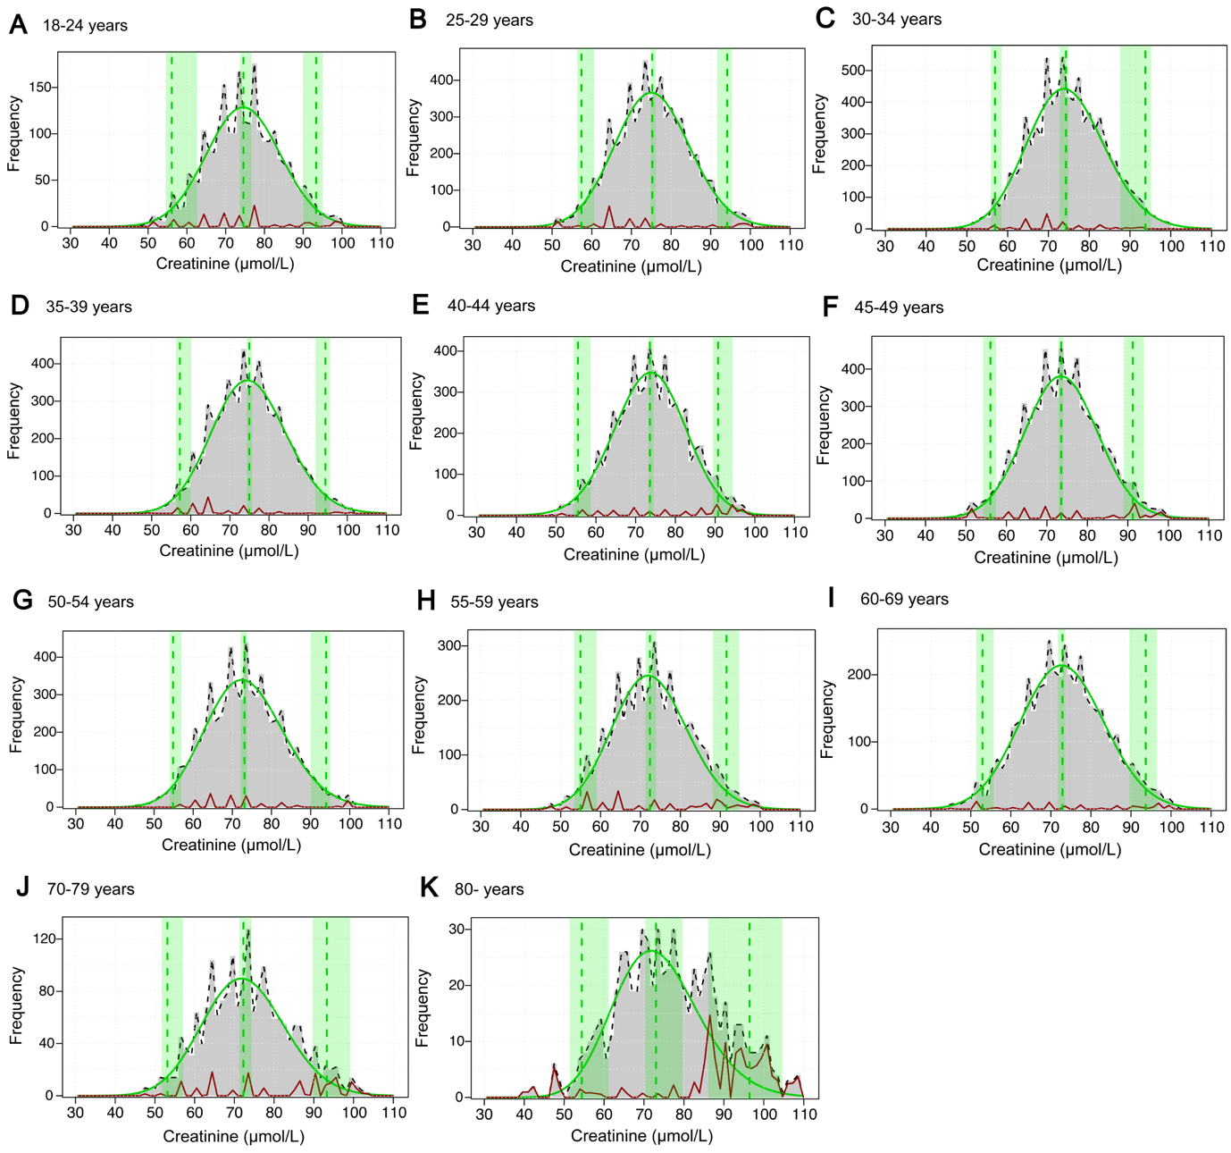
Figure S3. The reference intervals of serum creatinine estimated using refineR algorithm in males across all age groups. The green and red curves represent the distributions of healthy individuals and pathological samples, respectively. From left to right, three vertical dashed green lines indicate the lower limit, median, and upper limit of the estimated reference intervals. The green regions represent their corresponding 95% confidence intervals.

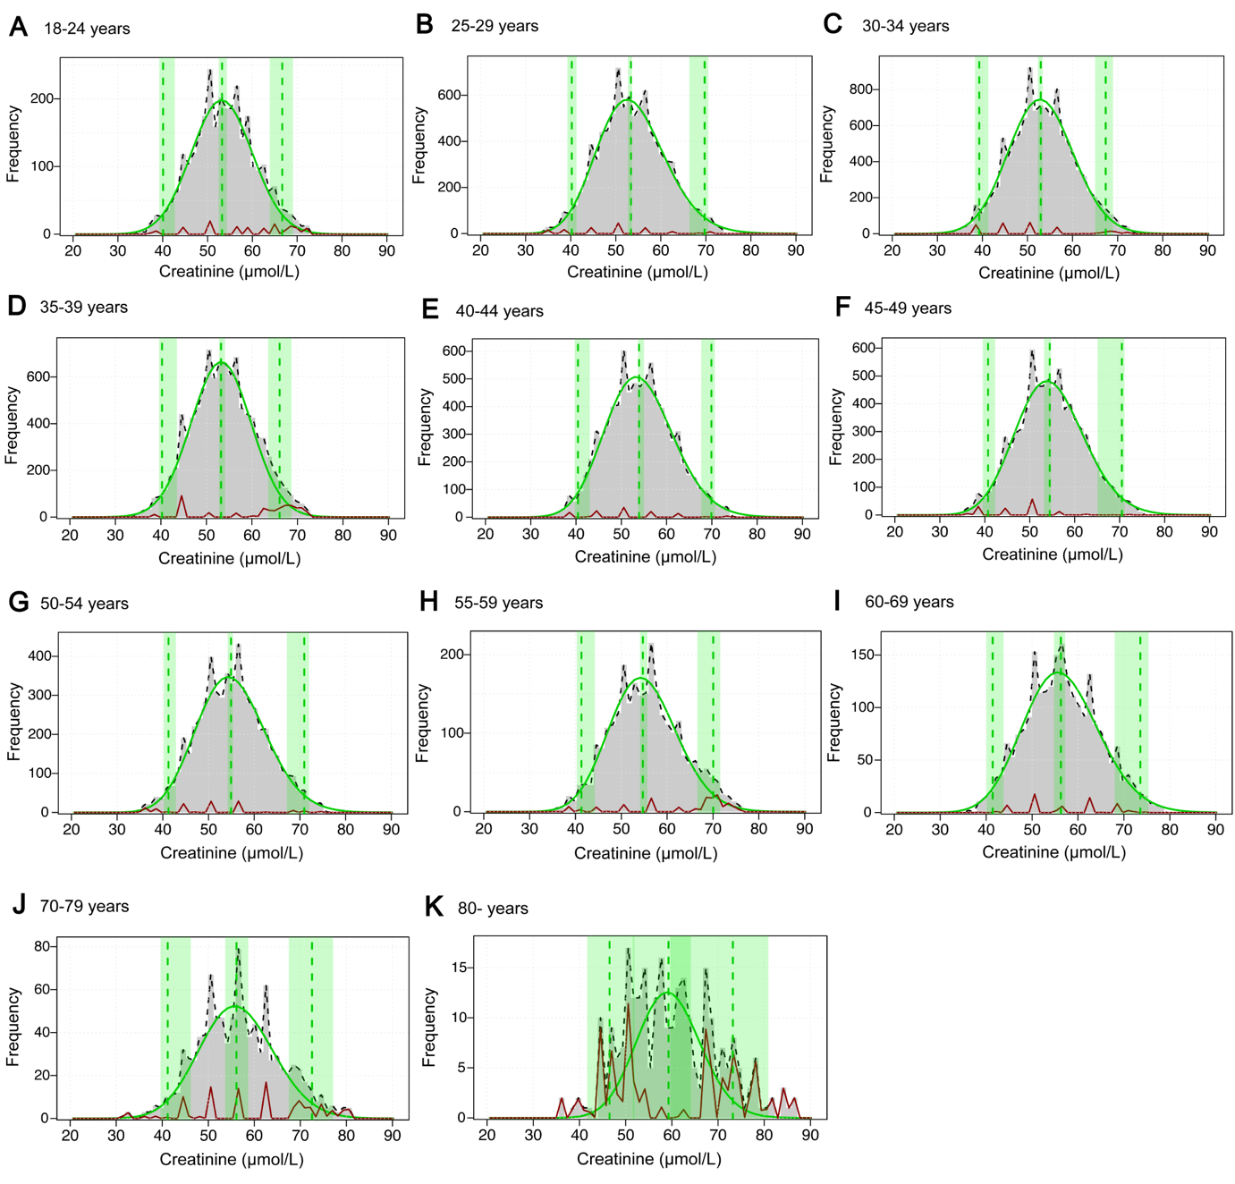
Figure S4. The reference intervals of serum creatinine estimated using refineR algorithm in females across all age groups. The green and red curves represent the distributions of healthy individuals and pathological samples, respectively. From left to right, three vertical dashed green lines indicate the lower limit, median, and upper limit of the estimated reference intervals. The green regions represent their corresponding 95% confidence intervals.

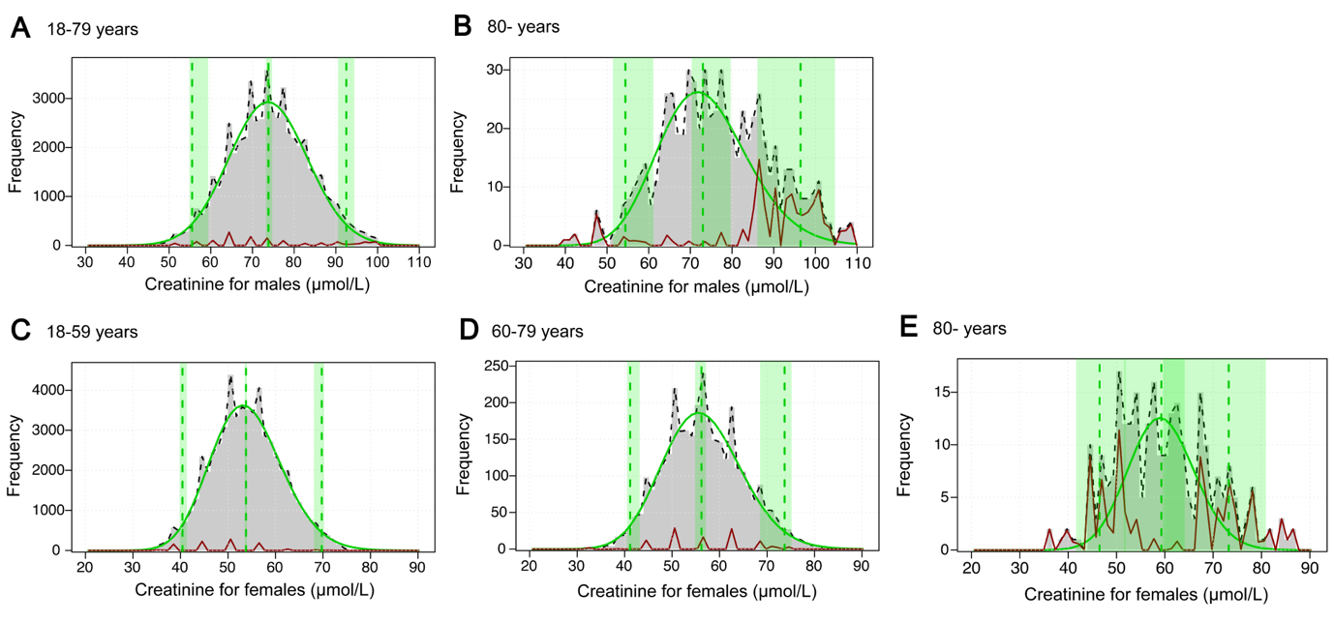
Figure S5. The reference intervals of serum creatinine estimated using refineR algorithm in groups divided by the adjusted optimal segmentation points. (A), Creatinine in males aged 18-79 years. (B), Creatinine in males over 80 years. (C), Creatinine in females aged 18-59 years. (D), Creatinine in females aged 60-79 years. (E), Creatinine in females aged over 80 years. The green and red curves represent the distributions of healthy individuals and pathological samples, respectively. From left to right, three vertical dashed green lines indicate the lower limit, median, and upper limit of the estimated reference intervals. The green regions represent their corresponding 95% confidence intervals.

Figure S6. Agreement of GFR categories among FAS and EKFC equations with different Q-values. (A), Males. (B), Females. (C), The subgroup of age<60 years. (D), The subgroup of age≥60 years. ª P<0.05, ^{b} P<0.001, ^{ns} P≥0.05, compared the two FAS or two EKFC equations.

