Supplementary material

1. Parallelism
In order to assess parallelism and matrix effects, we conducted duplicate measurements on a serial dilution of four distinct serum samples. Each well was subjected to parallel measurements within three Glass Nano Reactors (GNRs), yielding a total of six measurements per sample, as detailed in Table S1.
Table S1. GFAP raw concentrations obtained through six parallel measurements per sample.
Measured GFAP concentrations (pg/mL)
Dilution | Sample 1 | Sample 2 | Sample 3 | Sample 4
Neat | 3 | 6.09 | 25 | 11.9
 | 3.1 | 6.5 | 23.8 | 16.5
 | 3.1 | 6.06 | 24.1 | 14.6
 | 3.41 | 6.31 | 25 | 15.2
 | 2.68 | 4.74 | 24.6 | 13.8
 | 2.36 | - | 23.4 | 14.7
1:2 | 2.37 | 2.25 | 12.2 | 7.27
 | 1.44 | 2.7 | - | 6.73
 | 2.47 | 2.12 | 10.8 | 6.92
 | 2.41 | 2.68 | 12.3 | 6.75
 | 1.35 | 2.18 | 12 | 6.16
 | 1.25 | 2.78 | 11.2 | 6.5
1:4 | 0.69 | 1.30 | 6.32 | 3.75
 | 0.92 | 1.18 | 6.9 | 3.78
 | 0.51 | 1.57 | 7.3 | 3.3
 | 1.06 | 1.35 | 7.76 | 3.51
 | - | 1.12 | 7.39 | 3.35
 | 0.75 | 1.01 | 6.81 | 3.38
1:8 | 0.33 | 0.32 | 3.12 | 1.87
 | 0.63 | 1.05 | 3.5 | 2.4
 | 0.20 | 0.66 | 3.63 | 2.12
 | 0.37 | 0.59 | 3.54 | 2.25
 | 0.05 | 0.45 | 3.12 | 1.97
 | 0.11 | 0.53 | 3.58 | 2.17

2. GFAP correlations with age
The correlation between GFAP concentrations and age was assessed in both the control and whole cohort. Obtained results revealed a positive correlation in the control and the entire cohort with all three assays (Fig. S1 A-F). However, a stronger correlation was observed in entire cohort (2nd gen Ella : (spearman r = 0.68 (95% CI: 0.59 – 0.74), P < 0.0001), Simoa: r = 0.70 (95% CI: 0.61 – 0.76), P < 0.0001) compared to the control cohort (2nd gen Ella : r = 0.60 (95% CI: 0.44 – 0.71), P < 0.0001, Simoa: r = 0.65 (95% CI: 0.50 – 0.75), P < 0.0001). Although this was less clear for the homemade Ella assay in the total cohort (r = 0.56 (95% CI: 0.45 – 0.65), P < 0.0001) (Fig. S1 E) and in the control cohort (r = 0.35 (95% CI: 0.14 – 0.52), P = 0.0009) (Fig. S1 F), in comparison with the other two assays.
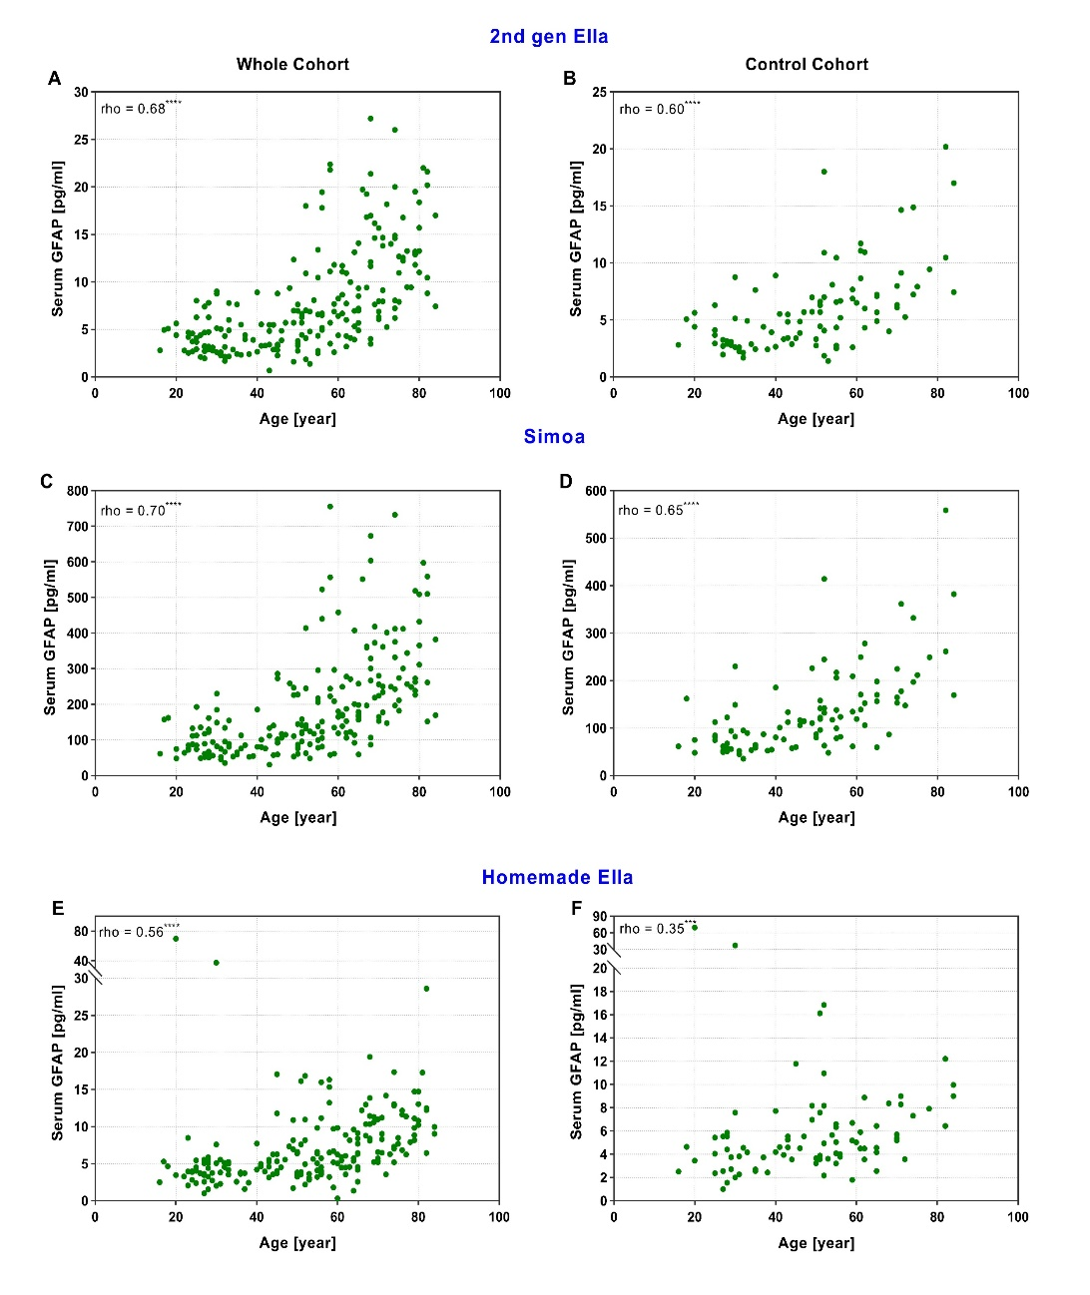

Figure S1. Assessment of correlation between GFAP concentration and age.
Spearman correlation (rho) between age and serum GFAP measured using the 2nd gen Ella assay in the whole cohort (n = 210) (A) and the control cohort (n = 95) (B), the Simoa assay in the whole cohort (n = 210) (C) and the control cohort (n = 95) (D), and the homemade Ella assay in the entire cohort (n = 198) (E) and the control cohort (n = 86) (F). GFAP, Glial fibrillary acidic protein; Simoa, Single-molecule array.
3. Sensitivity and specificity of assays
To compare assay performance in diagnosis of AD, cut-off values were calculated using Receiver operating characteristics (ROC) and subsequent maximization of the Youden index (Fig. S2). The corresponding sensitivity and specificity were presented in Table S1.
Figure S2. ROC analysis of AD.
Comparison of GFAP concentrations in AD cohort versus control group measured by three assays. AD, Alzheimer’s disease; AUC, area under the curve; GFAP, Glial fibrillary acidic protein; O.Con, Old control; ROC, receiver operating characteristics; Simoa, Single-molecule array.
Assay | Cut-off [pg/ml] | Sensitivity (95% CI)[%] | Specificity (95% CI) [%] | Likelihood ratio
2nd gen Ella | > 10.9 | 77 (63-87) | 85 (73-93) | 5
Simoa | > 229 | 84 (71-92) | 79 (66-88) | 4
Homemade Ella | > 9.31 | 70 (55-81) | 89 (76-95) | 6
Table S2. Sensitivity and specificity of serum GFAP measured by three assays for discrimination between AD and control cohort.
AD, Alzheimer’s disease; CI, confidence interval; GFAP, Glial fibrillary acidic protein; Simoa, Single-molecule array.

4. Calibrator measurements
Due to observed discrepancies in absolute GFAP values measured by the 2nd generation Ella and Simoa, we examined the concentration of two Simoa calibrators using the 2nd generation Ella. These calibrators had producer-defined concentrations of 333 pg/ml and 111 pg/ml. The 2nd generation Ella yielded measured concentrations of 23.9 pg/ml and 10.4 pg/ml for the respective calibrators. Notably, a mean ratio of 12 was identified between the Simoa-defined concentrations and the measured concentrations in the 2nd generation Ella, falling within the agreement range of values established in the Bland-Altman graph (see Figure 5A).
It is crucial to note that these calibrators underwent a single freeze and thaw cycle before measurement by the 2nd generation Ella, potentially influencing the actual protein concentration as per the producer's instructions. This finding may explain the observed differences in absolute values, as the standard curves in different assays could be calibrated differently.

