

**Supplemental Figure 2. Bland and Altman plot of androstenedione measures according to the calibration system.**



Bold line: median agreement line; dashed line: 95% interval of agreement.

**External calibration**

***In-house calibration***

**Supplemental Figure 3. Bland and Altman plot of DHEAS measures according to the calibration system.**



Bold line: median agreement line; dashed line: 95% interval of agreement.

**External calibration**

***In-house calibration***

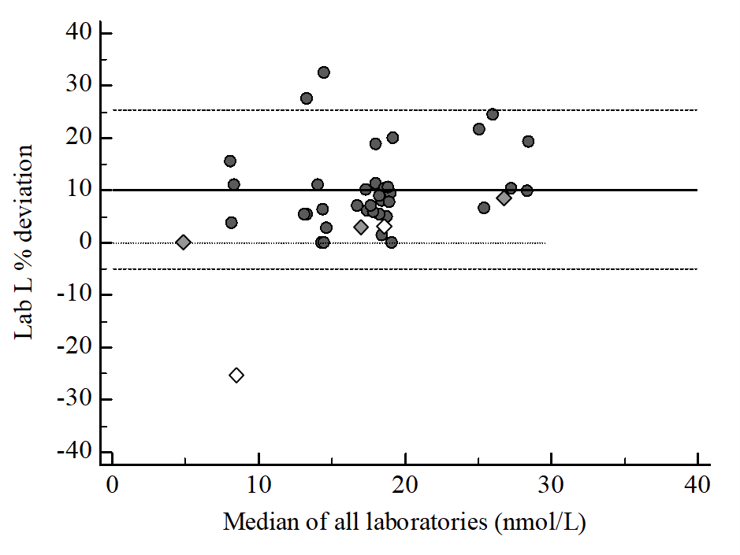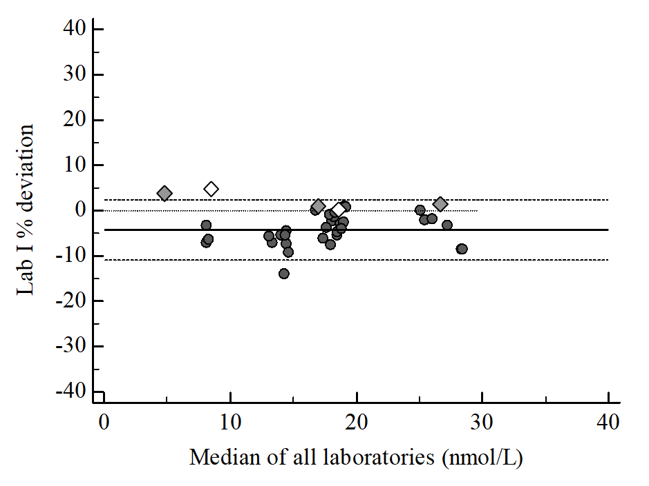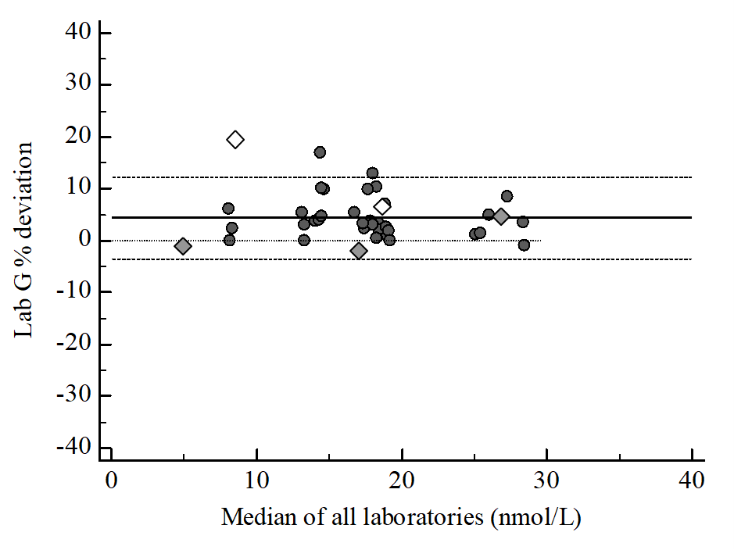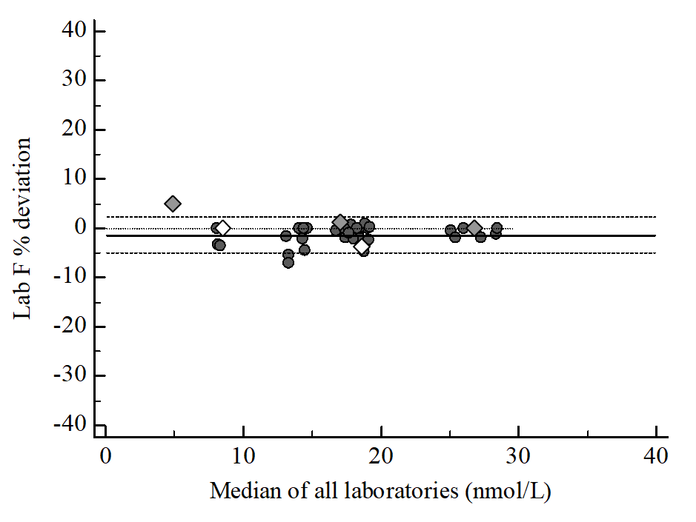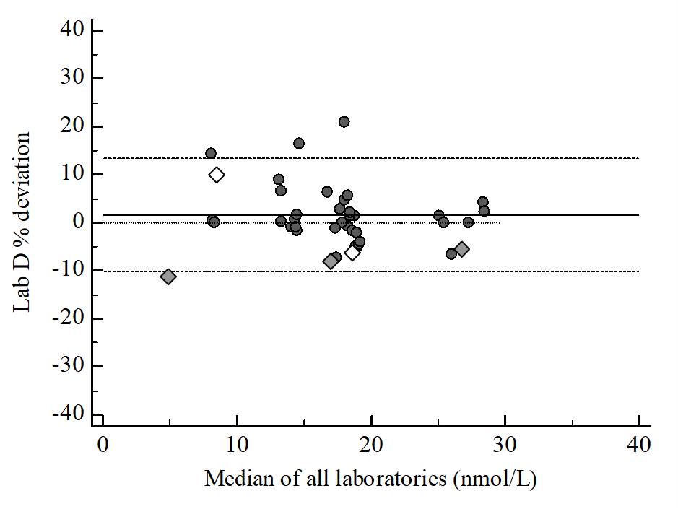

Bold line: median agreement line; dashed line: interval of agreement; dotted line: zero bias line; gray diamond: RfB HM materials; white diamond: Instand N°302 materials.

**Supplemental Figure 4. Commutability of EQA materials tested for testosterone measurement.**



**Supplemental Figure 5. Bland and Altman plot of testosterone measures in the female range according to the calibration system.**



Bold line: median agreement line; dashed line: 95% interval of agreement.



**Supplemental Figure 6. Bland and Altman plot of testosterone measures in the male range according to the calibration system.**



Bold line: median agreement line; dashed line: 95% interval of agreement.