**A** (HbAS ) **B** (HbAC) **C** (HbAD)

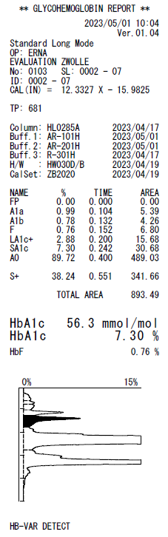 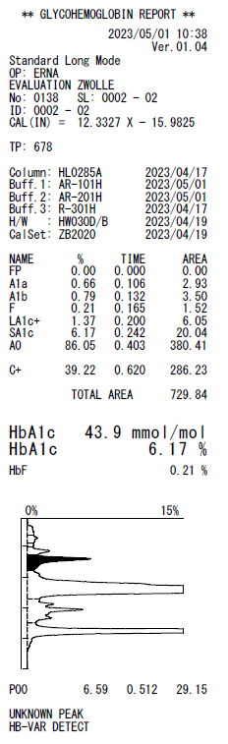 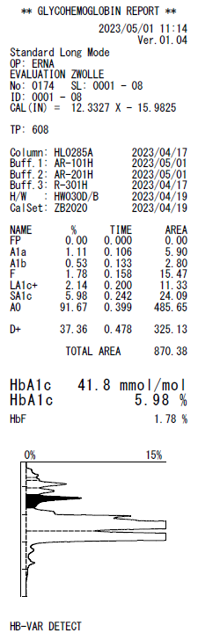

**D** (HbAE) **E** (HbF=21% ) **F (**A2=3.9%)

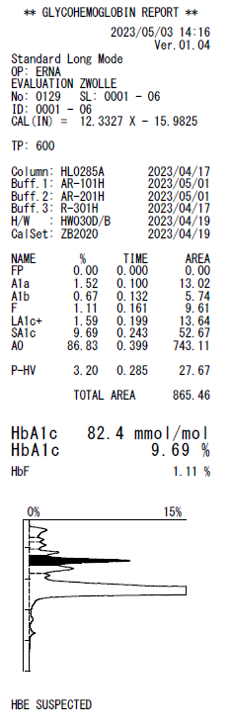 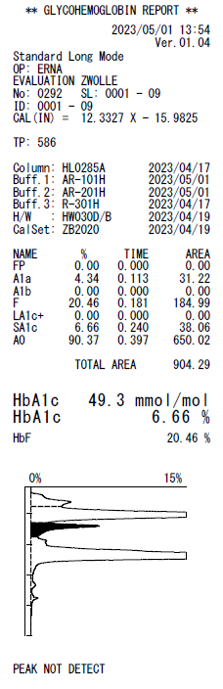 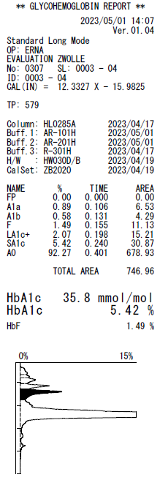

**Supplemental Figure 1B** Chromatograms of Tosoh GR01 Long Mode of different Hb-variants (**A**=HbAS, **B**=HbAC, **C**=HbAD, **D**=HbAE, **E**=HbF and **F**=A2).