**Supplemental material**

**Supplementary Figure 1:** **Glucose difference in glycemic subgroups**

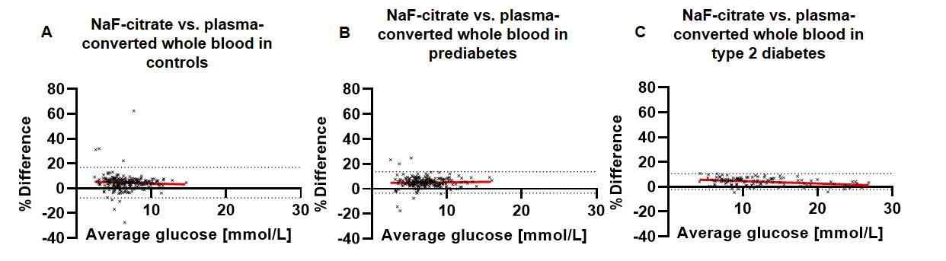

Bland-Altman analyses of plasma and plasma-converted whole blood glucose concentrations analogue to Fig. 1. Glycemic subgroups were stratified: (A) controls (n=253), (B) prediabetes (n=213) and (C) type 2 diabetes (n=112). Red lines indicate slope for linear regression of single data points from Bland-Altman analysis to estimate alterations of glucose difference over the whole glucose range. Dotted lines represent lower and upper boundaries of 95% CI for glucose difference. 95% CI, 95% confidence interval.

**Supplementary table 1: Difference of ~~FH~~ fluoride-heparin plasma and venous whole blood**

|  |  |  |  |
| --- | --- | --- | --- |
| **Sample type** | | **** | **Standard Error** |
| ~~FH~~ Fluoride-heparin plasma | whole blood | 11.10 | 0.63 |

|  |  |  |  |  |  |
| --- | --- | --- | --- | --- | --- |
| **Variable 1** | **Variable 2** | **Estimate** | **Standard Error** | **|t|** | ***p* > |t|** |
| ~~FH~~ fluoride-heparin plasma/1.11 | whole blood (IVGTT) | 0.433 | 0.900 | 0.48 | 0.630 |

Glucose concentrations from ~~FH~~ fluoride-heparin plasma at fasting prior to IVGTT were compared to whole blood glucose concentrations in German Diabetes Study and the delta was estimated using the least square means approach. Subsequently, ~~FH~~ fluoride-heparin plasma glucose concentrations were divided by 1.11 (IFCC conversion factor), resulting in insignificant difference as indicated by the estimate of difference (estimate) between ~~FH~~ fluoride-heparin plasma and whole blood glucose concentrations. ~~FH, Fluoride heparin;~~ IVGTT, intra-venous glucose tolerance test.

**Supplementary Table 2: Multiple regression analysis of Glucose with variables of cohort characteristics**

|  |  |  |  |  |  |
| --- | --- | --- | --- | --- | --- |
| **Variable** | **Estimate** | **Standard error** | **95% CI (asymptotic)** | **|t|** | **p** |
| **Intercept** | 1.934 | 18.74 | -35.67 to 39.54 | 0.103 | 0.918 |
| **Hematocrit** | **0.811** | **0.388** | **0.032 to 1.590** | **2.090** | **0.042** |
| **Creatinine** | -1.654 | 4.640 | -10.96 to 7.66 | 0.356 | 0.723 |
| **Cystatin C** | -4.086 | 7.969 | -20.08 to 11.91 | 0.513 | 0.610 |
| **eGFR** | -0.036 | 0.110 | -0.256 to 0.184 | 0.325 | 0.746 |
| **Triglycerides** | -0.011 | 0.010 | -0.031 to 0.010 | 1.004 | 0.320 |
| **HDL** | -0.0131 | 0.041 | -0.096 to 0.070 | 0.315 | 0.754 |
| **Uric acid** | -0.352 | 0.484 | -1.324 to 0.620 | 0.726 | 0.471 |
| **RBC count** | -2.425 | 2.236 | -6.911 to 2.062 | 1.084 | 0.283 |
| **~~Hb~~ Hemoglobin** | -0.552 | 0.723 | -2.003 to 0.899 | 0.763 | 0.449 |

Multiple regression analysis was performed with cohort characteristics and Glucose as dependent variable. 95% CI, 95%-confidence interval, eGFR, estimated glomerular filtration rate; HDL, high-density lipoprotein; RBC, red blood cell count.

**Supplementary table 3: Calculation of glucose difference between NaF-citrate plasma and different type of plasma and serum**

|  |  |  |  |
| --- | --- | --- | --- |
| **Plasma sample type** | **~~% of difference~~ Difference, %** | **95% CI, %** | **Mean glucose difference,~~in~~ mmol/L** |
| **K2-EDTA** | 3.506* | -0.6528-7.666 | -0.2856 |
| **~~FH~~ Fluoride-heparin** | 7.199* | 2.382-12.02 | -0.5766 |
| **~~FE~~ Fluoride-EDTA** | 4.922* | 1.178-8.666 | -0.4056 |
| **Serum** | 4.054* | -0.06479-8.173 | -0.3265 |

Glucose level difference (% of difference) from NaF-citrate plasma vs other sample type was calculated by Bland-Altman analysis with n=14 paired measurements of each sample type. Asterisk indicate significant differences (*p*<0.0001) of mean glucose level from NaF-citrate plasma vs. indicated sample types estimated by RM one-way ANOVA with Tukey corrections. 95% CI, 95%-confidence interval; EDTA, ethylenediaminetetraacetic acid~~FH, Fluoride-heparin; FE, Fluoride-EDTA~~