Supplementary material
Figure S1 Correlations among CSF and plasma Aβ42/Aβ40 assessed by N3PA and N4PE assays. Heatmap presenting results of Spearman correlation analysis for CSF and plasma Aβ42/Aβ40 assessed across the whole cohort by N3PA and N4PE assays. The color gradient indicates the strength of correlation according to Spearman ρ.

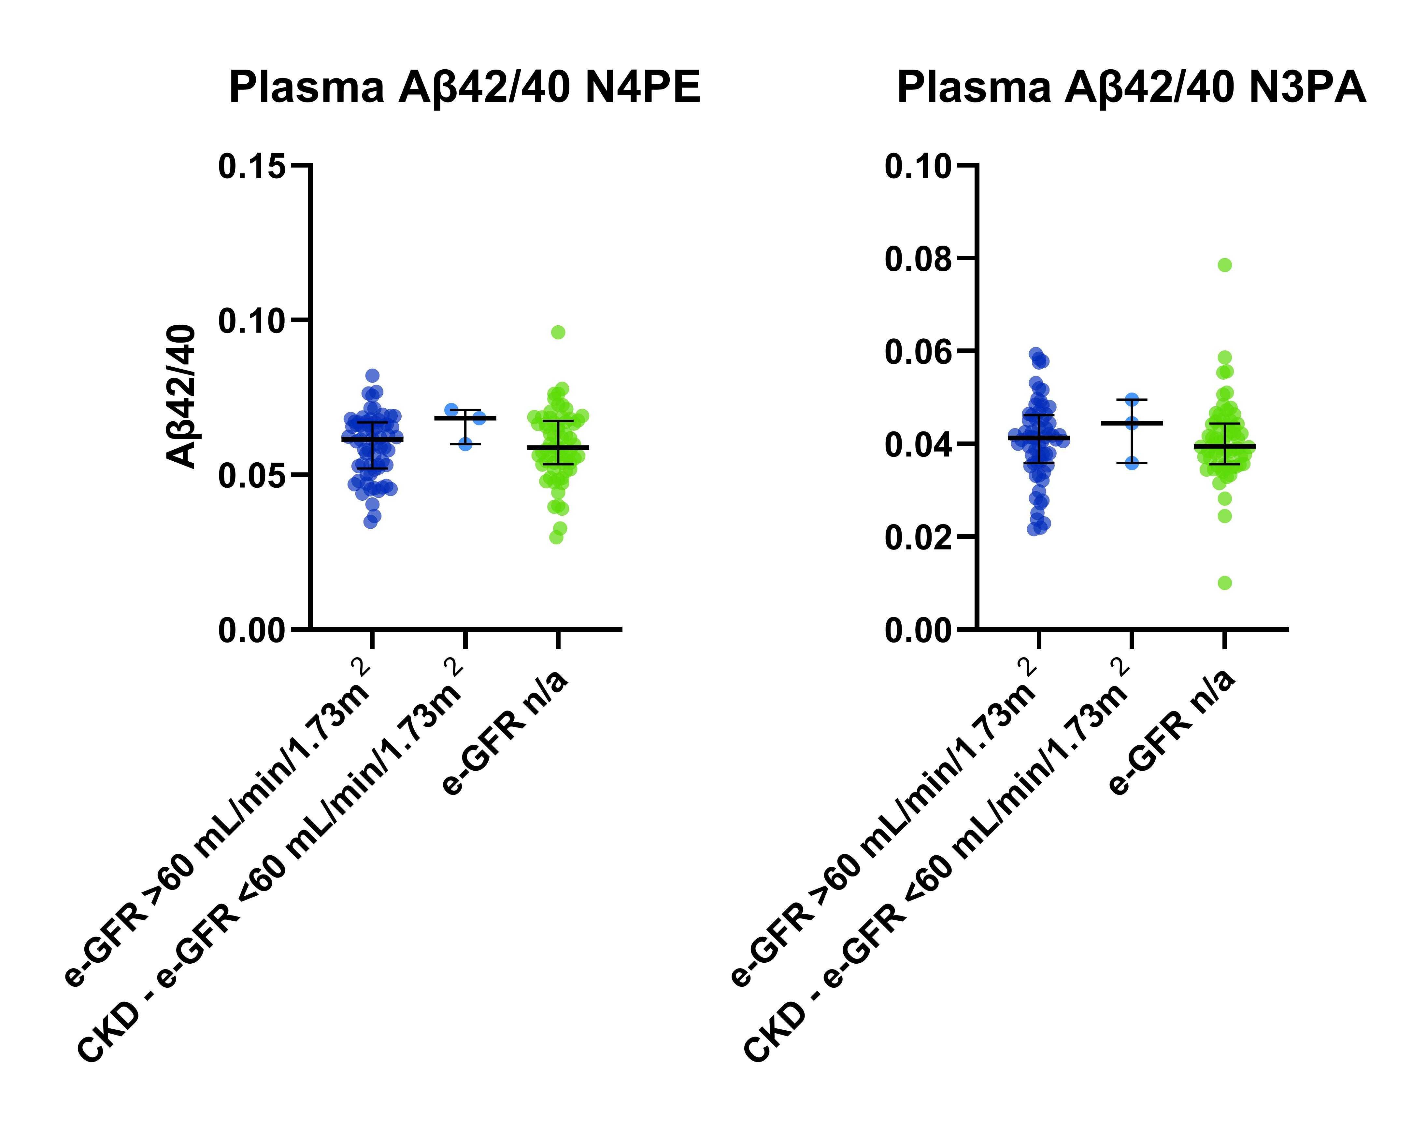Figure S2 Plasma Aβ42/40 among patients with and without chronic kidney disease (CKD) as assessed by e-GFR. e-GFR calculated by the Chronic Kidney Disease-Epidemiology Collaboration (CKD-EPI) formula with cut-off = 60 (mL/min/1.73m²).

Comparison | Aβ42/40 assay | AUC non-adjusted | 95% CI (Wilson/Brown)
CSF CTRL vs. AD-dem | N4PE | 0.992 | 0.977-1.000
 | N3PA | 0.999 | 0.994-1.000
CSF CTRL vs. MCI-AD | N4PE | 1 | 0.994-1.000
 | N3PA | 1.000 | 0.998-1.000
CSF CTRL vs. pre-AD | N4PE | 0.997 | 0.990-1.000
 | N3PA | 0.999 | 0.996-1.000
Plasma CTRL vs. AD-dem | N4PE | 0.773 | 0.664-0.882
 | N3PA | 0.684 | 0.557-0.811
Plasma CTRL vs. MCI-AD | N4PE | 0.793 | 0.694-0.892
 | N3PA | 0.716 | 0.596-0.837
Plasma CTRL vs. pre-AD | N4PE | 0.914 | 0.834-0.994
 | N3PA | 0.726 | 0.595-0.857
Table S1 Area Under Curve (AUC) values for comparison of the accuracy of each assay to discriminate between control group and different AD continuum stages (pre-AD, MCI-AD, AD-dem). AUC values with 95% CI calculated by using Wilson/Brown method and AUC values for age- and gender-adjusted AUC with 95% CI calculated by using 2000 bootstrap replicates. AD: Alzheimer’s disease, pre-AD: preclinical AD, MCI-AD: mild cognitive impairment due to AD, AD-dem: AD at dementia stage, CTRL: control group.

