Supplemental Data
Full title：Evaluation of the analytical and clinical performance of a new high-sensitivity cardiac troponin I assay: hs-cTnI (CLIA) assay
Short Head：Cardiac Troponin I Assay Evaluation
List of all authors: Ling Li^{1a,} Xin Shu^{2a}, Litao Zhang², Ao Xu¹, Juan Yang¹, Yisha Jing², Hui Wang², Zhenlu Zhang^{1*}
ª These authors contributed equally to this work
Author’s institution:
¹ Clinical Laboratory of Wuhan Asia Heart Hospital, Wuhan, Hubei, China
² Clinical Laboratory of Wuhan Asia General Hospital, Wuhan, Hubei, China
Corresponding author:
Dr. Zhenlu Zhang, e-mail: zhenluzhangwh@163.com
Clinical Laboratory of Wuhan Asia Heart Hospital, Wuhan, Hubei, China 432000
Keywords: High-sensitivity; Cardiac troponin I; Chemiluminescence immunoassay; Acute myocardial infarction; Analytical performance; Diagnostic performance.

Contents
Materials and methods
Supplemental Tables: Supplemental Table 1 - Supplemental Table 5
Supplemental Figures: Supplemental Figure 1 - Supplemental Figure 3
References

Materials and methods
Mindray hs-cTnI (CLIA) is a one-step muti-site immunoenzymatic assay based on chemiluminescent immunoassay technology to determine the concentration of cTnI in samples. As the claim of hs-cTnI (CLIA) assay, the measuring range of reagent kit is 2.4 to 25000.0 ng/L. The limit of blank (LoB), the limit of detection (LoD) and the limit of quantification (LoQ) of hs-cTnI (CLIA) assay are 0.1-0.5 ng/L, 0.5-0.7 ng/L and 1.1-2.4 ng/L (20% CV), respectively. Total imprecision is <10%. Linearity was demonstrated in the range of 2.4 to 25000.0 ng/L with the correlation coefficient r≥0.9900. The analytical specificity of cross-reactivity is ≤0.1% with CK-MB, tropomyosin protein, skeletal troponin I, cardiac troponin T, skeletal troponin T, troponin C, myosin light chain protein, myoglobin and actin protein. No interference was observed with the potential endogenous substances including triglycerides, unconjugated bilirubin, conjugated bilirubin, cholesterol and hemoglobin.

Precision studies were performed following the Clinical and Laboratory Standards Institute (CLSI) document EP05-A3 [1] to evaluate the total precision. Two levels of serum samples were aliquoted and freshly thawed for analysis. The test collected 80 measurements for each sample, including two runs per test day and two replicate measurements per sample in twenty test days.

Reproducibility studies were performed following the CLSI document EP05-A3 [1]. Two serum samples with different cTnI levels were measured 20 consecutive times. The mean, standard deviation (SD) and coefficient of variation (CV) were calculated.

Linearity was determined according to CLSI document EP06-Ed2 [2]. A series of diluents containing cTnI from LoQ to the upper measurable limit of analytical measurement range were obtained by mixing two serum samples close to the upper and lower limit of analytical measurement range. Each diluent was measured for two times and linearity was evaluated by regression analysis. The correlation coefficient r≥0.9900 within the linearity range is acceptable.

Sample Dilution was determined using seven serum samples with high-concentration of cTnI within the measurement range. Dilute the high-value samples (1:10) to get the diluted samples. Each undiluted and diluted sample was measured twice and calculated the mean concentration. Percent recovery for each diluted sample and the average percent recovery were calculated as: recovery rate = measured concentration/ expected concentration.

Cross reactivity studies were performed in accordance with CLSI Document EP07-A2 [3]. To test the cross reactivity of hs-cTnI (CLIA) assay with CK-MB, tropomyosin protein, skeletal troponin I, cardiac troponin T, skeletal troponin T, troponin C, myosin light chain protein, myoglobin and actin protein, 1000000 ng/L each of the above proteins were added to serum samples containing cTnI. The spiked samples and the unspiked control samples were measured to determine the ratio of cross reactivity, which was calculated as: (hs-cTnI spiked sample - hs-cTnI unspiked sample)/ 1000000 ng/L. The ratio of cross reactivity < 0.1% was acceptable.

Supplemental Tables
Sample | Mean, ng/L | Totsl precision
Sample | Mean, ng/L | SD | CV%
Sample 1 | 42 | 1.47 | 3.49%
Sample 2 | 9656 | 273.7 | 2.83%
Supplemental Table 1 Precision studies of hs-cTnI (CLIA).

Hs-cTnI (CLIA), ng/L | Sample 1 | Sample 2
Mean | 30.32 | 150.69
SD | 0.42 | 2.22
CV | 1.38% | 1.48%
Supplemental Table 2 Reproducibility of hs-cTnI (CLIA).

Sample | SD | CV | Measured value, ng/L | Expected value, ng/L | Percent recovery | Average Percent recovery
0 | 0.06 | 27.62% | 0.21 | 0.00 | — | 97%
1 | 13.83 | 0.27% | 5113.96 | 5605.88 | 91% | 97%
2 | 38.44 | 0.36% | 10765.67 | 11211.75 | 96% | 97%
3 | 64.21 | 0.39% | 16372.23 | 16817.63 | 97% | 97%
4 | 212.73 | 0.96% | 22211.77 | 22423.51 | 99% | 97%
5 | 177.33 | 0.63% | 28029.38 | 28029.38 | 100% | 97%
Supplemental Table 3 Linearity study of hs-cTnI (CLIA).

Sample | Cross reactivity
Blank | —
CK-MB | 0.0001%
tropomyosin protein | 0.0007%
skeletal troponin I | 0.0001%
cardiac troponin T | 0.0030%
skeletal troponin T | 0.0001%
troponin C | 0.0007%
myosin light chain protein | 0.0001%
myoglobin | 0.0001%
actin protein | 0.0001%
Supplemental Table 4 Cross reactivity study of hs-cTnI (CLIA) assay.

Substance | Concentration | Observed interference
Substance | Concentration | Sample Low | Sample High
Triglycerides | 3000 mg/dL | -1.72% | -3.55%
Unconjugated bilirubin | 60 mg/dL | 0.99% | -3.79%
Conjugated bilirubin | 40 mg/dL | -0.98% | -2.96%
Hemoglobin | 608 mg/dL | 0.26% | -2.52%
Supplemental Table 5 Interference study of hs-cTnI (CLIA) assay.

Supplemental Figures
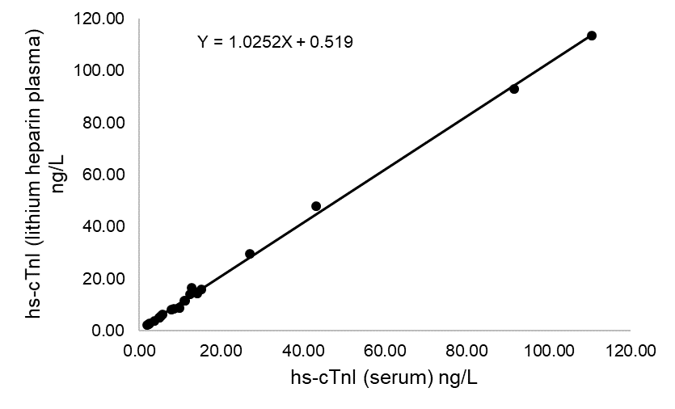
Supplemental Figure 1 Sample type studies of hs-cTnI (CLIA) assay between serum and lithium heparin plasma

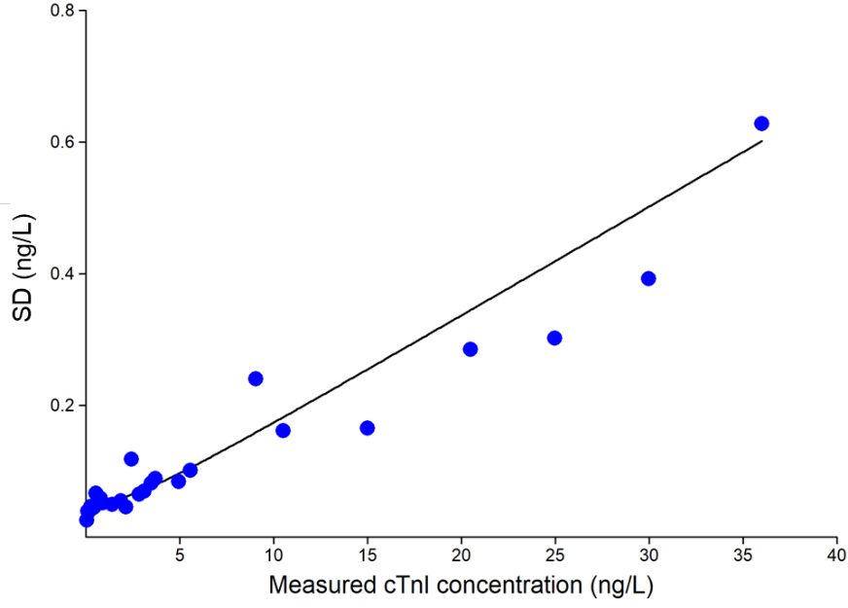
Supplemental Figure 2 Imprecision profile of hs-cTnI (CLIA) assay according to SD and measured cTnI concentration.

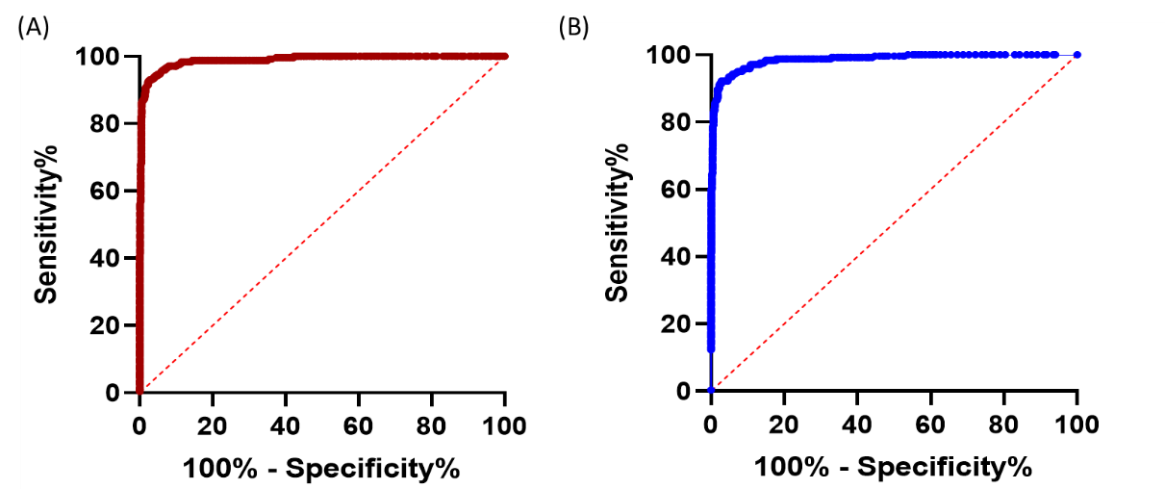
Supplemental Figure 3 ROC analysis of the assessment of diagnostic performance of hs-cTnI (CLIA) (A) and ARCHITECT hs-cTnI (B).

References
1. Clinical and laboratory standards institute. Evaluation of precision of quantitative measurement procedures; approved guideline, third edition. CLSI Document EP05-A3 2014.
2. Clinical and laboratory standards institute. Evaluation of linearity of quantitative measurement procedures, second edition. CLSI document EP06 2020.
3. Clinical and laboratory standards institute. Interference testing in clinical chemistry; approved guideline, second edition. CLSI document EP07-A2 2005.

