Inhoud
Summary 2
Frameset: 3
Tableau dashboards 4
Temperature alarms export 4
Exports Glims 4
Header 5
Function setup: 6
Emergency drug tests 9
Query setup: 10
Function setup: 11
Results to be phoned 13
Query setup: 14
Function setup: 15
Turnaround time overruns per Specimens 17
Function setup: 18
Turnaround time overruns per Stations 21
Function setup: 22
QC alarms 24
Query setup: 24
Function setup: 25
Moving Average (Now) 27
Query setup: 28
Function setup: 29
Moving Average (Today) 31
Query setup: 32
Function setup: 33

Summary
From our LIS exports are made in .html format, combined with Tableau dashboards all the different pages are shown as one pages using a (HTML) frameset.
The header is used to monitor that the pages exported from the LIS are being renewed, and therefore the latest information is shown, the Tableau dashboards have their own date and time stamp for the same reason.
The renewal is manually checked via the Date and Time in the upper right corner of the Header, if the date and time is more than 15 minutes behind the current date and time it indicates that there is a problem in our LIS.
Not only is the Monitor showing old data but also the Result reporting to the HIS can be affected, the result export in HL7 uses the same task scheduler as for creating the files for the Monitor.
Even the Replication status of our Progress database is checked every 5 minutes when the new files are created and if the Replication status is wrong this is also displayed in the Header.
This way the Monitor also functions as an early detection system for problem with our LIS.

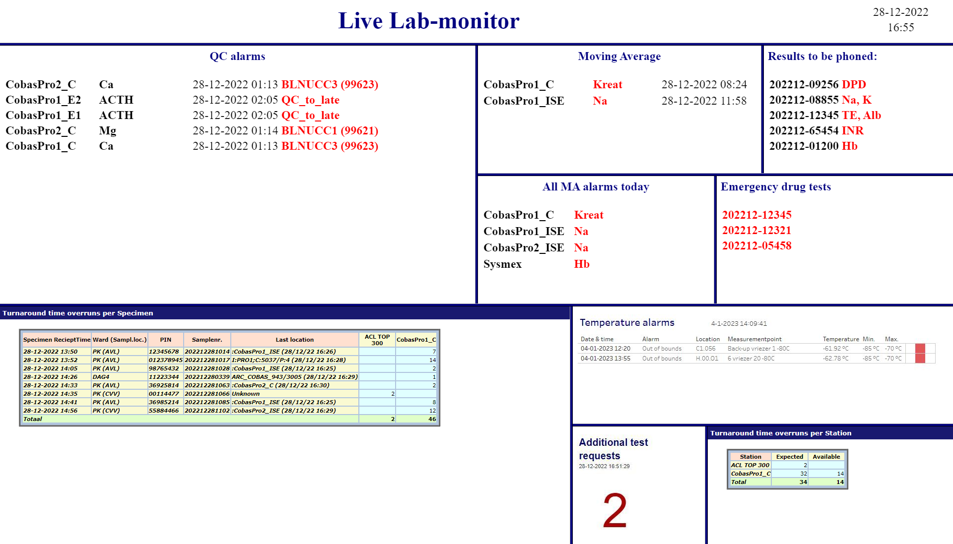

Frameset:
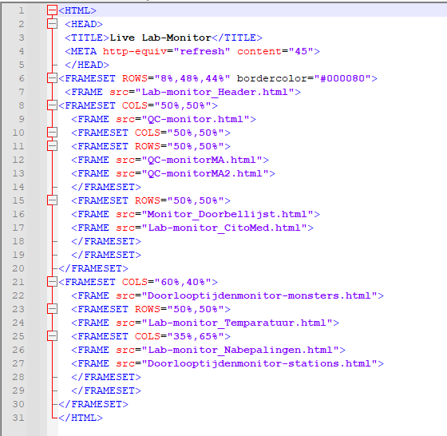
Save it as a .htm file.

This can be opened with any web browser, this page is de default home page and the web browser starts automatically when windows starts.

It’s show on a big screen with a computer that automatically starts when there is power, automatically signs in with a user that only has read only privilege (for just the location of the files). Computer doesn’t have a keyboard or a mouse (so users can’t change settings or hide the screen), for Application management we plug in a keyboard/mouse when needed.

All files are in same folder. They are all copied from the server directory (every 5 minutes) to a windows share directory via a Windows task scheduler task. If someone manages to change something in de share location in one of the files it’s replaced with a new copy from the original on the server.

Tableau dashboards
Our LIS makes .html files but other web pages can also be shows, such as Tabelau pages, for this we use a .html file with these settings:
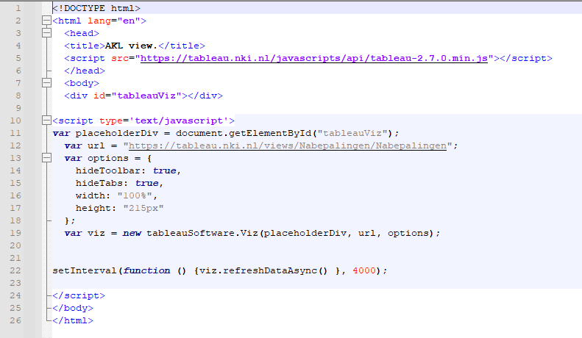
The .html for tableau has its own refresh rate, sometimes we see that the monitor shows old Tableau data after refreshing for just a few seconds. We show the date/time on the Tableau pages so we can see if the Tableau pages shown are current and contain the latest data (If old date stays it may indicate that database with the Tableau data isn’t up to date).

Temperature alarms export
With a Python script (using JSON) the API of the temperature alarms is read out, the data is put into a database.
Using Tableau de data from the database is shown.

Exports Glims
HTML files exported from our LIS GLIMS:
We use 2 types of exports, Programmed exports and Statistical exports.

Header
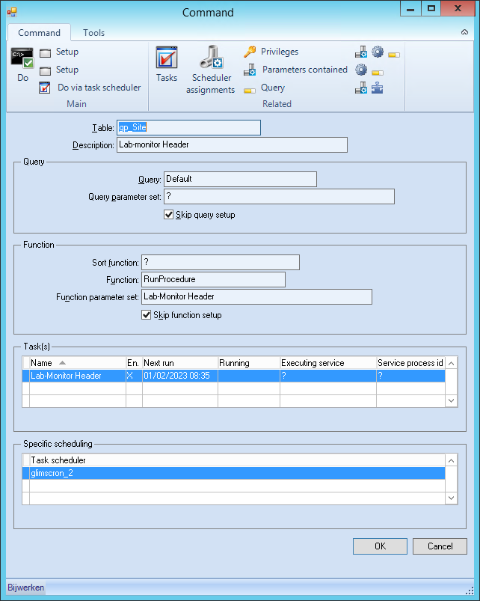

Function setup:
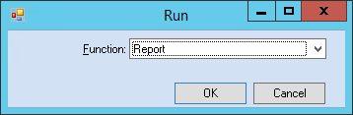

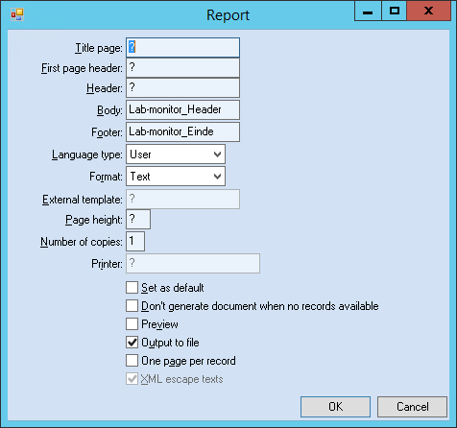

Body mispl:
<HTML>

<HEAD>
<TITLE>Live Lab-monitor</TITLE>
<META HTTP-EQUIV="refresh" CONTENT="60">
<!-- commentaar: het getal hierboven betekent verversen in ... sec. -->

{:
String Header, strStatus, strCodeGlims, strCodeGenrw;
DATETIME dtStatus, dtNu;
LOGICAL lError;

strStatus := GetSiteAttribute("SpecificSite",Glims().id,"ReplicationPlus_Status");
strCodeGlims := Entry(4,strStatus,"|");
strCodeGenrw := Entry(6,strStatus,"|");
dtStatus := DateAndTimeToDateTime (StringToDate(Replace(Entry(1,strStatus,"|"),"-","/")),StringToTime(Entry(2,strStatus,"|")));
dtNu := DateAndTimeToDateTime (Today(),Now());

IF strCodeGlims <> "6021" OR strCodeGenrw <> "6021" OR (dtNu - dtStatus) > 0.0208 /* 30 min. */ THEN
lError := TRUE;
Endif;

IF lError THEN
Header :=
"<Table width=""100%"">" +
"<TR>" +
"<TD bgcolor=""red"" align=""center"" width=""45""><FONT size = +3 color=""#000000""><B> Replication+ ERROR </B></FONT></TD>" +
"<TD rowspan=""2"" align=""center"" width=""45%""><FONT size = +5 color=""#000080""><B> Live Lab-monitor </B></FONT></TD>" +
"<TD width=""10%"" align=""center""><FONT size = +2>" + DateToString(Today(),"%d-%m-%Y") + "</FONT></TD>" +
"</TR>" +
"<TR>" +
"<TD align=""center""><FONT size = +2 color=""#DC143C""> Contact AKL Applicatiebeheer of DD KC! </FONT></TD>" +
"<TD align=""center""><FONT size = +2>" + TimeToString(Now(), "%H:%M") + "</FONT></TD>" +
"</TR>" +
"</Table>";

ELSE

Header :=
"<Table width=""100%"">" +
"<TR>" +
"<TD rowspan=""2"" align=""center"" width=""90%""><FONT size = +5 color=""#000080""><B> Live Lab-monitor </B></FONT></TD>" +
"<TD width=""10%"" align=""center""><FONT size = +2>" + DateToString(Today(),"%d-%m-%Y") + "</TD>" +
"</TR>" +
"<TR>" +
"<TD align=""center""><FONT size = +2>" + TimeToString(Now(), "%H:%M") + "</FONT></TD>" +
"</TR>" +
"</Table>";
Endif;

Return Header ;
}
</HEAD>

<BODY>

Footer mispl:
</BODY>
</HTML>

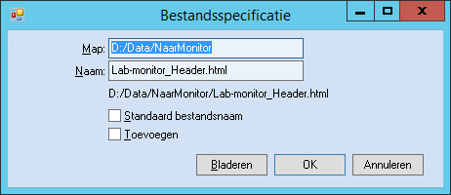

Emergency drug tests
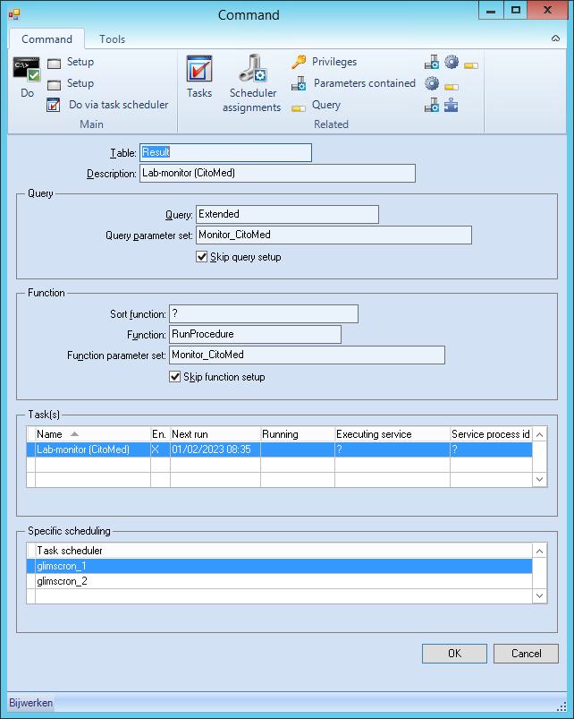

Query setup:
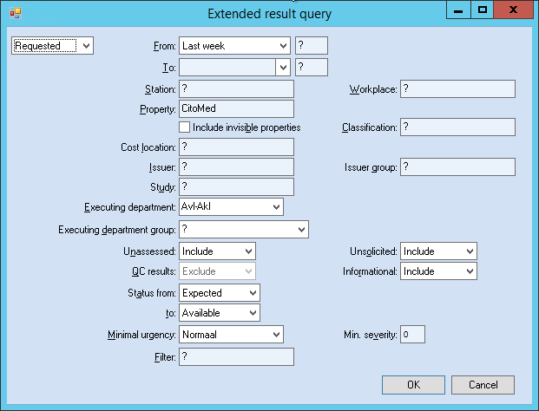

Function setup:
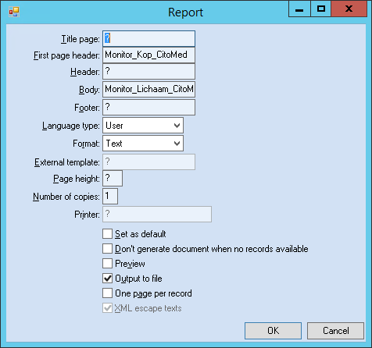

Header mispl:
<HTML>
<HEAD>
{:

String sReturnStr;

sReturnStr := "<FONT size = +2 color=""#000080""><B>Emergency drug tests" + "<BR><BR>";

Return sReturnStr;
}
</HEAD>

Body mispl:
<BODY>

<TABLE border="0" width="100%">
{:
String sReturnStr;

sReturnStr :=
"<TR align=""left""><TD width=""100%""><FONT size= ""+2""><B>" + "<FONT color=""red"">" + .Order.InternalId + "</B></TD></TR>";

Return sReturnStr;
}
</TABLE>
</BODY>
</HTML>

Results to be phoned
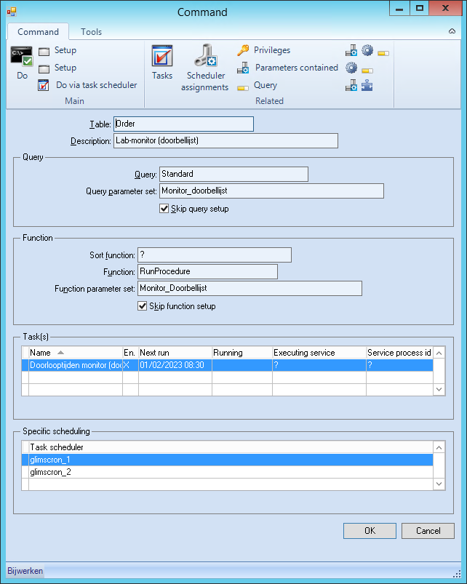

Query setup:
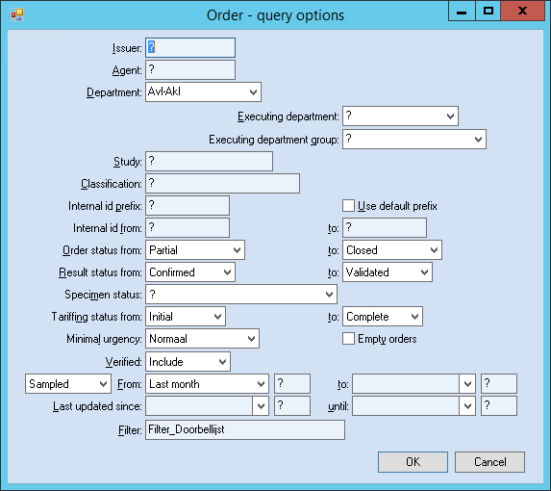

Filter mispl:
String sList;
Integer iNum, iTeller;

sList := .Attribute("PropertyList");
iNum := NumEntries(sList, ",");
iTeller := 1;

IF .PhoneStatus = 2 THEN
While iTeller <= iNum Do
IF .Result(Entry(iTeller,sList,","), ?, ?).Status > 3 THEN
Return True;
ELSE
Return False;
Endif;
iTeller := iTeller + 1;
Done;
ELSE
Return False;
Endif;

Function setup:
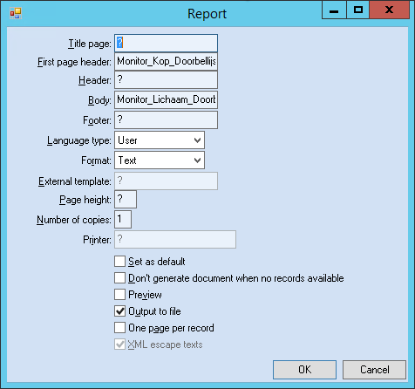

Header mispl:
<HTML>
<HEAD>
{:

String sReturnStr;

sReturnStr := "<FONT size = +2 color=""#000080""><B>Results to be phoned:" + "<BR><BR>";

Return sReturnStr;
}
</HEAD>

Body mispl:
<BODY>

<TABLE border="0" width="100%">
{:
String sReturnStr, sList, sBep;
Integer iNum, iTeller;

sList := .Attribute("PropertyList");
iNum := NumEntries(sList, ",");
sBep := "";
iTeller := 1;

While iTeller <= iNum Do
IF .Result(Entry(iTeller,sList,","), ?, ?).PhoneStatus = 2 THEN
IF sBep = "" THEN
sBep := .Result(Entry(iTeller,sList,","), ?, ?).Property.Mnemonic;
ELSE
sBep := sBep + ", " + .Result(Entry(iTeller,sList,","), ?, ?).Property.Mnemonic;
Endif;
Endif;
iTeller := iTeller + 1;
Done;

sBep := Rtrim(sBep, ",");

sReturnStr :=
"<TR align=""left""><TD width=""100%""><FONT size= ""+2""><B>" + .InternalId + " " + "<FONT color=""red"">" + sBep + "</B></TD></TR>";

Return sReturnStr;
}
</TABLE>
</BODY>
</HTML>

Turnaround time overruns per Specimens
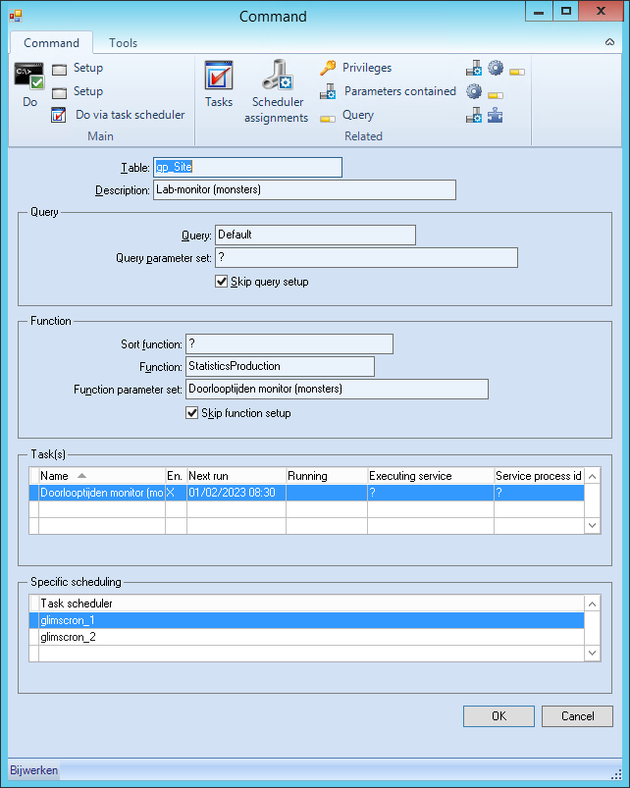

Function setup:
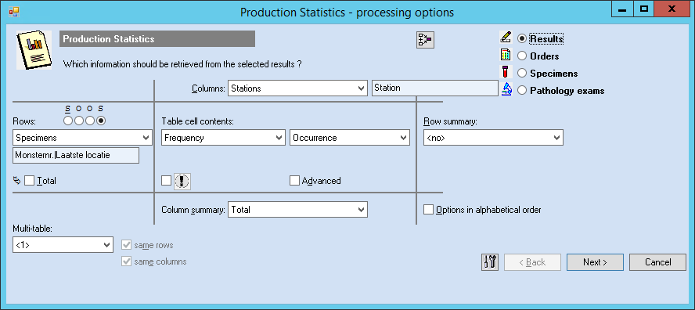

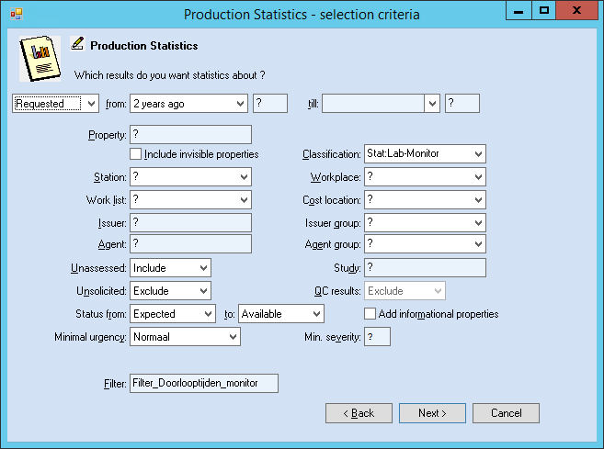

Filter mispl:
/* Filter_Doorlooptijden_Monitor */

STRING Station;
DATETIME Rekentijd, Nu;
LOGICAL ExtInst;
SPECIMEN TheSpecimen;

Station := .PropertyOutput.AssessmentMethod.Station.Mnemonic;
TheSpecimen := .Specimen;

IF .LastRequest(?).CreationTime > .Specimen.ReceiptTime THEN
RekenTijd := .LastRequest(?).CreationTime;
ELSE
RekenTijd := .Specimen.ReceiptTime;
Endif;

ExtInst := .Order.Agent.IsGroupMember("Externe Instelling");
IF ExtInst THEN
Return False;
Endif;

Nu := DateAndTimeToDateTime(Today(),Now());

IF TheSpecimen.Status > 2 AND Substr(.Object.PIN("Avl-Inst"),1,5) <> "LAKL-" AND .Object.Type <> 2 THEN
IF Lookup(Station,"RP500AKL,RP500IC,RP500OK",",") > 0 THEN
Return True;
ELSE
IF Lookup(Station,"Sysmex_XN10,Sysmex_XN20",",") > 0 THEN
IF Nu - RekenTijd > 0.04167 THEN /*= 1 hour*/
RETURN True;
ELSE
RETURN False;
ENDIF;
ELSE
IF Lookup(Station,"CobasPro1_E1,CobasPro1_E2,CobasPro2_E1,CobasPro2_E2",",") > 0 THEN
IF Nu - RekenTijd > 0.125 THEN /*= 3 hours*/
RETURN True;
ELSE
RETURN False;
ENDIF;
ELSE
IF Lookup(Station,"Urinelab,Atellica-Strip,Atellica-Sedi,CliniTek_AKL,CliniTek_UrLab,Mini-Cube1,Mini-Cube2,ACL_TOP,CobasPro1_ISE,CobasPro1_C,CobasPro2_ISE,CobasPro2_C,Cobas_Infinity",",") > 0 THEN
IF Nu - RekenTijd > 0.0625 THEN /*= 1,5 hours*/
RETURN True;
ELSE
RETURN False;
ENDIF;
ENDIF;
ENDIF;
ENDIF;
ENDIF;
ELSE
RETURN False;
ENDIF;
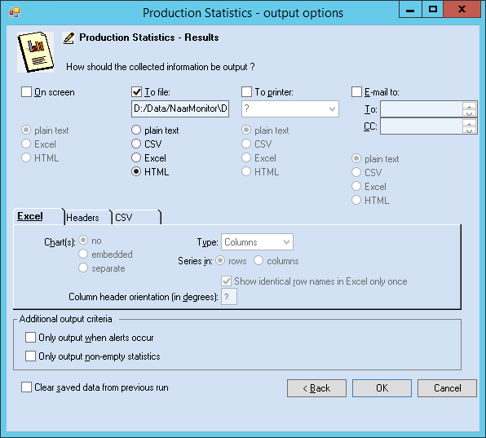
Document header:
Turnaround time overruns per Specimen

Turnaround time overruns per Stations
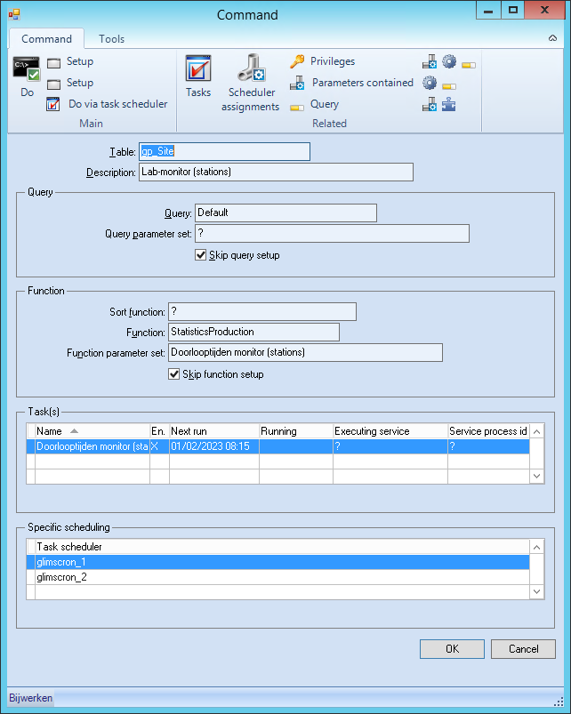

Function setup:
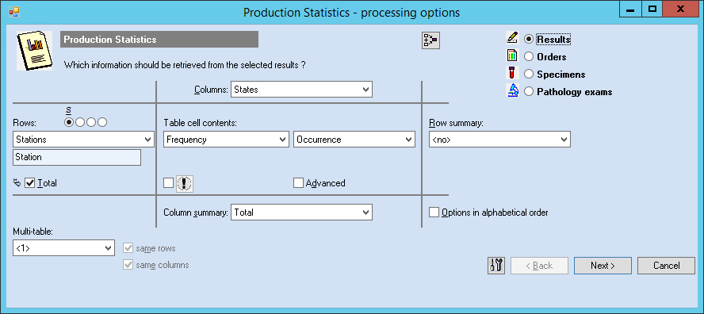

Filter mispl:
Same filter as with Specimens.
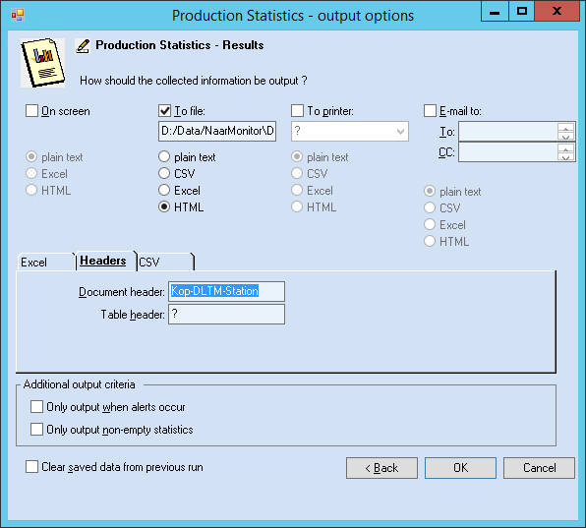
Document header:
Turnaround time overruns per Station

QC alarms
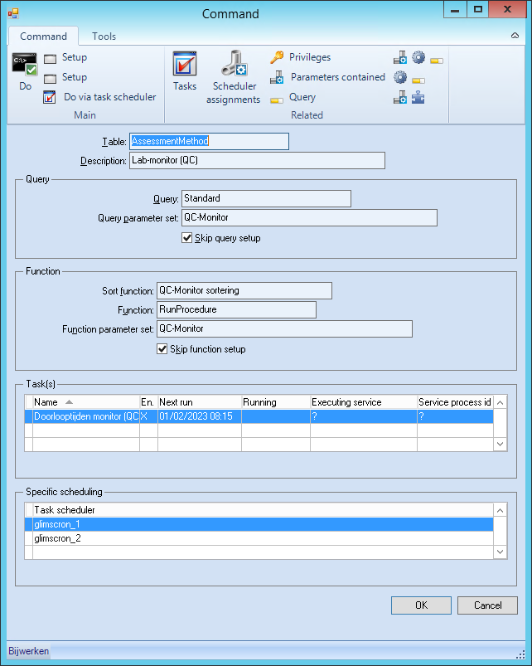

Query setup:
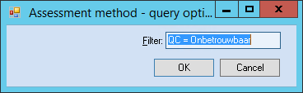
Filter mispl:
RETURN .Quality = 1;

Function setup:
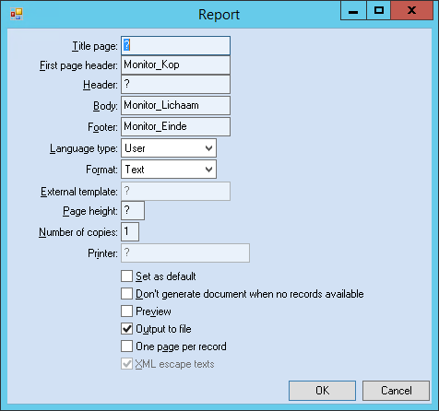
Header mispl:
<HTML>
<HEAD>
<TITLE>QC-Monitor</TITLE>
<META HTTP-EQUIV="refresh" CONTENT="60">
<!-- commentaar: het getal hierboven betekent verversen in ... sec. -->

{:
String Header ;

Header := "<CENTER><FONT size = +2 color=""#000080""><B> QC alarms </CENTER></B><BR>";
Return Header ;
}
</HEAD>
<BODY>

Body mispl:
<TABLE border="0" width="100%">
<TR align="left">

{:
String UitvoerStr;
Result QCrslt;
QClot QCcontr;

QCrslt := .FirstQCAlarm;
QCcontr := QCrslt.QCPopulation.Lot;

UitvoerStr := "";

IF (QCrslt <> ?) AND (QCcontr <> ?) THEN
UitvoerStr := IfKnownString(DateTimeToString(QCrslt.AvailabilityTime, "%d-%m-%Y %H:%M") + " ") + "<B><FONT color=""red"">" + IfKnownString(QCcontr.Material.Mnemonic) + IfKnownString(" (" + QCcontr.LotNumber + ") ") + "</FONT>";
Else
UitvoerStr := IfKnownString(DateTimeToString(.LastUpdateTime, "%d-%m-%Y %H:%M")) + "<B><FONT color=""red"">" + IFKnownString(" " + Replace(Replace(Strip(Replace(.QualityComment," ","_"),"<"),Chr(123),"("),Chr(125),") ")) + "</FONT>";
Endif;

UitvoerStr := "<TD width=""20%""><FONT size= ""+2""><B>" + .Station.Mnemonic + "</B></FONT></TD>" + "<TD width=""30%""><FONT size= ""+2""><B>" + .Property.Mnemonic + "</B></FONT></TD>" + "<TD width=""50%""><FONT size= ""+2"">" + UitvoerStr + "</B></FONT></TD>";

Return UitvoerStr ;
}

</TR>
</TABLE>

Footer mispl:
</BODY>
</HTML>

Moving Average (Now)
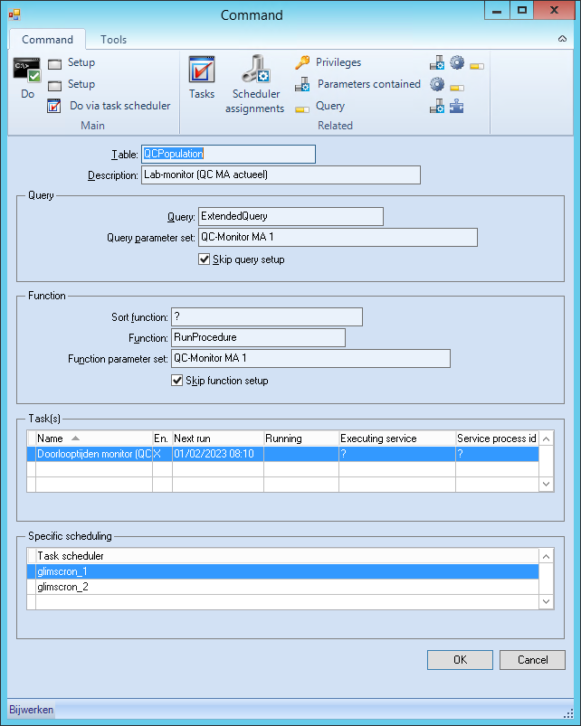

Query setup:
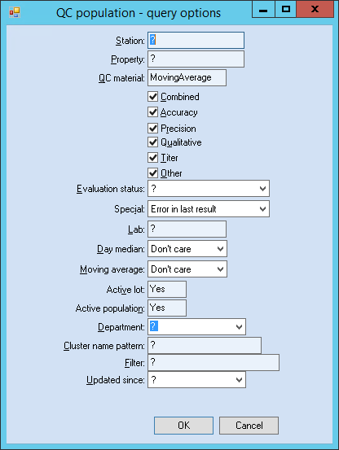

Function setup:
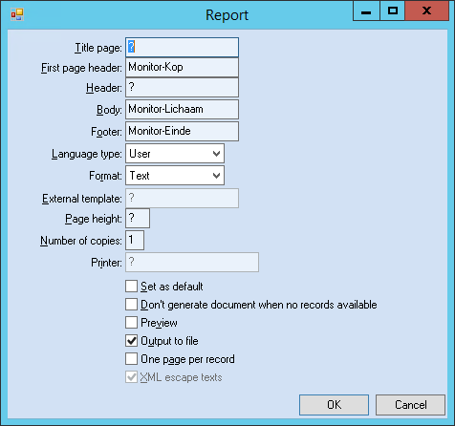
Header mispl:
<HTML>
<HEAD>
<TITLE>QC-Monitor</TITLE>
<META HTTP-EQUIV="refresh" CONTENT="60">
<!-- commentaar: het getal hierboven betekent verversen in ... sec. -->

{:
String Header ;

Header := "<CENTER><FONT size = +2 color=""#000080""><B> Moving Average </CENTER></B>" + "<BR>";

Return Header ;
}
</HEAD>
<BODY>

Body mispl:
<TABLE border="0" width="100%">
<TR align="left">

{:
String UitvoerStr;

UitvoerStr := "";

UitvoerStr := DateTimeToString(.LastUpdateTime, "%d-%m-%Y %H:%M ");

UitvoerStr := "<TD width=""40%""><FONT size= ""+2""><B>" + .AssessmentMethod.Station.Mnemonic + "</B></FONT></TD>" + "<TD width=""25%""><FONT size= ""+2""><B>" + "<FONT color=""red"">" + .AssessmentMethod.Property.Mnemonic + "</B></FONT></TD>" + "<TD width=""35%""><FONT size= ""+2"">" + UitvoerStr + "</FONT></TD>";

Return UitvoerStr ;
}

</TR>
</TABLE>

Footer mispl:
</BODY>
</HTML>

Moving Average (Today)
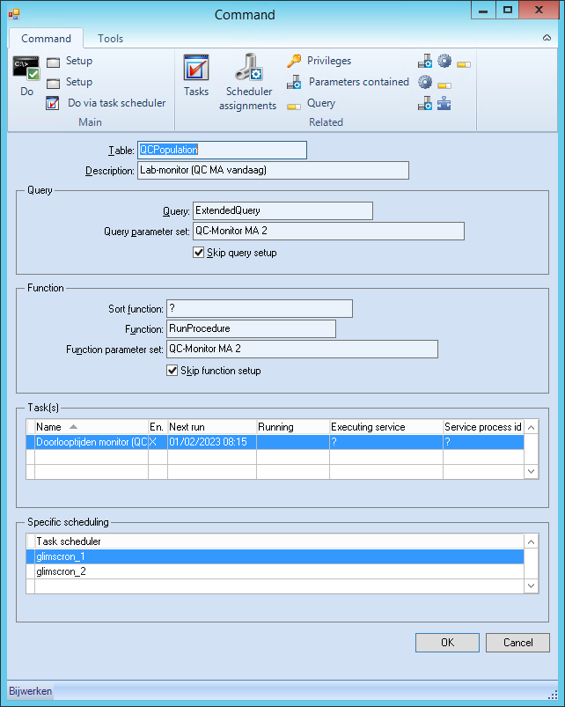

Query setup:
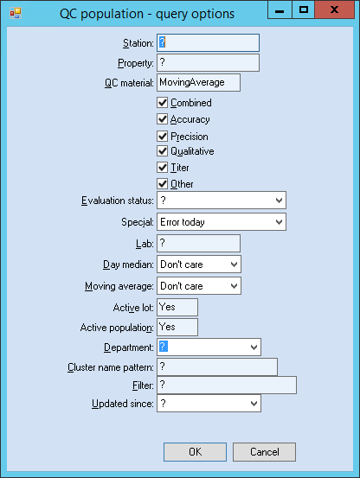

Function setup:
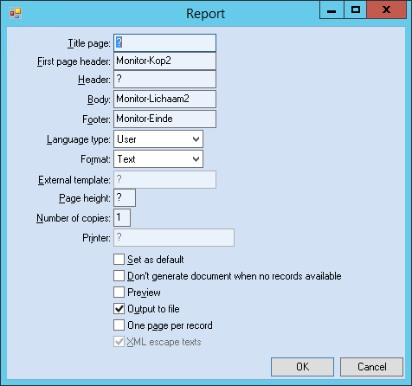

Header mispl:
<HTML>
<HEAD>
<TITLE>QC-Monitor</TITLE>
<META HTTP-EQUIV="refresh" CONTENT="60">
<!-- commentaar: het getal hierboven betekent verversen in ... sec. -->

{:
String Header ;

Header := "<CENTER><FONT size = +2 color=""#000080""><B> All MA alarms today </CENTER></B>" + "<BR>";

Return Header ;
}
</HEAD>
<BODY>

Body mispl:
<TABLE border="0" width="100%">
<TR align="left">

{:
String UitvoerStr;

UitvoerStr := "";

UitvoerStr := "<TD width=""40%""><FONT size= ""+2""><B>" + .AssessmentMethod.Station.Mnemonic + "</B></FONT></TD>" + "<TD width=""25%""><FONT size= ""+2""><B>" + "<FONT color=""red"">" + .AssessmentMethod.Property.Mnemonic + "</B></FONT></TD>" + "<TD width=""35%""><FONT size= ""+2"">" + UitvoerStr + "</FONT></TD>";

Return UitvoerStr ;
}

</TR>
</TABLE>

Footer mispl:
</BODY>
</HTML>

