Supplemental for the manuscript:

Elevated Hemolysis Index is strongly associated with
higher risk of cardiovascular diseases

Authors:
Charlotte Gils^{1,2}*, Dennis Lund Hansen^{2,3}*, Mads Nybo^{1,2}, Henrik Frederiksen^{2,3}

Affiliations:
¹ Department of Clinical Biochemistry, Odense University Hospital, Odense, Denmark
² Department of Clinical Research, University of Southern Denmark, Odense, Denmark
³ Department of Hematology, Odense University Hospital, Odense, Denmark

* Contributed equally to this manuscript
Methods
Hemolysis Index measurement
Pre-programmed mathematic formulas for the HI used the absorbance readings to calculate the HI values. The HI formula used for Architect is HI = Correction factor for sample dilution x (Constant for interfering substance x A500/524 nm + Constant for interfering substance x A572/604 nm + Constant for interfering substance x 628/660 nm + Constant for interfering substance x 524/804 nm) (18). Local verification of the HI analysis on Architect c8000/c16000 revealed an intra-serial imprecision from 0.3-1.2 % and intermediate imprecision of 0.6-3.0 % tested in the HI concentration range from 0.2 – 25.0 g/L. The highest intra-serial and intermediate imprecision was found for the lowest HI concentration of 0.2 g/L. Linear agreement between the HI analysis on Architect and the reference method for hemoglobin measurement was good (r² for linear regression: 0.99; regression equation: y = 1.03x + 0.19; 95 % CI for slope: 1.02 – 1.04 g/L, 95 % CI for intercept: -0.30 - -0.09 g/L) and no systematic bias for HI levels above 2 g/L was found (16).

Supplemental Table 1. ICD-10 diagnosis codes of cardiovascular events in a study of cardiovascular disease risk among persons with an elevated Hemolysis Index (HI⁺) in blood samples analyzed on chemistry equipment and age-sex matched comparators subjected to blood sampling and from the general population.
Grouping ICD-10 diagnosis codes from the Danish National Patient Register (DNRP)
Group | Disease | ICD-10
Arterial diseases | Acute myocardial infarction (AMI) | I21-I23
 | Overall stroke | I61, I63, I64
 | Ischemic stroke | I63
 | Peripheral arterial disease (PAD) | I702
Venous diseases | Venous thromboembolism (VTE) | I26, I80.1-I80.9
 | Splanchnic vein thrombosis (SVT) | I81, I82.0, K550H

Supplemental Table 2. ICD-10 diagnosis codes of comorbidity in a study of cardiovascular disease risk among persons with an elevated Hemolysis Index (HI⁺) in blood samples analyzed on chemistry equipment and age-sex matched comparators subjected to blood sampling and from the general population.
Grouping ICD-10 diagnosis codes from the Danish National Patient Register (DPNR)
Disease | ICD-10
HIV infection | B20-B24
Antiphospholipid syndrome | D686F, R768D
Alcohol related disease | E592A, F101-F109, G312, K700-K703, K709, L278A, =354, Q860, T500A, Z502, Z714
Atrial fibrillation | I48
Chronic pulmonary disease | J40-J67, J684, J701, J703, J841, J920, J961, J982-J983
Coagulopathy | D66, D67, D680, D681, D682, D689, D691, D693, D694
Congestive heart failure | I099, I110, I130, I132, I255, I420, I425, I426, I427, I428, I429, I43, I50, P290
Connective tissue disease | M05, M06, M08, M09, M30-M36, D86
Dementia | F00-F03, F051, G30, G311
Diabetes | E102-E108, E112-E118, E122-E128, E132-E138, E142-E148
Dyslipidemia | E780-E785
Hemiplegia | G114, G801, G802, G81, G82, G830, G831, G832, G833, G834, G839
Hypertension | I10-I15
Ischemic heart disease | I21-I23, I120.0, I24.9, I20, I25
Liver disease | B150, B160, B162, B190, I85, I864, I982, K704, K711, K72, K765, K766, K767
Renal disease | N00-N05, N07, N11, N14, N17-N19, N250, Q61, Z940, Z992
Obesity | E65-E68

Supplemental Table 3. Risk of arterial cardiovascular disease in a study of cardiovascular disease risk among persons with an elevated Hemolysis Index (HI⁺) in blood samples analyzed on chemistry equipment and age-sex matched comparators subjected to blood sampling and from the general population.
 | HI⁺ cohort  n = 43,102 | Blood sample comparator cohort  n = 186,544 | General population comparator cohort  n = 385,040
Numbers with arterial cardiovascular disease | 2.634 | 7.952 | 14.644
Cumulative incidence (%)
1 year | 2.58 [2.43;2.73] | 2.13 [2.06;2.20] | 1.02 [0.99;1.06]
5 years | 7.12 [6.84;7.41] | 5.75 [5.61;5.89] | 4.53 [4.45;4.61]
Cause-specific hazard ratio and hazard ratio
csHR (95% CI)  Unadjusted/adjusted | 1.27 [1.21;1.32] / 1.11 [1.06;1.16] | 1.00 [.;.] /  1.00 [.;.] | 0.71 [0.69;0.73] /  0.75 [0.73;0.77]
subHR (95% CI)  Unadjusted/adjusted | 1.22 [1.17;1.27] / 1.04 [1.00;1.09] | 1.00 [.;.] /  1.00 [.;.] | 0.74 [0.72;0.76] /  0.81 [0.78;0.83]
Abbreviations for Supplemental Table 3: csHR: Cause-specific hazard ratio; subHR: Subdistribuion hazard ratio

Supplemental Table 4. Risk of venous cardiovascular disease in a study of cardiovascular disease risk among persons with an elevated Hemolysis Index (HI⁺) in blood samples analyzed on chemistry equipment and age-sex matched comparators subjected to blood sampling and from the general population.
 | HI⁺ cohort  n = 43,102 | Blood sample comparator cohort  n = 186,544 | General population comparator cohort  n = 385,040
Numbers with venous cardiovascular disease | 967 | 2.924 | 4.755
Cumulative incidence (%)
1 year | 0.93 [0.85;1.03] | 0.81 [0.77;0.86] | 0.31 [0.29;0.32]
5 years | 2.59 [2.42;2.77] | 2.09 [2.01;2.17] | 1.50 [1.45;1.54]
Cause-specific hazard ratio and hazard ratio
csHR (95% CI)  Unadjusted/adjusted | 1.26 [1.17;1.35] / 1.15 [1.07;1.24] | 1.00 [.;.] /  1.00 [.;.] | 0.63 [0.63;0.65] /  0.65 [0.62;0.68]
subHR (95% CI)  Unadjusted/adjusted | 1.21 [1.12;1.30] / 1.09 [1.01;1.17] | 1.00 [.;.] /  1.00 [.;.] | 0.65 [0.62;0.68] /  0.69 [0.66;0.72]
Abbreviations for Supplemental Table 4: csHR: Cause-specific hazard ratio; subHR: Subdistribuion hazard ratio

Supplemental Figure 1. Box plots of HI readings for the HI⁺ cohort and blood sample comparator cohort
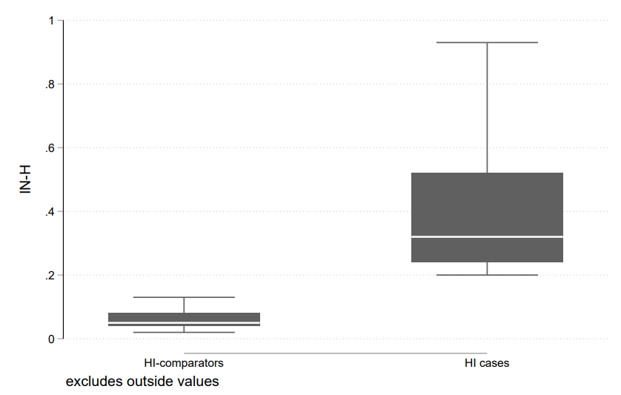

Supplemental Figure 2. The distribution of days between the measurements of twice increased HI
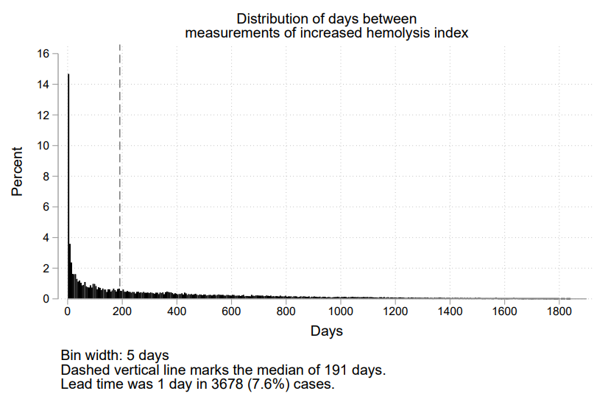

Supplemental Figure 3. Cumulative incidences of arterial cardiovascular disease in persons with increased Hemolysis Index (HI⁺) in blood samples analyzed on chemistry equipment and age-sex matched persons from the blood sample comparator cohort and the general population comparator cohort.

Supplemental Figure 4. Cumulative incidences of venous vascular disease in persons with an elevated Hemolysis Index (HI⁺) in blood samples analyzed on chemistry equipment and age-sex matched persons from the blood sample comparator cohort and the general population comparator cohort.

