**Supplementary Figure 1.** Cumulative diagnostic accuracy (Summary Receiver Operating Characteristic Curve; SROC), sensitivity and specificity (with 95% confidence interval; 95%CI) of seven laboratory-based SARS-CoV-2 Antigen immunoassays in respiratory samples.

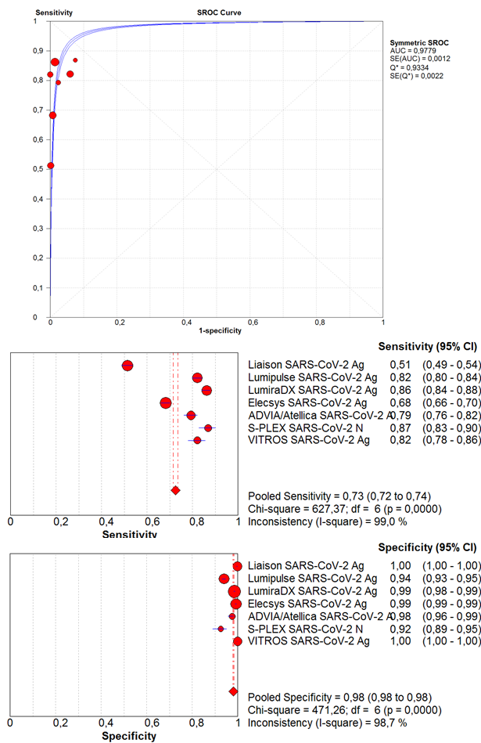

**Supplementary Figure 2.** Diagnostic sensitivity (with 95% confidence interval; 95%CI) of four laboratory-based SARS-CoV-2 Antigen immunoassays in high viral load respiratory samples.

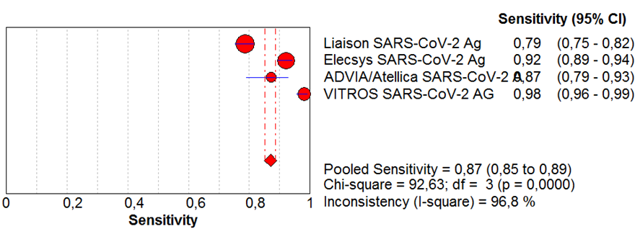

**Supplementary Table 1.** Description of the laboratory-based SARS-CoV-2 Antigen (Ag) immunoassays and meta-analyses included in this pooled analysis.

|  |  |  |  |  |  |
| --- | --- | --- | --- | --- | --- |
| **Method** | **Company** | **Technique** | **Studies** | **Samples** | **Cut-off** |
| Liaison SARS-CoV-2 Ag | DiaSorin | CLIA | 11 | 4449 | 200 TCID50/mL |
| Lumipulse SARS-CoV-2 Ag | Fujirebio | CLIA | 12 | 5109 | 1.34 pg/mL |
| LumiraDX SARS-CoV-2 Ag | LumiraDx | FIA | 11 | 8527 | 32 TCID50/mL |
| Elecsys SARS-CoV-2 Ag | Roche | CLIA | 11 | 6130 | AT ≥1.0 |
| ADVIA/Atellica SARS-CoV-2 Ag | Siemens | CLIA | 4 | 1310 | AT ≥1.0 |
| S-PLEX SARS-CoV-2 N | Meso Scale Discovery | CLIA | 4 | 657 | 0.32 pg/mL |
| VITROS SARS-CoV-2 Ag | Ortho | CLIA | 5 | 2734 | AT ≥1.0 |

*AT, arbitrary threshold; CLIA, chemiluminescent immunoassay; FIA, immunoassay fluorescence*