Supplemental Materials

Supplemental Table 1: Drug interference with the prototype SARS-CoV-2 antigen ARCHITECT immunoassay
Active Ingredient | Mean S/C |  |  |  | 2-sided 95% CI
Active Ingredient | NEG SMP (w/o Drug) | NEG SMP (w/ Drug) | POS SMP (w/o Drug) | POS SMP (w/ Drug) | NEG SMP (Upper Limit) | POS SMP (Lower Limit)
Menthol/benzocaine | 0.06 | 0.07 | 2.21 | 2.36 | 0.01 | 0.4
Sodium chloride | 0.06 | 0.06 | 2.08 | 2.27 | 0.00 | 6.9
Phenylephrine hydrochloride | 0.06 | 0.06 | 2.36 | 2.16 | 0.00 | -10.7
Oxymetazoline | 0.06 | 0.06 | 2.07 | 2.41 | 0.00 | 13.4
Cromolyn sodium | 0.06 | 0.06 | 2.29 | 2.34 | 0.00 | -0.2
Zincum gluconium | 0.06 | 0.07 | 2.31 | 2.15 | 0.01 | -8.4
Alkalol | 0.06 | 0.05 | 2.20 | 2.13 | -0.01 | -4.7
Fluticasone furoate | 0.06 | 0.07 | 2.22 | 2.18 | 0.01 | -3.6
Phenol | 0.06 | 0.05 | 2.29 | 2.07 | -0.01 | -11.5
Tobramycin | 0.06 | 0.06 | 2.03 | 2.17 | 0.00 | -5.6
Mupirocin | 0.06 | 0.07 | 2.23 | 2.03 | 0.01 | -10.7
Oseltamivir phosphate | 0.06 | 0.06 | 2.19 | 2.31 | 0.00 | 4.8
NEG SMP, negative specimen pool + BD UTM + inactivator; POS SMP, positive specimen pool + BD UTM + inactivator (~10k RLUs); S/C, signal-to-cutoff ratio.
Cutoff specimen was calibrator diluent at 6.5 pg/mL (~5k RLUs).

Supplemental Table 2: Long-term storage (90 days) of positive specimens at -20°C does not affect detection by prototype SARS-CoV-2 antigen ARCHITECT immunoassay
Specimen | Baseline S/C | Day 90 S/C | S/C % Difference
1 | 30.5 | 30.6 | 0.0
2 | 419.2 | 457.7 | 9.2
3 | 2.3 | 2.2 | -4.3
4 | 8.0 | 8.6 | 7.5
5 | 101.8 | 99.0 | -2.8
6 | 9.3 | 9.5 | 2.2
7 | 78.5 | 82.4 | 5.0
S/C, signal-to-cutoff ratio.

Supplemental Table 3: Clinical performance of the prototype SARS-CoV-2 antigen ARCHITECT immunoassay compared to the Roche Elecsys SARS-CoV-2 Ag immunoassay for nasopharyngeal specimens (see also Figure 3) [7]
 | Abbott ARCHITECT |  |  |  |  | Roche Elecsys
 |  | Instrument 1 |  | Instrument 2 |  | Cobas
Ct | N | Reactive (n) | Sensitivity (%) | Reactive (n) | Sensitivity (%) | N | Reactive (n) | Sensitivity (%)
<26 | 88 | 87 | 98.86 | 87 | 98.86 | 163 | 163 | 100.00
<27 | 90 | 89 | 98.89 | 89 | 98.89 | 178 | 177 | 99.40
<28 | 100 | 96 | 96.00 | 95 | 95.00 | 189 | 185 | 97.90
<29 | 107 | 103 | 96.26 | 101 | 94.39 | 204 | 198 | 97.10
<30 | 113 | 106 | 93.81 | 103 | 91.15 | 226 | 209 | 92.50
<31 | 119 | 107 | 89.92 | 104 | 87.40 | 243 | 221 | 90.90
<32 | 125 | 108 | 86.40 | 105 | 84.00 | 258 | 224 | 86.80
<33 | 127 | 108 | 85.04 | 105 | 82.68 | 270 | 229 | 84.80
<34 | 131 | 108 | 82.44 | 105 | 80.15 | 288 | 234 | 81.30
<35 | 142 | 109 | 76.76 | 106 | 74.65 | 308 | 235 | 76.30
Overall | 150 | 109 | 72.67 | 106 | 70.67 | 390 | 236 | 60.50

Supplemental Figure 1: Loss of S/C over time in specimens stored at 5°C or room temperature is similar for the prototype SARS-CoV-2 antigen immunoassay run on the ARCHITECT instrument and the Access SARS-CoV-2 Antigen Assay run on the Beckman Access 2 instrument. (A) rAg spiked in negative patient specimen matrix or (B,C) positive patient specimens at 1X, 4X, or 50X S/C (based on S/C of calibrator diluent of 6.5 RLUs) were stored for the indicated times and at the indicated temperatures, and run on the ARCHITECT (solid lines) or Beckman Access 2 (dashed lines).
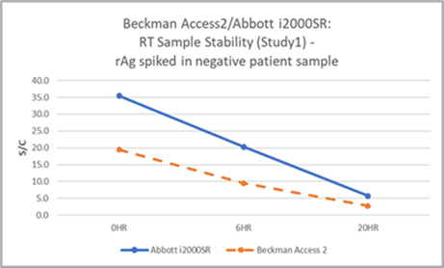
A

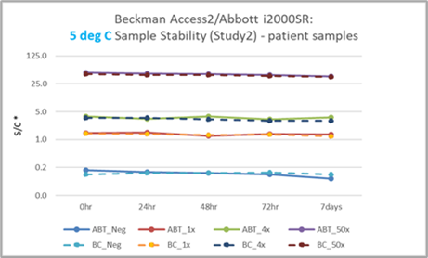
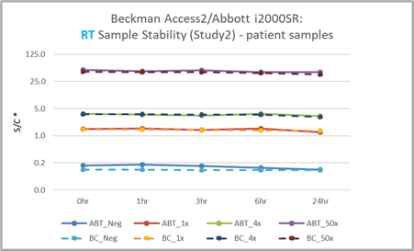
C
B

Supplemental Figure 2: Stability of individual and pooled positive patient nasal and nasopharyngeal specimens in UTM handled and stored under various conditions. Specimens were inactivated before or after storage at 2-5°C or -80°C. Frozen samples were thawed and all samples were stored at room temperature (15-30°C) for up to 24 hours, then assayed on the prototype SARS-CoV-2 antigen ARCHITECT immunoassay. (A) S/C % difference from baseline, with a loss of 20% indicating instability (red line). (B) S/C at each indicated RT storage timepoint and condition, with S/C ≥1.00 indicating a positive result. F/T, freeze/thaw; S/C signal-to-cutoff ratio.
A
B
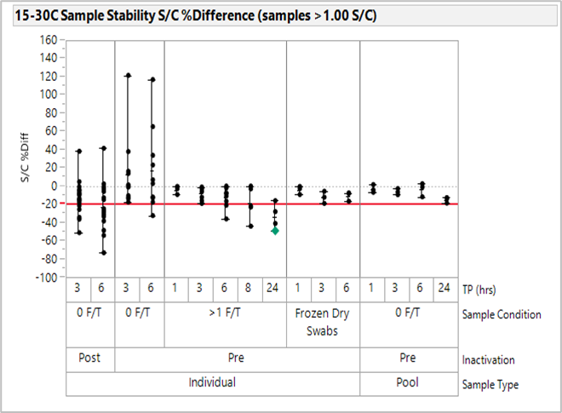
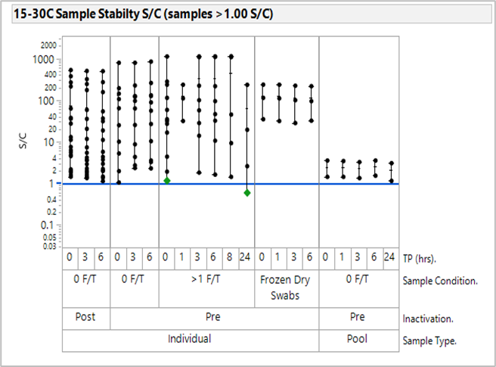

Supplemental Figure 3: Clinical performance of the prototype SARS-CoV-2 antigen ARCHITECT immunoassay run on two ARCHITECT instruments. Negative and positive patient nasopharyngeal specimens with known viral loads as reported by the vendor (Cerba Research; using the PerkinElmer® SARS-CoV-2 Real-time RT-PCR Assay run on the BioRad CFX384 instrument) were tested in duplicate across two ARCHITECT i2000SR instruments using three calibrator lots.
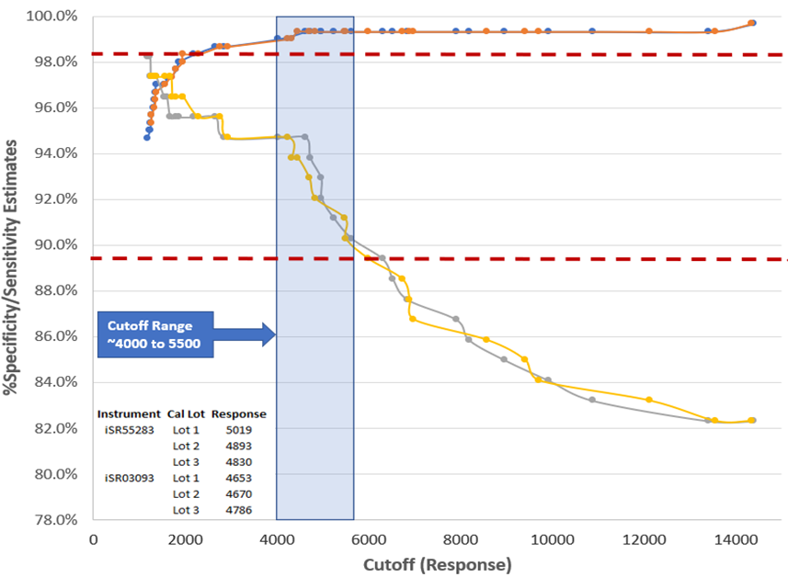
ARCHITECT Instrument 1

ARCHITECT Instrument 2
Sensitivity ≥89.5%
Specificity ≥98.5%

