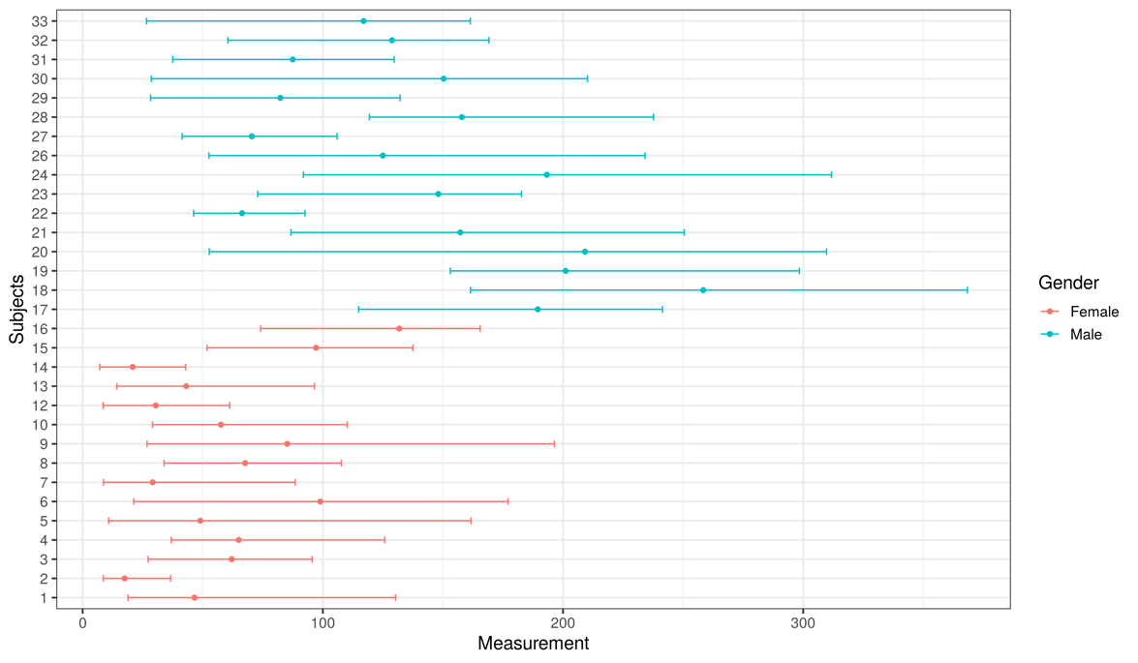

Figure 1. Distribution of creatinine concentrations (mg/dL) for individuals based on weekly samplings for 10 weeks.

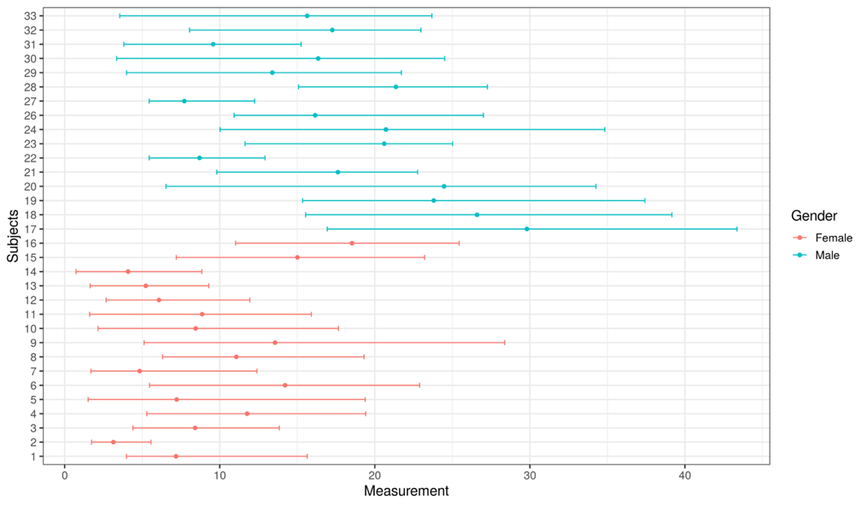

Figure 2. Distribution of urea concentrations (g/L) for individuals based on weekly samplings for 10 weeks.

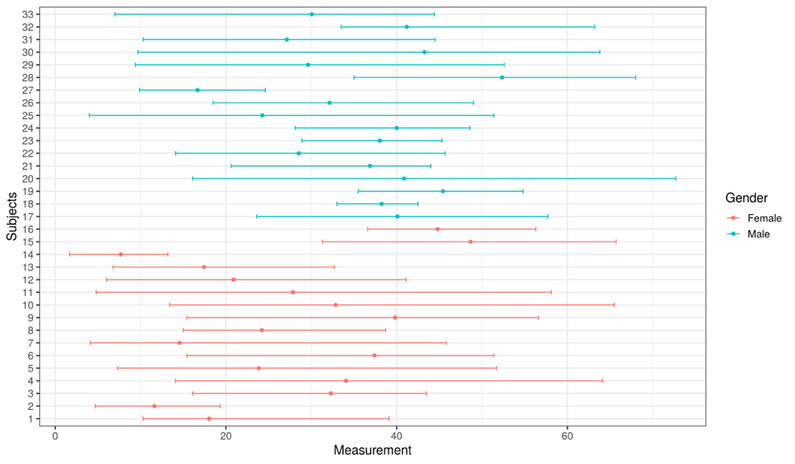

Figure 3. Distribution of uric acid concentrations (mg/dL) for individuals based on weekly samplings for 10 weeks.

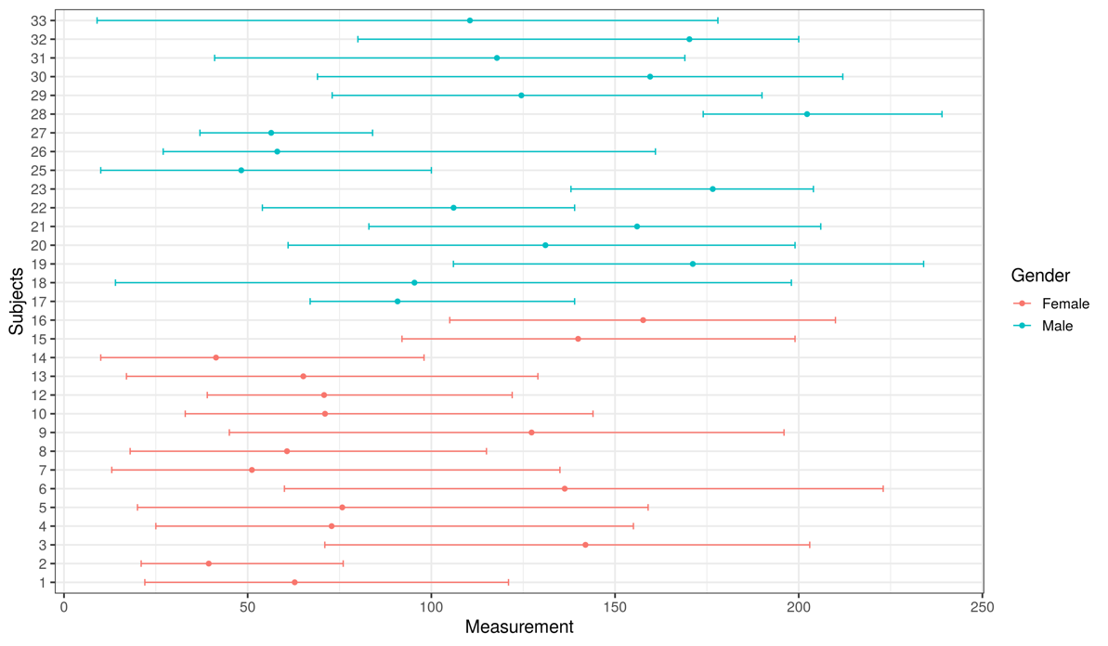

Figure 4. Distribution of sodium concentrations (mmol/L) for individuals based on weekly samplings for 10 weeks.

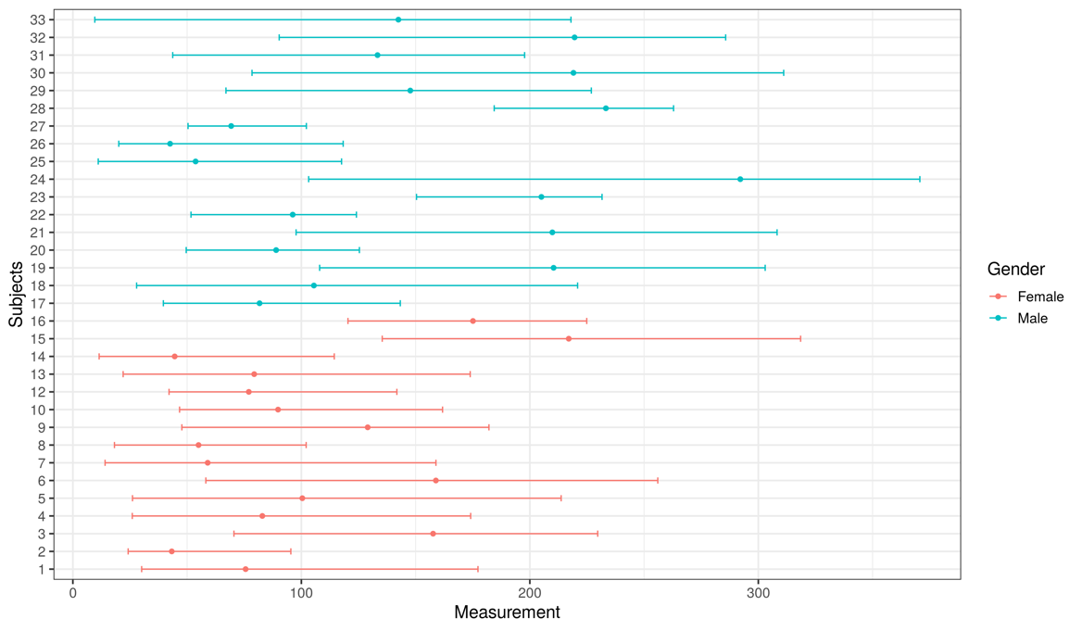

Figure 5. Distribution of chloride concentrations (mmol/L) for individuals based on weekly samplings for 10 weeks.

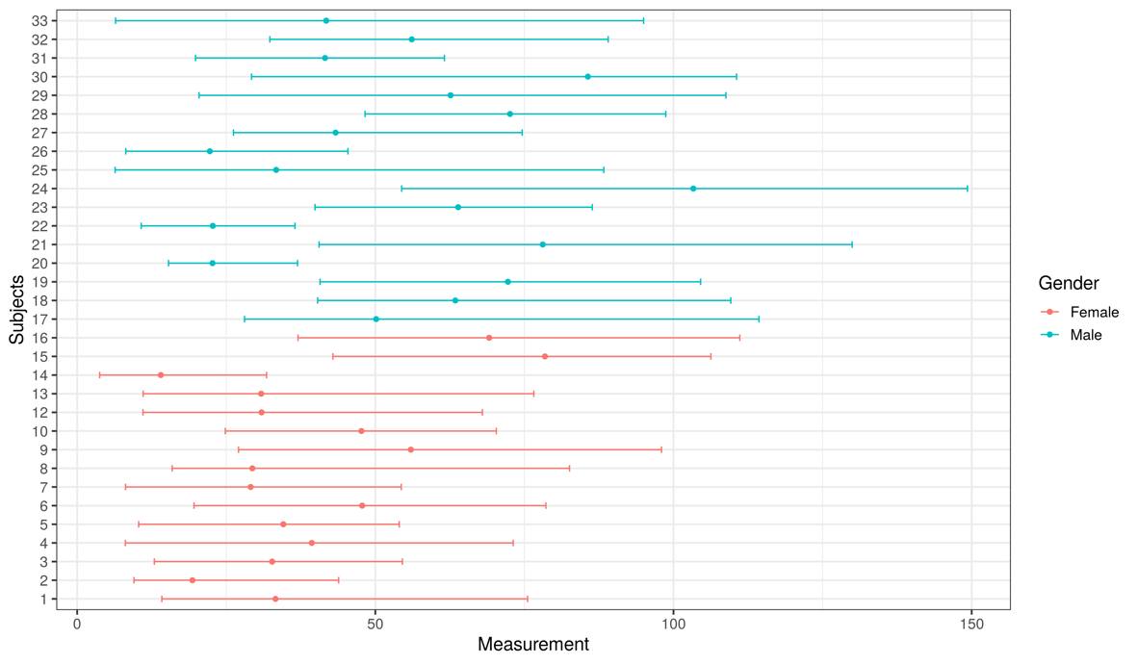

Figure 6. Distribution of potassium concentrations (mmol/L) for individuals based on weekly samplings for 10 weeks.

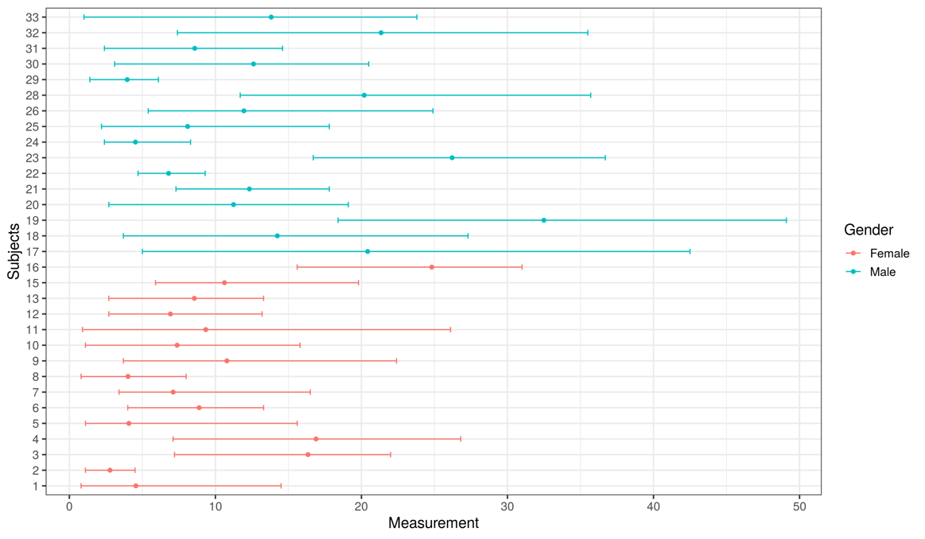

Figure 7. Distribution of calcium concentrations (mg/dL) for individuals based on weekly samplings for 10 weeks.

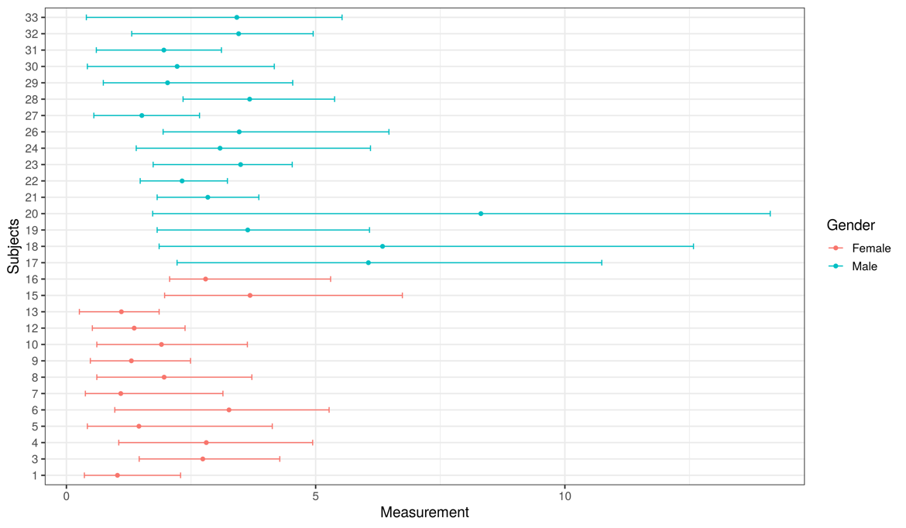

Figure 8. Distribution of magnesium concentrations (mmol/L) for individuals based on weekly samplings for 10 weeks.

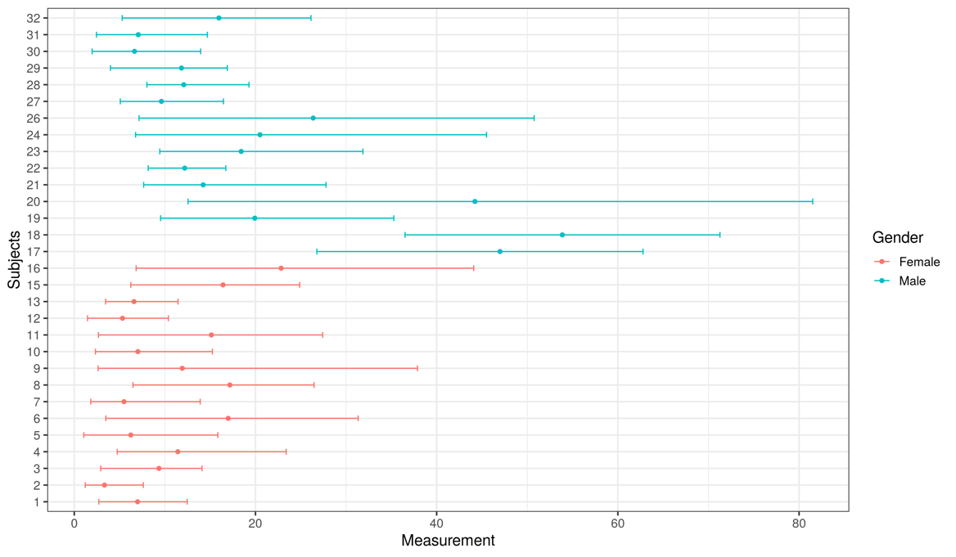

Figure 9. Distribution of phosphate concentrations (mmol/L) for individuals based on weekly samplings for 10 weeks.

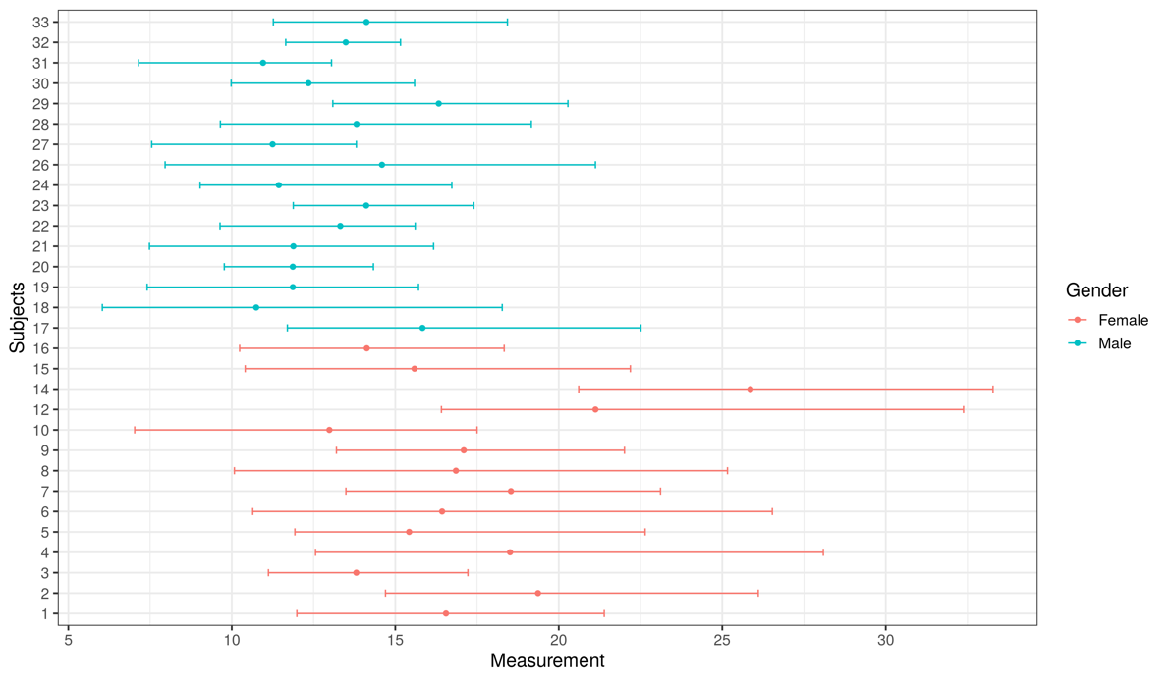

Figure 10. Distribution of urea/creatinine ratio (g/g creatinine) for individuals based on weekly samplings for 10 weeks.

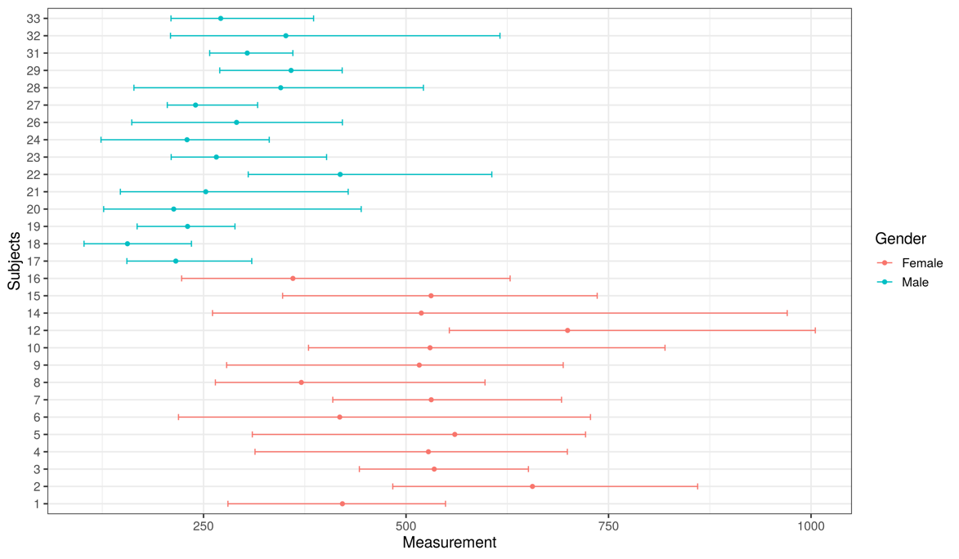

Figure 11. Distribution of uric acid/creatinine ratio (mg/g creatinine) for individuals based on weekly samplings for 10 weeks.

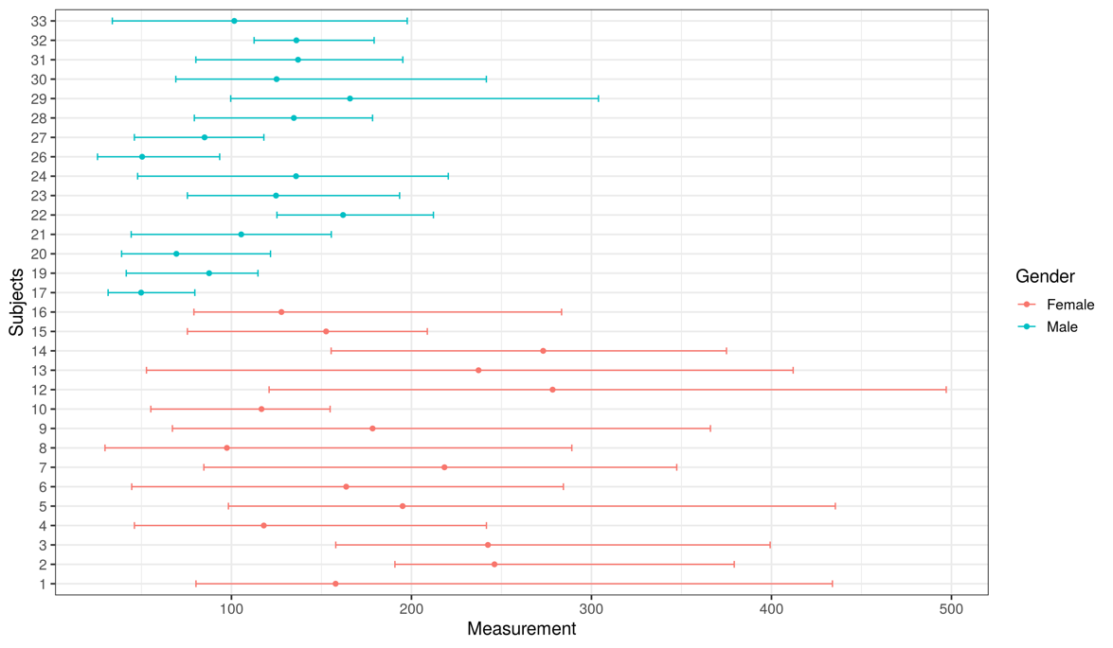

Figure 12. Distribution of sodium/creatinine ratio (mmol/g creatinine) for individuals based on weekly samplings for 10 weeks.

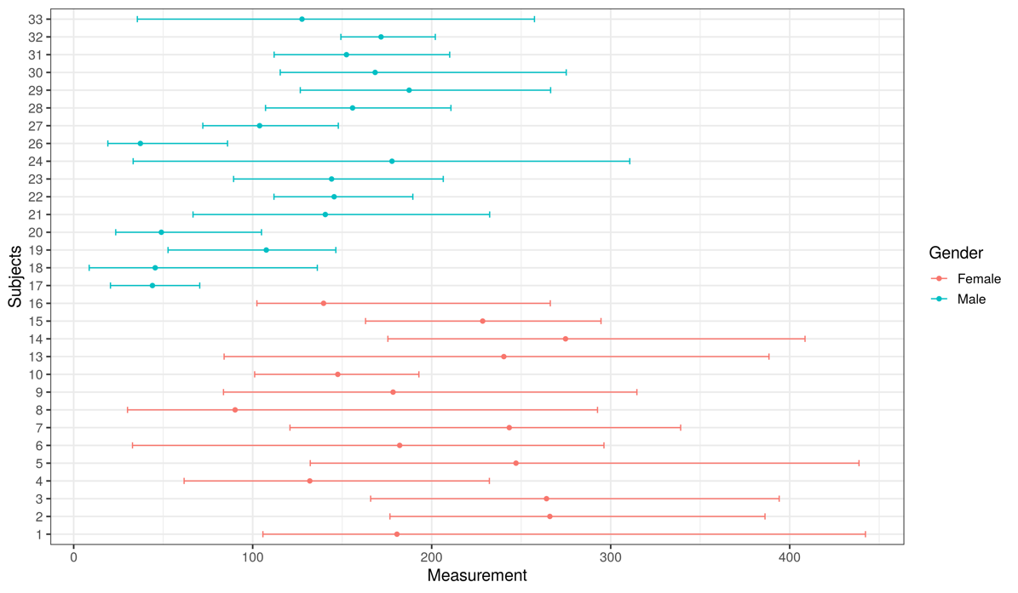

Figure 13. Distribution of chloride/creatinine ratio (mmol/g creatinine) for individuals based on weekly samplings for 10 weeks.

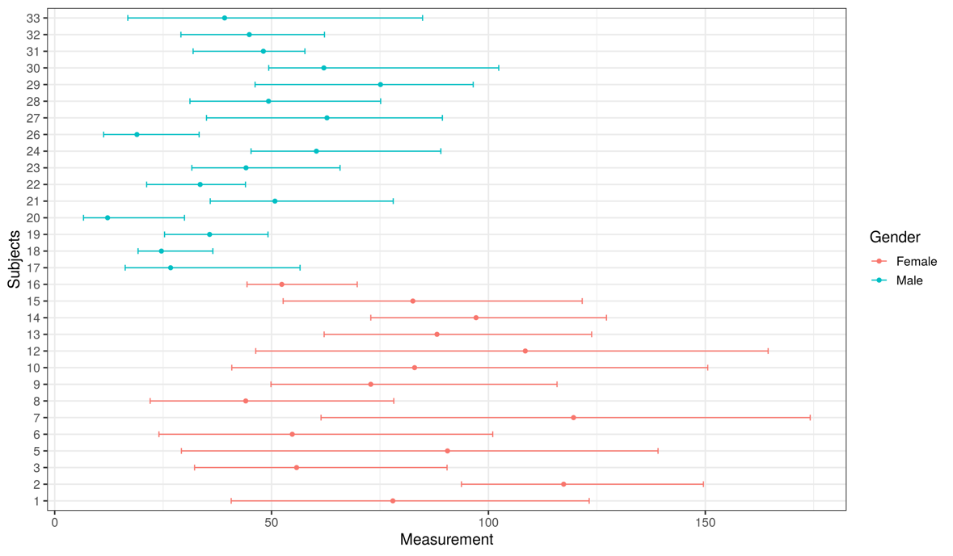

Figure 14. Distribution of potassium/creatinine ratio (mmol/g creatinine) for individuals based on weekly samplings for 10 weeks.

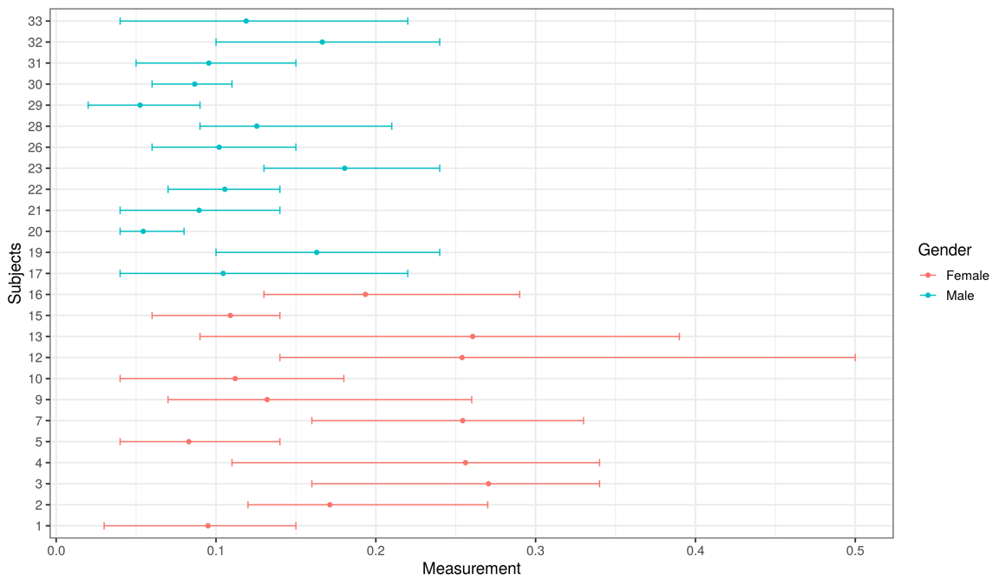

Figure 15. Distribution of calcium/creatinine ratio (mg/mg creatinine) for individuals based on weekly samplings for 10 weeks.

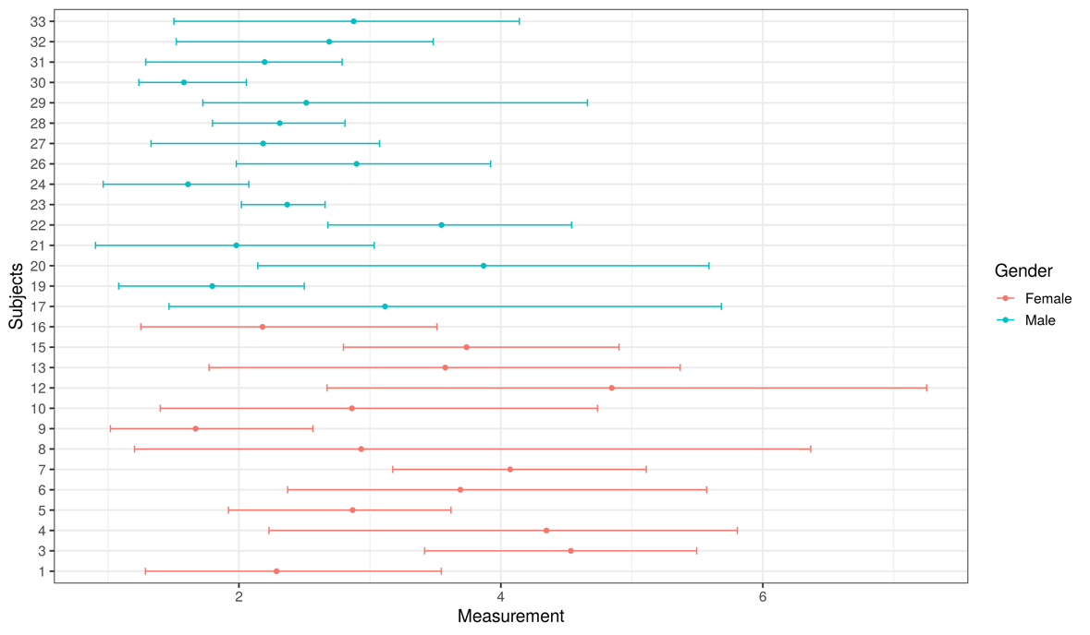

Figure 16. Distribution of magnesium/creatinine ratio (mmol/g creatinine) for individuals based on weekly samplings for 10 weeks.

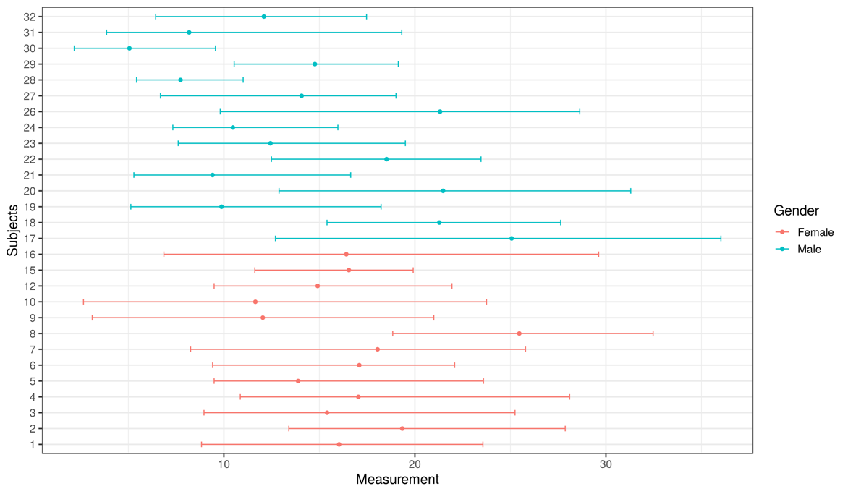

Figure 17. Distribution of phosphate/creatinine ratio (mmol/g creatinine) for individuals based on weekly samplings for 10 weeks.