SUPPLEMENTAL MATERIAL 2

An isotope dilution-liquid chromatograph-tandem mass spectrometry (ID-LC-MS/MS)-based candidate reference measurement procedure for the quantification of topiramate in human serum and plasma

Linda Salzmannª, Tino Speschaª, Neeraj Singh^{b}, Anja Kobelª, Vanessa Fischer^{b}, Tobias Schierscherª, Friederike Bauland^{c}, Andrea Geistanger^{b}, Lorenz Rischª, Christian Geletneky^{b}, Christoph Segerª, Judith Taibon^{b}*

ªDr. Risch Ostschweiz AG, Lagerstrasse 30, 9470 Buchs, Switzerland
^{b}Roche Diagnostics GmbH, Nonnenwald 2, 82377 Penzberg, Germany
^{c}Chrestos Concept GmbH & Co. KG, Girardestaße 1–5, 45131 Essen, Germany

* Corresponding author:
Judith Taibon, PhD, Nonnenwald 2, 82377 Penzberg, Germany
Phone: +49 8856 6012941
E-mail: judith.taibon@roche.com

Characterization of reference material by quantitative nuclear magnetic resonance (qNMR) measurements

Quantitative nuclear magnetic resonance (qNMR) measurements were performed in six replicates using the International System of Units (SI units) traceable internal standard (ISTD) for the quantification of the absolute content of topiramate.

The following formula was utilized to calculate the absolute content of topiramate:

$$P_{x}=\frac{I_{x}*N_{std}*M_{x}*m_{std}}{I_{std}*N_{x}*M_{std}*m_{x}}*P_{std}$$

P_{x} : Purity of the analyte (topiramate) as mass fraction
P_{std} : Purity of the internal qNMR standard as mass fraction
I_{x} : Integral of the analyte (topiramate)
I_{std} : Integral of the internal standard
N_{x} : No. of analyte (topiramate) protons
N_{std} : No. of internal qNMR standard protons
M_{x} : Molecular weight of the analyte (topiramate)
M_{std} : Molecular weight of the qNMR internal standard
m_{x} : Mass of analyte (topiramate)
m_{std} : Mass of qNMR internal standard

The following values are common to all the qHNMR measurements:
Molecular Weight of topiramate = 339.362 g/mol; Molecular weight of the qNMR internal standard ISTD (Duroquinone = 164.2011 g/mol; Purity of the qNMR internal standard as mass fraction = 99.71 ± 0.17% (k = 2); Number of Protons taken into account for the ISTD = 12 and for topiramate = 2; Integral of Topiramate proton = 2.

Procedure for sample preparation and processing parameter:
Topiramate and the qNMR standard were weighed (Supplemental Table 1) together in a glass vial on an Ultra-microbalance (XPR6U), from Mettler Toledo. CD₃OD (approx. 700 µL) was added to the glass vial, and after a short vortexing, the solution was transferred to a 5 mm NMR tube. The NMR measurements were performed on a JEOL 600 MHz NMR spectrometer (Jeol Ltd, Tokyo, Japan) equipped with an ultra-cool probe head, which provides 4-5 times sensitivity enhancement compared to normal room-temperature probe heads. NMR measurements were performed at 298K/300K utilizing 64k data points and the number of scans were limited to 64 with automatic receiver gain conditions. Processing was performed with an exponential window function (line broadening = 0.3 Hz), followed by manual phase and baseline corrections.

Supplemental Table 1: qNMR calculation of the purity of topiramate (source Sigma).
Measurement No. | Mass of topiramate weighed (mx, mg) | Mass of qNMR ISTD weighed (mstd, mg) | Integral of the qNMR ISTD (Istd) | Purity of topiramate as mass fraction (Px) %
1 | 4.6598 | 2.0146 | 10.7797 | 99.18
2 | 5.8777 | 1.6650 | 7.0476 | 99.40
3 | 6.1795 | 1.7235 | 6.9479 | 99.27
4 | 6.2573 | 1.7203 | 6.8583 | 99.13
5 | 6.0518 | 1.5290 | 6.3032 | 99.12
6 | 5.8390 | 1.6369 | 6.9945 | 99.11

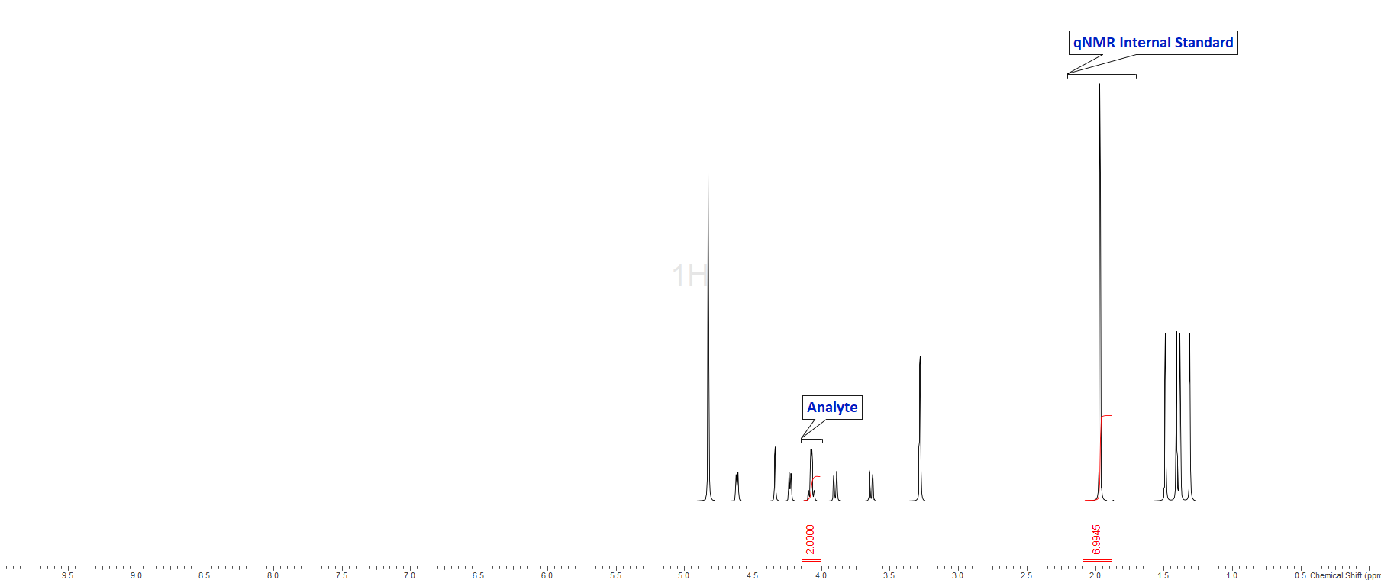

Supplemental Figure 1: qNMR spectrum indicating the resonance utilized for the quantification of topiramate.

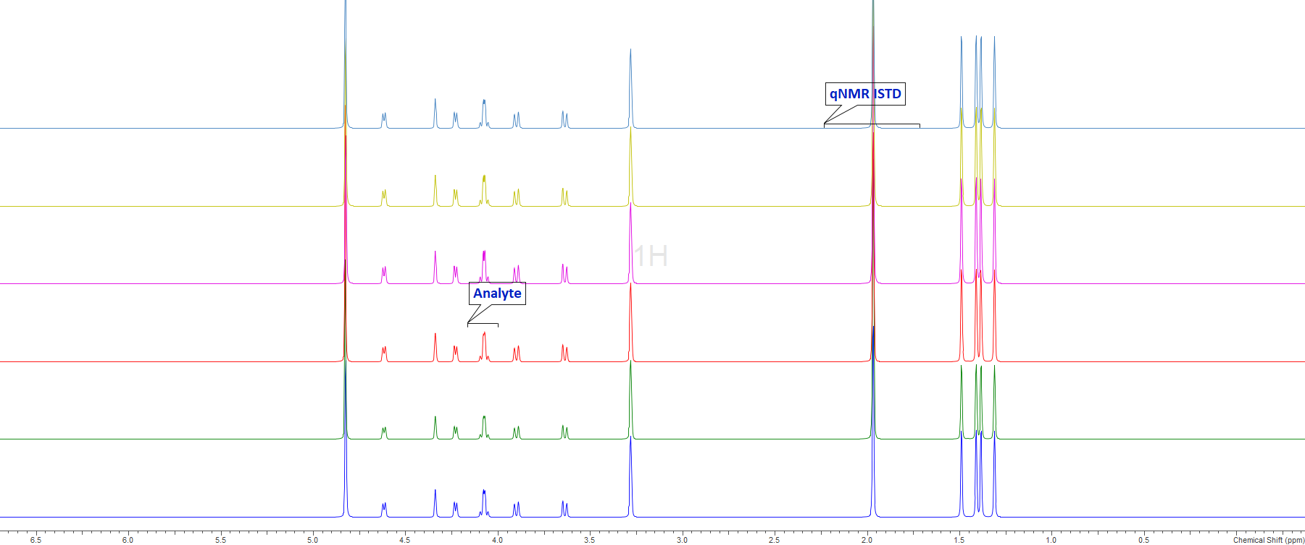
Supplemental Figure 2: Overlay of the 6 spectra acquired under the afore-mentioned quantitative conditions.

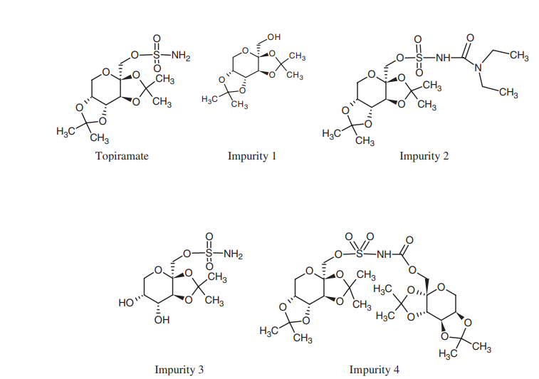
Supplemental Figure 3. Structure of Topiramate and the relevant impurities (Figure adapted from the manuscript of A Biro et al.[S1]*

Supplemental reference:

[S1]* A. Biro et al., High-Performance liquid chromatographic study of topiramate and its impurities. Chromatographia, 2006, 137‒141.

