**Supplementary material**

Development of a candidate reference measurement procedure by ID-LC-MS/MS for total tau protein measurement in cerebrospinal fluid (CSF).

Chiara Giangrande1*, Hélène Vaneeckhoutte1, Amandine Boeuf1, Béatrice Lalere1, Christophe Hirtz2, Sylvain Lehmann2, Milena Quaglia3, Vincent Delatour1

1 Laboratoire National de Métrologie et d’Essais (LNE), Department of Biomedical and Organic Chemistry, Paris, France

2 LBPC-PPC, Univ Montpellier, IRMB CHU Montpellier, INM INSERM, Montpellier, France

3 LGC, Teddington, UK

**\*Corresponding author:** Phone: +33 (0) 140433971; Email: [chiara.giangrande@lne.fr](mailto:chiara.giangrande@lne.fr)

Supplementary material: 1 document/3 tables/4 figures

**Table of content:**

Document S1: Measurement equation and uncertainty estimation for the determination of t-tau concentration in CSF samples. p.3

Table S1: Transitions monitored for all eleven peptides in the t-tau method. For each peptides, three transitions are monitored and their sum is used for the quantification of t-tau. p.5

Table S2: Bias and precision calculated on the results obtained from the six calibration curves for each of the five calibration blends. The t-tau nominal concentration is the mean value for the six replicates of the calibration blend. The bias is the mean deviation to theoretical value, calculated on each of the six replicates of the calibration blend. The precision is calculated as the coefficient of variation of the t-tau concentration obtained on the six different calibration curves. p.6

Table S3: t-tau concentration of the three CSF pools obtained by the ID-LC-MS/MS procedure and by IA, calculation of the intra-day and inter-day precision (CV%) and estimation of the uncertainty for the ID-LC-MS/MS method. p.7

Figure S1: Results of the time-course experiment on the ratio of the area of the 156-163 peptide (GAAPPGQK) to the labelled peptide (GAAPPGQK*). Results on the ratio show that after 2-hour of trypsin digestion, the ratio is enough to reach steadiness, confirming that the presence of the labelled protein internal standard ensures to get rid of digestion incompleteness and sample preparation steps, since both labelled and unlabelled proteins behave similarly during sample preparation and digestion. A digestion time of 18 hours was selected to reach complete release of the peptide of interest thus increasing methods sensitivity. p.8

Figure S2: Full chromatogram showing the intensities of the eleven peptides included in the method. p.9

Figure S3: Calibration curves for all eleven peptides included in the t-tau method. Results of six independent sets of calibration blends are gathered to create these curves. p.10

Figure S4: Comparison between the chromatographic peaks obtained for each of the eleven peptides monitored on the t-tau method in the calibration blend with a ratio r-tau/r-tau* around one (recombinant tau) and in a CSF sample (endogenous tau). p.11

**Document S1**: Measurement equation and uncertainty estimation for the determination of t-tau concentration in CSF samples.

A 5-point linear calibration model was constructed by plotting the ratio between the amounts of substance of r-tau and r-tau* of the calibration blends (Qcalibrator, obtained from weighing) to the ratio between the peak areas of the peptide 156-163 (GAAPPGQK) and its labelled counterpart (GAAPPGQK*) (Rcalibrator). For t-tau quantification in the samples (QCs and CSF pools), peak area ratio Rsample was calculated and amount of substance ratio Qsample was derived from the linear regression model. The concentration of t-tau in the samples C*t-tau* was then determined by taking into account the amount of r-tau* solution added to the sample m*spike* and the mass of sample m*s*.

The standard measurement uncertainty associated with the concentration of t-tau in the samples (usample) was determined using the GUM approach [21] by taking into account uncertainties associated with the mass of sample u(m*s*), the amount of r-tau* solution added to the sample u(m*spike*) and the uncertainty associated with calibration u(Q), which combines u(Q*lin*) and u(Q*cal*) according to the following equation:

$$u\left(Q\right)=\sqrt{{\left(\frac{u(Q_{lin})}{Q_{lin}}\right)}^{2}+{u(Q_{cal})}^{2}}$$

where,

u(Q*lin*): standard uncertainty associated with the amount of substance ratio calculated through the calibration regression model (linearity of the calibration curve).

u(Q*cal*): standard uncertainty associated with the gravimetric preparation and value assignment of the calibration blends, which includes i) weighing of r-tau and r-tau* and ii) determination of the r-tau concentration by AAA.

Standard uncertainty of t-tau mass fraction u(C*t-tau*) includes a precision component (u*rep*), which corresponds to the standard deviation of the mass fraction values divided by the square root of the number of independent replicates.

$$u(C_{t-tau})=\sqrt{{u_{sample}}^{2}+{u_{rep}}^{2}}$$

**Table S1**: Transitions monitored for all eleven peptides in the t-tau method. For each peptides, three transitions are monitored and their sum is used for the quantification of t-tau.

|  |  |  |  |  |
| --- | --- | --- | --- | --- |
| **Peptide** | **Precursor**  **(m/z)** | **Fragment 1**  **(m/z)** | **Fragment 2**  **(m/z)** | **Fragment 3**  **(m/z)** |
| TPPAPK | 305.6816++ | 171.1128+ [a2] | 255.1577++ [y5] | 199.1077+ [b2] |
| VQIINK | 357.7291++ | 487.3239+ [y4] | 228.1343+ [b2] | 615.3824+ [y5] |
| GAAPPGQK | 363.2007++ | 526.2984+ [y5] | 299.1714++ [y6] | 263.6528++ [y5] |
| IGSTENLK | 431.2374++ | 748.3836+ [y7] | 691.3621+ [y6] | 171.1128+ [b2] |
| TPPSSGEPPK | 498.7535++ | 798.3992+ [y8] | 448.2296++ [y9] | 399.7032++ [y8] |
| LDLSNVQSK | 502.2746++ | 775.4308+ [y7] | 229.1183+ [b2] | 662.3468+ [y6] |
| TPSLPTPPTR | 533.7982++ | 668.3726+ [y6] | 199.1077+ [b2] | 286.1397+ [b3] |
| SPVVSGDTSPR | 551.2804++ | 719.3319+ [y7] | 818.4003+ [y8] | 284.1605+ [b3] |
| STPTAEDVTAPLVDEGAPGK | 977.9838++ | 301.1870+ [y3] | 982.5204+ [y10] | 883.9440++ [y18] |
| LQTAPVPM(ox)PDLK | 663.3603++ | 912.4859+ [y8] | 1084.5707+ [y10] | 716.3647+ [y6] |
| LQTAPVPMPDLK | 655.3629++ | 896.4910+ [y8] | 1068.5758+ [y10] | 700.3698+ [y6] |

**Table S2**: Bias and precision calculated on the results obtained from the six calibration curves for each of the five calibration blends. The t-tau nominal concentration is the mean value for the six replicates of the calibration blend. The bias is the mean deviation to theoretical value, calculated on each of the six replicates of the calibration blend. The precision is calculated as the coefficient of variation of the t-tau concentration obtained on the six different calibration curves.

|  |  |  |  |  |
| --- | --- | --- | --- | --- |
| **Calibration blend** | **Ratio** | **t-tau nominal concentration (ng/g)** | **Bias** | **Precision (%CV)** |
| 1 | 2.0 | 7.46 | 1.0% | 1,1% |
| 2 | 1.5 | 4.42 | 2.7% | 3,7% |
| 3 | 1.0 | 3.04 | 1.7% | 1,7% |
| 4 | 0.75 | 2.21 | 1.6% | 1,9% |
| 5 | 0.5 | 1.46 | 3.6% | 4,4% |

**Table S3**: t-tau concentration of the three CSF pools obtained by the ID-LC-MS/MS procedure and by IA, calculation of the intra-day and inter-day precision (CV%) and estimation of the uncertainty for the ID-LC-MS/MS method.

|  |  |  |  |  |  |  |
| --- | --- | --- | --- | --- | --- | --- |
|  | **CSF Low** | | | | | |
|  | Rep. 1 (ng/g) | Rep. 2 (ng/g) | Rep. 3 (ng/g) | Mean value (ng/g) | SD (ng/g) | CV |
| Day 1 | 2,02 | 2,03 | 2,14 | 2,06 | 0,06 | 3,04% |
| Day 2 | 2,13 | 2,39 | 2,24 | 2,25 | 0,13 | 5,67% |
| Day 3 | 2,12 | 2,27 | 1,95 | 2,11 | 0,16 | 7,58% | s/√n (n=9) | U (k=2) (ng/g) | U (k=2) % |
|  |  | **All replicates (ng/g)** | | **2,14** | 0,14 | 6,40% | 0,05 | **0,18** | 8,49% |
|  |  | **IA conc. (ng/g)** | | **0,23** |

|  |  |  |  |  |  |  |
| --- | --- | --- | --- | --- | --- | --- |
|  | **CSF Medium** | | | | | |
|  | Rep. 1 (ng/g) | Rep. 2 (ng/g) | Rep. 3 (ng/g) | Mean value (ng/g) | SD (ng/g) | CV |
| Day 1 | 4,21 | 4,03 | 4,12 | 4,12 | 0,09 | 2,18% |
| Day 2 | 3,83 | 3,99 | 4,05 | 3,96 | 0,11 | 2,82% |
| Day 3 | 3,87 | 3,85 | 4,11 | 3,94 | 0,15 | 3,74% | s/√n (n=9) | U (k=2) (ng/g) | U (k=2) % |
|  |  | **All replicates** | | **4,01** | 0,13 | 3,32% | 0,04 | **0,32** | 7,88% |
|  |  | **IA conc. (ng/g)** | | **0,60** |

|  |  |  |  |  |  |  |
| --- | --- | --- | --- | --- | --- | --- |
|  | **CSF High** | | | | | |
|  | Rep. 1 (ng/g) | Rep. 2 (ng/g) | Rep. 3 (ng/g) | Mean value (ng/g) | SD (ng/g) | CV |
| Day 1 | 5,52 | 5,57 | 4,73 | 5,27 | 0,47 | 8,85% |
| Day 2 | 5,21 | 5,44 | 5,16 | 5,27 | 0,15 | 2,86% |
| Day 3 | 5,23 | 5,12 | 4,99 | 5,12 | 0,12 | 2,32% | s/√n (n=9) | U (k=2) (ng/g) | U (k=2) % |
|  |  | **All replicates** | | **5,22** | 0,26 | 5,05% | 0,09 | **0,42** | 8,09% |
|  |  | **IA conc. (ng/g)** | | **0,92** |

**Figure S1**: Results of the time-course experiment on the ratio of the area of the 156-163 peptide (GAAPPGQK) to the labelled peptide (GAAPPGQK*). Results on the ratio show that a 2-hour trypsin digestion is enough, but analysis of peak areas suggests that more time is needed to reach complete release of the peptide of interest. A digestion time of 18 hours was selected to increase methods sensitivity. As seen on the ratio, the presence of the internal standard ensures to minimise the effect of digestion incompleteness and sample preparation steps, since both r-tau and r-tau* behave similarly during sample preparation and digestion.

**Figure S2**: Full chromatogram showing the intensities of the eleven peptides included in the method.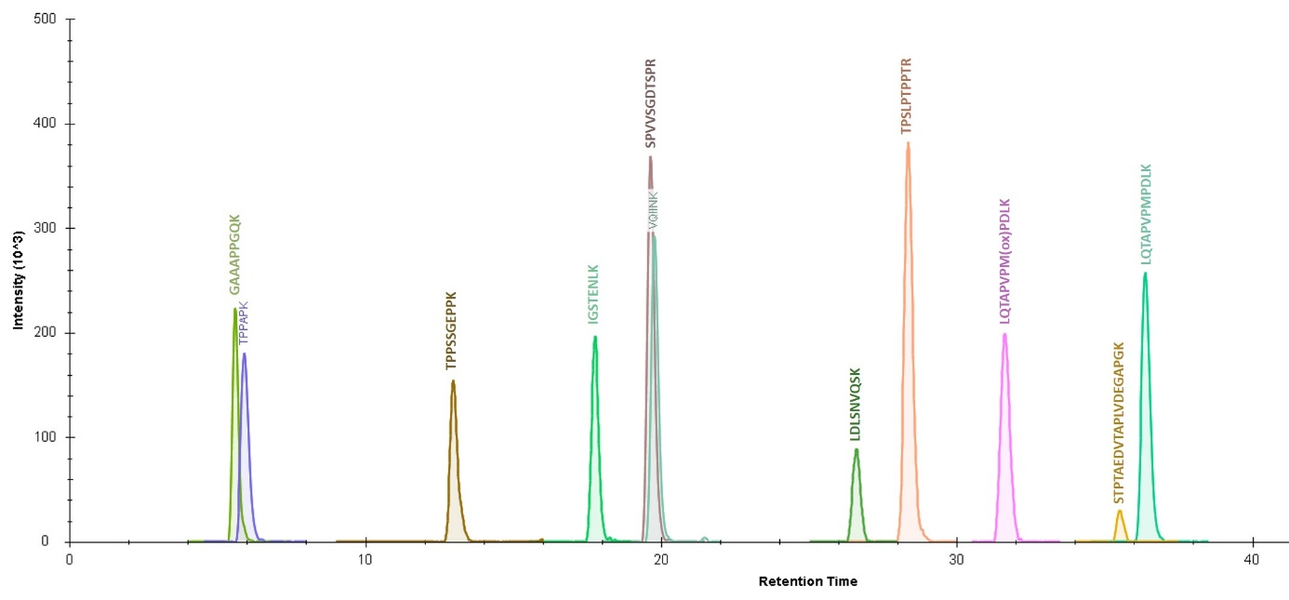

**Figure S3**: Calibration curves for all eleven peptides included in the t-tau method. Results of six independent sets of calibration blends are gathered to create these curves.

|  |  |  |
| --- | --- | --- |
|  |  |  |
|  |  |  |
|  |  |  |
|  |  |  |

**Figure S4**: Comparison between the chromatographic peaks obtained for each of the eleven peptides monitored on the t-tau method in the calibration blend with a ratio r-tau/r-tau* around one (recombinant tau) and in a CSF sample (endogenous tau).

|  |  |  |
| --- | --- | --- |
| Peptide | Signal after r-tau digestion | Signal after CSF digestion |
| TPPAPK |  |  |
| VQIINK |  |  |
| GAAPPGQK |  |  |
| IGSTENLK |  |  |
| TPPSSGEPPK |  |  |
| LDLSNVQSK |  |  |
| TPSLPTPPTR |  |  |
| SPVVSGDTSPR |  |  |
| STPTAEDVTAPLVDEGAPGK |  |  |
| LQTAPVPM(ox)PDLK |  |  |
| LQTAPVPMPDLK |  |  |