Supplementary Material

Supplementary Table 1. Correlation coefficient, slope, and intercept according to Passing and Bablok regression for each testosterone immunoassay compared with the LC-MS/MS in healthy controls and HDp.
 |  | Passing and Bablok regression
Assay compared to LC-MS/MS | n | Slope | 95% CI | Intercept (nmol/L) | 95% CI | r² | 95% CI
Alinity
Healthy controls | 30 | 1.10 | 1.05-1.15 | -0.05 | -0.12-0.03 | 0.996 | 0.99-1.0
HDp | 30 | 1.20 | 1.07-1.32 | 0.01 | -0.41-0.13 | 0.933 | 0.86-0.97
Atellica
Healthy controls | 30 | 1.0 | 0.96-1.05 | -0.02 | -0.14-0.03 | 0.993 | 0.99-1.0
HDp | 30 | 0.92 | 0.78-1.16 | -0.05 | -0.89-0.06 | 0.883 | 0.77-0.94
Cobas
Healthy controls | 30 | 1.10 | 1.07-1.14 | -0.02 | -0.09-0.11 | 0.998 | 0.995-1.0
HDp | 30 | 1.15 | 1.10-1.19 | -0.05 | -0.23-0.08 | 0.986 | 0.97-0.99
Lumipulse
Healthy controls | 30 | 1.02 | 0.97-1.06 | 0.11 | -0.07-0.24 | 0.994 | 0.99-1.0
HDp | 30 | 1.26 | 1.18-1.40 | 0.22 | -0.07-0.49 | 0.955 | 0.91-0.98
UniCel DXI
Healthy controls | 30 | 0.90 | 0.85-1.02 | 0.54 | 0.39-0.64 | 0.987 | 0.994-0.997
HDp | 30 | 0.97 | 0.89-1.06 | 1.08 | 0.55-1.65 | 0.967 | 0.93-0.98

Supplementary Table 2. Correlation coefficient, slope, and intercept according to Passing and Bablok regression for each cortisol immunoassay compared with the LC-MS/MS in healthy controls and HDp.
 |  | Passing and Bablok regression
Assay compared to LC-MS/MS | n | Slope | 95% CI | Intercept (nmol/L) | 95% CI | r² | 95% CI
Alinity
Healthy controls | 30 | 0.94 | 0.88-0.98 | -5.85 | -15.97-8.07 | 0.986 | 0.97-0.99
HDp | 30 | 0.82 | 0.77-0.88 | 34.49 | 22.20-47.40 | 0.974 | 0.94-0.99
Atellica
Healthy controls | 30 | 1.19 | 1.09-1.26 | -33.06 | -53.08 - -9.30 | 0.970 | 0.94-0.99
HDp | 30 | 1.04 | 0.81-1.29 | 107.62 | 37.10-179.13 | 0.708 | 0.48-0.85
Cobas
Healthy controls | 30 | 0.96 | 0.93-0.98 | 1.28 | -4.85-8.11 | 0.996 | 0.99-1.0
HDp | 30 | 0.99 | 0.94-1.04 | 21.88 | 11.02-30.28 | 0.972 | 0.94-0.99
UniCel DXI
Healthy controls | 30 | 0.88 | 0.76-0.99 | 4.18 | -19.86-28.85 | 0.942 | 0.88-0.97
HDp | 30 | 0.84 | 0.70-1.01 | 89.18 | 39.06-124.84 | 0.807 | 0.63-0.90

Supplementary Table 3. Correlation coefficient, slope, and intercept according to Passing and Bablok regression for each FT4 immunoassay compared with the LC-MS/MS in healthy controls and HDp.
 |  | Passing and Bablok regression
Assay compared to LC-MS/MS | n | Slope | 95% CI | Intercept (pmol/L) | 95% CI | r² | 95% CI
Alinity
Healthy controls | 30 | 0.41 | 0.36-0.48 | 4.37 | 3.05-5.43 | 0.917 | 0.83-0.96
HDp | 29 | 0.32 | 0.23-0.42 | 4.68 | 2.01-6.73 | 0.740 | 0.52-0.87
Atellica
Healthy controls | 30 | 0.69 | 0.61-0.78 | 1.65 | -0.07-3.33 | 0.901 | 0.80-0.95
HDp | 29 | 0.47 | 0.34-0.65 | 3.18 | -1.40-6.15 | 0.768 | 0.56-0.88
Cobas
Healthy controls | 30 | 0.79 | 0.70-0.85 | 0.49 | -0.69-2.22 | 0.898 | 0.79-0.95
HDp | 29 | 0.57 | 0.41-0.81 | 1.34 | -4.99-5.26 | 0.735 | 0.51-0.87
Lumipulse
Healthy controls | 30 | 0.71 | 0.63-0.80 | -0.004 | -1.71-1.66 | 0.905 | 0.81-0.95
HDp | 29 | 0.51 | 0.30-0.68 | 0.29 | -4.24-5.38 | 0.454 | 0.17-0.70
UniCel DXI
Healthy controls | 30 | 0.55 | 0.44-0.66 | -0.13 | -2.20-1.94 | 0.762 | 0.56-0.88
HDp | 29 | 0.38 | 0.28-0.48 | 1.82 | -0.47-4.25 | 0.868 | 0.74-0.94

Supplementary Figure 1. Bland–Altman plots for the 5 automated testosterone immunoassays in HDp compared to healthy controls (experiment 1).
To provide better insight in the effect of the matrix of HDp, we recalculated the immunoassays based on the method comparison for healthy controls. The recalculated concentrations from HDp were used to make these Bland-Altman plots. On the x-axis, the mean testosterone concentrations in HDp measured using LC-MS/MS are shown and, on the y-axis, the % deviation of the respective immunoassays compared to the LC-MS/MS are shown. (A) Alinity; (B) Atellica; (C) Cobas; (D) Lumipulse; (E) UniCel DXI.

A. B.
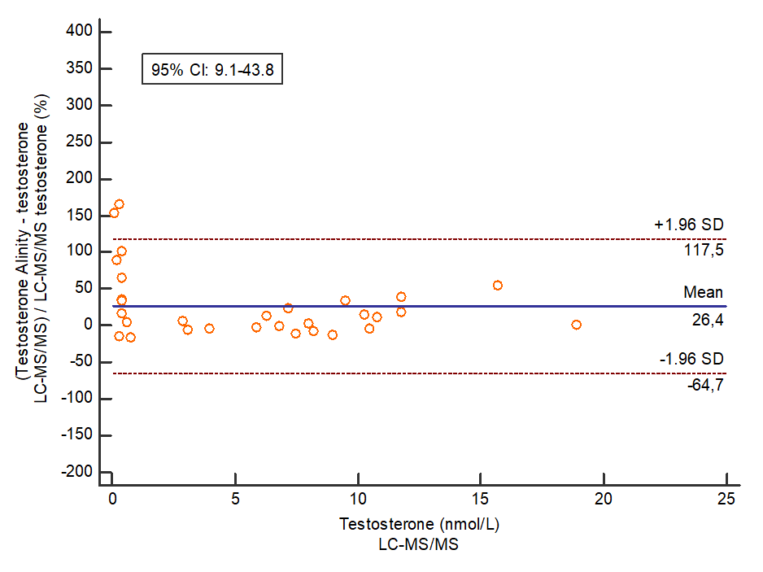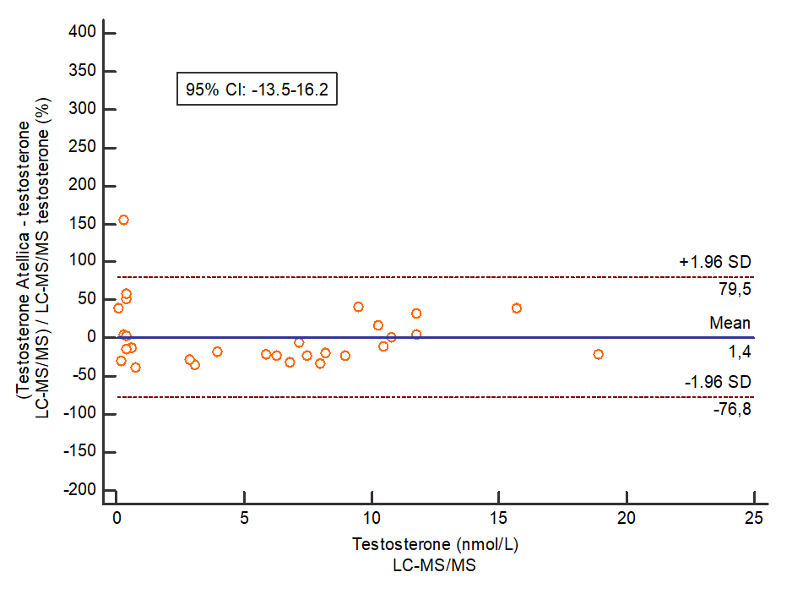
C. D.
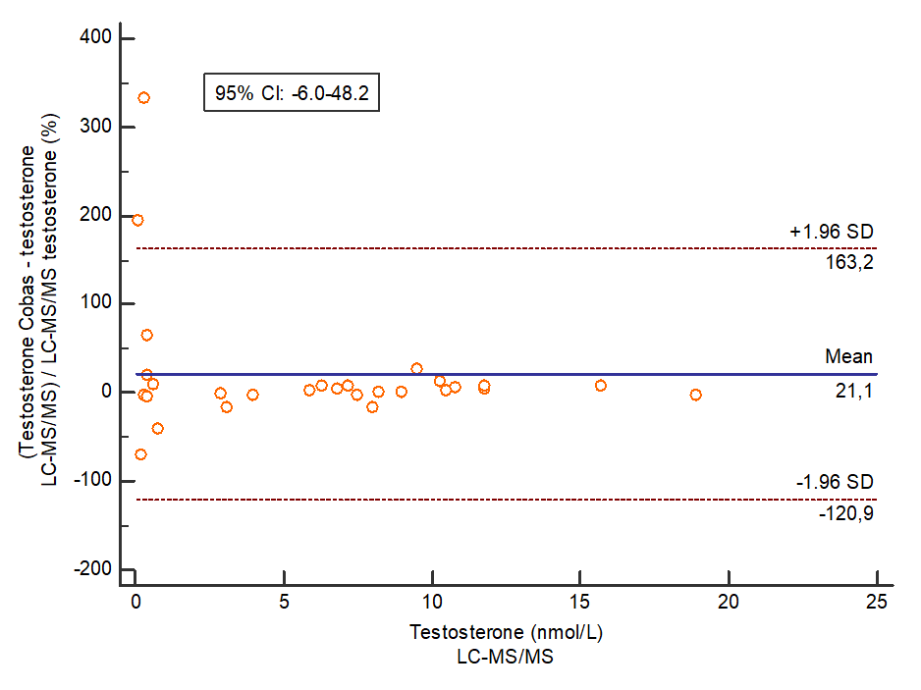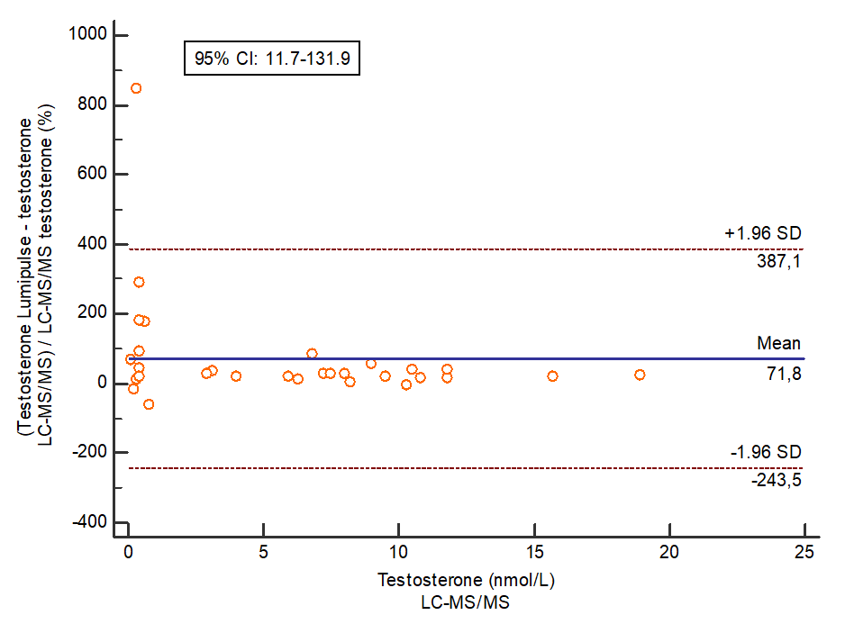
E.
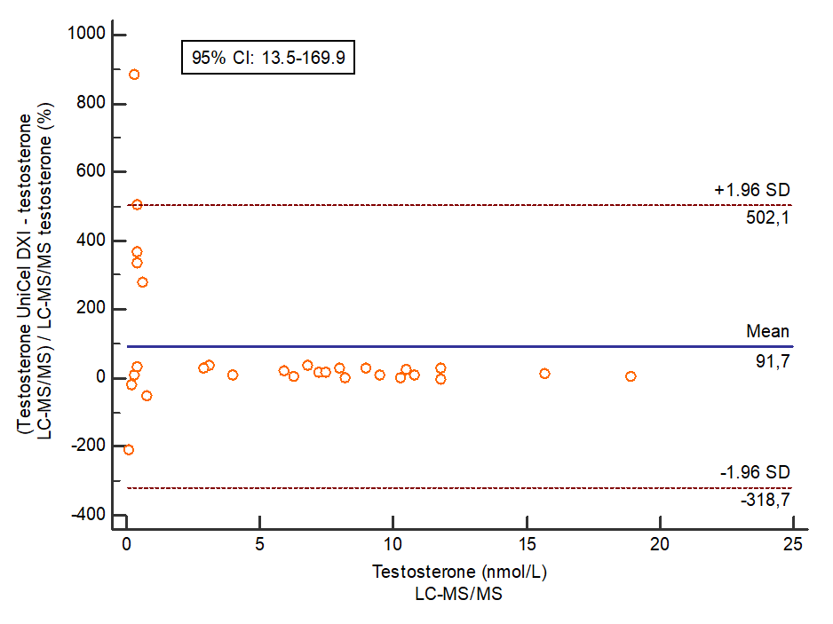

Supplementary Figure 2. Bland–Altman plots for the 4 automated cortisol immunoassays in HDp compared to healthy controls (experiment 1).
To provide better insight in the effect of the matrix of HDp, we recalculated the immunoassays based on the method comparison for healthy controls. The recalculated concentrations from HDp were used to make these Bland-Altman plots. On the x-axis, the mean cortisol concentrations in HDp measured using LC-MS/MS are shown and, on the y-axis, the % deviation of the respective immunoassays compared to the LC-MS/MS are shown. (A) Alinity; (B) Atellica; (C) Cobas; (D) UniCel DXI.

A. B.
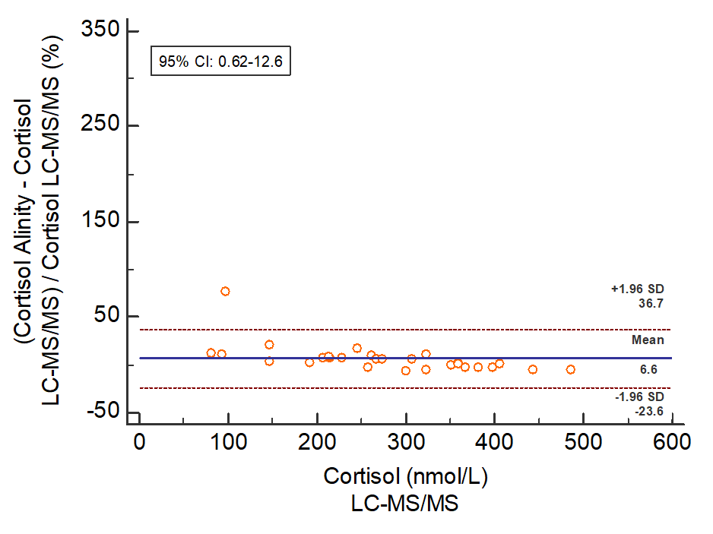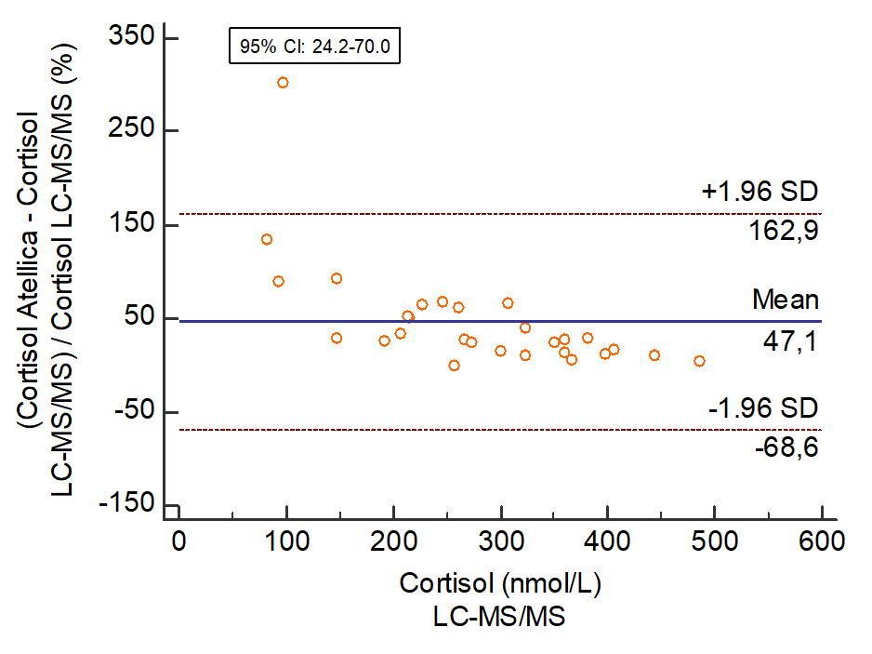
C. D.
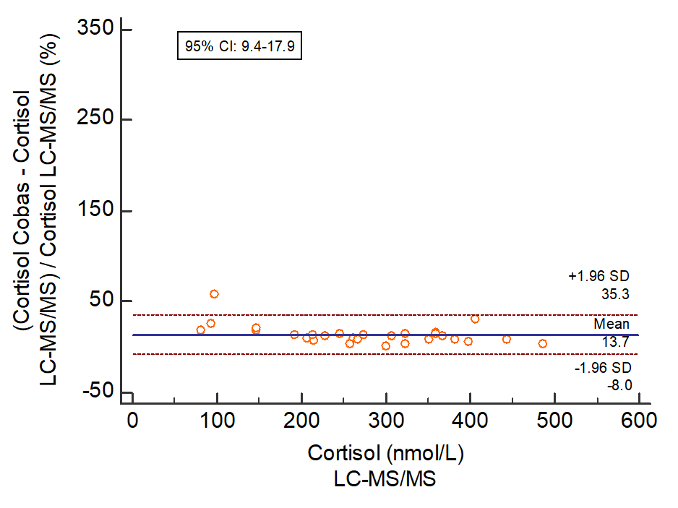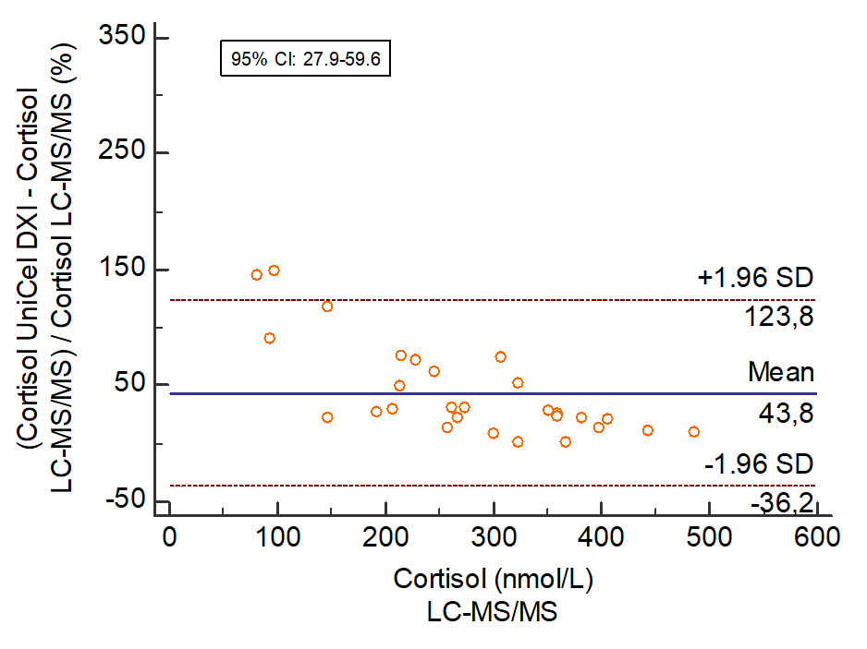
Supplementary Figure 3. Bland–Altman plots for the 5 automated FT4 immunoassays in HDp compared to healthy controls (experiment 1).
To provide better insight in the effect of the matrix of HDp, we recalculated the immunoassays based on the method comparison for healthy controls. The recalculated concentrations from HDp were used to make these Bland-Altman plots. On the x-axis, the mean FT4 concentrations in HDp were measured using LC-MS/MS and, on the y-axis, the % deviation of the respective immunoassays compared to the LC-MS/MS are shown. (A) Alinity; (B) Atellica; (C) Cobas; (D) Lumipulse; (E) UniCel DXI.

A. B.
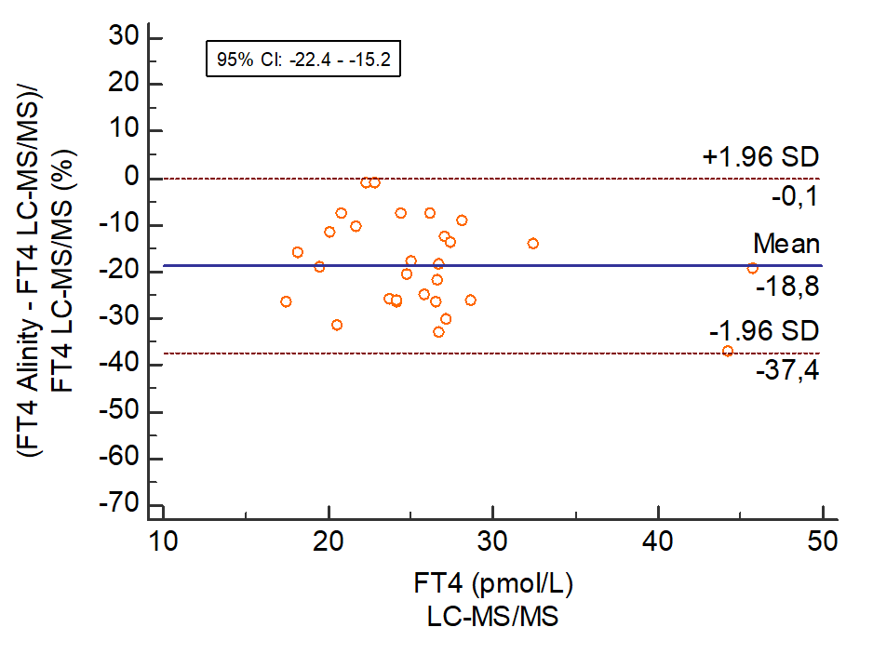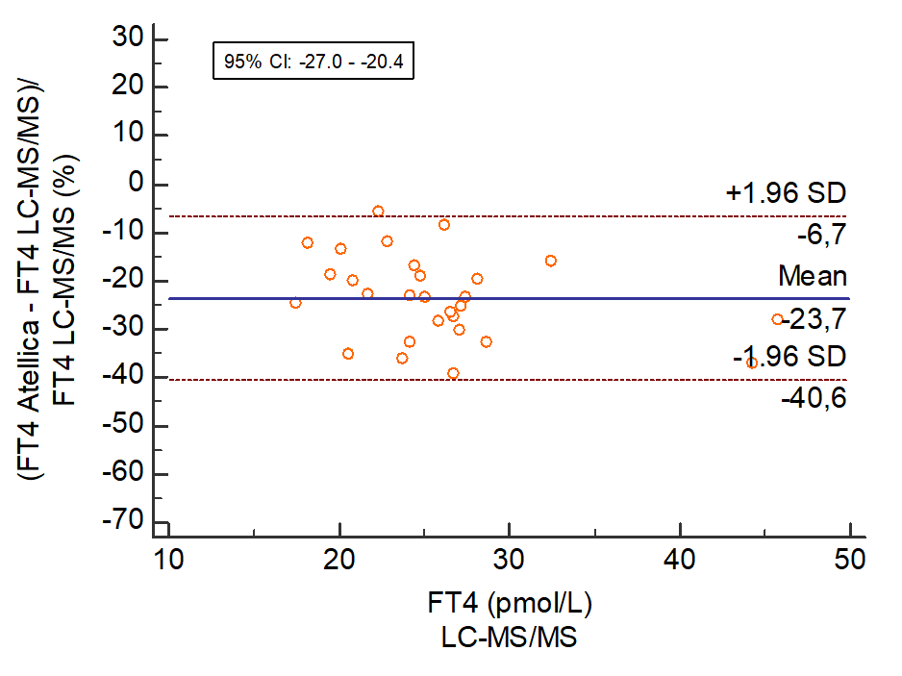
C. D.
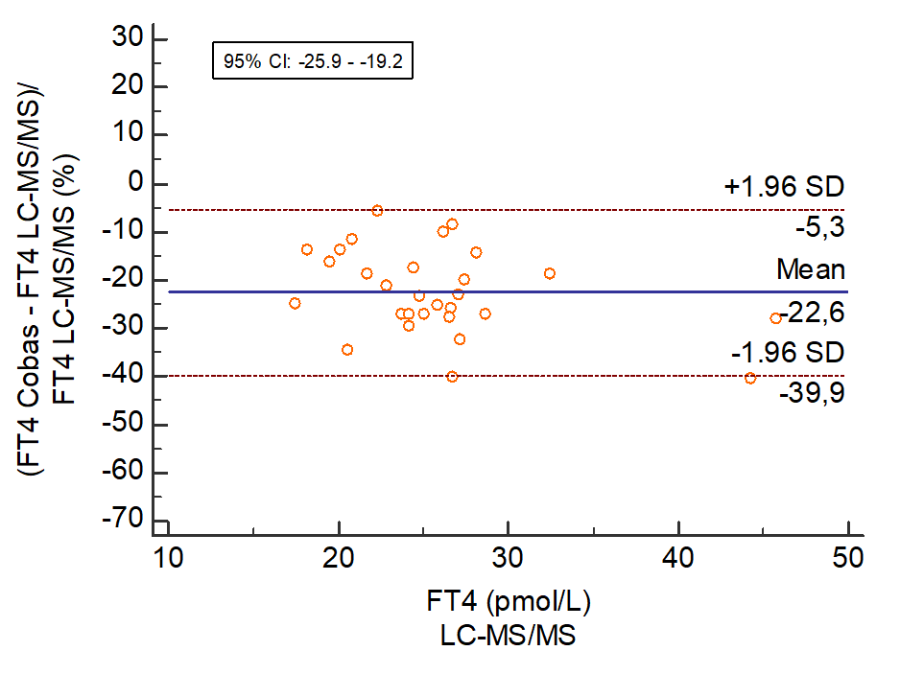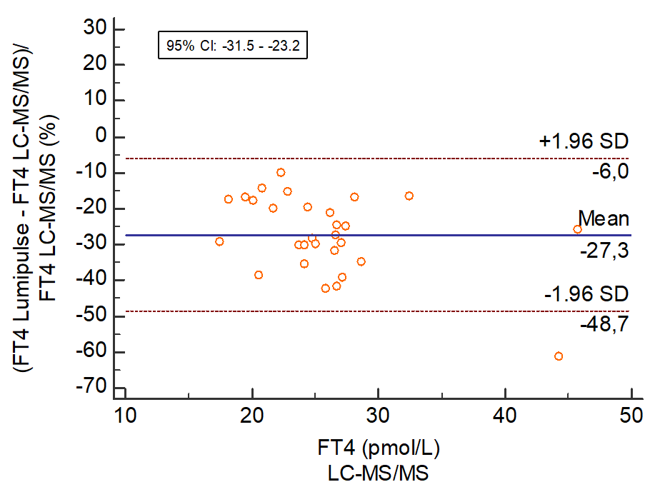
E.
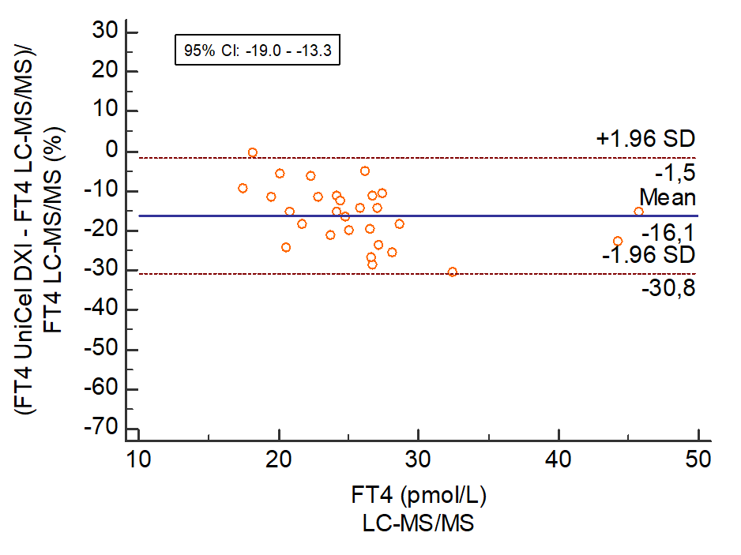

Supplementary Figure 4. Bland–Altman plots for the 5 automated testosterone immunoassays in HDp compared to healthy controls: men and women separately (experiment 1).
To provide better insight in the effect of the matrix of HDp, we recalculated the immunoassays based on the method comparison for healthy controls. The recalculated concentrations from HDp were used to make these Bland-Altman plots. On the x-axis, the mean testosterone concentrations in HDp measured using LC-MS/MS are shown and, on the y-axis, the % deviation of the respective immunoassays compared to the LC-MS/MS are shown. Bland-Altman plots for men and women separately are shown. (A) Alinity; (B) Atellica; (C) Cobas; (D) Lumipulse; (E) UniCel DXI.

A.
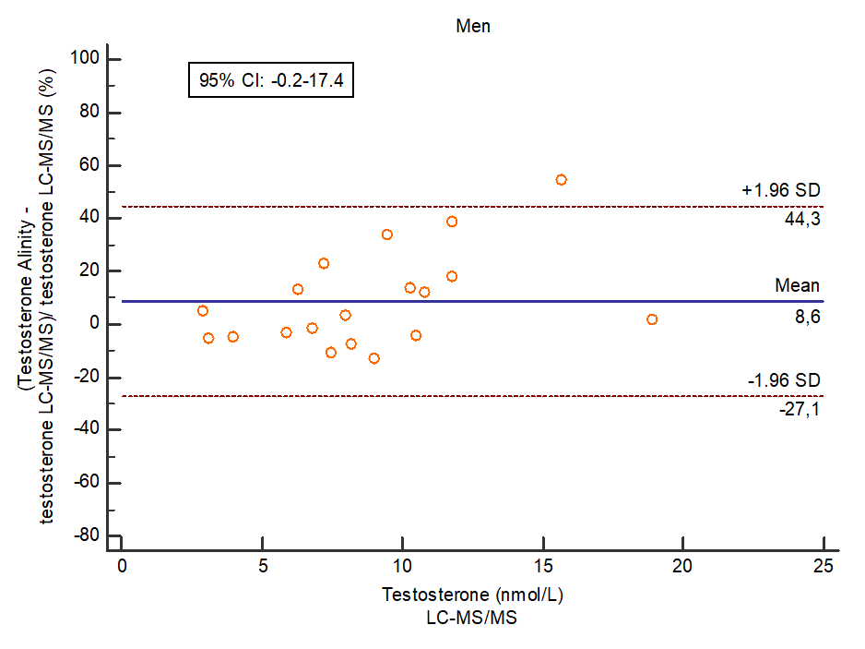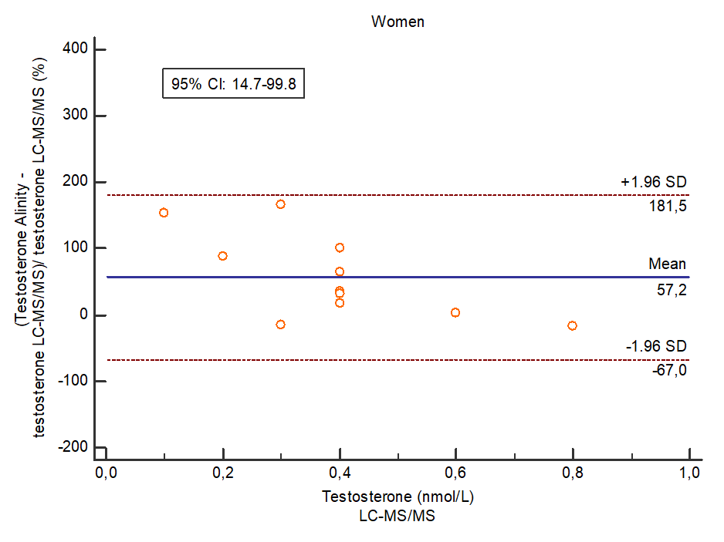

B.
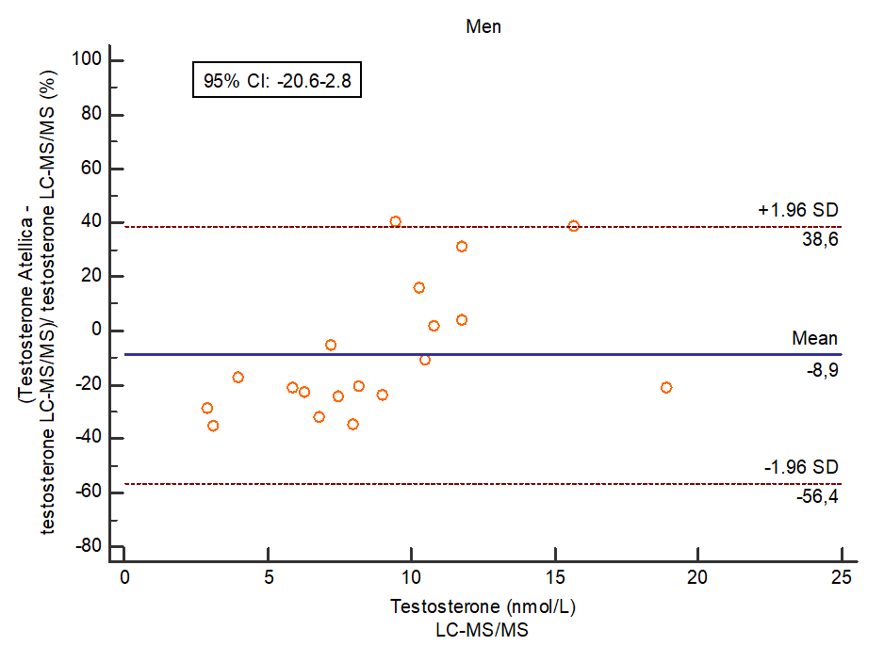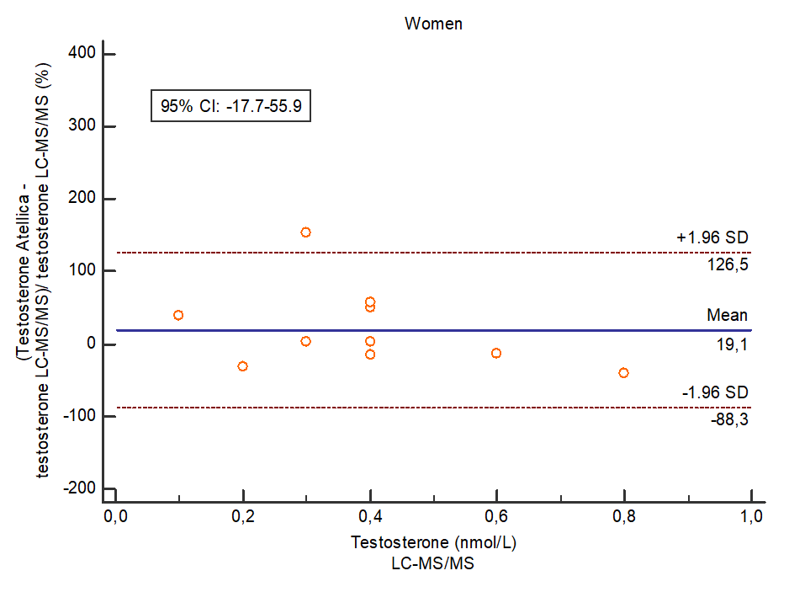
C.
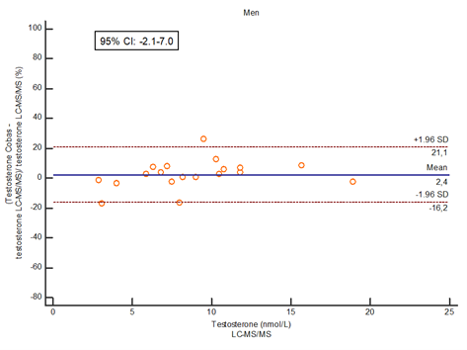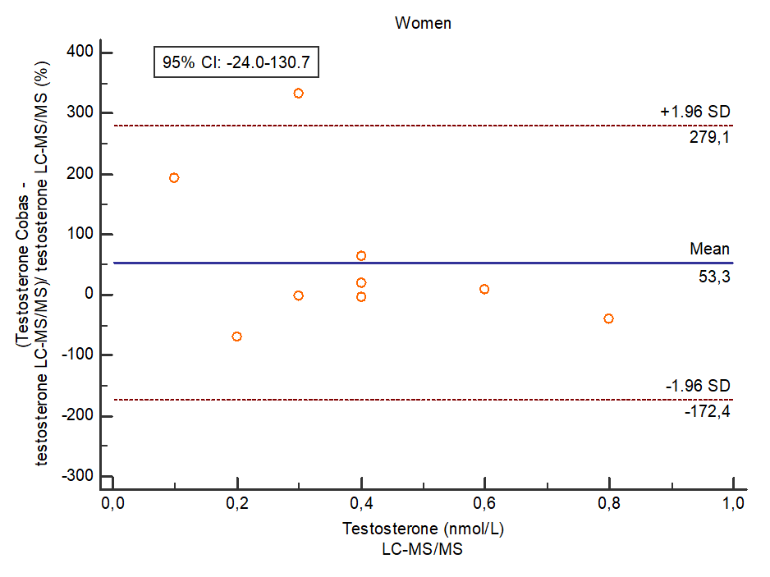

D.
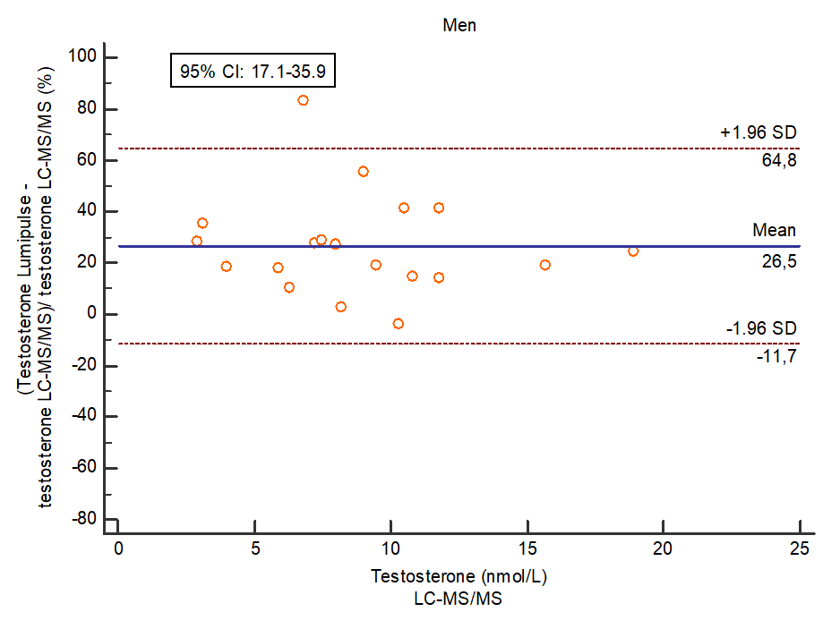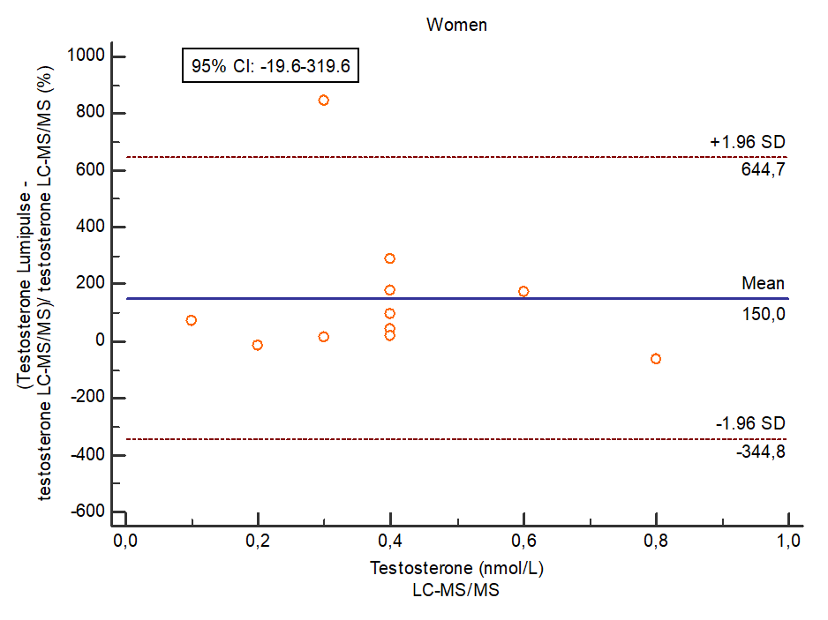
E.
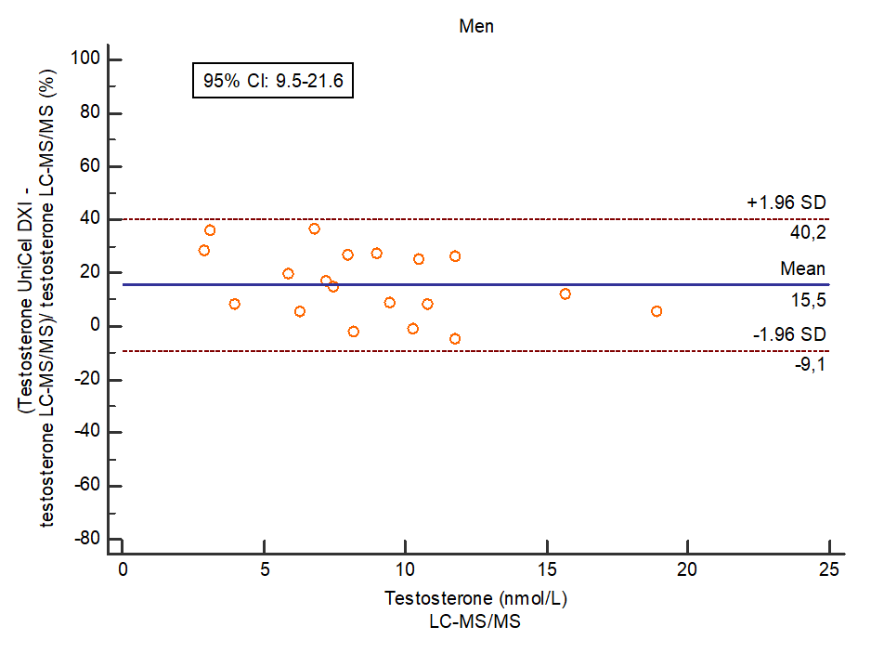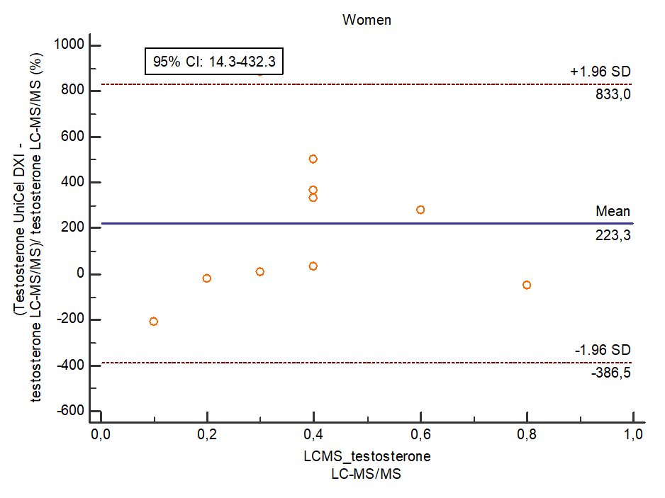

Supplementary Figure 5. Passing and Bablok regression analyses for two automated testosterone (A), cortisol (B) and FT4 (C) immunoassays and the LC-MS/MS before and after hemodialysis (experiment 2).
On the x-axis, the testosterone, cortisol and FT4 concentrations were measured using LC-MS/MS and, on the y-axis, the testosterone, cortisol and FT4 concentrations measured using the respective immunoassays are shown. Alinity IA is depicted on the left and Atellica IA on the right.
A.
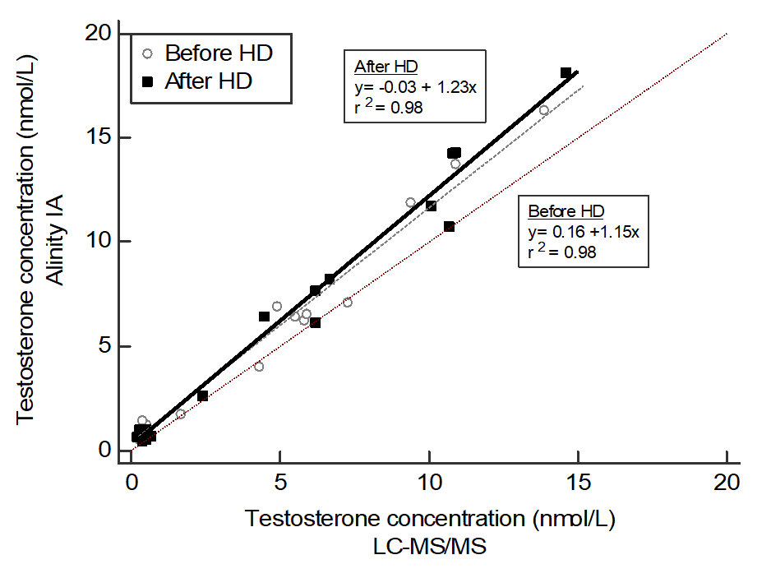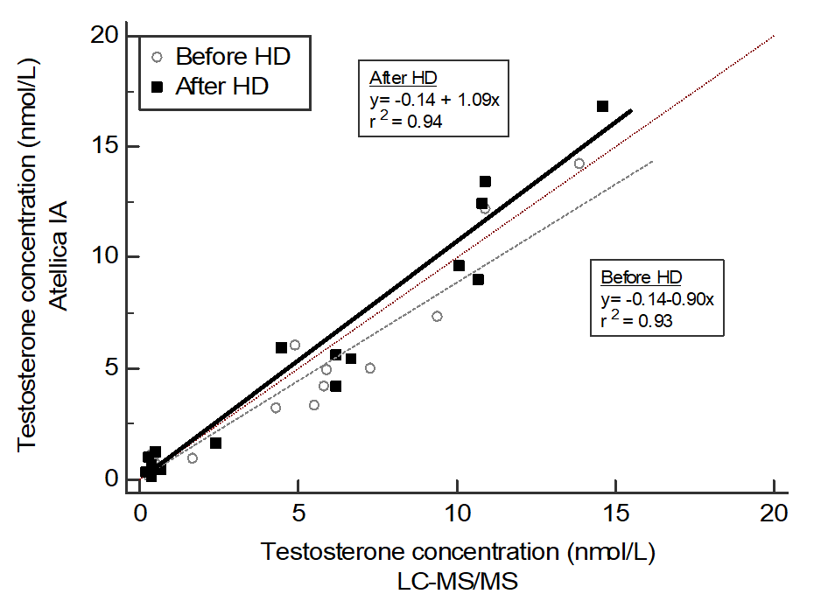
B.
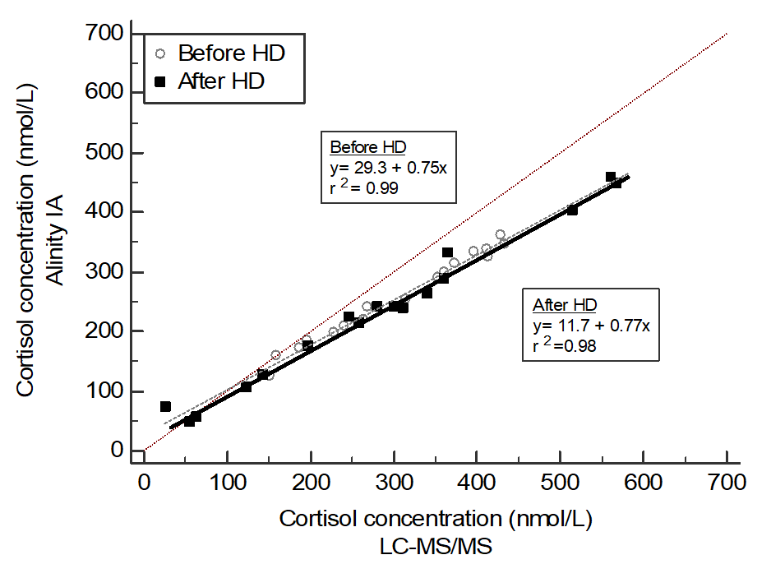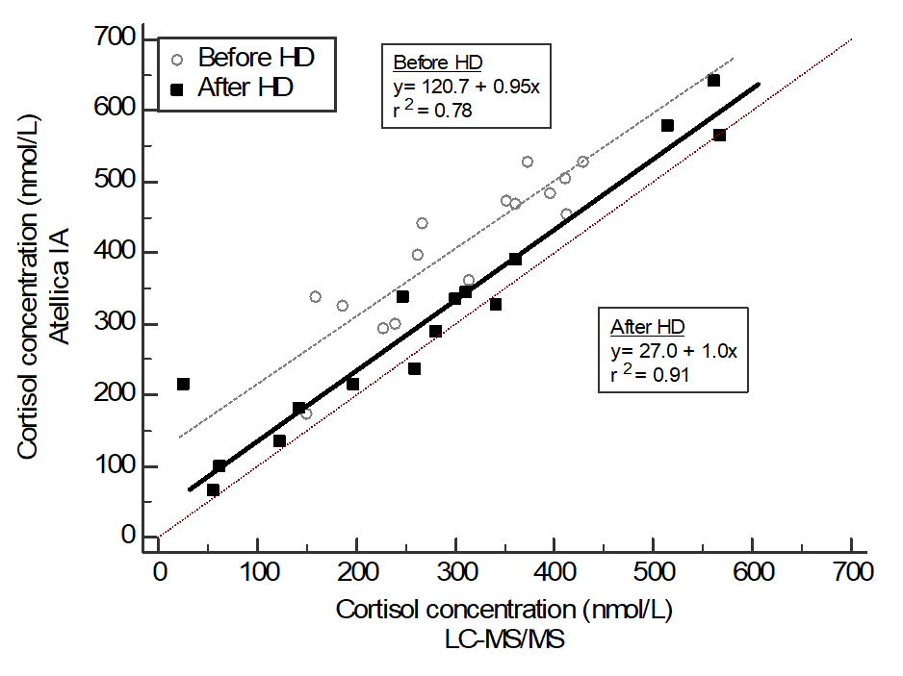
C.
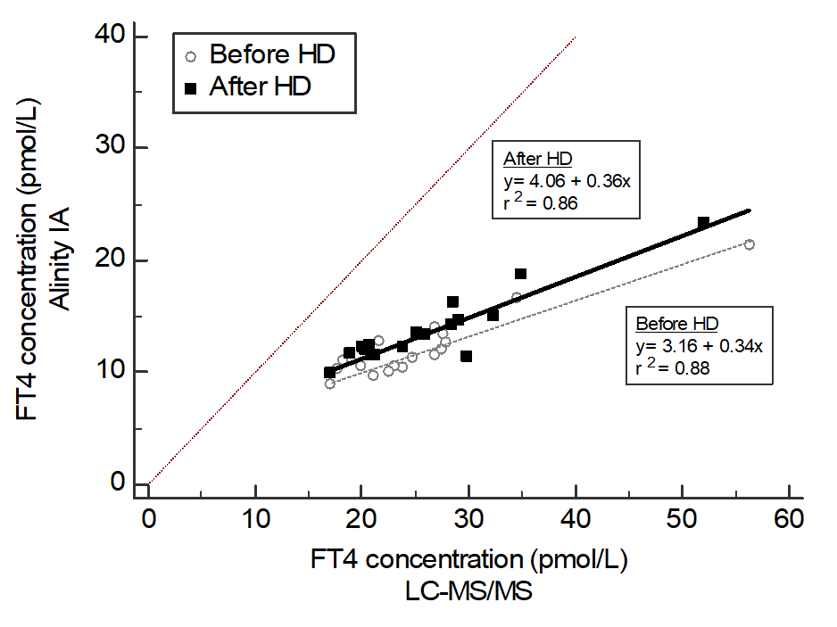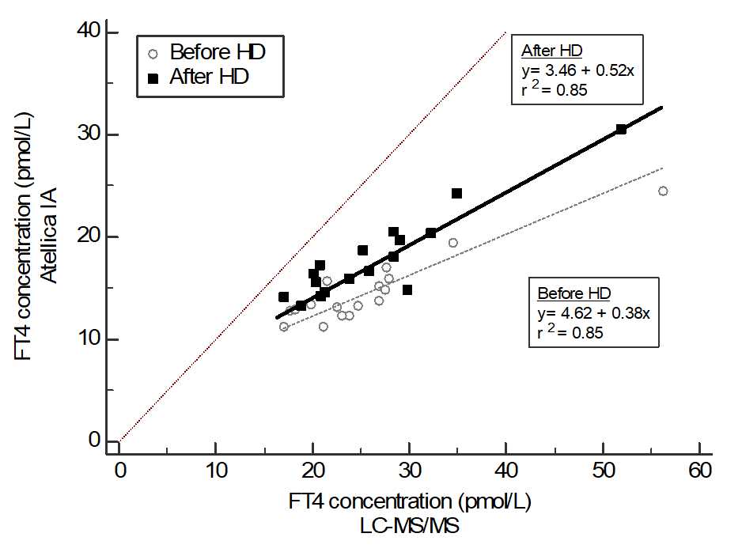

Supplementary Table 4. Correlation coefficient, slope, and intercept according to the Passing and Bablok regressions for two automated testosterone, cortisol, and FT4 immunoassays compared with the LC-MS/MS before and after hemodialysis in HDp (experiment 2).
 |  |  | Passing and Bablok regression
Hormone | Assay compared to LC-MS/MS | n | Slope | 95% CI | Intercept | 95% CI | r² | 95% CI
Testosterone | Alinity
 | Before HD | 17 | 1.15 | 1.0-1.27 | 0.16 | -0.16-0.40 | 0.980 | 0.94-0.99
 | After HD | 17 | 1.23 | 1.09-1.32 | -0.03 | -0.16-0.45 | 0.979 | 0.94-0.99
 | Atellica
 | Before HD | 17 | 0.90 | 0.70-1.14 | -0.14 | -0.29-0.20 | 0.928 | 0.81-0.97
 | After HD | 17 | 1.09 | 0.86-1.26 | -0.14 | -0.49-0.25 | 0.945 | 0.85-0.98
Cortisol | Alinity
 | Before HD | 17 | 0.75 | 0.70-0.82 | 29.3 | 10.5-47.3 | 0.985 | 0.96-0.99
 | After HD | 17 | 0.77 | 0.72-0.82 | 11.7 | 1.71-30.1 | 0.985 | 0.96-0.99
 | Atellica
 | Before HD | 15 | 0.95 | 0.71-1.41 | 120.7 | -40.6-210.9 | 0.780 | 0.46-0.92
 | After HD | 16 | 1.01 | 0.87-1.14 | 27.0 | -9.95-64.7 | 0.914 | 0.76-0.97
FT4 | Alinity
 | Before HD | 17 | 0.34 | 0.26-0.50 | 3.16 | -0.96-5.30 | 0.879 | 0.69-0.96
 | After HD | 17 | 0.36 | 0.26-0.44 | 4.06 | 2.35-6.86 | 0.862 | 0.65-0.95
 | Atellica
 | Before HD | 17 | 0.38 | 0.28-0.61 | 4.62 | -1.20-7.80 | 0.848 | 0.62-0.94
 | After HD | 17 | 0.52 | 0.43-0.68 | 3.46 | 0.24-6.78 | 0.852 | 0.63-0.95

