Supplementary Materials for Evaluation of hemolysis, lipemia, and icterus interference with common clinical immunoassays
Short title: Impact of HIL on clinical immunoassays
Authors: Amir Karin^{1,2,3}, Victoria Higgins^{1,4,5}, Jessica Miller⁶, Davor Brinc^{6,7}, Vathany Kulasingam^{6,7}, Rajeevan Selvaratnam^{6,7}*
¹Equal contributions

Supplementary Table

Table S1. Concentration and Index Equivalents on the Abbott Alinity c
Hemolysis
Index | Concentration Range in g/L | Concentration Range in mg/dL
0 | < 0.30 | < 30
1+ | 0.30 - 0.99 | 30 - 99
2+ | 1.00 - 1.99 | 100 - 199
3+ | 2.00 - 4.99 | 200 - 499
4+ | ≥5.00 | ≥500
Icterus
Index | Concentration Range in μmol/L | Concentration Range in mg/dL
0 | <34.2 | <2.0
1+ | 34.2 - 68.3 | 2.0 – 3.9
2+ | 68.4 - 170.9 | 4.0 – 9.9
3+ | 171.0 - 341.9 | 10.0 – 19.9
4+ | ≥342.0 | ≥20
Lipemia
Index | Concentration Range in mmol/L | Concentration Range in mg/dL
0 | <0.57 | <50
1+ | 0.57 - 1.12 | 50 – 99
2+ | 1.13 - 1.69 | 100 – 149
3+ | 1.70 - 2.25 | 150 – 199
4+ | ≥2.26 | ≥200

Table S2. Within Run Precision (Repeatability) and Reference Intervals Applied
Assay | *Within-run Coefficient of Variation (CV) |  | Reference Intervals¹
Assay | Mean | %CV | Reference Intervals¹
AFP | 28.5 | 2.4 | 0.89 – 8.78 μg/L
AFP | 118 | 2.0 | 0.89 – 8.78 μg/L
AFP | 233 | 2.1 | 0.89 – 8.78 μg/L
Anti-TPO | 48 | 2.4 | < 5.61 IU/mL
Anti-TPO | 129 | 2.5 | < 5.61 IU/mL
Anti-TPO | 303 | 2.7 | < 5.61 IU/mL
B-hCG | 3.3 | 7.8 | ≥ 25 mIU/mL
B-hCG | 22.1 | 4.1 | ≥ 25 mIU/mL
B-hCG | 413.2 | 2.3 | ≥ 25 mIU/mL
BNP | 67.7 | 4.4 | < 100 pg/mL
BNP | 343.9 | 3.3 | < 100 pg/mL
BNP | 1491.4 | 2.1 | < 100 pg/mL
CA125 | 35 | 2.5 | < 35.0 U/mL
CA125 | 94 | 2.1 | < 35.0 U/mL
CA125 | 268.4 | 1.9 | < 35.0 U/mL
Cortisol | 114.5 | 3.1 | Before 10 am: 102.1 -535.2 nmol/L  After 5pm: 80.0 – 477.3 nmol/L
Cortisol | 473.5 | 1.8
Cortisol | 839.6 | 1.8
C-Peptide | 315.0 | 2.9 | 260 – 1730 pmol/L
C-Peptide | 1408.8 | 1.9 | 260 – 1730 pmol/L
C-Peptide | 3978.6 | 2.1 | 260 – 1730 pmol/L
DHEA-S | 2.1 | 2.7
  Age (years) | 5-95th Percentile (μmol/L)
  Females
  11-14 | 0.2-4.6
  15-19 | 1.7-13.4
  20-24 | 3.6-11.1
  25-34 | 2.6-13.9
  35-44 | 2.0-11.1
  45-54 | 1.5-7.7
  55-64 | 0.8-4.9
  65-70 | 0.9-2.1
  Males
  11-14 | 0.5-6.6
  15-19 | 1.2-10.4
  20-24 | 6.5-14.6
  25-34 | 4.6-16.1
  35-44 | 3.8-13.1
  45-54 | 3.7-12.1
  55-64 | 1.3-9.8
  65-70 | 6.2-7.7
DHEA-S | 4.4 | 2.1
DHEA-S | 17.6 | 2.2
Estradiol | 156 | 7.9
  Males | 40 -162 pmol/L
  Normally Menstruating Females
  Follicular Phase: | 77 –921 pmol/L
  Mid-Cycle Peak: | 139-2382 pmol/L
  Luteal Phase: | 77-1145 pmol/L
  Post-Menopausal Females not on hormone therapy: | <37 – 103 pmol/L
  Postmenopausal females on HRT: | <37 – 529 pmol/L
Estradiol | 952 | 2.4
Estradiol | 2097.8 | 2.1
Ferritin | 29 | 3.1 | Males: 21.8 -274.7 μg/L  Females: 4.6 – 204.0 μg/L
Ferritin | 224 | 3.0 | Males: 21.8 -274.7 μg/L  Females: 4.6 – 204.0 μg/L
Ferritin | 504 | 3.2 | Males: 21.8 -274.7 μg/L  Females: 4.6 – 204.0 μg/L
Ferritin | 6.9 | 5.2 | Males: 21.8 -274.7 μg/L  Females: 4.6 – 204.0 μg/L
Folate* | 31.2 | 2.5 | 7.0-46.4 nmol/L
Folate* | 177.9 | 2.8 | 7.0-46.4 nmol/L
Folate* | 380.7 | 4.5 | 7.0-46.4 nmol/L
Free PSA | 0.16 | 3.3 | Interpreted in conjunction with total PSA, when total PSA is between 4-10 μg/L; free PSA: total PSA > 0.26
Free PSA | 2.46 | 3.0
Free PSA | 18.98 | 5.3
Total PSA | 0.19 | 4.1 | ≤ 4.0 μg/L
Total PSA | 0.10 | 4.1 | ≤ 4.0 μg/L
Total PSA | 2.96 | 4.4 | ≤ 4.0 μg/L
Total PSA | 21.1 | 4.6 | ≤ 4.0 μg/L
Homocysteine | 4.6 | 3.3 | Males: 5.46 -16.20 μmol/L  Females: 4.44 – 13.56 μmol/L
Homocysteine | 11 | 2.5 | Males: 5.46 -16.20 μmol/L  Females: 4.44 – 13.56 μmol/L
Homocysteine | 23.9 | 2.5 | Males: 5.46 -16.20 μmol/L  Females: 4.44 – 13.56 μmol/L
Free T3 | 3.7 | 4.5 | 2.9 – 4.9 pmol/L
Free T3 | 8.4 | 2.3 | 2.9 – 4.9 pmol/L
Free T3 | 16.0 | 2.4 | 2.9 – 4.9 pmol/L
Free T4 | 11.6 | 1.8 | 9.0 – 19.0 pmol/L
Free T4 | 26.0 | 2.7 | 9.0 – 19.0 pmol/L
FSH | 9.9 | 2.4
  Males | 0.95-11.95 (IU/L)
  Normally Menstruating Females
  Follicular Phase: | 3.03-8.08 (IU/L)
  Mid-Cycle Peak: | 2.55-16.69 (IU/L)
  Luteal Phase: | 1.38-5.47 (IU/L)
  Post-Menopausal Females: | 26.72-133.41 (IU/L)
FSH | 17.2 | 2.3
FSH | 39.0 | 2.4
hsTnI | 16 | 4.5 | Females: >15.6 ng/L  Males: >34.2 ng/L
hsTnI | 1743 | 2.3 | Females: >15.6 ng/L  Males: >34.2 ng/L
hsTnI | 7300 | 2.1 | Females: >15.6 ng/L  Males: >34.2 ng/L
Insulin | 101 | 2.1 | Fasting: 13-142 pmol/L*
Insulin | 434 | 1.8 | Fasting: 13-142 pmol/L*
Insulin | 1182 | 1.3 | Fasting: 13-142 pmol/L*
LH | 4.1 | 2.1
  Males | 0.57-12.07 (IU/L)
  Normally Menstruating Females
  Follicular Phase: | 1.80-11.78 (IU/L)
  Mid-Cycle Peak: | 7.59-89.08 (IU/L)
  Luteal Phase: | 0.56-14.00 (IU/L)
  Post-Menopausal Females not on hormone therapy: | 5.16-61.99 (IU/L)
LH | 16.8 | 1.9
LH | 53.2 | 1.7
Progesterone | 2.6 | 3.1
  Males | <0.32-0.64 nmol/L
  Normally Menstruating Females
  Follicular Phase: | 0.32-0.95 nmol/L
  Luteal Phase: | 3.82-50.56 nmol/L
  Post-Menopausal Females | <0.32-0.64 nmol/L
  Pregnant Females
  1st Trimester | 8.90-468.41 nmol/L
  2nd Trimester | 71.55-303.05 nmol/L
  3rd Trimester | 88.72-771.15 nmol/L
Progesterone | 25.8 | 2.9
Progesterone | 49.0 | 1.7
Prolactin | 9.8 | 2.0 | Males: 3.46-19.40 μg/L  Females: 5.18-26.53 μg/L
Prolactin | 22.4 | 1.9 | Males: 3.46-19.40 μg/L  Females: 5.18-26.53 μg/L
Prolactin | 62.2 | 2.1 | Males: 3.46-19.40 μg/L  Females: 5.18-26.53 μg/L
iPTH | 3.8 | 2.6 | 1.59-7.24 pmol/L
iPTH | 37.0 | 2.1 | 1.59-7.24 pmol/L
iPTH | 120.4 | 2.1 | 1.59-7.24 pmol/L
SHBG | 8.6 | 3.8 | Males: 17.1 – 77.6 nmol/L  Premenopausal women: 34.3 – 147.7 nmol/L  Postmenopausal women: 26.4 – 118 – nmol/L
SHBG | 24.3 | 3.6
SHBG | 141.9 | 4.3
Testosterone | 3.3 | 3.6 | Males (21-49 years of age): 8.33 – 30.19 nmol/L  Males(≥50 years of age): 7.66 – 24.82 nmol/L
Testosterone | 14.8 | 3.1
Testosterone | 30.4 | 3.1
TSH | 0.70 | 1.9 | 0.35-4.94 mIU/L
TSH | 4.83 | 2.0 | 0.35-4.94 mIU/L
TSH | 24.09 | 1.9 | 0.35-4.94 mIU/L
VitaminB12 | 376 | 3.6 | 138-652 pmol/L
VitaminB12 | 502.1 | 3.5 | 138-652 pmol/L
VitaminB12 | 123.6 | 6.7 | 138-652 pmol/L
VitaminB12 | 220.9 | 4.2 | 138-652 pmol/L
Vitamin D | 198 | 3.1 | 16.5 – 124.8 nmol/L
Vitamin D | 81 | 2.7 | 16.5 – 124.8 nmol/L
Vitamin D | 17 | 4.5 | 16.5 – 124.8 nmol/L
Vitamin D | 36 | 3.3 | 16.5 – 124.8 nmol/L
¹Source of reference intervals are packager inserts unless otherwise indicated by *.
**Source of within run CV: in-house studies obtained as part of total imprecision studies, by running quality control materials at various levels in duplicate, twice per day for 20 days (n = 80 points per QC level).

Supplementary Figures

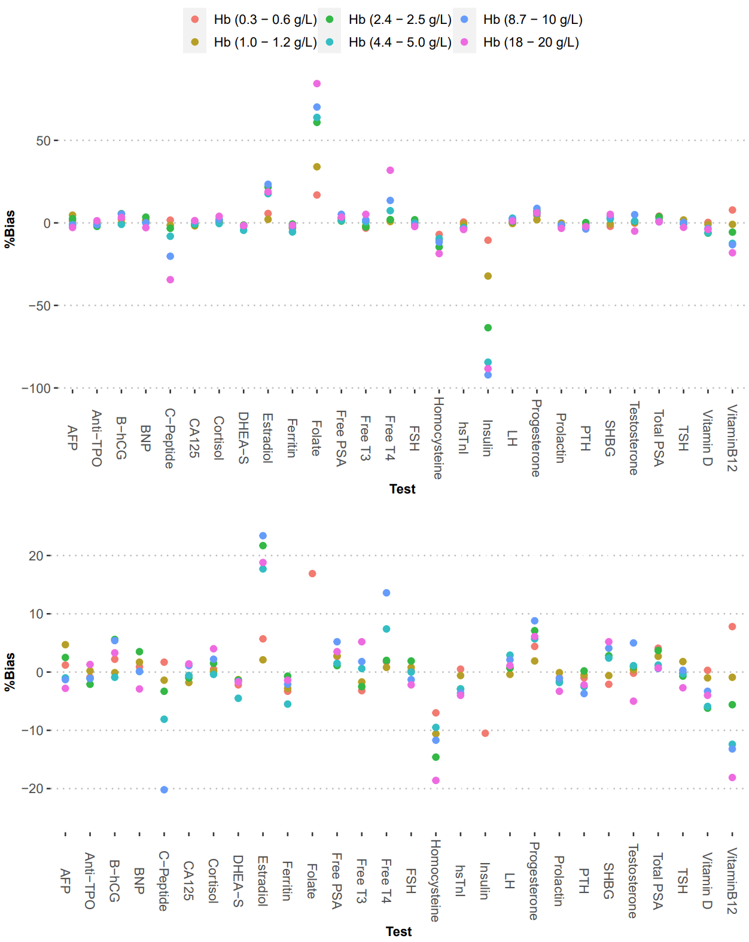Supplementary Figure 1: Effect of Hemolysis on Abbott Alinity i immunoassays. A) Mean bias relative to baseline concentration for a given test at various concentrations of Hb, as noted in the legend. Plot is scaled to visualize the maximum (positive or negative) bias observed. B) Same as A, but the plot is scaled to visualize trends within 土25% bias.
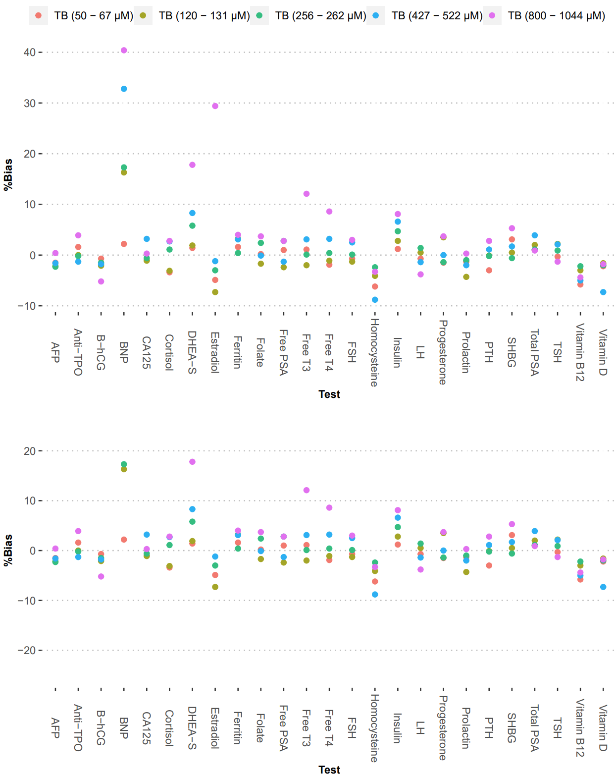
Supplementary Figure 2: Effect of icterus on IA tests on the Abbott Alinity i. A) Mean bias relative to baseline concentration for a given test at various spiked concentrations of conjugated bilirubin as noted in the legend. Plot is scaled to visualize the maximum (positive or negative) bias observed. B) Same as A, but the plot is scaled to visualize trends within 土25% bias.

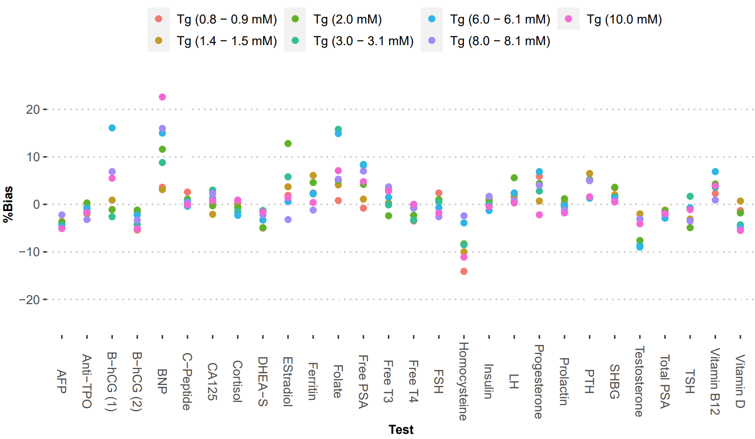
Supplementary Figure 3: Effect of lipemia on IA tests on the Abbott Alinity i. A) Mean bias relative to baseline concentration for a given test at various spiked concentrations of Intralipid, measured by the triglyceride (Tg) assay on the Abbott Architect c as noted in the legend.

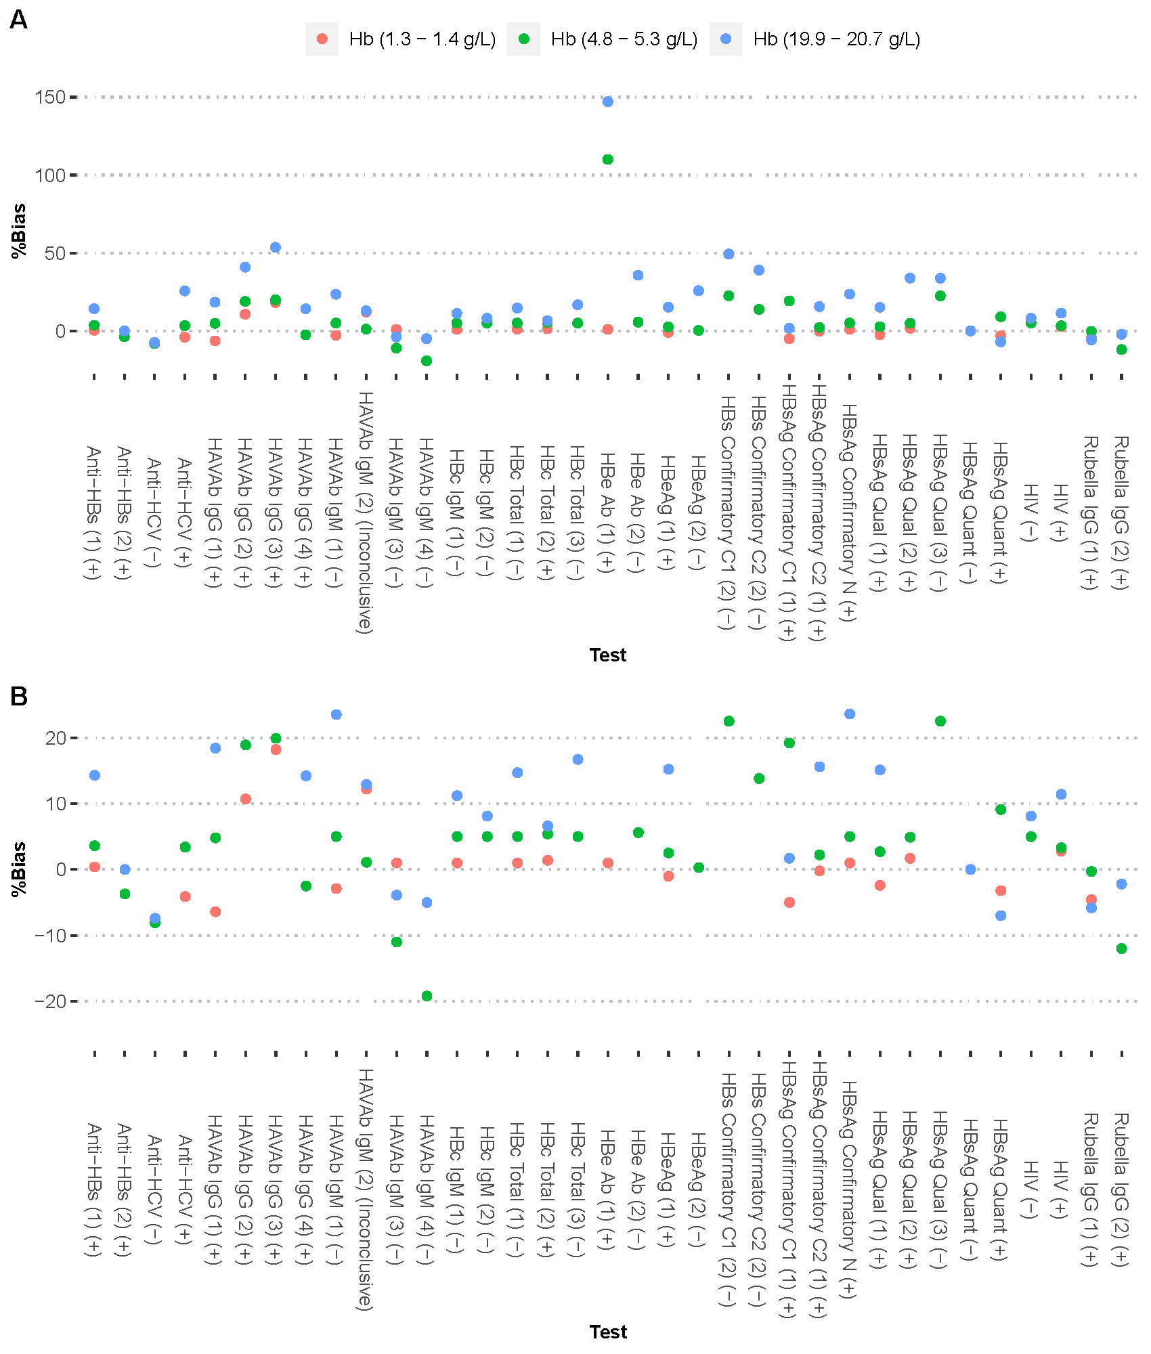
Supplementary Figure 4: Effect of hemolysis on various serology tests on the Abbott Alinity i. Top panel: Mean bias relative to baseline concentration for a given test at various concentrations of Hb, as noted in the legend. Plot is scaled to visualize the maximum (positive or negative) bias observed. Bottom Panel: Same as above, but the plot is scaled to visualize trends within 土25% bias.

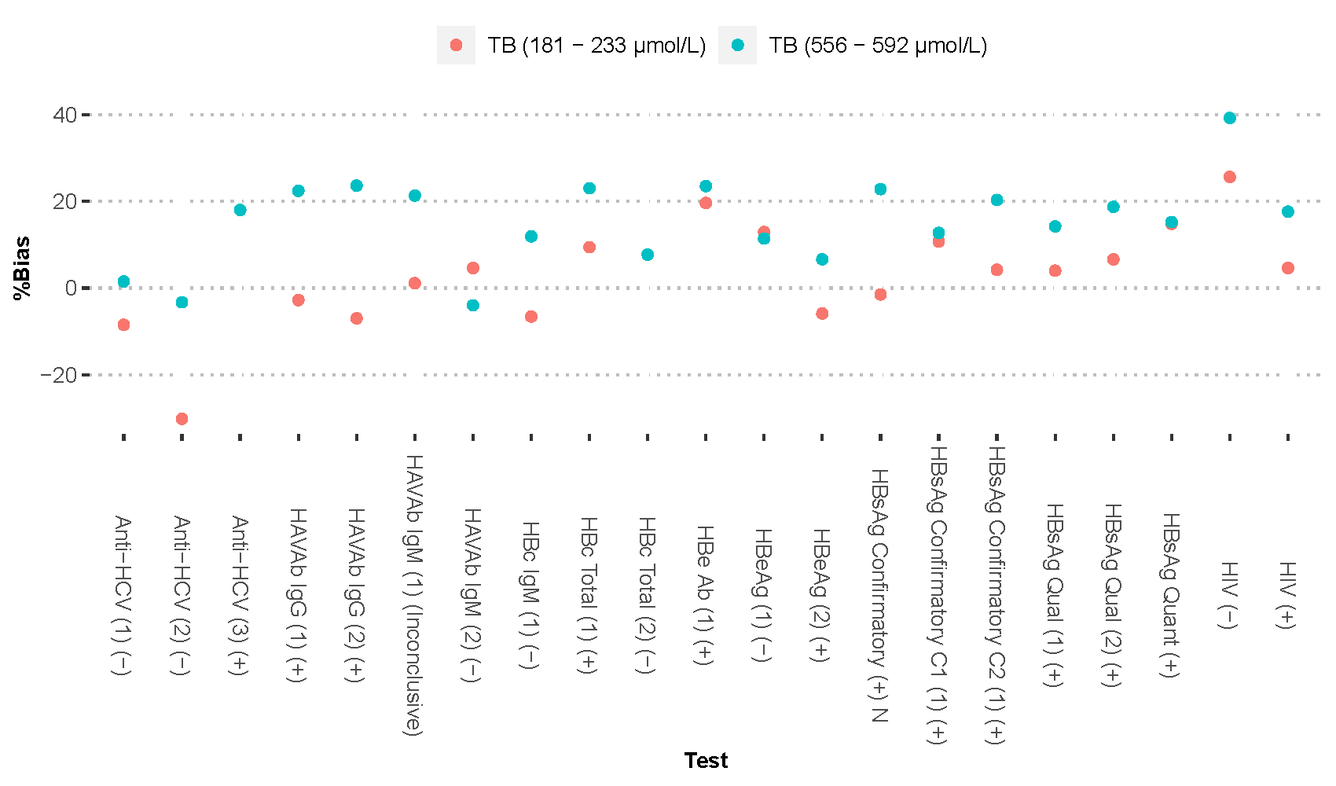
Supplementary Figure 5: Effect of icterus on serology tests on the Abbott Alinity i. A) Mean bias relative to baseline concentration for a given test at various spiked concentrations of conjugated bilirubin as noted in the legend. Plot is scaled to visualize the maximum (positive or negative) bias observed. B) Same as A, but the plot is scaled to visualize trends within 土25% bias.

