Supplementary Figures and Tables
Supplementary Table 1
P-values of the hypothesis test that the beta coefficient of the regression of the difference from the mean is equal to 1.
Roche vs Abbot | Roche vs Beckman | Roche vs Siemens
1.184352e-17 | 8.089334e-31 | 4.508082e-19

Supplementary Table 2
Slope and intercept of the Passing-Bablok regression analysis, performed first on each set of measurements and then on the mean values of tPSA.
 |  | Roche vs Abbot | Roche vs Beckman | Roche vs Siemens
Intercept | Run 1 | -0.036(-0.102, 0.007) | -0.058(-0.128, -0.003) | -0.065(-0.161, 0.004)
Slope |  | 0.998(0.983, 1.014) | 0.826(0.804, 0.852) | 0.874(0.856, 0.894)
Intercept | Run 2 | -0.038(-0.093, 0.023) | -0.104(-0.191, -0.01) | -0.088(-0.149, -0.016)
Slope |  | 0.95(0.936, 0.969) | 0.812(0.791, 0.835) | 0.856(0.835, 0.874)
Intercept | Mean values of tPSA | -0.033(-0.098, 0.026) | -0.08(-0.144, -0.004) | -0.059(-0.138, -0.014)
Slope |  | 0.974(0.959, 0.988) | 0.818(0.797, 0.838) | 0.863(0.849, 0.88)

Supplementary Figure 1.
Scatter plots comparing the first set with the second run of tPSA measurements for each assay
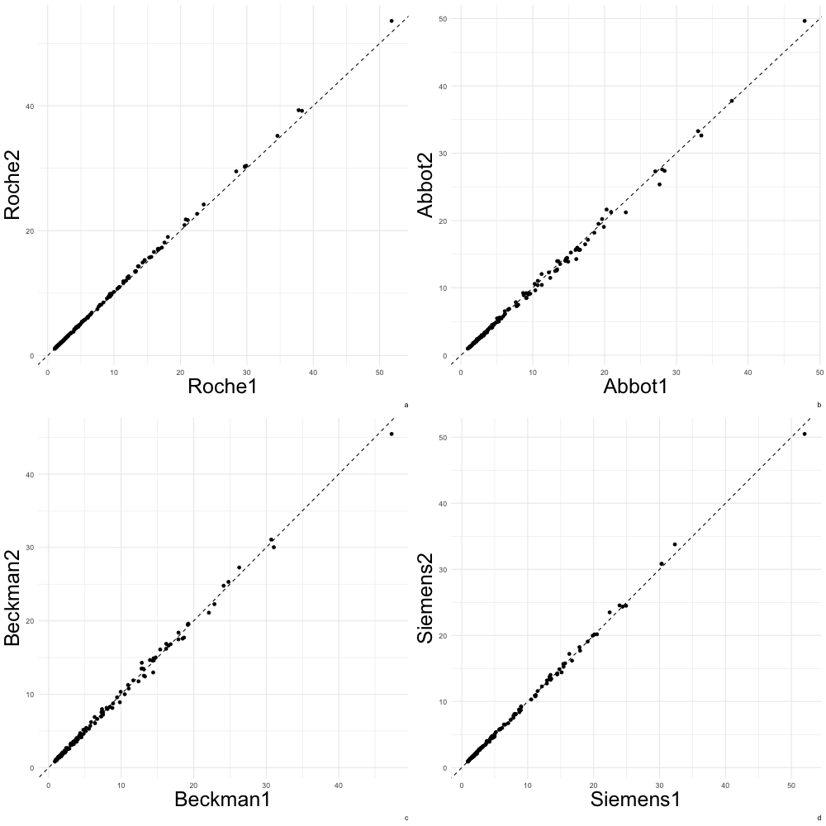

Supplementary Figure 2.
Scatter plots comparing the first set with the second run of fPSA measurements for each assay

