**Supplemental material**

**Red blood cell parameters in the newborn and infant: a prospective cohort study**

**Sofie Taageby Nielsen, Rikke Mohr Lytsen, Nina Strandkjær,Malene Kongsgaard Hansen, Anne-Sophie Sillesen, R Ottilia B Vøgg, Anna Axelsson Raja, Ida Juul Rasmussen, Pia R. Kamstrup, Marianne Benn, Kasper Iversen, Henning Bundgaard, Ruth Frikke-Schmidt.**

***Supplemental Table 1:*** Summary of a comparison of Sysmex XN-9000 instrument used at Rigshospitalet and Advia 2120 instrument used at Herlev Hospital performed before study initiation.

***Supplemental Figure 1:*** Linear regression models and average-difference plots for hemoglobin, erythrocytes, and hematocrit comparing Sysmex XN-9000 instrument used at Rigshospitalet and Advia 2120 instrument used at Herlev Hospital.

***Supplemental Figure 2:*** Linear regression models and average-difference plots for MCV, MCH, and MCHC comparing Sysmex XN-9000 instrument used at Rigshospitalet and Advia 2120 instrument used at Herlev Hospital.

***Supplemental Figure 3:*** Difference plots for hemoglobin, erythrocytes, hematocrit, MCV, MCH, and MCHC for samples analyzed in parallel during the study period (2016-2018).

***Supplemental Table 2:*** Reference intervals for hemoglobin, erythrocytes, hematocrit, MCV, MCH, and MCHC in umbilical cord blood from Rigshospitalet and Herlev Hospital.

***Supplemental Table 3:*** Medians and 25th and 75th percentiles for hemoglobin, erythrocytes, hematocrit, MCV, MCH, and MCHC stratified by sex in umbilical cord blood and venous blood at birth, two months after birth, and 14-16 months after birth.

***Supplemental Table 4:*** Medians and 25th and 75th percentiles for hemoglobin, erythrocytes, hematocrit, MCV, MCH, and MCHC stratified by gestational age in umbilical cord blood and venous blood at birth.

***Supplemental Table 5:*** Medians and 25th and 75th percentiles for feto-placental weight ratios and numbers of placenta insufficiency events stratified by mode of delivery.

**Supplemental Table 1. Summary of a comparison of Sysmex XN-9000 instrument used at Rigshospitalet and Advia 2120 instrument used at Herlev Hospital performed before study initiation.**

|  |  |  |  |  |  |  |  |  |  |  |
| --- | --- | --- | --- | --- | --- | --- | --- | --- | --- | --- |
|  |  | Linear regression | | | |  | Average-difference plot | | | |
|  | n | Slope | Lower 95% CI | Upper 95% CI | R2 |  | Bias | Lower 95% CI | Upper 95% CI | SD |
| Hemoglobin | 68 | 1.037 | 1.026 | 1.049 | 0.998 |  | -0.044 | -0.320 | 0.232 | 0.141 |
| Erythrocytes | 112 | 1.075 | 1.057 | 1.092 | 0.992 |  | 0.059 | -0.224 | 0.342 | 0.145 |
| Hematocrit | 112 | 1.030 | 1.004 | 1.055 | 0.983 |  | -0.002 | -0.028 | 0.024 | 0.013 |
| MCV | 112 | 0.949 | 0.916 | 0.981 | 0.968 |  | -1.827 | -6.391 | 2.737 | 2.329 |
| MCH | 113 | 1.009 | 0.897 | 1.121 | 0.740 |  | -0.551 | -0.254 | 0.144 | 0.101 |
| MCHC | 112 | 1.034 | 0.791 | 1.278 | 0.392 |  | -0.111 | -1.558 | 1.336 | 0.738 |

Results from linear regression models and average-difference plots comparing Sysmex XN-9000 used at Rigshospitalet and Advia 2120 used at Herlev Hospital. The comparisons were conducted in 2016 before study initiation and based on randomly collected patient samples covering the measurement ranges. MCH=Mean Corpuscular Hemoglobin. MCHC=Mean Corpuscular Hemoglobin Concentration. MCV=Mean Corpuscular Volume. N=number of individuals.

**Supplemental Figure 1. Linear regression models and average-difference plots for hemoglobin, erythrocytes, and hematocrit comparing Sysmex XN-9000 instrument used at Rigshospitalet and Advia 2120 instrument used at Herlev Hospital.**

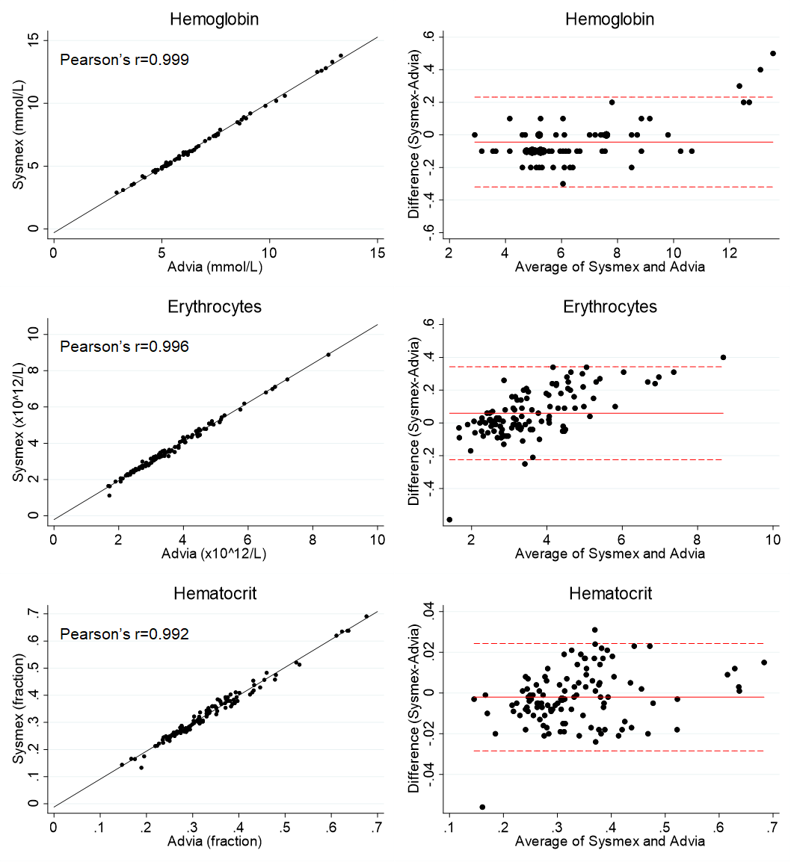

Scatter plots with linear regression models and Pearson’s correlations coefficients and average-difference plots comparing Sysmex XN-9000 instrument used at Rigshospitalet and Advia 2120 instrument used at Herlev Hospital. The comparisons were conducted in 2016 before study initiation and based on randomly collected patient samples covering the measurement ranges. In the average-difference plots the solid lines represent the mean difference and the dashed lines the limits of agreement.

**Supplemental Figure 2. Linear regression models and average-difference plots for MCV, MCH, and MCHC comparing Sysmex XN-9000 instrument used at Rigshospitalet and Advia 2120 instrument used at Herlev Hospital.**

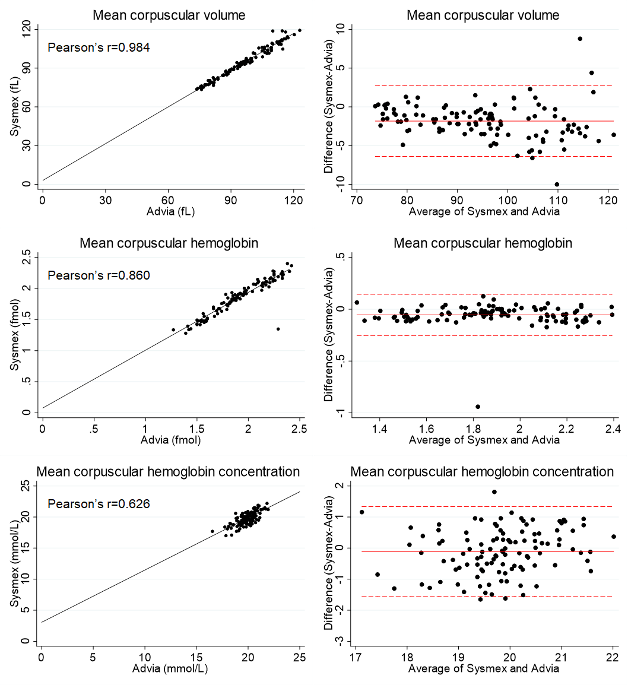

Scatter plots with linear regression models and Pearson’s correlations coefficients and average-difference plots comparing Sysmex XN-9000 instrument used at Rigshospitalet and Advia 2120 instrument used at Herlev Hospital. The comparisons were conducted in 2016 before study initiation and based on randomly collected patient samples covering the measurement ranges. In the average-difference plots the solid lines represent the mean difference and the dashed lines the limits of agreement.

**Supplemental Figure 3. Difference plots for hemoglobin, erythrocytes, hematocrit, MCV, MCH, and MCHC for samples analyzed in parallel during the study period (2016-2018).**

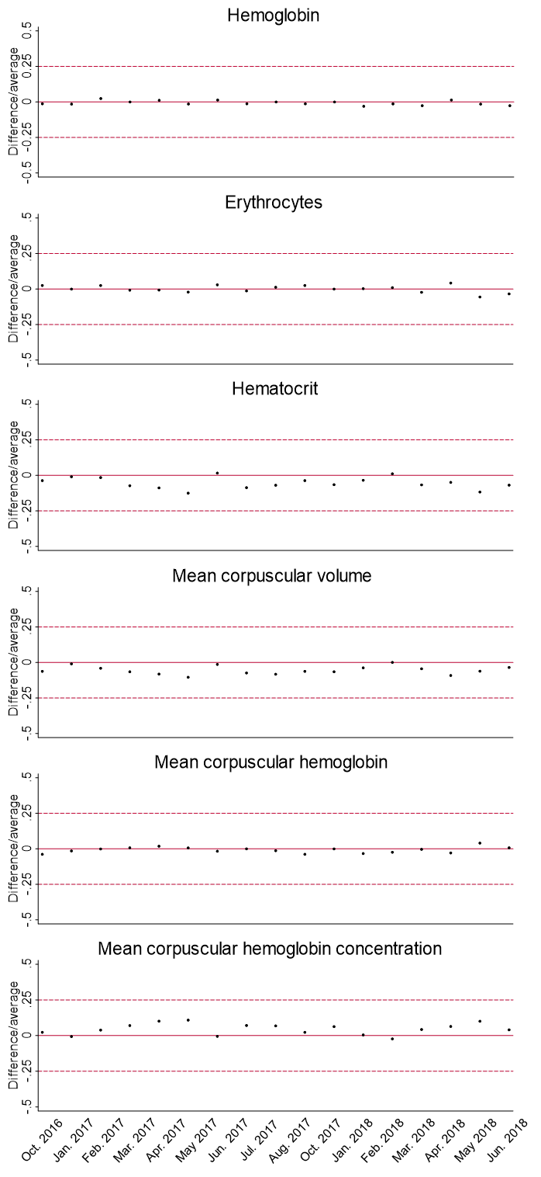

The plots show differences in red blood cell parameters measured with the Sysmex XN-9000 instrument used at Rigshospitalet and the Advia 2120 instrument used at Herlev Hospital during the study period (2016-2018).

**Supplemental Table 2. Reference intervals for hemoglobin, erythrocytes, hematocrit, MCV, MCH, and MCHC in umbilical cord blood from Rigshospitalet and Herlev Hospital.**

|  |  |  |  |
| --- | --- | --- | --- |
|  | Rigshospitalet | Herlev Hospital | Combined |
| Hemoglobin, mmol/L (n) | 8.1-11.8 (4,017) | 8.2-11.9 (2,990) | 8.1-11.9 (7,028) |
| Erythrocytes, ×1012/L (n) | 3.60-5.38 (4,043) | 3.67-5.39 (2,996) | 3.62-5.39 (7,039) |
| Hematocrit, fraction (n) | 0.39-0.57 (4,029) | 0.40-0.59 (2,993) | 0.39-0.58 (7,050) |
| MCV, fL (n) | 99-115 (4,046) | 100-118 (2,971) | 99-117 (7,011) |
| MCH, fmol (n) | 2.0-2.4 (4,074) | 2.1-2.4 (2,878) | 2.0-2.4 (7,088) |
| MCHC, mmol/L (n) | 19.6-21.7 (4,034) | 19.0-21.5 (2,996) | 19.3-21.6 (7,017) |

Values are 2.5th and 97.5th percentiles (number of individuals) and are from the day of birth. The reference intervals were created with the non-parametric method and outliers and exclusion criteria were removed. The samples were analyzed using Sysmex XN-9000 at Rigshospitalet and Advia 2120 at Herlev Hospital. MCH=Mean Corpuscular Hemoglobin. MCHC=Mean Corpuscular Hemoglobin Concentration. MCV=Mean Corpuscular Volume. N=number of individuals.

**Supplemental Table 3. Medians and 25th and 75th percentiles for hemoglobin, erythrocytes, hematocrit, MCV, MCH, and MCHC stratified by sex in umbilical cord blood and venous blood at birth, two months after birth, and 14-16 months after birth.**

|  |  |  |  |  |  |  |  |  |  |  |  |
| --- | --- | --- | --- | --- | --- | --- | --- | --- | --- | --- | --- |
|  | Umbilical cord blood | |  | Venous blood at birth | |  | Venous blood two months after birth | |  | Venous blood 14-16 months after birth | |
|  | Median (25th, 75th) | Numbers |  | Median (25th, 75th) | Numbers |  | Median (25th, 75th) | Numbers |  | Median (25th, 75th) | Numbers |
| **Hemoglobin, mmol/L** | |  |  |  |  |  |  |  |  |  |  |
| Females | 9.8 (9.2-10.5) | 3,864 |  | 11.7 (10.9-12.5) | 134 |  | 7.1 (6.6-7.6) | 133 |  | 7.4 (7.0-7.7) | 67 |
| Males | 10.0 (9.3-10.6)* | 4,074 |  | 11.6 (10.7-12.3) | 161 |  | 6.9 (6.5-7.4)† | 165 |  | 7.3 (6.9-7.7) | 72 |
| **Erythrocytes, ×1012/L** | |  |  |  |  |  |  |  |  |  |  |
| Females | 4.5 (4.2-4.8) | 3,863 |  | 5.4 (4.9-5.6) | 134 |  | 3.7 (3.5-4.0) | 133 |  | 4.8 (4.6-5.0) | 67 |
| Males | 4.5 (4.2-4.8)* | 4,074 |  | 5.3 (4.8-5.6) | 161 |  | 3.6 (3.4-3.9)† | 165 |  | 4.8 (4.6-5.1) | 72 |
| **Hematocrit, fraction** | |  |  |  |  |  |  |  |  |  |  |
| Females | 0.5 (0.5-0.5) | 3,863 |  | 0.6 (0.5-0.6) | 134 |  | 0.33 (0.31-0.36) | 133 |  | 0.37 (0.36-0.39) | 67 |
| Males | 0.5 (0.5-0.5)* | 4,074 |  | 0.6 (0.5-0.6) | 161 |  | 0.32 (0.30-0.34)† | 165 |  | 0.37 (0.35-0.38) | 72 |
| **MCV, fL** |  |  |  |  |  |  |  |  |  |  |  |
| Females | 108 (105-111) | 3,864 |  | 103 (101-106) | 134 |  | 89 (86-92) | 133 |  | 78 (75-80) | 67 |
| Males | 107 (104-111)* | 4,074 |  | 103 (100-106) | 161 |  | 88 (86-91) | 165 |  | 77 (74-79) | 72 |
| **MCH, fmol** |  |  |  |  |  |  |  |  |  |  |  |
| Females | 2.2 (2.1-2.3) | 3,863 |  | 2.2 (2.2-2.3) | 134 |  | 1.9 (1.9-2.0) | 133 |  | 1.6 (1.5-1.6) | 67 |
| Males | 2.2 (2.2-2.3) | 4,074 |  | 2.2 (2.1-2.3) | 161 |  | 1.9 (1.8-2.0) | 165 |  | 1.5 (1.4-1.6)† | 72 |
| **MCHC, mmol/L** | |  |  |  |  |  |  |  |  |  |  |
| Females | 20.5 (20.0-20.9) | 3,864 |  | 21.3 (21.0-21.6) | 134 |  | 21.5 (21.1-21.8) | 133 |  | 19.8 (19.4-20.2) | 67 |
| Males | 20.6 (20.1-21.0)* | 4,074 |  | 21.3 (21.0-21.7) | 161 |  | 21.6 (21.2-21.9) | 165 |  | 19.7 (19.5-20.1) | 72 |

Values are medians (25th and 75th percentiles) and numbers of individuals. Values are from umbilical cord blood samples and venous blood samples two-three hours after birth, two months after birth and 14-16 months after birth. *p<0.001 and †p<0.05 by Mann-Whitney U test. MCH=Mean Corpuscular Hemoglobin. MCHC=Mean Corpuscular Hemoglobin Concentration. MCV=Mean Corpuscular Volume.

**Supplemental Table 4. Medians and 25th and 75th percentiles for hemoglobin, erythrocytes, hematocrit, MCV, MCH, and MCHC stratified by gestational age in umbilical cord blood and venous blood at birth.**

|  |  |  |  |  |  |  |  |  |  |  |  |  |  |  |  |  |  |
| --- | --- | --- | --- | --- | --- | --- | --- | --- | --- | --- | --- | --- | --- | --- | --- | --- | --- |
|  | Umbilical cord blood | | | | | | | |  | | Venous blood at birth | | | | | | |
|  | Median (25th, 75th) | | Numbers | | Mann-Whitney U test | | Kruskal-Wallis test | |  | | Median (25th, 75th) | | Numbers | | Mann-Whitney U test | | Kruskal-Wallis test |
| **Hemoglobin, mmol/L** | |  | |  | |  | |  | |  | |  | |  | |  | |
| GA 32 | 9.2 (7.4-10.5) | | 4 | | 0.3 | | 0.0001 | |  | | - | | 0 | |  | |  |
| GA 33 | 9.5 (8.9-10.5) | | 9 | | 0.3 | |  | |  | | - | | 0 | |  | |  |
| GA 34 | 9.7 (9.1-10.1) | | 29 | | 0.1 | |  | |  | | - | | 0 | |  | |  |
| GA 35 | 10.3 (9.5-10.8) | | 42 | | 0.06 | |  | |  | | - | | 0 | |  | |  |
| GA 36 | 10.0 (9.2-10.5) | | 120 | | 0.4 | |  | |  | | - | | 0 | |  | |  |
| GA 37 | 9.9 (9.2-10.7) | | 393 | | 0.6 | |  | |  | | 10.9 (10.4-12.2) | | 23 | | 0.07 | | 0.3 |
| GA 38 | 9.8 (9.2-10.6) | | 959 | | 0.02 | |  | |  | | 11.6 (10.5-12.4) | | 56 | | 0.1 | |  |
| GA 39 | 9.8 (9.1-10.5) | | 1,669 | | <0.0001 | |  | |  | | 11.6 (11.0-12.2) | | 67 | | 0.1 | |  |
| GA 40 | 10.0 (9.3-10.5) | | 2,461 | | Ref. | |  | |  | | 12.0 (10.8-12.7) | | 70 | | Ref. | |  |
| GA 41 | 10.0 (9.4-10.6) | | 2,091 | | 0.004 | |  | |  | | 11.8 (10.7-12.6) | | 76 | | 0.7 | |  |
| GA 42 | 10.0 (9.6-10.5) | | 159 | | 0.07 | |  | |  | | 11.1 (10.9-11.6) | | 3 | | 0.3 | |  |
| **Erythrocytes, ×1012/L** | |  | |  | |  | |  | |  | |  | |  | |  | |
| GA 32 | 4.1 (3.2-4.8) | | 4 | | 0.4 | | 0.0001 | |  | | - | | 0 | |  | |  |
| GA 33 | 4.1 (3.9-4.7) | | 9 | | 0.1 | |  | |  | | - | | 0 | |  | |  |
| GA 34 | 4.4 (4.1-4.5) | | 29 | | 0.009 | |  | |  | | - | | 0 | |  | |  |
| GA 35 | 4.5 (4.3-4.7) | | 42 | | 0.9 | |  | |  | | - | | 0 | |  | |  |
| GA 36 | 4.4 (4.0-4.7) | | 120 | | 0.0003 | |  | |  | | - | | 0 | |  | |  |
| GA 37 | 4.4 (4.1-4.8) | | 393 | | 0.002 | |  | |  | | 5.0 (4.7-5.4) | | 23 | | 0.07 | | 0.1 |
| GA 38 | 4.4 (4.1-4.8) | | 959 | | <0.0001 | |  | |  | | 5.3 (4.8-5.6) | | 56 | | 0.08 | |  |
| GA 39 | 4.4 (4.1-4.8) | | 1,669 | | <0.0001 | |  | |  | | 5.3 (5.0-5.5) | | 67 | | 0.2 | |  |
| GA 40 | 4.5 (4.2-4.8) | | 2,461 | | Ref. | |  | |  | | 5.5 (4.9-5.8) | | 70 | | Ref. | |  |
| GA 41 | 4.6 (4.3-4.9) | | 2,090 | | <0.0001 | |  | |  | | 5.4 (4.9-5.8) | | 76 | | 1.0 | |  |
| GA 42 | 4.6 (4.4-4.8) | | 159 | | 0.01 | |  | |  | | 5.1 (5.1-5.4) | | 3 | | 0.5 | |  |
| **Hematocrit, fraction** | |  | |  | |  | |  | |  | |  | |  | |  | |
| GA 32 | 0.43 (0.36-0.51) | | 4 | | 0.2 | | 0.0001 | |  | | - | | 0 | |  | |  |
| GA 33 | 0.47 (0.45-0.50) | | 9 | | 0.4 | |  | |  | | - | | 0 | |  | |  |
| GA 34 | 0.47 (0.45-0.49) | | 29 | | 0.02 | |  | |  | | - | | 0 | |  | |  |
| GA 35 | 0.50 (0.46-0.53) | | 42 | | 0.3 | |  | |  | | - | | 0 | |  | |  |
| GA 36 | 0.48 (0.44-0.52) | | 120 | | 0.2 | |  | |  | | - | | 0 | |  | |  |
| GA 37 | 0.48 (0.44-0.52) | | 393 | | 0.1 | |  | |  | | 0.52 (0.49-0.57) | | 23 | | 0.1 | | 0.2 |
| GA 38 | 0.48 (0.44-0.51) | | 959 | | <0.0001 | |  | |  | | 0.54 (0.49-0.57) | | 56 | | 0.1 | |  |
| GA 39 | 0.48 (0.44-0.51) | | 1,669 | | <0.0001 | |  | |  | | 0.56 (0.52-0.57) | | 67 | | 0.5 | |  |
| GA 40 | 0.49 (0.45-0.52) | | 2,461 | | Ref. | |  | |  | | 0.56 (0.51-0.59) | | 70 | | Ref. | |  |
| GA 41 | 0.49 (0.46-0.52) | | 2,090 | | 0.0001 | |  | |  | | 0.55 (0.51-0.60) | | 76 | | 1.0 | |  |
| GA 42 | 0.49 (0.47-0.52) | | 159 | | 0.03 | |  | |  | | 0.52 (0.50-0.53) | | 3 | | 0.2 | |  |
| **MCV, fL** |  | |  | |  | |  | |  | |  | |  | |  | |  |
| GA 32 | 107 (104-112) | | 4 | | 0.8 | | 0.0001 | |  | | - | | 0 | |  | |  |
| GA 33 | 113 (107-117) | | 9 | | 0.03 | |  | |  | | - | | 0 | |  | |  |
| GA 34 | 108 (107-110) | | 29 | | 0.6 | |  | |  | | - | | 0 | |  | |  |
| GA 35 | 108 (106-113) | | 42 | | 0.1 | |  | |  | | - | | 0 | |  | |  |
| GA 36 | 110 (107-113) | | 120 | | <0.0001 | |  | |  | | - | | 0 | |  | |  |
| GA 37 | 108 (105-111) | | 393 | | 0.008 | |  | |  | | 104 (102-107) | | 23 | | 0.5 | | 0.4 |
| GA 38 | 108 (104-111) | | 959 | | 0.6 | |  | |  | | 103 (100-106) | | 56 | | 0.9 | |  |
| GA 39 | 108 (105-111) | | 1,669 | | 0.5 | |  | |  | | 103 (101-107) | | 67 | | 0.4 | |  |
| GA 40 | 108 (105-111) | | 2,461 | | Ref. | |  | |  | | 103 (101-106) | | 70 | | Ref. | |  |
| GA 41 | 107 (104-110) | | 2,090 | | 0.007 | |  | |  | | 103 (100-105) | | 76 | | 0.5 | |  |
| GA 42 | 107 (105-110) | | 159 | | 0.7 | |  | |  | | 99 (99-104) | | 3 | | 0.2 | |  |
| **MCH, fmol** |  | |  | |  | |  | |  | |  | |  | |  | |  |
| GA 32 | 2.3 (2.2-2.4) | | 4 | | 0.2 | | 0.0001 | |  | | - | | 0 | |  | |  |
| GA 33 | 2.3 (2.2-2.3) | | 9 | | 0.09 | |  | |  | | - | | 0 | |  | |  |
| GA 34 | 2.3 (2.2-2.3) | | 29 | | 0.003 | |  | |  | | - | | 0 | |  | |  |
| GA 35 | 2.3 (2.2-2.3) | | 42 | | 0.0003 | |  | |  | | - | | 0 | |  | |  |
| GA 36 | 2.3 (2.2-2.3) | | 120 | | <0.0001 | |  | |  | | - | | 0 | |  | |  |
| GA 37 | 2.2 (2.2-2.3) | | 393 | | <0.0001 | |  | |  | | 2.2 (2.2-2.3) | | 23 | | 0.8 | | 0.8 |
| GA 38 | 2.2 (2.2-2.3) | | 959 | | <0.0001 | |  | |  | | 2.2 (2.2-2.3) | | 56 | | 0.9 | |  |
| GA 39 | 2.2 (2.2-2.3) | | 1,669 | | 0.007 | |  | |  | | 2.2 (2.1-2.3) | | 67 | | 0.5 | |  |
| GA 40 | 2.2 (2.1-2.3) | | 2,461 | | Ref. | |  | |  | | 2.2 (2.2-2.2) | | 70 | | Ref. | |  |
| GA 41 | 2.2 (2.1-2.3) | | 2,090 | | <0.0001 | |  | |  | | 2.2 (2.1-2.2) | | 76 | | 0.1 | |  |
| GA 42 | 2.2 (2.1-2.3) | | 159 | | 0.05 | |  | |  | | 2.2 (2.2-2.2) | | 3 | | 0.7 | |  |
| **MCHC, mmol/L** | |  | |  | |  | |  | |  | |  | |  | |  | |
| GA 32 | 20.9 (20.2-21.7) | | 4 | | 0.2 | | 0.0001 | |  | | - | | 0 | |  | |  |
| GA 33 | 20.0 (19.8-20.8) | | 9 | | 0.2 | |  | |  | | - | | 0 | |  | |  |
| GA 34 | 20.9 (20.5-21.2) | | 29 | | 0.004 | |  | |  | | - | | 0 | |  | |  |
| GA 35 | 20.7 (20.4-21.0) | | 42 | | 0.05 | |  | |  | | - | | 0 | |  | |  |
| GA 36 | 20.7 (20.2-21.0) | | 120 | | 0.08 | |  | |  | | - | | 0 | |  | |  |
| GA 37 | 20.6 (20.2-21.1) | | 393 | | 0.0001 | |  | |  | | 21.3 (20.9-21.5) | | 23 | | 0.2 | | 0.04 |
| GA 38 | 20.7 (20.3-21.0) | | 959 | | <0.0001 | |  | |  | | 21.4 (21.1-21.4) | | 56 | | 0.6 | |  |
| GA 39 | 20.5 (20.1-21.0) | | 1,669 | | 0.02 | |  | |  | | 21.2 (20.9-21.5) | | 67 | | 0.03 | |  |
| GA 40 | 20.5 (20.1-20.9) | | 2,461 | | Ref. | |  | |  | | 21.4 (21.0-21.8) | | 70 | | Ref. | |  |
| GA 41 | 20.4 (20.0-20.8) | | 2,091 | | 0.001 | |  | |  | | 21.3 (21.0-21.6) | | 76 | | 0.2 | |  |
| GA 42 | 20.3 (19.9-20.8) | | 159 | | 0.03 | |  | |  | | 21.7 (21.2-22.0) | | 3 | | 0.4 | |  |

Values are medians (25th and 75th percentiles), numbers, p-values from Mann-Whitney U tests with GA=40 as the reference, and p-values from Kruskal-Wallis tests. Values are from umbilical cord blood samples and venous blood samples and are from the day of birth (2016-2018). MCH=Mean Corpuscular Hemoglobin. MCHC=Mean Corpuscular Hemoglobin Concentration. MCV=Mean Corpuscular Volume.

**Supplemental Table 5. Medians and 25th and 75th percentiles for feto-placental weight ratios and numbers of placenta insufficiency events stratified by mode of delivery.**

|  |  |  |  |
| --- | --- | --- | --- |
| **Feto-placental weight ratios** | Median (25th, 75th) | Numbers | Kruskal-Wallis test |
| Vaginal delivery | 5.63 (5.05-6.26) | 5,060 | 0.0001 |
| Acute caesarean section | 5.32 (4.81-5.91)* | 415 |  |
| Prelabour caesarean delivery | 5.10 (4.57-5.72)* | 676 |  |
| **Placenta insufficiency** | Events (%) | Total numbers | Kruskal-Wallis test |
| Vaginal delivery | 87 (1.69) | 5,140 | 0.0001 |
| Acute caesarean section | 8 (1.91) | 418 |  |
| Prelabour caesarean delivery | 42 (6.14)* | 684 |  |

Values are medians (25th and 75th percentiles), numbers, and p-value from Kruskal-Wallis test for feto-placental weight ratios and events (%), total numbers, and p-value from Kruskal-Wallis test for placenta insufficiency. Data are from day of birth (2016-2018). *p<0.001 and †p<0.05 by Mann-Whitney U test with vaginal delivery as reference.