**Supplemental Material**

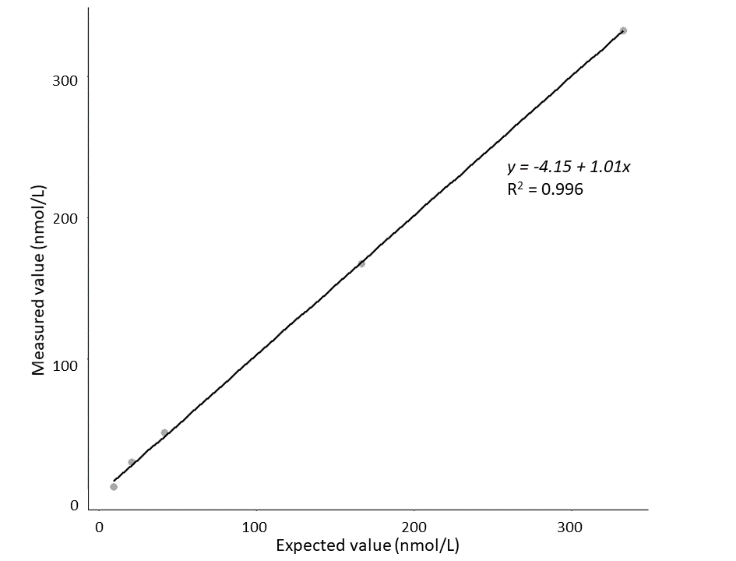

**Supplemental Figure 1:** Calibration curve low concentrations of 5-hydroxytrpyophan.

In this additional experiment the medium QC-sample of 5-hydroxytrpyophan was diluted 2 times, 8 times, and 16 times. The medium and low QC-samples were extracted in four-fold. The dilutions were extracted in duplicate. The number of runs was 3. The R2 of 0.996 indicates excellent linearity.

**Supplemental Table 1:** Mass spectrometry conditions.

|  |  |  |
| --- | --- | --- |
| **Parameters** |  |  |
| Capillary voltage | 3.30 kV |  |
| Source temperature | 150 °C |  |
| Desolvation temperature | 500 °C |  |
| Cone gas | 50 L/h |  |
| Desolvation gas | 1000 L/h |  |
| Ion mode | Electrospray positive ion mode |  |

**Supplemental Table 2:** Liquid chromatography conditions.

|  |  |  |  |  |  |
| --- | --- | --- | --- | --- | --- |
| **Time, min** | **Flow, mL/min** |  | **A, %** | **B, %** | **Curve** |
| Initial | 0.300 |  | 99 | 1 | Initial |
| 5.00 | 0.300 |  | 60 | 40 | 6 |
| 6.00 | 0.300 |  | 10 | 90 | 6 |
| 6.30 | 0.300 |  | 90 | 10 | 6 |
| 7.00 | 0.300 |  | 99 | 1 | 6 |

**Supplemental Table 3:** Analyte concentrations in quality control-samples.

|  |  |  |  |
| --- | --- | --- | --- |
| **Quality control-level** | **Low** | **Medium** | **High** |
| **Analyte** | *Endogenous* | *Spiked* | *Spiked* |
| Tryptophan | ±52 | 30 | 60 |
| Kynurenine | ±2.2 | 0.4 | 4 |
| 5-hydroxytryptophan | ±9 | 400 | 4000 |
| 5-hydroxytryptamine | ±500 | 400 | 4000 |
| 5-hydroxyindole acetic acid | ±65 | 400 | 4000 |

Concentrations of tryptophan and kynurenine are in µmol/L. Concentrations of 5-hydroxytryptophan, 5-hydroxytryptamine and 5-hydroxyindole acetic acid are in nmol/L.

**Supplemental Table 4:** Comparison with a liquid chromatography tandem mass spectrometry method from another laboratory.

|  |  |  |  |  |  |  |  |  |  |  |  |  |  |  |  |  |  |  |  |  |
| --- | --- | --- | --- | --- | --- | --- | --- | --- | --- | --- | --- | --- | --- | --- | --- | --- | --- | --- | --- | --- |
| **Analyte** | **Tryptophan** | | | | **Kynurenine** | | | | **5-hydroxytryptophan** | | | | **5-hydroxytryptamine** | | | | **5-hydroxyindole acetic acid** | | | |
|  | A | B | Difference | %Difference | A | B | Difference | %Difference | A | B | Difference | %Difference | A | B | Difference | %Difference | A | B | Difference | %Difference |
| Low | 52.6 | 57.3 | 4.7 | 8.9 | 2.4 | 2.4 | 0.01 | 0.4 | 8.7 | 7.8 | 0.9 | 10.3 | 507.0 | 535.8 | 28.8 | 5.7 | 67.0 | 49.9 | 17.1 | 25.5 |
| Medium | 83.8 | 88.8 | 5.0 | 6.0 | 2.7 | 2.8 | 0.1 | 3.7 | 368.0 | 325.6 | 42.4 | 11.5 | 889.0 | 936.3 | 47.3 | 5.3 | 463.9 | 353.7 | 110.2 | 23.8 |
| High | 111.3 | 113.8 | 2.5 | 2.2 | 5.5 | 6.1 | 0.6 | 10.9 | 3306.0 | 2783.4 | 522.6 | 15.8 | 4398.0 | 4391.9 | 6.1 | 0.1 | 3905.4 | 2879.7 | 1025.7 | 26.3 |
| Calibrator 1 | 60.2 | 66.9 | 6.7 | 11.1 | 4.1 | 3.6 | 0.5 | 12.2 | 3815.4 | 3495.6 | 319.8 | 8.4 | 3811.3 | 4038.7 | 227.4 | 6.0 | 3858.3 | 3720.1 | 138.2 | 3.6 |
| Calibrator 2 | 100.2 | 109.6 | 9.4 | 9.4 | 6.2 | 5.8 | 0.4 | 6.5 | 6066.2 | 5408.1 | 658.1 | 10.8 | 6135.1 | 6424.7 | 289.6 | 4.7 | 6002.0 | 5882.1 | 119.9 | 2.0 |

A is our liquid chromatography tandem mass spectrometry method and B is a liquid chromatography tandem mass spectrometry method from the Department of Laboratory Medicine, University Medical Center Groningen. Concentrations of 5-hydroxytryptophan, 5-hydroxytryptamine and 5-hydroxyindole acetic acid are in nmol/L. Concentrations of tryptophan and kynurenine are in µmol/L. Low, medium and high refer to quality control samples. Differences are presented in absolute concentrations and relative differences in percentages (absolute differences divided by analyte concentrations measured by our method, multiplied by 100%).