Supplementary information associated with

Quantitative Protein Mass-Spectrometry Requires a Standardized Pre-Analytical Phase.

Nico P.M. Smit¹, Fred P.H.T.M. Romijn¹, Vanessa J.J. van Ham², Esther Reijnders¹, Christa M. Cobbaert¹, L. Renee Ruhaak¹

¹Department of Clinical Chemistry and Laboratory Medicine and ²Biobank Facility, Leiden University Medical Center, Leiden, The Netherlands

Contents:

Table ST1: Blood collection tubes
Table ST2: Apolipoprotein dMRM specification
Figure S1: (a) Matrix and (b) peptide comparisons of additional peptides
Table ST3: Calculated TE values Apos based on bias and EP15 imprecision
Figure S2: Difference plots for matrix comparisons
Table ST4A,B: Statistics One Way Anova matrix comparisons
Figure S3 and Table ST5; ITA measurement for ApoA-I and ApoB, matrix comparison
Figure S4; Digestion kinetics 9 apolipoproteins
Table ST6; Digestion kinetics at 3 hours

Tube Code | Tube Type | Gel | Volume (ml) | BD ref. | n | % male
3B | Plasma, sodium citrate (9NC) | no | 2.7 | # 363048 | 44 | 32
4A | Serum, clot activator tube (CAT) | no | 4 | # 369032 | 44 | 32
5B | Serum, separator tubes (SST) | yes | 3.5 | # 367957 | 44 | 32
6B | Plasma, lithium heparin (LHPST) | yes | 3 | # 367374 | 44 | 32
7B | Plasma, K₂EDTA (K2E) | no | 4 | # 368861 | 43 | 33
PIC | Plasma, K2E + protease inhibitor (PIC) | no | 2 | # 366422 | 44 | 32

Table ST1. Beckton Dickinson blood collection tubes.
For all blood tubes 44 donors were measured in duplicate, except for the 7B (K₂EDTA) tubes (one missing sample n=43).
For all blood tubes 44 donors were measured in duplicate, except for the 7B (K₂EDTA) tubes (one missing sample n=43).

Apo | Peptide | Prec m/z | CE (V) | Ion 1 | CE (V) | Ion 2 | CE (V) | Ion 3 | Rt (min)
A-I | AKPALEDLR | 338.2 | 14 | 288.2 | 5 | 532.4 | 5 | 403.2 | 6.8
 | VQPYLDDFQK | 626.8 | 15 | 228.1 | 15 | 1025.5 | 25 | 765.4 | 9.3
(a) | LFLEPTQADIALLK | 786.4 | 25 | 1069.6 | 25 | 1198.7 | 25 | 374.2 | 13.3
 | GISSTTVTGR | 489.8 | 15 | 808.4 | 15 | 634.4 | 15 | 533.3 | 5.9
 | GTYSTTVTGR | 521.8 | 20 | 634.4 | 20 | 721.5 | 20 | 533.3 | 5.3
A-II | SPELQAEAK | 486.7 | 18 | 443.2 | 18 | 788.4 | 18 | 659.4 | 5.2
 | EQLTPLIK | 471.2 | 15 | 571.4 | 15 | 684.5 | 25 | 260.2 | 9.9
A-IV | LEPYADQLR | 552.8 | 15 | 431.7 | 25 | 602.3 | 15 | 243.1 | 8.1
 | LTPYADEFK | 542.2 | 12 | 435.2 | 25 | 609.3 | 12 | 215.1 | 8.8
 | SLAPYAQDTQEK | 675.8 | 18 | 540.3 | 18 | 575.8 | 25 | 201.1 | 6.8
B | TGISPLALIK | 506.8 | 15 | 741.5 | 15 | 654.5 | 15 | 272.2 | 12.4
 | TEVIPPLIENR | 640.9 | 15 | 838.5 | 15 | 443.2 | 15 | 330.2 | 11.4
B100 | FPEVDVLTK | 524.3 | 18 | 450.8 | 18 | 900.5 | 18 | 803.5 | 11.2
C-I | EFGNTLEDK | 526.7 | 15 | 605.3 | 15 | 776.5 | 15 | 391.2 | 7.0
 | TPDVSSALDK | 516.8 | 19 | 466.2 | 19 | 834.4 | 19 | 620.3 | 7.6
C-II | ESLSSYWESAK | 643.8 | 19 | 957.4 | 19 | 870.4 | 19 | 783.4 | 9.6
 | TYLPAVDEK | 518.3 | 15 | 265.1 | 15 | 771.4 | 15 | 658.3 | 8.4
C-III | GWVTDGFSSLK | 598.8 | 18 | 244.1 | 15 | 953.5 | 15 | 854.4 | 11.3
 | DALSSVQESQVAQQAR | 572.9 | 15 | 502.2 | 12 | 300.2 | 15 | 672.4 | 8.8
E | SELEEQLTPVAEETR | 577.6 | 15 | 801.4 | 12 | 829.4 | 20 | 605.2 | 10.0
 | LGPLVQGR | 484.8 | 20 | 588.3 | 20 | 701.4 | 18 | 489.2 | 7.8
E34 | LAVYQAGAR | 474.8 | 14 | 665.3 | 14 | 764.4 | 14 | 502.3 | 6.7
E2 | C[cm]LAVYQAGAR | 554.8 | 20 | 835.4 | 20 | 764.4 | 20 | 665.3 | 7.3
E4 | LGADMEDVR | 503.2 | 20 | 764.3 | 20 | 649.3 | 20 | 518.3 | 7.5
E23 | LGADMEDVC[cm]GR | 611.8 | 20 | 735.3 | 20 | 981.4 | 20 | 866.3 | 7.9

Table ST2. M/z values, retention times (Rt) and collision energies (CE) for the 3 MRM transitions measured for 22 peptides of 9 apolipoproteins as published earlier for 6 apos (4). Apo(a), A-II and A-IV were newly added in the MRM-MS/MS measurements of the multiplex apolipoproteins. Bold and underlined amino acids indicate labeled Valine (+6), Leucine (+7), Lysine (+8) or Arginine (+10) in the corresponding SIL peptides (measured with identical transitions with correction for expected mass shift). [cm] Represents the carbamydomethylation of the cysteine causing a +57 mass shift. E2, E3 and E4 indicates the apoE isoforms where the peptides will be encountered.
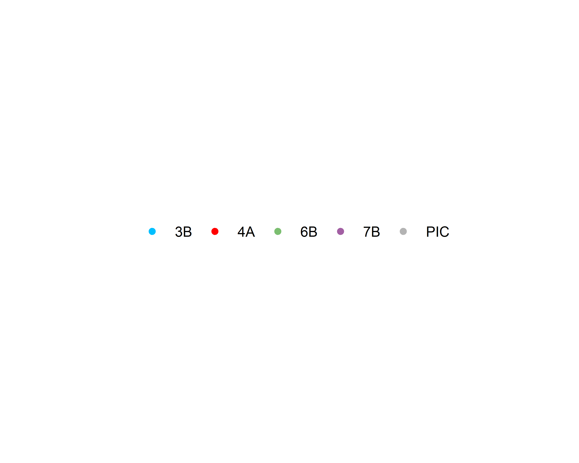
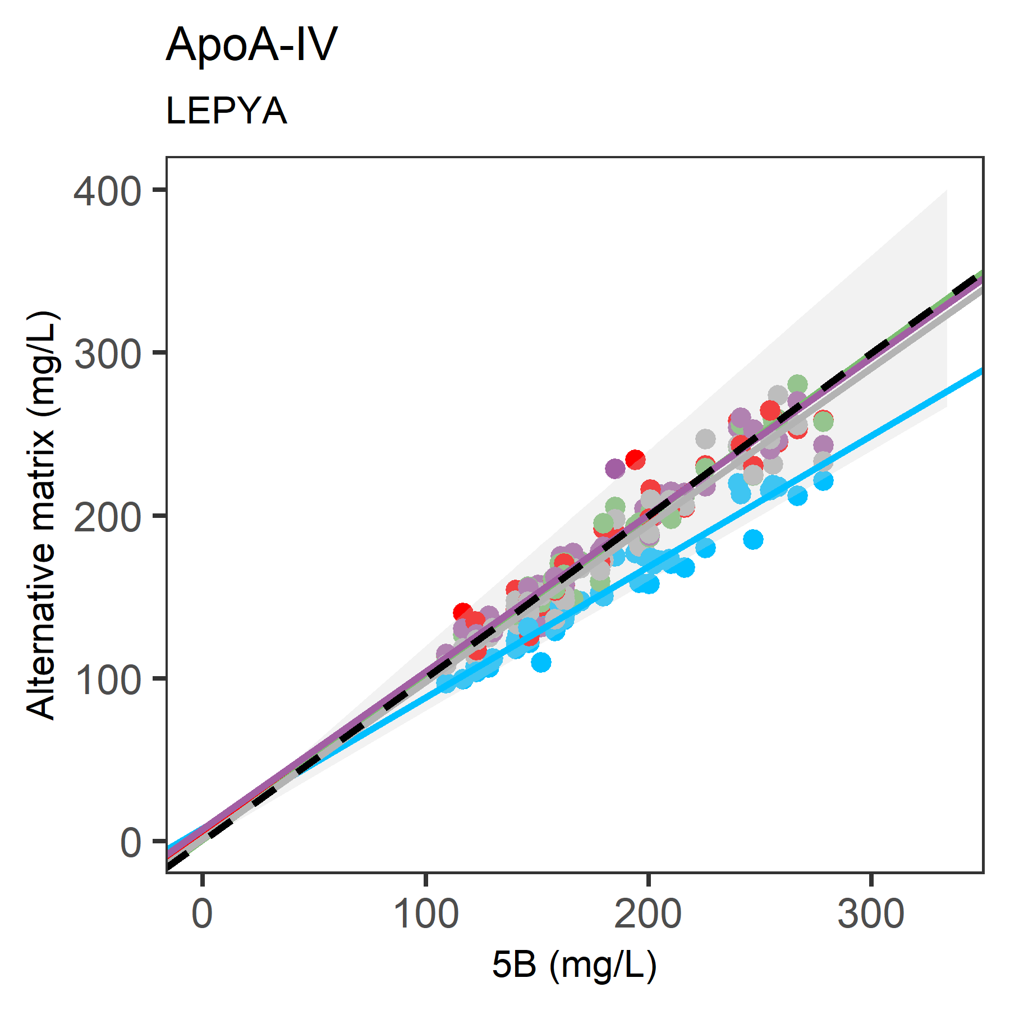
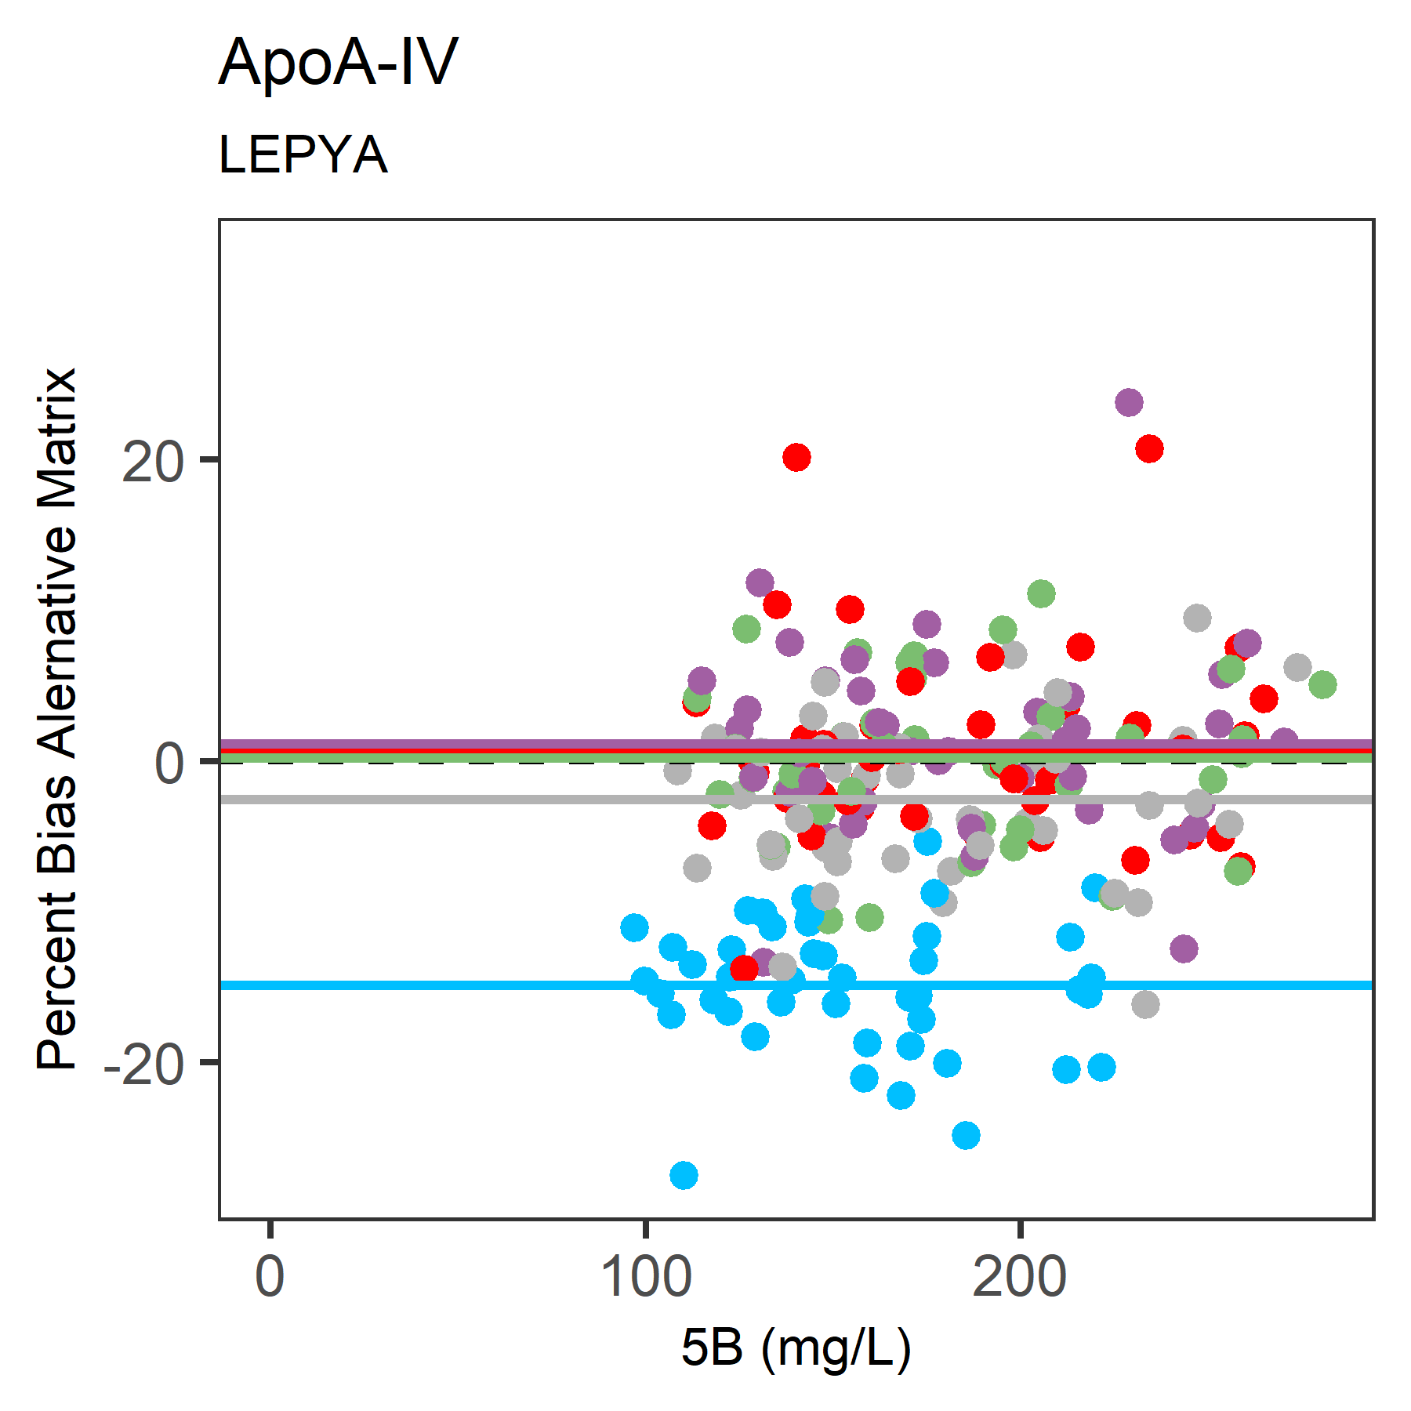
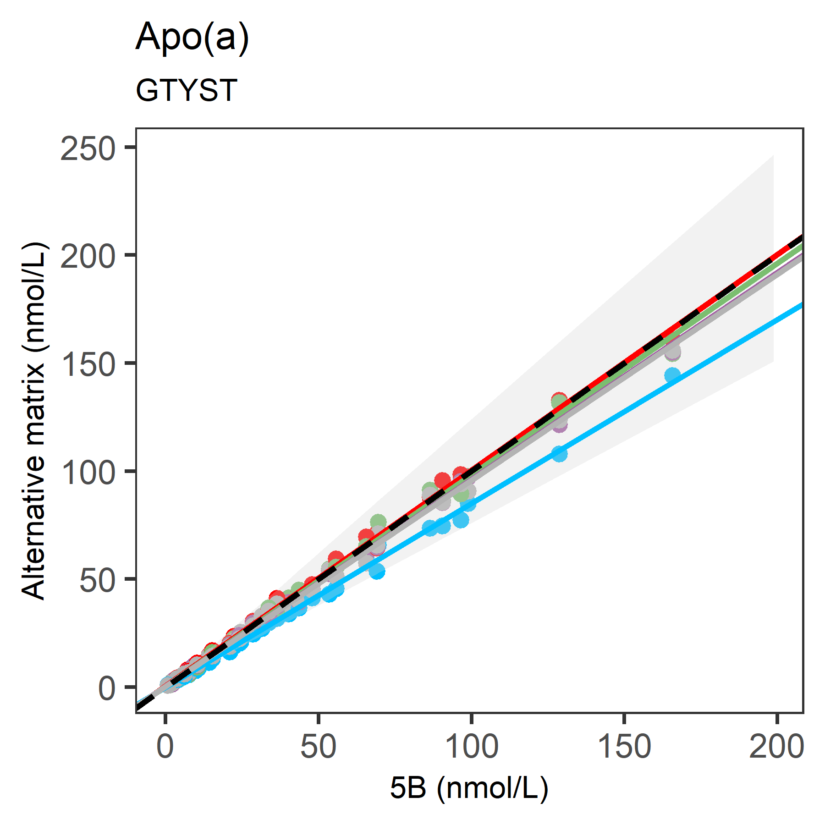
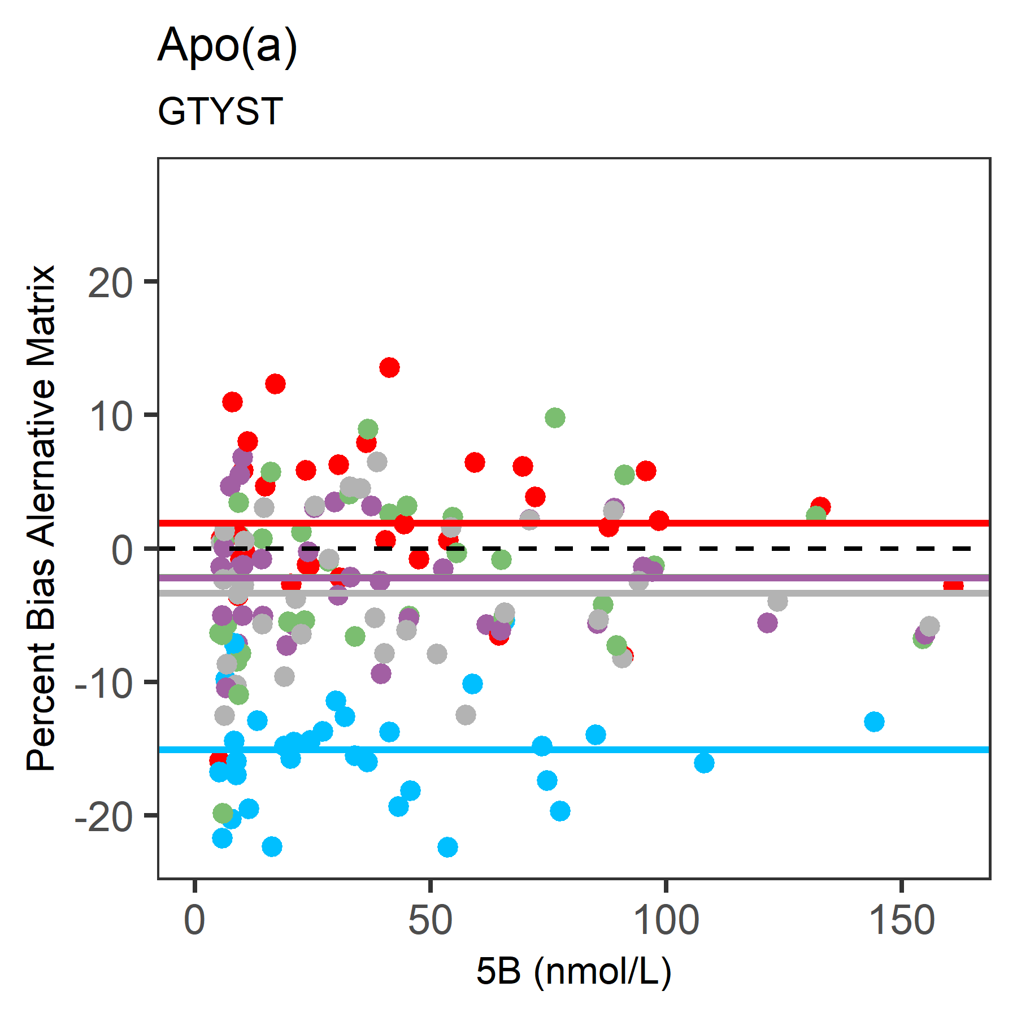
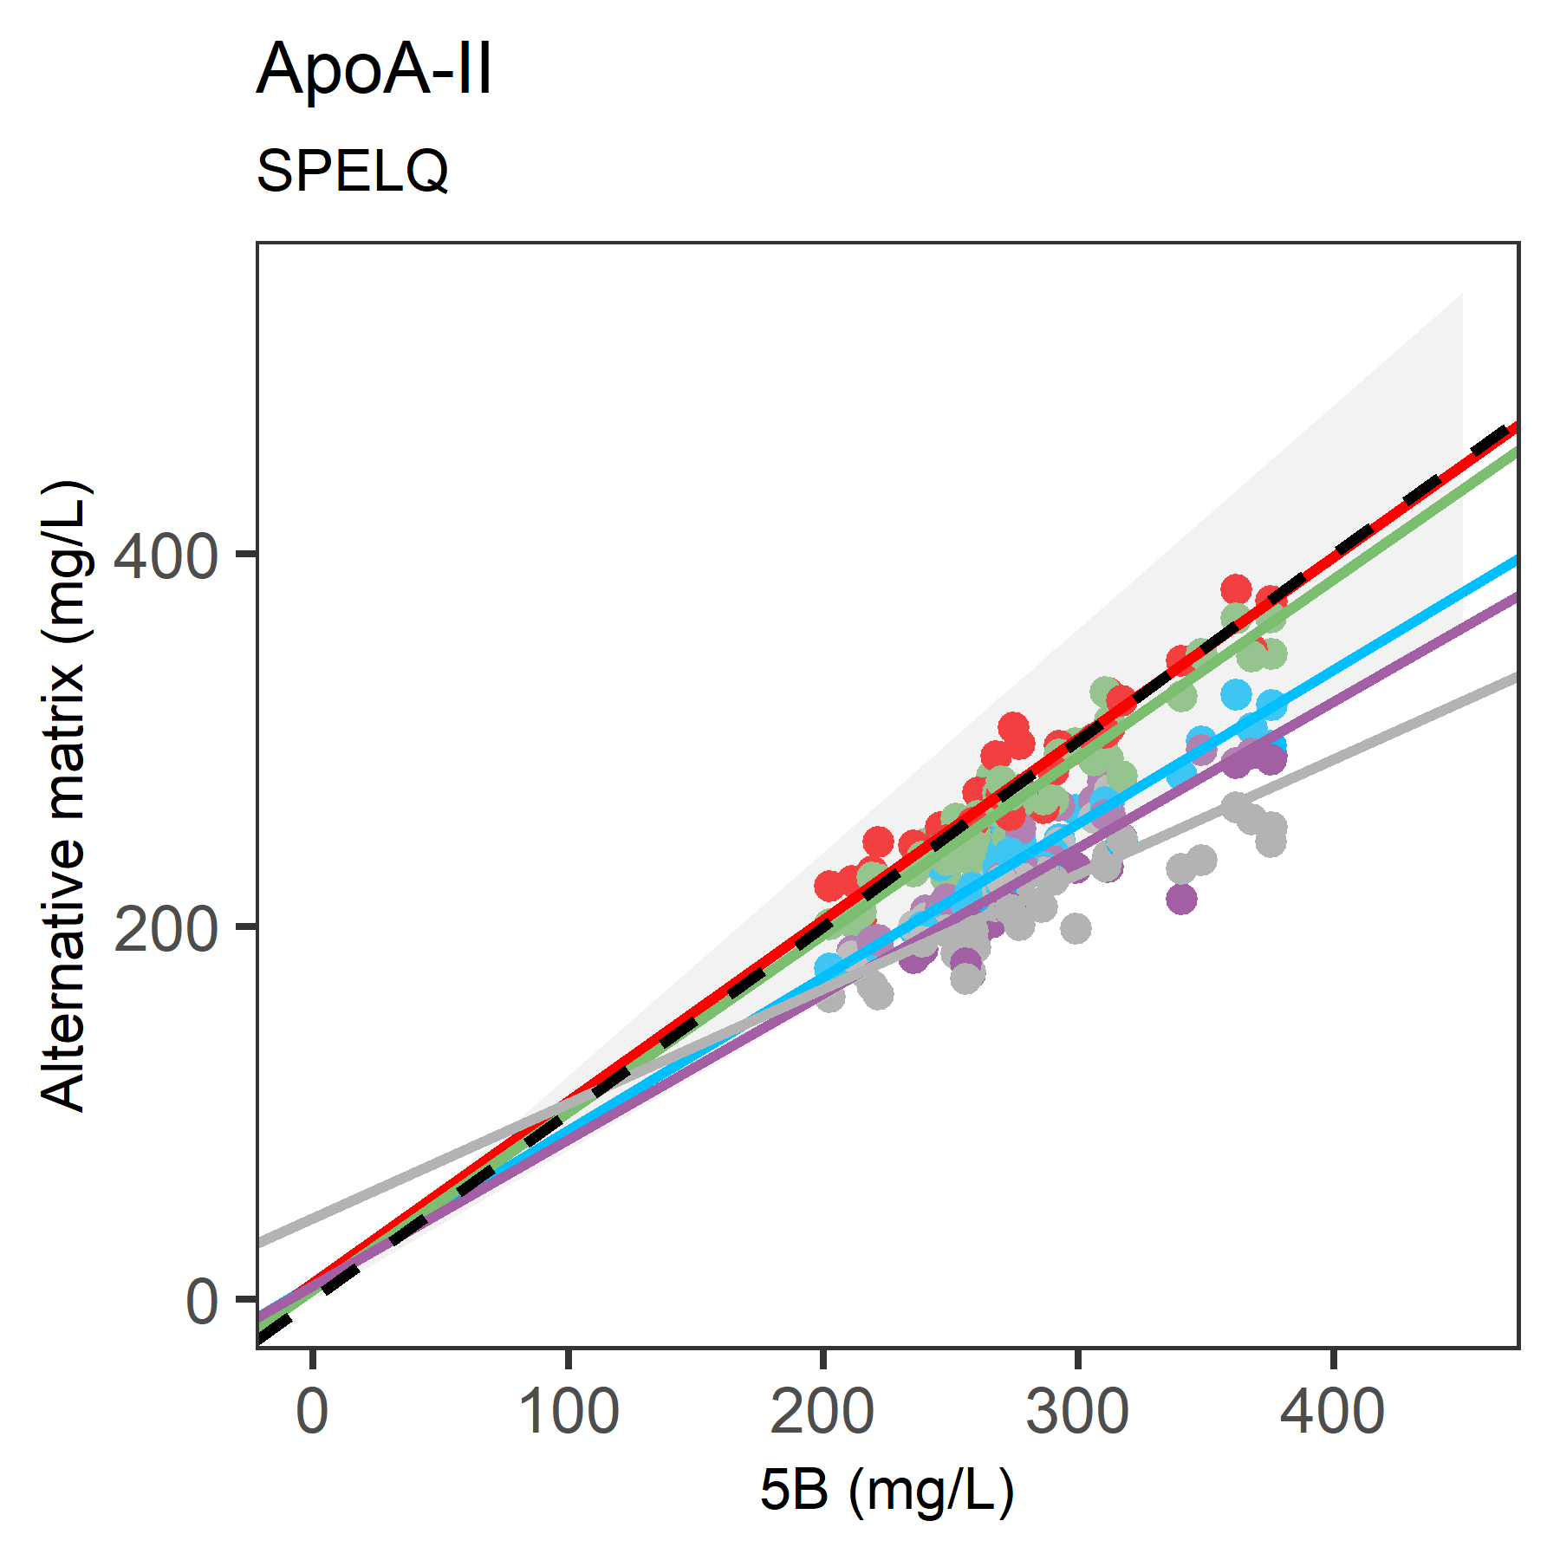
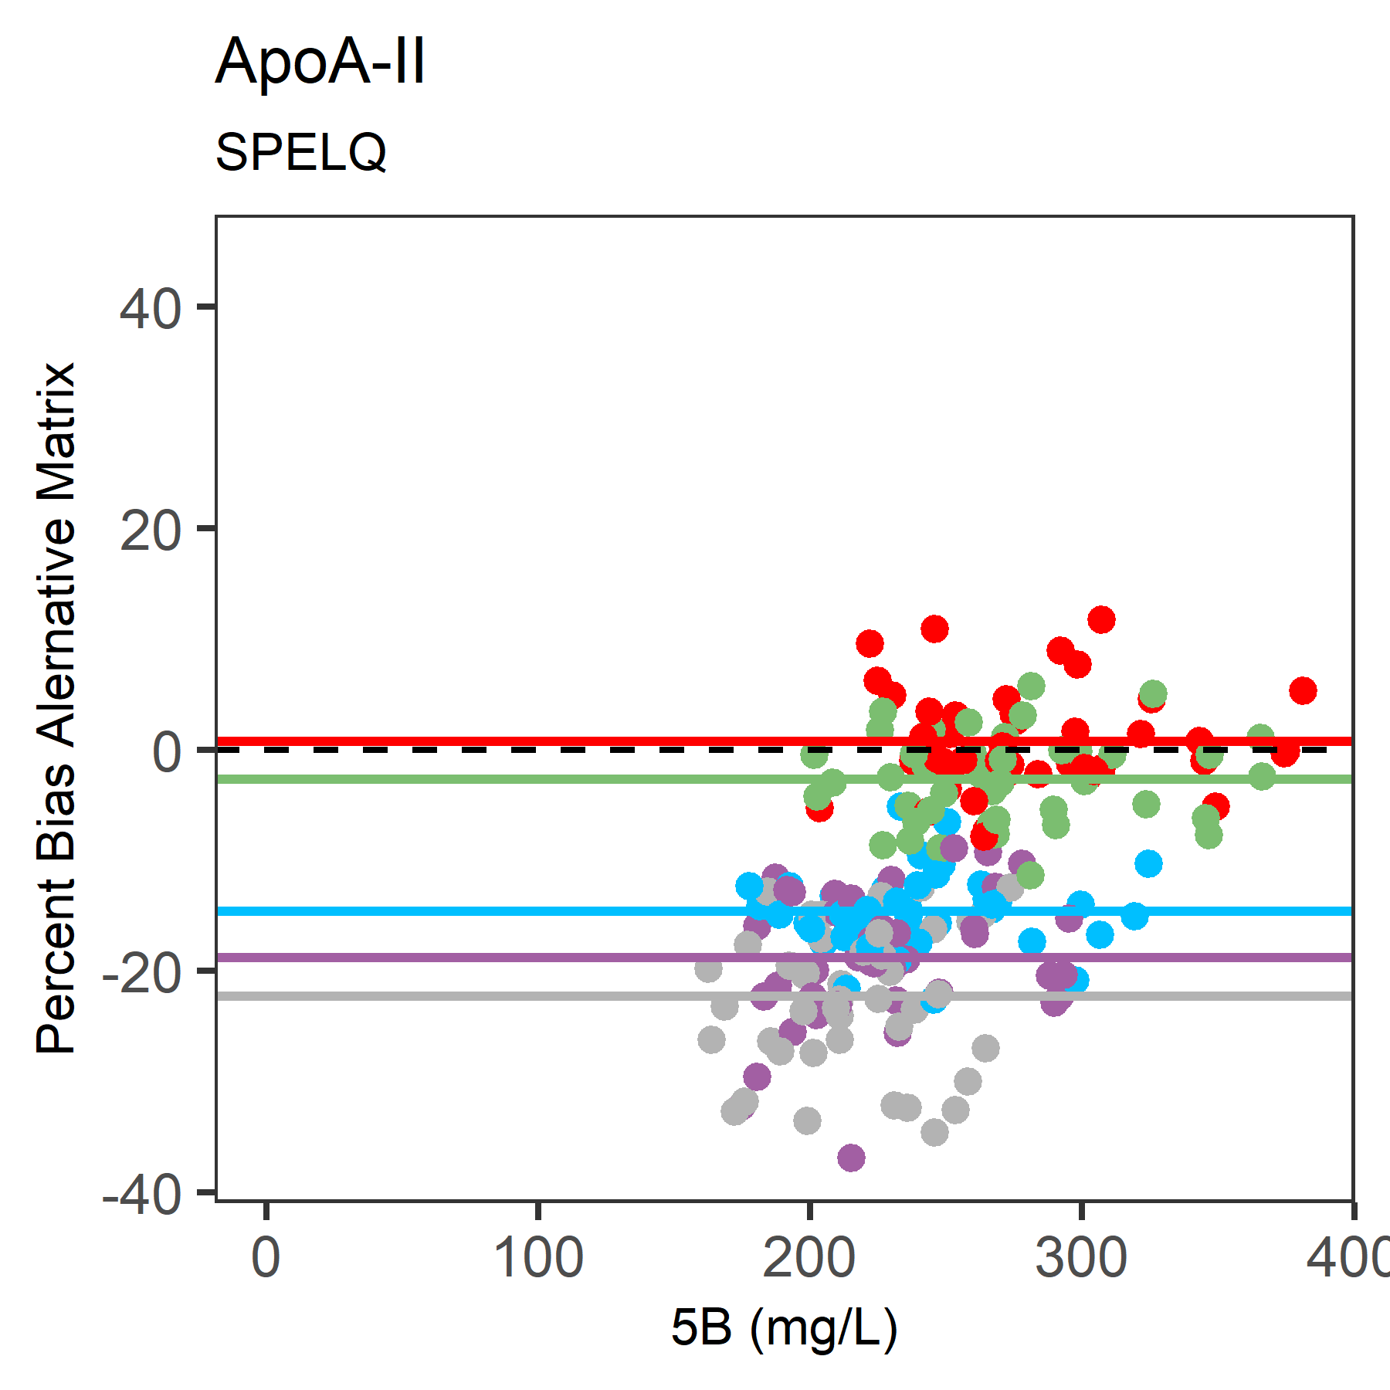
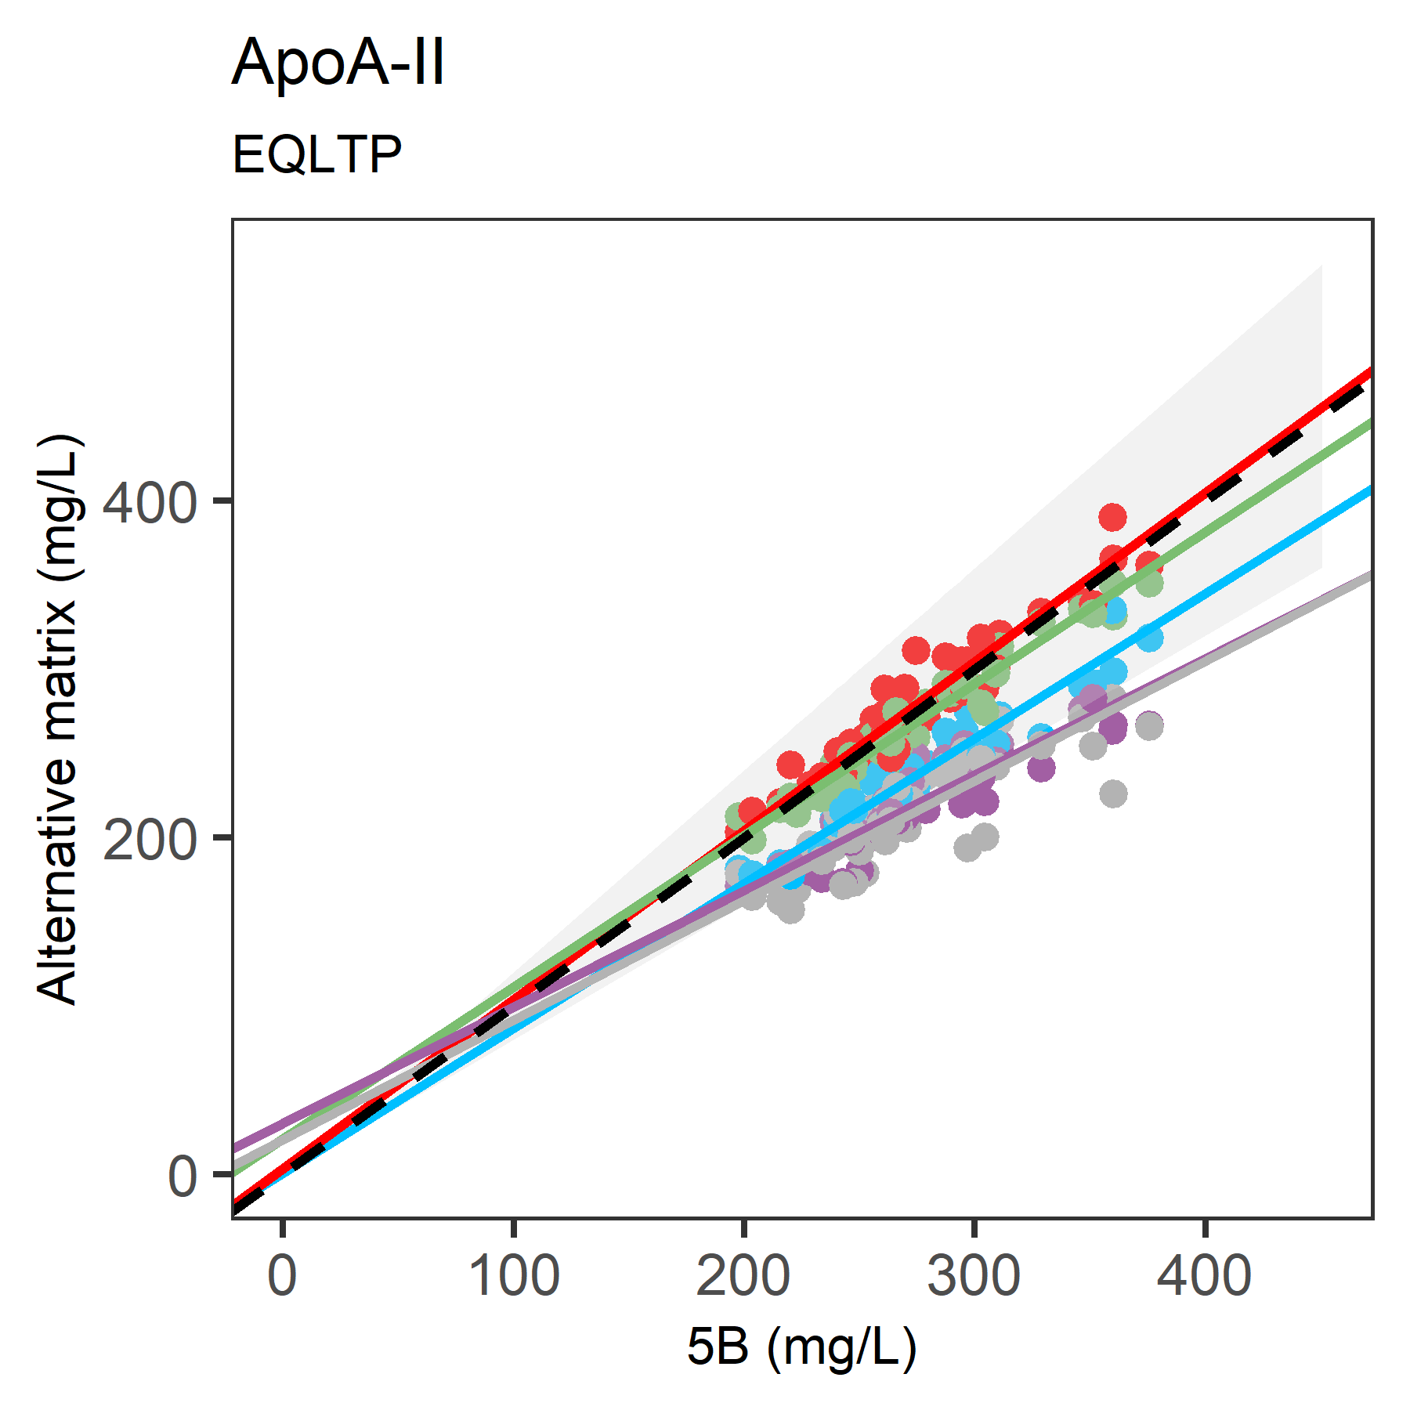
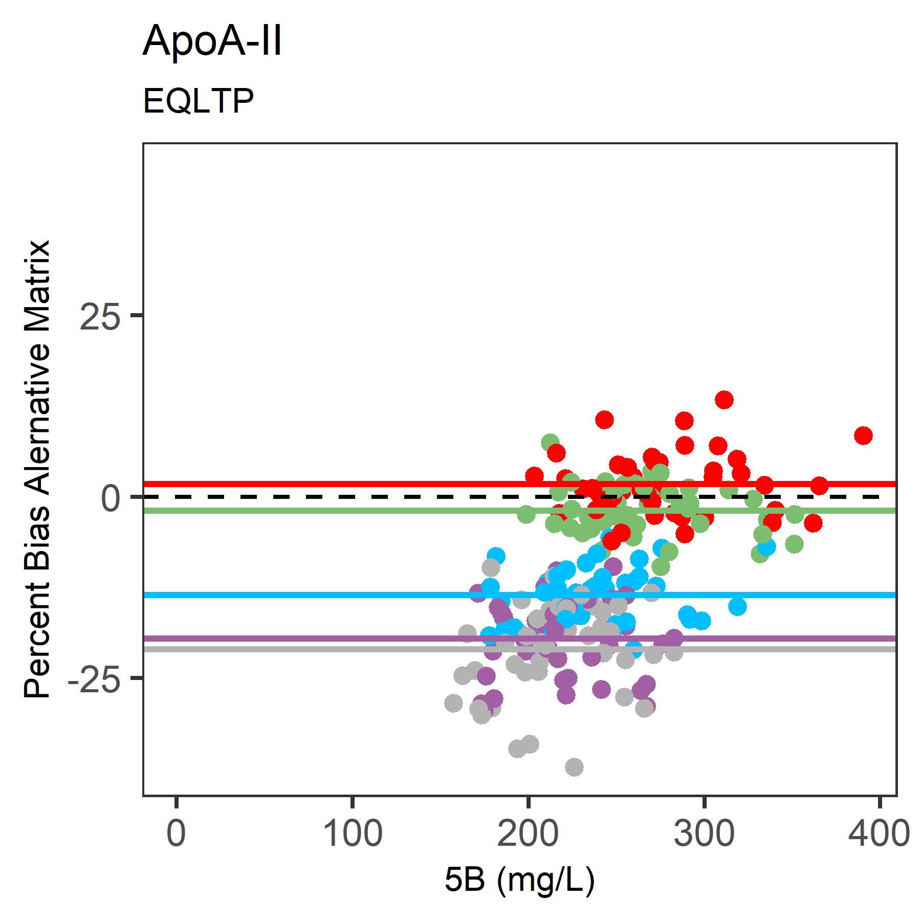
Matrix comparisons.
S1(A)
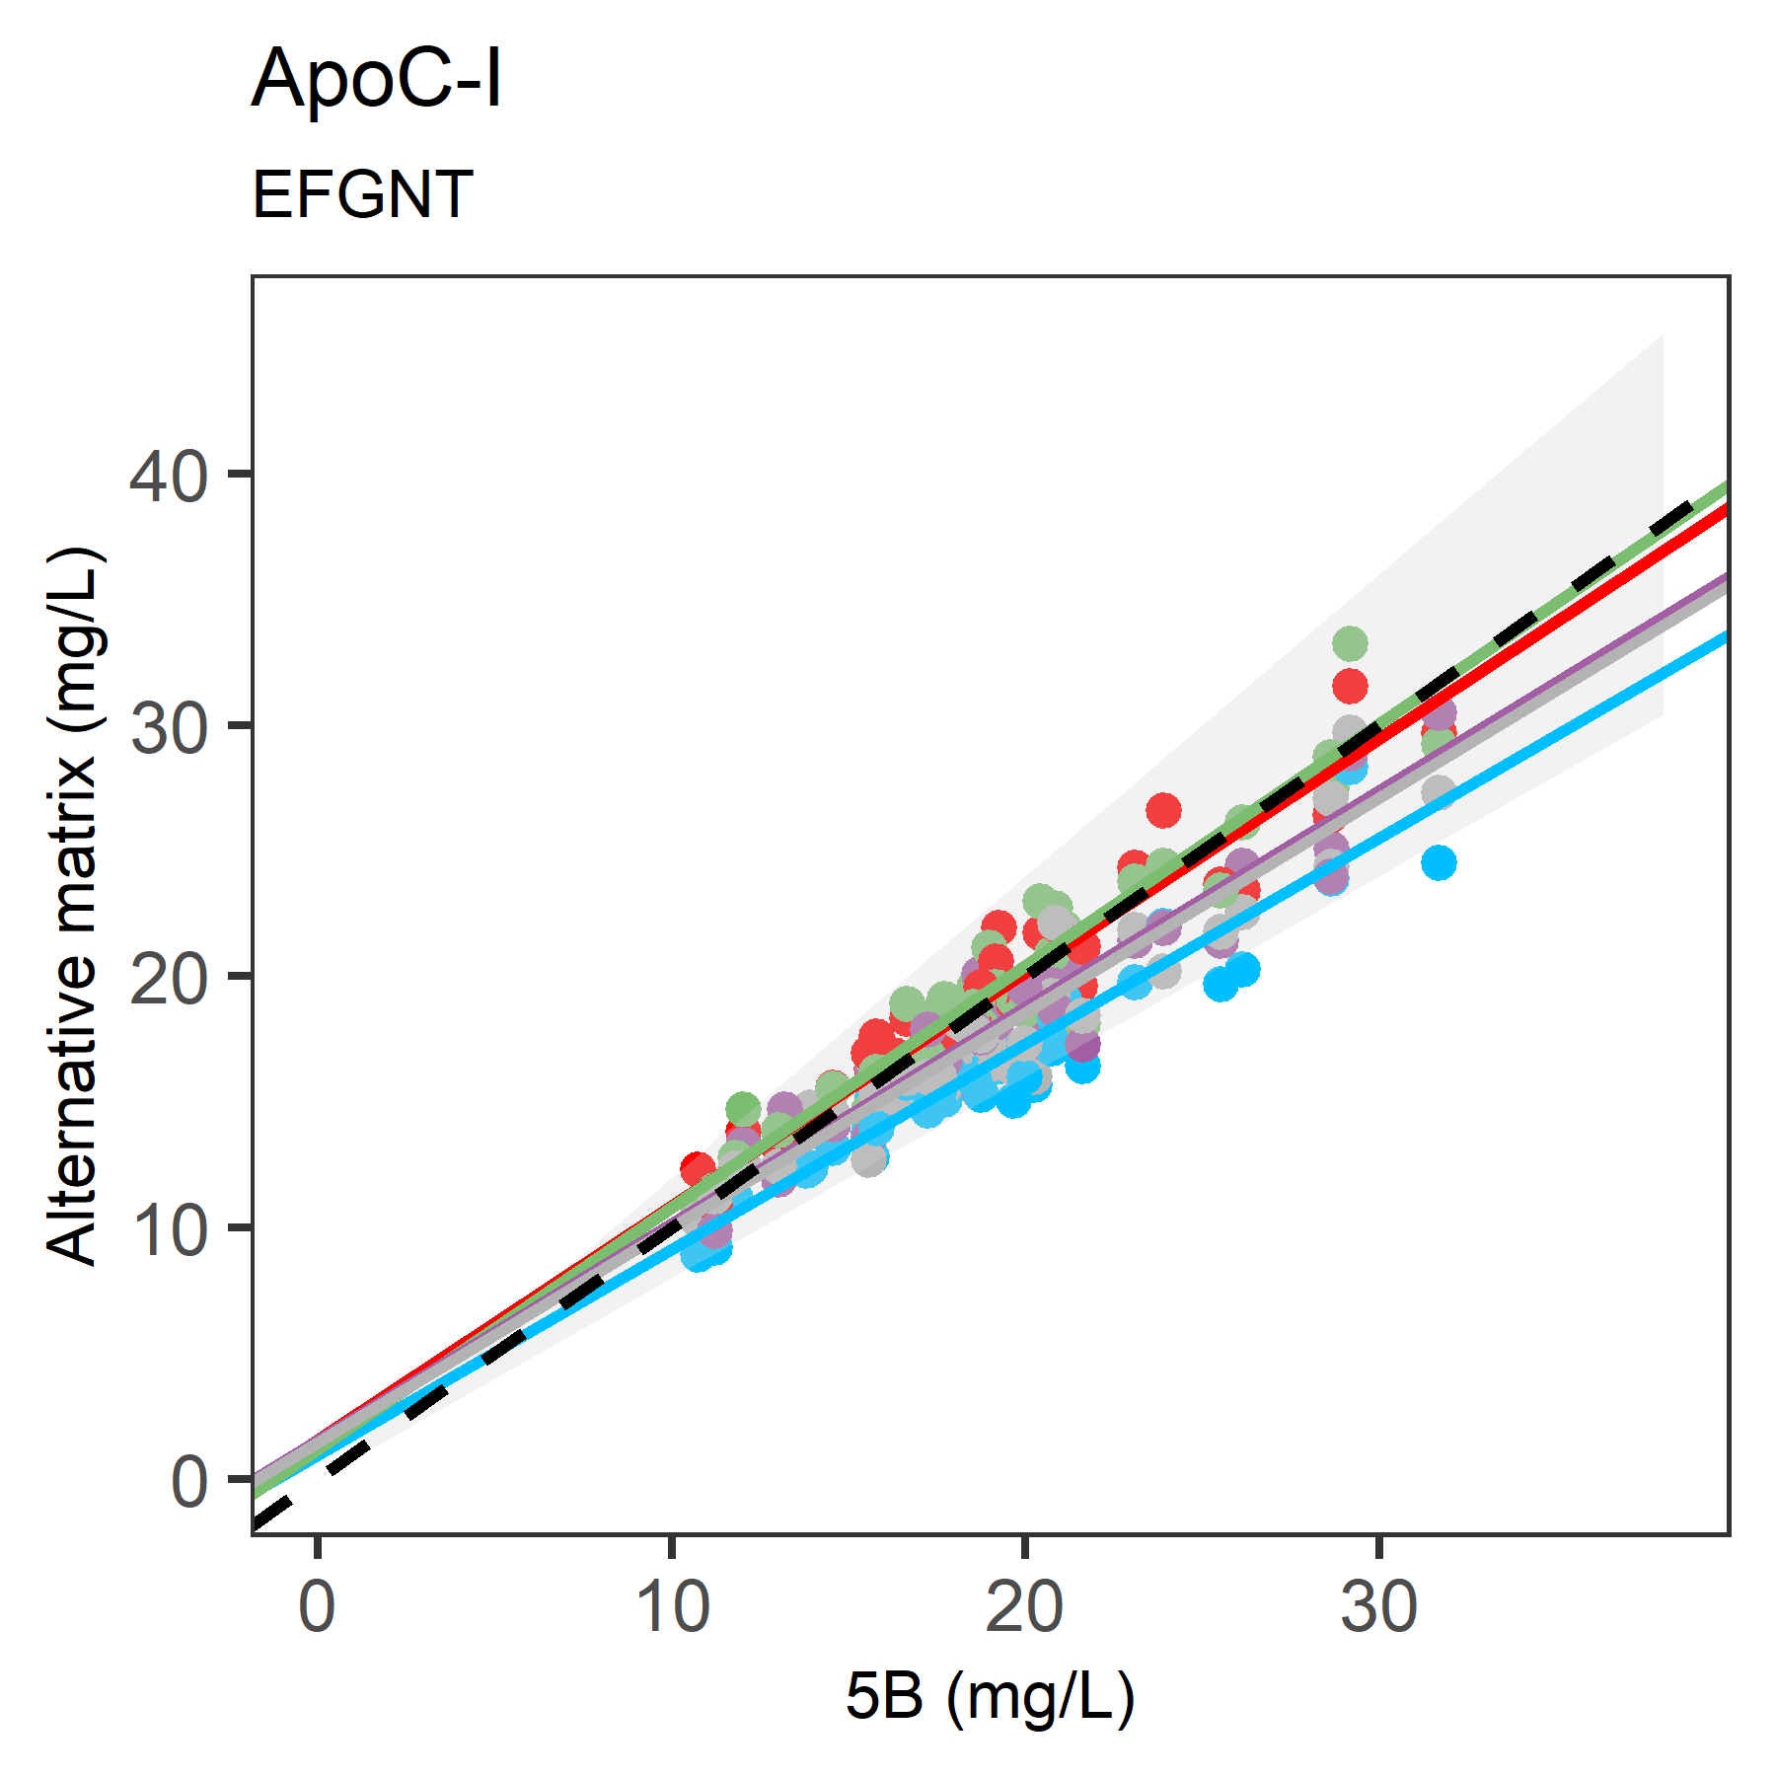
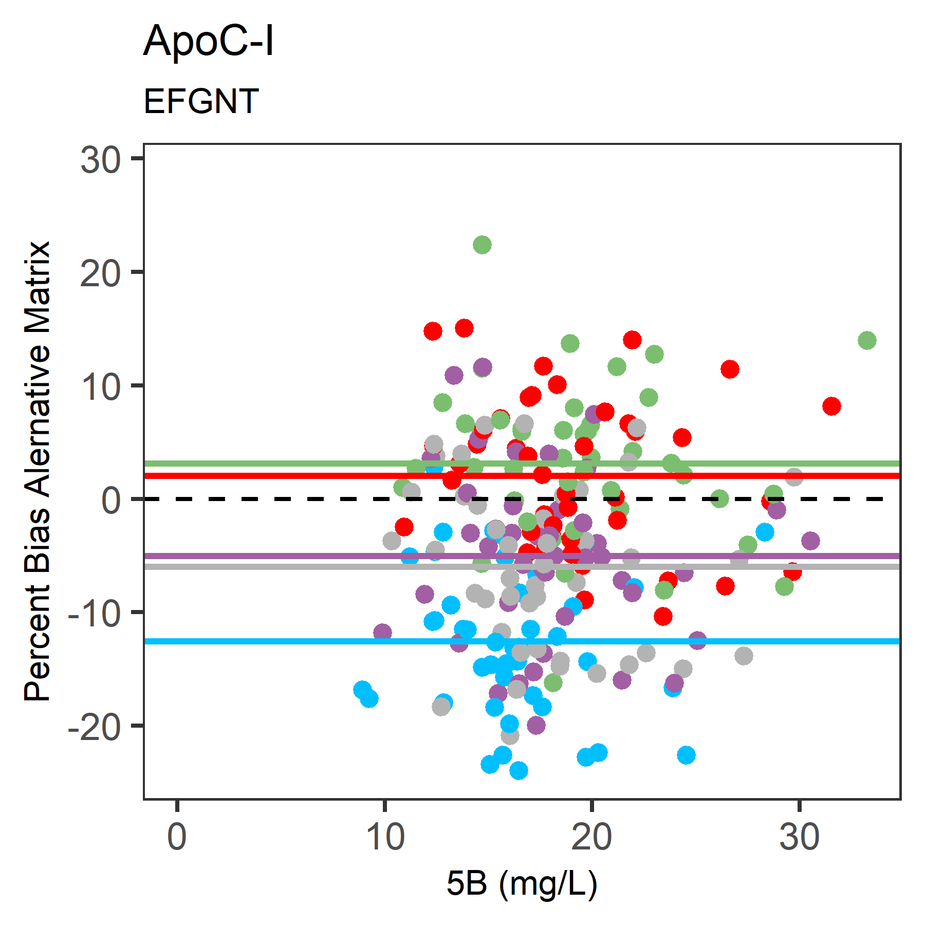
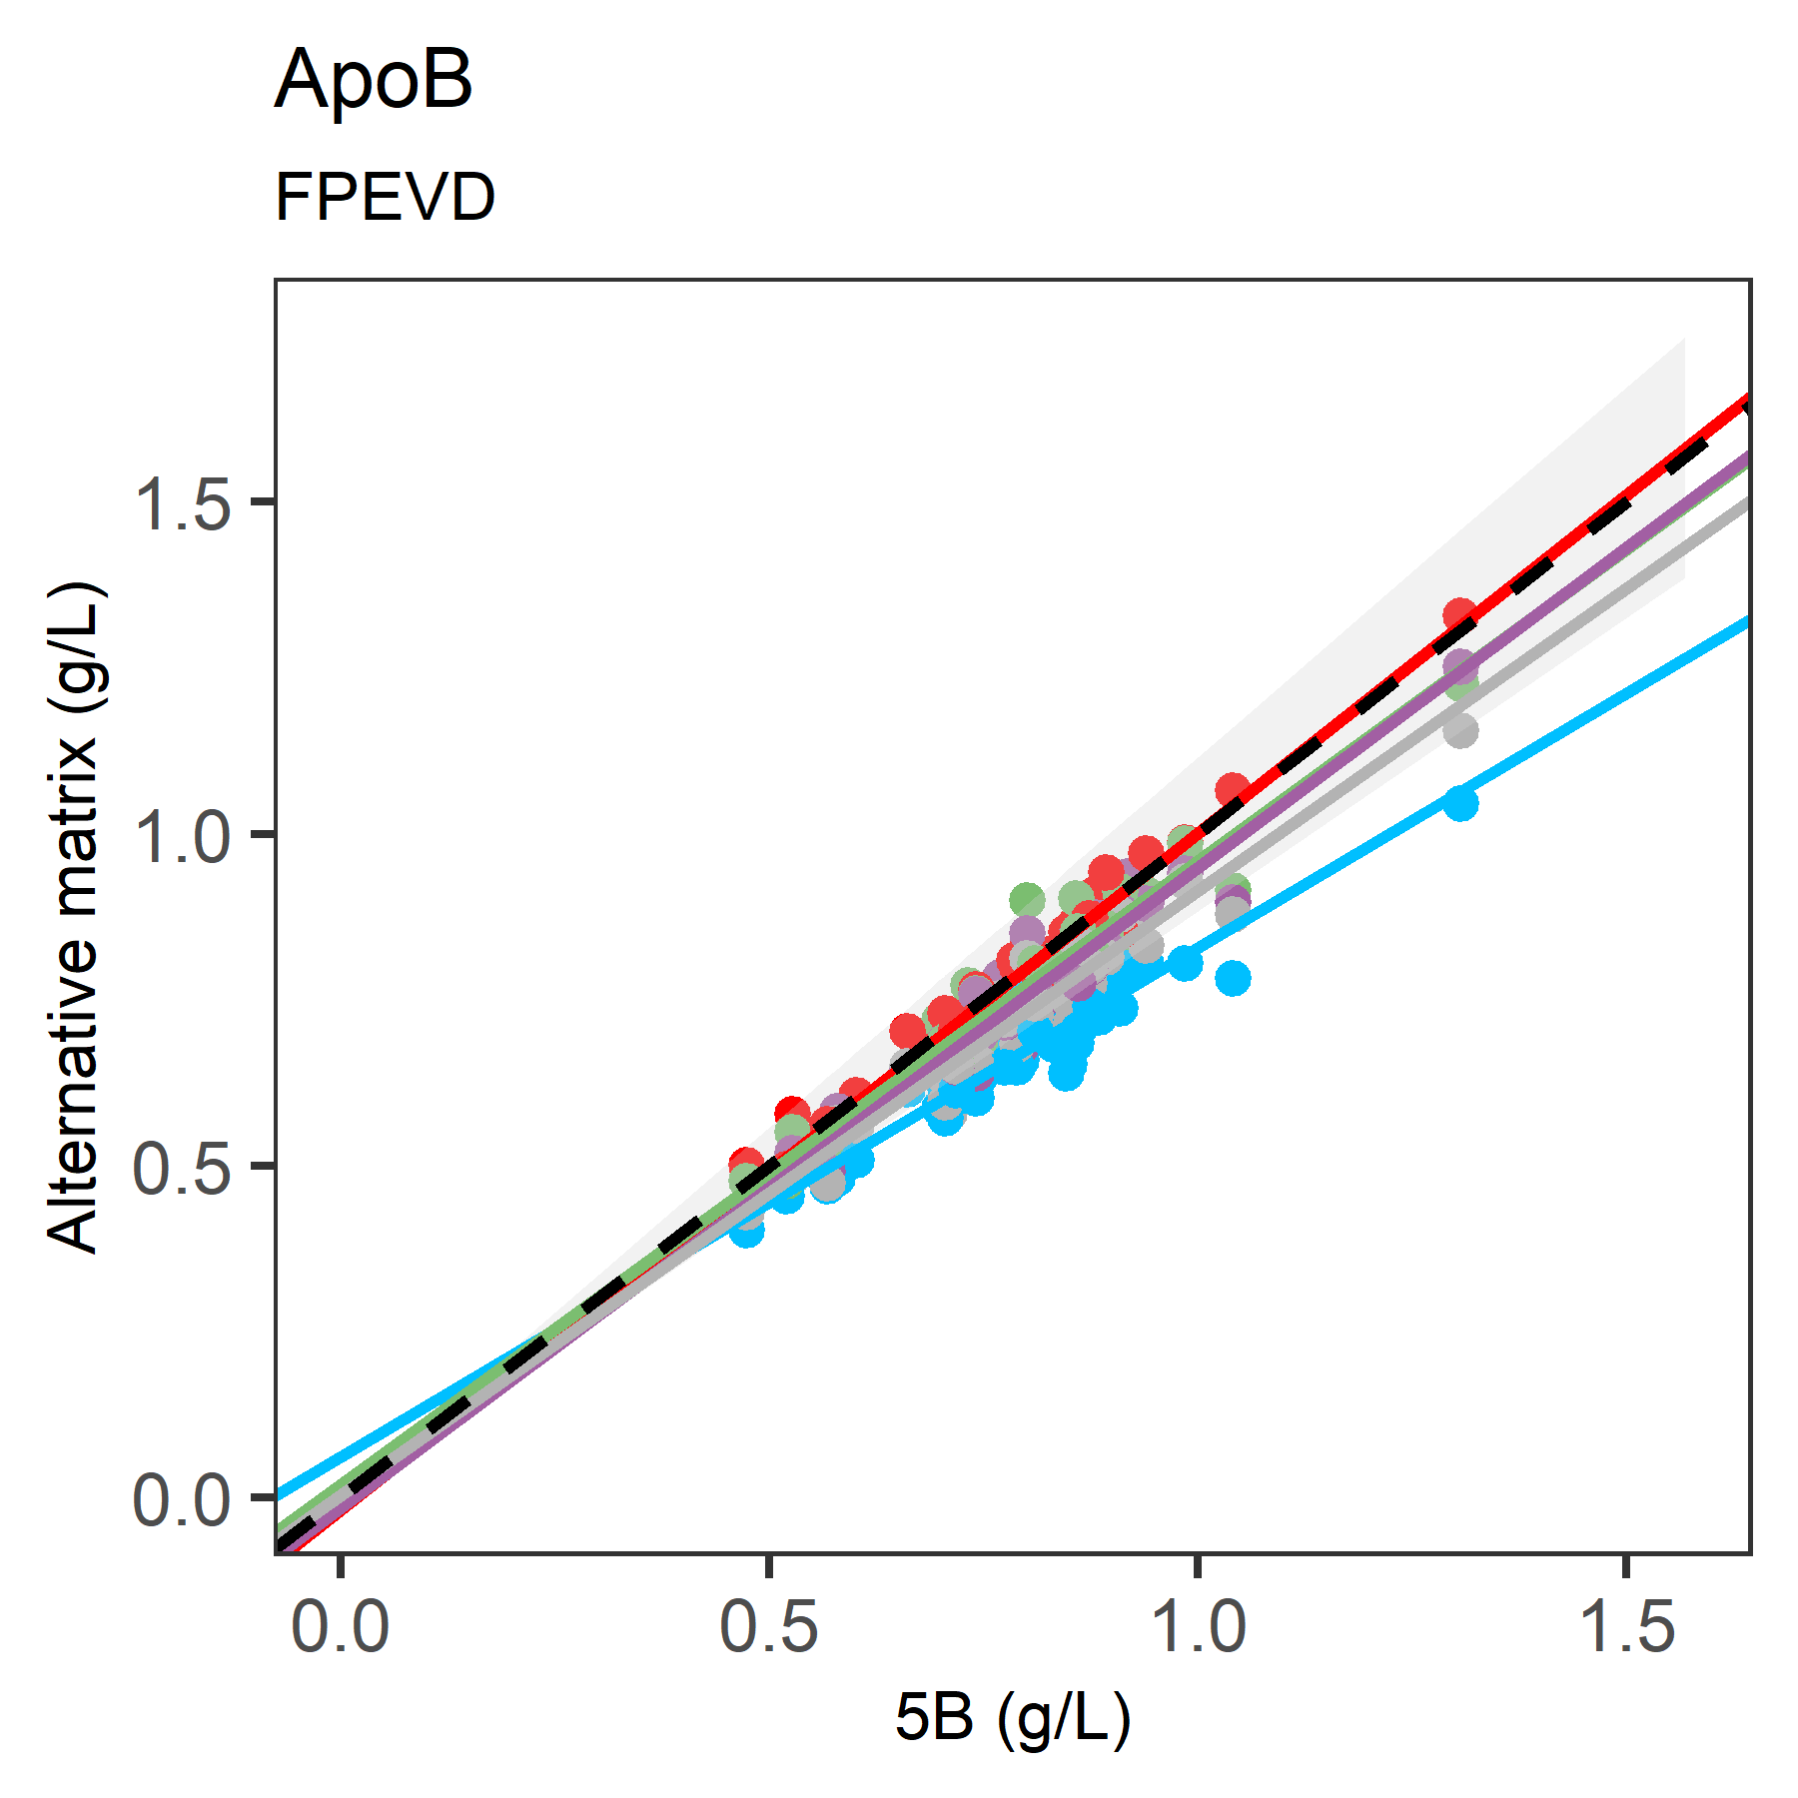
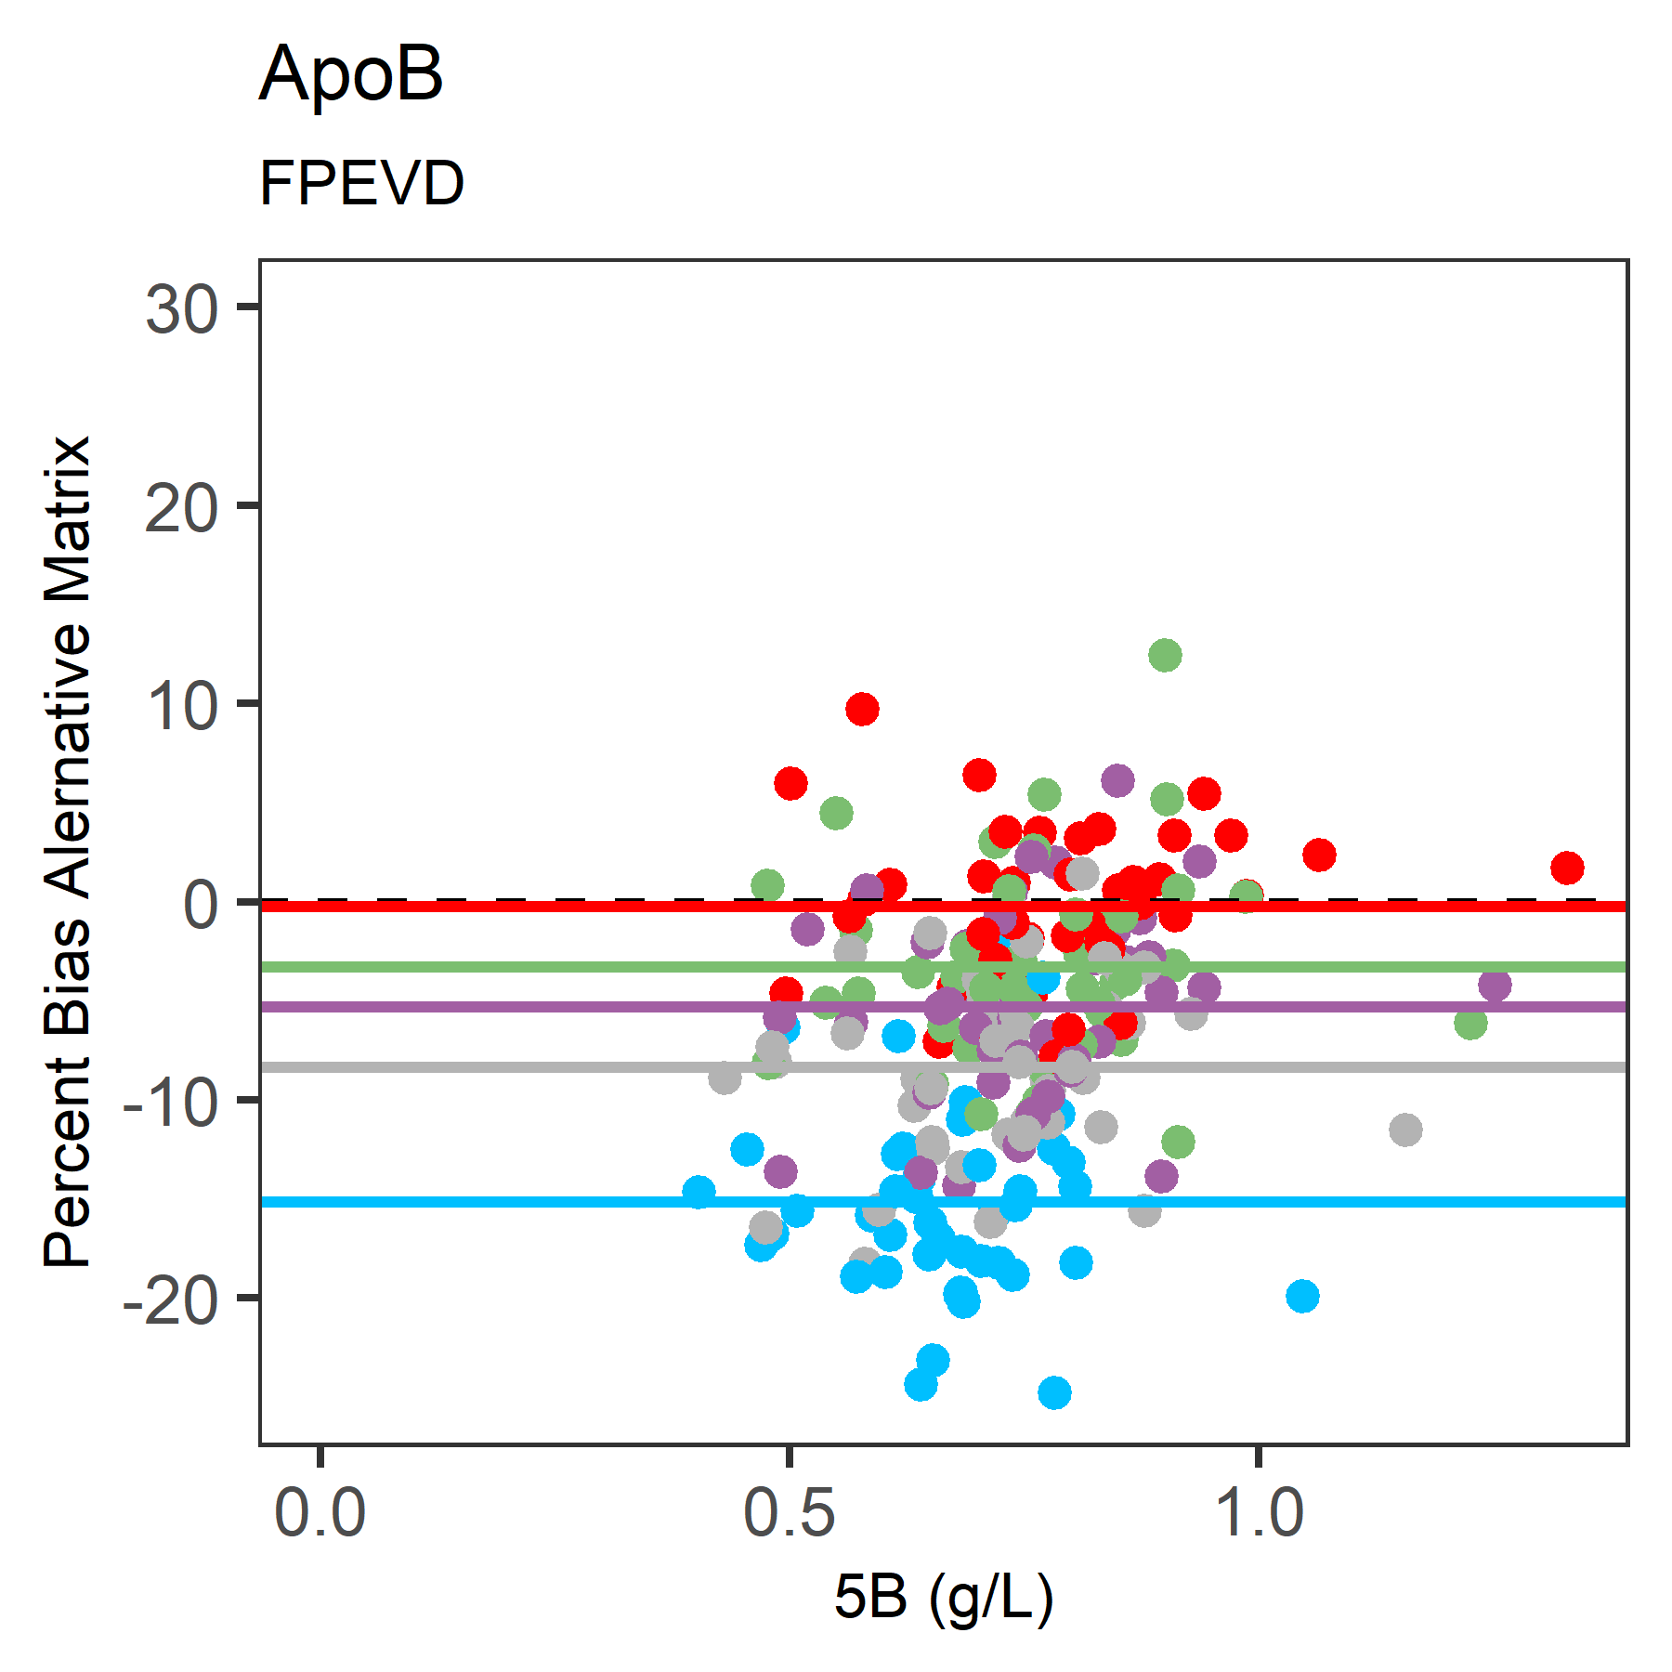
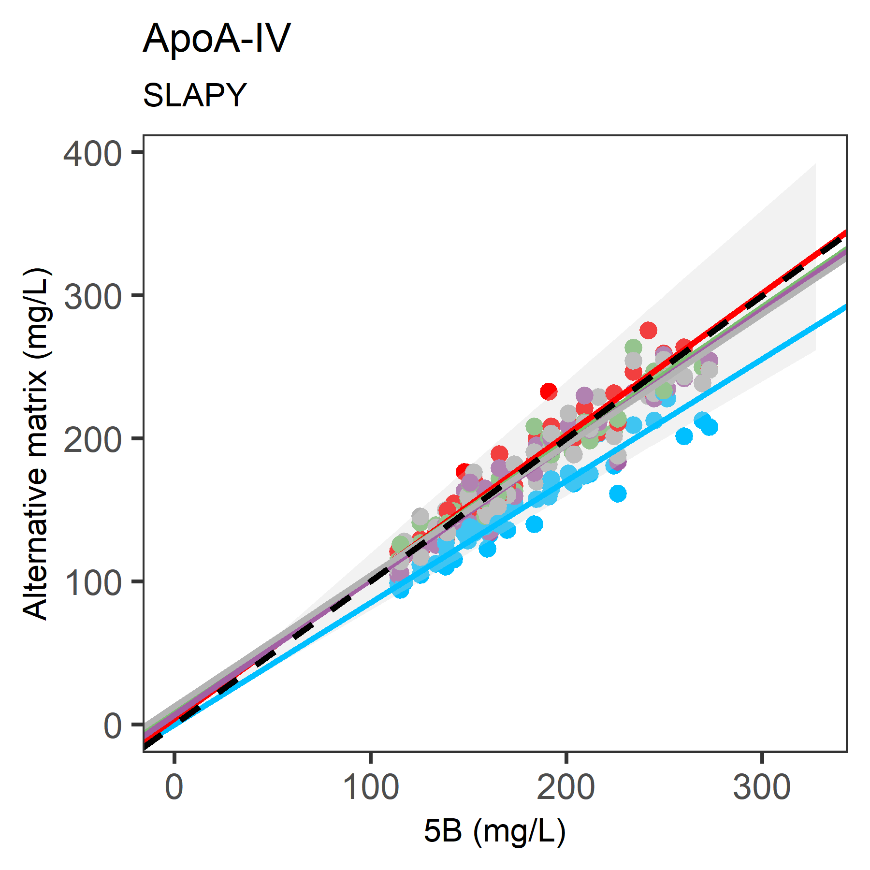
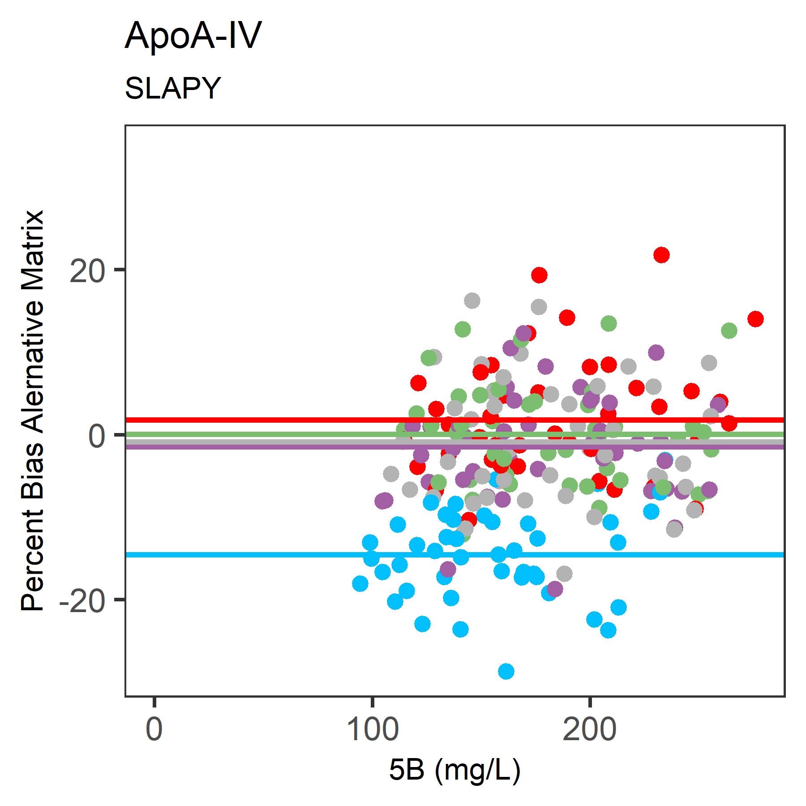
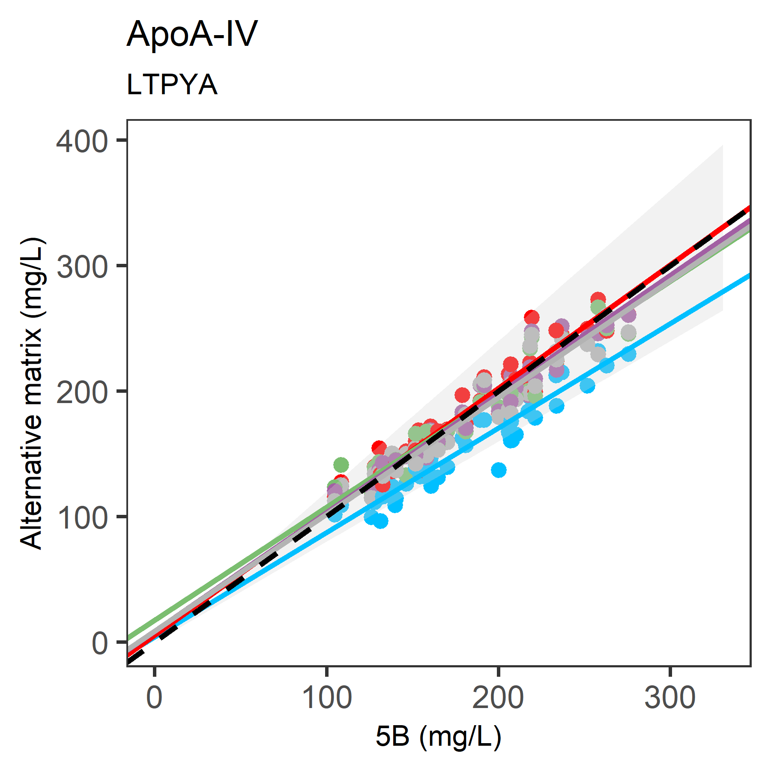
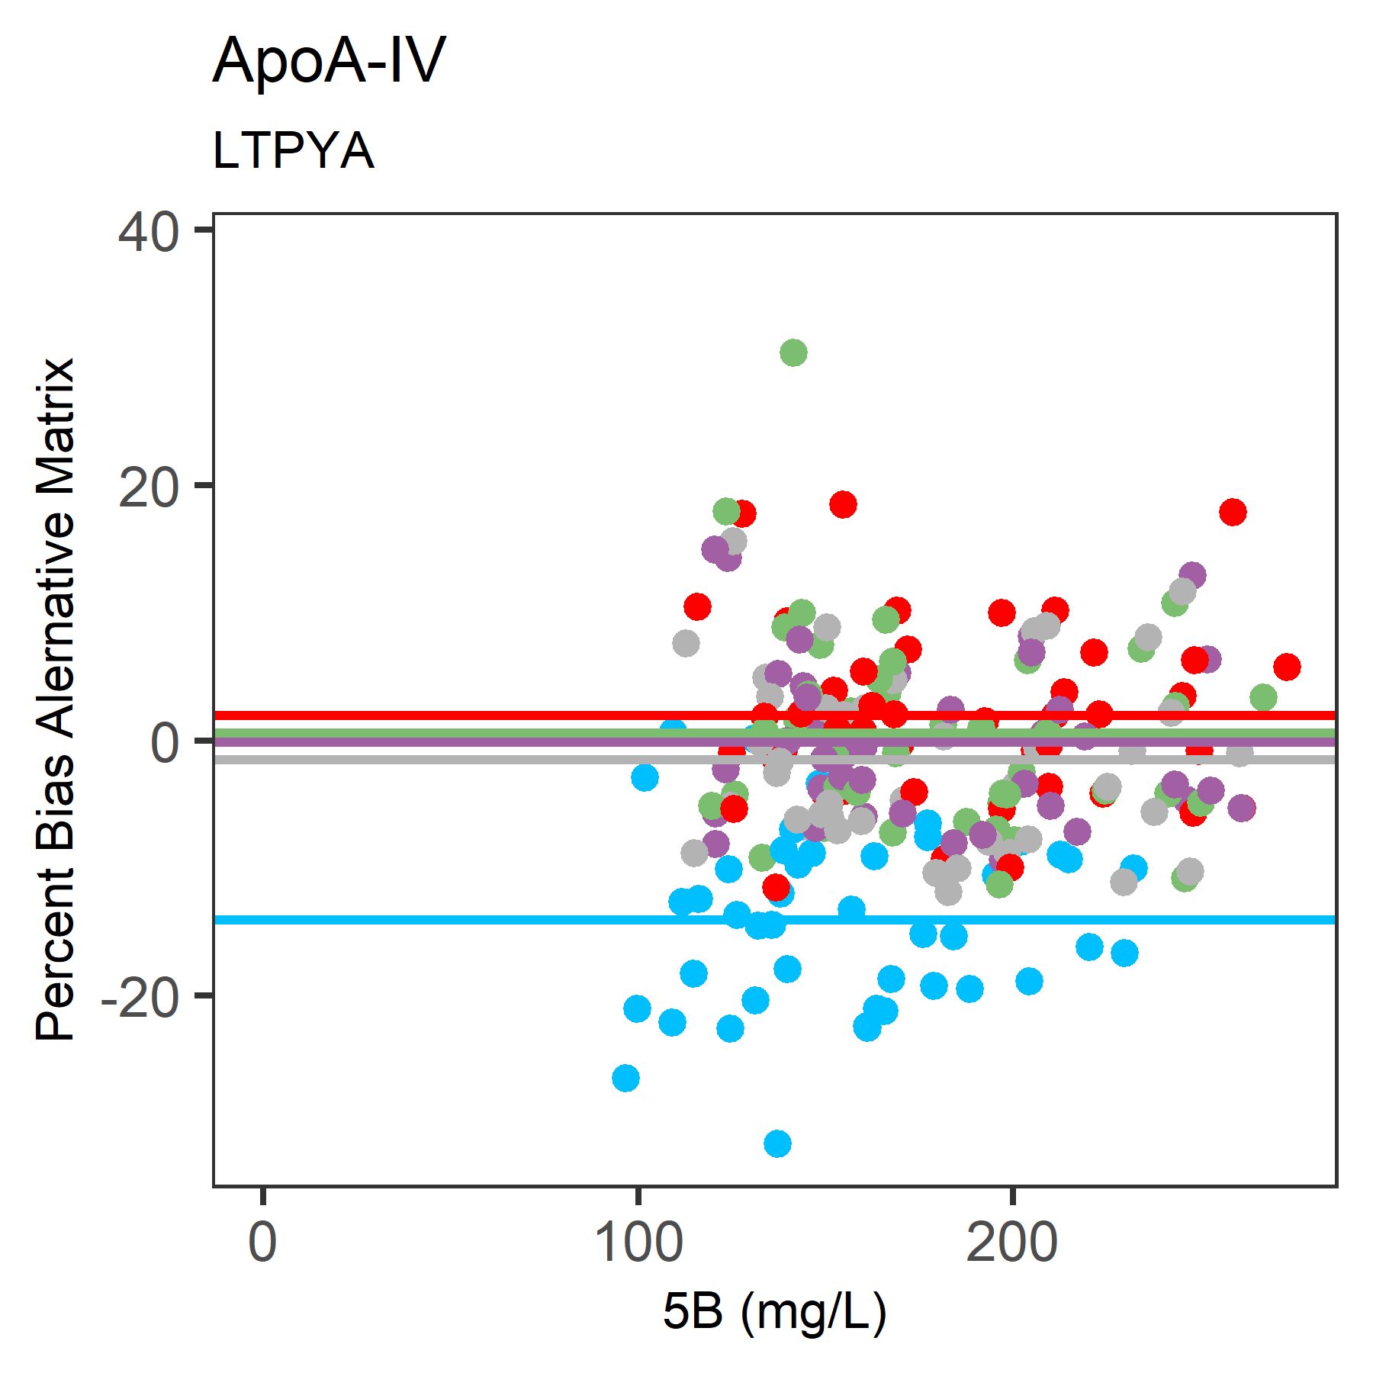
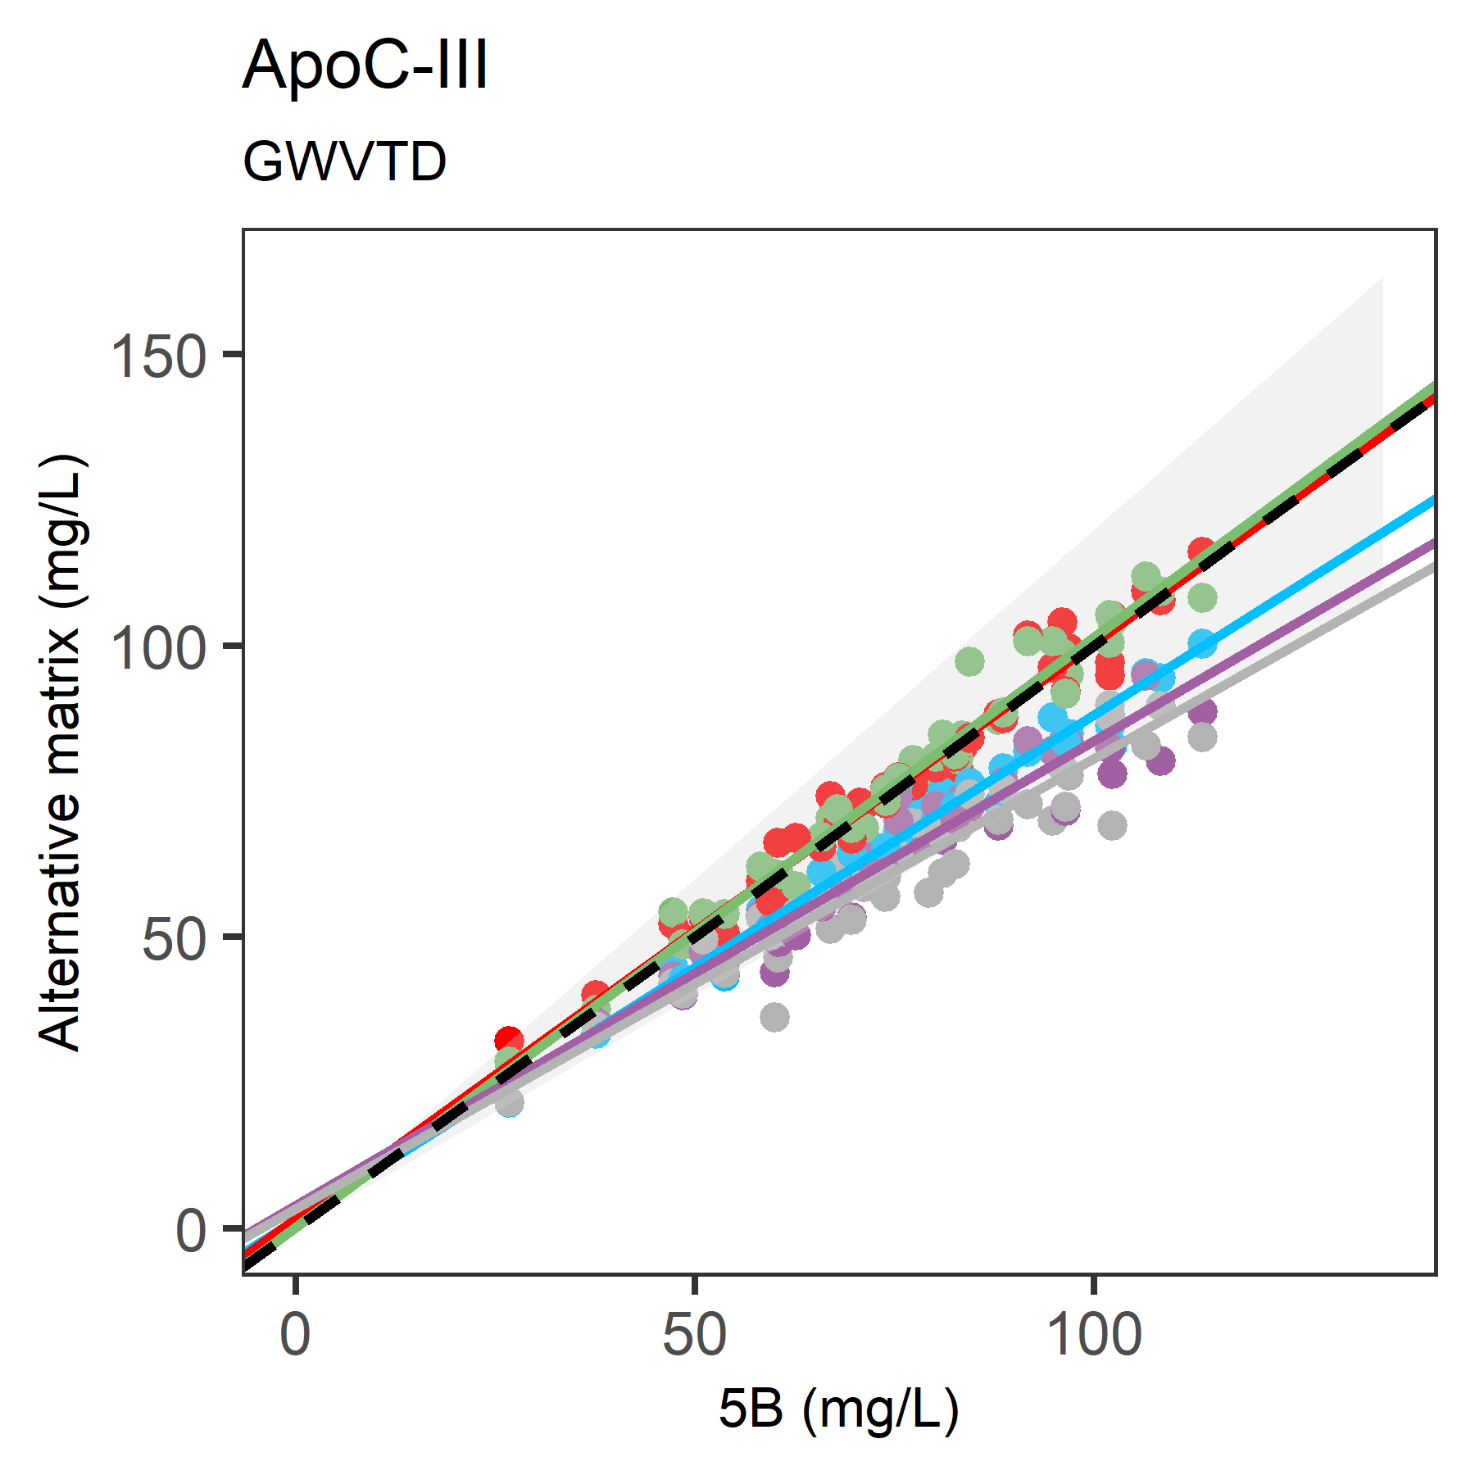
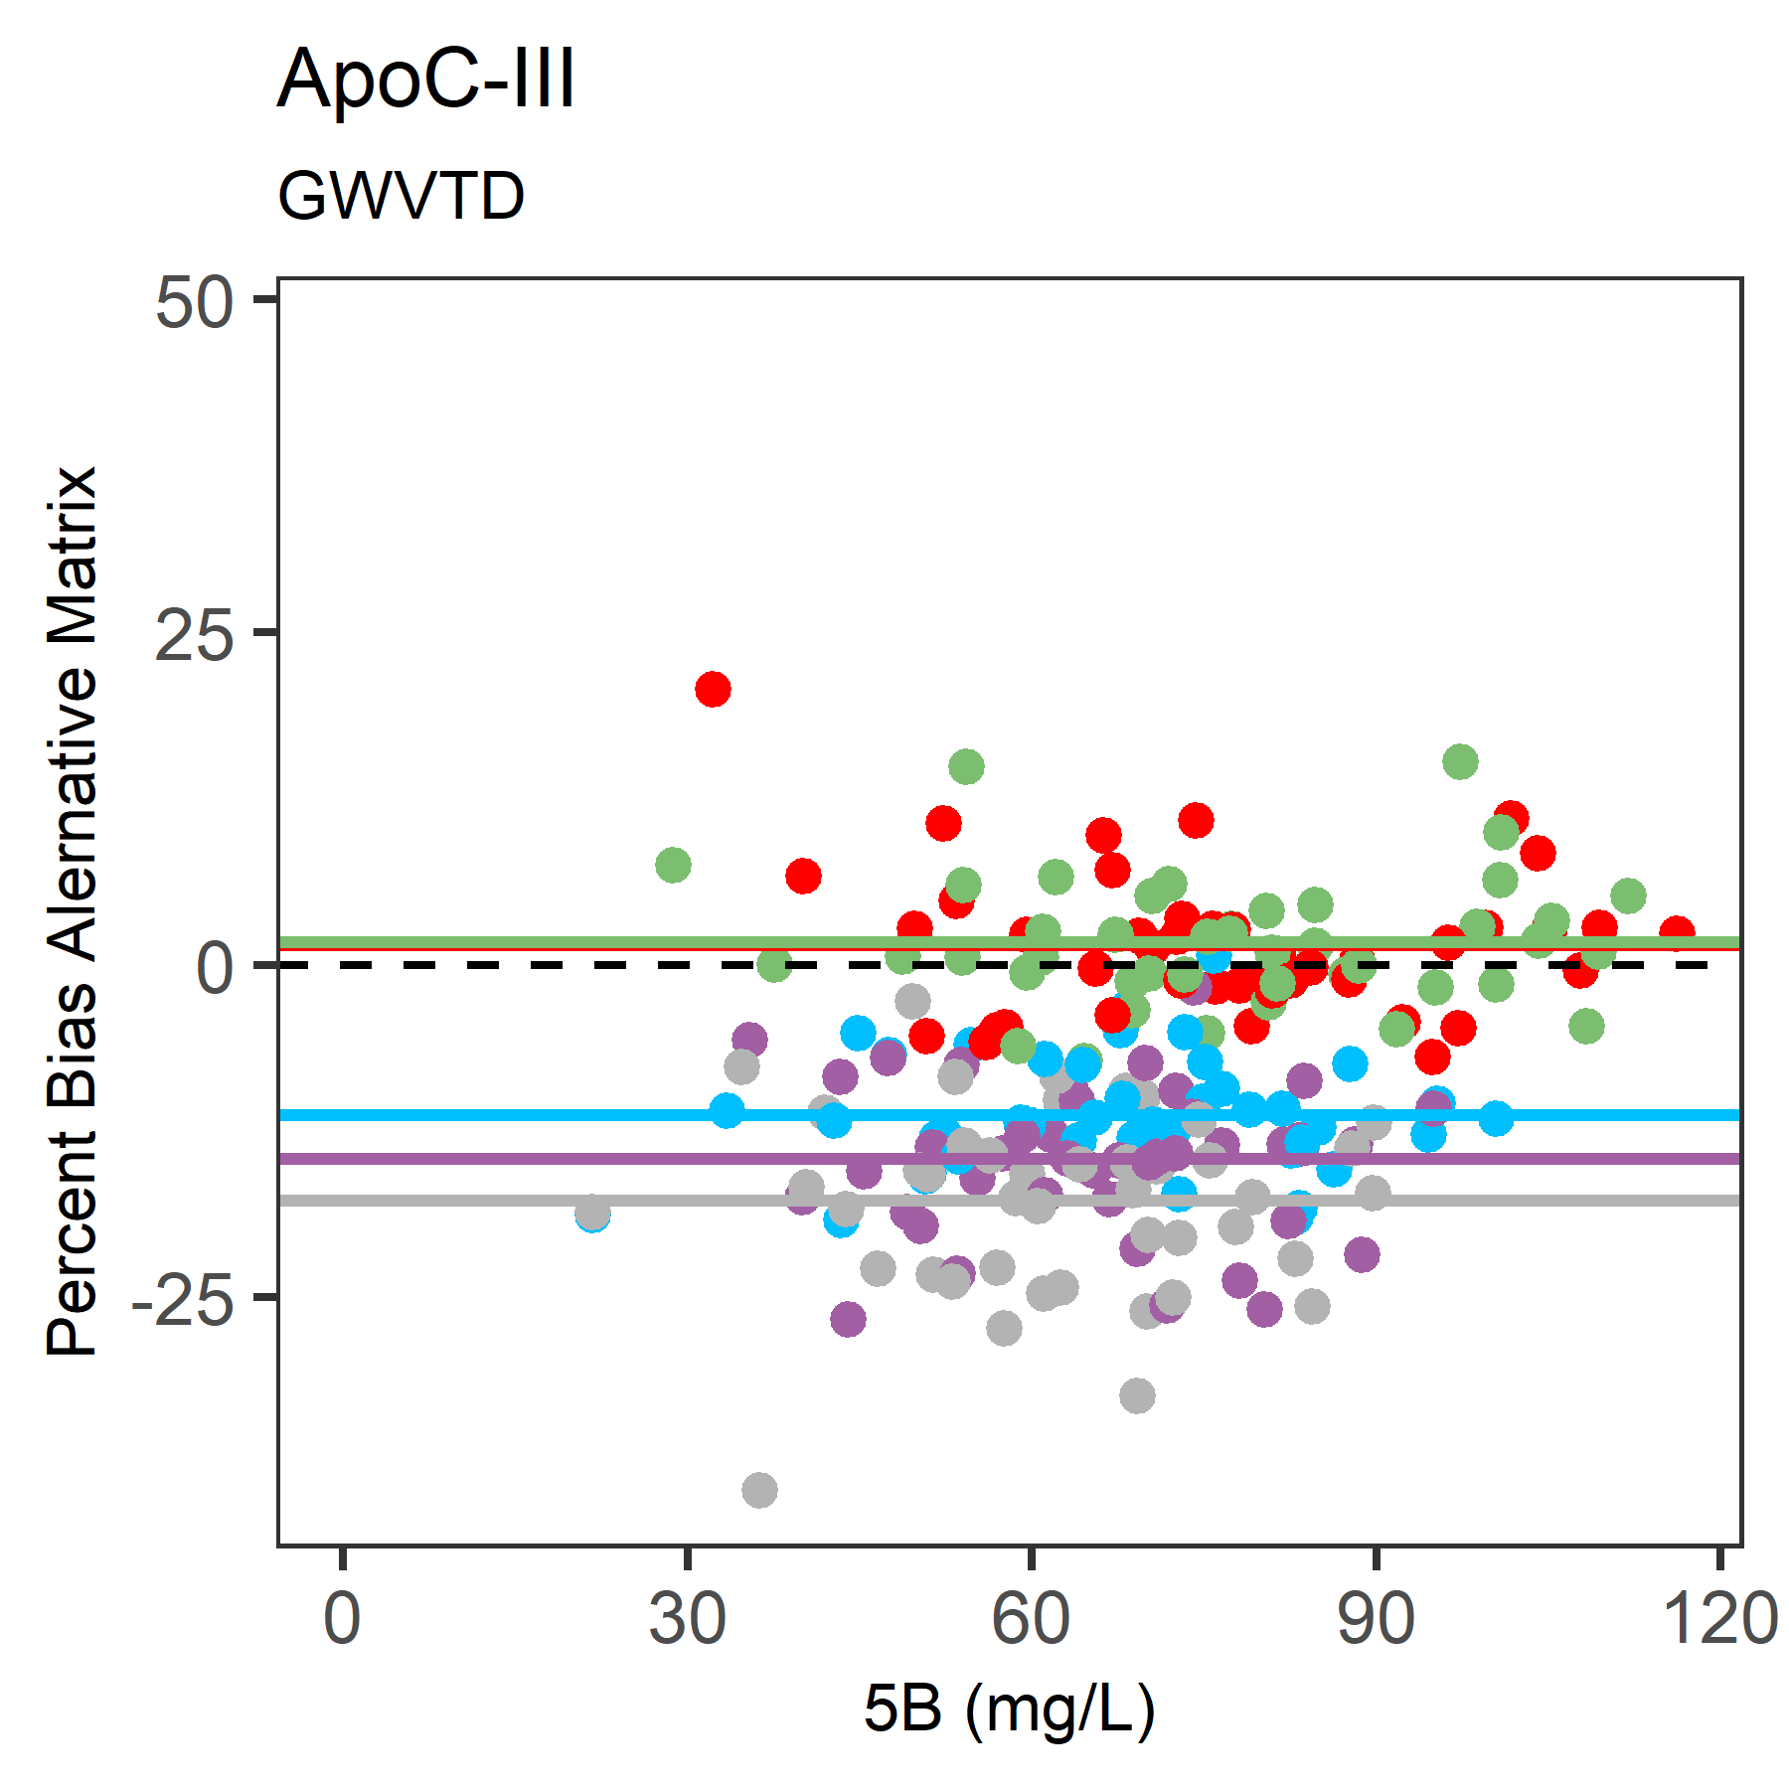
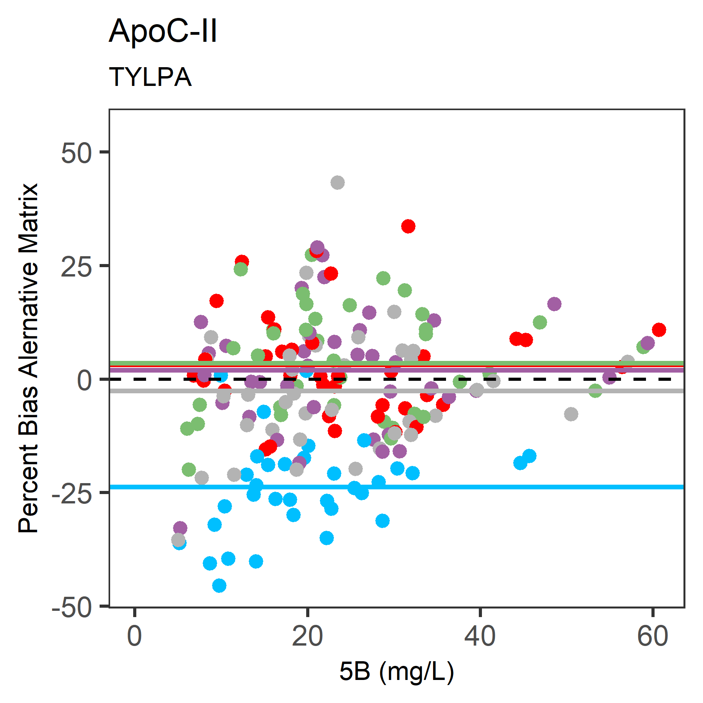
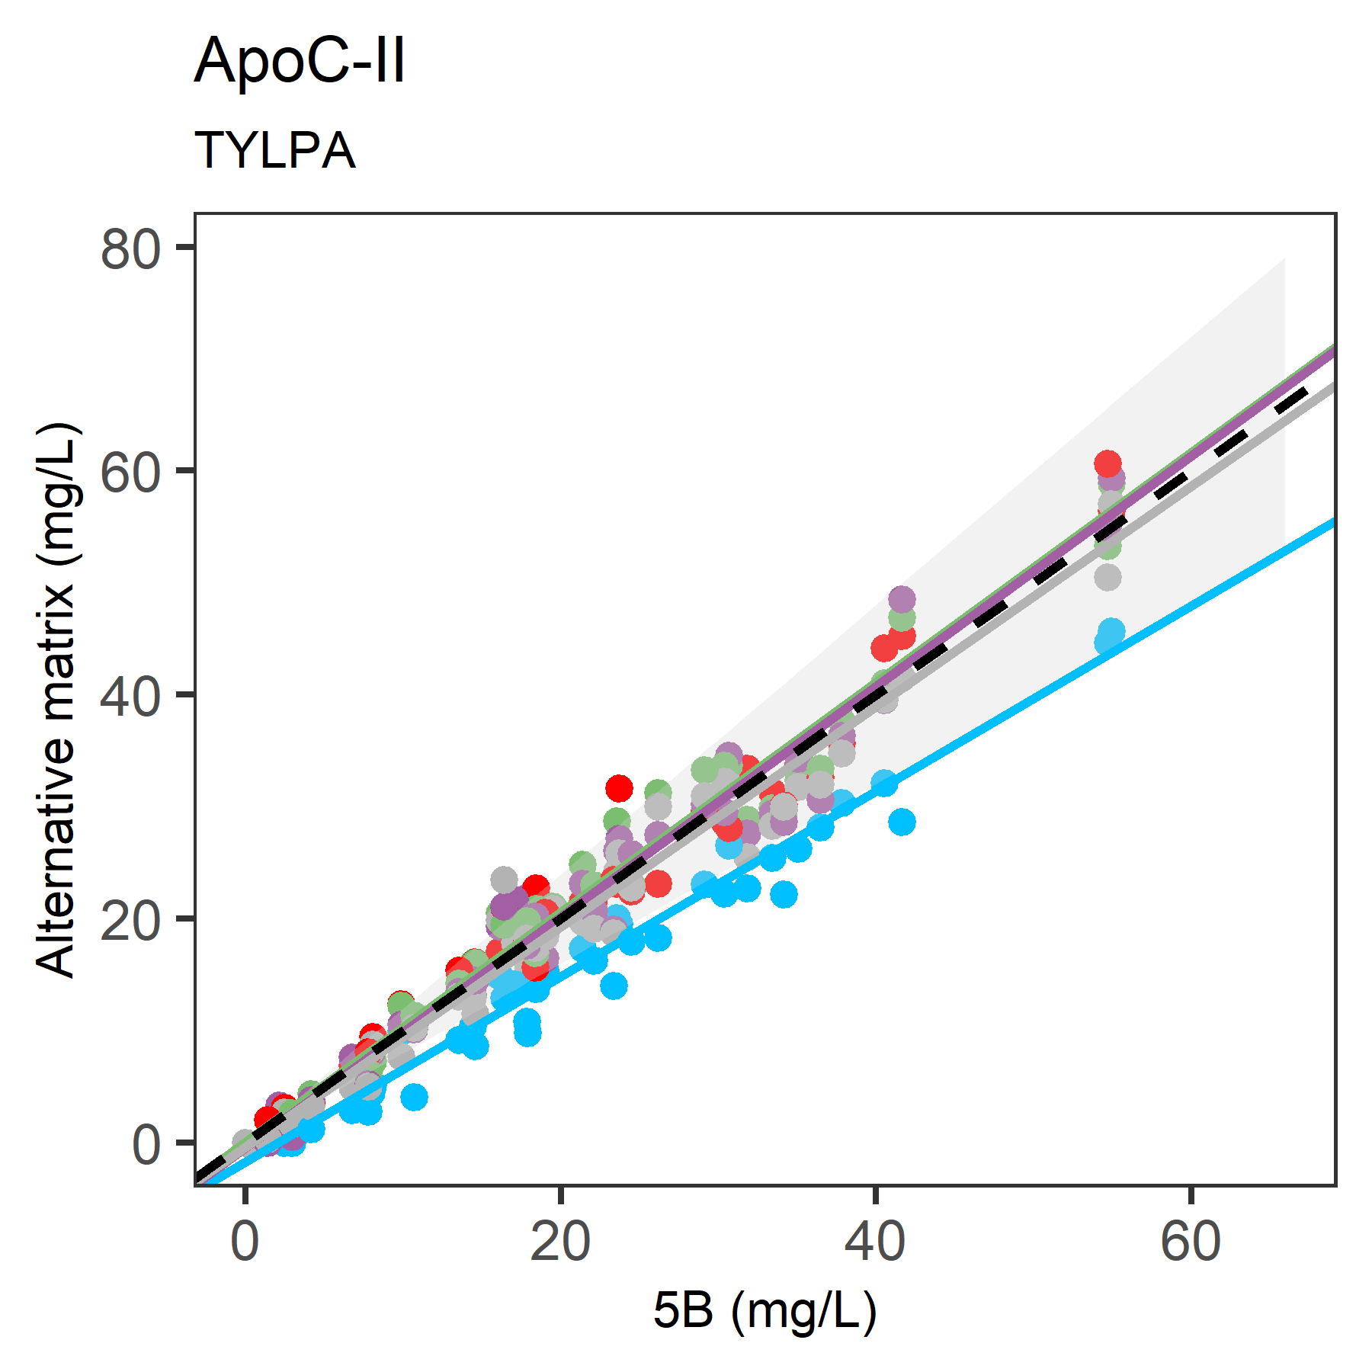
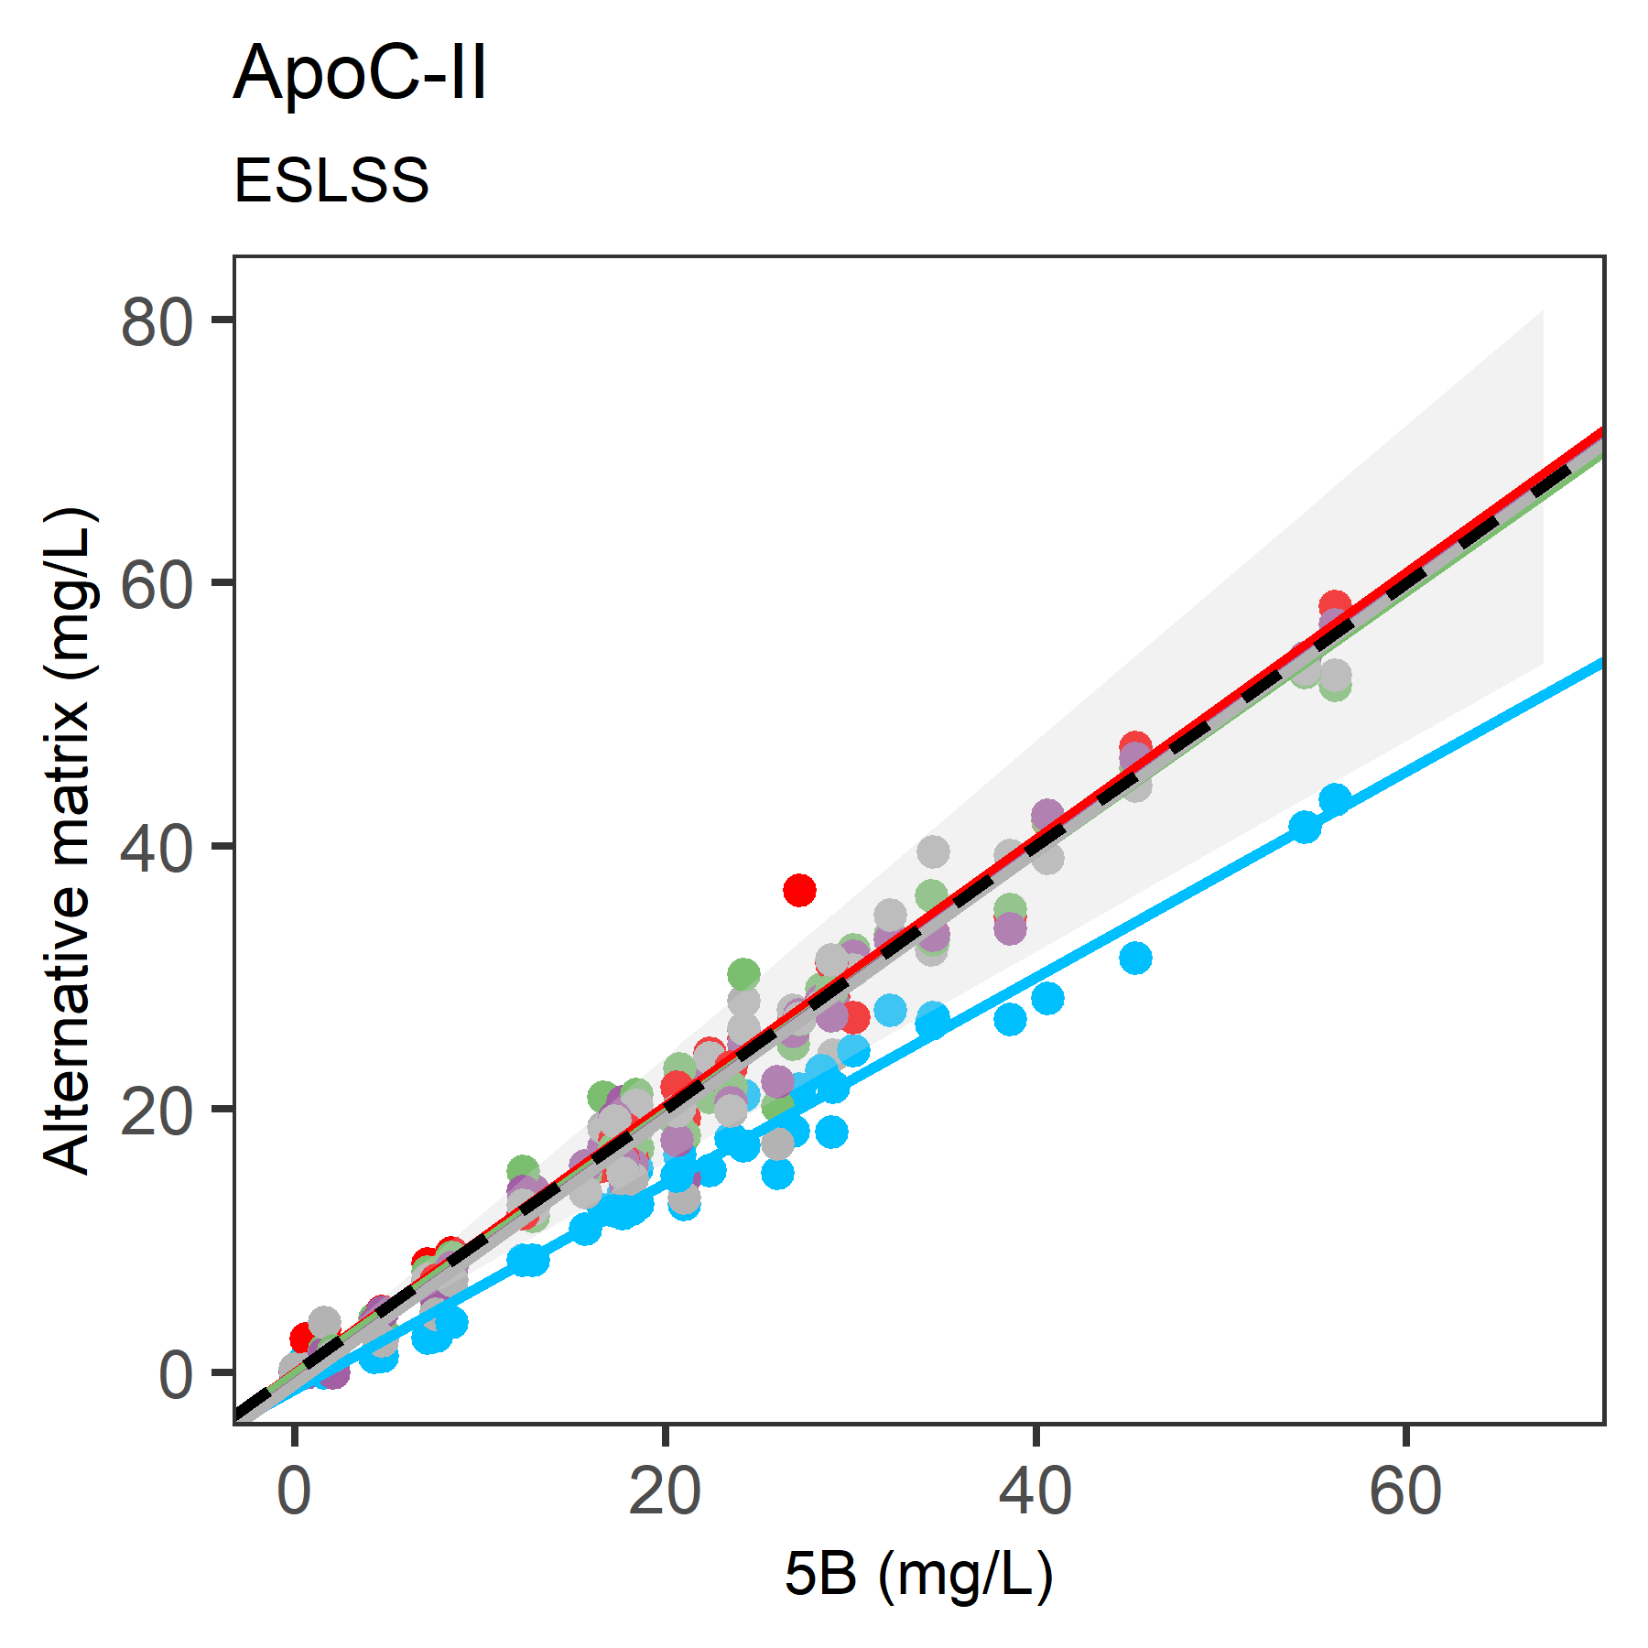
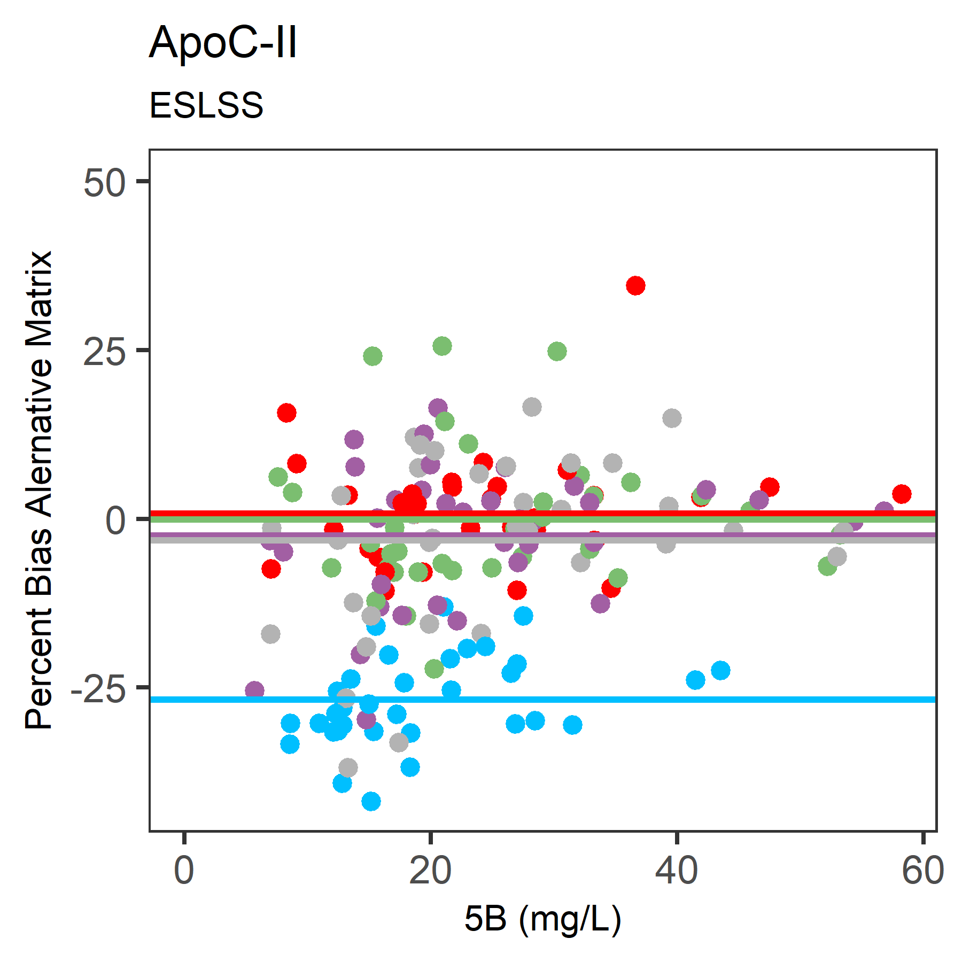
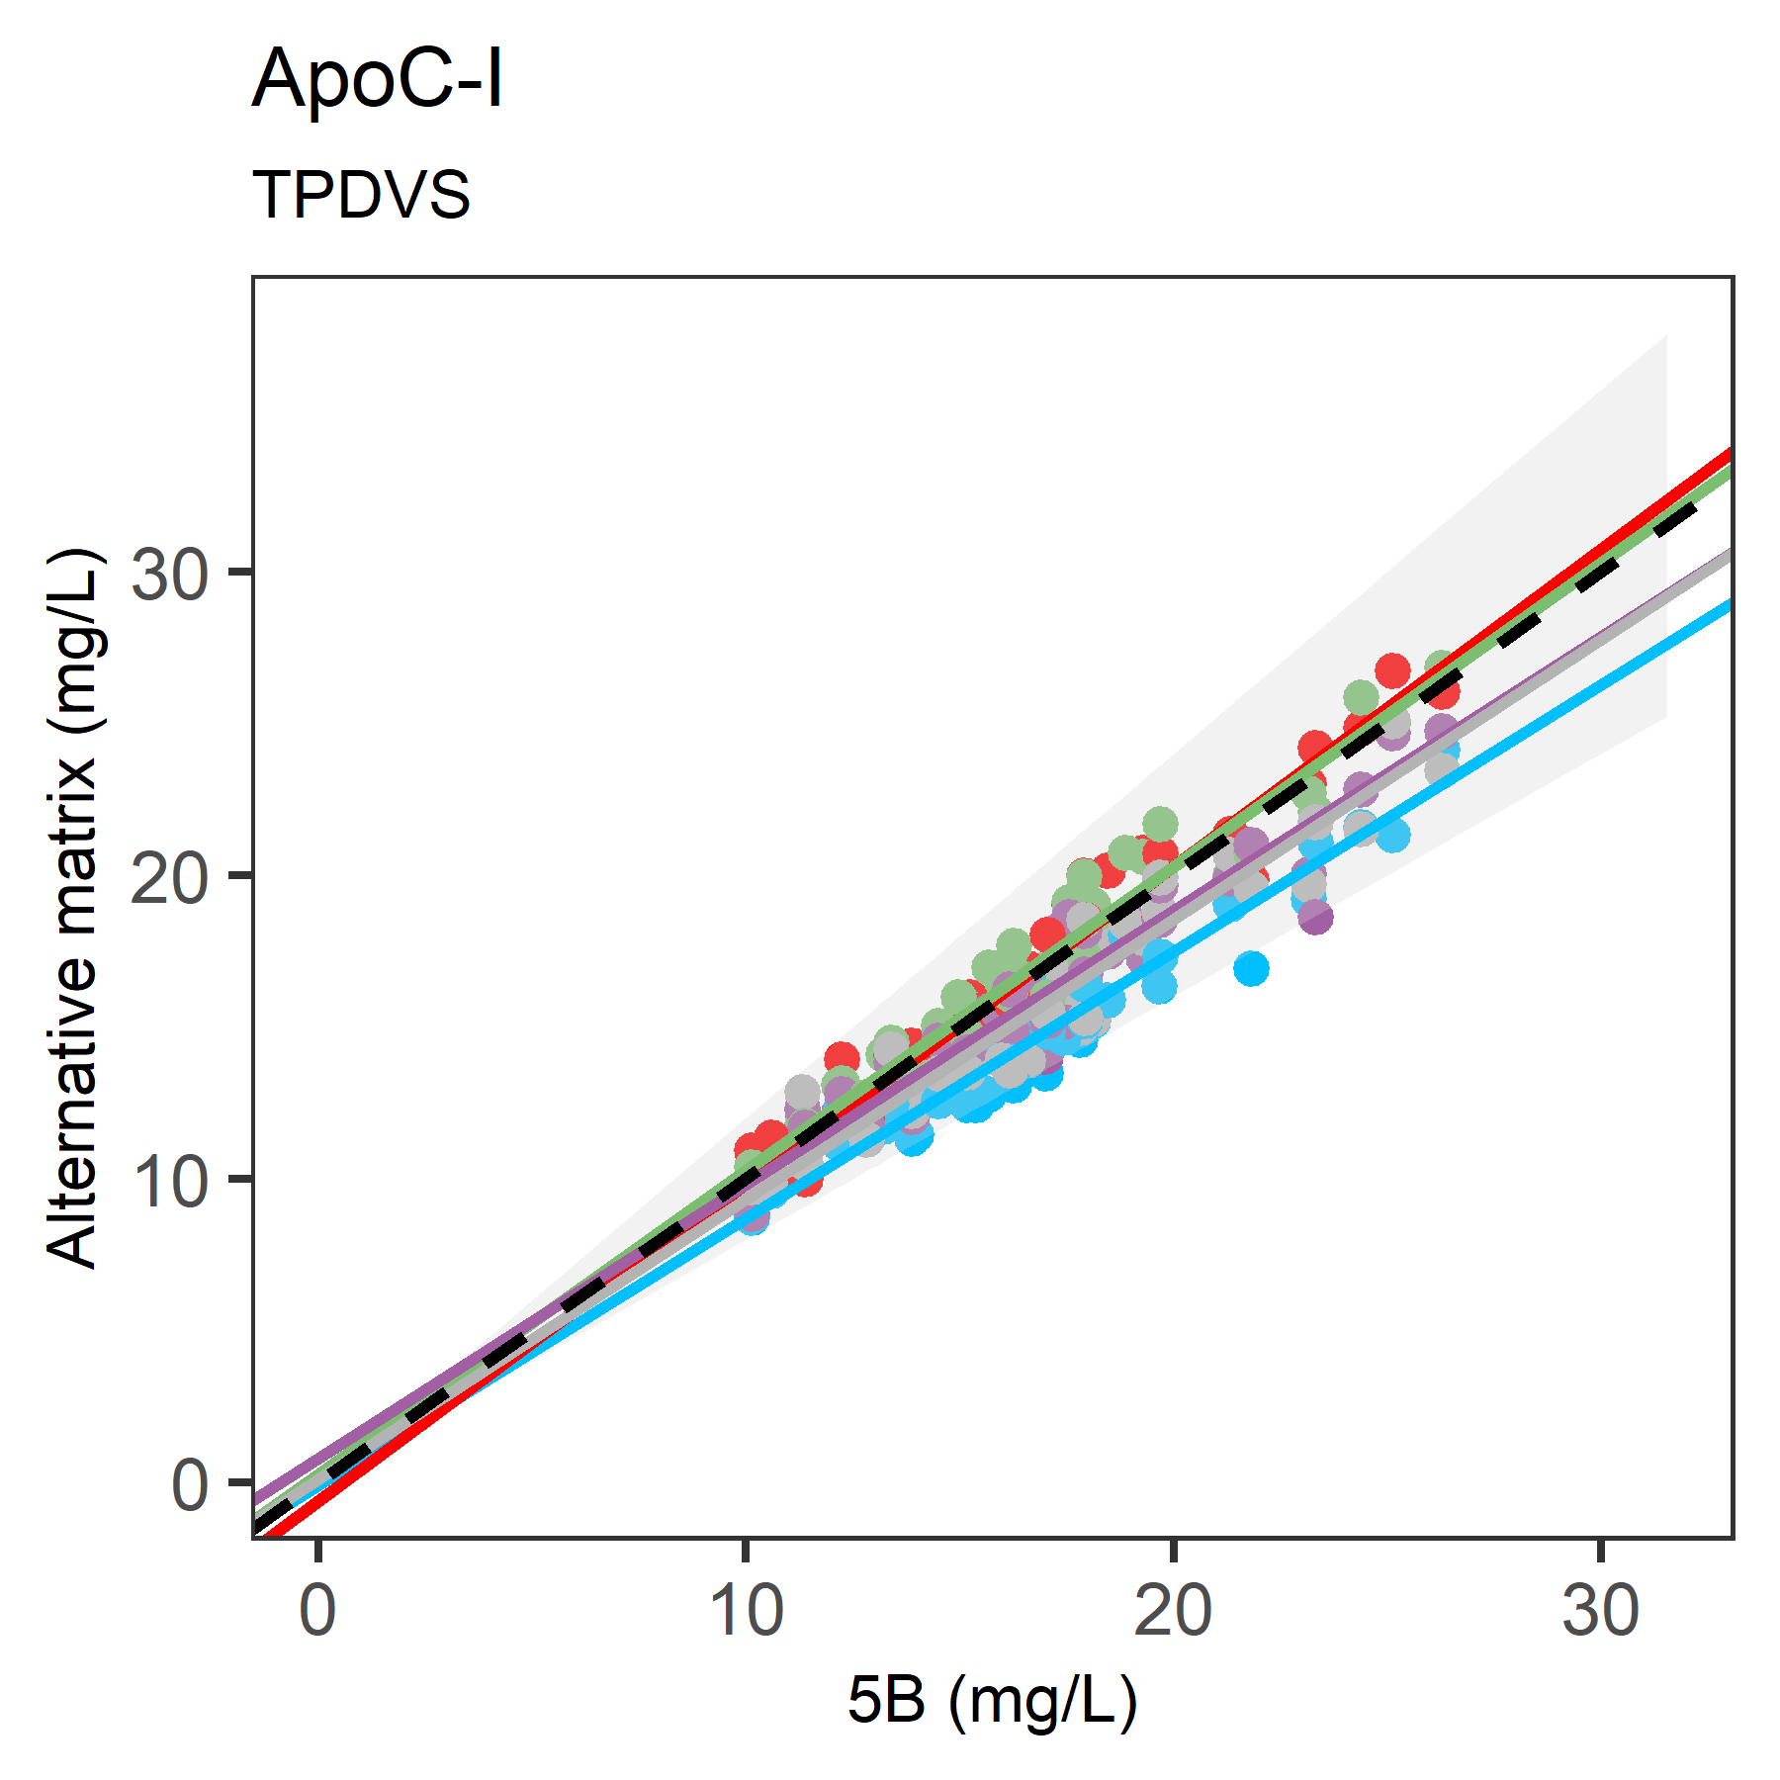
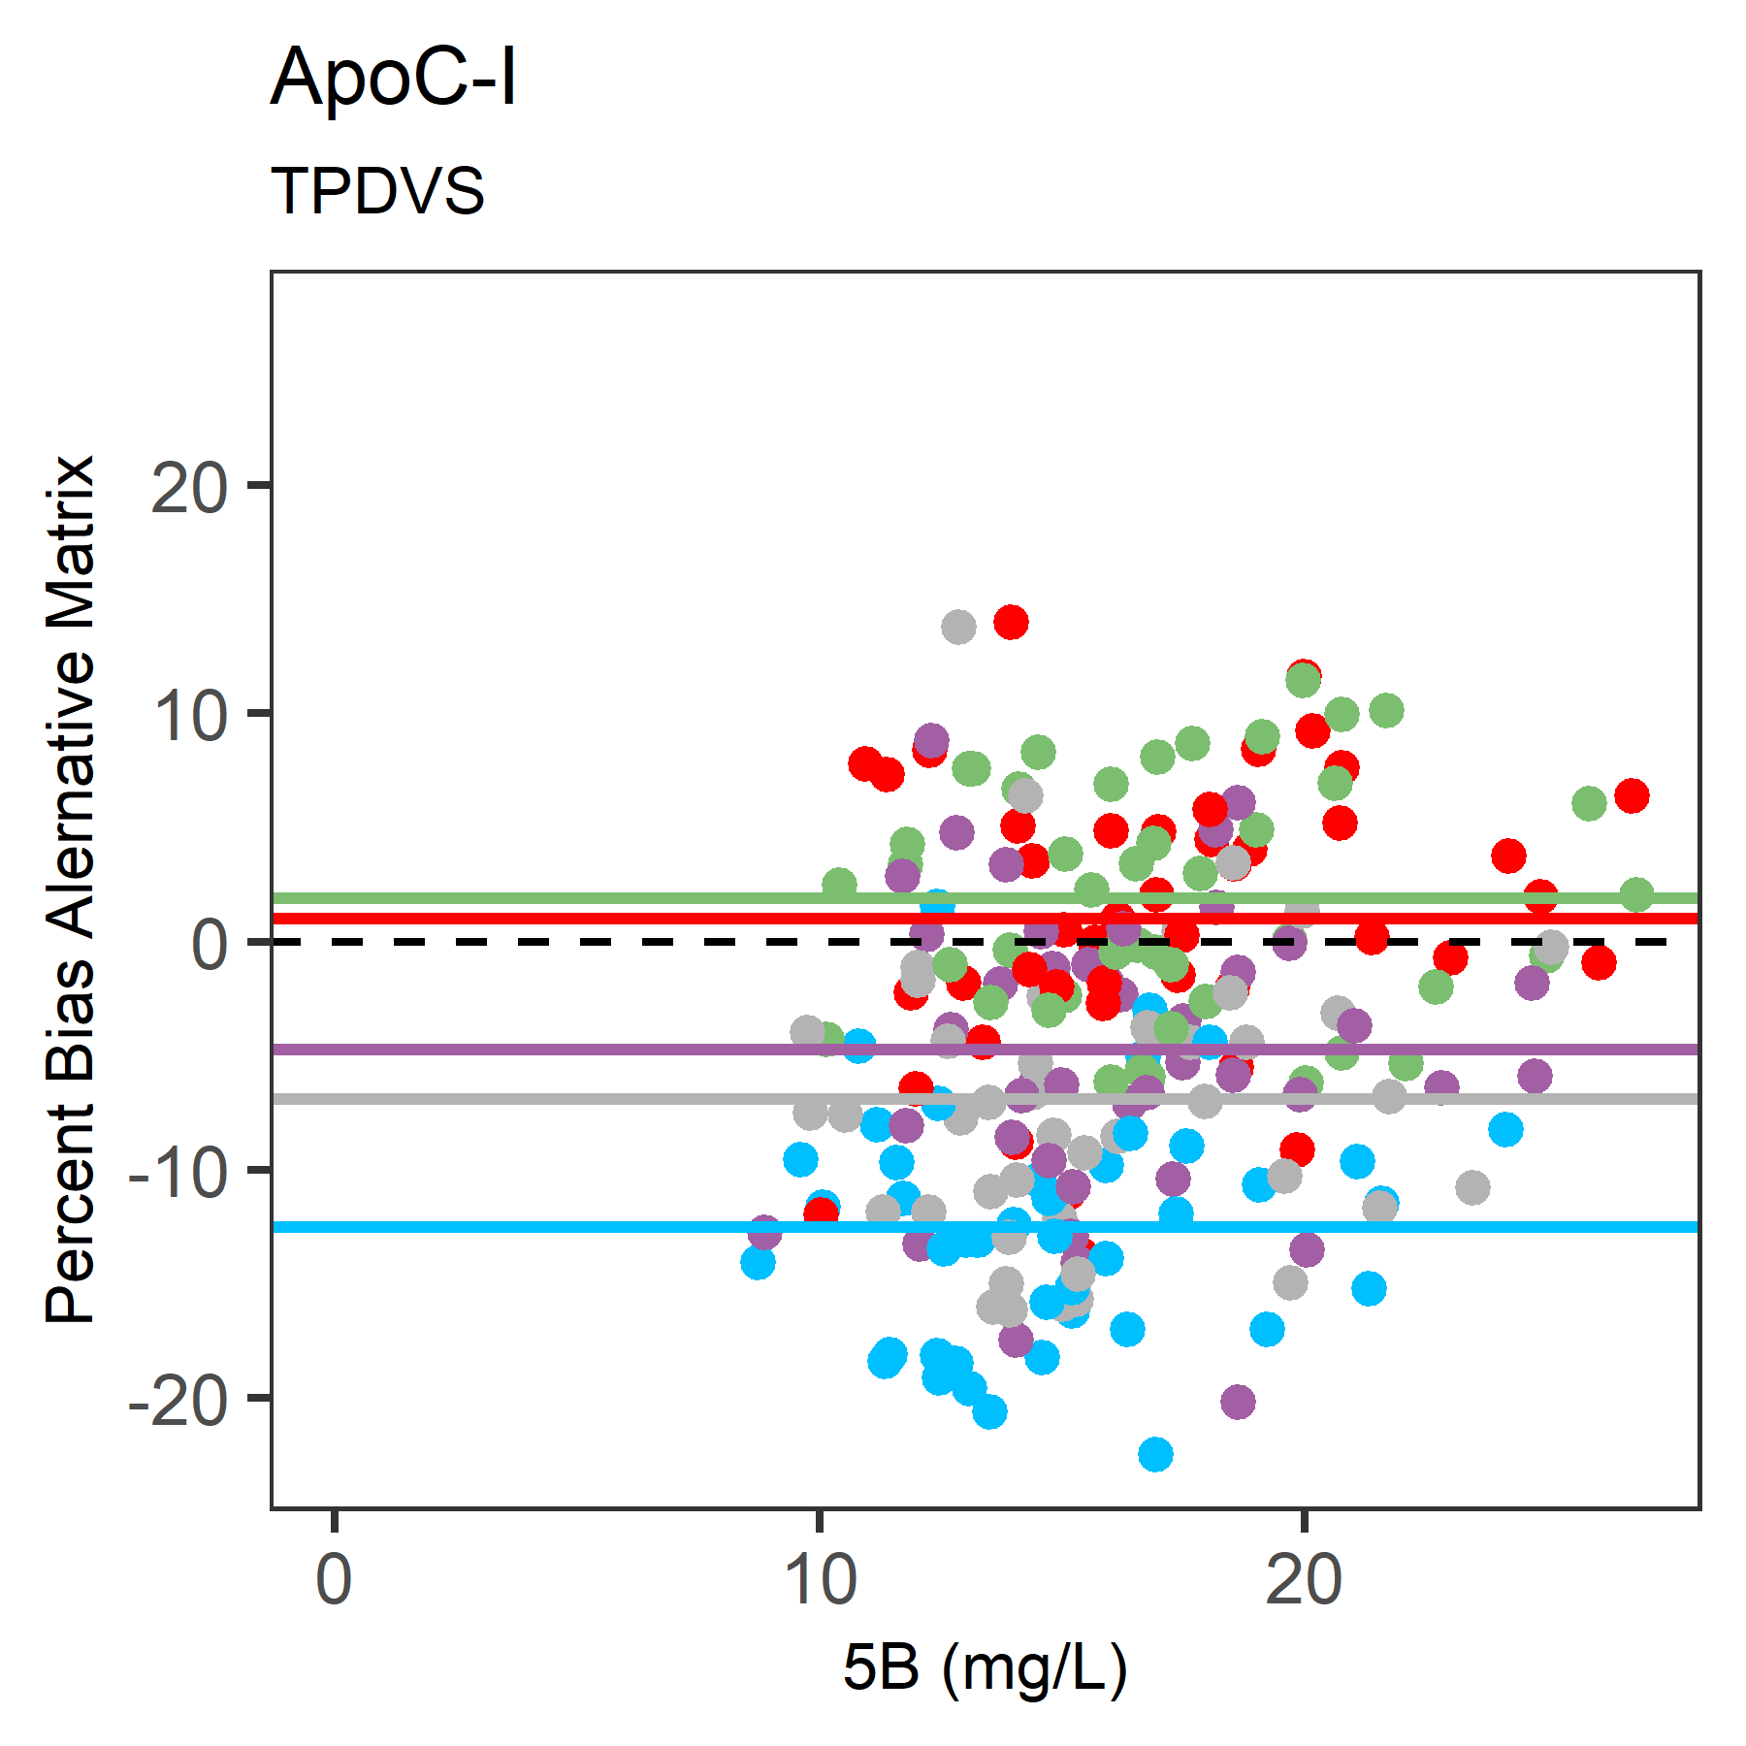
S1(A)
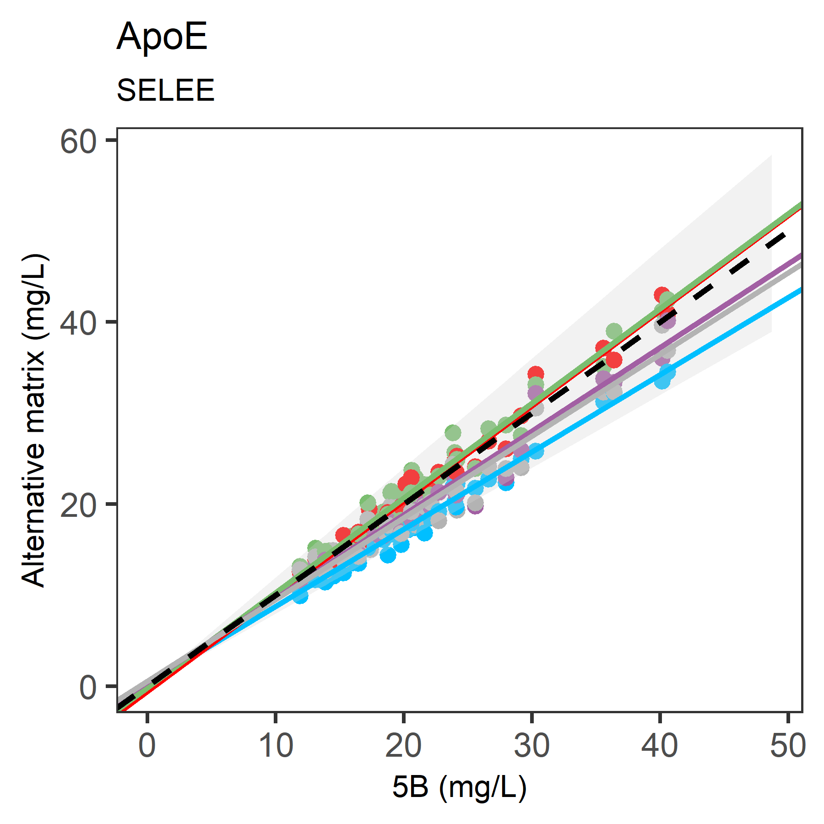
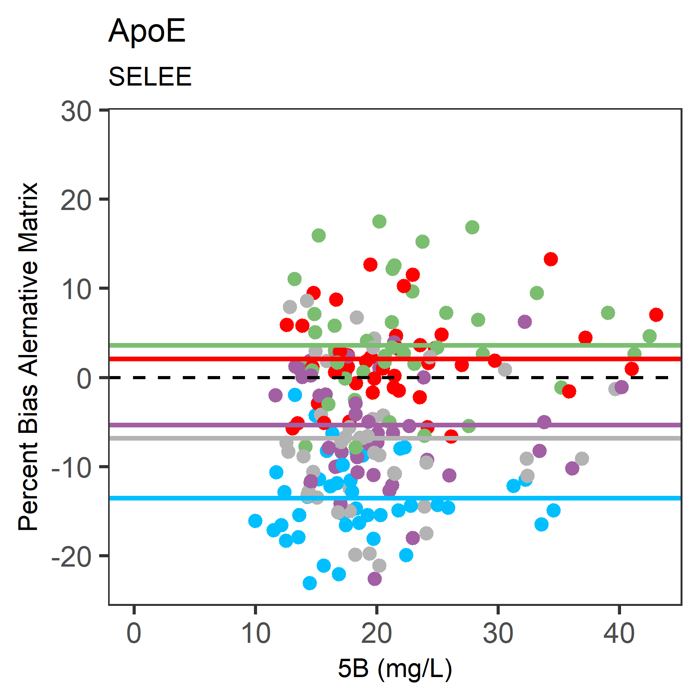
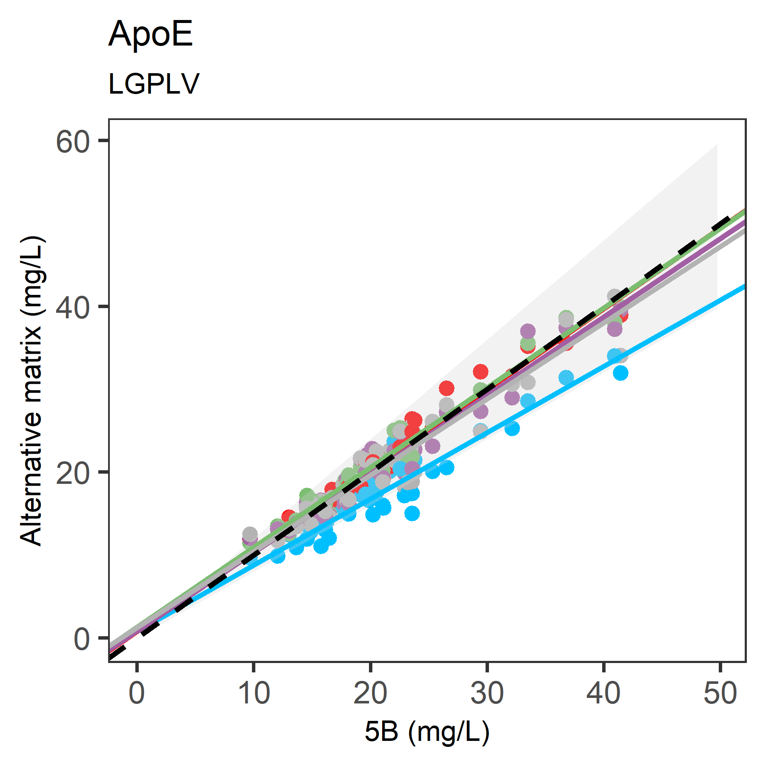
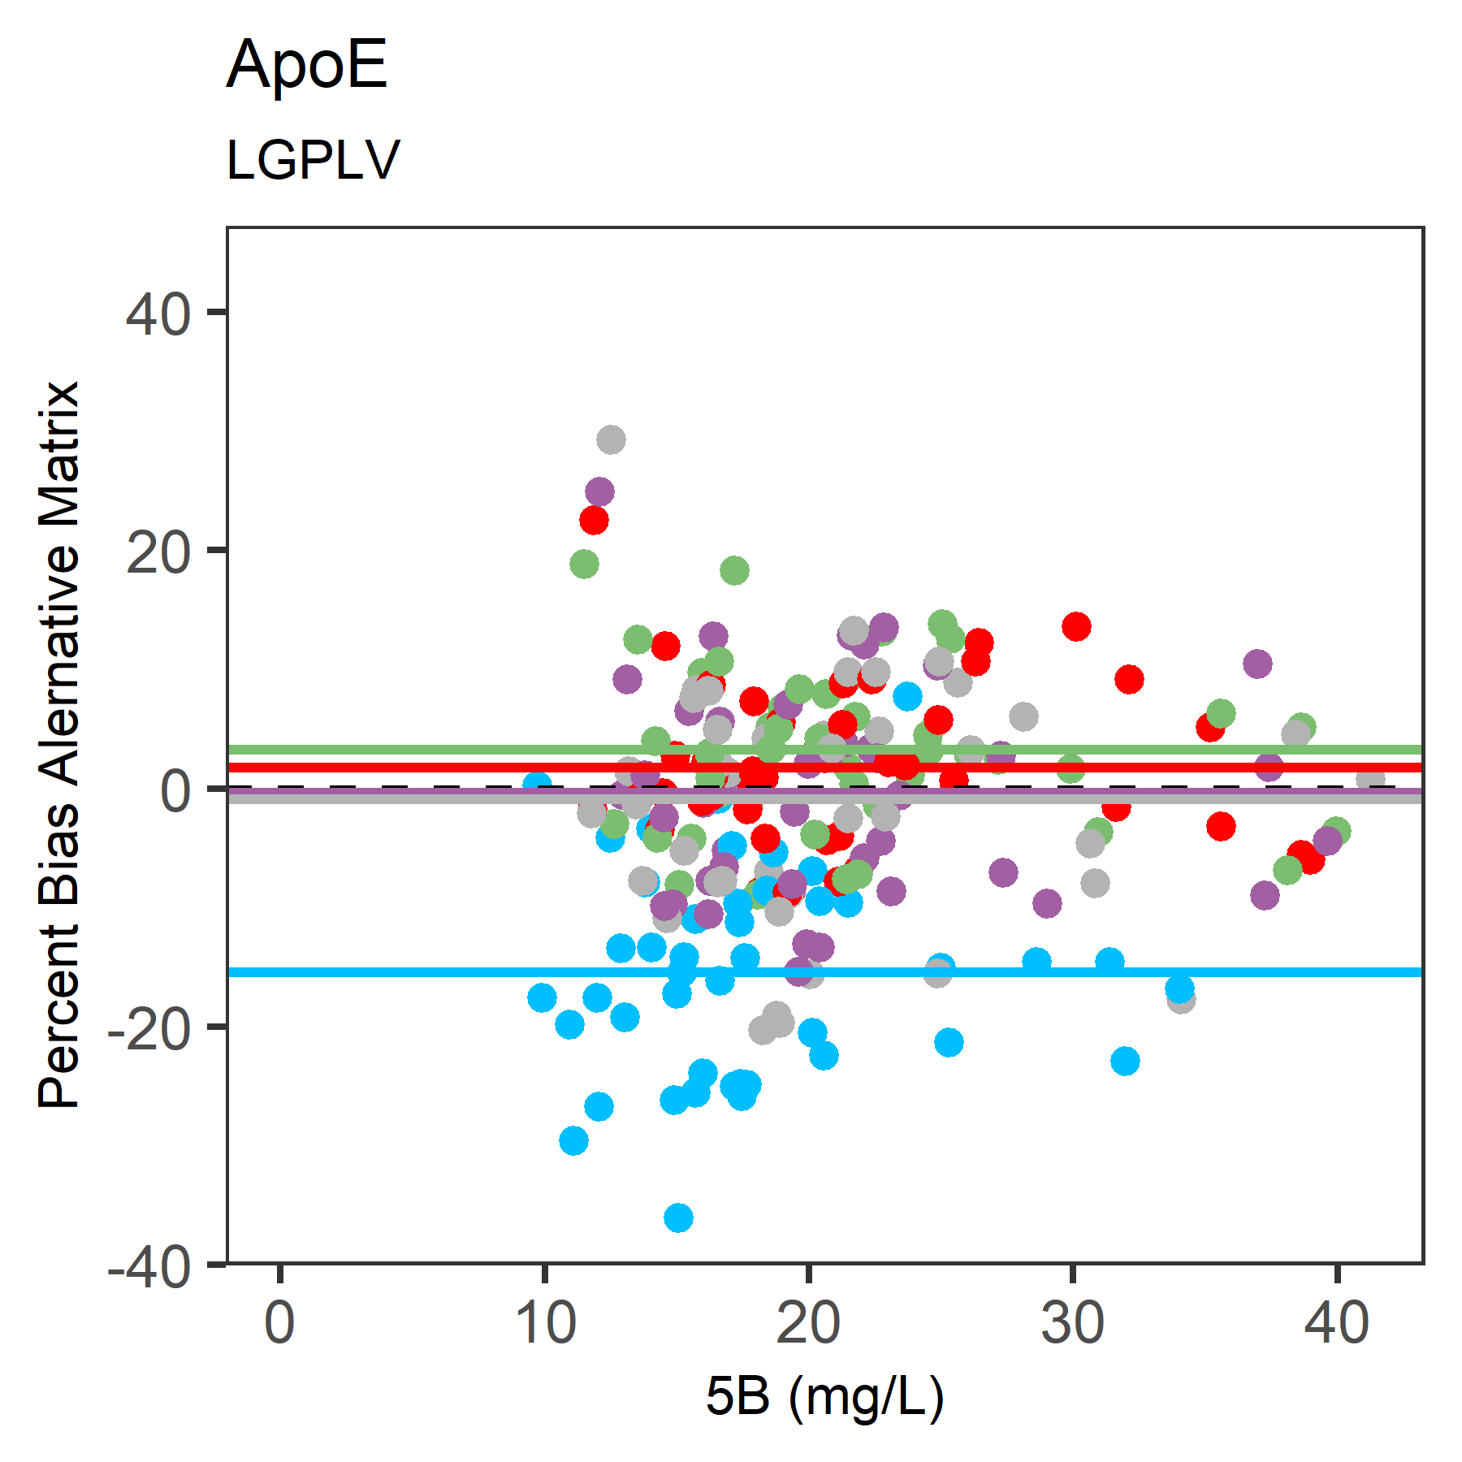
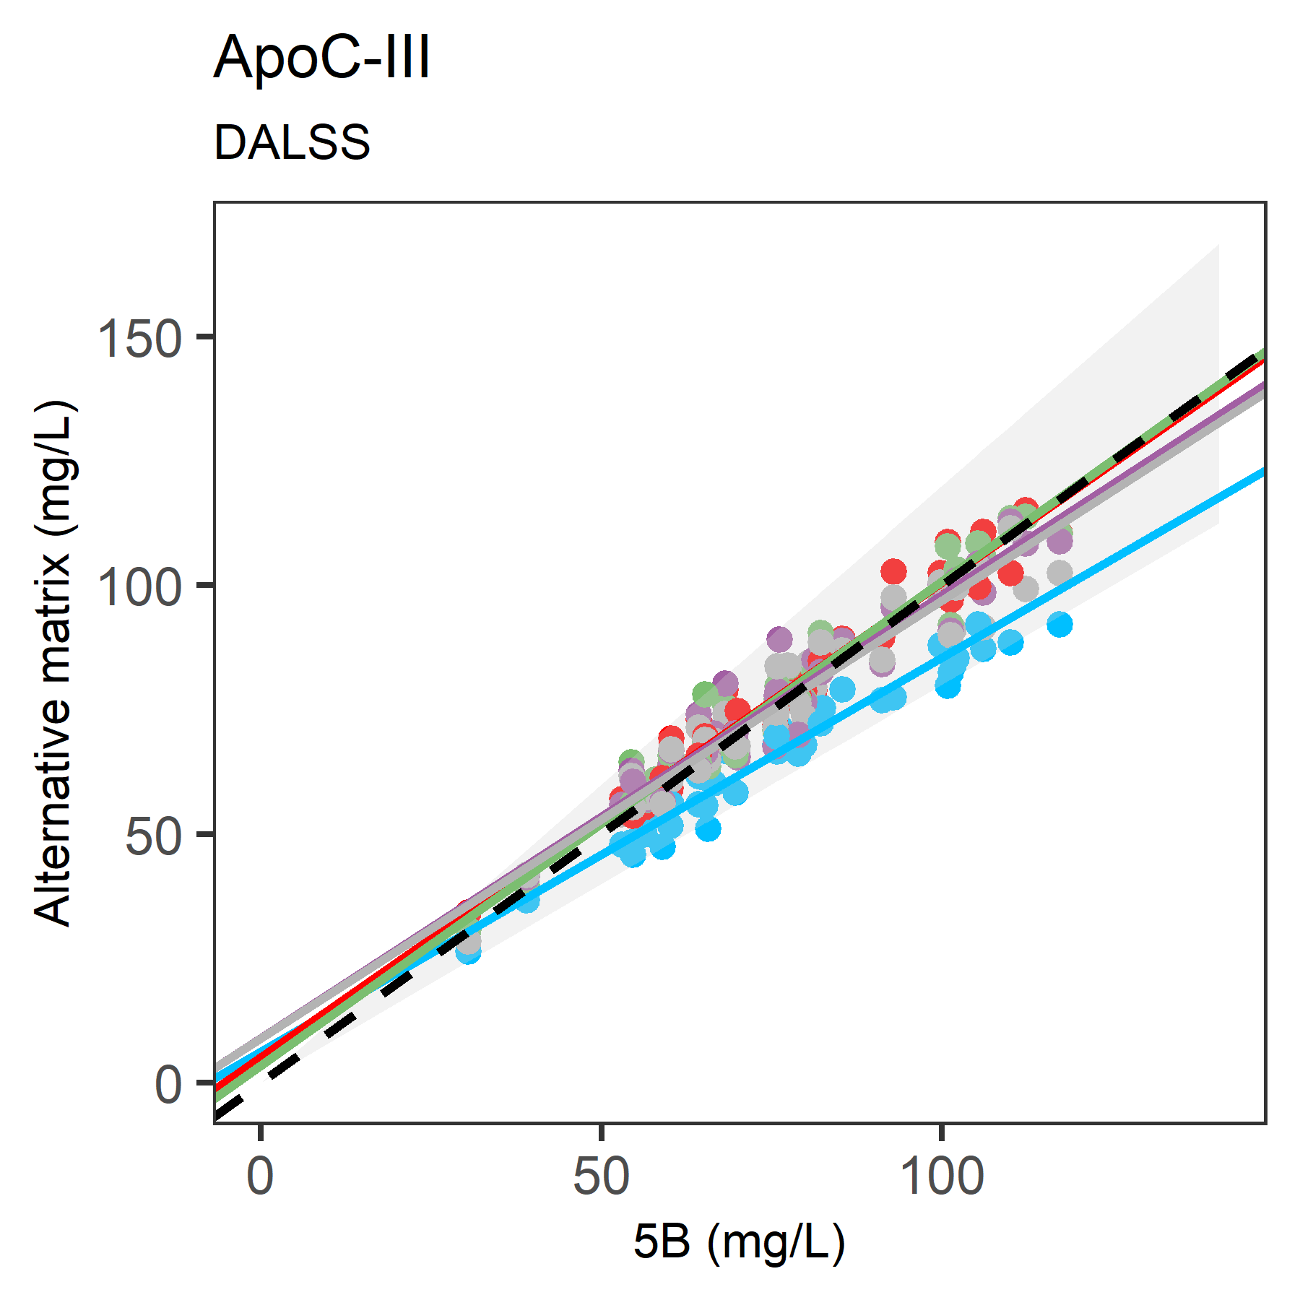
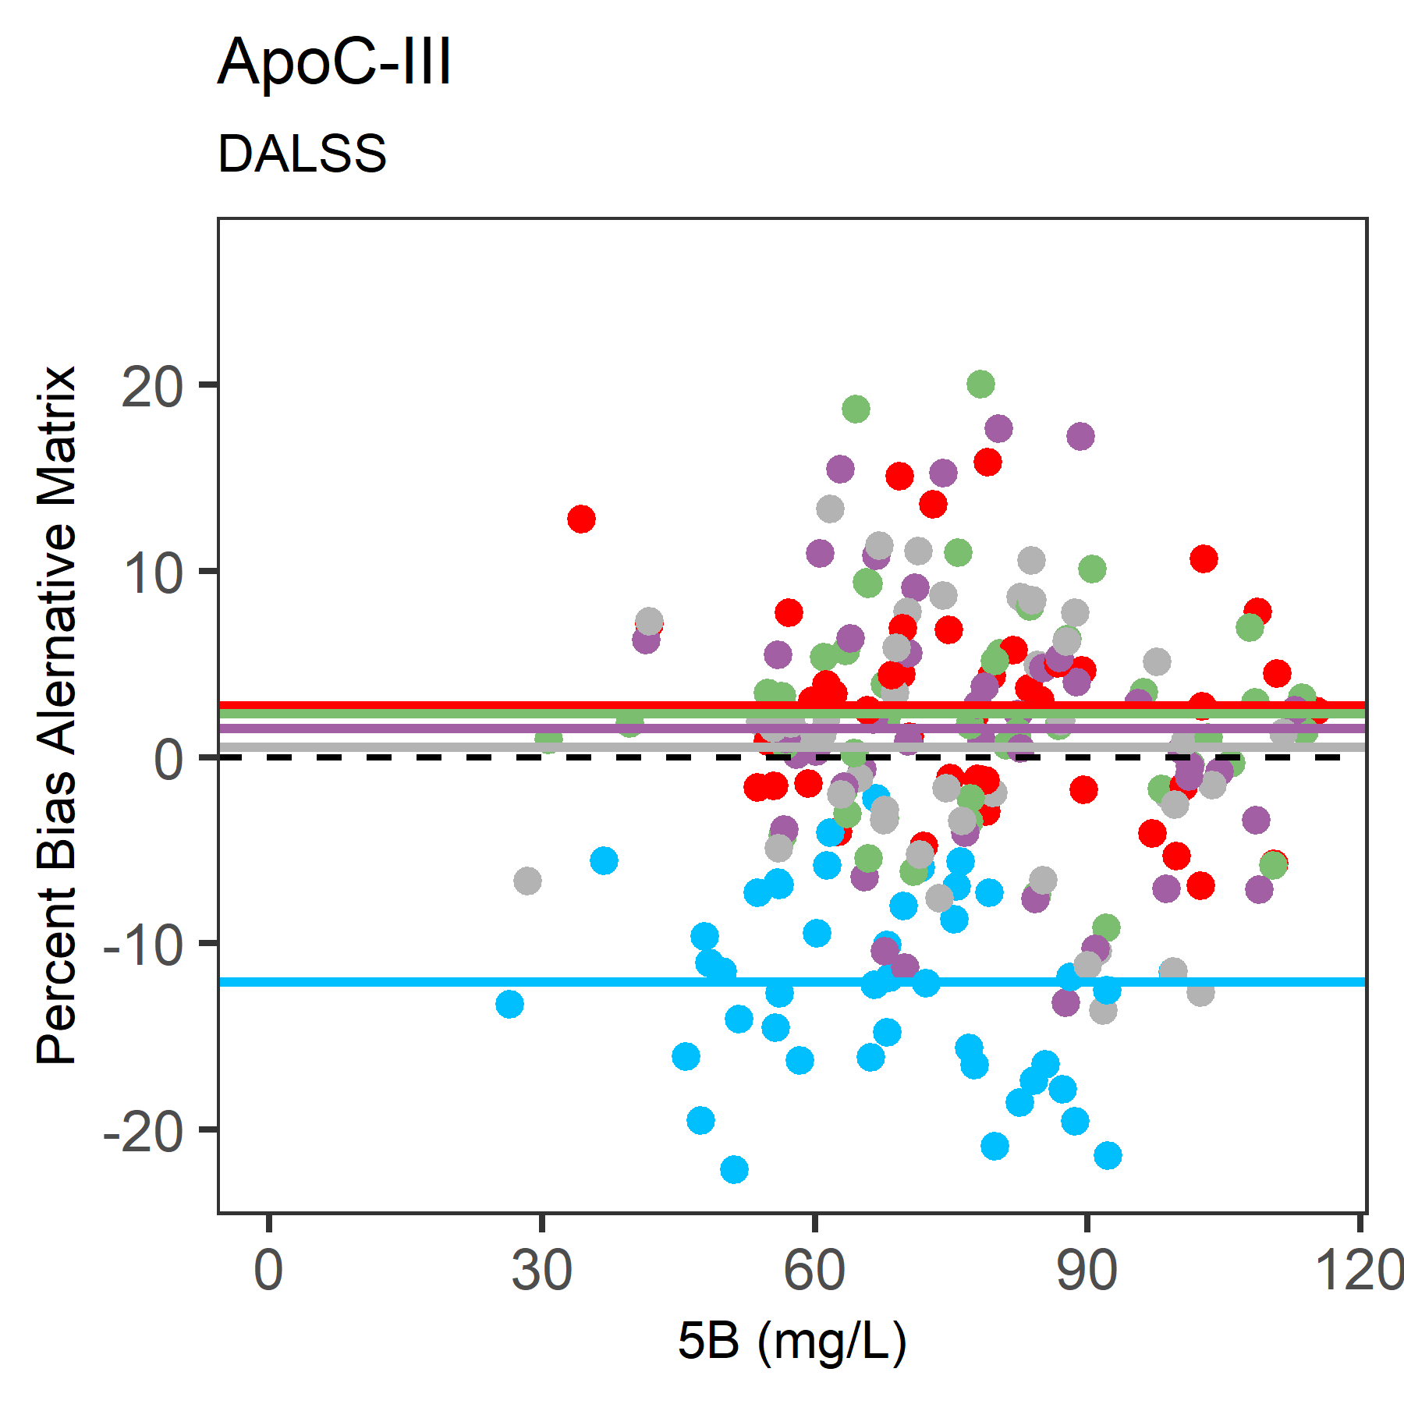
S1(A)

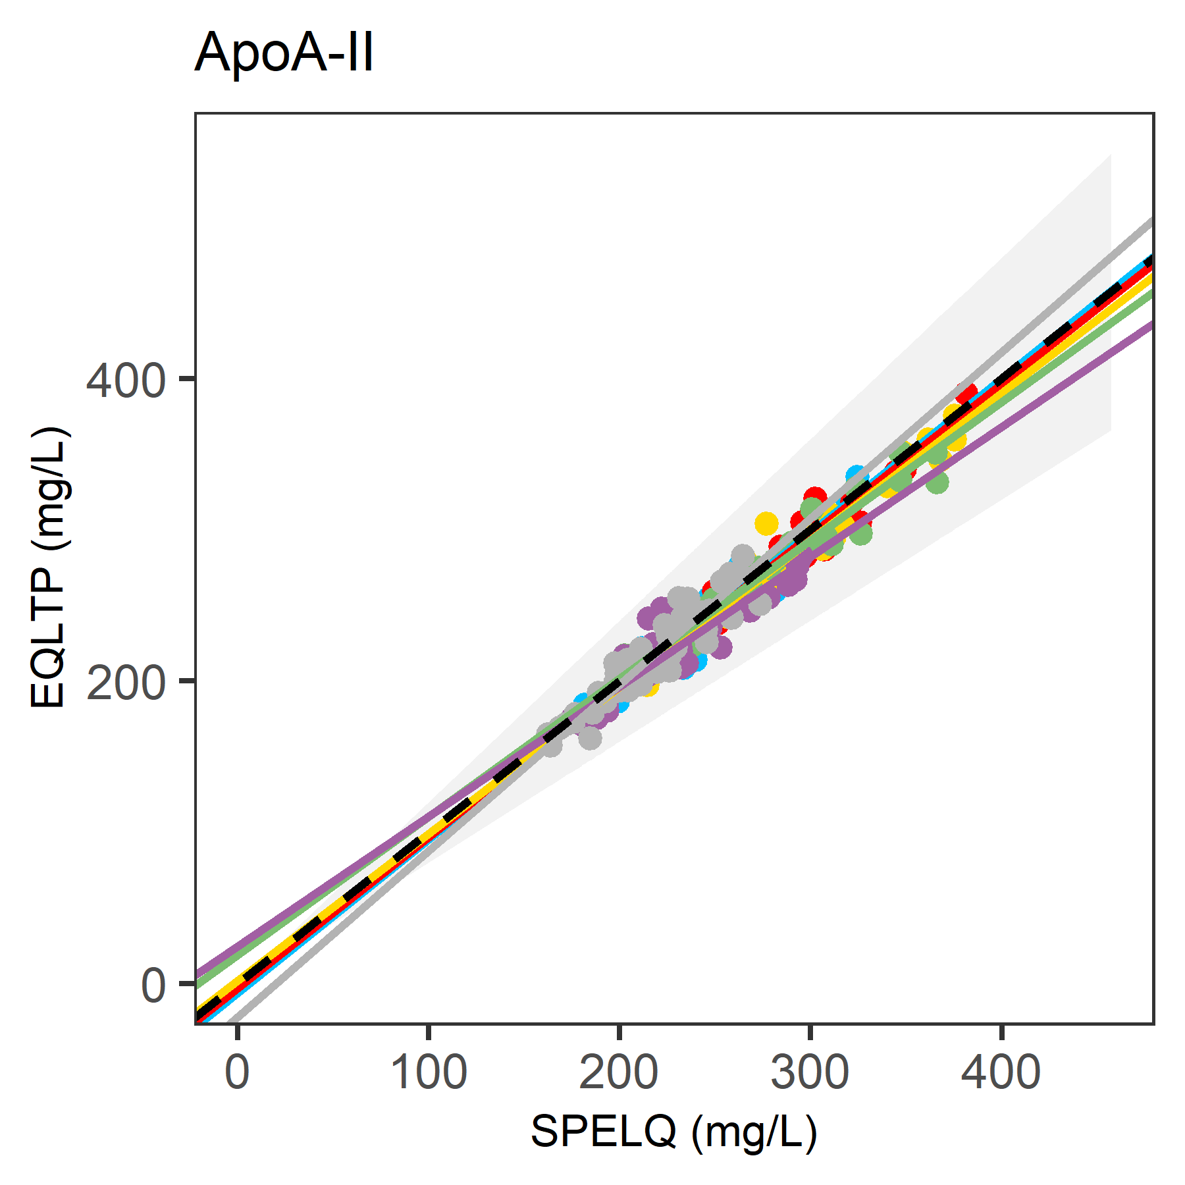
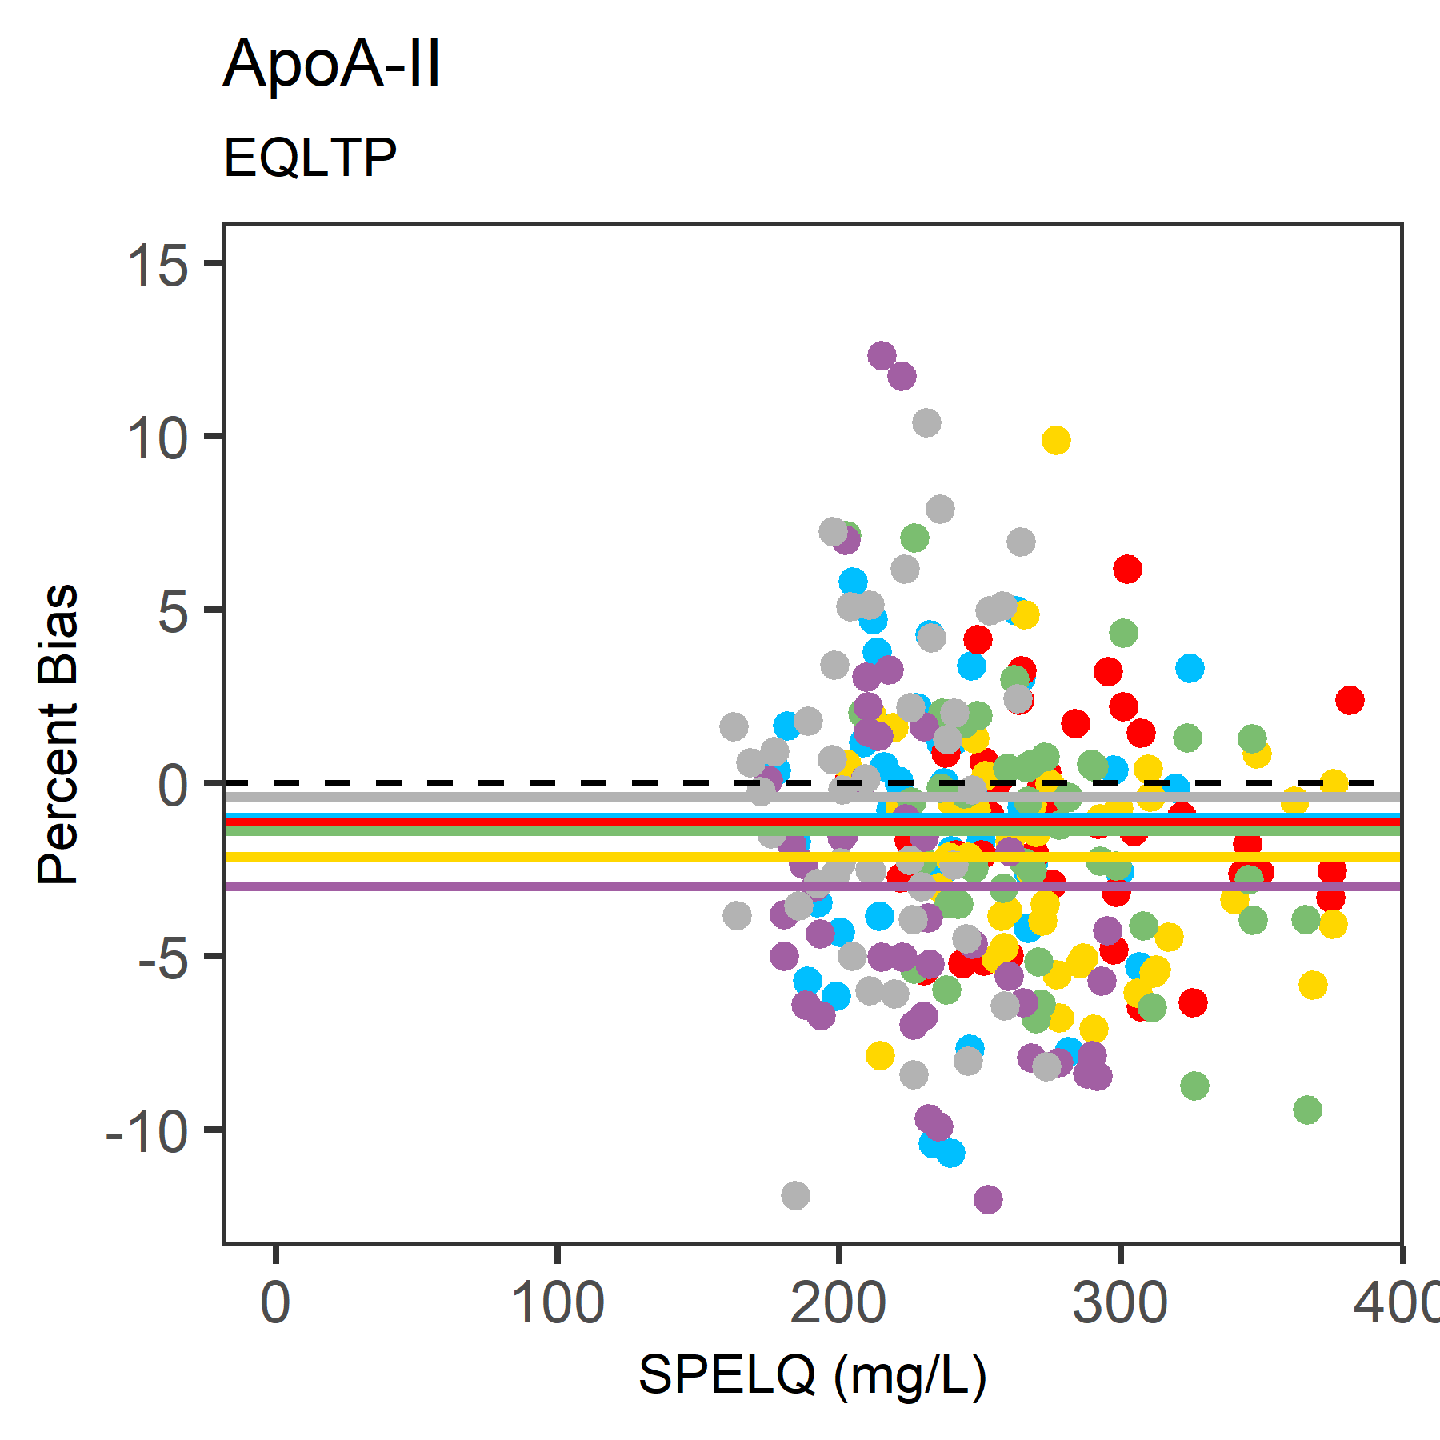
Peptide Comparisons.
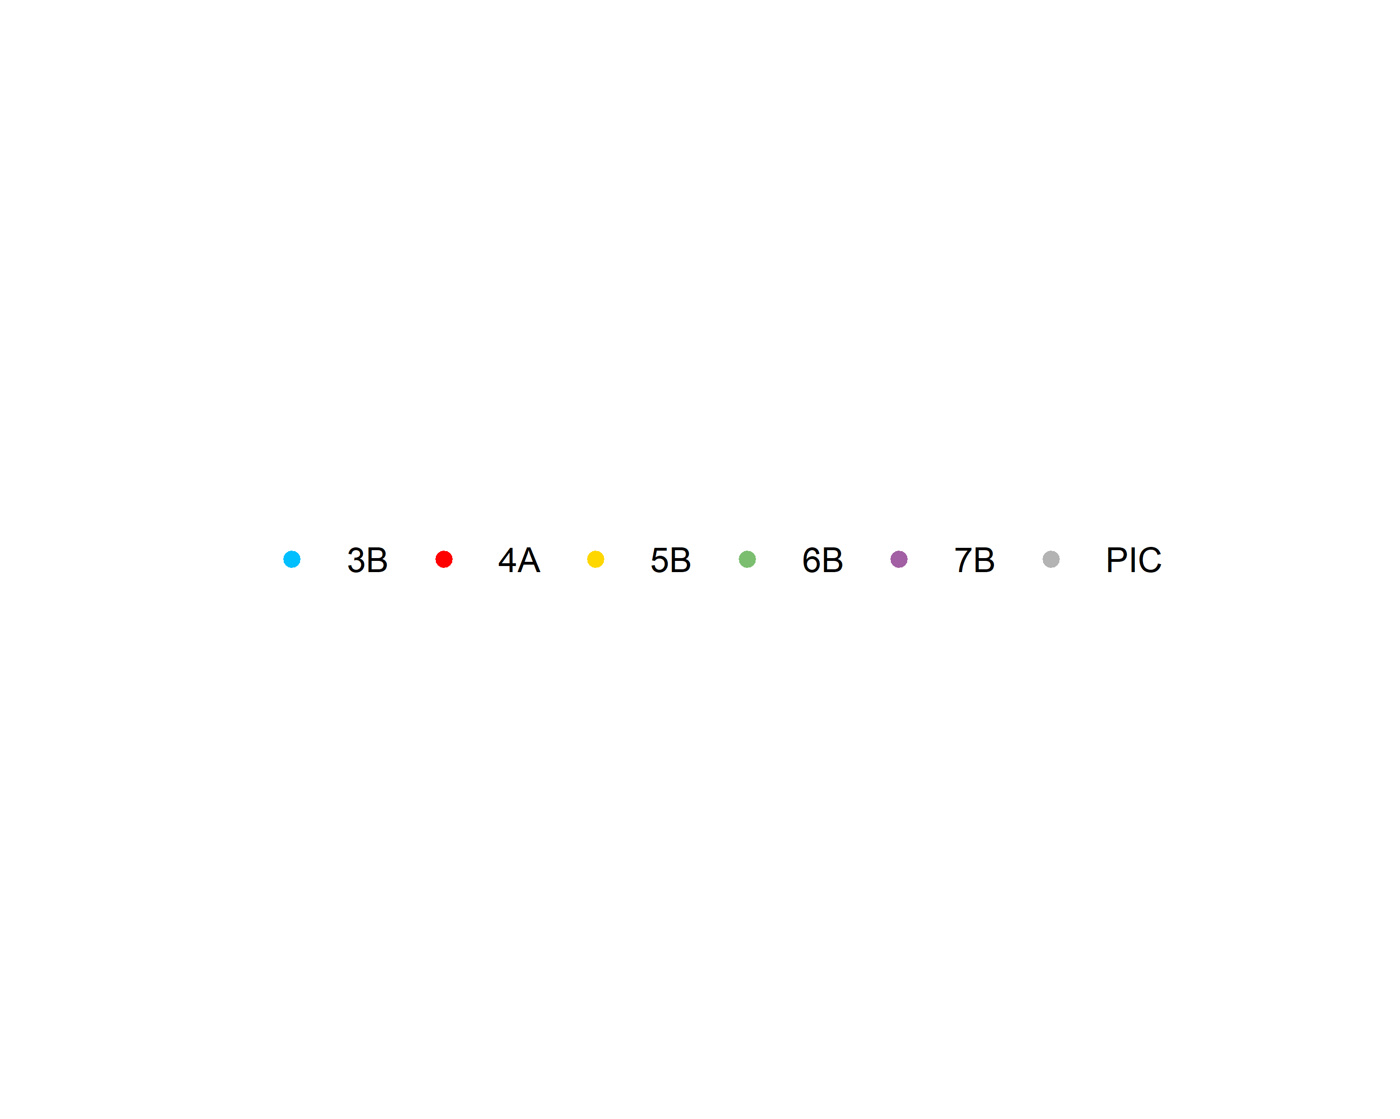
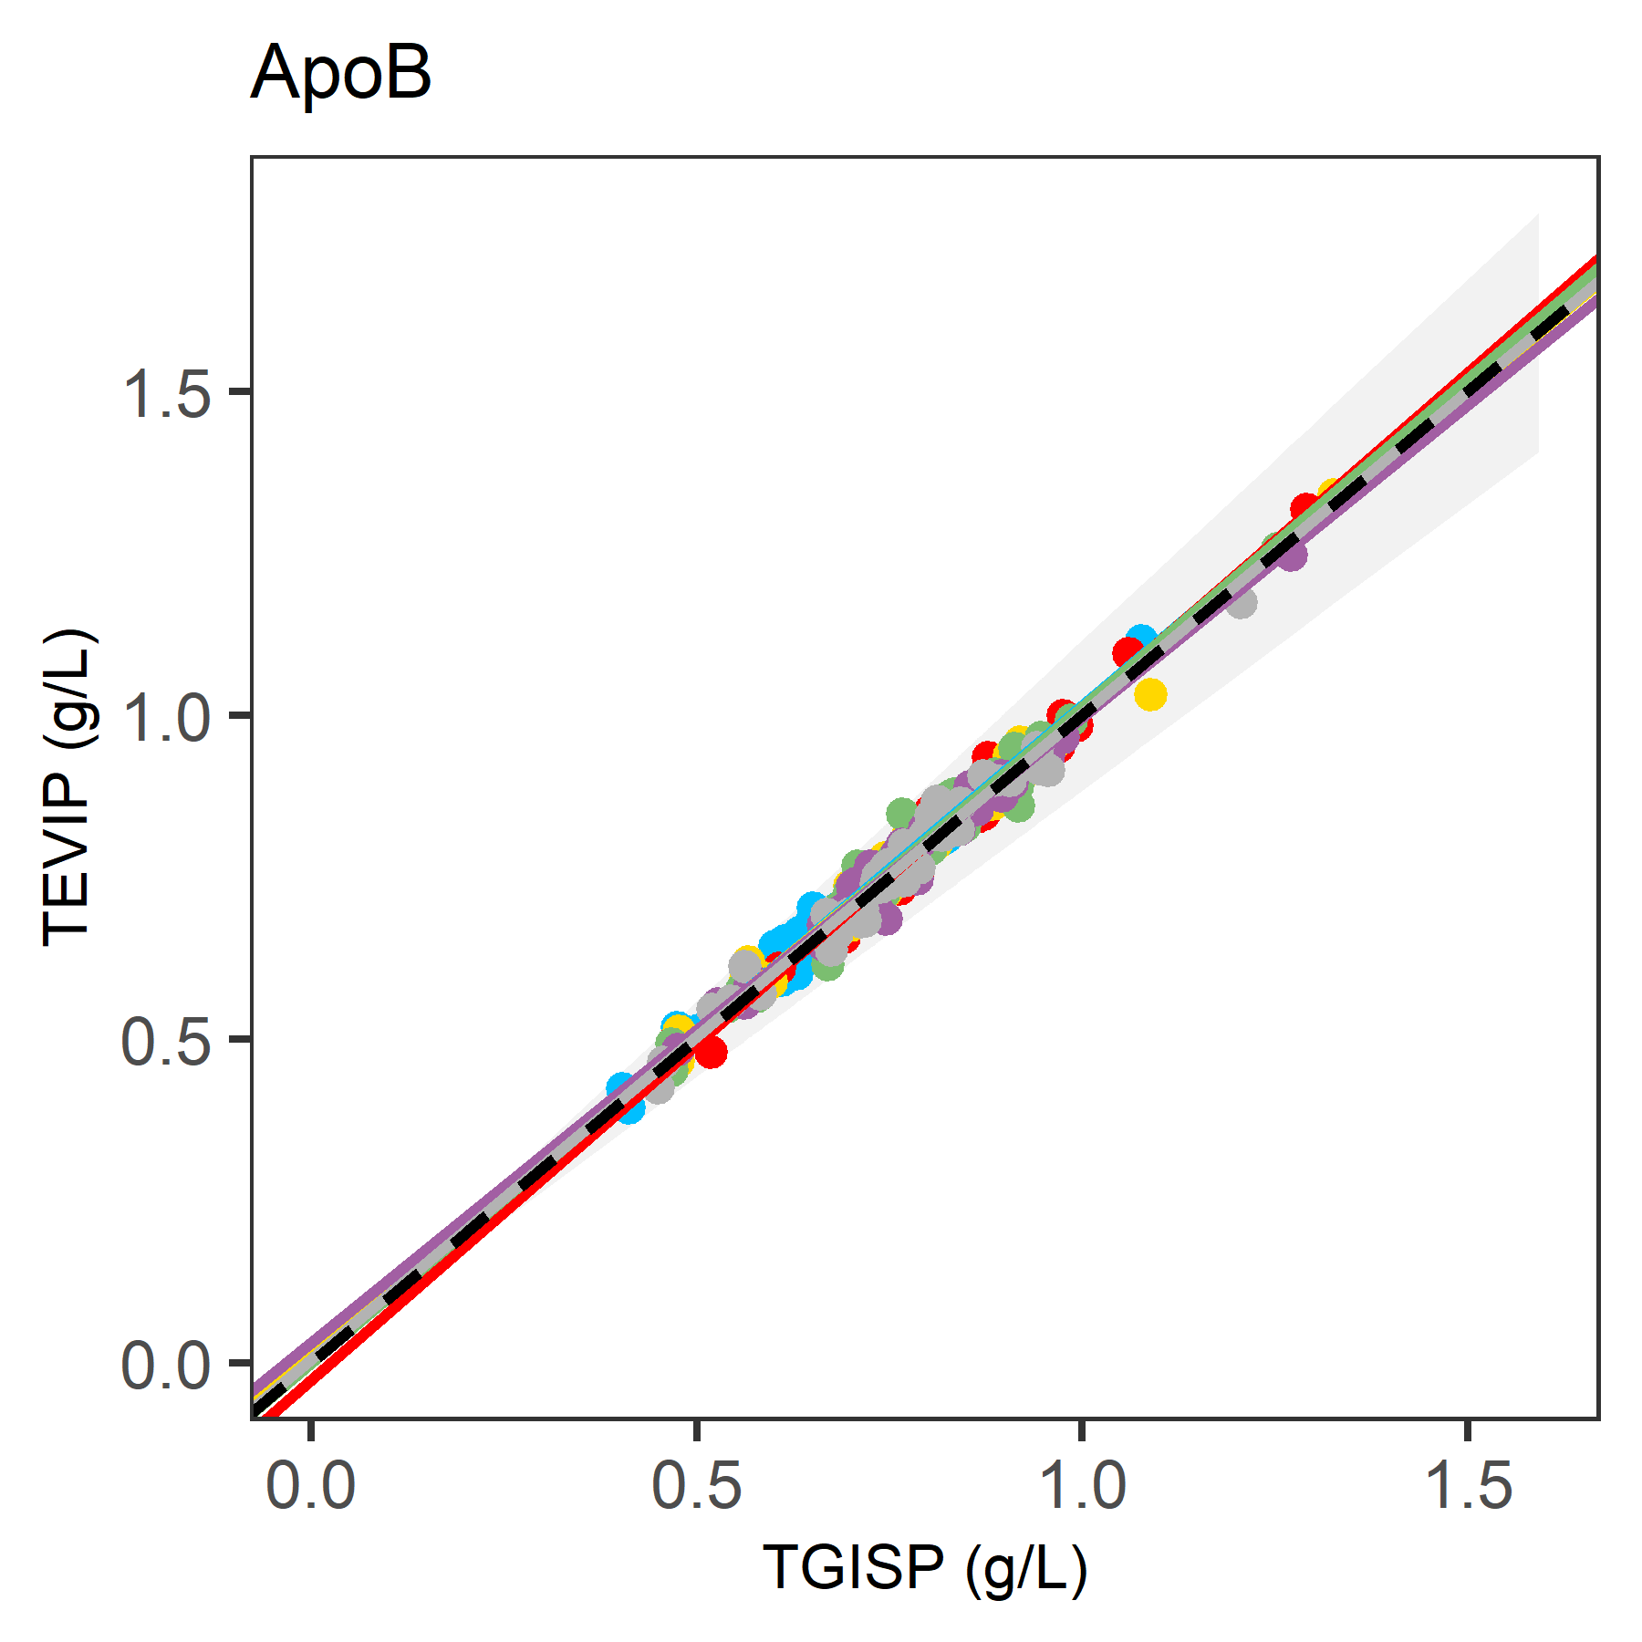
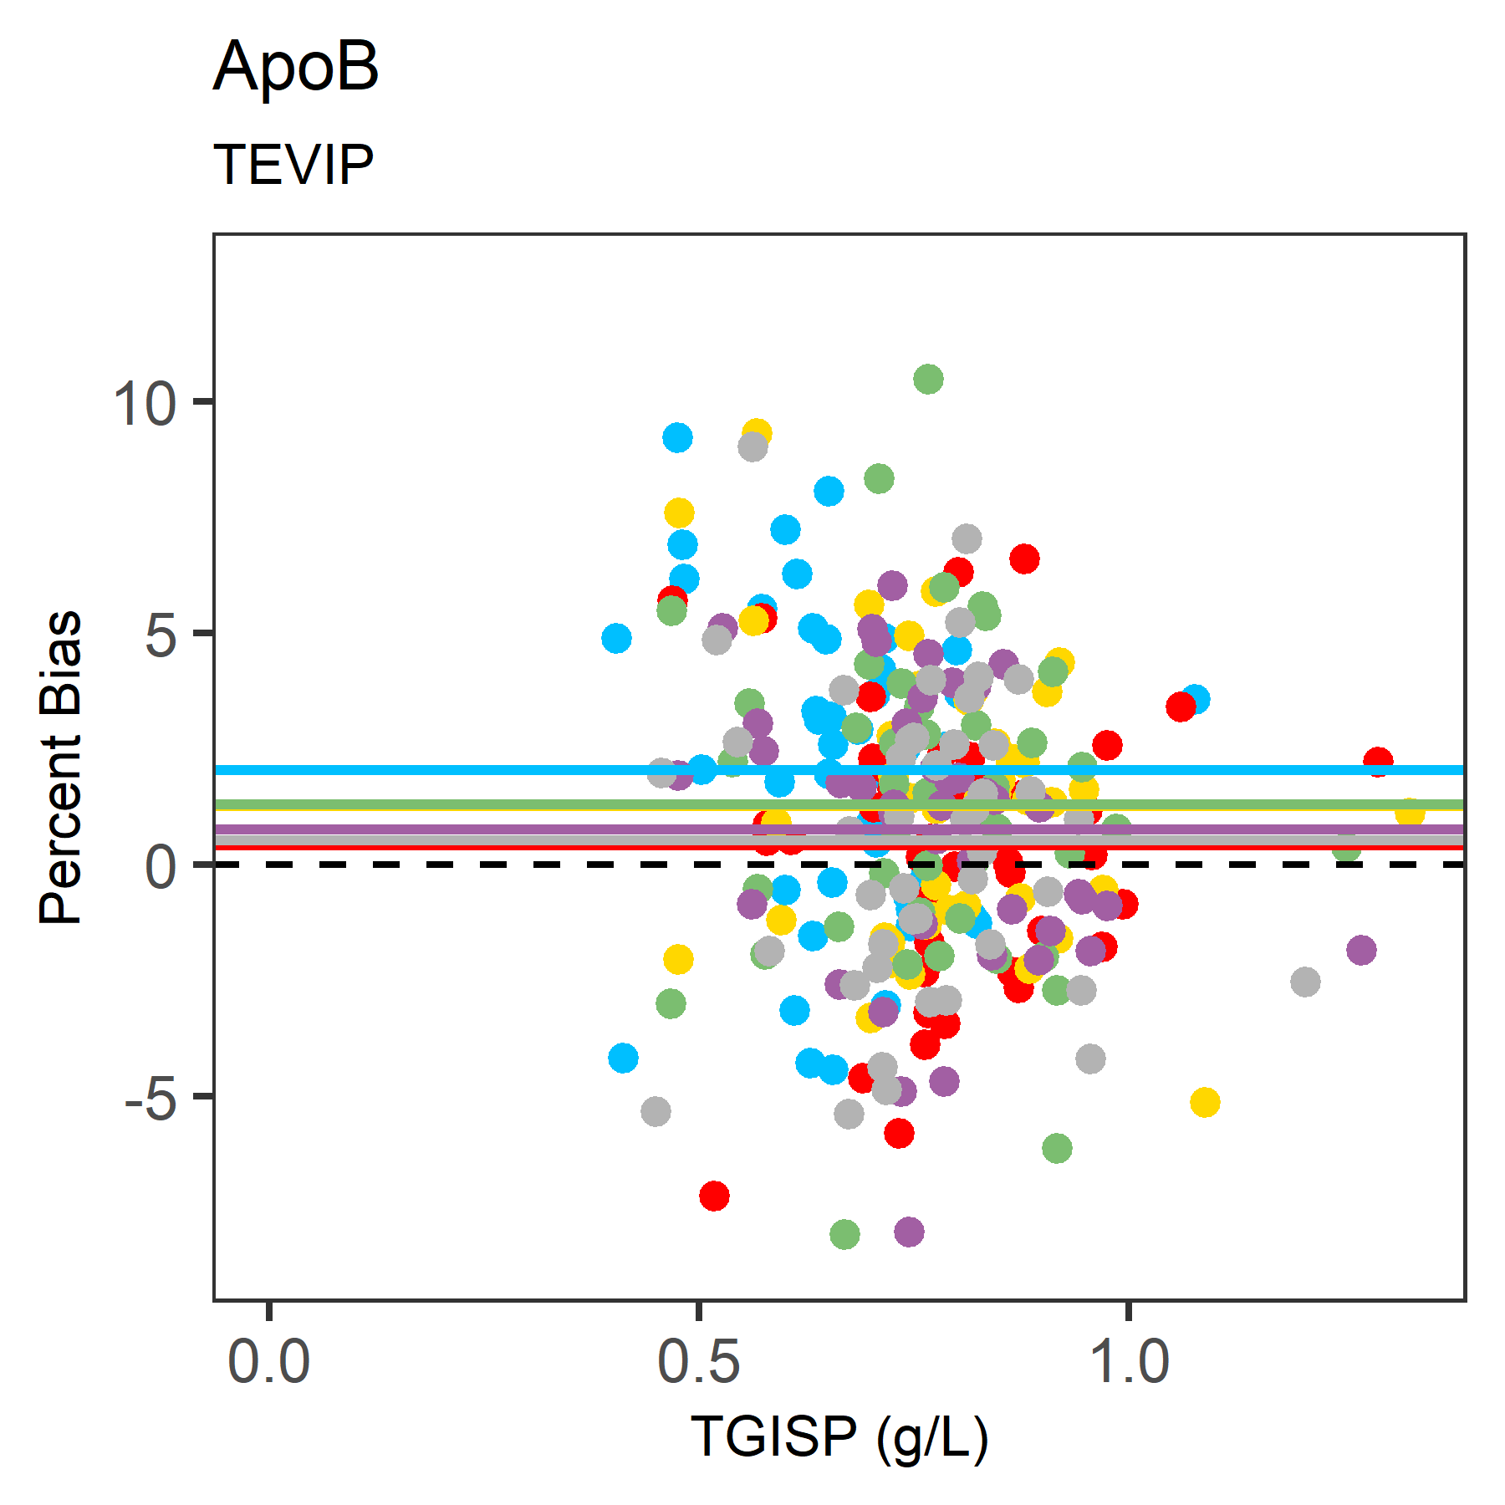
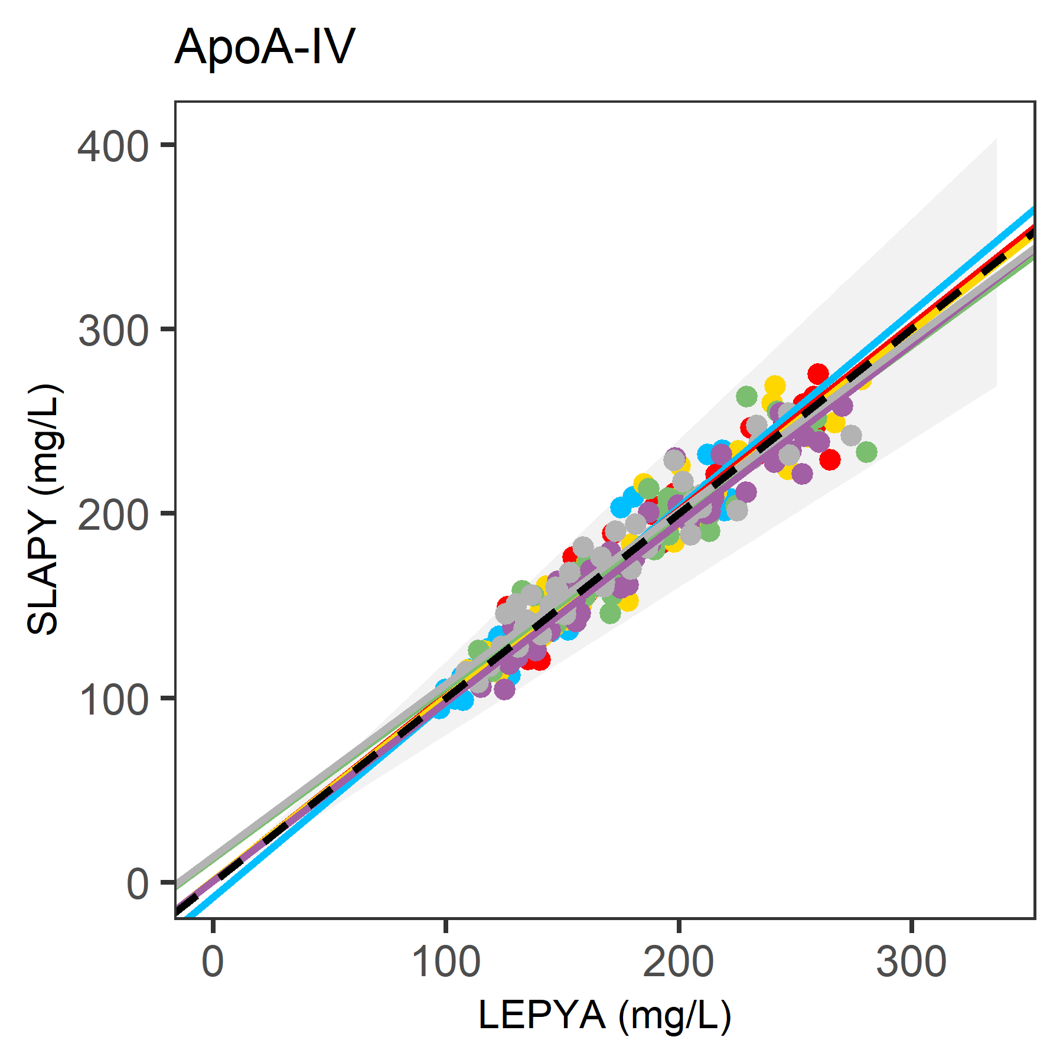
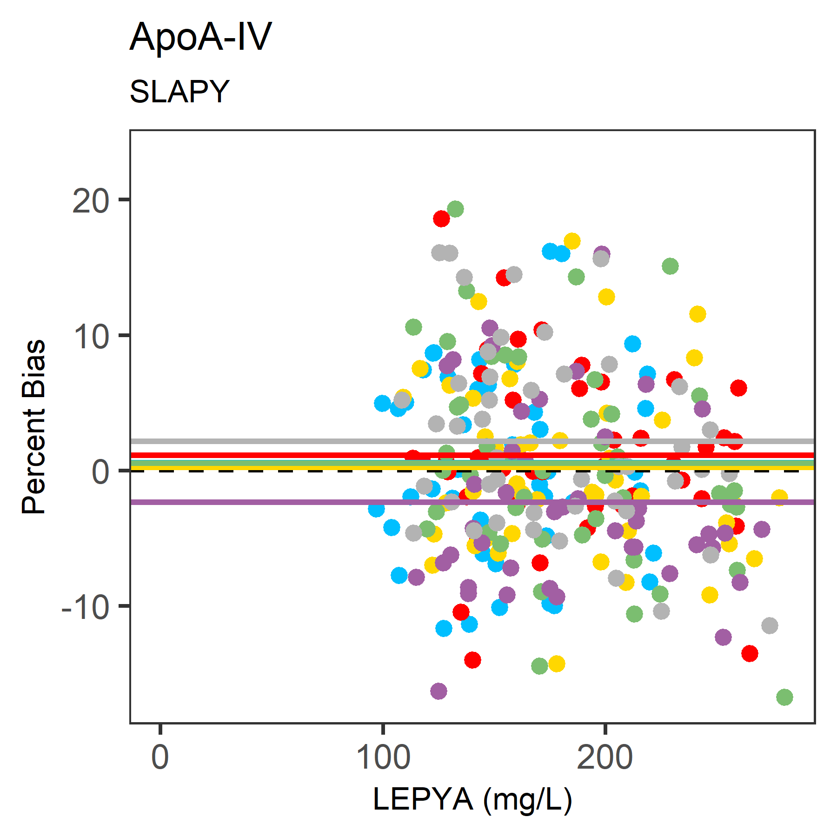
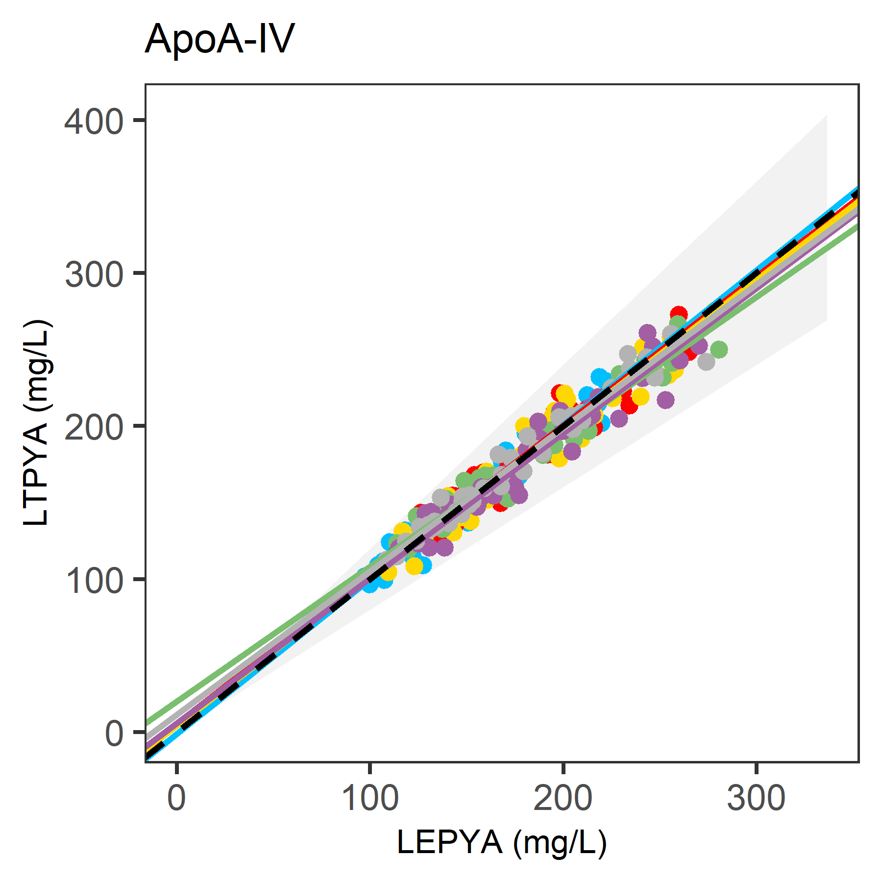
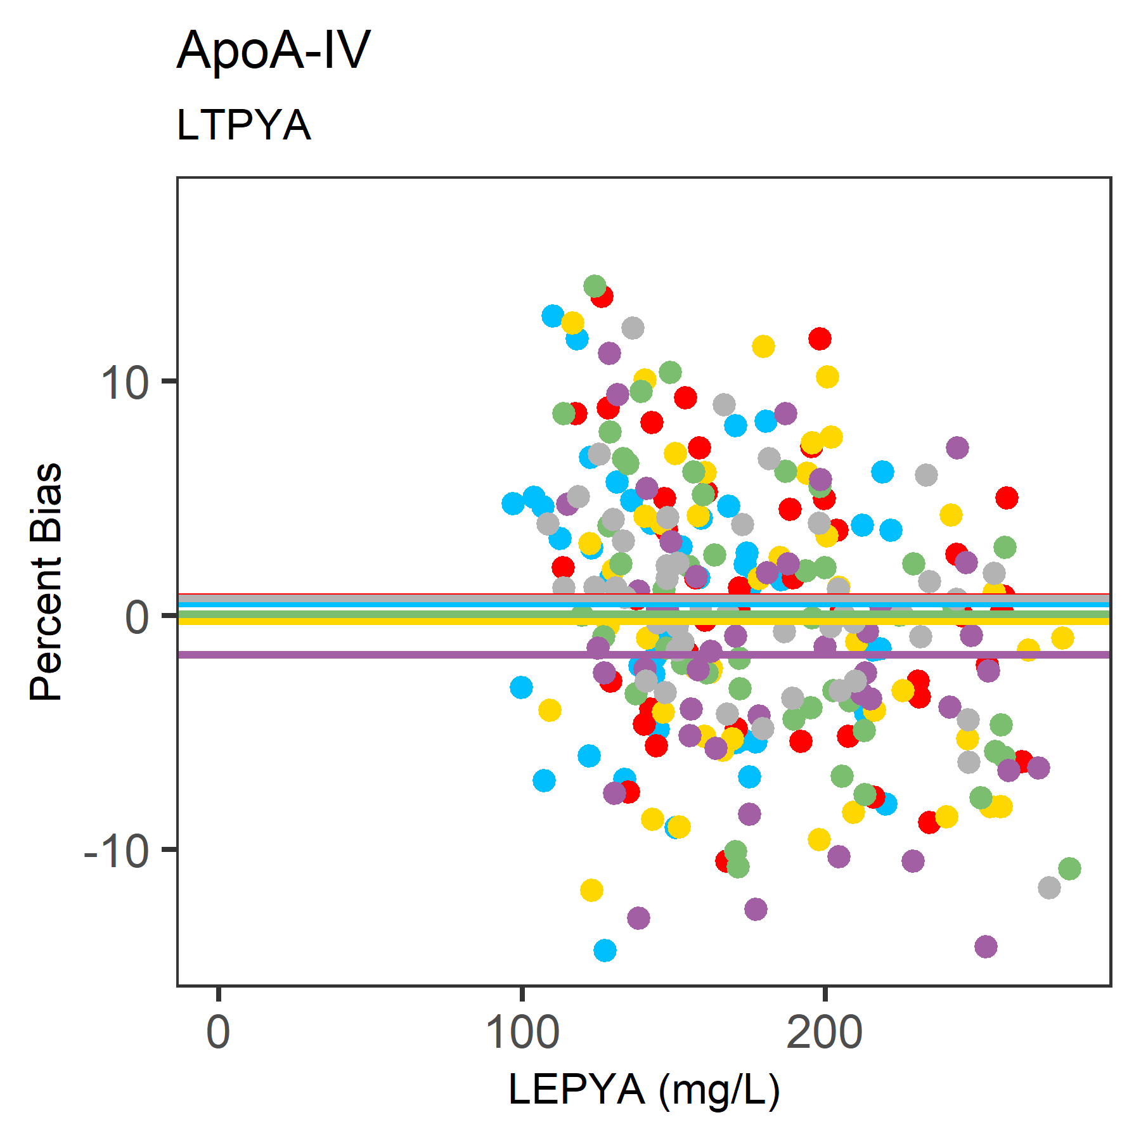
S1(B)
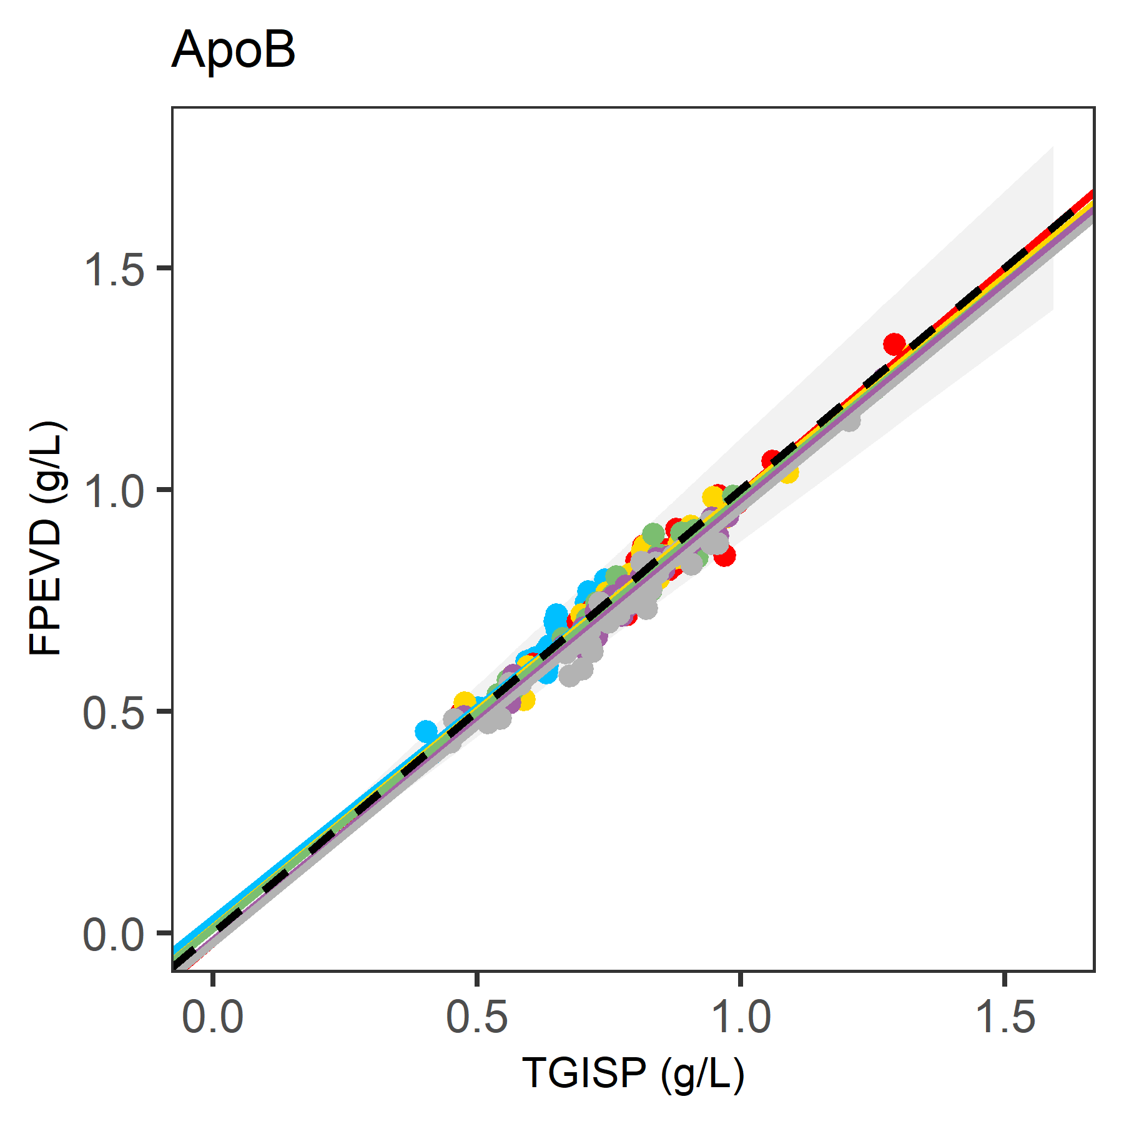
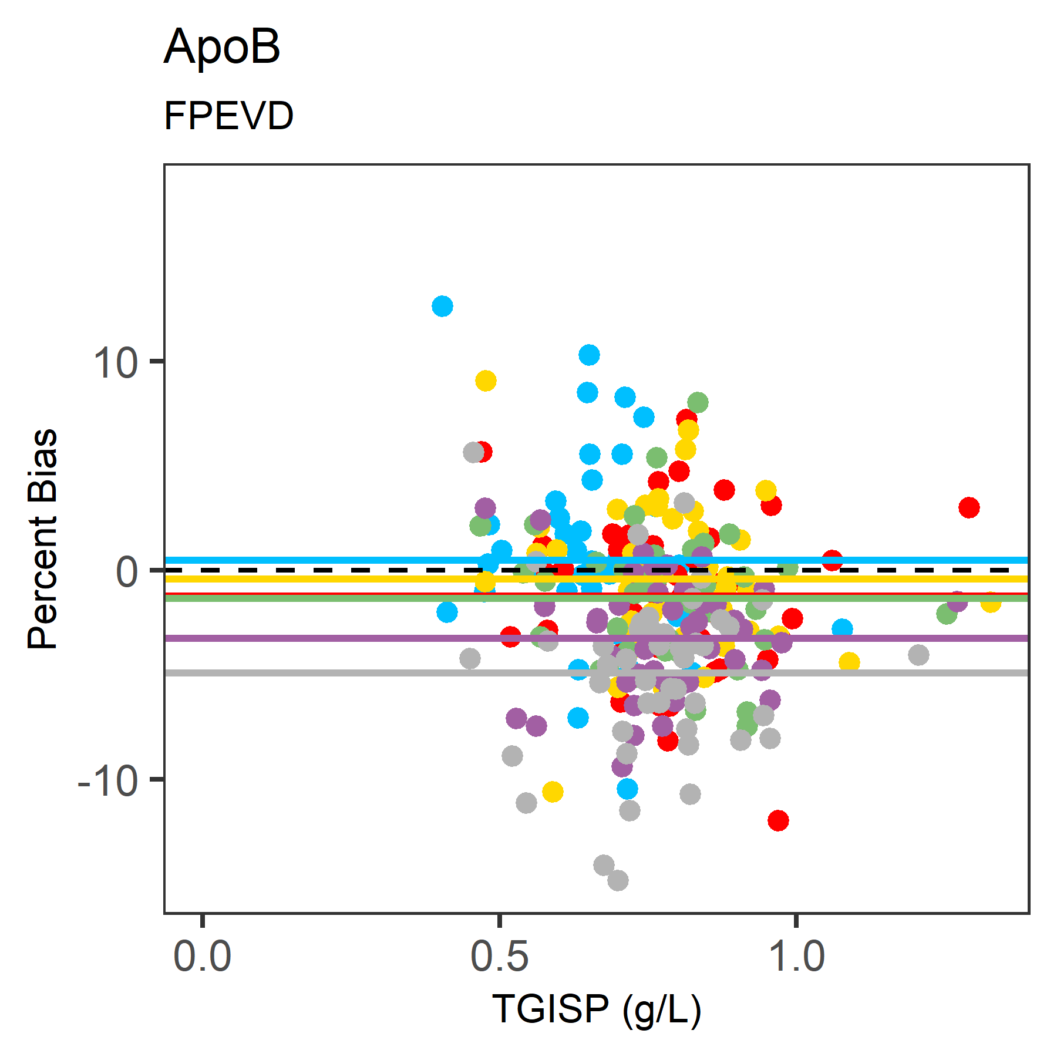
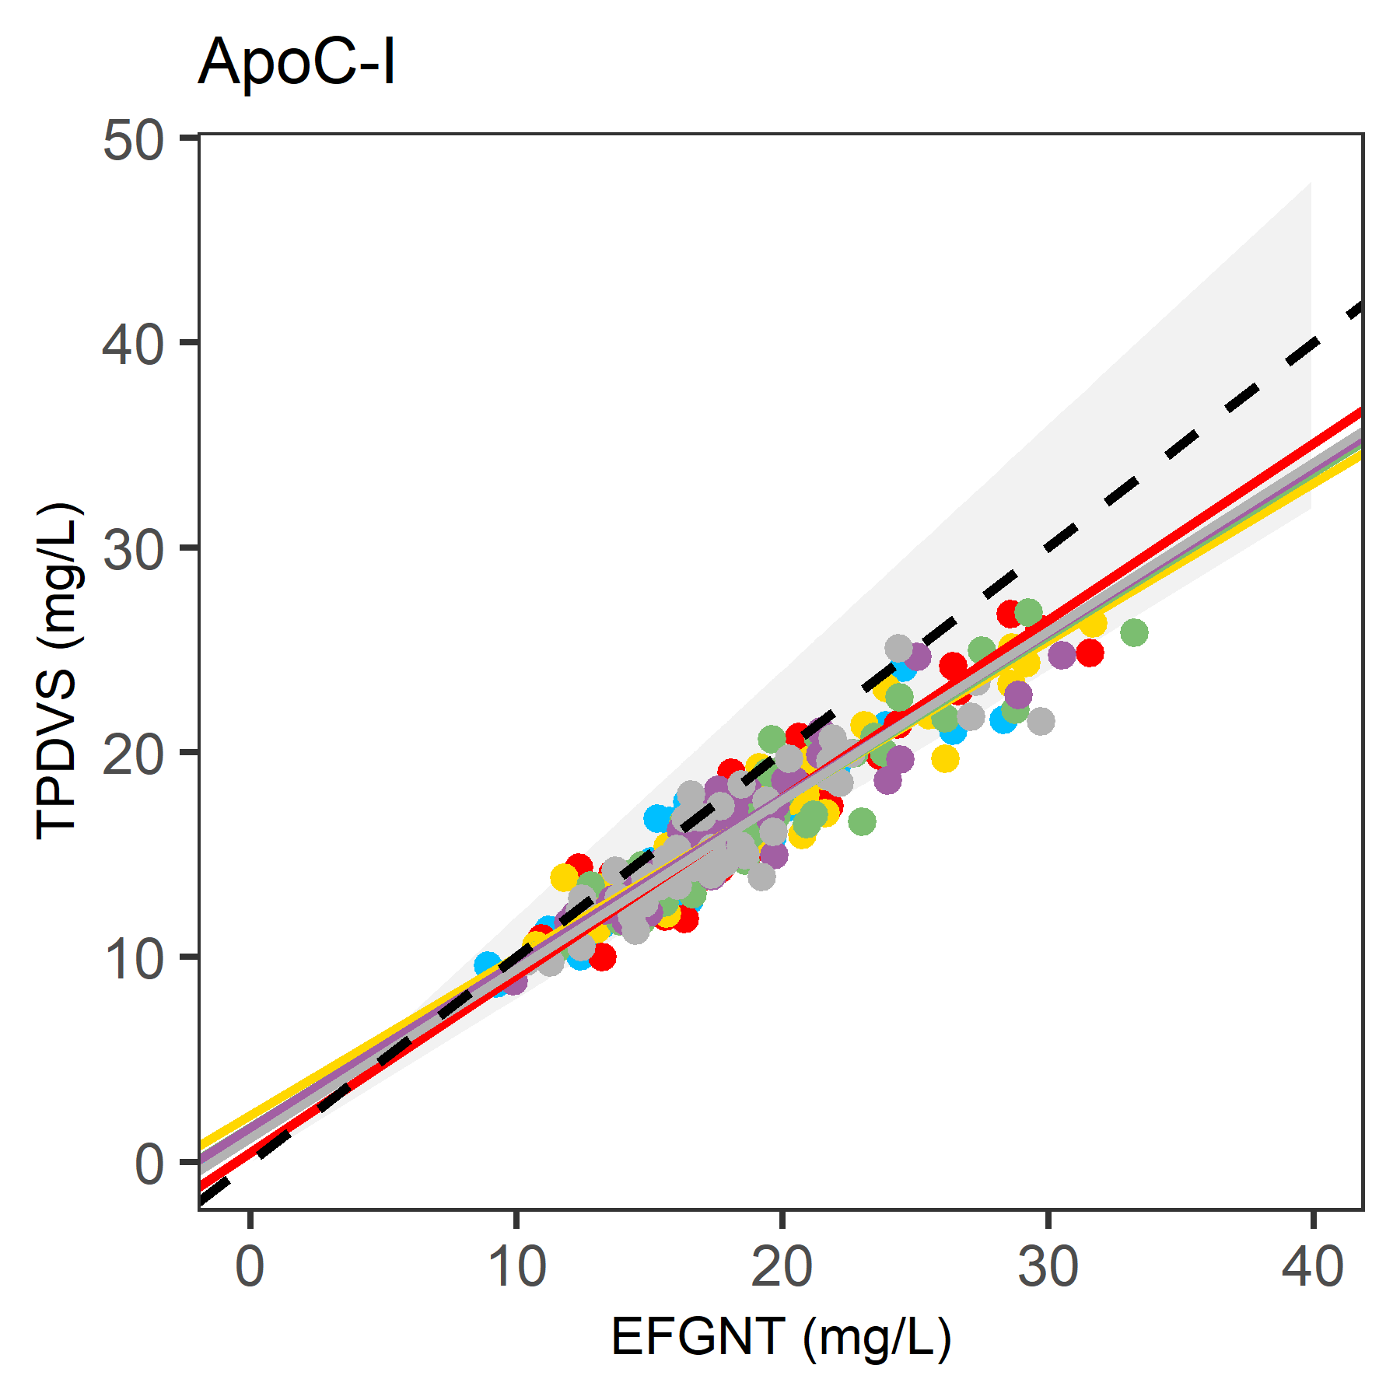
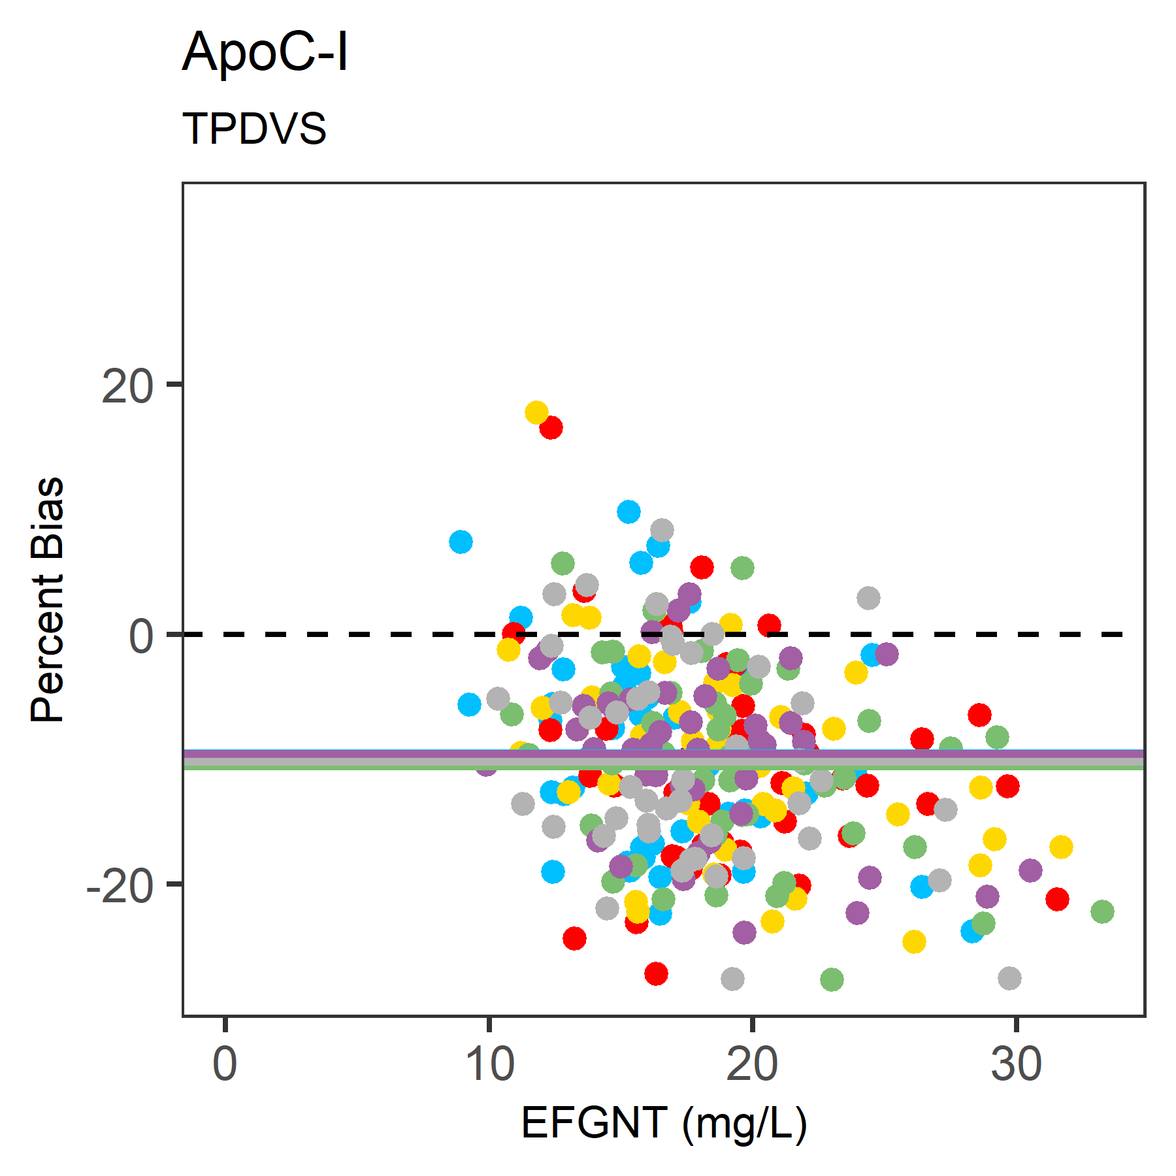
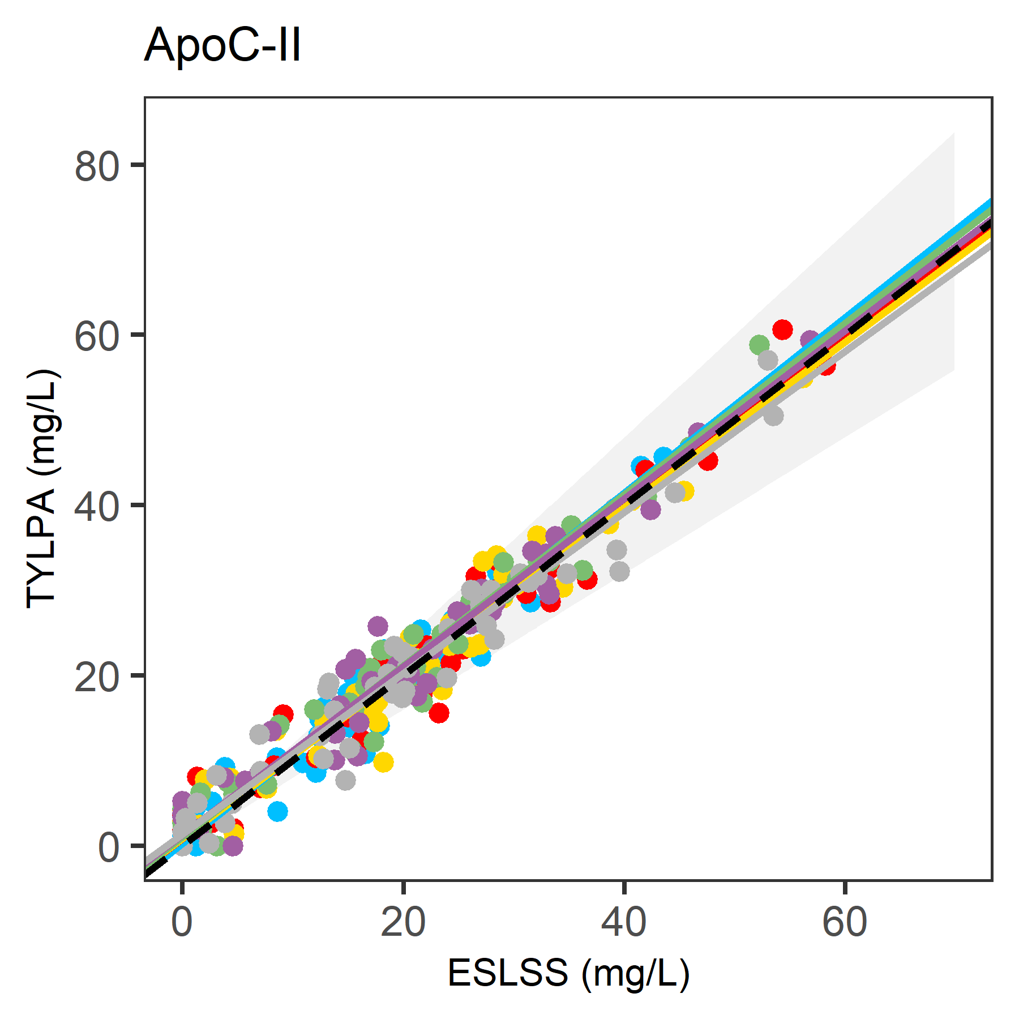
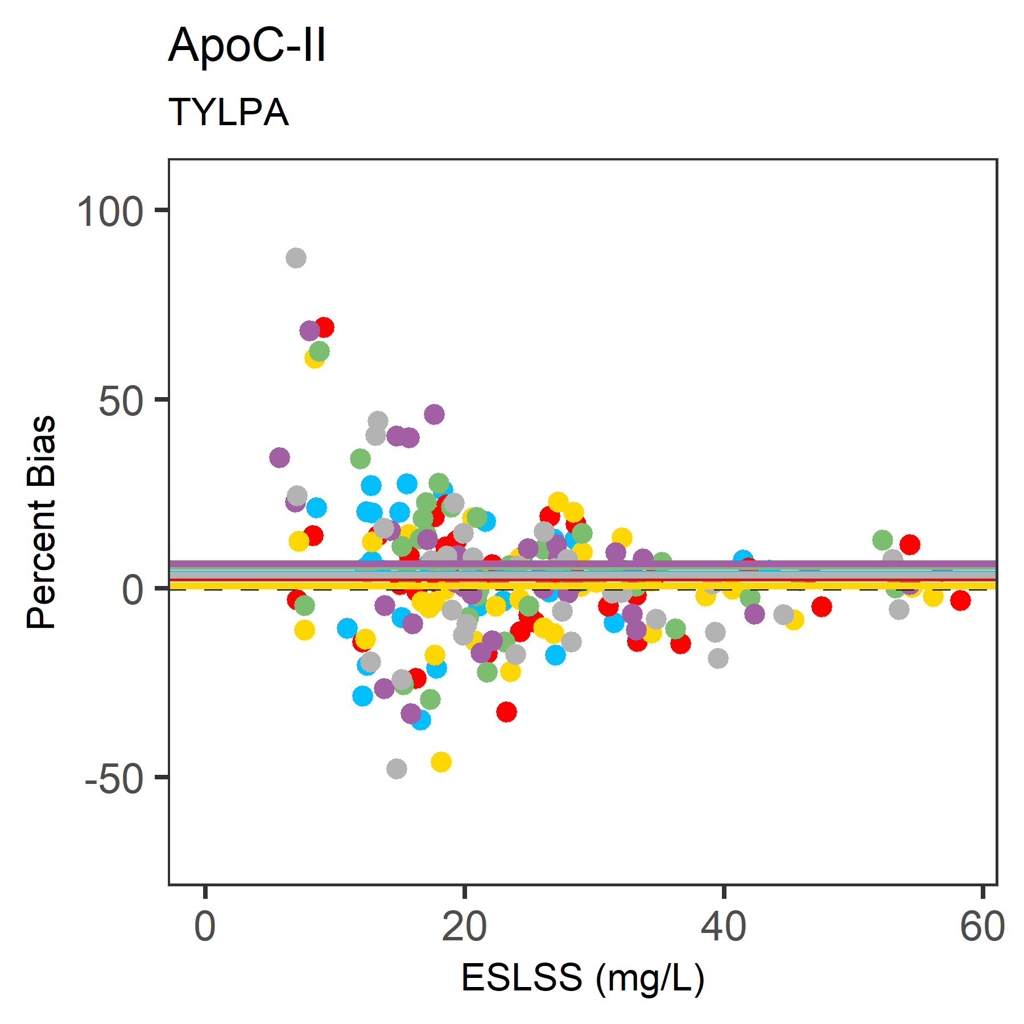
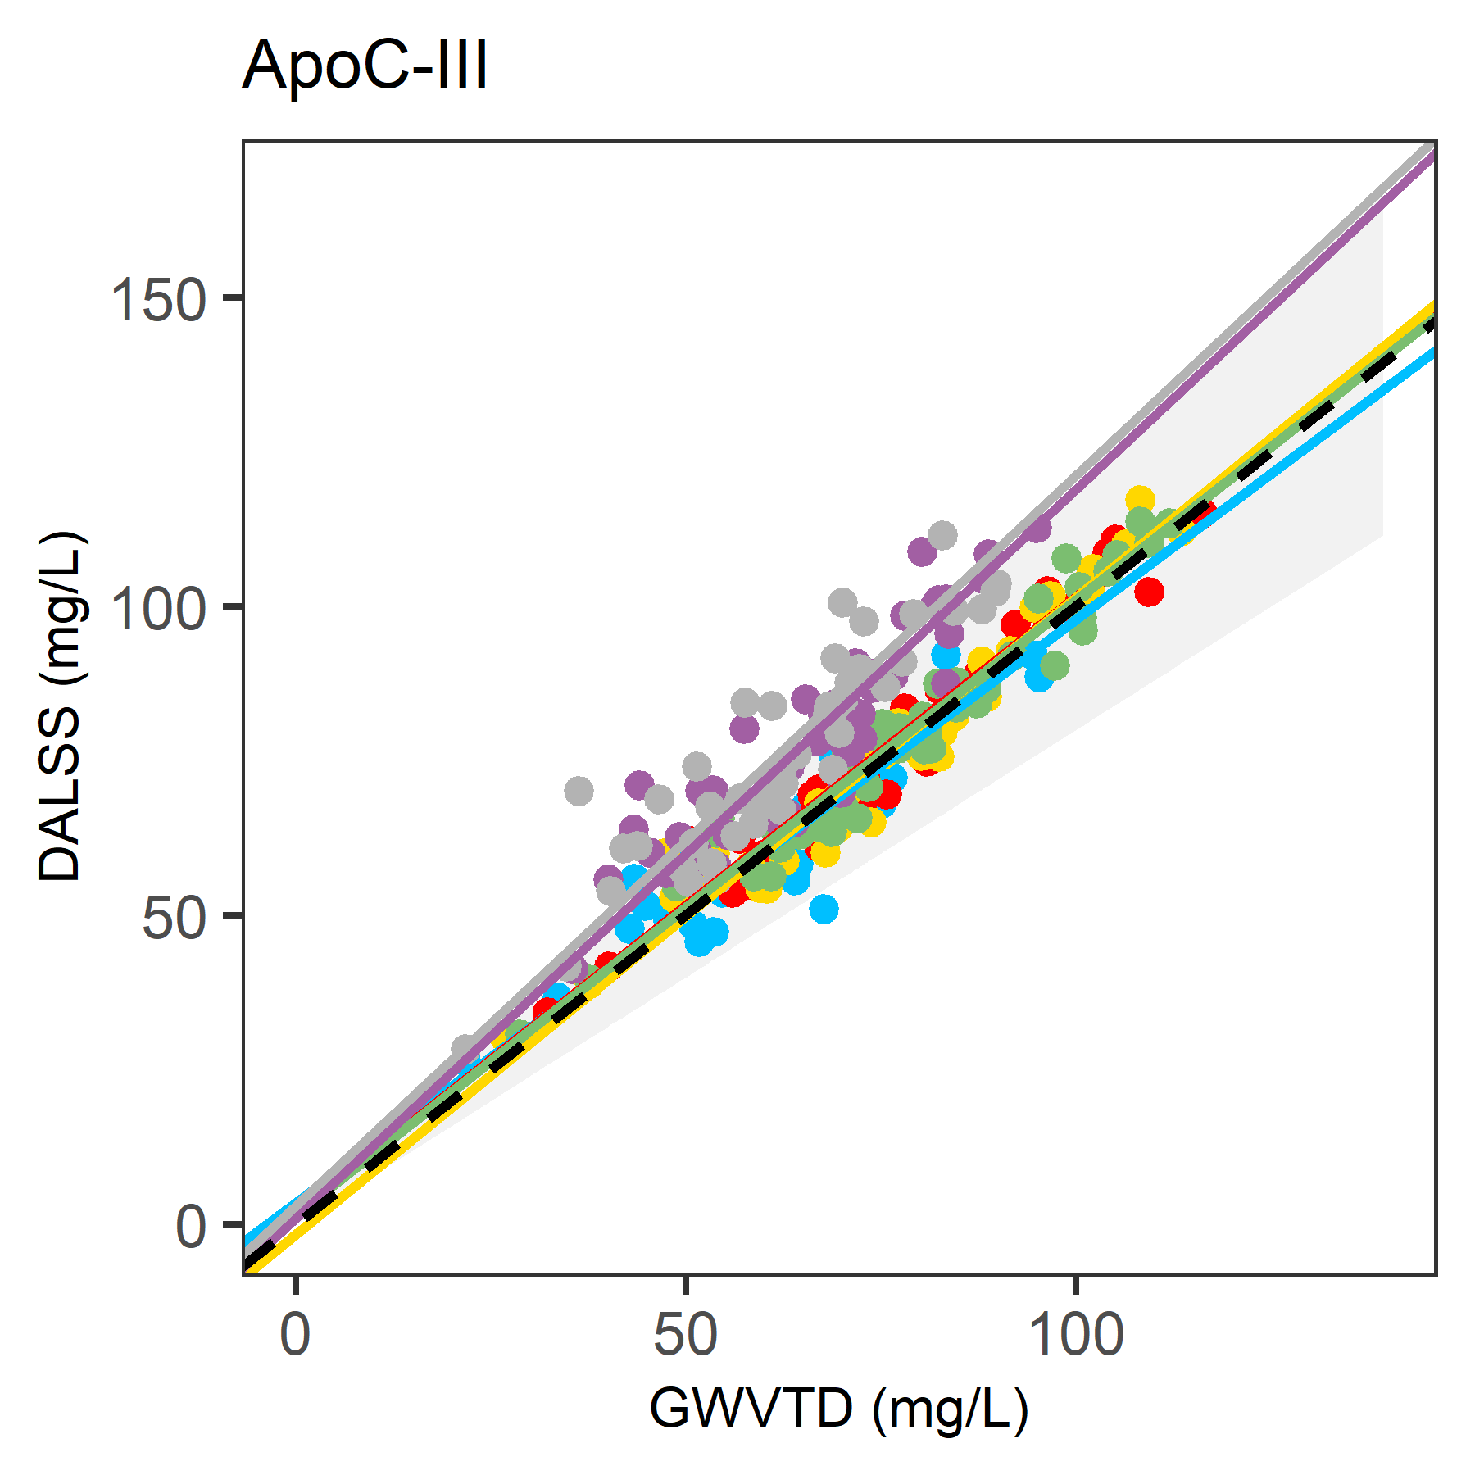
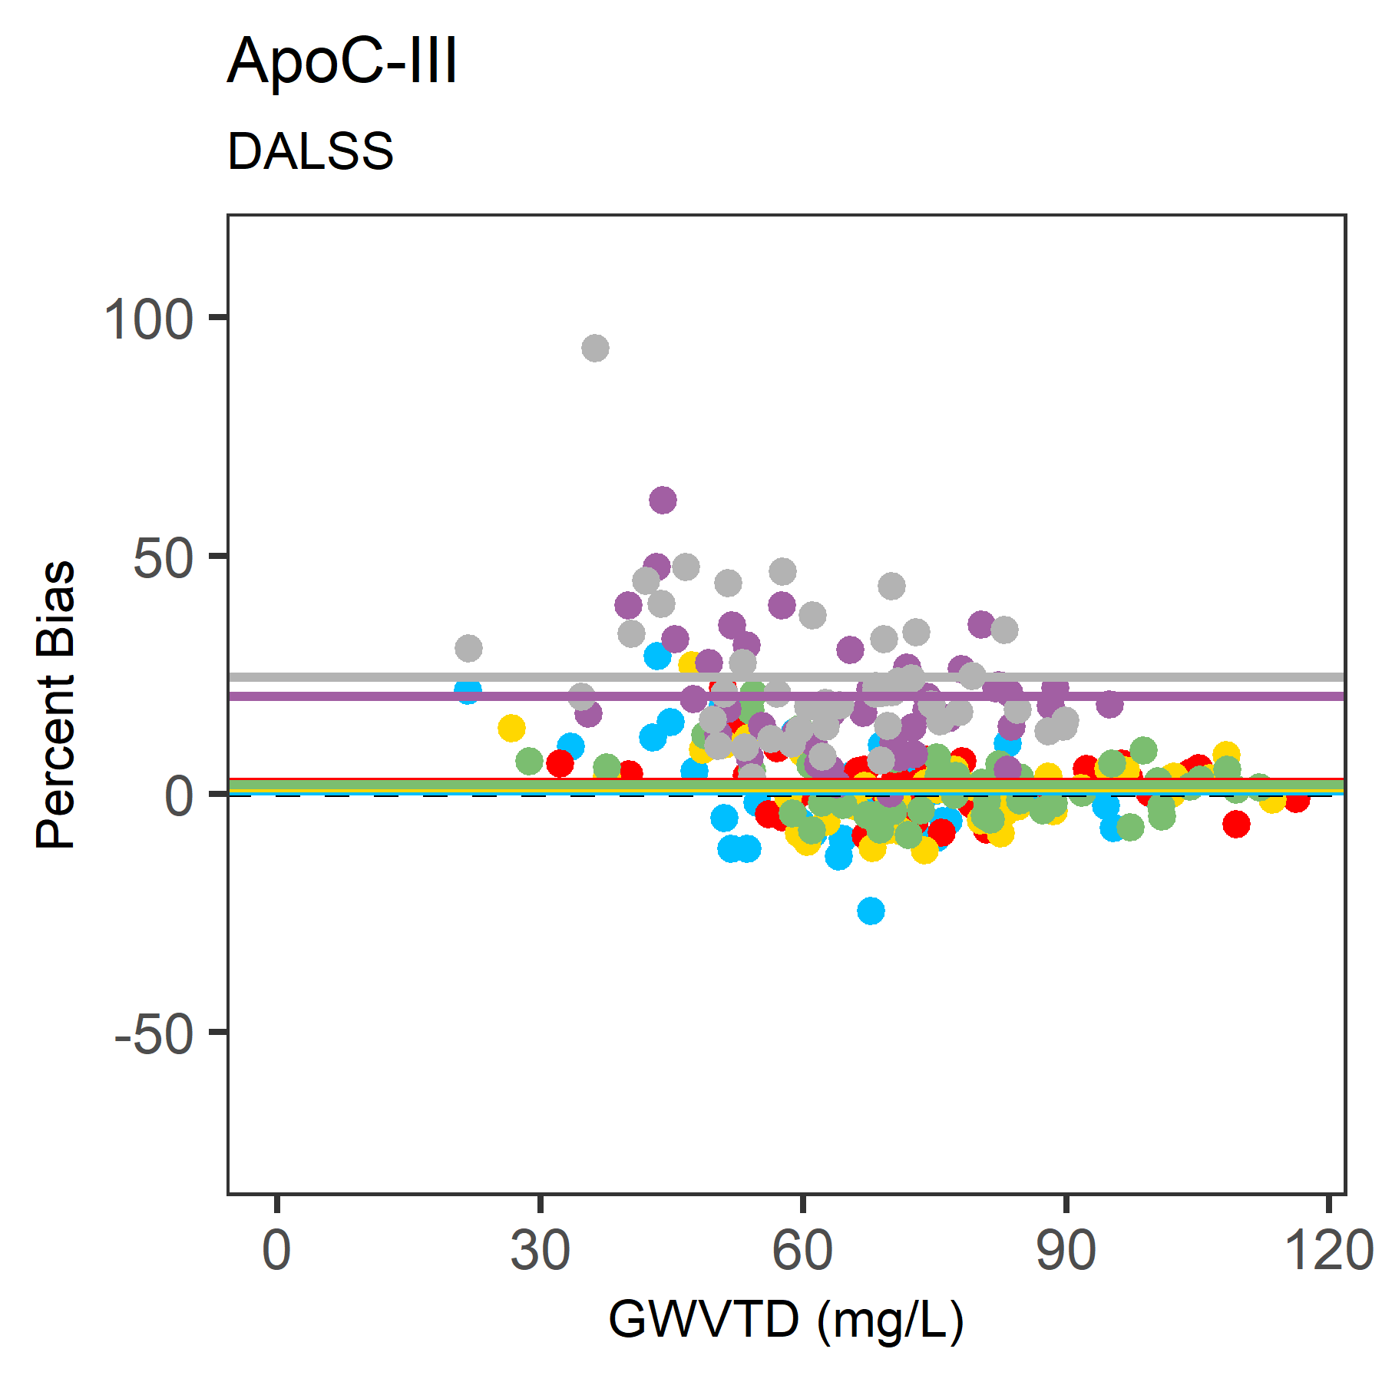
S1(B)

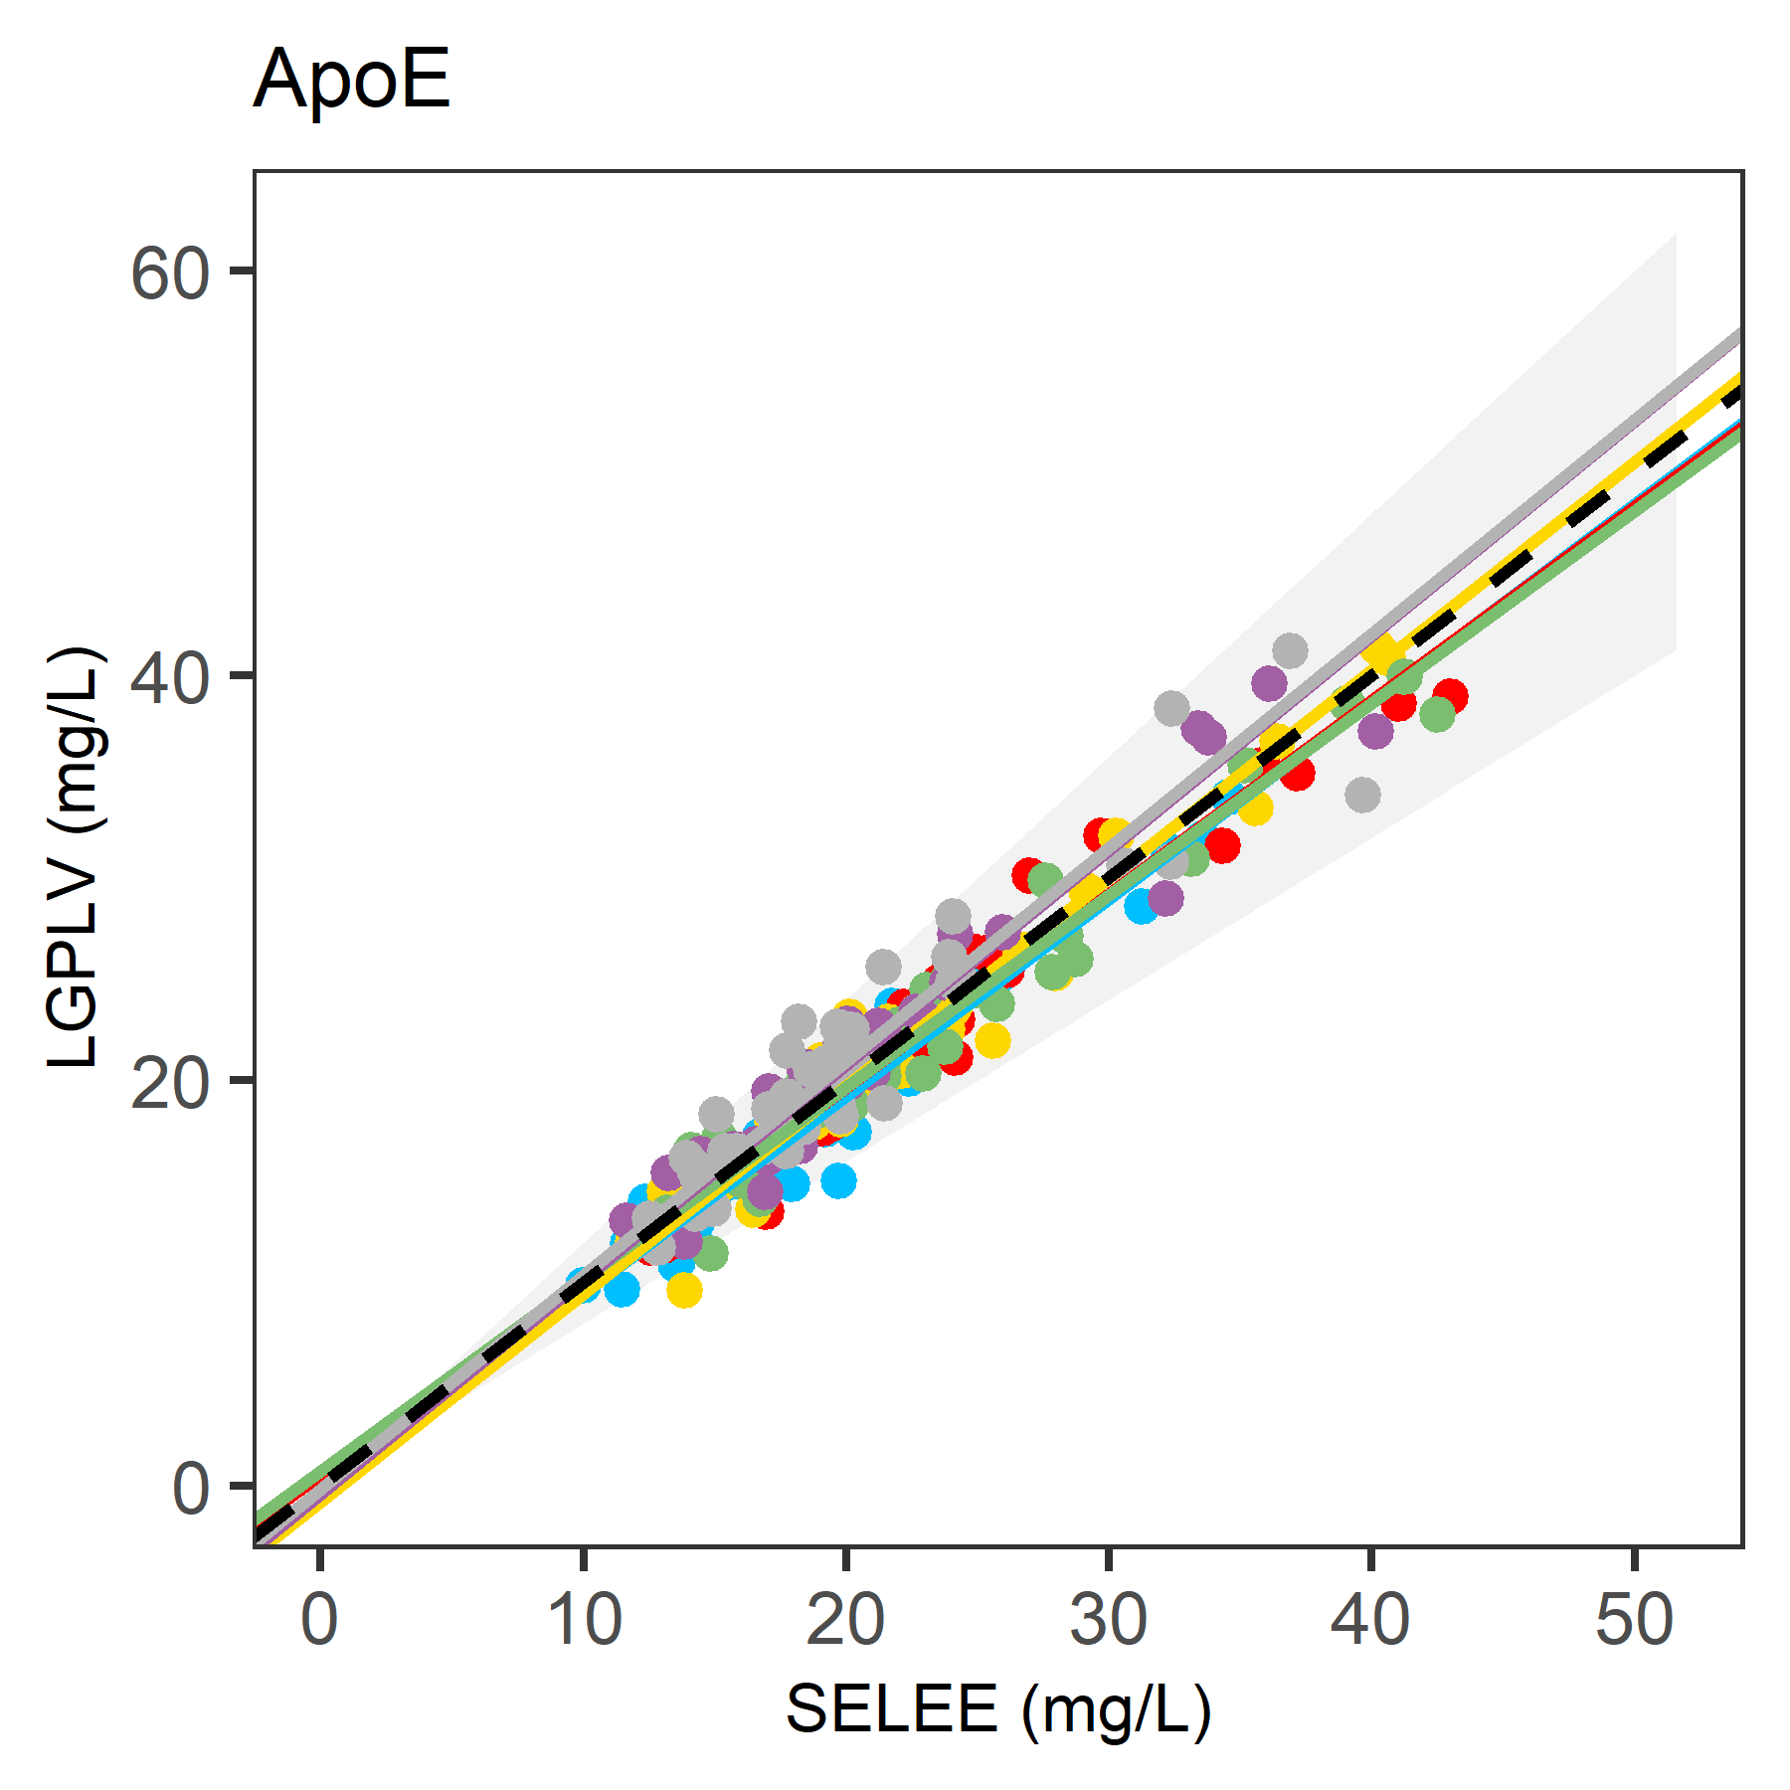
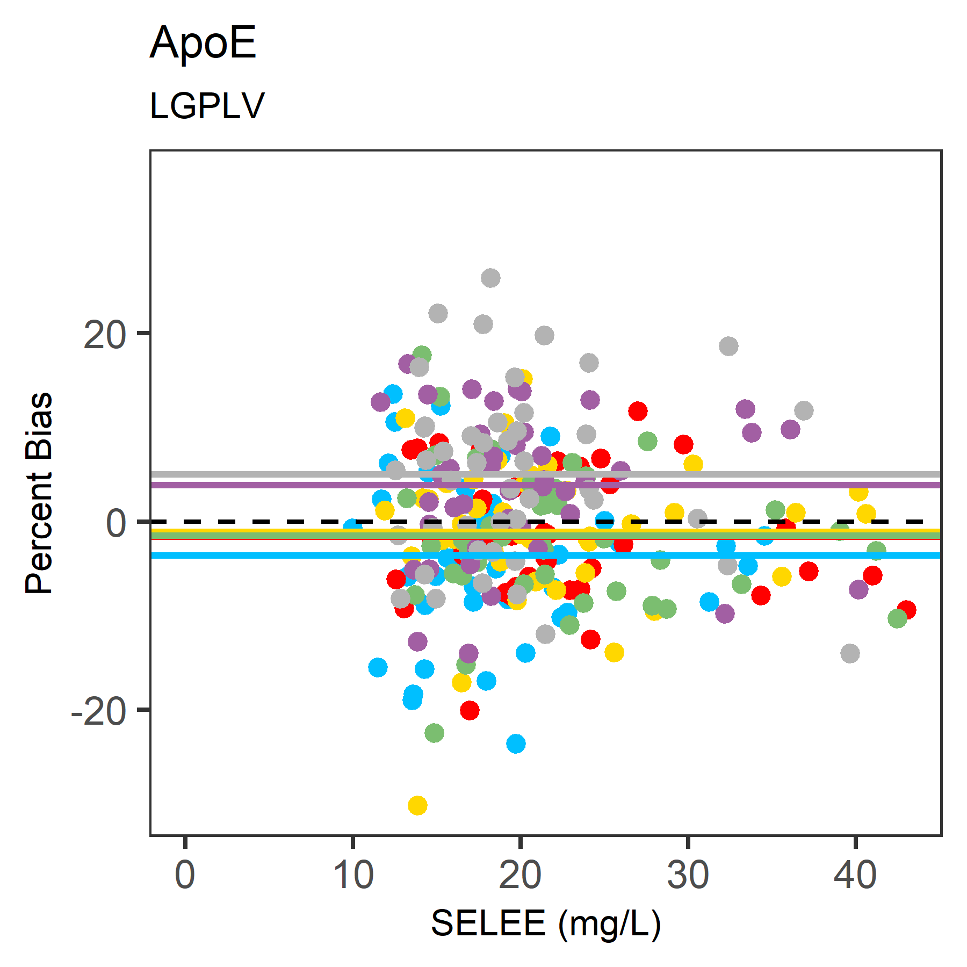
S1(B)
Figure S1 (A): Apo(a) GTYST, A-II (2x), A-IV (3x), B100 (FPEVD), C-I, C-II, C-III and E (all 2x), measured by QPMS. Deming regression results are shown for matrix comparison of the serum gel tubes 5B with the alternative matrices; serum (4A) and plasma (3B, 6B, 7B and PIC) tubes. Corresponding bias plots show the % bias for the alternative matrices compared to serum gel tubes (5B) . Dotted lines; line of equality. Grey area indicates total allowable error (TEa), 24.1% for apo(a), 11.6% for apoB and 20% for all other apos. (S1B) Peptide comparison showing Deming regression lines for the quantifying and confirmation peptides with the corresponding bias plots. Data for correlations (r), slopes and biases are summarized in Tables 1 and 2 of the main document.
ApoB, FPEVD (B100) slopes for sodium citrate < PIC< K₂EDTA < lithium heparin < serum; Slopes for apoA-II SPELQ and EQLTP show strong deviation for both K₂EDTA tubes (7B and PIC), even more than the sodium citrate tubes (3B). ApoA-IV slopes are all very close to 5B except for 3B. ApoE SELEE sodium citrate < K₂EDTA and PIC < lithium heparin and serum.

ApoA-I | Comparison of gel serum 5B vs |  |  |  |  | ApoA-II 5B vs |  |  |  |  |  | ApoA-IV 5B vs
AKPAL | 4A | 6B | 7B | PIC | 3B | SPELQ | 4A | 6B | 7B | PIC | 3B |  | LEPYA | 4A | 6B | 7B | PIC | 3B
Imprecision %CV | 5.3 |  |  |  |  |  | 4.0 |  |  |  |  |  |  | 5.1
Bias % | 0.4 | −2.1 | −1.6 | −3.7 | −14.9 |  | 0.7 | −2.7 | −18.8 | −22.3 | −14.6 |  |  | 0.8 | 0.2 | 1.1 | −2.6 | −14.9
TE* % | 9.2 | 10.9 | 10.4 | 12.5 | 23.7 |  | 7.4 | 9.3 | 25.5 | 29.0 | 21.2 |  |  | 9.3 | 8.3 | 9.6 | 11.1 | 23.4
VQPYL |  |  |  |  |  | EQLTP |  |  |  |  |  |  | LTPYA
Imprecision %CV | 3,2 |  |  |  |  |  | 5,1 |  |  |  |  |  |  | 6,2
Bias % | 0.8 | −2.5 | −13.7 | −15.1 | −14.7 |  | 1.7 | −1.9 | −19.6 | −21.0 | −13.6 |  |  | 1.9 | 0.6 | −0.2 | −1.5 | −14.1
TE* % | 6.2 | 7.8 | 19.0 | 20.4 | 20.0 |  | 10.1 | 10.3 | 28.0 | 29.4 | 22.0 |  |  | 12.1 | 9.6 | 10.3 | 11.7 | 24.2
 |  |  |  |  |  |  |  |  |  |  |  |  | SLAPY
Imprecision %CV |  |  |  |  |  |  |  |  |  |  |  |  |  | 6,6
Bias % |  |  |  |  |  |  |  |  |  |  |  |  |  | 1.8 | 0.1 | −1.5 | −0.9 | −14.6
TE* % |  |  |  |  |  |  |  |  |  |  |  |  |  | 12.7 | 10.8 | 12.4 | 11.8 | 25.5
Apo(a) | 5B vs |  |  |  |  | ApoB | 5B vs |  |  |  |  |  | ApoC-I | 5B vs
LFLEP* | 4A | 6B | 7B | PIC | 3B | TGISP | 4A | 6B | 7B | PIC | 3B |  | EFGNT | 4A | 6B | 7B | PIC | 3B
Imprecision %CV | 7.1 |  |  |  |  |  | 2.8 |  |  |  |  |  |  | 7.3
Bias % | 1.4 | −1.3 | −3.00 | −4.1 | −14.0 |  | 0.5 | −2.4 | −2.6 | −4.0 | −16.0 |  |  | 2.0 | 3.1 | −5.0 | −6.0 | −12.6
TE* % | 13.0 | 13.0 | 14.7 | 15.7 | 25.7 |  | 5.1 | 7.0 | 7.2 | 8.5 | 20.5 |  |  | 14.1 | 15.2 | 17.1 | 18.0 | 24.6
GISST* |  |  |  |  |  | TEVIP
Imprecision %CV | 11,5 |  |  |  |  |  | 2,4 |  |  |  |  |  | TPDVS | 5,9
Bias % | 2.2 | 4.1 | −0.20 | −0.2 | −9.3 |  | −0.3 | −2.4 | −3.2 | −4.7 | −15.3 |  |  | 1.0 | 1.9 | −4.7 | −6.9 | −12.5
TE* % | 16.8 | 23.0 | 19.1 | 19.1 | 28.2 |  | 3.7 | 6.4 | 7.2 | 8.7 | 19.3 |  |  | 10.7 | 11.5 | 14.4 | 16.5 | 22.2
GTYST |  |  |  |  |  | FPEVD
Imprecision %CV | 5,9 |  |  |  |  |  | 3,6
Bias % | 1.9 | −2.2 | −2.21 | −3.4 | −15.1 |  | −0.3 | −3.3 | −5.3 | −8.4 | −15.2
TE* % | 11.6 | 11.9 | 11.9 | 13.1 | 24.8 |  | 6.2 | 9.2 | 11.3 | 14.3 | 21.1
ApoC-II | 5B vs |  |  |  |  | ApoC-III | 5B vs |  |  |  |  |  | ApoE | 5B vs
ESLSS | 4A | 6B | 7B | PIC | 3B | GWVTD | 4A | 6B | 7B | PIC | 3B |  | SELEE | 4A | 6B | 7B | PIC | 3B
Imprecision %CV | 8.3 |  |  |  |  |  | 4.1 |  |  |  |  |  |  | 3.8
Bias % | 0.8 | −0.1 | −2.5 | −3.2 | −26.8 |  | 1.5 | 1.7 | −14.6 | −17.7 | −11.3 |  |  | 2.1 | 3.6 | −5.3 | −6.8 | −13.5
TE* % | 14.4 | 13.7 | 16.1 | 16.8 | 40.4 |  | 8.3 | 8.5 | 21.4 | 24.5 | 18.1 |  |  | 8.4 | 9.9 | 11.7 | 13.2 | 19.9
TYLPA |  |  |  |  |  | DALSS |  |  |  |  |  |  | LGPLV
Imprecision %CV | 5,7 |  |  |  |  |  | 4,8 |  |  |  |  |  |  | 6,5
Bias % | 3.1 | 3.5 | 2.0 | −2.6 | −23.8 |  | 2.7 | 2.3 | 1.5 | 0.5 | −12.1 |  |  | 1.7 | 3.3 | −0.4 | −0.9 | −15.4
TE* % | 12.6 | 12.9 | 11.4 | 12.0 | 33.2 |  | 10.6 | 10.2 | 9.4 | 7.4 | 19.9 |  |  | 12.5 | 14.0 | 11.1 | 11.6 | 26.2

Table ST3; Total error values were calculated using bias values obtained for the matrix comparisons (Table 1) and EP15 imprecision CVs (% indicated in bold for 21 peptides). Imprecision was established with EP15 protocol performed for validation of the 9 apolipoproteins. EP15 results for the 9 apos confirmed the results published earlier for the original 6 apolipoproteins A-I, B, C-I, C-II, C-III and E(4). Total allowable error for apoA-I, B and (a) are 9.1, 11.6 and 24,1% respectively. All others were set to 20%. Peptides exceeding the TEa are indicated in yellow.
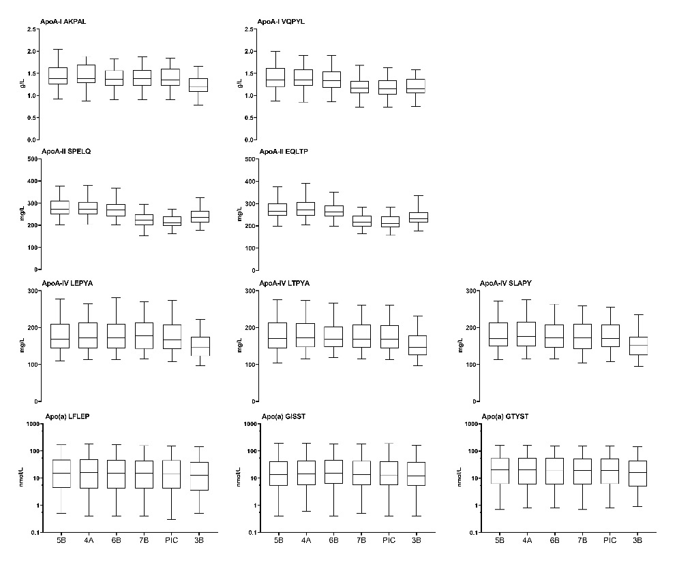
A
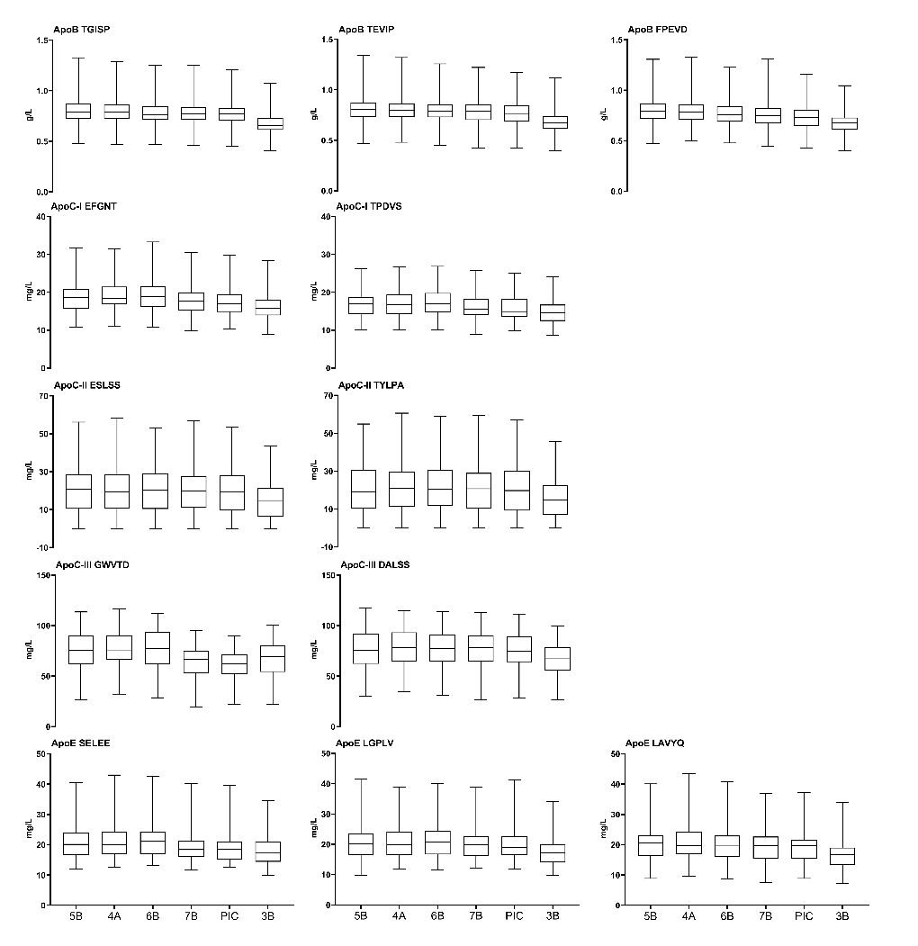
B
Figure S2.
Figure S2; Box and whisker plots show the distribution of apoA-I, A-II, A-IV and (a) (A) and for ApoB, C-I, C-II, C-III and E (B) for quantifying (left) and confirmation (middle and right) peptides showing the median, 25% and 75% percentile for the 45 donors in the 6 matrices (from left to right 5B, 4A, 6B, 7B, PIC and 3B). For apo(a) a log scale was used for the y-axis. Deviations for sodium citrate are indicated with blue ovals for all peptides and for K₂EDTA and PIC with purple ovals for the confirmation peptide of apoA-I VQPYL, both peptides of apoA-II and GWVTD for apoC-III

Ad (a) and B: Except for the sodium citrate matrix (3B) similar results were found for serum (5B and 4A), lithium heparin (6B) and K₂EDTA (7B and PIC).
For apoC-I; both peptides show slightly reduced values for K₂EDTA matrix samples (7B + PIC). For apoC-II reduction is found for the sodium citrate matrix (3B).
Ad apoA-IV (left) and apoE (right); The quantitative peptide for apoE shows highest reduction in the K₂EDTA samples (apart from sodium citrate 3B).
Statistics are summarized in Table ST4A and B below.

Apo | Peptide |  | Serum  gel | Serum | Plasma  lithium heparin | Plasma K2EDTA | Plasma K2EDTA | Plasma  sodium citrate
(a) | (nmol/L) |  | 5B | 4A | 6B | 7B | PIC | 9NC
 | LFLEP | mean | 31,5 | 31,5 | 31,0 | 29,9 | 29,8 | 26,4
 |  | mean diff |  | 0,0 | 0,6 | 1,6 | 1,7 | 5,1
 | GISST | mean | 32,3 | 32,1 | 32,6 | 31,2 | 31,5 | 28,0
 |  | mean diff |  | 0,2 | -0,3 | 1,1 | 0,8 | 4,3
 | GTYST | mean | 34,3 | 34,7 | 33,8 | 33,1 | 33,0 | 29,1
 |  | mean diff |  | −0,4 | 0,5 | 1,2 | 1,3 | 5,2
A-I | (g/L)
 | AKPAL | mean | 1,44 | 1,44 | 1,40 | 1,41 | 1,38 | 1,22
 |  | mean diff |  | 0,00 | 0,04 | 0,03 | 0,06 | 0,22
 | VQPYL | mean | 1,40 | 1,41 | 1,36 | 1,20 | 1,18 | 1,19
 |  | mean diff |  | 0,00 | 0,04 | 0,20 | 0,22 | 0,21
A-II | (mg/L)
 | SPELQ | mean | 280,0 | 281,3 | 272,2 | 225,8 | 216,1 | 238,8
 |  | mean diff |  | −1,3 | 7,8 | 54,2 | 63,9 | 41,2
 | EQLTP | mean | 274,0 | 278,6 | 267,8 | 219,6 | 215,4 | 236,6
 |  | mean diff |  | −4,6 | 6,2 | 54,4 | 58,6 | 37,4
A-IV | (mg/L)
 | LEPYA | mean | 181,4 | 182,1 | 181,2 | 182,8 | 176,3 | 153,9
 |  | mean diff |  | −0,7 | 0,2 | −1,4 | 5,1 | 27,5
 | LTPYA | mean | 180,5 | 182,8 | 179,9 | 178,7 | 176,8 | 154,3
 |  | mean diff |  | −2,3 | 0,6 | 1,8 | 3,7 | 26,2
 | SLAPY | mean | 182,0 | 183,8 | 181,0 | 178,6 | 179,0 | 154,4
 |  | mean diff |  | −1,8 | 1,0 | 3,4 | 3,0 | 27,6
B | (g/L)
 | TGISP | mean | 0,79 | 0,80 | 0,77 | 0,77 | 0,76 | 0,67
 |  | diff |  | 0,00 | 0,02 | 0,02 | 0,03 | 0,13
 | TEVIP | mean | 0,80 | 0,80 | 0,78 | 0,77 | 0,76 | 0,68
 |  | diff |  | 0,00 | 0,02 | 0,03 | 0,04 | 0,12
 | FPEVD | mean | 0,79 | 0,79 | 0,76 | 0,75 | 0,72 | 0,67
 |  | diff |  | 0,00 | 0,03 | 0,04 | 0,07 | 0,12
C-I | (mg/L)
 | EFGNT | mean | 19,0 | 19,2 | 19,4 | 17,8 | 17,6 | 16,5
 |  | mean diff |  | −0,2 | −0,4 | 1,2 | 1,3 | 2,5
 | TPDVS | mean | 17,0 | 17,1 | 17,2 | 16,1 | 15,7 | 14,8
 |  | mean diff |  | −0,1 | −0,2 | 0,9 | 1,2 | 2,2
C-II | (mg/L)
 | ESLSS | mean | 20,8 | 20,9 | 20,4 | 20,3 | 20,0 | 14,9
 |  | mean diff |  | −0,1 | 0,4 | 0,5 | 0,8 | 5,9
 | TYLPA | mean | 21,0 | 21,4 | 21,6 | 21,2 | 20,3 | 15,7
 |  | mean diff |  | −0,4 | −0,6 | −0,2 | 0,7 | 5,3
C-III | (mg/L)
 | GWVTD | mean | 76,2 | 76,8 | 77,2 | 64,7 | 62,3 | 67,5
 |  | mean diff |  | −0,6 | −1,0 | 11,5 | 14,0 | 8,7
 | DALLS | mean | 76,9 | 78,5 | 78,4 | 77,6 | 76,6 | 67,2
 |  | mean diff |  | −1,6 | −1,4 | −0,6 | 0,3 | 9,7
E | (mg/L)
 | SELEE | mean | 21,4 | 21,8 | 22,1 | 20,1 | 19,8 | 18,4
 |  | mean diff |  | −0,4 | −0,7 | 1,3 | 1,6 | 3,0
 | LGPLV | mean | 21,2 | 21,4 | 21,7 | 20,9 | 20,7 | 17,7
 |  | mean diff |  | −0,2 | −0,5 | 0,3 | 0,5 | 3,5
 | LAVYQ | mean | 20,6 | 20,9 | 20,6 | 19,9 | 19,5 | 16,8
 |  | mean diff |  | −0,3 | 0,0 | 0,7 | 1,1 | 3,7

Table ST4A; Results of one-way ANOVA comparisons (means and mean differences) summarized for the nine apolipoproteins, 22 peptides and 6 matrices (as shown in box and whisker plots Fig S2).

Quantifying peptides
 |  |  | Apo(a) | ApoA-I | ApoA-II | ApoA-IV | ApoB | ApoC-I | ApoC-II | ApoC-III | ApoE
Serum | Tube |  | LFLEP | AKPAL | SPELQ | LEPYA | TGISP | EFGNT | ESLSS | GWVTD | SELEE
Gel | 5B | SST
No Gel | 4A | CAT | ns | ns | ns | ns | ns | ns | ns | ns | ns
Plasma
Lithium heparin | 6B | LH | ns | * | *** | ns | ** | ns | ns | ns | *
K2EDTA | 7B | K2E | ns | ns | **** | ns | *** | *** | ns | **** | ****
K2EDTA +PIC | PIC | P100 | ns | *** | **** | * | **** | **** | ns | **** | ****
Sodium citrate | 3B | 9NC | *** | **** | **** | **** | **** | **** | **** | **** | ****
Confirmation peptides
 |  |  | Apo(a) | ApoA-I | ApoA-II | ApoA-IV | ApoB | ApoC-I | ApoC-II | ApoC-III | ApoE
Serum | Tube |  | GISST | VQPYL | EQLTP | LTPYA | TEVIP | TPDVS | TYLPA | DALSS | LGPLV
Gel | 5B | SST |  |  |  |  |  |  | - | - | -
No Gel | 4A | CAT | ns | ns | ns | ns | ns | ns | ns | ns | ns
Plasma
Lithium heparin | 6B | LH | ns | ** | ** | ns | ** | ns | ns | ns | ns
K2EDTA | 7B | K2E | ns | **** | **** | ns | **** | *** | ns | ns | ns
K2EDTA +PIC | PIC | P100 | ns | **** | **** | ns | **** | **** | ns | ns | ns
Sodium citrate | 3B | 9NC | ** | **** | **** | **** | **** | **** | **** | **** | ****
Additional peptides
 |  |  | Apo(a) | ApoA-IV | ApoB | ApoE |  | Overall Results
Serum | Tube |  | GTYST | SLAPY | FPEVD | LAVYQ |  | Serum |  | Tube | ns
Gel | 5B | SST |  |  |  |  |  | Gel |  | 5B
No Gel | 4A | CAT | ns | ns | ns | ns |  | No Gel |  | 4A | 22
Plasma |  |  |  |  |  |  |  | Plasma
Lithium heparin | 6B | LH | ns | ns | *** | ns |  | Lithium heparin |  | 6B | 14
K2EDTA | 7B | K2E | * | ns | **** | ns |  | K2EDTA |  | 7B | 11
K2EDTA +PIC | PIC | P100 | * | ns | **** | *** |  | K2EDTA +PIC |  | PIC | 8
Sodium citrate | 3B | 9NC | **** | **** | **** | **** |  | Sodium citrate |  | 3B | 0

Table ST4B; Statistics for comparison of results One Way Anova with P value style (ns) 0.1234, (*) 0.0332, (**) 0.0021, (***) 0.0002, (****) < 0.0001
ApoA-I and B immunoassays in matrices 5B, 4A, 6B, 7B and
Figure S3. Top; Linear regression of immunoturbidimetric measurements of apoA-I and apoB in serum gel tubes (5B) as compared to other tubes of serum (4A) and plasma (6B, 7B and PIC). Dotted line (equality). Yellow area indicates TEa of 9.1% for apoA-I and 11.6% for apoB. Bottom; Box and whisker plots ApoA-I and ApoB measurements in the matrices 5B, 4A, 6B, 7B and PIC with immunoturbidimetric measurements (ITA) on a Cobas C502 analyzer.
 | ApoA-I |  |  | ApoB
 | Mean | Mean Diff | Slopes | Mean | Mean Diff | Slopes
5B | 1.514 | - | - | 0.880 | - | -
4A | 1.535 | −0.021 | 1.015 | 0.888 | −0.008 | 1.008
6B | 1.511 | 0.003 | 0.966 | 0.862 | 0.018 | 0.980
7B | 1.487 | 0.027 | 0.982 | 0.857 | 0.023 | 0.972
PIC | 1.470 | 0.044 | 0.969 | 0.851 | 0.029 | 0.966

Table ST5; Results for the slopes of the linear regression comparisons to matrix 5B for the ITA measurements (as in Fig S3), and the means of apoA-I and B for the 44 samples in the different matrices and the (mean) differences compared to 5B as shown in the box and whisker plots for apoA-I and B results in the serum (5B and 4A) and plasma (6B, 7B and PIC) matrices for the 44 donors.
Digestion kinetics
Figure S4(a)

Figure S4(b)
Figure S4; Kinetics for trypsin digestion for nine apos in serum and plasma samples of six donor samples up to 22 hrs digestion time; left results for the quantification peptides and middle and right the confirmation/additional peptides All data are normalized to the relative responses (RR) at T=22 hrs (100%) for each matrix. 4(a); ApoA-I, A-II, A-IV, (a) and B, 4(b); ApoC-I, C-II, C-III and E

Apo | 5B | 6B | 7B | 3B | 5B | 6B | 7B | 3B | 5B | 6B | 7B | 3B
A-I | AKPAL |  |  |  | VQPYL
avge | 103.7 | 101.1 | 72.8 | 80.0 | 85.3 | 84.8 | 59.2 | 69.3
sdev | 4.0 | 9.8 | 6.1 | 4.7 | 5.5 | 5.9 | 4.4 | 3.4
A-II | SPELQ |  |  |  | EQLTP
avge | 45.0 | 42.8 | 31.8 | 37.5 | 28.8 | 27.9 | 19.8 | 24.0
sdev | 3.5 | 2.3 | 1.8 | 3.4 | 1.8 | 1.2 | 1.8 | 1.4
A-IV | LEPYA |  |  |  | LTPYA |  |  |  | SLAPY
avge | 102.0 | 96.3 | 96.8 | 85.9 | 102.8 | 104.2 | 89.1 | 86.8 | 95.4 | 100.7 | 95.9 | 82.2
sdev | 3.3 | 13.1 | 4.7 | 13.4 | 5.1 | 8.1 | 4.9 | 6.8 | 9.9 | 11.2 | 10.3 | 8.1
(a) | LFLEP |  |  |  | GISST |  |  |  | GTYST
avge | 98.5 | 90.8 | 88.6 | 79.9 | 58.9 | 55.3 | 55.9 | 50.9 | 95.1 | 94.8 | 89.8 | 80.2
sdev | 5.6 | 6.6 | 5.1 | 4.3 | 22.7 | 16.6 | 17.4 | 17.6 | 7.4 | 12.0 | 12.9 | 9.9
B | TGISP |  |  |  | TEVIP |  |  |  | FPEVD
avge | 100.4 | 99.1 | 92.9 | 83.7 | 101.5 | 97.7 | 94.6 | 100.3 | 94.9 | 94.9 | 84.8 | 77.6
sdev | 3.9 | 5.8 | 4.7 | 3.6 | 5.0 | 4.1 | 6.8 | 39.2 | 4.8 | 5.3 | 2.1 | 5.2
C-I | EFGNT |  |  |  | TPDVS
avge | 78.8 | 76.5 | 66.7 | 69.5 | 85.4 | 86.9 | 77.6 | 72.1
sdev | 5.3 | 6.0 | 4.9 | 5.1 | 2.2 | 10.1 | 5.9 | 6.5
C-II | ESLSS |  |  |  | TYLPA
avge | 97.2 | 101.5 | 87.6 | 84.4 | 99.6 | 103.9 | 93.7 | 87.7
sdev | 8.7 | 10.6 | 9.1 | 10.0 | 6.0 | 9.9 | 8.5 | 4.0
C-III | GWVTD |  |  |  | DALLS
avge | 70.5 | 73.9 | 47.8 | 62.8 | 103.3 | 106.5 | 97.6 | 89.8
sdev | 5.3 | 10.3 | 4.9 | 10.1 | 5.7 | 8.0 | 11.0 | 6.8
E | SELEE |  |  |  | LGPLV |  |  |  | LAVYQ
avge | 87.9 | 98.1 | 82.8 | 83.5 | 95.5 | 100.5 | 89.5 | 81.5 | 96.6 | 101.1 | 71.6 | 85.9
sdev | 5.5 | 9.6 | 5.8 | 8.8 | 7.9 | 8.5 | 14.4 | 6.6 | 5.3 | 8.1 | 10.5 | 7.8

Table ST6; Digestion kinetics after 3 hours digestion; RR values at 3 hour timepoint of each of 6 donors calculated as % of the 22 hrs time point in the gel serum (5B) matrix. Averages of the six donors and standard deviations are shown for four matrices serum gel (5B), lithium heparin 96B), K₂EDTA (7B) and sodium citrate (3B).
Normal incubation time for tryptic digestion for the multiplex apolipoprotein QPMS test is 3 hours. Digestion kinetics for the 6 donors at the 3 hour timepoint reveals that digestion is reduced for the K₂EDTA matrix (7B) for both apoA-I peptides but especially VQPYL, both apoA-II peptides SPELQ and EQLTP are slowly formed and especially in the 7B matrix, for apoC-III the peptide formation of GWVTD is mostly delayed in matrix 7B. These are the peptides that also showed strongest deviation of results in the linear regression and peptide comparisons and strong bias in the EP comparisons.
Kwantificerende Peptiden
Kwalificerende Peptiden

