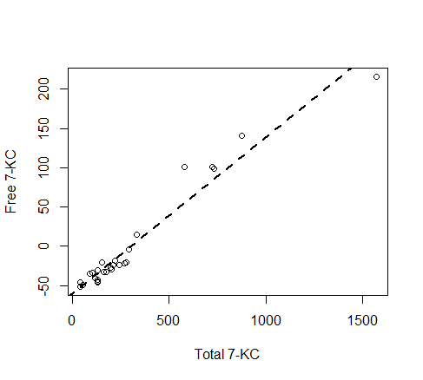
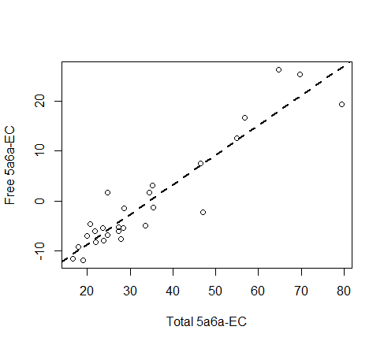
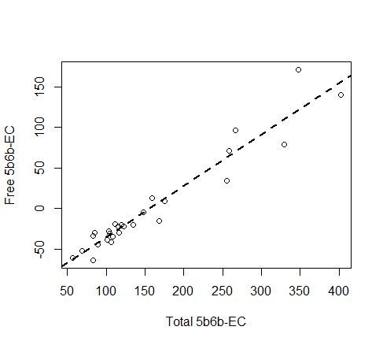
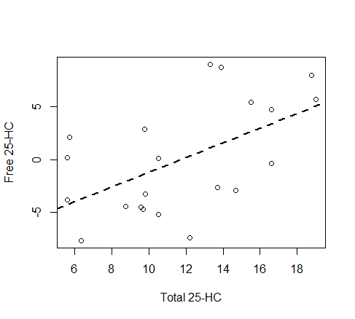
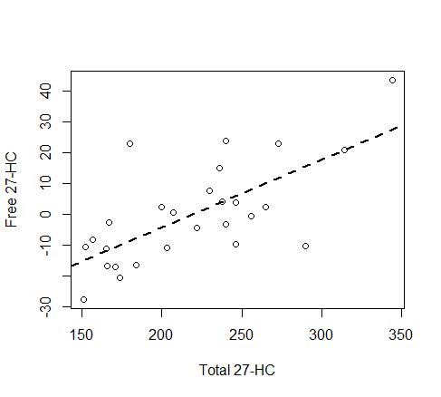
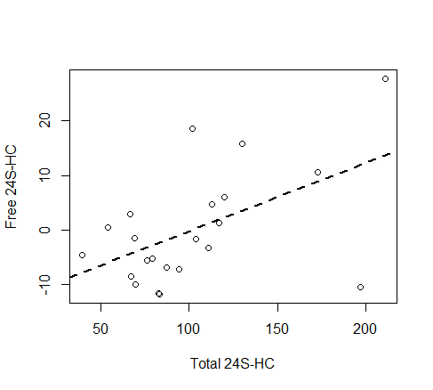
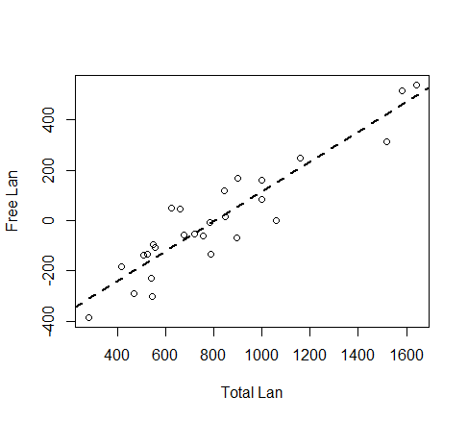
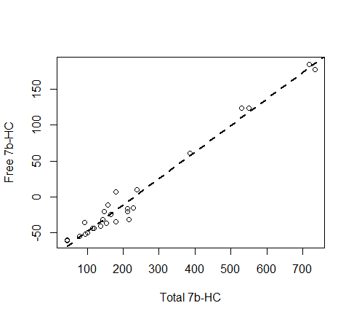
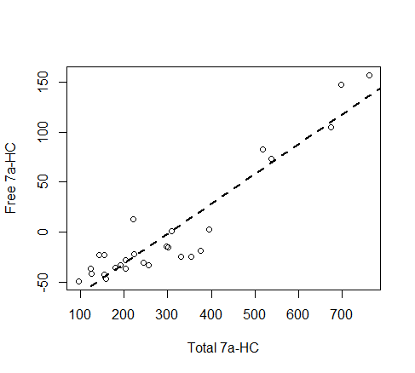
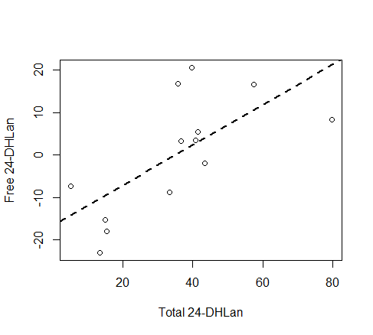
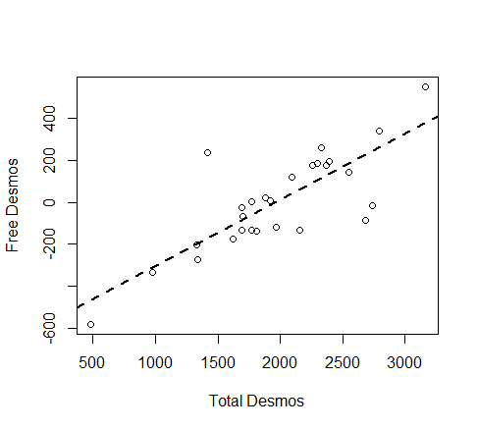
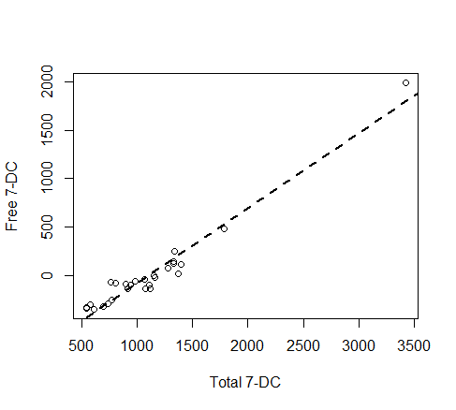
Supplementary Figure 1: Partial residual plots of free oxysterols (residuals) vs. total oxysterols (nM), adjusted for age and study region. n=27, except for 7b-HC (n=26), 24S-HC (n=22), 25-HC (n=21), and 24-DHLan (n=13).
Abbreviations: 27-HC, 27-hydroxycholesterol; 25-HC, 25-hydroxycholesterol; 24S-HC, 24S-hydroxycholesterol; 5a6a-EC, 5α,6α-epoxycholesterol; 5b6b-EC, 5β,6β-epoxycholesterol; 7-KC, 7-ketocholesterol; 7a-HC, 7α-hydroxycholesterol; 7b-HC, 7β-hydroxycholesterol; Lan, lanosterol; 24-DHLan, 24,25-dihydrolanosterol; 7-DC, 7-dehydrocholesterol; Desmos, desmosterol.

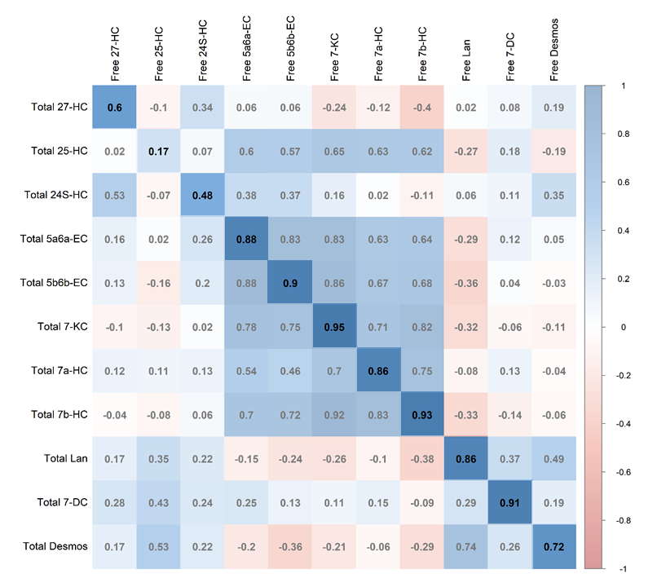
Supplementary Figure 2: Correlation matrix between circulating free and total oxysterols. Correlation on highlighted diagonal showing associations between corresponding free and total oxysterols. Calculated using Spearman partial correlation (unadjusted). n=27, except for 7b-HC (n=26), 24S-HC (n=22), 25-HC (n=21) Oxysterols with values >50% below LOD were excluded. Abbreviations: 27-HC=27-hydroxycholesterol; 25-HC=25-hydroxycholesterol; 24S-HC=24S-hydroxycholesterol; 5a6a-EC=5α,6α-epoxycholesterol; 5b6b-EC=5β,6β-epoxycholesterol; 7-KC=7-ketocholesterol; 7a-HC=7α-hydroxycholesterol; 7b-HC=7β-hydroxycholesterol; Lan=lanosterol; 7-DC=7-dehydrocholesterol; Desmos=desmosterol.

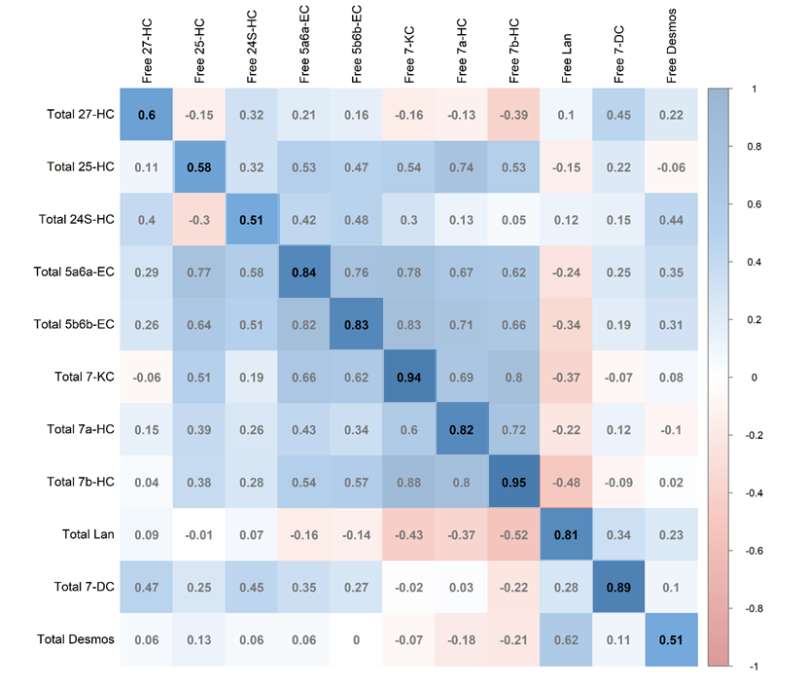
Supplementary Figure 3 Correlation matrix between circulating free and total oxysterols. Correlation on highlighted diagonal showing associations between corresponding free and total oxysterols. Calculated using Spearman partial correlation coefficients adjusted for age at diagnosis, study region, BMI, leisure physical activity. n=26, except for 7b-HC (n=25), 25-HC (n=21), 24S-HC (n=21). Oxysterols with values >50% below LOD were excluded. Abbreviations: 27-HC=27-hydroxycholesterol; 25-HC=25-hydroxycholesterol; 24S-HC=24S-hydroxycholesterol; 5a6a-EC=5α,6α-epoxycholesterol; 5b6b-EC=5β,6β-epoxycholesterol; 7-KC=7-ketocholesterol; 7a-HC=7α-hydroxycholesterol; 7b-HC=7β-hydroxycholesterol; Lan=lanosterol; 7-DC=7-dehydrocholesterol; Desmos=desmosterol.
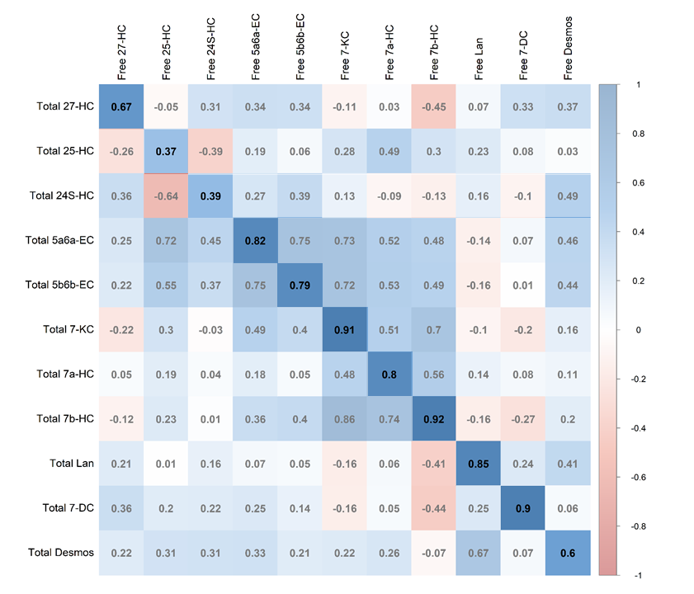
Supplementary Figure 4 Correlation matrix between circulating free and total oxysterols. Correlation on highlighted diagonal showing associations between corresponding free and total oxysterols. Calculated using Spearman partial correlation coefficients adjusted for age at diagnosis, study region, date of blood collection, chemotherapy, endocrine therapy (tamoxifen or aromatase inhibitor). n=26, except for 7b-HC (n=25), 24S-HC (n=22), 25-HC (n=21). Oxysterols with values >50% below LOD were excluded. Abbreviations: 27-HC=27-hydroxycholesterol; 25-HC=25-hydroxycholesterol; 24S-HC=24S-hydroxycholesterol; 5a6a-EC=5α,6α-epoxycholesterol; 5b6b-EC=5β,6β-epoxycholesterol; 7-KC=7-ketocholesterol; 7a-HC=7α-hydroxycholesterol; 7b-HC=7β-hydroxycholesterol; Lan=lanosterol; 7-DC=7-dehydrocholesterol; Desmos=desmosterol.
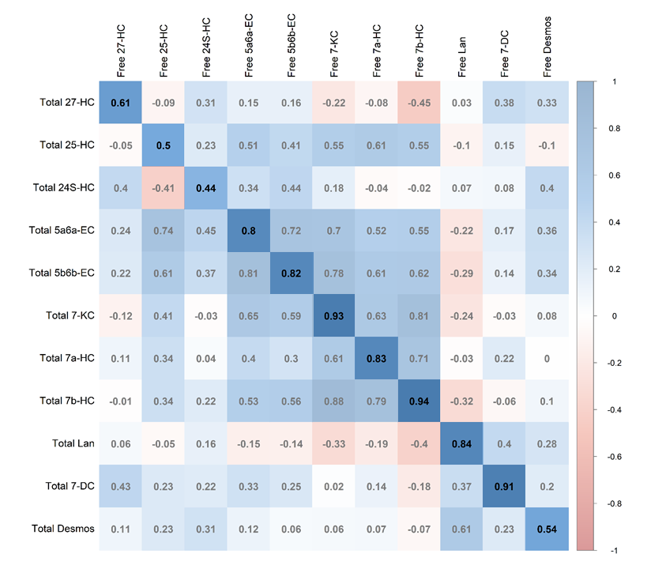
Supplementary Figure 5: Correlation matrix between circulating free and total oxysterols including ER/PR-positive breast cancer participants only. Correlation on highlighted diagonal showing associations between corresponding free and total oxysterols. Calculated using Spearman partial correlation coefficients adjusted for age at diagnosis and study region. n=25, except for 7b-HC (n=24), 24S-HC (n=22), 25-HC (n=20). Oxysterols with values >50% below LOD were excluded. Abbreviations: 27-HC=27-hydroxycholesterol; 25-HC=25-hydroxycholesterol; 24S-HC=24S-hydroxycholesterol; 5a6a-EC=5α,6α-epoxycholesterol; 5b6b-EC=5β,6β-epoxycholesterol; 7-KC=7-ketocholesterol; 7a-HC=7α-hydroxycholesterol; 7b-HC=7β-hydroxycholesterol; Lan=lanosterol; 7-DC=7-dehydrocholesterol; Desmos=desmosterol.
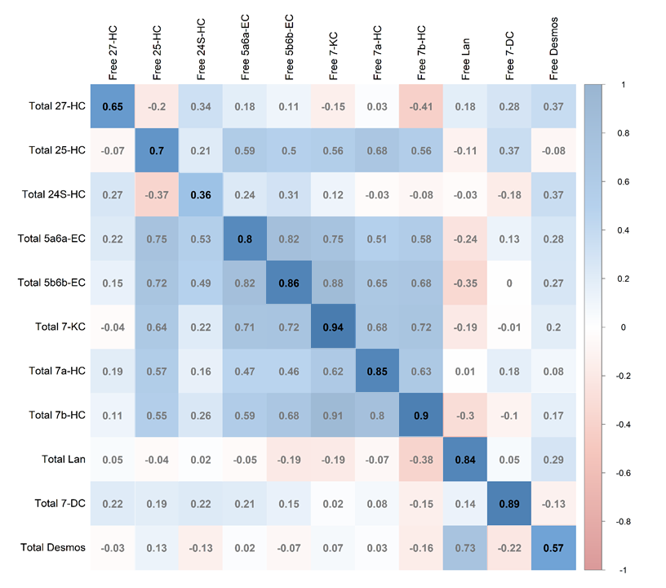
Supplementary Figure 6: Correlation matrix between circulating free and total oxysterols including Her2/neu-negative breast cancer participants only. Correlation on highlighted diagonal showing associations between corresponding free and total oxysterols. Calculated using Spearman partial correlation coefficients adjusted for age at diagnosis and study center. n=22, except for 7b-HC (n=21), 24S-HC (n=19), 25-HC (n=17). Oxysterols with values >50% below LOD were excluded. Abbreviations: 27-HC=27-hydroxycholesterol; 25-HC=25-hydroxycholesterol; 24S-HC=24S-hydroxycholesterol; 5a6a-EC=5α,6α-epoxycholesterol; 5b6b-EC=5β,6β-epoxycholesterol; 7-KC=7-ketocholesterol; 7a-HC=7α-hydroxycholesterol; 7b-HC=7β-hydroxycholesterol; Lan=lanosterol; 7-DC=7-dehydrocholesterol; Desmos=desmosterol.

