**Supplemental Material**

**Commutability assessment of reference materials for homocysteine**

Tongtong Xing,1,2 Jianyi Liu,1 Haofeng Sun1,3, Yanhong Gao,*,4 Yi Ju,5 Xiaolin Liu,*,2 Dewei Song*,1

1Division of Chemical Metrology and Analytical Science, National Institute of Metrology, (Key Laboratory of Chemical Metrology and Applications on Nutrition and Health for State Market Regulation) Beijing 100029, China

2School of Chemical Engineering, Beijing University of Chemical Technology, Beijing 100029, China

3School of Chemical and Engineering, Nanjing University of Science and Technology, Jiangsu 210094, China

4Laboratory Department of the First Medical Center of PLA General Hospital, Beijing 100039, China

5Shanghai Center for Clinical Laboratory, Shanghai 200126, China

*Corresponding Authors

Email:

[songdw@nim.ac.cn](mailto:songdw@nim.ac.cn) (Dewei Song)

[gyh25cn@126.com](mailto:gyh25cn@126.com) (Yanhong Gao)

[liuxl@mail.buct.edu.cn](mailto:liuxl@mail.buct.edu.cn) (Xiaolin Liu)

Telephone:

+86-10-64524789

Word count : 2913

Number of figures : 3

Number of tables : 3

Supplemental material: Included

**Supplemental Table 1.** Calibration material and main MS parameters for homocysteine determination.

|  |  |  |  |  |
| --- | --- | --- | --- | --- |
| Compound | Parent ion (m/z) | Production (m/z) | Fragmentor (V) | Collision energy (V) |
| Hcy | 136.0 | 90 | 80 | 7 |
| [2H4]-Hcy | 140.0 | 94 | 80 | 7 |

DL-Homocystine was obtained from Sigma Chemical Company (St. Louis, MO, USA), and the purity, determined by NMR, was calculated as 98.8%. DL-[2H8]-Homocystine was obtained from C.D.N. Isotopes (PointeClaire, Quebec, Canada).

We performed the analyses on an Agilent 6410 Triple Quad mass spectrometer equipped with an Agilent 1200 LC system. Samples were analyzed using a Supelcosil LC-CN analytical column (4.6 mm × 250 mm, 5 μm particle size) at 30 ℃ and were eluted at 0.5 mL/min using a mobile phase of 10:90 acetonitrile/water with 0.1% formic acid (isocratic elution). The autosampler temperature was 4 °C and the injection volume was 10 μL.

**Supplemental Table 2.** Prediction interval for each RM and mean measurement result according to CLSI EP30-A.

|  |  |  |  |  |  |
| --- | --- | --- | --- | --- | --- |
|  | RM | Mean | Lower bound of the 95% prediction interval | Upper bound of the 95% prediction interval | Commutability assessment Results |
| Mindray | GBW09864 | 26.30 | 24.35 | 29.09 | 1 |
| GBW09863 | 17.74 | 14.24 | 18.62 | 1 |
| GBW09862 | 15.08 | 11.27 | 15.63 | 1 |
| GBW09861 | 8.34 | 4.98 | 9.47 | 1 |
| SRM 1955-2 | 8.95 | 5.77 | 10.23 | 1 |
| SRM 1955-3 | 16.80 | 14.18 | 18.55 | 1 |
| SRM 1950 | 8.50 | 5.44 | 9.91 | 1 |
| Roche | GBW09864 | 31.25 | 27.95 | 32.89 | 1 |
| GBW09863 | 19.63 | 15.74 | 20.30 | 1 |
| GBW09862 | 15.99 | 12.16 | 16.71 | 1 |
| GBW09861 | 8.77 | 4.59 | 9.27 | 1 |
| SRM 1955-2 | 9.02 | 5.54 | 10.19 | 1 |
| SRM 1955-3 | 17.88 | 15.66 | 20.22 | 1 |
| SRM 1950 | 8.77 | 5.13 | 9.80 | 1 |
| Bsbe | GBW09864 | 34.04 | 28.86 | 38.47 | 1 |
| GBW09863 | 21.48 | 15.36 | 24.23 | 1 |
| GBW09862 | 17.45 | 11.36 | 20.21 | 1 |
| GBW09861 | 8.40 | 2.84 | 11.95 | 1 |
| SRM 1955-2 | 9.29 | 3.91 | 12.97 | 1 |
| SRM 1955-3 | 18.59 | 15.27 | 24.14 | 1 |
| SRM 1950 | 9.19 | 3.46 | 12.53 | 1 |
| Kehua | GBW09864 | 31.12 | 25.76 | 35.37 | 1 |
| GBW09863 | 19.55 | 14.14 | 23.01 | 1 |
| GBW09862 | 16.18 | 10.68 | 19.53 | 1 |
| GBW09861 | 7.88 | 3.31 | 12.41 | 1 |
| SRM 1955-2 | 9.89 | 4.24 | 13.29 | 1 |
| SRM 1955-3 | 17.70 | 14.06 | 22.93 | 1 |
| SRM 1950 | 9.06 | 3.84 | 12.91 | 1 |
| Abbott | GBW09864 | 27.13 | 24.39 | 31.33 | 1 |
| GBW09863 | 17.49 | 13.53 | 19.93 | 1 |
| GBW09862 | 14.15 | 10.31 | 16.70 | 1 |
| GBW09861 | 8.21 | 3.49 | 10.06 | 1 |
| SRM 1955-2 | 9.01 | 4.35 | 10.88 | 1 |
| SRM 1955-3 | 16.97 | 13.45 | 19.85 | 1 |
| SRM 1950 | 9.31 | 3.98 | 10.53 | 0 |
| 1: Commutable  0: Non-commutable  ?: Inconclusive result | | | | | |

**Supplemental Table 3.** Difference in bias of reference material according the IFCC recommended difference in bias approach.

|  |  |  |  |  |
| --- | --- | --- | --- | --- |
|  | RM | DRM | U(DRM) | Commutability assessment Results |
| Mindray | GBW09861 | 0.05630 | 0.02045 | 0 |
| GBW09862 | 0.04967 | 1 |
| GBW09863 | 0.03753 | 1 |
| GBW09864 | 0.01241 | 1 |
| 1955-2 | 0.04327 | ? |
| 1955-3 | 0.01996 | 1 |
| 1950 | 0.03812 | 0 |
| Roche | GBW09861 | 0.05957 | 0.02203 | 0 |
| GBW09862 | 0.05065 | 1 |
| GBW09863 | 0.05185 | 1 |
| GBW09864 | 0.04294 | 1 |
| 1955-2 | 0.02598 | 0 |
| 1955-3 | 0.02078 | 1 |
| 1950 | 0.03187 | ? |
| Bsbe | GBW09861 | 0.00453 | 0.02571 | ? |
| GBW09862 | 0.04887 | 1 |
| GBW09863 | 0.04880 | 1 |
| GBW09864 | 0.03406 | 1 |
| 1955-2 | 0.00516 | ? |
| 1955-3 | -0.00002 | 1 |
| 1950 | 0.01938 | ? |
| Kehua | GBW09861 | -0.01594 | 0.02370 | 1 |
| GBW09862 | 0.03091 | 1 |
| GBW09863 | 0.02629 | 1 |
| GBW09864 | 0.01755 | 1 |
| 1955-2 | 0.04407 | ? |
| 1955-3 | -0.00688 | 1 |
| 1950 | 0.02293 | ? |
| Abbott | GBW09861 | 0.04650 | 0.02438 | 0 |
| GBW09862 | 0.02368 | 1 |
| GBW09863 | 0.03034 | 1 |
| GBW09864 | 0.01941 | 1 |
| 1955-2 | 0.04408 | 0 |
| 1955-3 | 0.02120 | 1 |
| 1950 | 0.07839 | 0 |
| 1: Commutable  0: Non-commutable  ?: Inconclusive result | | | | |

**Supplemental Figure 1. Precision plots for the five routine methods and the RMP**

Data 1BData 1Data 3BData 3For each routine method and the RMP, two precision plots are presented: those marked as ‘A’ are based on the standard deviations of the concentrations measured for the three replicates of each serum pool ($SD(conc,MP)$); those marked as ‘B’ are based on the standard deviations of the ln-transformed concentrations measured for the three replicates of each serum pool (${SD(ln⁡(conc,MP}_{ })$). The X-axis of the precision plots represents the mean concentration measured by the routine method or the RMP. Serum pools are indicated with (▇) .

B

B

A

A

A

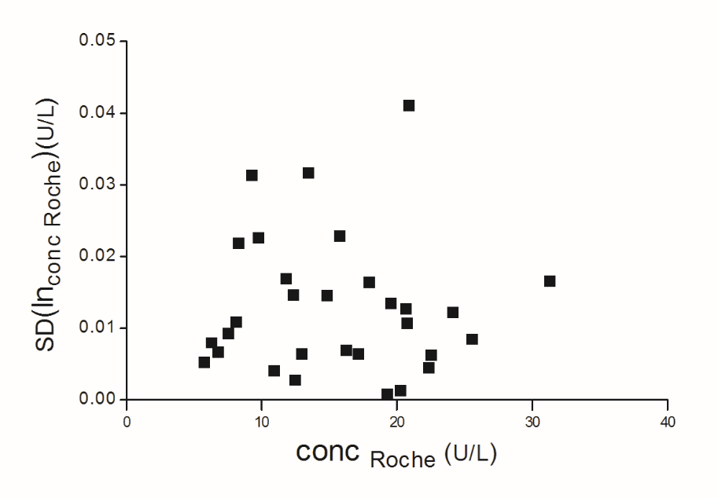

B

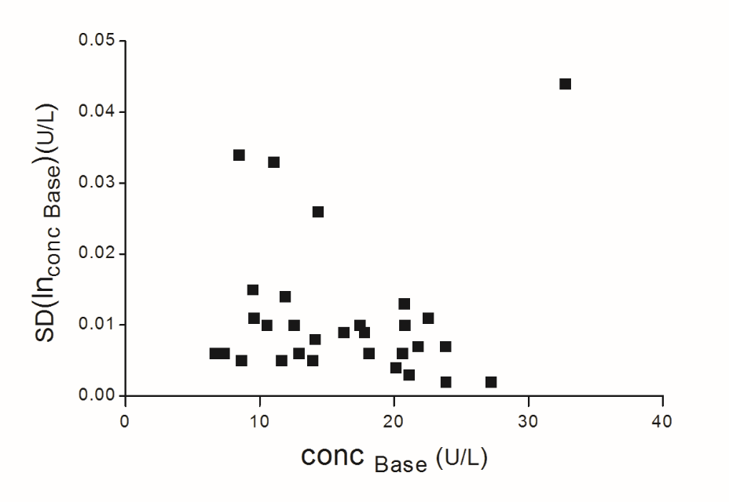

B

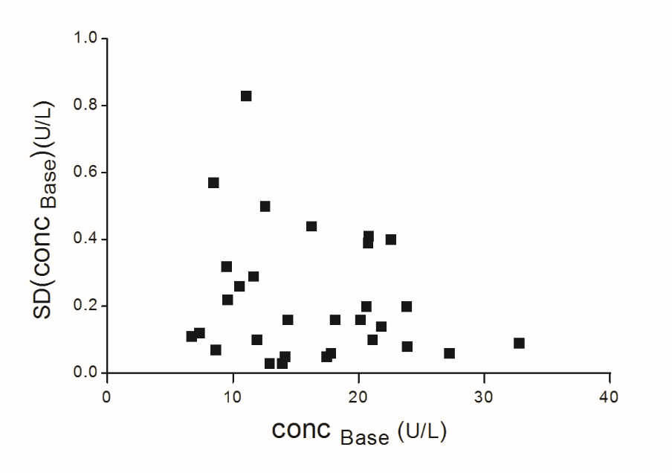

A

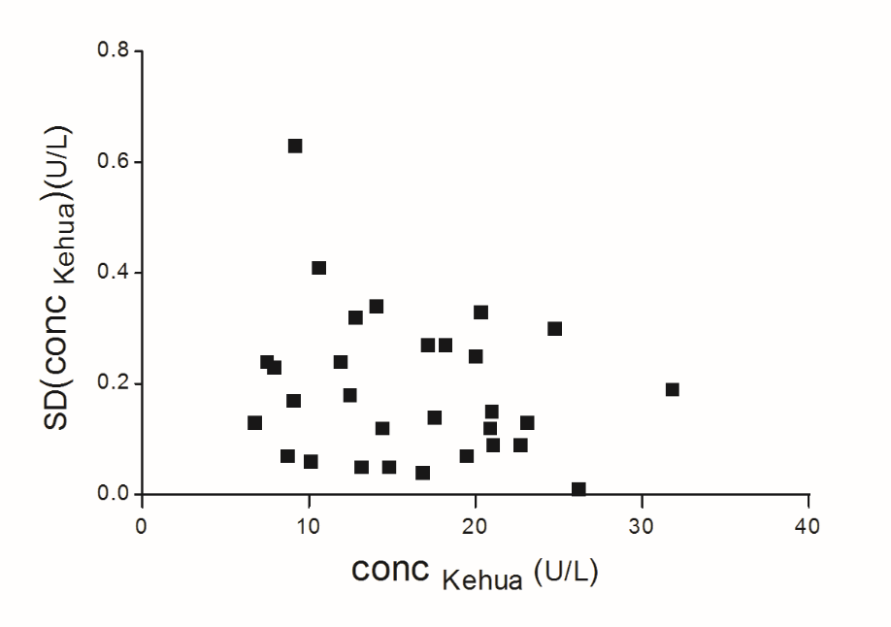

A

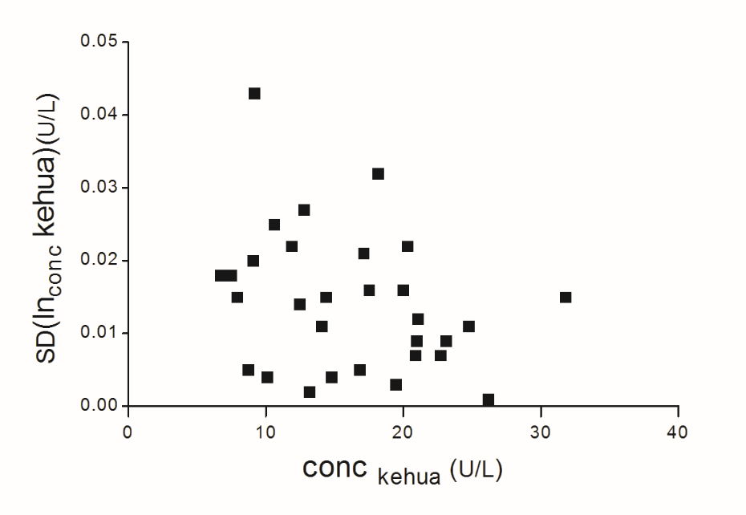

B

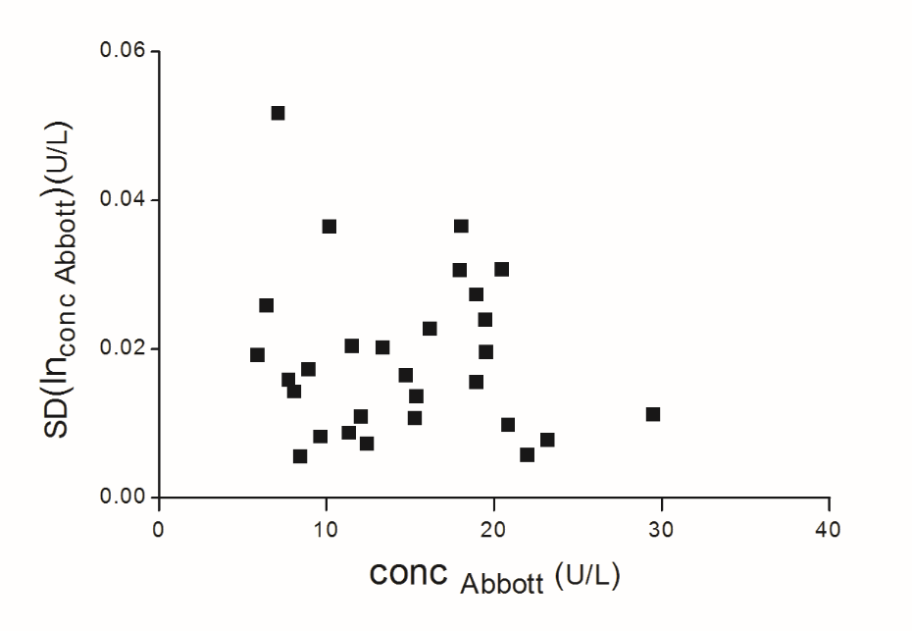

B

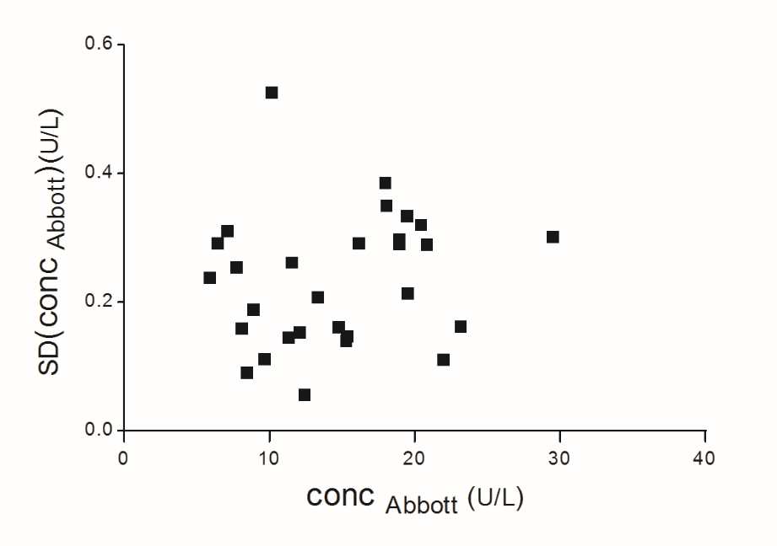

A

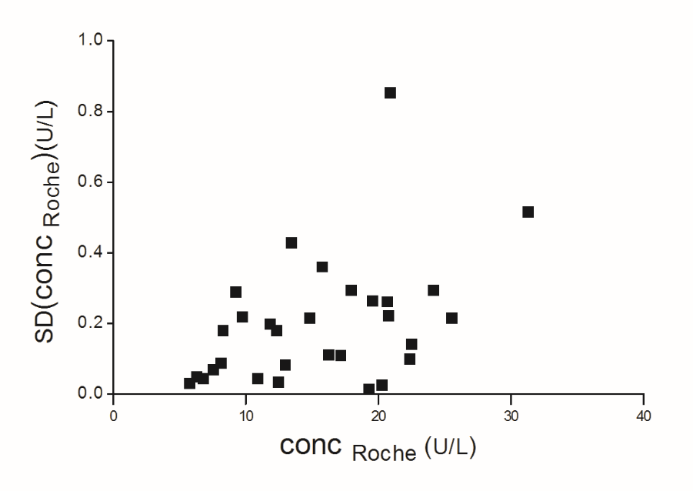

A

**Supplemental Figure 2. Bias plots for the five routine methods versus the RMP**

For each routine method, two bias plots are presented. Panels marked as ‘A’ show the bias of each serum pool calculated as the difference between the mean concentration measured with the routine method and the mean concentration measured with the RMP ($B_{{conc}_{CS,}rout})$. Panels marked as ‘B’ show the bias calculated as the difference between the ln–transformed mean concentration measured with the routine method and the ln–transformed mean concentration measured with the RMP ($B_{ln⁡({conc}_{CS},rout)})$. The X‑axis on all bias plots represents the mean concentration measured with the RMP ().

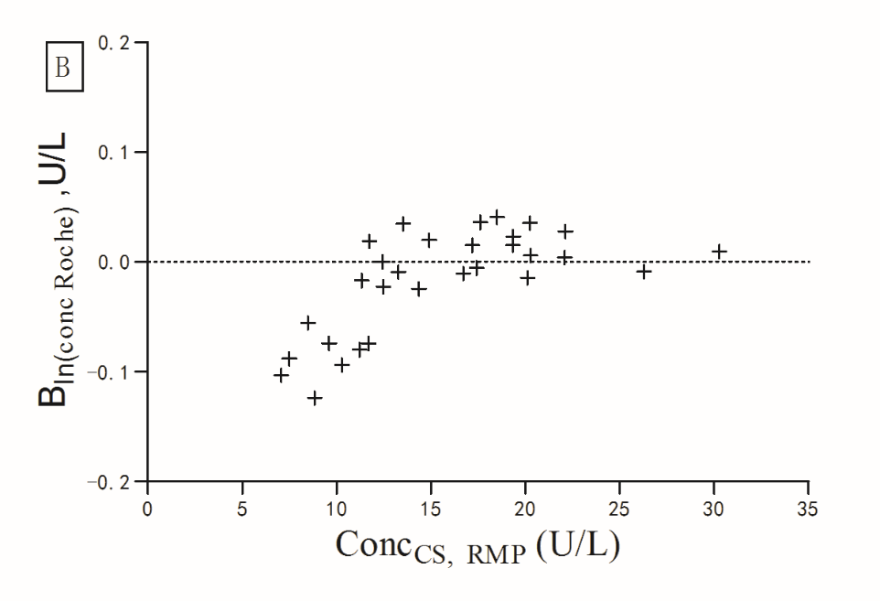

B

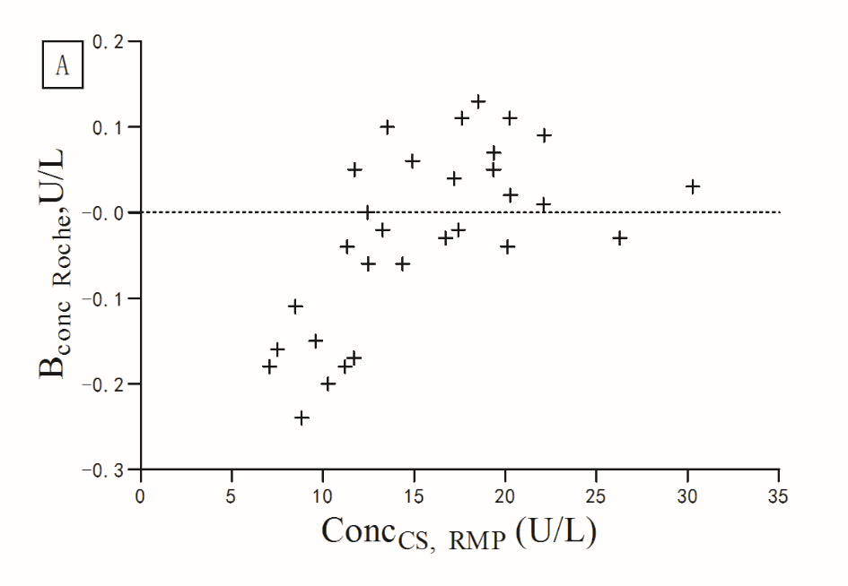

A

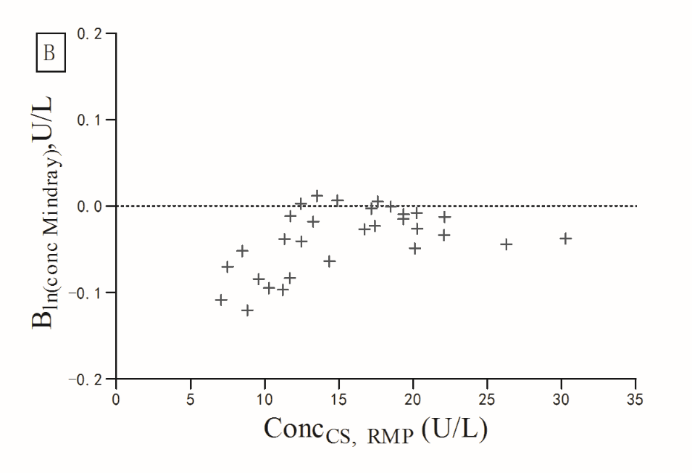

B

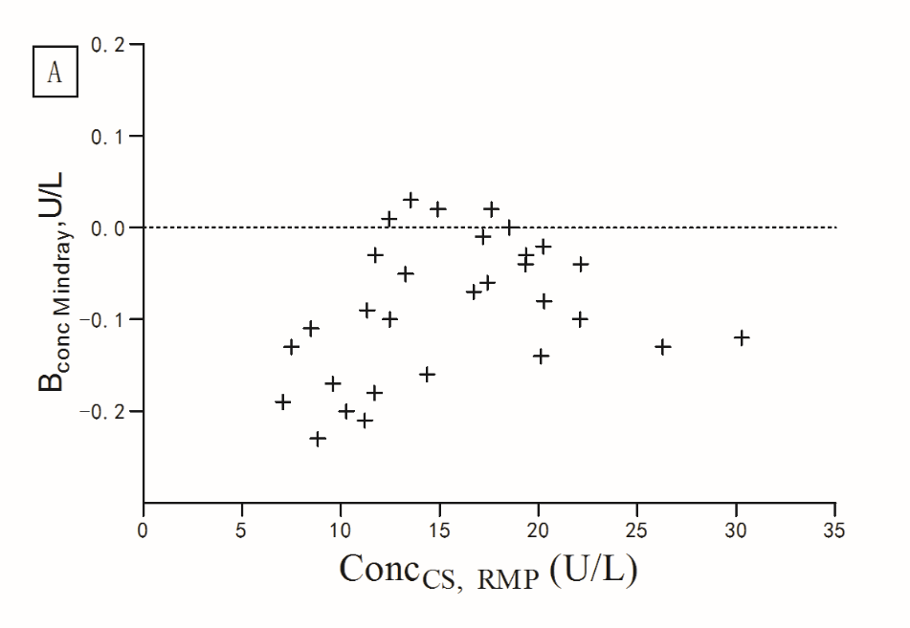

A

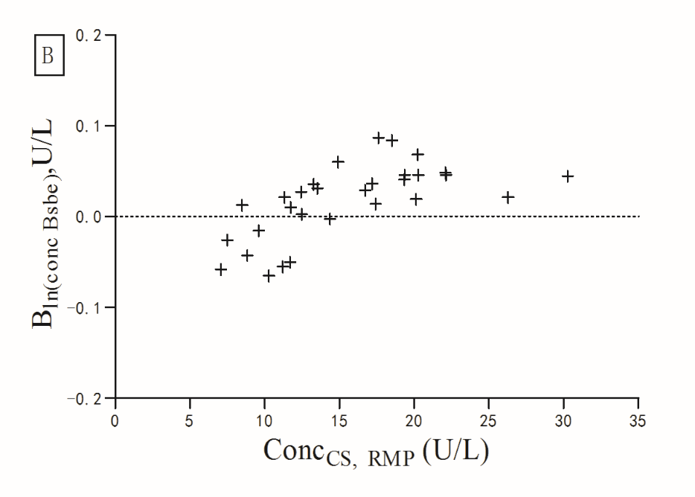

B

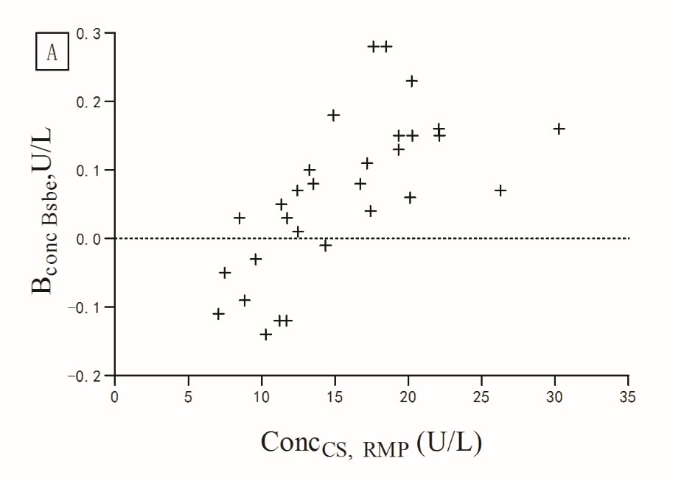

A

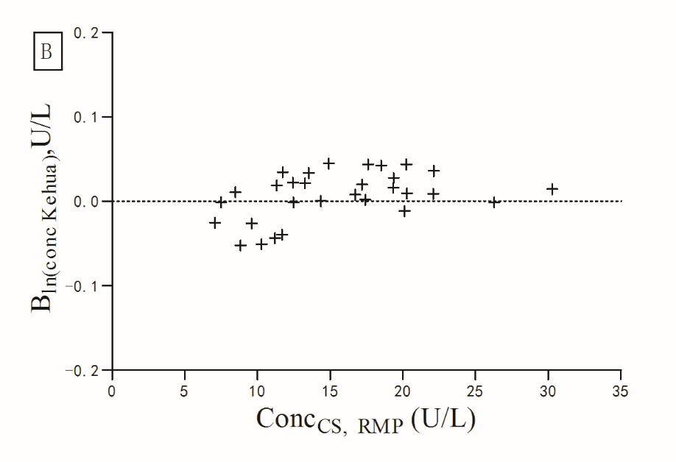

B

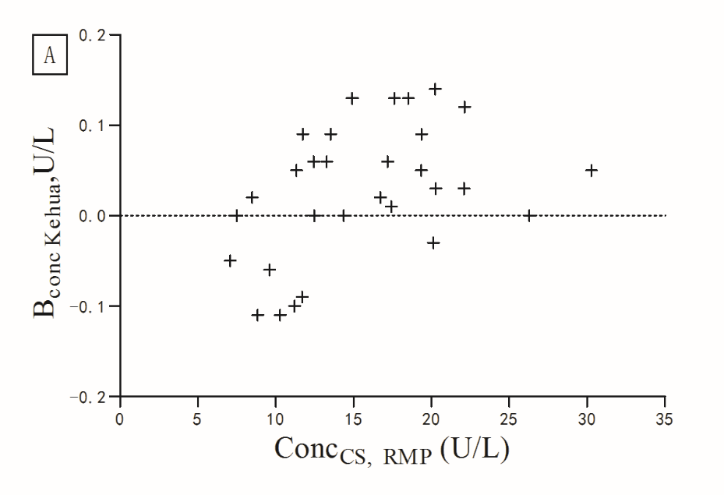

A

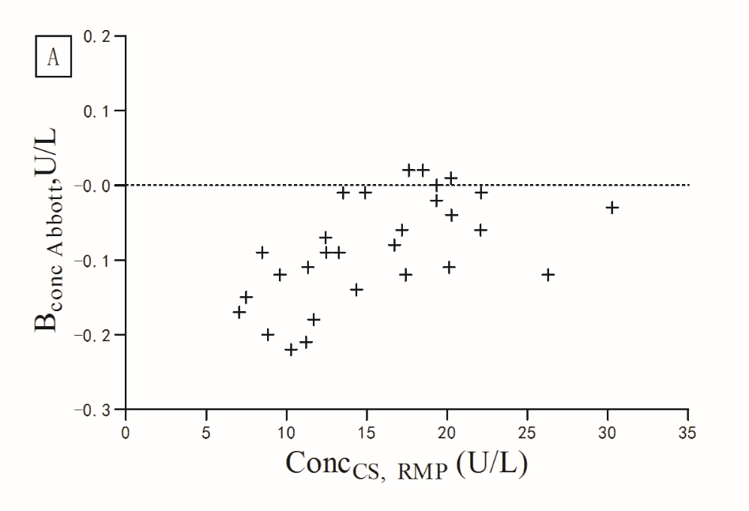

A

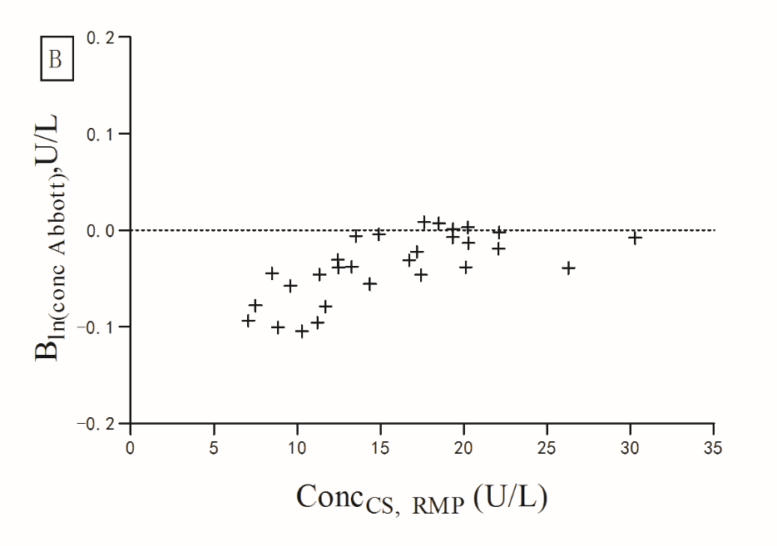

B

**Supplemental Figure 3. Bias plots for the five routine methods versus the RMP at two different concentration intervals**

After data conversion (Supplemental Figure 2), the difference map distribution was still not found to be approximately constant in this concentration interval. The commutability of the reference materials was evaluated in two different concentration intervals where the distribution was approximately constant. Panels marked as ‘A’ (concentrations below 13 U/L) and those marked as ‘B’ (concentrations above 13 U/L) show the bias calculated as the difference between the ln–transformed mean concentration measured with the routine method and the ln–transformed mean concentration measured with the RMP ($B_{ln⁡({conc}_{CS},rout)})$. The X‑axis on all bias plots represents the mean concentration measured with the RMP ().

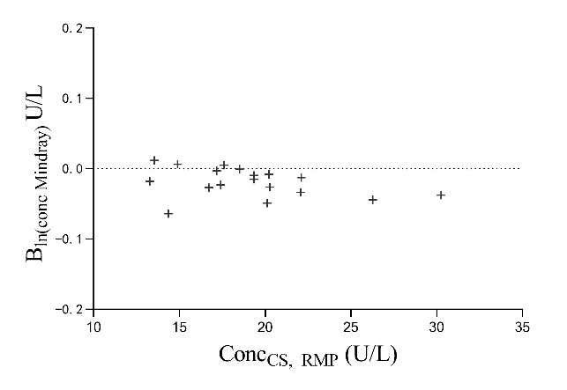

B

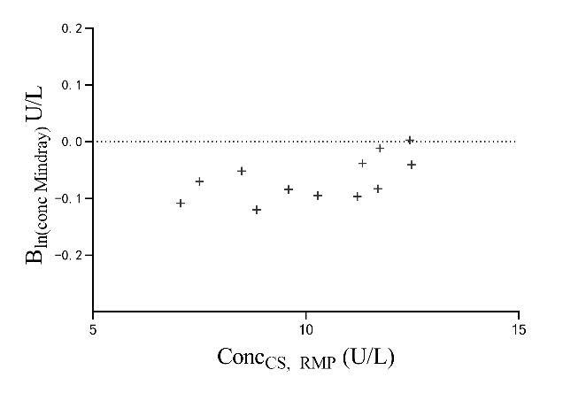

A

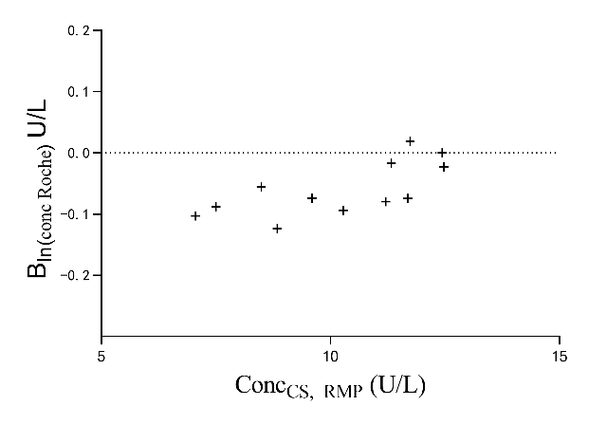

A

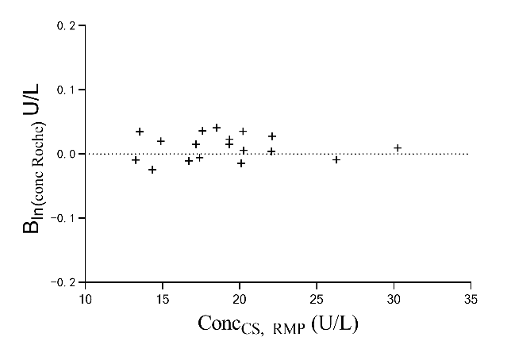

B

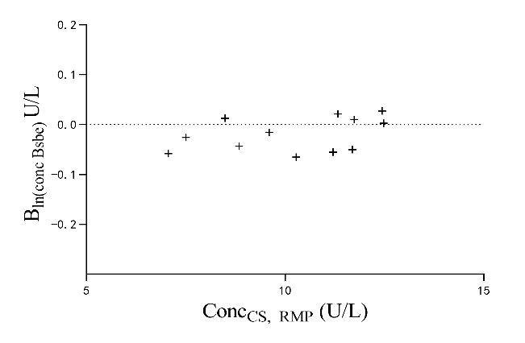

A

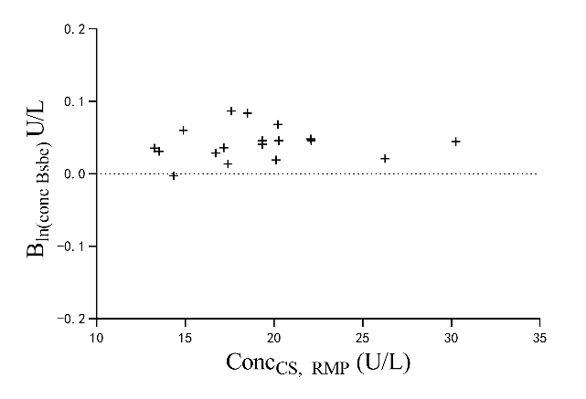

B

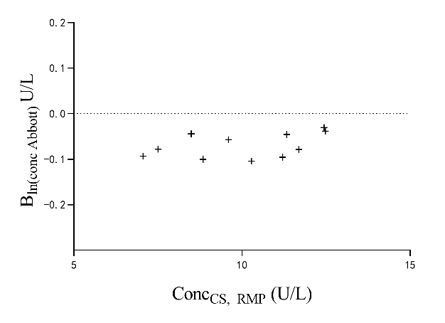

A

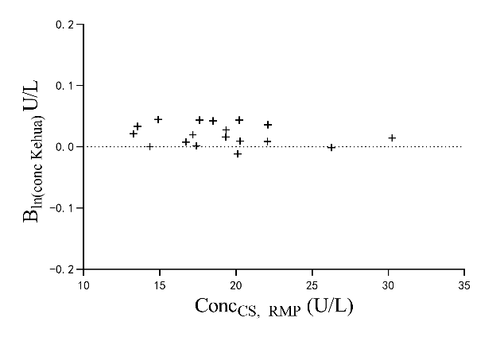

B

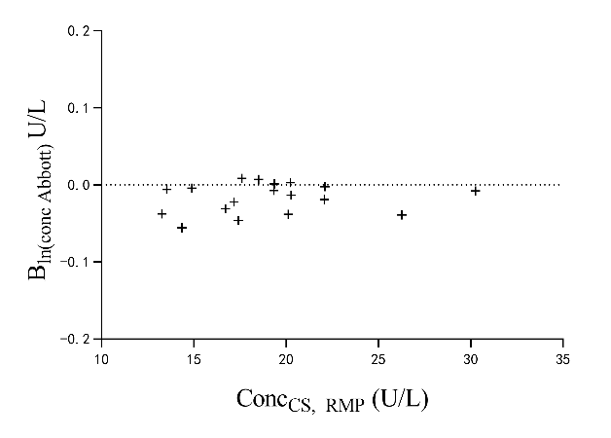

B

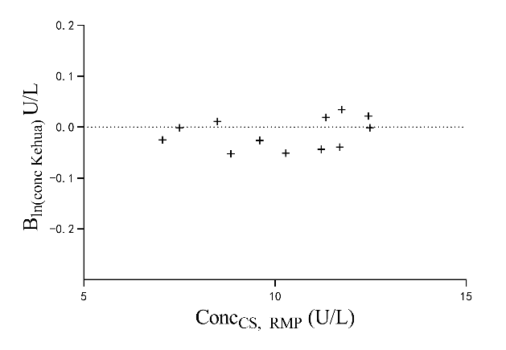

A

**Supplemental Figure 4. Comparison of the measurement results obtained with each routine method and with the RMP**

The data points on the graphs represent the mean concentrations obtained from the three replicate measurements of each serum pool. The mean concentrations measured

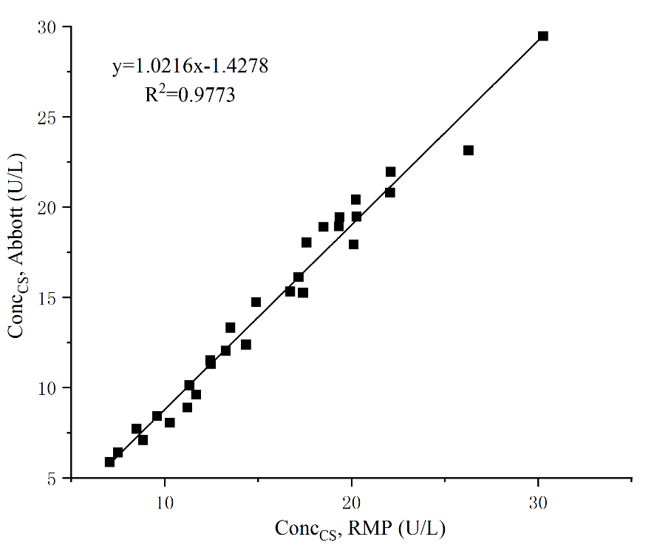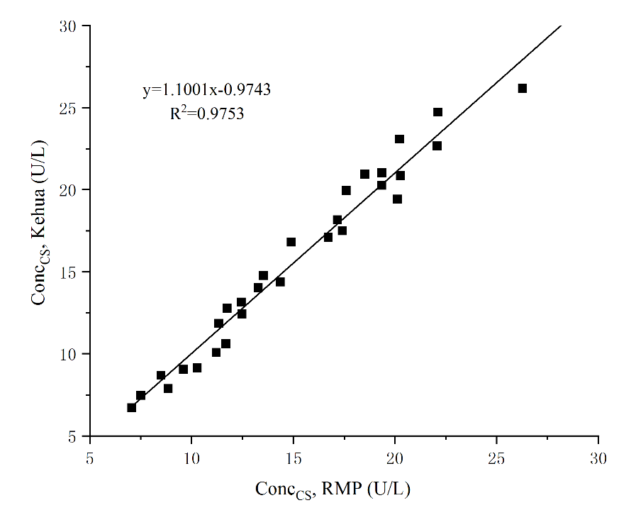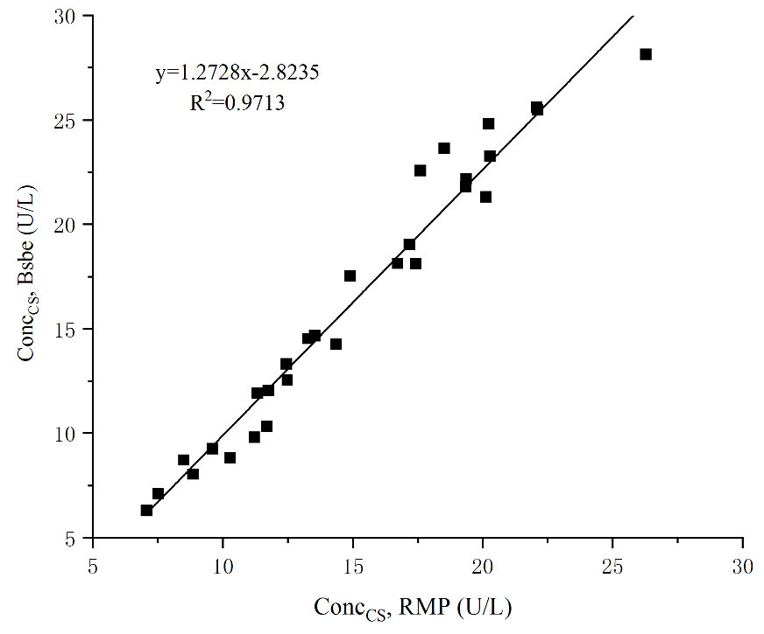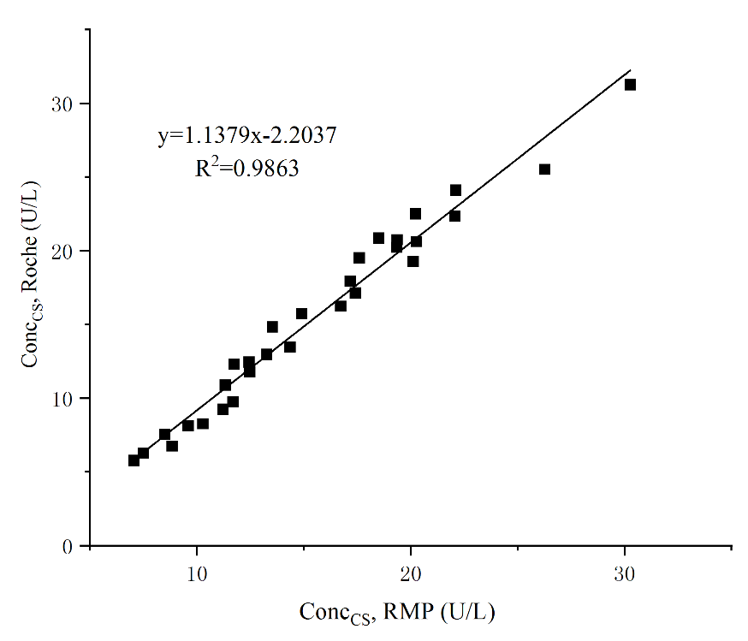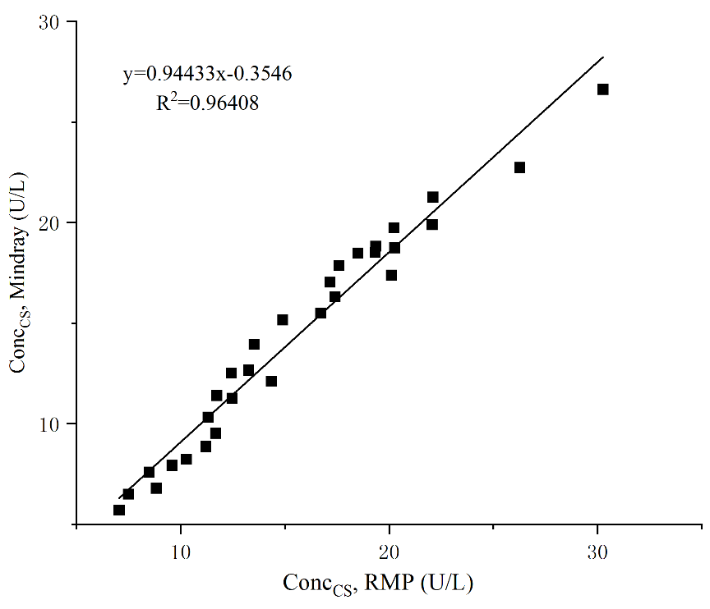with the routine method ( ${\overline{conc}}_{CS, rout})$ are plotted on the Y-axis and the concentrations measured with the RMP ( ${\overline{conc}}_{CS,RMP})$ are plotted on the X-axis. The linear regression line was obtained using the Deming regression equation.