**Age and sex specific reference intervals of 13 hematological analytes in Chinese children and adolescents aged from 28 days up to 20 years: the PRINCE study**

Wenqi Song#, Ruohua Yan#, Mingting Peng#, Hong Jiang#, Guixia Li#, Sancheng Cao#, Yongmei Jiang#, Zhenxin Guo#, Dapeng Chen#, Hongling Yang#, Jin Xu#, Yong Chang#, Yun Xiang#, Min Zhao, Chenbin Li, Ying Shen, Fang Jin, Qiliang Li, Yan Wang, Yaguang Peng, Lixin Hu, Ying Liu, Xiaofei Zhang, Wenxiang Chen*, Xiaoxia Peng*, Xin Ni*, on behalf of the study group of Pediatric Reference Intervals in China (PRINCE)

**Supplementary Materials**

Table S1. Region and instrument distributions of the establishment and validation populations 2

Table S2. Out-of-range values of validation centers for red blood cell profiles 3

Table S3. Out-of-range values of validation centers for white blood cell profiles 4

Figure S1. Distributions of red blood cell profiles by age and sex 5

Figure S2. Distributions of white blood cell profiles by age and sex 6

Figure S3. Consistency of red blood cell counts, hemoglobin, and hematocrit between Sysmex and Mindray 7

Figure S4. Consistency of platelet counts and white blood cell counts between Sysmex and Mindray 8

**Table S1. Region and instrument distributions of the establishment and validation populations**

|  |  |  |  |  |  |  |  |  |
| --- | --- | --- | --- | --- | --- | --- | --- | --- |
| **Region** | **Center** | **Establishment population** | | | |  | **Validation population** | |
|  |  | **Instrument** | **n** | **Instrument** | **N** |  | **Instrument** | **n** |
| North | Beijing | Sysmex XE-5000 | 1424 |  |  |  | Sysmex XE-5000 | 700 |
|  | Hebei (Shijiazhuang) | Sysmex XS-500i | 1379 | Mindray BC-5310 | 1432 |  | Sysmex XS-500i | 208 |
|  | Shanxi (Taiyuan) |  |  |  |  |  | Sysmex XN-3000 | 299 |
|  | Inner Mongolia (Hohhot) |  |  |  |  |  | Sysmex XE-2100 | 200 |
| Northeast | Liaoning (Shenyang) | Sysmex XS-500i | 939 |  |  |  |  |  |
|  | Liaoning (Dalian) |  |  |  |  |  | Sysmex XN-350L | 284 |
| East | Shanghai | Sysmex XN-2000(B3) | 745 |  |  |  | Sysmex XN-2000(B3) | 191 |
|  | Jiangsu (Nanjing) | Sysmex XE-2100 | 754 |  |  |  |  |  |
|  | Zhejiang (Hangzhou) |  |  |  |  |  | Sysmex XN-1000(B2) | 310 |
|  | Anhui (Hefei) |  |  |  |  |  | Sysmex XS-500i | 296 |
|  | Jiangxi (Nanchang) |  |  |  |  |  | Sysmex XN-1000 | 270 |
|  | Shandong (Liaocheng) |  |  |  |  |  | Sysmex XN-3000 | 428 |
| Middle | Henan (Zhengzhou) | Sysmex XE-5000 | 1147 |  |  |  | Sysmex XE-5000 | 371 |
|  | Hubei (Wuhan) | Sysmex XN-3000 | 665 |  |  |  | Sysmex XN-3000 | 153 |
|  | Hunan (Changsha) |  |  |  |  |  | Sysmex XN-2000(A1) | 302 |
| South | Guangdong (Guangzhou) | Sysmex XE-5000 | 1375 |  |  |  | Sysmex XE-5000 | 315 |
|  | Guangdong (Shenzhen) |  |  |  |  |  | Sysmex XN-350L | 263 |
|  | Guangxi (Liuzhou) |  |  |  |  |  | Mindray BC-5300 | 266 |
| Southwest | Chongqing | Sysmex XE-2100 | 1026 |  |  |  | Sysmex XE-2100 | 348 |
|  | Sichuan (Chengdu) | Sysmex XE-2100 | 1094 |  |  |  |  |  |
|  | Guizhou (Guiyang) |  |  |  |  |  | Sysmex XN-3000 | 213 |
| Northwest | Shaanxi (Xi’an) | Sysmex XS-500i | 1950 | Mindray BC-5310 | 1658 |  | Mindray BC-5310 | 351 |
|  | Qinghai (Xining) |  |  |  |  |  | Sysmex XN-1000(B2) | 169 |
|  | Xinjiang (Urumchi) |  |  |  |  |  | Mindray BC-5390 | 387 |

**Table S2. Out-of-range values of validation centers for red blood cell profiles**

|  |  |  |  |  |
| --- | --- | --- | --- | --- |
| **Region** | **Center** | **OOR (%)** | | |
|  |  | **MCV** | **MCH** | **MCHC** |
| North | Beijing | 1.57 | 1.14 | 3.43 |
|  | Hebei (Shijiazhuang) | 0.00 | 4.81 | 7.69 |
|  | Shanxi (Taiyuan) | 6.02 | 5.35 | 21.07 |
|  | Inner Mongolia (Hohhot) | 4.00 | 5.00 | 1.50 |
| Northeast | Liaoning (Dalian) | 1.76 | 3.17 | 1.76 |
| East | Shanghai | 2.62 | 2.62 | 2.62 |
|  | Zhejiang (Hangzhou) | 0.65 | 1.94 | 1.94 |
|  | Anhui (Hefei) | 2.03 | 3.04 | 1.01 |
|  | Jiangxi (Nanchang) | 1.85 | 2.59 | 1.85 |
|  | Shandong (Liaocheng) | 0.93 | 1.40 | 0.93 |
| Middle | Henan (Zhengzhou) | 3.50 | 1.89 | 3.77 |
|  | Hubei (Wuhan) | 1.31 | 5.88 | 0.00 |
|  | Hunan (Changsha) | 1.66 | 1.32 | 1.32 |
| South | Guangdong (Guangzhou) | 3.81 | 2.86 | 0.63 |
|  | Guangdong (Shenzhen) | 2.28 | 1.52 | 1.14 |
|  | Guangxi (Liuzhou) | 4.51 | 4.14 | 2.63 |
| Southwest | Chongqing | 1.72 | 3.16 | 5.46 |
|  | Guizhou (Guiyang) | 2.35 | 6.10 | 1.88 |
| Northwest | Shaanxi (Xi’an) | 4.27 | 12.25 | 15.95 |
|  | Qinghai (Xining) | 7.10 | 8.28 | 3.55 |
|  | Xinjiang (Urumchi) | 9.04 | 5.94 | 8.53 |

OOR, out-of-range; MCV, mean corpuscular volume; MCH, mean corpuscular hemoglobin; MCHC, mean corpuscular hemoglobin concentration.

**Table S3. Out-of-range values of validation centers for white blood cell profiles**

|  |  |  |  |  |  |  |
| --- | --- | --- | --- | --- | --- | --- |
| **Region** | **Center** | **OOR (%)** | | | | |
|  |  | **NEUT** | **LYMPH** | **MONO** | **EO** | **BASO** |
| North | Beijing | 2.43 | 4.57 | 2.00 | 2.14 | 0.57 |
|  | Hebei (Shijiazhuang) | 1.44 | 2.40 | 2.88 | 0.96 | 2.40 |
|  | Shanxi (Taiyuan) | 3.34 | 5.02 | 2.34 | 0.67 | 2.68 |
|  | Inner Mongolia  (Hohhot) | 5.00 | 4.00 | 0.50 | 13.50 | 3.00 |
| Northeast | Liaoning (Dalian) | 3.87 | 4.58 | 14.44 | 2.46 | 2.11 |
| East | Shanghai | 5.29 | 7.33 | 3.53 | 5.76 | — |
|  | Zhejiang (Hangzhou) | 4.84 | 2.90 | 1.29 | 3.87 | 2.58 |
|  | Anhui (Hefei) | 3.72 | 7.43 | 2.36 | 6.08 | 3.72 |
|  | Jiangxi (Nanchang) | 3.70 | 4.81 | 4.81 | 8.15 | 8.52 |
|  | Shandong (Liaocheng) | 3.50 | 5.37 | 2.57 | 3.04 | 3.74 |
| Middle | Henan (Zhengzhou) | 3.50 | 3.77 | 12.40 | 1.08 | 0.00 |
|  | Hubei (Wuhan) | 3.27 | 1.31 | 9.15 | 1.31 | 4.58 |
|  | Hunan (Changsha) | 1.99 | 5.96 | 0.66 | 5.96 | 3.31 |
| South | Guangdong  (Guangzhou) | 2.54 | 5.71 | 1.59 | 4.44 | 0.63 |
|  | Guangdong (Shenzhen) | 6.08 | 4.94 | 1.52 | 0.38 | 0.76 |
|  | Guangxi (Liuzhou) | 1.50 | 7.14 | 0.38 | 10.53 | 6.77 |
| Southwest | Chongqing | 2.30 | 2.01 | 14.08 | 4.89 | 12.07 |
|  | Guizhou (Guiyang) | 3.29 | 7.98 | 5.16 | 8.45 | 7.51 |
| Northwest | Shaanxi (Xi’an) | 4.27 | 5.98 | 0.85 | 1.71 | 6.55 |
|  | Qinghai (Xining) | 5.36 | 1.78 | 1.18 | 0.59 | 7.69 |
|  | Xinjiang (Urumchi) | 3.88 | 2.33 | 1.81 | 3.36 | 4.39 |

OOR, out-of-range; NEUT, neutrophil counts; LYMPH, lymphocyte counts; MONO, monocyte counts; EO, eosinophil counts; BASO, basophil counts.

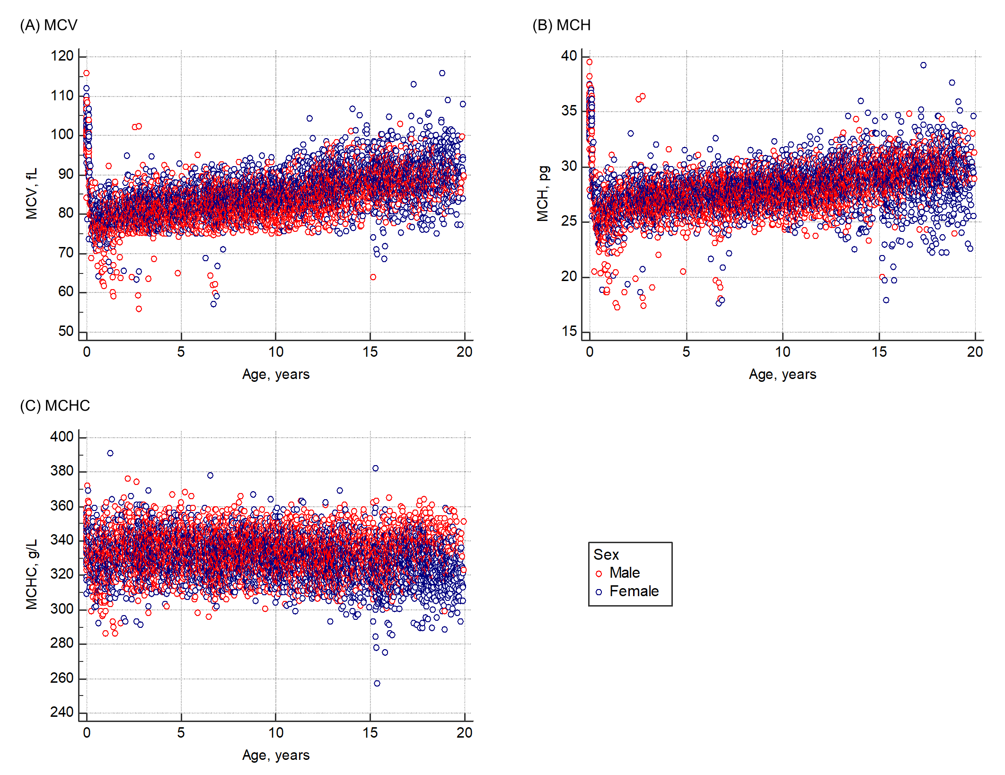

**Figure S1. Distributions of red blood cell profiles by age and sex**

MCV, mean corpuscular volume; MCH, mean corpuscular hemoglobin; MCHC, mean corpuscular hemoglobin concentration.

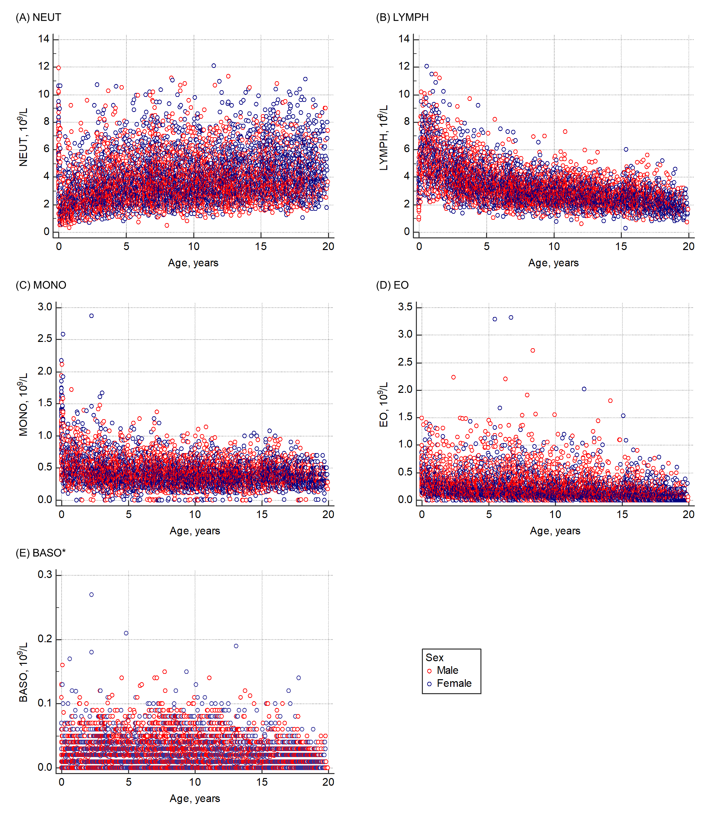

**Figure S2. Distributions of white blood cell profiles by age and sex**

NEUT, neutrophil counts; LYMPH, lymphocyte counts; MONO, monocyte counts; EO, eosinophil counts; BASO, basophil counts.

* Shaanxi (Xi’an) were excluded because of the low verification of trueness.

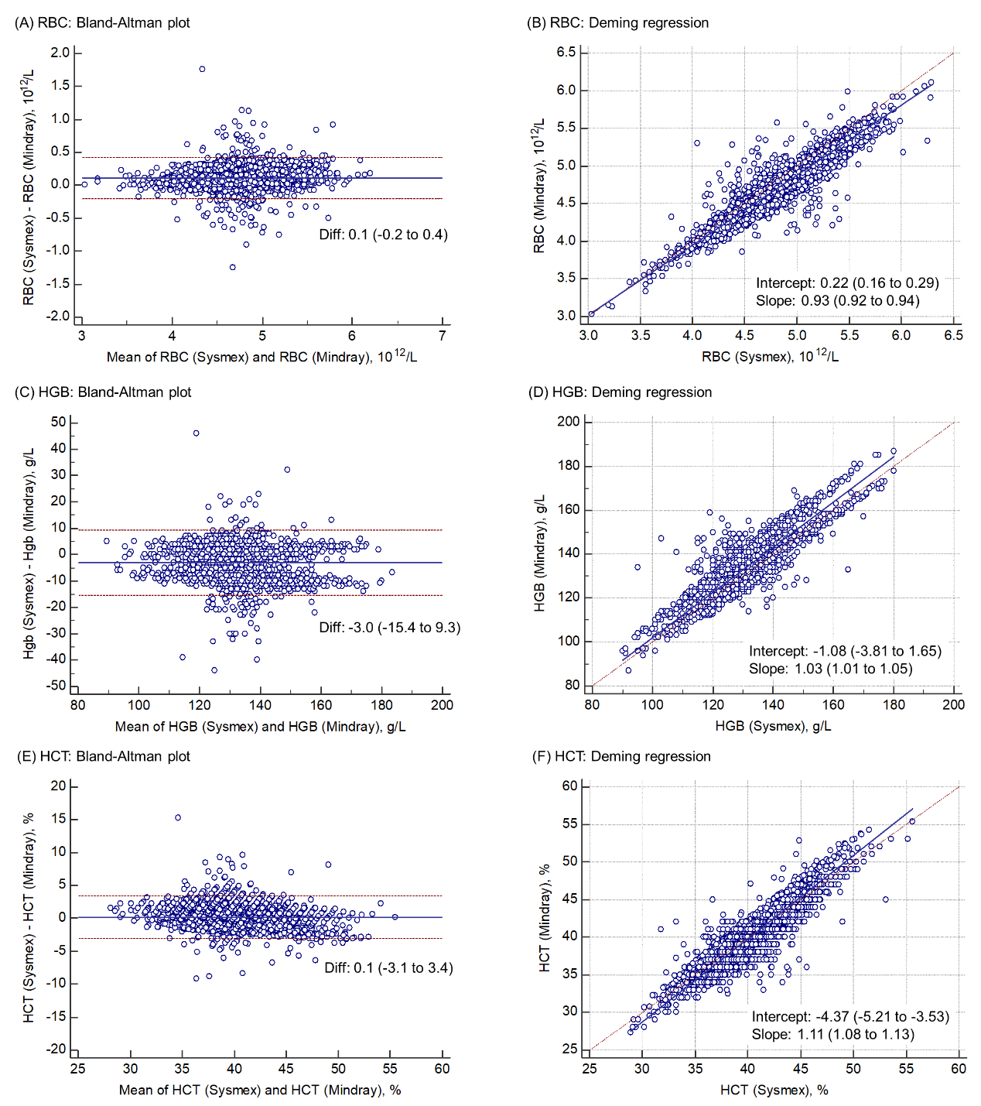

**Figure S3. Consistency of red blood cell counts, hemoglobin, and hematocrit between Sysmex and Mindray**

RBC, red blood cell counts; HGB, hemoglobin; HCT, hematocrit.

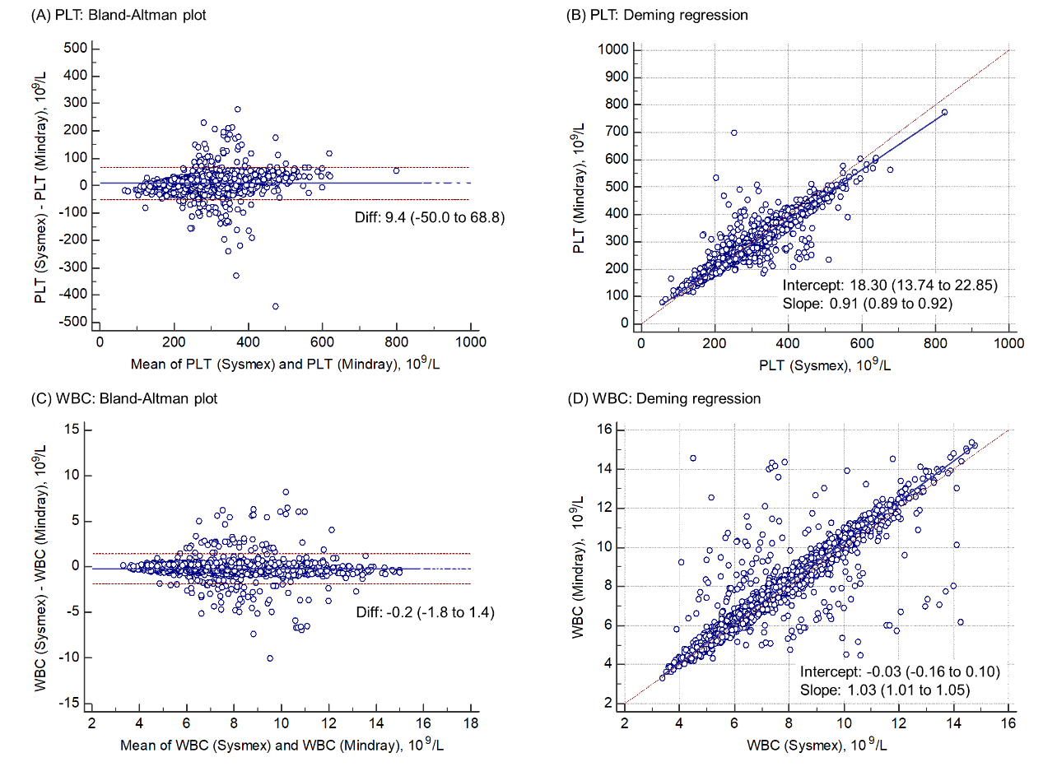

**Figure S4. Consistency of platelet counts and white blood cell counts between Sysmex and Mindray**

PLT, platelet counts; WBC, white blood cell counts.