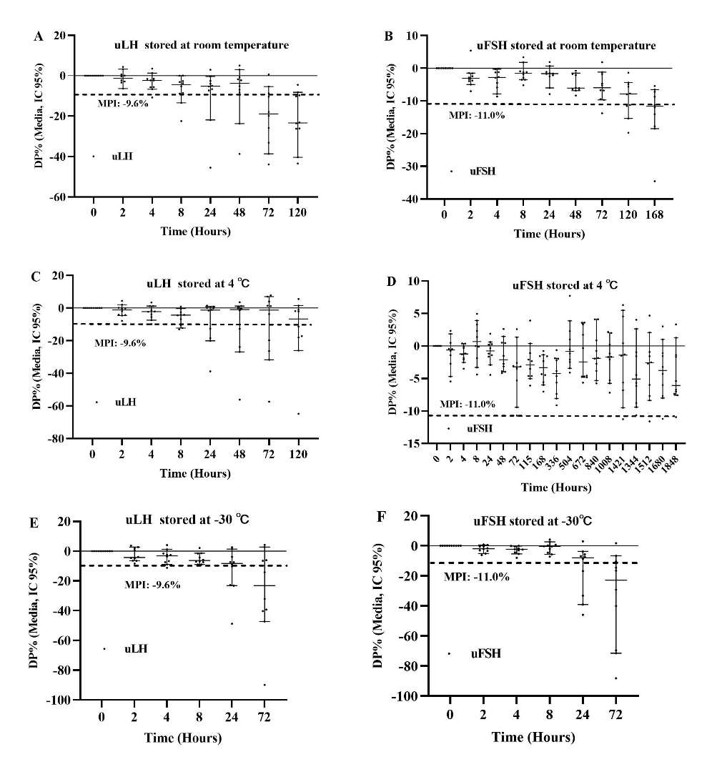

**Supplemental Figure 1. Effects of temperature on the measured uLH and uFSH concentrations.** uLH, urinary luteinizing hormone; uFSH, urinary follicle-stimulating hormone; MPI, maximum permissible instability; PD, percentage deviation. Data are represented as scatter plots, with horizontal and vertical lines representing the median and 95% confidence interval (CI). The X axis indicates the duration of storage of the urine samples at the various temperatures and the Y axis indicates the PD between the measured value (after storage for a specific period of time) and the baseline value (0 hour). The MPIs for uLH and uFSH were defined as 9.6% and 11.0%, respectively. (A) Percentage changes and trends for uLH at room temperature from 0 to 120 hours. (B) Percentage changes and trends for uFSH at room temperature from 0 to 168 hours. (C) Percentage changes and trends for uLH at 4°C from 0 to 120 hours. (D) Percentage changes and trends for uFSH at 4°C from 0 to 1,848 hours. (E) Percentage changes and trends for uLH at −20°C from 0 to 72 hours. (F) Percentage changes and trends for uFSH at −20°C from 0 to 72 hours.