**Supplemental Figure 1.** Intra-laboratory Passing and Bablok comparison of results obtained by *in-house* and external calibration within laboratories using Chromsystems’ material for *in house* calibration.

**CORTICOSTERONE**

**11-DEOXYCORTISOL**

**CORTISONE**



**Lab D**

*In house* calibration (nmol/L)

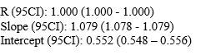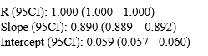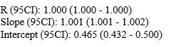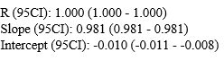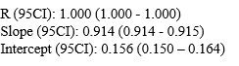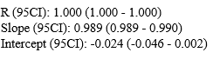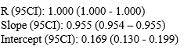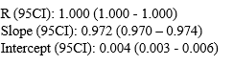

**Lab E**

*In house* calibration (nmol/L)

**Lab L**

*In house* calibration (nmol/L)

External calibration (nmol/L)

External calibration (nmol/L)

External calibration (nmol/L)



**Supplemental Figure 2.** Bland-Altman plot of corticosterone measurements as function of the calibration system.

**Lab B % bias**

**Lab C % bias**

**Lab D % bias**

***In house* calibration**

**External calibration**

**Lab E % bias**

**Lab G % bias**

**Lab H % bias**

**Lab I % bias**

**Lab L % bias**

*Bias (%) = ((laboratory value – median of all laboratories) / median of all laboratories) x 100.*

Continuous and broken lines: mean bias and 95% agreement interval. Dashed line: 0% bias.



**Supplemental Figure 3.** Bland-Altman plot of 11-deoxycortisol measurements as function of the calibration system.

***In house* calibration**

**External calibration**

*Bias (%) = ((laboratory value – median of all laboratories) / median of all laboratories) x 100.*

Continuous and broken lines: mean bias and 95% agreement interval. Dashed line: 0% bias.



**Lab B % bias**

**Lab C % bias**

**Lab D % bias**

**Lab L % bias**

**Lab E % bias**

**Lab G % bias**

**Lab H % bias**

**Lab I % bias**



**Supplemental Figure 4.** Bland-Altman plot of cortisone measurements as function of the calibration system.

**Lab B % bias**

***In house* calibration**

**External calibration**

*Bias (%) = ((laboratory value – median of all laboratories) / median of all laboratories) x 100.*

Continuous and broken lines: mean bias and 95% agreement interval. Dashed line: 0% bias.



**Lab C % bias**



**Lab D % bias**



**Lab E % bias**



**Lab G % bias**



**Lab H % bias**



**Lab I % bias**



**Lab L % bias**

