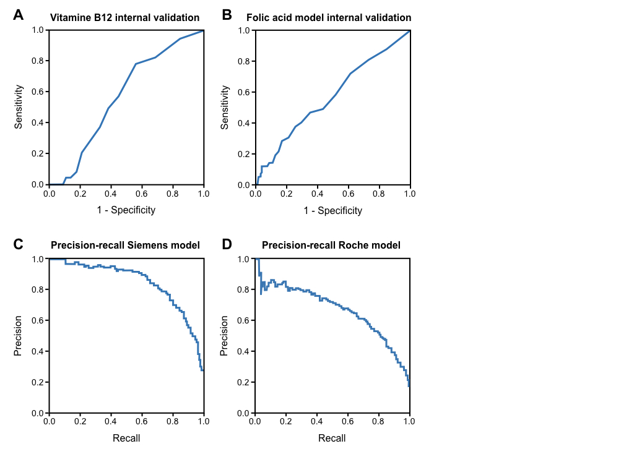

Supplementary Figure 1. (A) ROC plot for the prediction of low vitamin B12 values (<156 pmol/L) in the validation population of the Jeroen Bosch Hospital (Siemens), with an area under the curve of 0.52. (B) ROC plot for the prediction of low folic acid values (<6.0 nmol/L) in the validation population of the Jeroen Bosch Hospital (Siemens), with an area under the curve of 0.57. (C) Precision-recall curve for the validation population of the JBH-S algorithm. (D) Precision-recall curve for the validation population of the Medlon-R algorithm.

Supplementary Table 1. The sensitivity and specificity for each cut-off value of the algorithm, as an arbitrary machine learning value from 0 to 1.

|  |  |  |
| --- | --- | --- |
| **Siemens ML algorithm** | | |
| **Cut-off value (arbitrary unit)** | **Sensitivity** | **Specificity** |
| ≤0.0  ≤0.1 *  ≤0.2 | 100%  94%  88% | 10%  67%  82% |
| ≥0.30  ≥0.40  ≥0.50 *  ≥0.60  ≥0.70  ≥0.80  ≥0.90 | 81%  77%  69%  63%  53%  38%  23% | 88%  92%  95%  97%  98%  99%  100% |
| **Roche ML algorithm** | | |
| **Cut-off value (arbitrary unit)** | **Sensitivity** | **Specificity** |
| ≤0.0  ≤0.05 *  ≤0.1 | 99%  93%  87% | 30%  64%  76% |
| ≥0.30  ≥0.40 *  ≥0.50  ≥0.60  ≥0.70  ≥0.80  ≥0.90 | 70%  59%  49%  39%  28%  18%  7% | 91%  95%  97%  98%  99%  99%  100% |

* The cut-off values as chosen in this study.