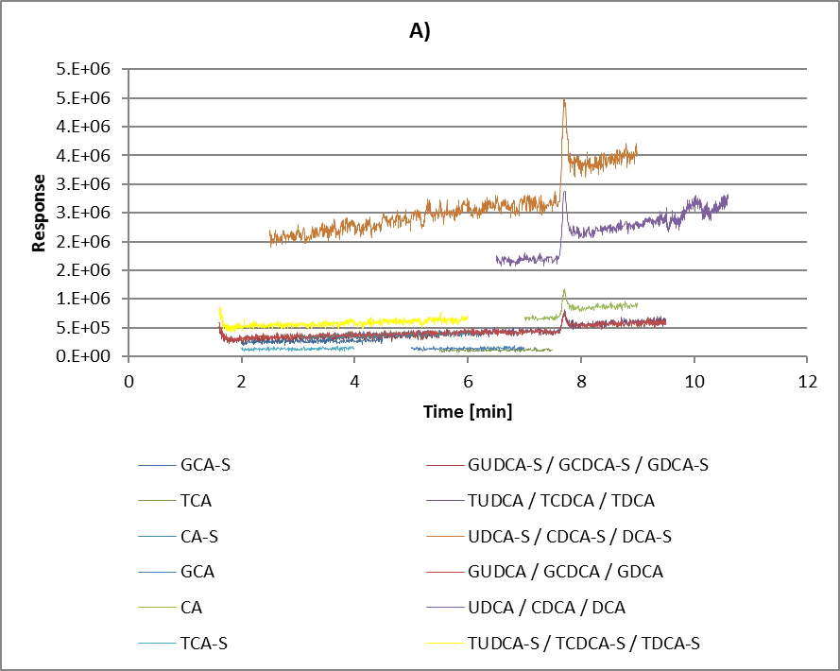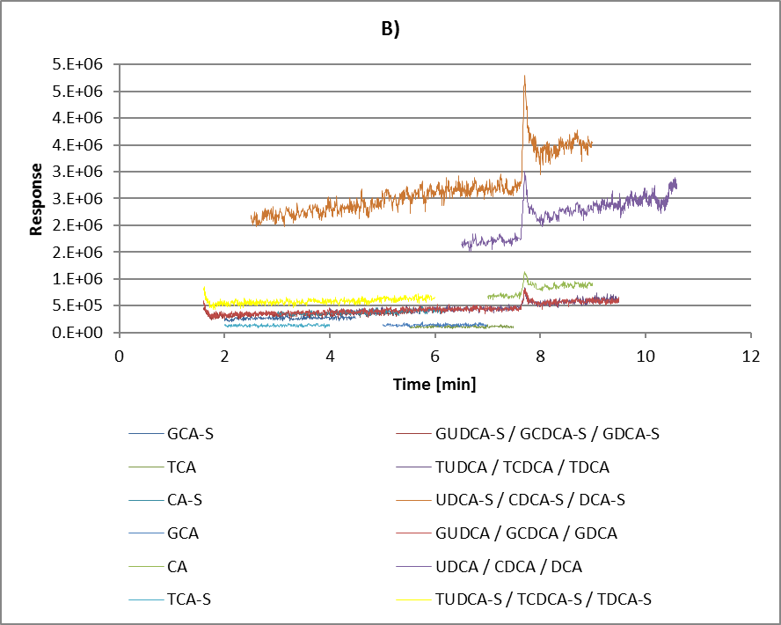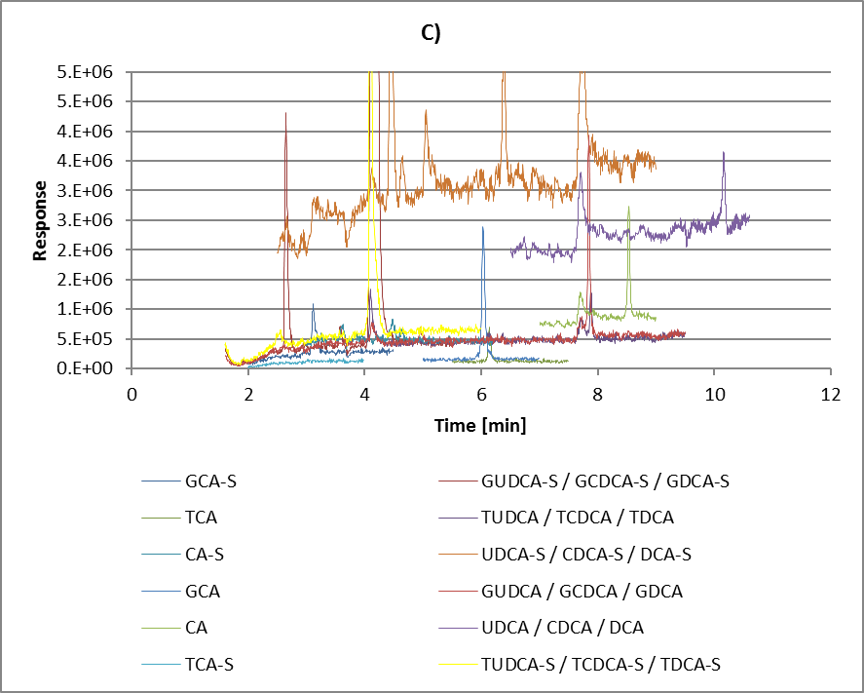
Suppl. Figure 1 Qualitative matrix effect: Post-column infusion experiments.
Infusion of a solution of all BAs with 1.0 ng/min and meanwhile injection of A) methanol/water (1/1; v/v); B) artificial urine; C) authentic urine with endogenous bile acids (TUDCA-S 32.7 µg/L, 2.5 min; TCDCA-S 13.0 µg/L, 4.1 min; TDCA-S 8.88 µg/L, 4.3 min; TCA-S <LLOQ; GUDCA-S 335 µg/L, 2.6 min; GCDCA-S 166 µg/L, 4.1 min; GDCA-S 65.8 µg/L, 4.3 min; GCA-S 8.48 µg/L, 3.1 min, UDCA-S 292 µg/L, 4.8 min; CDCA-S 5.81 µg/L, 7.6 min; DCA-S <LLOQ; CA-S <LLOQ; TUDCA 10.5 µg/L, 5.1 min; TCDCA 1.00 µg/L, 7.8 min; TDCA <LLOQ; TCA 1.26 µg/L, 6.1 min; GUDCA 354 µg/L, 4.9 min; GCDCA 9.78 µg/L, 7.8 min; GDCA <LLOQ; GCA 19.4 µg/L, 6.0 min; UDCA 18.4 µg/L, 7.9 min; CDCA 2.47 µg/L, 10 min; DCA <LLOQ; CA 34.3 µg/L, 8.4 min).

