Supplemental Figure 1
Electrophoretic data used to calculate the theoretical plate number and the symmetry factor (a) on the Helena V8 and (b) the Sebia Capillarys 2.
(A)
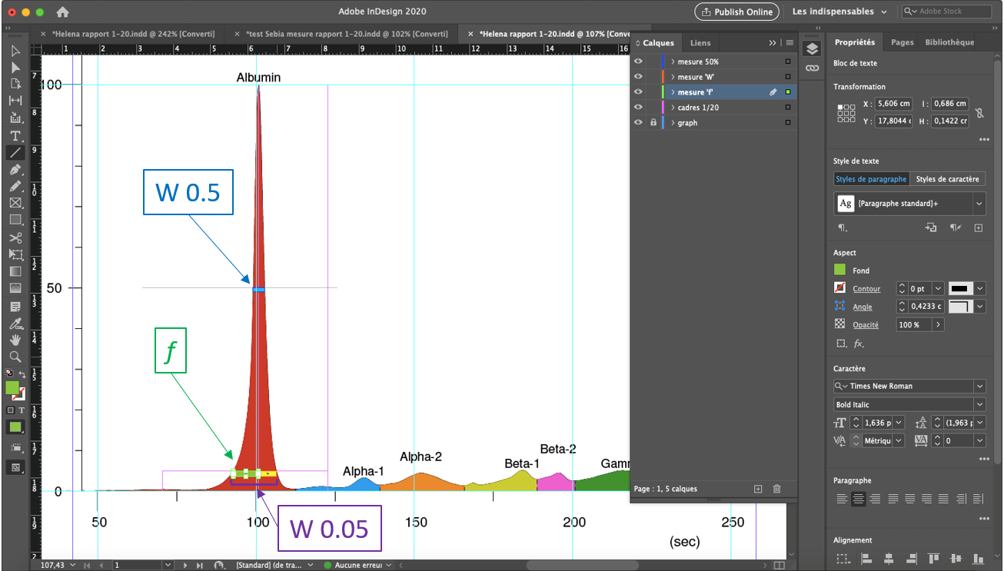
(B)
