Supplemental Material

Supplemental Table 1.

Multivariate logistic regression models.

Logit curves coefficients (Coeff), goodness of fit (GOF) and receiver-operating characteristics (ROC) area under the curve (AUC) are indicated by different microneutralization (MNT) IC90 dilution titers in naturally infected (N) or vaccinated subjects (V).

|  |  |  |  |  |  |
| --- | --- | --- | --- | --- | --- |
| **MNT**  **(IC90 titer)** | **Status** | **Constant** | **Coeff anti-SARS-CoV-2 IgG RBD (BAU/mL)** | **Model Hosmer Lameshow Test GOF**  **p value** | **ROC AUC [95% CI]** |
| 1:20 | N | -0.94 | 0.005 | <0.001 | 0.84 [0.74-0.93] |
| V | -2.1 | 0.006 | 0.97 [0.95-1.00] |
| 1:40 | N | -1.337 | 0.0039 | 0.06 | 0.86 [0.80-0.93] |
| V | -12.9. | 0.0021 | 0.98 [0.96-1.00] |
| 1:80 | N | -1.425 | 0.0017 | 0.31 | 0.77 [0.73-0.88] |
| V | -4.875 | 0.0052 | 0.99 [0.99-1.00] |
| 1:160 | N | -2.7 | 0.0012 | 0.15 | 0.79 [0.72-0.87] |
| V | -2.8 | 0.0010 | 0.97 [0.95-1.00] |

RBD, receptor binding domain; BAU, banding antibody unit.

Supplemental Table 2.

Anti-SARS CoV 2 IgG RBD levels (BAU/mL) by age and gender in association with different microneutralization (MNT) IC90 titers in naturally infected (N) vs vaccinated (V) subjects.

Distributions medians were compared at ≥ 1:20 or ≥ 1:80 MNT IC90 dilution titers; 95% upper and lower confidence intervals [CI] are indicated in brackets; non-significant p-values (>0.05) are highlighted in gray fields.

|  |  |  |  |  |
| --- | --- | --- | --- | --- |
|  |  | **Anti-SARS-CoV-2 IgG RBD (BAU/mL)** | |  |
| **MNT ≥ 1:20** |  | **N** | **V** |  |
| **Age (years)** | Median [95%CI] | Median [95%CI] | p-value |
| <50 | 497 [422-751] | 2,305 [1,539-2,950] | <0.001 |
| ≥50 | 742 [492-993] | 1,923 [981-2,896] | <0.001 |
| p-value | 0.25 | 0.80 |  |
|  |  |  |  |
|  | **N** | **V** |  |
| **Gender** | Median [95%CI] | Median [95%CI] | p-value |
| M | 630 [492-951] | 1,383 [593-3,132] | 0.0014 |
| F | 812 [422-1,057] | 2,318 [1,837-2,750] | <0.001 |
| p-value | 0.84 | 0.21 |  |
| **MNT ≥ 1:80** |  | **N** | **V** |  |
| **Age (years)** | Median [95%CI] | Median [95%CI] | p-value |
| <50 | 536 [422-959] | 2,750 [2,303-3,308] | <0.001 |
| ≥50 | 986 [610-1,303] | 2,602 [1,923-3,361] | <0.001 |
| p-value | 0.12 | 1.00 |  |
|  | **N** | **V** |  |
| **Gender** | Median [95%CI] | Median [95%CI] | p-value |
| M | 756 [514-1,170] | 3,132 [1,562-3,427] | <0.001 |
| F | 980 [446-1,909] | 2,602 [2,303-2,950] | <0.001 |
| p-value | 0.44 | 1.00 |  |

BAU, banding antibody unit; M=, male; F, female.

Supplemental Figure 1.

Average interaction plot: graphical analysis of anti-SARS-CoV-2 IgG receptor binding domain (RBD) levels (BAU/mL) in naturally infected (N) vs vaccinated (V) subjects at different microneutralization (MNT) IC90 titers.

(A) The average of IgG levels is plotted against the reciprocal dilution of MNT IC90 titer. Error bars are representative of calculated 95% confidence intervals. (B) Graphical evaluation of each single reciprocal neutralization titer contribution on anti-RBD average levels (BAU/mL) in N and V subject groups.

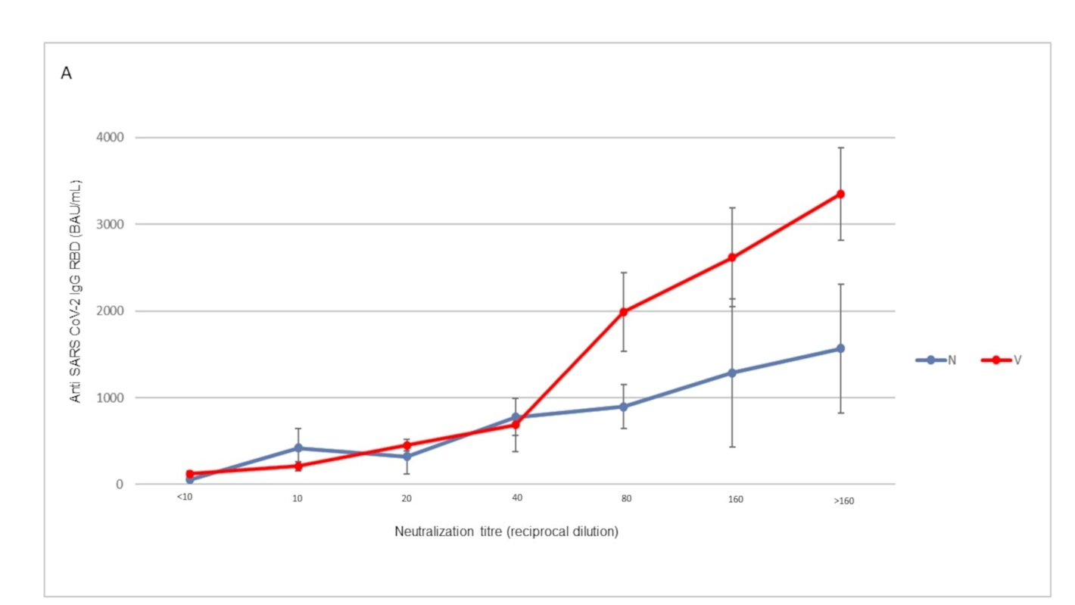

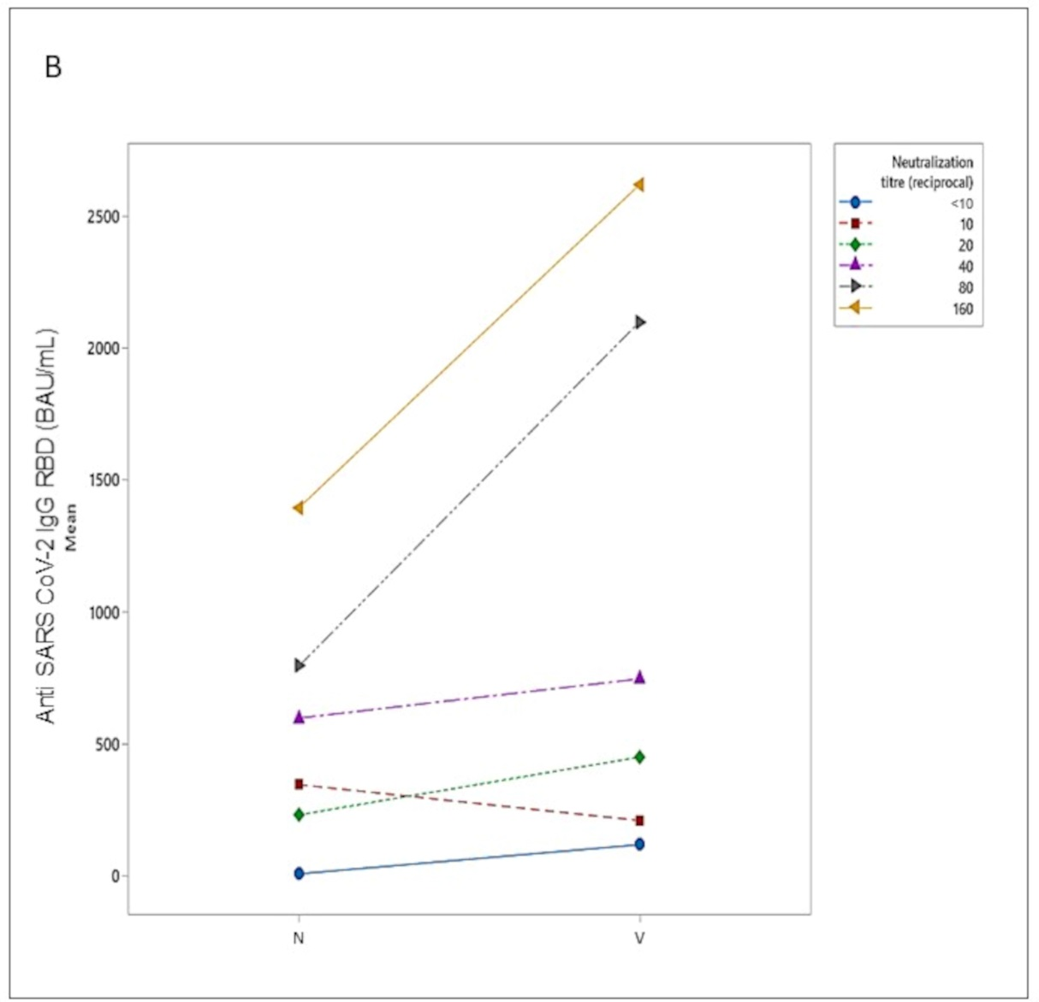

Supplemental Figure 2.

Anti-SARS-CoV-2 IgG receptor binding domain (RBD) levels dispersion (BAU/mL) at 1:80 microneutralization (MNT) IC90 dilution titer.

Jitter plots depict the levels of anti-RBD by a binary response at <1:80 or >1:80 MNT titers. Naturally infected (N) and vaccinated (V) individuals are indicated in red and light blue respectively.

