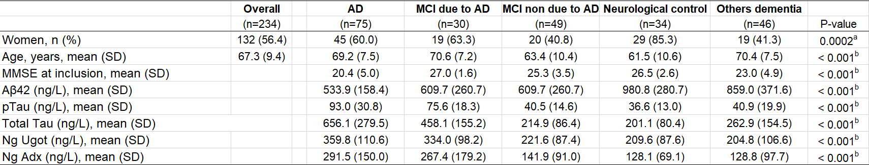
Supplementary Table 1: Patient sample characteristics.
Data are represented as n (%) or mean (SD). ªp-Value for comparison of multiples qualitative data have been calculated using a Chi-2 square test. ^{b}p-Values for comparison of multiples quantitative data have been calculated using an analysis of variance ANOVA.

