Supplemental data

Immunosuppressant quantification in intravenous microdialysate – Towards novel quasi-continuous therapeutic drug monitoring in transplanted patients

Running head: Microdialysis-based TDM of immunosuppressants

Susanne Weber¹, Sara Tombelli², Ambra Giannetti², Cosimo Trono², Mark O´Connell³, Ming Wen⁴, Ana B. Descalzo⁵, Heike Bittersohl¹, Andreas Bietenbeck¹, Pierre Marquet⁶, Lutz Renders^{4,7}, Guillermo Orellana⁵, Francesco Baldini², Peter B. Luppa^{1*}

¹ Institute of Clinical Chemistry and Pathobiochemistry, Klinikum rechts der Isar, Technische Universität München, 81675 Munich, Germany
² Institute of Applied Physics “Nello Carrara”, National Research Council, 50019 Sesto Fiorentino (FI), Italy
³ Cornel Medical Ltd., London N10 2QD, U. K.
⁴ Department of Nephrology, Klinikum rechts der Isar, Technische Universität München, 81675 Munich, Germany
⁵ Department of Organic Chemistry, Universidad Complutense de Madrid, 28040 Madrid, Spain
⁶ U1248 IPPRITT, INSERM, University of Limoges, CHU Limoges, 87000 Limoges, France
⁷ German Centre for Infection Research (DZIF), Munich, Germany
* Corresponding author:
Peter B. Luppa, Institute of Clinical Chemistry and Pathobiochemistry, Klinikum rechts der Isar, Technische Universität München, Ismaninger Str. 22, 81675 Munich, Germany; phone +49 89 4140-4759; e-mail p.luppa@tum.de

Supplemental Material and Methods:

Chemicals and Reagents
MPA, and D₃-MPA were obtained from Cerilliant (Round Rock, TX, USA). CsA was purchased from either Cerilliant or Abcam (Cambridge, UK), while D₁₂-CsA was a kind gift from Novartis Pharma (Nuremberg, Germany, www.novartis.de). The synthesis and structure confirmation of the carboxylated CsA derivative (CsA-O-CO₂H, Supplemental Figure S2 and S3) is described below. Acetonitrile (Ultra-LC-MS grade), methanol (LC-MS hypergrade), and hexane (HPLC grade) or 1-chlorobutane (reagent plus grade) were from Carl Roth (Karlsruhe, Germany), Merck Chemicals (Darmstadt, Germany), and Sigma-Aldrich (Munich, Germany), respectively.
Anti-cyclosporine A monoclonal mouse IgG1 primary antibody, clone CSZ.22 was from Abcam. AlexaFluor 647-conjugated goat anti-mouse IgG (H+L) was from Invitrogen (Invitrogen by Thermo Fisher Scientific, Milan, Italy).
Ultrapure water was provided by a Milli-Q water purification system from Merck Millipore (Darmstadt, Germany). All other chemicals were purchased from either Carl Roth, Merck, or Sigma-Aldrich, unless otherwise stated.

Synthesis of carboxylated CsA (CsA-O-CO₂H)
Derivatization of CsA with a carboxyl group, required for its immobilization to the chip surface, was performed on its only hydroxyl group by reaction with a 6-membered cyclic anhydride. Here, nucleophilic substitution on the anhydride by the hydroxyl group of CsA led to ring opening of the former yielding a free carboxylic acid function linked to CsA via a C₅ spacer (ω-carboxyl ester).
Initial attempts of CsA acylation with glutaric anhydride using different reaction conditions (pyridine or toluene as solvent, different number of equivalents of glutaric anhydride, use of conventional thermal reaction or a microwave reactor) either did not yield the desired product at all or only in very poor yields. This was probably due to a significant steric hindrance around the secondary alcohol group of CsA. However, after replacing glutaric anhydride by the more reactive 6-membered analogue diglycolic anhydride, the carboxylated CsA (CsA-O-CO₂H, Supplemental Figure S2) could be obtained with an excellent yield (see below).

Reagents and solvents
Cyclosporine (>99%) was purchased from Sinoway Industrial Co. (Xiamen, China); diglycolic anhydride (>96%) and 4-dimethylaminopyridine (>99%; DMAP) were from Sigma-Aldrich (Madrid, Spain). Anhydrous toluene (99.8%, Sigma-Aldrich and dichloromethane (HPLC grade, Fischer Chemical, Madrid, Spain) were used as received. Water was purified with a Direct-Q3-UV system (Merck Millipore, Madrid, Spain).

Instrumentation
Fast atom bombardment mass spectra (FAB-MS) were obtained with a high-resolution MAT 95XP Thermo Finnigan mass spectrometer in the Complutense University of Madrid (UCM) Central Research Support facilities (CAIs). A Biotage® Initiator+ microwave (MW) reactor together with 5 mL MW-safe glass reactor vessels was used for the one-step acylation. The reaction temperature was set at 60 ºC, with a temperature increase of typically 2–5 °C/s. The pressure range was 0–30 bar and the power range 0–400 W (from magnetron at 2.45 GHz).
Experimental procedure
CsA (261 mg, 0.217 mmol), diglycolic anhydride (253 mg, 2.17 mmol), and DMAP (83 mg, 0.679 mmol) were dissolved in 4 mL of anhydrous toluene. This reaction mixture was microwaved for 20 min at 60 °C. After removing the solvent by vacuum rotavaporation, the crude product was isolated by liquid-liquid extraction (dichloromethane/brine) in the organic phase. Evaporation of the organic solvent under reduced pressure yielded CsA-O-CO₂H as white solid in 84% yield.

Synthesis product verification
The identity of synthesis product was verified by mass spectrometry, recording FAB-MS in positive mode. The observed spectrum is shown in Supplemental Figure S3. The peak of the protonated CsA-O-CO₂H synthesis product mother ion was found at m/z 1319.28 (calculated m/z for [M+H]⁺ C₆₆H₁₁₆N₁₁O₁₆⁺: 1318.85). The base peak observed at m/z 1184.86 corresponds to the protonated McLafferty rearrangement fragment due to the loss of the -O₂C-CH₂-O-CH₂-CO₂H moiety (calculated m/z for C₆₂H₁₁₀N₁₁O₁₁⁺:1184.84).

The heterogeneous immunoassay
Chip characteristics
The applied 10-channel microfluidic chip (microfluidic ChipShop, Jena, Germany) had been developed within the European project NANODEM. The chip has approximately the dimensions of a standard slide (75 x 50 mm) with a thickness of about 1.3 mm. It was made by using two different polymeric parts bonded together by an adhesive tape: a bottom foil with refractive index n₁ and a top slide with refractive index n₂, which are properly structured. The microfluidic channels are built by cutting the adhesive tape between the two polymer parts. The fluorescent sensing layer has been immobilized on the surface of the microfluidic channels, and the condition n₁ > n₂ ensures that the fluorescent light emitted by the sensing layer is efficiently coupled to the photodetector located on the top side of the chip.

CsA-O-CO₂H coating
Using a peristaltic pump (pulling fluidic mode), the channels of the chip were modified via a carbodiimide crosslinking chemistry. The carboxylic group of CsA-O-CO₂H (10 mg/mL in DMSO) was first activated by dilution (final concentration: 100 µg/mL) and 20-min incubation in a freshly prepared aqueous solution containing 200 mM ethyl-(N’,N’-dimethylamino)propylcarbodiimide (EDC) hydrochloride and 50 mM N-hydroxysuccinimide (NHS), and then flowed through the channels for 1 h. After immobilization, the channels were washed with phosphate buffered saline (PBS) before their surface was blocked with undiluted Pierce protein-free blocking buffer (ThermoFisher Scientific, Monza, Italy) in order to prevent any potential non-specific adsorption of reagents onto the channel surface. For this, the modified channels were flushed with blocking solution for 20 min and then washed with PBS.

The immunoassay
The principle of the applied heterogeneous immunoassay (Figure 1) and the steps of the preincubation of µDs and anti-CsA antibody as well as the interaction of antibodies with the CsA-modified chip surface are described in the main text of the manuscript. A calibration curve for CsA was obtained by using µDs with known CsA concentrations. The different samples were tested sequentially with a regeneration step between each assay procedure. Per chip, two CsA and one blank µD sample were analyzed in parallel (three channels were used per sample). The blank sample, containing no CsA, corresponded to the maximum signal without binding inhibition. The remaining channel on each chip was used for the disposal of the different solutions from the fluidic line of the device. The fluorescence signal was recorded every 2 s as an average of eight acquired points (acquisition frequency 250 ms).
The total analysis time for each chip, including incubation, the secondary antibody injection and washing steps, was of about one hour. It should be considered, however, that the presence of 10 channels on each chip allowed the analysis of more than one sample (at least 3 if performed in triplicate) in the reported total analysis time.

Regeneration step
For the regeneration step, the regeneration solution (0.25% sodium dodecyl sulfate, pH 2.5) was injected sequentially into each channel and allowed to act for 60 s. The subsequent washing step was conducted for 5 min with PBS.
The regeneration efficiency and the restoration of the binding capacity of the chip surface bearing the analyte derivative were evaluated by analyzing the optical signal after the regeneration cycle. An average signal recovery of 93% (n = 15) was obtained after testing the same sample (µD without CsA), demonstrating the effectiveness of the regeneration process. The good reproducibility of sample measurements after regeneration, which is presented in the section "Results" in the main text, further confirmed the restoring of the binding capacity of the chip surface.

Supplemental Tables:

Supplemental Table S1: Pre-dose clinical chemistry profiles of patients collected within the study.
 | Overall range | Mean ± SD | Median (IQR)
Hematocrit, % | 25.30–49.30 | 38.47 ± 5.41 | 37.75 (5.50)
RBC, x10⁶/µL | 2.72–5.20 | 4.14 ± 0.57 | 4.12 (0.71)
WBC, x10³/µL | 1.82–10.26 | 6.34 ± 2.25 | 5.92 (2.87)
Lymphocytes, x10⁶/µL | 0.25–3.75 | 1.63 ± 0.81 | 1.59 (0.75)
Total protein, g/dL | 4.54–7.38 | 6.70 ± 0.66 | 6.86 (0.57)
Albumin, g/dL | 2.33–4.66 | 4.18 ± 0.53 | 4.27 (0.25)
HDL, mg/dL | 30.6–85.2 | 50.3 ± 13.5 | 48.8 (16.4)
LDL, mg/dL | 90.3–240.70 | 146.3 ± 47.4 | 138.4 (60.6)
Cholesterol, mg/dL | 145.0–353.0 | 216.3 ± 57.2 | 199.5 (67.0)
Triglycerides, mg/dL | 121.0–568.0 | 224.4 ± 115.9 | 178.0 (82.3)
SD, standard deviation; IQR, interquartile range; RBC, red blood cells; WBC, white blood cells.

Supplemental Table S2: HPLC method for the analysis of free CsA and MPA via LC-MS/MS. 10 µL sample were injected onto a Synergy 4 µm Fusion RP column at 60 °C.
 | Total time, min | Flow rate, µL/min | Mobile phase B, %
UC method | 0.0 0.5 | 750 | 2.0
UC method | 0.5 2.0 | 750 | 2.0 98.0
UC method | 2.0 4.0 | 750 | 98.0
UC method | 4.0 4.1 | 750 | 98.0 2.0
UC method | 4.1 5.5 | 750 | 2.0
µD method | 0.0 1.0 | 750 | 2.0
µD method | 1.0 3.5 | 750 400 | 2.0 100.0
µD method | 3.5 4.0 | 400 250 | 100.0
µD method | 4.0 6.5 | 250 | 100.0
µD method | 6.5 7.0 | 250 750 | 100.0 2.0
µD method | 7.0 9.0 | 750 | 2.0
Mobile phase A: 0.1% acetic acid, 10 mM ammonium acetate in water; mobile phase B: 0.1% acetic acid in acetonitrile.

Supplemental Table S3: MS/MS method for the quantification of free CsA and MPA.
 | MRM-ID | Q1  [m/z] | Q3  [m/z] | T  [msec] | DP  [V] | EP  [V] | CE  [V] | CXP  [V]
CsA MRMs | CsA + H⁺ (quant) | 1202.740 | 1184.600 | 50 | 70 | 10 | 39 | 12
CsA MRMs | CsA + H⁺ (quant) | 1202.740 | 425.300 | 50 | 80 | 10 | 67 | 12
CsA MRMs | D₁₂-CsA + H⁺ (IS, quant) | 1214.800 | 1196.800 | 50 | 66 | 10 | 42 | 12
CsA MRMs | D₁₂-CsA + H⁺ (IS, quant) | 1214.800 | 437.300 | 50 | 66 | 10 | 73 | 12
MPA MRMs | MPA + H⁺ (quant) | 320.850 | 207.094 | 50 | 101 | 10 | 29 | 12
MPA MRMs | MPA + H⁺ (qual) | 320.850 | 159.063 | 50 | 36 | 10 | 31 | 12
MPA MRMs | D₃-MPA + H⁺ (IS, quant) | 323.880 | 210.092 | 50 | 116 | 10 | 29 | 12
MPA MRMs | MPA + NH₄⁺ (quant) | 337.912 | 207.094 | 50 | 116 | 10 | 47 | 12
MPA MRMs | MPA + NH₄⁺ (qual) | 337.912 | 159.074 | 50 | 61 | 10 | 33 | 12
MPA MRMs | D₃-MPA + NH₄⁺ (IS, quant) | 340.800 | 210.197 | 50 | 61 | 10 | 51 | 12
CUR: 25 psi CAD: Medium ISV: 5000 V TEM: 500 °C GS1: 60 psi GS2: 70 psi
MRM, multiple reaction monitoring; MRM-ID, MRM acronym / mother ion; Q1, first quadrupole m/z ratio; Q3, third quadrupole m/z ratio; T, dwell time; DP, declustering potential; EP, entrance potential; CE, collision energy; CXP, collision cell exit potential; CUR, curtain gas; CAD, collision gas; ISV, ion source voltage; TEM, source temperature; GS1, ion source gas 1; GS2, ion source gas 2; quant, quantifier mass transition; IS, internal standard; qual, qualifier mass transition.

Supplemental Table S4: Basic characteristics of the sample preparation and LC-MS/MS method performance used for quantification of CsA and MPA in UCs and µDs.
 | UC method |  | µD method
 | CsA | MPA | CsA | MPA
LOD, ng/mL | 0.05 | 0.2 | 0.05 | < 0.2
LOQ, ng/mL | 0.1 | 1.0 | 0.1 | 1.0
t_{R}, min | 3.44 | 2.83 | 7.00 | 5.35
t_{R} CV_{intraday}, % | 0.12 | 0.21 | 0.07 | 0.14
t_{R} CV_{interday}, % | 0.18 | 0.08 | 0.18 | 0.16
Recovery*, % | 21 | 73 | 15 | 75
Mean accuracy ± SD**, % | 100 ± 11 | 105 ± 9 | 108 ± 10 | 111 ± 8

LOD, limit of detection; LOQ, limit of quantification; t_{R}, retention time; CV, coefficient of variation; SD, standard deviation.
* Recovery of analytes being reported by the recovery of internal standard (2 ng/mL D₁₂-CsA and 20 ng/mL D₃-MPA) from the sample preparation process. Mean peak areas of IS, spiked in UC or µD matrix and processed as described in material and methods, were set in relation to mean peak areas of IS, spiked in methanol.
** Mean accuracy ± SD was determined over the whole concentration range used for the calibration curve.
Supplemental Figures:

Supplemental Figure S1: Setup of the described pilot study. In vivo microdialysis was started before the first blood sample was taken. EDTA anticoagulated blood to determine through concentrations (C_{trough}) in whole blood lysate (total) and ultracentrifugate (UC) samples was taken immediately prior drug intake at t = 0 h. Due to the dead volume of the MicroEye® microdialysis catheter (24 µL), microdialysate (µD) collection tubes were changed with a delay of 15 min.

Supplemental Figure S2: Synthesis of CsA-O-CO₂H from CsA and diglycolic anhydride under microwave (MW) irradiation at 60 °C for 20 min with a yield of 84%.
Supplemental Figure S3: FAB-MS spectrum (positive mode) of the CsA-O-CO₂H synthesis product. The protonated mother ion peak of CsA-O-CO₂H was found at m/z 1319.28 (m/z for [M+H]⁺ C₆₆H₁₁₆N₁₁O₁₆⁺: 1318.85). The abundant protonated McLafferty rearrangement fragment with a m/z of 1184.86 (calculated m/z for C₆₂H₁₁₀N₁₁O₁₁⁺: 1184.84) was the spectrum base peak. NBA, 3-nitrobenzyl alcohol.

Supplemental Figure S4: Linear correlation of immunosuppressant concentrations in paired total, UC, and µD samples determined by LC-MS/MS. Samples of different patients are shown in different colors, the 95% confidence intervals are shadowed in grey, and the overall linear regression equations and respective R² values are indicated.
* For better comparison of total drug concentrations or free drug concentrations in UCs, taken at a defined time point, and free drug concentrations in µDs, taken over a time interval, mean values of total drug concentrations or free drug concentrations in UCs confining the respective µD sample interval were taken.

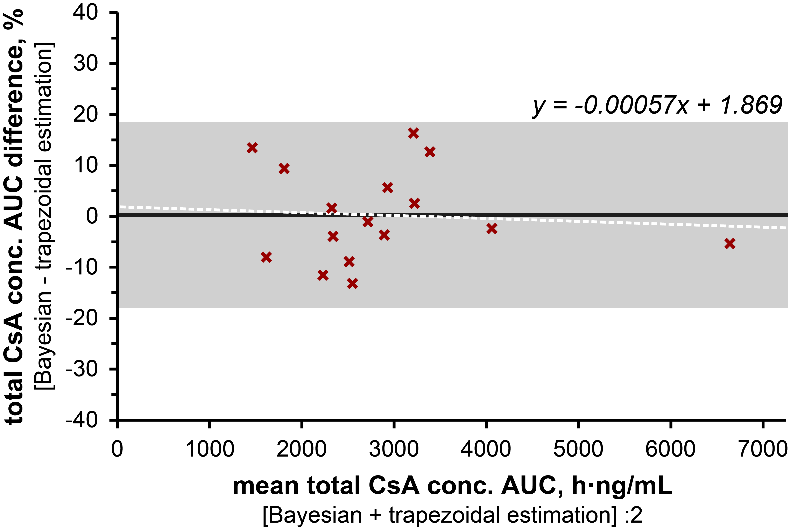
Supplemental Figure S5: Bland-Altman plot with Deming regression for the comparison of trapezoidal and Bayesian estimations of total CsA AUCs. The black line and grey shadow represent mean difference (-1.75%) and 95% confidence interval of the Bland-Altman plot, respectively. The Deming regression (y = -0.0005x + 1.869), which is not significantly different from zero is depicted as dotted white line.

