Supplemental Figure 5: Program structure utilized during the Build to Last program
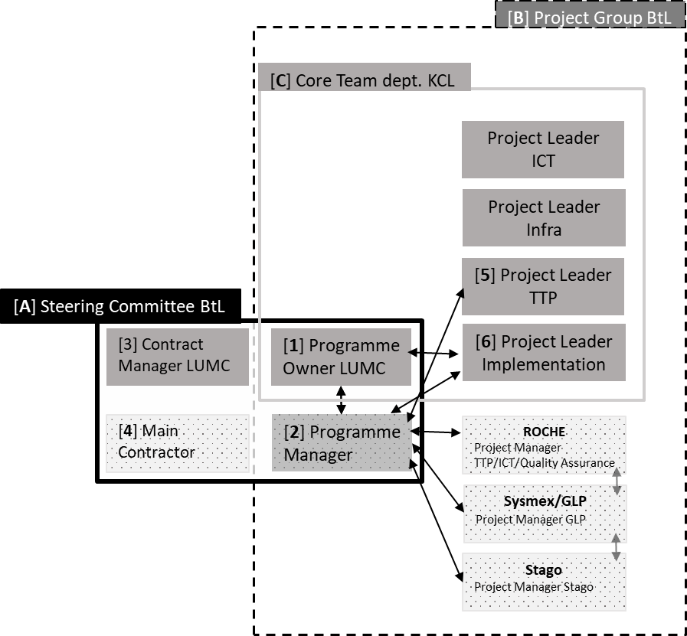
In order to accomplish the implementation of the new Total Testing Process the following programme and governance structure was set in place:
With a 4-6 weekly meeting frequency the Steering Committee BtL (A) consisting of Programme Owner (1), Programme Manager BtL (2), Contract Manager LUMC (3) and Main Contractor (4) focused in the first phase 2015-2016 on defining the TO BE process and thus provided the framework for the project group. In 2017 the focus was more on escalation and decision-making in relation to implementation. Since 2019, the Steering Committee operates on a quarterly basis to further steer and monitor the ongoing development-oriented process themes.
The Project Group BtL (B) focused during preparation for the Go-Life on the realization (monthly meeting), fed by the various internal working groups (standardization of tubes, workflow integration, etc....). The Project Leaders responsible for the preparation of the Construction and Housing and the Total Test Process (5) played an essential role during the entire preparation period. In the final year before the Go-Live a dedicated Implementation Project Leader (6) was added to the project team. That project leader was responsible for the communication and aligning between external parties and KCL-employees regarding operational and organizational issues, and reported or escalated directly to the end responsible Programme owner. The role of linking pin between Project- and Steering Committee was accomplished by the Programme Manager BtL (2) who took care of continuous alignment and finetuning regarding the implications of decisions taken in the Steering Committee.
Embedded within our organisation a Core Team (C) operated as management team for the TO BE process. Frameworks from the steering committee for the project team were discussed and approved by the core team before they were implemented by the project organisation. In this way, the programme was directly linked to the line organisation, so that decisions were supported and enforceable.

